**Mass conserving glacier algorithm SPHY**

Discussed 1 June 2016 by Wilco, Walter, Arthur, Santosh, Sonu

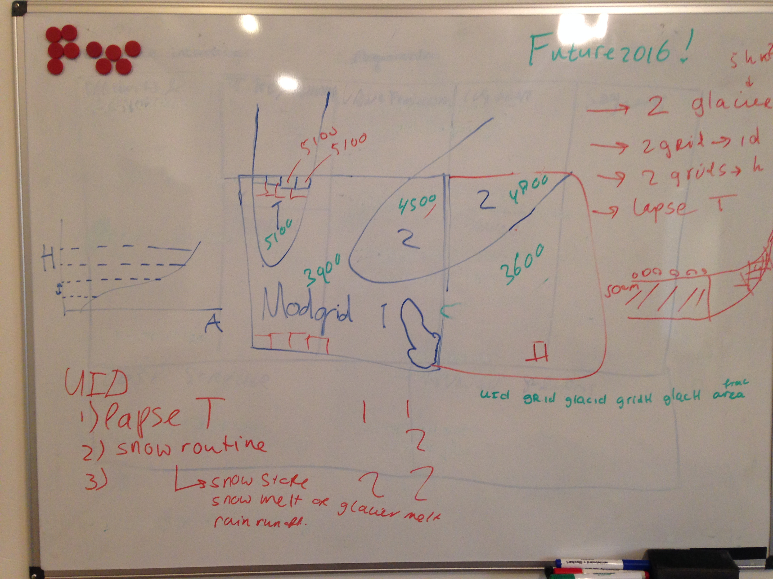

Modgrid = 5x5 km  
Subgrid = 100x100 m

Each Modgrid cell has a unique ID (see above cells 1 and 2)  
Each glacier has a unique ID (see above glaciers with ID’s 1 and 2), but can be located in different cells (see glacier 2 above). Each Modgrid cell has a mean elevation (gridH, above Modgrid 1 has elevation 3900 m and Modgrid 2 has elevation 3600 m)

**Preprocessing**

At subgrid for each (part of) glacier a mean elevation (glacH) is calculated. In the above figure this is 5100 m for glacier 1 in Modgrid 1, 4500 m for glacier 2 in Modgrid 2, 4800 m for glacier 2 in Modgrid 2.

A table is made with records for each (part of) glacier in each grid cell:

|  |  |  |  |  |  |  |
| --- | --- | --- | --- | --- | --- | --- |
| UID (-) | Modgrid ID (-) | GlacID (-) | gridH (m asl) | glacH (m asl) | DDFglac | Frac_area (-) |
| 1 | 1 | 1 | 3900 | 5100 | DDFDC or DDFCI | … |
| 2 | 1 | 2 | 3900 | 4500 | DDFDC or DDFCI | … |
| 3 | 2 | 2 | 3600 | 4800 | DDFDC or DDFCI | … |
| 4 | .. | .. | .. | .. | DDFDC or DDFCI | .. |

**Calculations per time step**

For each time step for each Modgrid cell Tavg is lapsed from gridH to glacH (glacT). This temperature is used in SPHY’s SnowStore routine to keep track of a snow storage for each UID. If no snow storage is present, the glacier surface melts according to its degree day factor (either debris covered or debris-free).

If the present snow storage is melted within the time step, also glacier melt occurs. This is scaled according to the thickness of the snow storage and the degree day factors for snow and ice. For example if the lapsed temperature is 5 °C, the DDFsnow = 10 mm d-1 °C-1, the DDFglac = 7 d-1 °C-1and the snow storage is 20 mm then the snowmelt on that day is 20 mm and the glacier melt is (5 – (20/10))*7 = 21 mm.

Rainfall on glacier ice runs of as rainfall-runoff. Each of these water sources is tracked for each UID. They are returned to Modgrid cell level using the glacier (part)’s fractional areas. For both rain runoff and glacier melt a part infiltrates to groundwater according to the GlacF parameter

For each glacID the mass balance components can be tracked (solid P, melt), also if the glacier is distributed over multiple glacier grid cells.

A table is updated every time step with calculated model variables per UID (table split in two parts for readability here)

|  |  |  |  |  |  |  |
| --- | --- | --- | --- | --- | --- | --- |
| UID | glacT | Prain | Psnow | Potsnowmelt | Actsnowmelt | Snowstore |
| 1 |  |  |  |  |  |  |
| 2 |  |  |  |  |  |  |
| 3 |  |  |  |  |  |  |
| 4 |  |  |  |  |  |  |

|  |  |  |  |  |  |
| --- | --- | --- | --- | --- | --- |
| UID | MaxSnowWatStore | SnowWatStore | TotalSnowStore | GlacMelt | RainR |
| 1 |  |  |  |  |  |
| 2 |  |  |  |  |  |
| 3 |  |  |  |  |  |
| 4 |  |  |  |  |  |

For the glaciers new output files will be created. For each variable a CSV will be created with the time steps as rows and the GLACID as colums.