**Medical Image Classification Analysis using Convolution Neural Network**

Drishti Jain1, Adivya Jain2, Tej Singh3

1Centre for Artificial Intelligence, MİTS Gwalior

1drishtij3@gmail.com

2 Centre for Artificial Intelligence, MITS Gwalior

2adivyajain@gmail.com

3Centre for Artificial Intelligence, MITS Gwalior

3tejs@mitsgwalior.in

* Corresponding Author

**Abstract.** Coronavirus disease (COVID-19) is a respiratory infectious disease caused by the SARS-CoV-2 virus. As per Covid data by WHO dated March 24, COVID-19 has put the entire world under lockdown, infecting 704.73 million people and killing 7.01 million. In India alone, 45.04 million people are infected and 0.53 million people died, according to WHO data. It was urgently needed to detect and diagnose disease early at that time. As one of the most effective methods of detecting infection, the RT-PCR test was found to be time consuming, not 100% accurate, giving strategic boost to AI-based deep-learning CNN Covid detection methods that are relatively quick with chest X-rays, which are becoming increasingly common. This study of X-Ray dataset for covid classification used 4 predefined CNN architectures and 1 custom build model: LeNet-5, VGG16, AlexNet, ResNet, and a custom model.

**Keywords:** Covid-19, CNN. X-ray, Deep Learning, Artificial intelligence.

**1 Introduction**

Throughout the world, the rapid spread of a deadly respiratory disease called COVID 19 is posing a threat not only to human life but also negatively impacting the economies of countries[][][][]. Also the global scale lockdown negatively impacted the lives of citizens throughout the world. After the spread of COVID-19, some orthodox practitioners began employing traditional or ancestral approaches to treat respiratory diseases as a response to the outbreak. However, these methods did not have the necessary solid evidence of effectiveness because the disease was evolving with new variants of the disease such as Alpha, Beta, Gamma, and Delta, each of which has its own variations like spread speed, and death rate etc.

To detect SARS-CoV-2, scientists developed a method called RT-PCR or reverse transcription polymerase chain reaction. By using this method one to one sample is taken, fats and proteins are removed from the sample after several chemical solutions are applied. RNA is the only substance extracted from the sample, which contains a person's own genetic material and any virus RNA that may also be present. Furthermore, RT-PCR was not 100% effective and required significant time as one to one samples were to be taken and tested to overcome these challenges, Researchers and scientists began to become increasingly interested in advanced technologies of artificial intelligence as demand for this increased.[][][]

COVID-19 is more than just a respiratory disease - its main impact is on the respiratory tract, leading to lung damage. In addition to COVID-19, there is another condition known as Pneumonia that can also affect the lungs by causing inflammation or fluid buildup in our lungs. While COVID-19 is highly contagious, Pneumonia spreads more slowly but can result in prolonged lung damage. There are instances where both conditions can occur simultaneously, adding complexity to diagnosis for researchers and scientists. Common symptoms include shortness of breath, extreme fatigue, cough, chest pain, and fever, further complicating the process of differentiation.

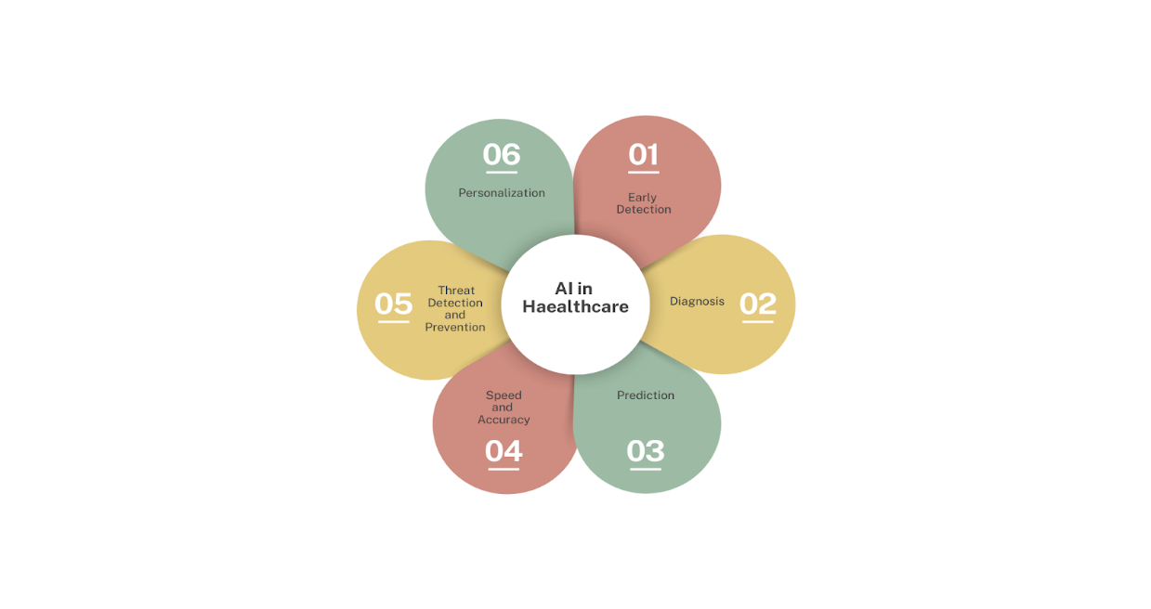

**Fig. 1.** Artificial Intelligence in Health Care

Scientists and researchers face a significant challenge due to the rapid exponential growth of vast amounts of data every day. This data is gathered through various methods such as RTP-CR, CT scans, and Chest X-Ray images, creating complexity in the handling and analysis process. Fortunately, cutting-edge AI technology offers a solution. Machine Learning and Deep Learning, prominent branches of AI, can streamline tasks, minimize human involvement, and enhance efficiency in medical image classification and analysis.

As a broader category Artificial intelligence with the motive to resemble the human mind having different machine learning algorithms which uses data to learn patterns and make decisions. Machine learning has a specific architecture called neural network used for the purpose of deep learning. A Neural Network is similar to the structure of the brain consisting of interconnected nodes (neurons) having architecture of multiple layers for efficient processing of data.Convolution neural networks (CNNs) are a particular kind of neural network that adaptively learn features automatically from input images to perform image identification and processing tasks. Technique used in this paper was to learn from input X-ray images of Covid Infected, Pneumonia Infected, Normal, X-ray images and to detect Infection type of new unseen data input.

**2 METHODOLOGY**

**2.1 PROPOSED WORK**

This section focuses on how to compile relevant research articles. Several investigations are being conducted to detect and diagnose COVID-19 based on previously reported cases. This section analyzes prior articles that used ML and DL algorithms to identify and predict COVID-19.Several studies have been conducted in this field, focusing on compiling previous research and analyzing the knowledge gained.

One study applied the NIH chest X-ray with a ResNet-50 approach[2] to identify disease patterns, aiming to create an automated system integrated into a hospital management system.

Similarly, research on the COVID-19 radiography database utilized a CNN model to distinguish between infected and normal images, employing different kernel sizes at two concurrent levels[6]. Another study employed an LSTM and CNN model combination[7] for COVID-19 diagnosis, where LSTM was utilized in conjunction with CNN for feature extraction. An ensemble classifier was applied to the NIH chest X-ray 14 set, COVID chest X-ray set, and Montgomery set for automatic COVID screening and feature extraction, achieving an accuracy of 98.06% through a two-phase categorization technique[8].

A study on the COVID-R dataset implemented the CORODNET model, consisting of 22 layers of CNN[10], achieving an accuracy of 99.1%. Lastly, research on the COVID-19 Radiography chest X-ray database using a CNN approach attained an accuracy of 93.96%[1]

**2.2 SYSTEM REQUIREMENTS**

A computer with an advanced operating system, such as Windows, with at least 8 GB of RAM(12 GB preferable) , a 4 GB graphics card, and an Intel core i5 processor with above 8th Gen are the bare minimum requirements for the suggested model. Also, there are software prerequisites that include Pycharm and Jupyter Notebook, Python is used to build the model, and libraries such as OpenCV, Numpy, and Matplotlib are commonly used.

**2.3 DATASET**

Our dataset, obtained freely from Kaggle's COVID-19 Radiography Database (recipient of the COVID-19 Database Award by the Kaggle Community), presents a collection of chest X-ray images showcasing Covid-19 positive cases, as well as Normal and Viral Pneumonia images.

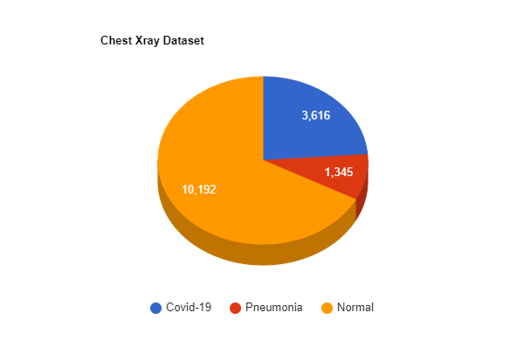

**Fig. 2.** Represents pie chart of database

The dataset features 3616 COVID-19 positive cases, together with 10,192 Normal, and 1345 Viral Pneumonia images. Please refer to the accompanying figure displaying the pie chart of this comprehensive database.

**2.4 DATA PREPROCESSING**

In the initial stage, we meticulously preprocessed each image, resizing them uniformly to a dimension of 100x100 pixels. This step proved vital as it allowed us to normalize the pixel values. By doing so, we ensured that each feature, or rather each pixel, contributed optimally to the learning process of the neural network. This was achieved by scaling the pixel values to an appropriate range of 0 to 1. Simultaneously, we employed the efficient utilization of Python libraries such as OpenCV, numpy, and matplotlib to merge the images of chest X-Rays, encompassing instances of Covid infection, pneumonia, and normal conditions. An intrinsic aspect of this merging process was to ensure an equitable distribution of these images. We did so diligently, thereby avoiding any unwarranted skewing in the test or training datasets.

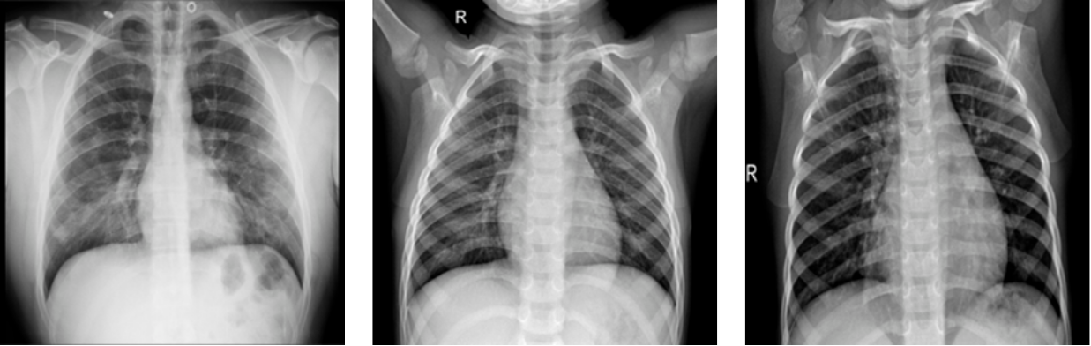

**Fig. 3.** Chest X-Ray Images [COVID-19 Radiography Database]

**2.5 EXISTING DEEP LEARNING MODEL**

**VGG 16.** VGG-16 model is a convolutional neural network termed as deep as it consists of 16 layers, including 13 convolution layers and 3 fully connected or dense layers. It is known for its ability to perform well in a variety of OpenCV tasks, such as image classification. Through this model we got a maximum validation accuracy of 73.65% through the dataset we described before.

**AlexNet.** It is composed of five convolution layers, three maximum pooling layers, two normalized layers, and two fully connected layers. The convolutional layers consist of a convolutional filter and a nonlinear activation function. Pooling layer that performs maximum pooling. There is a batch size of 128 for AlexNet. There is a great deal of potential for data augmentation to be performed.Through this model we got a maximum validation accuracy of 67.5% through the database we described before.

**LeNet-5.** The Lenet network is a simple convolutional neural network. The primary goal is to identify handwritten digits. Takes input in 32x32x1 gray image. It has 5 layers : Conv >Pooling(6) > Conv > Pooling (16) > Fully Connected (120 neuron) > Fully Connected (84 neuron) > Output (softmax). While using this model and with the dataset described above we achieved maximum validation accuracy of 66.16%.[]

**ResNet.** The Residual Neural Network (ResNet) is a predefined deep learning model, which, unlike previous CNN architectures, allows for the addition of a large number of layers, addressing the "vanishing gradient" problem. It introduces a new technique of skipping connections during the initial training phase, which accelerates the training process. Subsequently, during retraining, all layers are expanded, and the remaining "residual" parts are utilized to extract additional feature space from input images. After adding ResNet50 some custom layers are added for custom classification making a model having a total of 54 layers. Using the dataset described above, we achieved an accuracy of 77.59% with this model.

**Table 1.** Models accuracy

|  |  |
| --- | --- |
| Existing DL model | Accuracy |
| VGG-16 | 73.65% |
| AlexNet | 67.5% |
| LeNet-5 | 66.16% |
| ResNet | 77.59% |
| Custom Model | 95.80% |

**2.6 Proposed Model architecture for covid-19 classification model**

Our custom model has an input layer where chest X-Ray images with each dimension of 100x100x3 pixels followed by 3 pairs of each convolution and max pooling layer then the features extracted are flatten into single 1D vector which in turn connected with 3 dense or fully connected layers,last layer having 3 nodes to classify the input image into 3 classes (Covid, Normal, Pneumonia).

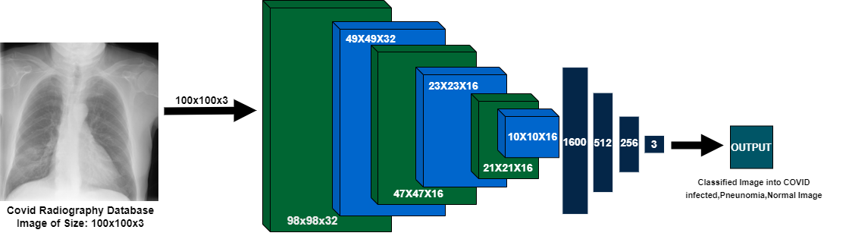

**Fig. 4**. Custom Proposed Model

**2.7 Explaining Architecture Layer by Layer**

**Conv2D.**Convolutional layers are the foundation of a CNN, identifying spatial patterns within an image using learnable filters or kernels. These layers create feature maps by analyzing input images to identify edges, textures, and complicated patterns. Key parameters include filter number, kernel size, stride, and padding to preserve spatial dimensions.

**Max Pooling.**Max pooling is a CNN downsampling operation that reduces feature map spatial dimensions while retaining important information. It involves sliding a fixed-size window over the input feature map and selecting the maximum value within each window, reducing computational complexity and making the model more robust to input variations.

**Dropout.** Dropout serves as a regularization technique by randomly deactivating a percentage of neurons during training, aiming to prevent overfitting. Typically set between 20% and 50%, this method reduces the network's reliance on specific sets of neurons, promoting the acquisition of more resilient features. The dropout rate stands out as a crucial factor in this approach.

**Dense layer.** It is also Known as fully connected layers, these are traditional neural networks where each neuron is connected to every previous one. They are crucial for learning complex patterns by combining input neuron information. The primary parameter is the number of neurons.

**2.8 Some Others Related Important Parameters**

**Optimizer.** Optimizers are techniques that alter a neural network's parameters during training to reduce the loss function, hence reducing the error between expected and actual target output. Examples include Gradient Descent, Adam, RMSProp, and AdaGrad.We used SGD and Adam as optimizers in our model.

**Activation Function.** Activation functions add nonlinearities to neural networks, enabling them to learn complex structures and correlations. They determine neuron output and are applied element-wise to each neuron in the network, such as ReLU, Sigmoid, Tanh, and Leaky ReLU.

**Learning Rate.** Learning rate is a significant hyperparameter that affects the model's training and final performance. It determines the step size with which neural network parameters are altered. A high learning rate could end in rapid convergence but exceed the optimal answer, whereas a low rate may delay convergence but produce more accurate results.

**Momentum.** Momentum is a technique used to accelerate the convergence of the optimization algorithm, especially in cases where the loss surface is rough or noisy. It adds a portion of the prior update vector to the current update, allowing for a more continuous advance towards the optimum. Momentum is another hyperparameter that needs to be tuned, and typical values range from 0.9 to 0.99.

**3 Result and Discussion**

In this research, different CNN techniques are used for detection of Covid Images which is beneficial for early detection of infection.X-rays images of the chest have been used to successfully predict the patient's infection status. In addition to the custom model some well known pre-trained DL algorithms like VGG-16, Alexnet and LeNet-5 have also been implemented.The experiment was performed on Covid-19 Radiography dataset which is available for free on kaggle.This dataset was Awarded by the Kaggle Community for the best COVID-19 dataset on kaggle. It contains 15,153 chest X-ray images. The partitioning of the data set is done in the ratio of sixty percent for training purpose, twenty five percent for testing purpose and remaining fifteen for validation purpose.

In this research we classified the images into 3 categories Normal, Covid and Pneumonia,then integer 0 is assigned for category 1 or Normal image (with no infection), 1 for category 2 or Covid Infected X-ray and 2 for category 3 or Pneumonia infected image which makes it categorical. The metrics accuracy was used for calculating the model efficiency. And different activation functions namely ReLu and Elu are used in custom models. Model is trained with different dropouts to regularize the robustness in the model which inturn helps in regularizing the model and decreasing the chances of overfitting .Also, the model is tested under different optimizers like Adaptive moment estimation and Stochastic Gradient Descent.

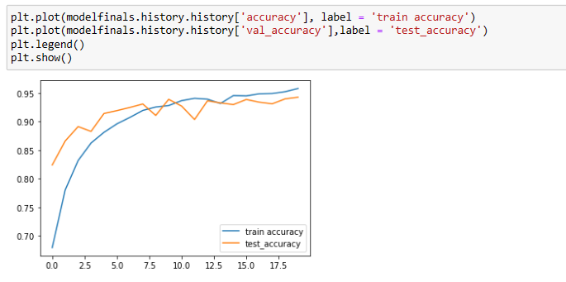

**Fig. 5.** Test and Train Accuracy Plot

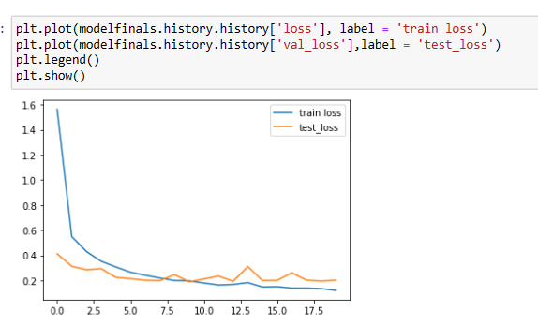

**Fig. 6.** Test and Train Loss Plot

Below table shows the accuracy and validation accuracy of custom proposed under different parameters.

**Table 2.**Accuracy of Activation functions

|  |  |  |  |  |
| --- | --- | --- | --- | --- |
| Accuracy/ Valid_Accuracy | | | | |
| ACTİVATİON FUNCTİON – ReLu | | | ACTIVATION FUNCTION - ELu | |
| DROPOUT  OPTIMIZER | 0.5 | 0.8 | 0.5 | 0.8 |
| Adam | 89.30/ 89.15 | 69.62/ 71.42 | 95.80/ 94.27 | 74.22/81.89 |
| SGD | 67.02/ 67.99 | 67.02/ 67.99 | 67.02/ 67.99 | 74.22/81.89 |

**4 Conclusion**

With the growing number of COVID-19 cases worldwide with several new variations, necessitates the rapid increase in the number of testing thereby helping in early detection and diagnosis. Utilizing new technologies like machine learning and artificial intelligence in medical analysis directly helps in early detection and mass testing.

The custom model proposed achieved an accuracy of 95.80% surpassing other predefined existing deep learning CNN architectures using the chest radiography dataset which accomplish the main aim to assist medical professionals, researchers and scientist and speeds up mass testing. Being such high accuracy can not only increase the testing and detection of infected patients also can be more cost efficient then other COVID detection approaches like RT-PCR.

This model can efficiently classify X-Ray images into three types: Normal, COVID and Pneumonia. We recommend further validation for an actual use and consultation with medical specialists as well for precautions. Overall, our research provides valuable insights about the importance of artificial intelligence in healthcare and we hope our study’s insightful findings will stimulate more research in this area.

**REFERENCES**

1. Dawar I., Singh I., Gupta S. D., Kothari Y., Raj R., and Kumar N., “Deep learning based detection of coronavirus (COVID-19) using chest X-ray images” in Proceedings of the 2023 7th International Conference on Trends in Electronics and Informatics(ICOEI).Doi: 10.1109/ICOEI56765.2023.10125881
2. Jain G., Mittal, D., Thakur D., & Mittal M. K. (2020). A deep learning approach to detect Covid-19 coronavirus with X-Ray images. Biocybernetics and biomedical engineering, 40(4), 1391-1405.
3. J. Monsi, J. Saji, K. Vinod, L. Joy, and J. J. Mathew, "XRAY AI: Lung Disease Prediction using machine learning," International Journal of Information Systems and Computer Sciences, vol. 8, no. 2, pp. 51–54, 2019.
4. Kim T., Heo J., Jang D. K., Sunwoo L., Kim J., Lee K. J., Kang S. H. , Park S. J., Kwon O. K., and Oh C. W., "Machine learning for detecting moyamoya disease in plain skull radiography using a convolutional neural network," EBioMedicine, vol. 40, pp. 636–642, 2019.
5. Ouchicha C., Ammor O., and Meknassi M., "CVDNet: A novel deep learning architecture for detection of coronavirus (covid-19) from chest X-ray images," Chaos, Solitons & Fractals, vol. 140, p. 110245, 2020.
6. Li L., Qin L., Xu Z.,Yin Y., Wang X., Kong B., Bai J., Lu Y., Fang Z., Song Q., Cao K., Liu D., Wang G., Xu Q., Fang X., Zhang S., Xia J., and Xia J., "Using artificial intelligence to detect COVID-19 and community-acquired pneumonia based on pulmonary CT: Evaluation of the diagnostic accuracy," Radiology, vol. 296, no. 2, 2020.
7. Islam M. Z., Islam M. M., and Asraf A., "A combined deep CNN LSTM network for the detection of novel coronavirus (COVID 19) using X-ray images," Informatics in Medicine Unlocked, vol. 20, p. 100412, 2020.
8. Chandra T. B., Verma K., Singh B. K., Jain D., and Netam S. S., "Coronavirus disease (COVID-19) detection in chest X-ray images using majority voting based classifier ensemble," Expert Systems with Applications, vol. 165, p. 113909, 2021.
9. Rustam F., Khalid M., Aslam W., Rupapara V., Mehmood A., and Choi G. S., "A performance comparison of supervised machine learning models for covid-19 tweets sentiment analysis," PLOS ONE, vol. 16, no. 2, 2021.
10. Jain R., Gupta M., Taneja S., and Hemanth D. J., "Deep learning based detection and analysis of COVID-19 on chest X-ray images," Applied Intelligence, vol. 51, no. 3, pp. 1690–1700, Mar. 2021, doi: 10.1007/S10489-020-01902-1.
11. Kumar N.,Dahiya A. K. and Kumar K., "Modified Median Filter for Image Denoising", Int. J. Adv. Sci. Technol., vol. 29, no. 4s, pp. 1495-1502, 2020.
12. Kumar N., Kumar K. and Kumar A., "Application of Internet of Things in Image Processing," 2022 IEEE Delhi Section Conference (DELCON), New Delhi, India, 2022, pp. 1-5, doi: 10.1109/DELCON54057.2022.9753308.