

SVKM'S NMIMS
Mukesh Patel School of Technology Management & Engineering (MPSTME)
Shirpur Campus
Department of Information Technology

A SOFTWARE ENGINEERING SYSTEM REPORT
on
AUTOMATED POLICE ROSTER AND BURNOUT MANAGEMENT SYSTEM
Submitted in partial fulfilment of the requirements of the
Software Engineering course, B.Tech (Information Technology) - Third Year
Submitted by
ADIVYA KUMAR SINGH ()
Project Contributor ()
Project Contributor ()
Guided by : Project Supervisor

Academic Year 2026 - 27
TABLE OF CONTENTS
1. Introduction 1
1.1 Purpose of the Situation 1
1.2 Target Reader 1
1.3 Topic Background 1
1.4 Problem Context 1
1.5 Objective of the System 1
1.6 Functionality of the System 1
1.6.1 Roster Automation 1
1.6.2 Burnout Monitoring 1
1.6.3 Role-Based Access and Reporting 1
2. System Analysis 1
2.1 Target User / End User 1
2.1.1 Administrator 1
2.1.2 Police Supervisor / Station Head 1
2.1.3 Police Officers 1
2.1.4 Police Department Management 1
2.2 Use Case Overview 1
2.3 Functional and Non-Functional Requirements 1
2.3.1 Functional Requirements 1
2.3.2 Non-Functional Requirements 1
2.4 Benefits of the System 1
2.4.1 Tangible 1
2.4.2 Non-tangible 1
2.5 Technology Stack 1
2.6 Feasibility Study 1
2.6.1 Gantt Chart 1
2.6.2 Technical Feasibility 1
2.6.3 Operational Feasibility 1
2.6.4 Economic Feasibility 1
2.6.5 Schedule Feasibility 1
3. Research 1
3.1 Domain Research 1
3.1.1 Automated Workforce Scheduling 1
3.1.2 Burnout and Fatigue in Shift-Based Occupations 1
3.1.3 Research Gap Addressed by This Project 1
3.2 Existing System vs. Proposed System 1
4. Development Methodology 1
4.1 Methodology Selection 1
4.1.1 What Is a Development Methodology and Why It Matters 1
4.1.2 Methodologies Considered 1
4.1.3 Comparative Evaluation 1
4.1.4 Selected Methodology: Agile (Scrum-Based Iterative Development) 1
5. System Design 1
5.1 System Architecture 1
5.2 UML Class Diagram 1
5.3 UML State Machine Diagram 1
5.4 Data Flow Diagrams (Level 0 to Level 2) 1
5.4.1 Theory and Notation 1
5.4.2 Level-0 DFD (Context Diagram) 1
5.4.3 Level-1 DFD 1
5.4.4 Level-2 DFD (Process 2.0: Roster Generation) 1
5.4.5 Balancing Check 1
5.4.6 Data Dictionary 1
5.4.7 Process Specifications 1
5.5 Database Design 1
5.6 Mapping Data Flow into a Software Architecture 1
5.6.1 Transaction Analysis of Level 1 1
5.6.2 Transform Analysis of Process 2.0 1
5.6.3 Cohesion and Coupling of the Resulting Design 1
6. Cost Estimation 1
7. Testing Strategy 1
7.1 Levels of Testing 1
7.1.1 Unit Testing 1
7.1.2 Integration Testing 1
7.1.3 System Testing 1
7.1.4 User Acceptance Testing (UAT) 1
7.2 Sample Test Cases 1
8. Expected Results and Discussion 1
8.1 Roster Generation Module 1
8.2 Burnout Management Module 1
8.3 Dashboards and Reporting 1
8.4 Overall Discussion 1
9. Limitations and Future Scope 1
9.1 Limitations 1
9.2 Future Scope 1
10. Conclusion 1
References 1

1. Introduction

1.1 Purpose of the Situation
Police departments function every hour of every day, and this round-the-clock responsibility means that officers must be organised into overlapping, rotating shifts that cover mornings, evenings, nights, weekends, and public holidays without leaving any gap in coverage. Before any design decision for this project was made, it was necessary to establish exactly what real-world problem the system responds to, and why that problem is better solved with software than by continuing to manage it manually.
At present, most police stations construct their duty rosters using spreadsheets, printed charts, or handwritten registers. A duty-in-charge officer or station house officer typically sits down at the start of every week or month and manually assigns shifts, cross-checking who is on approved leave, who worked the most recent night shift, and who is due for a rest day. This is a cognitively demanding balancing act performed under time pressure, and it is repeated over and over, station after station, with almost no automated support. The purpose of building the Automated Police Roster and Burnout Management System is to remove this repetitive manual burden, replace it with a rules-based automated process, and simultaneously introduce a capability that manual systems cannot provide at scale: continuous, quantitative monitoring of every officer's workload, so that fatigue and burnout can be identified before they become a safety issue.

1.2 Target Reader
This report is written for several categories of reader, and the explanations throughout are structured so that each of them can extract what they need from it.
- Academic evaluators and project guides, who need to assess the completeness, feasibility, and technical soundness of the proposed system as a Software Engineering course deliverable.
- Police department administrators and station heads, who are the intended real-world decision-makers for adopting a system such as this, and who need to understand what the system does in operational rather than technical terms.
- Software developers and future contributors, including the project team itself, who will use this document as the reference point for what to design and build.
- Police officers and supervisors, as end users, whose daily workflow the system is meant to simplify.
Because the audience spans both technical and non-technical readers, this report deliberately explains concepts in plain language before introducing technical terminology, and technical sections such as the technology stack and methodology are written with enough justification that a non-technical reader can still follow why each choice was made.

1.3 Topic Background
Workforce scheduling is one of the oldest and most studied problems in operations management, and shift-based scheduling in particular has been the subject of decades of research because it directly affects both organisational efficiency and employee well-being. A large and mature body of this research is published under the heading of the "nurse rostering problem" (Burke et al., 2004), which studies exactly the kind of constraint-driven, continuous-coverage scheduling that a police department also requires. Police forces are an especially demanding case of shift-based workforce management: unlike a retail store or an office, a police station cannot simply reduce its service level when staff are unavailable, since public-safety coverage has to be maintained continuously. This forces trade-offs between fairness, cost, and officer welfare that are harder to satisfy simultaneously than in most other scheduling contexts.
Alongside scheduling, there is a substantial body of occupational health research on shift-work fatigue and burnout, particularly in emergency services, healthcare, and law enforcement. This research, most notably the Maslach Burnout Inventory framework (Maslach & Jackson, 1981) and dedicated police-fatigue studies (Vila, 2000), consistently finds that irregular hours, insufficient rest between shifts, and prolonged exposure to high-stress duty are strong predictors of physical fatigue, reduced alertness, and long-term psychological burnout. Burnout in a police context is not merely a personnel-management concern; it has direct implications for decision-making quality, response times, and the safety of both officers and the public they serve.
This project sits at the intersection of these two established problem areas, automated workforce scheduling and workload/fatigue monitoring, and proposes a single integrated system that addresses both together, rather than treating them as separate concerns to be solved by separate tools.

1.4 Problem Context
The specific problems this project responds to can be broken down into the following concrete pain points observed in the current manual approach to police roster management:
- Time-consuming manual preparation: preparing a roster by hand for a station with dozens of officers, multiple shifts, and constantly changing leave requests takes considerable administrative time every scheduling cycle.
- Human error and scheduling conflicts: manual processes are prone to double-booking, missed leave approvals, and accidental violation of rest-period norms, none of which are systematically checked.
- Uneven distribution of duty: without a systematic and auditable method of tracking who has worked which shifts, some officers end up disproportionately assigned to unpopular shifts such as night duty, while others are under-utilised, creating a perception of unfairness.
- No visibility into cumulative workload: a manual roster only shows what is scheduled, not how much strain that schedule places on an individual officer over time, since there is no running measure of overtime hours, consecutive working days, or consecutive night shifts.
- Reactive rather than preventive management of burnout: because workload is not measured, supervisors typically only become aware that an officer is overworked after the officer reports fatigue, requests leave suddenly, or an incident occurs, by which point preventive action is no longer possible.
- Fragmented leave and communication processes: leave requests, shift-change notifications, and emergency-duty assignments are often handled through informal channels such as phone calls or paper slips, leading to delays and miscommunication.
Taken together, this problem context describes a workforce-management gap that is both operational, in the form of inefficient and error-prone scheduling, and human, in the form of unmonitored fatigue risk. It is this combined gap that defines the scope of the proposed system.

1.5 Objective of the System
The main objective of the Automated Police Roster and Burnout Management System is to simplify and improve the process of police duty scheduling while ensuring that officers are assigned work fairly and efficiently. The specific objectives of the proposed system are as follows:
- To automate the process of preparing daily, weekly, and monthly duty rosters.
- To distribute shifts fairly among officers so that the workload is balanced.
- To reduce human errors and scheduling conflicts that commonly occur in manual roster preparation.
- To provide a centralised system for maintaining officer details, departments, and shift information.
- To allow officers to submit leave requests online and enable supervisors to approve or reject them easily.
- To automatically adjust duty schedules whenever leave requests or emergency duties arise.
- To monitor working hours, overtime, consecutive working days, and night shifts for every officer.
- To calculate a burnout score based on workload and identify officers who are at low, moderate, high, or critical risk.
- To notify supervisors whenever an officer shows signs of excessive workload or burnout.
- To generate reports and dashboards that help management analyse attendance, shift distribution, overtime, and burnout trends.
- To improve transparency, fairness, and efficiency in police workforce management.
Overall, the system aims to create a healthier working environment for police officers while making roster management faster, more organised, and more reliable.

1.6 Functionality of the System
At a functional level, the system is organised around three cooperating capabilities, each described below in terms of what the user actually does and what the system does in response.

1.6.1 Roster Automation
The system automatically generates duty rosters by taking into account officer availability, approved leave, prior shift history, working-hour limits, overtime already accrued, and departmental staffing requirements. Instead of a supervisor manually deciding every assignment, the system proposes a schedule that satisfies these constraints, which the supervisor can then review and adjust before it is finalised.

1.6.2 Burnout Monitoring
In parallel with scheduling, the system continuously tracks workload indicators for every officer, namely overtime hours, consecutive working days, consecutive night shifts, and emergency duty assignments, and converts these into a single burnout risk score. Officers are then classified into risk levels (low, moderate, high, or critical), and supervisors are alerted when an officer crosses into a higher-risk category so that preventive action, such as adjusting the schedule or granting rest, can be taken.

1.6.3 Role-Based Access and Reporting
The system provides distinct views and permissions for Administrators, Supervisors, and Officers, ensuring that each user sees and controls only what is relevant to their role. It also provides dashboards and reports covering attendance, overtime, leave statistics, shift allocation, and burnout trends, so that management can make workforce-planning decisions based on real data rather than informal impressions.

2. System Analysis

2.1 Target User / End User
The proposed system is intended to be used by different members of a police department, each having different responsibilities and access levels.

2.1.1 Administrator
The administrator is responsible for managing the overall system. They can add or update officer information, manage departments and shift timings, generate duty rosters, and monitor the performance of the system. The administrator also has access to reports and analytics for effective workforce management.

2.1.2 Police Supervisor / Station Head
Supervisors use the system to review generated rosters, approve leave requests, assign emergency duties, and monitor the workload of police officers. They can also receive burnout alerts and make necessary changes to prevent officers from being overworked.

2.1.3 Police Officers
Police officers are the primary users of the system. They can log in to view their duty schedules, apply for leave, receive notifications about shift changes, and check their own workload and burnout status. This helps them stay informed about their duties and maintain a better work-life balance.

2.1.4 Police Department Management
Senior management can use the reports and dashboards generated by the system to evaluate staffing patterns, monitor resource utilisation, and make informed decisions regarding manpower planning and workforce welfare. Unlike the three roles above, department management is a consumer of reports rather than a distinct login role in the current scope, and may be merged with the Administrator role in the first release.

2.2 Use Case Overview
The use case diagram below identifies Administrator, Supervisor, and Police Officer as the actors who directly interact with the system. It is worth noting, as a correction to an earlier draft of this report, that "Department" is modelled purely as a data entity in the class diagram (Section 5.2) and not as a use-case actor, since a department does not itself initiate any interaction with the system; only the human roles above do.
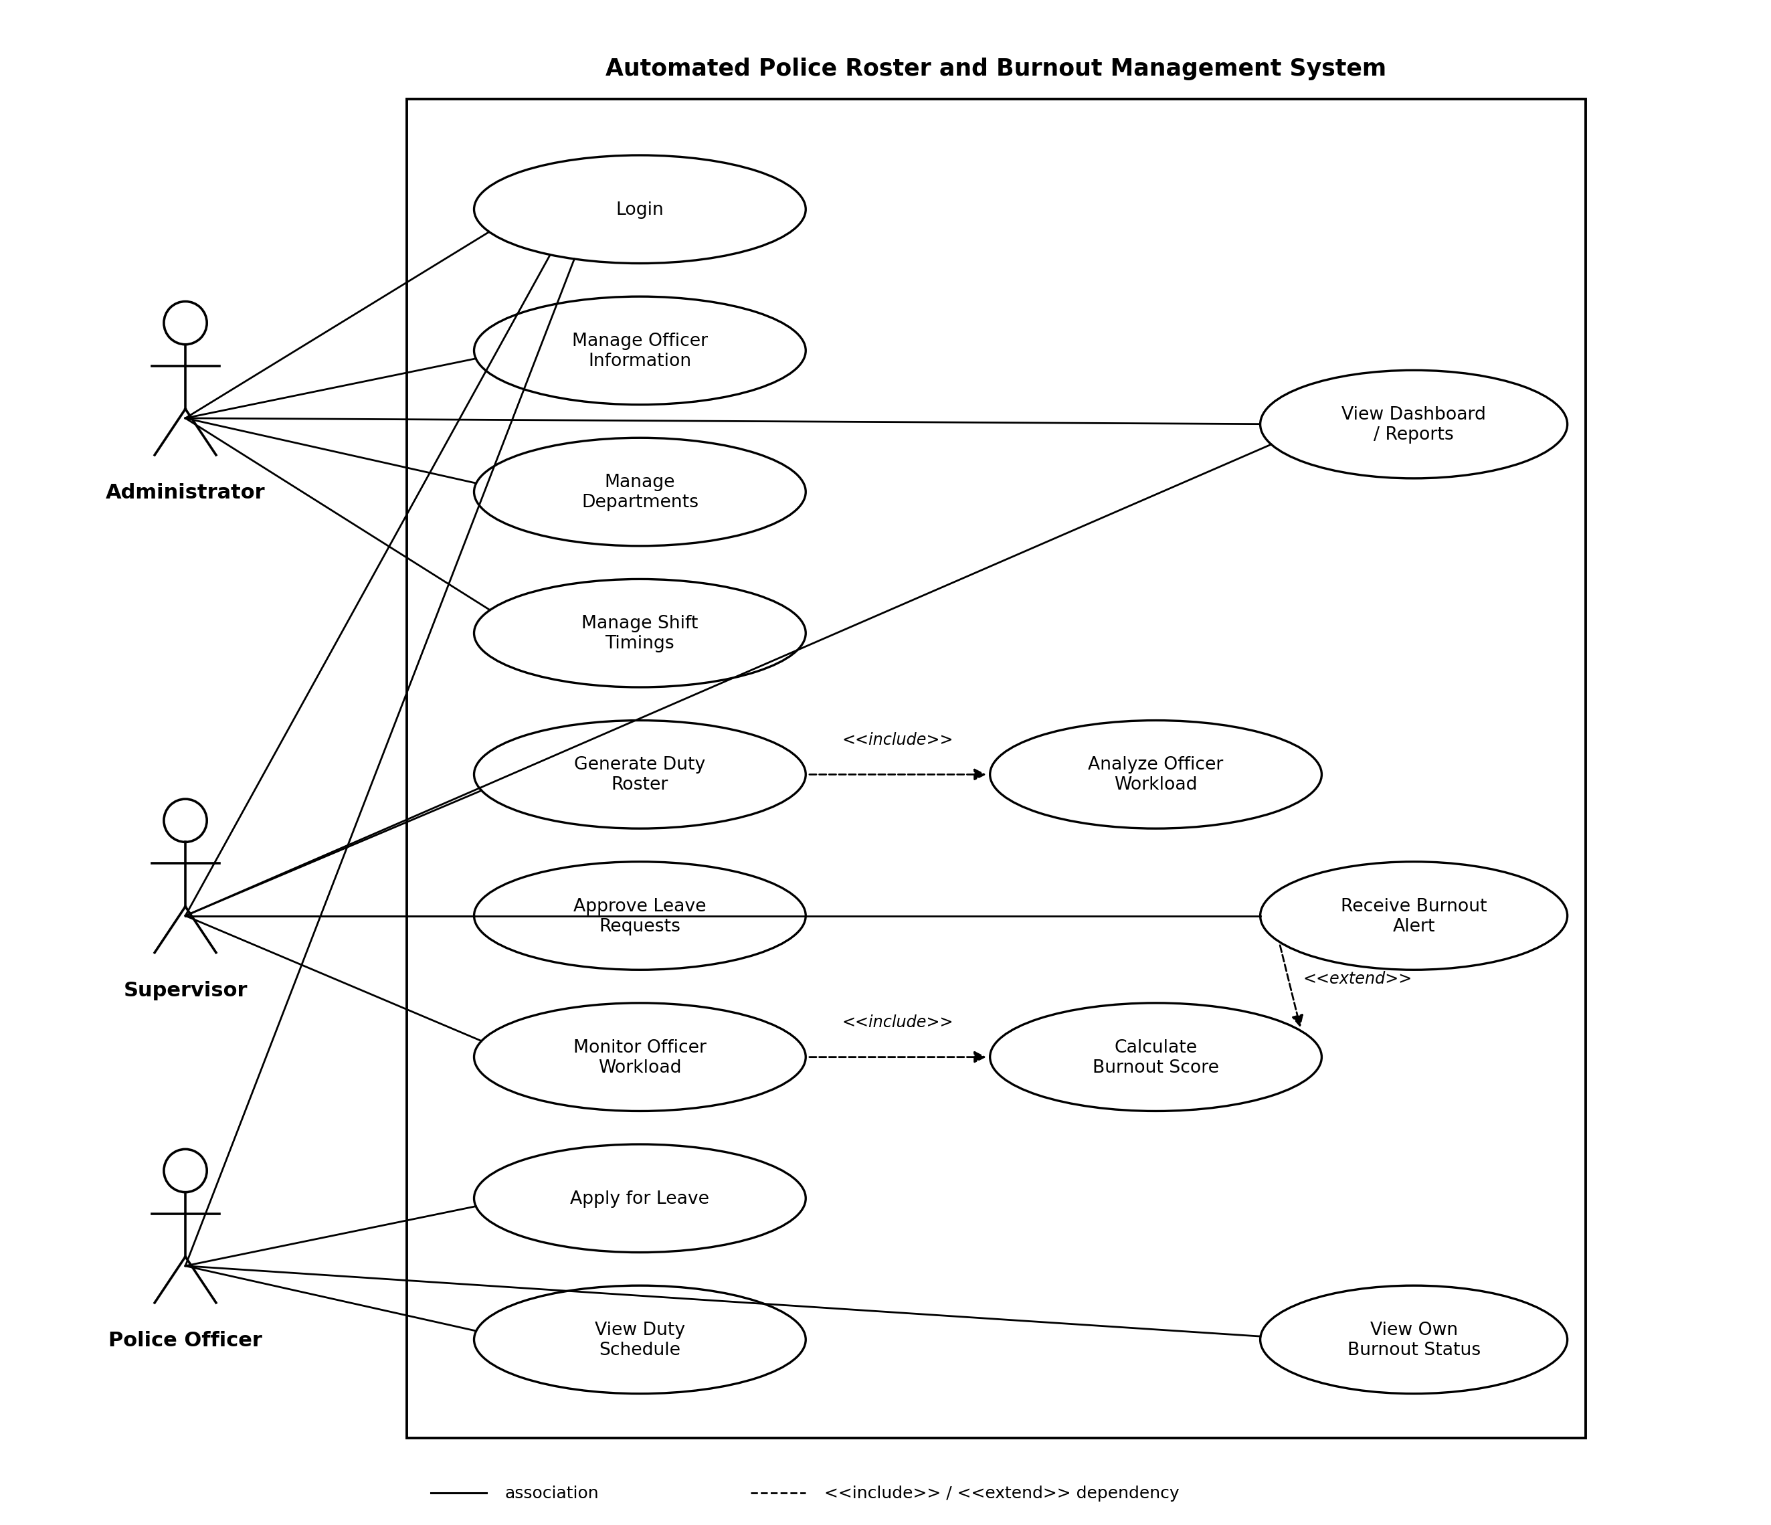
Fig. 2.1 UML Use Case Diagram of the Automated Police Roster and Burnout Management System
Two dependency relationships are shown using standard UML stereotypes. "Generate Duty Roster" includes "Analyze Officer Workload" as a mandatory sub-step, since the roster generator cannot propose a fair schedule without first checking current workload. "Receive Burnout Alert" extends "Calculate Burnout Score": the alert is only raised under the specific, optional condition that the calculated score crosses into the high or critical risk band, which is exactly what an extend relationship is meant to represent.

2.3 Functional and Non-Functional Requirements

2.3.1 Functional Requirements
- FR1: The system shall allow Administrators, Supervisors, and Officers to log in using a unique username and password, and shall restrict each user to actions permitted for their role.
- FR2: The system shall allow Administrators to create, update, and remove officer records, department records, and shift definitions.
- FR3: The system shall automatically generate a duty roster for a selected period, honouring approved leave, minimum rest periods, and maximum consecutive working days.
- FR4: The system shall allow Supervisors to review, manually adjust, and validate an automatically generated roster before it is published.
- FR5: The system shall allow Officers to submit leave requests with a start date, end date, and reason, and shall allow Supervisors to approve or reject them.
- FR6: The system shall record attendance, check-in and check-out times, and shall compute working hours and overtime hours for every officer automatically.
- FR7: The system shall compute a burnout score for every officer from overtime hours, consecutive working days, consecutive night shifts, and emergency-duty count, and shall classify the officer into a risk level.
- FR8: The system shall generate a notification to the relevant Supervisor whenever an officer's risk level becomes high or critical.
- FR9: The system shall send notifications to officers when their roster, shift, or leave status changes.
- FR10: The system shall provide dashboards and exportable reports covering attendance, overtime, leave, shift distribution, and burnout trends.

2.3.2 Non-Functional Requirements
- Usability: the interface shall be simple enough for an officer with no prior software experience to view their schedule and apply for leave without formal training.
- Performance: for a station of up to 150 officers, a roster for one week shall be generated in under 10 seconds on standard server hardware.
- Reliability: the system shall not lose a submitted leave request or attendance record even if the browser session is interrupted, since these are persisted to the database immediately on submission.
- Security: passwords shall be stored using a one-way hash, and every server-side action shall re-check the caller's role rather than trusting the client-side interface alone.
- Maintainability: the backend shall be organised into independent modules (authentication, roster generation, burnout scoring, notifications, reporting) so that one module can be modified without requiring changes to the others.
- Scalability: the relational schema and Flask application shall be structured so that additional departments or a larger officer count can be accommodated without a redesign.
- Portability: because the client is a standard web browser, the system shall run on any device with a modern browser and shall not depend on a specific operating system.

2.4 Benefits of the System

2.4.1 Tangible
The proposed system provides several measurable benefits that directly improve the efficiency of police roster management.
- Reduces the time required to prepare duty rosters.
- Minimises scheduling errors caused by manual work.
- Reduces paperwork by maintaining digital records.
- Simplifies leave management and shift replacement.
- Balances overtime among police officers.
- Improves utilisation of available manpower.
- Generates attendance, workload, and burnout reports automatically.
- Helps supervisors manage emergency duty assignments more efficiently.
- Reduces administrative effort and increases productivity.

2.4.2 Non-tangible
Apart from measurable improvements, the proposed system also offers several long-term qualitative benefits.
- Promotes fairness in duty allocation among all officers.
- Reduces stress and fatigue by monitoring workload.
- Improves officer morale and job satisfaction.
- Encourages a healthier work-life balance.
- Increases transparency in scheduling decisions.
- Supports better decision-making through real-time dashboards and reports.
- Improves communication between officers and supervisors.
- Creates a positive working environment by helping prevent burnout before it becomes a serious issue.

2.5 Technology Stack
The system is developed using a modern, freely available web technology stack, chosen to balance ease of development, performance, and future extensibility, particularly towards machine-learning-based burnout prediction. The table below summarises each technology, its purpose in the system, and the reasoning behind its selection.
Technology / Tool | Purpose | Why It Was Chosen
HTML5 | Structure of web pages | HTML is the standard language for creating web pages. It is simple, lightweight, and supported by every web browser.
CSS3 | Styling and layout | CSS creates an attractive, responsive, user-friendly interface while keeping design separate from content.
Bootstrap 5 | Responsive UI framework | Bootstrap provides pre-built components and a responsive grid system, reducing development time and ensuring the application works well on different screen sizes.
JavaScript | Client-side interactivity | JavaScript enables dynamic features such as form validation, interactive buttons, and real-time updates without reloading the page.
Python | Backend programming language | Python has simple syntax, is easy to learn, and offers excellent support for web development and data processing. It also allows future integration of machine learning for burnout prediction.
Flask | Backend web framework | Flask is lightweight, easy to configure, and ideal for small to medium-sized projects. It allows modules to be developed independently and gives flexibility in designing the application.
MySQL | Database management | MySQL is a reliable relational database that efficiently stores and retrieves structured data such as officer details, duty rosters, leave requests, attendance, and burnout records.
Chart.js | Data visualisation | Chart.js creates interactive charts and graphs, making it easier for supervisors to analyse workload, overtime, and burnout trends.
VS Code | Development environment | VS Code is lightweight, supports multiple programming languages, and provides useful extensions for Python, Flask, HTML, CSS, and JavaScript development.
Git & GitHub (optional) | Version control | Git and GitHub help track code changes, manage different versions of the project, and support team collaboration.

2.6 Feasibility Study
The feasibility study is carried out to determine whether the Automated Police Roster and Burnout Management System can be developed and used successfully. It considers whether the required technology is available, whether the system will be practical for its users, and whether the expected benefits justify the cost of development.

2.6.1 Gantt Chart
The Gantt chart below breaks the project down into its constituent activities across a fifteen-week development timeline, from initial problem identification through to final deployment and presentation. Activities are sequenced so that foundational work (requirement gathering, feasibility study, and design) precedes implementation, and implementation of the two core modules, Automated Roster Generation and Burnout Management, is scheduled to run alongside the supporting Dashboard and Notification features so that integration and testing can begin promptly in the final third of the schedule.
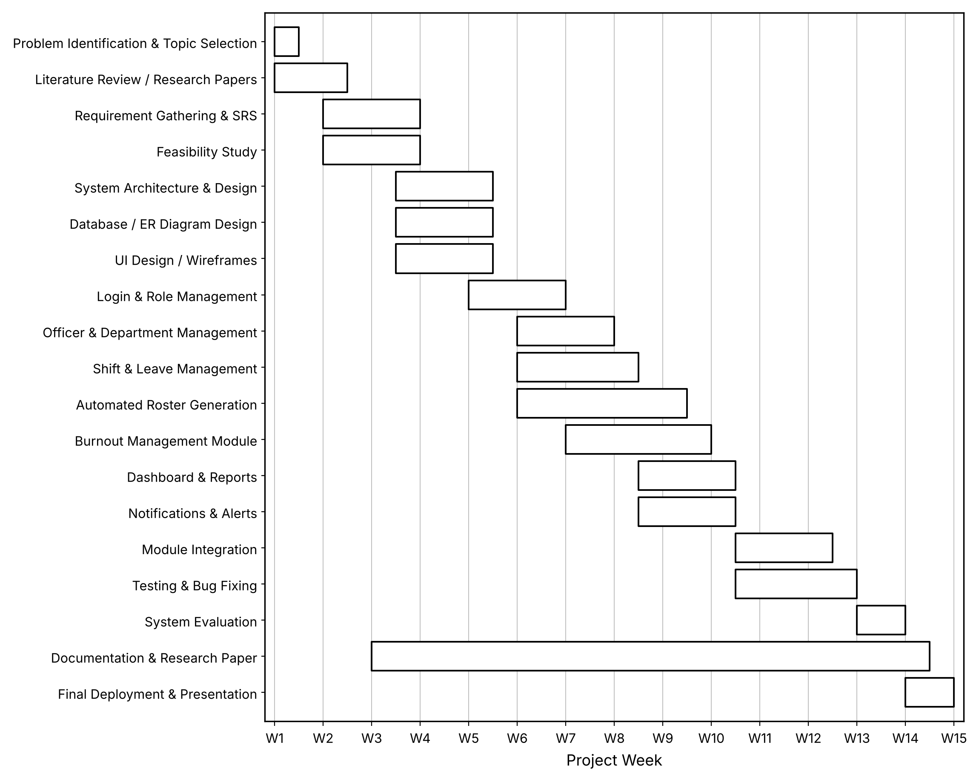
Fig. 2.2 Gantt Chart - Fifteen-Week Development Timeline

2.6.2 Technical Feasibility
The project is technically feasible because the required technologies are easily available and suitable for developing a web-based application. The frontend can be developed using HTML, CSS, Bootstrap, and JavaScript, while Python with Flask can be used for the backend. MySQL can store officer details, rosters, leave requests, attendance, and burnout information, and Chart.js can display workload and burnout statistics. The system does not require specialised hardware and can run on standard computers with a web browser, so the technical requirements are manageable for the proposed project.

2.6.3 Operational Feasibility
The system is operationally feasible because it is designed around the actual activities involved in police roster management. Administrators can manage officer records and system settings, Supervisors can generate rosters and monitor burnout, and Officers can view their schedules and apply for leave. The system reduces manual work and keeps information in one place, and because the interface is web-based and kept deliberately simple, users can learn to operate it with minimal training.

2.6.4 Economic Feasibility
The system is economically feasible because most of the technologies used are free and open-source. Python, Flask, MySQL, Bootstrap, JavaScript, and Chart.js do not require expensive software licences, and the system can be developed and tested on existing computer systems. As detailed in the cost estimation in Section 6, the great majority of the projected budget is salary and infrastructure cost rather than software licensing, and the system can reduce the time spent on manual roster preparation, paperwork, and workload monitoring. The expected benefits therefore justify the relatively low development cost.

2.6.5 Schedule Feasibility
The project is feasible within the available development period because it can be divided into smaller modules and developed incrementally, as shown in the Gantt chart above. The major tasks include requirement analysis, system design, database development, frontend and backend development, roster generation, burnout management, testing, and documentation. Using an Agile approach, justified in Section 4, allows these tasks to be completed in separate iterations, making it easier to monitor progress and complete the project within the planned fifteen-week schedule.

3. Research

3.1 Domain Research
Before finalising the design of the Automated Police Roster and Burnout Management System, it is important to situate the project within existing research on workforce scheduling and occupational burnout, since both are well-established fields whose findings directly shape design decisions.

3.1.1 Automated Workforce Scheduling
Academic and industry research on shift scheduling, often studied under the umbrella of the "nurse rostering problem" and its generalisation to other emergency and continuous-coverage professions, consistently identifies the same core constraints that any automated roster generator must satisfy: minimum rest periods between shifts, maximum consecutive working days, fair distribution of undesirable shifts such as night duty, and compliance with individually approved leave (Burke, De Causmaecker, Vanden Berghe, & Van Landeghem, 2004). These findings directly informed the constraint list used in Section 1.6.1 of this report, namely availability, leave, shift history, working hours, overtime, and departmental requirements, and confirm that the scheduling problem faced by a police department is a recognised variant of a well-studied class of constraint-satisfaction scheduling problems rather than a bespoke or unprecedented one.

3.1.2 Burnout and Fatigue in Shift-Based Occupations
Occupational health literature on shift work, particularly in policing, healthcare, and other emergency services, identifies a consistent set of measurable risk factors for fatigue and burnout: excessive overtime, insufficient recovery time between shifts, a high frequency of night shifts, and prolonged exposure to high-stress duty without adequate rest (Maslach & Jackson, 1981; Vila, 2000). This research supports the specific choice of inputs used by the system's burnout-scoring module, namely overtime hours, consecutive working days, consecutive night shifts, and emergency-duty assignments, since these are the same variables identified in the domain literature as leading indicators of fatigue risk, rather than an arbitrary or ad-hoc selection.

3.1.3 Research Gap Addressed by This Project
A review of existing roster-management tools shows that most commercial and open-source scheduling systems address only the scheduling problem in isolation: they generate a valid roster but do not track the cumulative physical or psychological strain that roster places on an individual over time. Conversely, occupational-health monitoring tools that do track fatigue and burnout risk are typically standalone survey or self-report instruments that are disconnected from the scheduling system itself, so a supervisor has no easy way to act on a burnout signal by directly adjusting the roster. The Automated Police Roster and Burnout Management System is positioned to close this gap by integrating both capabilities into a single platform, so that a burnout alert and the scheduling action needed to resolve it exist in the same system rather than in two disconnected tools.

3.2 Existing System vs. Proposed System
The table below compares the current manual approach, as practised in most police stations today, against the proposed system, parameter by parameter.
Parameter | Existing Manual System | Proposed Automated System
Roster preparation | Prepared by hand on spreadsheets or paper registers by a duty-in-charge officer. | Generated automatically by the RosterGenerator module against defined constraints, then reviewed by a Supervisor.
Time required per cycle | Several hours to a full day for a medium-sized station. | Seconds to a few minutes of computation, plus a short supervisor review.
Error / conflict rate | Prone to double-booking and missed leave conflicts, since checks are manual. | Constraint checks (leave, rest period, consecutive days) are enforced automatically before a roster is proposed.
Fairness in duty allocation | Depends on the memory and judgement of whoever prepares the roster. | Fairness is calculated explicitly by the RosterGenerator's calculateFairness() logic using shift history.
Leave management | Phone calls, paper slips, or informal requests, with delayed communication. | Submitted, approved, and tracked online through the LeaveRequest workflow, with automatic notification.
Workload / burnout visibility | Not tracked; supervisors learn of overwork only after an officer reports fatigue or an incident occurs. | Continuously computed burnout score and risk level, with proactive supervisor alerts.
Record keeping | Paper registers or disconnected spreadsheets, difficult to search or audit. | Centralised relational database (Section 5.5), queryable and auditable.
Reporting | Manually compiled, if produced at all. | Automatically generated dashboards and reports using Chart.js.

4. Development Methodology

4.1 Methodology Selection

4.1.1 What Is a Development Methodology and Why It Matters
A software development methodology is a structured framework that defines the sequence of activities, such as requirement analysis, design, coding, testing, and deployment, and the rules governing how a project moves between them. It is not merely a scheduling technique; it also encodes assumptions about how much is known upfront, how tolerant the process is to changing requirements, how much communication with the client or evaluator is expected during development, and how risk is identified and managed. Choosing the wrong methodology typically shows up later as one of two failure patterns: either the process is too rigid to accommodate legitimate changes in understanding as the project progresses, or it is too loosely structured to produce a coherent, deliverable system on schedule. Because this project has both fixed academic deliverable deadlines and a genuinely evolving understanding of a fairly complex domain, namely police scheduling combined with workload analytics, the choice of methodology has a direct, practical effect on whether the project can be completed successfully.

4.1.2 Methodologies Considered
(a) Waterfall Model
The Waterfall model is a linear, sequential methodology in which each phase, requirements, design, implementation, testing, deployment, and maintenance, must be completed in full before the next phase begins. Its strength lies in its simplicity and clear documentation structure, which suits projects with completely fixed, well-understood requirements. Its central weakness is inflexibility: because it assumes requirements will not change once the requirements phase is signed off, it copes poorly with course-correction. For this project, that is a serious limitation, since the exact rules for burnout scoring, meaning which risk factors matter and how they should be weighted, are the kind of thing that is likely to be refined once the team can see the system, in early prototypes, actually classifying real or simulated officer data.
(b) Spiral Model
The Spiral model combines iterative development with an explicit emphasis on risk analysis at every cycle: each iteration, or "spiral", involves planning, risk analysis, engineering, and evaluation before proceeding to the next. It suits large, high-risk projects, particularly those where the cost of failure is high. For a project of this size and academic scope, the overhead of a full, formal risk-analysis cycle at every iteration is disproportionate to the actual risk profile of the project, since this is a single-team academic project rather than a large multi-team system with significant financial or safety exposure during development itself. Spiral was therefore considered but not adopted.
(c) V-Model
The V-Model extends Waterfall by pairing each development phase with a corresponding testing phase planned in parallel, for example system design paired with system testing, and requirements analysis paired with acceptance testing. This produces excellent traceability between requirements and tests, which is valuable in safety-critical or highly regulated domains. However, it inherits Waterfall's core limitation of assuming requirements are fixed before development starts, which, for the same reason given for Waterfall above, makes it a poor fit for a project where the burnout-scoring logic is expected to be refined iteratively.
(d) Agile Methodology (Scrum-Based Iterative Development)
Agile methodology, and Scrum in particular, structures development into short, fixed-length iterations, commonly called sprints, each of which produces a working, testable increment of the system. Requirements are captured as a prioritised backlog rather than a single upfront specification, which allows the team to reorder work, refine understanding, and incorporate feedback between sprints without treating that as a process failure. This fits the project's actual working conditions closely: the module breakdown identified in the Gantt chart in Section 2.6.1, namely Login & Role Management, Officer & Department Management, Shift & Leave Management, Automated Roster Generation, Burnout Management Module, Dashboard & Reports, and Notifications & Alerts, already has the shape of an Agile backlog, where each module can be planned, built, and demonstrated as a largely self-contained increment.

4.1.3 Comparative Evaluation
The methodologies above can be compared directly against the specific demands of this project along the dimensions that matter most: tolerance to changing requirements, suitability for a modular system, ease of incremental demonstration, which is important for an academic project with staged evaluation, and process overhead relative to team size.
Criterion | Waterfall / V-Model | Spiral | Agile (Scrum)
Tolerance to changing requirements | Low - requirements frozen after sign-off | Moderate - revisited each spiral, but formally | High - backlog re-prioritised every sprint
Fit for a modular system (roster + burnout modules) | Poor - assumes one linear build | Moderate - modules possible but risk-heavy process | Strong - each module maps to one or more sprints
Incremental, demonstrable progress | Poor - working system only near the end | Moderate - working system per spiral | Strong - working increment every sprint
Process overhead vs. team size | Low overhead, but rigid | High - formal risk analysis every cycle | Low - lightweight ceremonies

4.1.4 Selected Methodology: Agile (Scrum-Based Iterative Development)
Based on the comparison above, Agile methodology, implemented using Scrum-style sprints, has been selected as the development methodology for this project. The justification for this choice rests on three points specific to this project.
- Modularity of the system: functionality naturally decomposes into distinct modules, namely authentication and role management, officer and department management, shift and leave management, roster generation, burnout scoring, dashboards and reporting, and notifications, and Agile's sprint-based structure maps directly onto building, testing, and reviewing one module at a time.
- Evolving understanding of the burnout-scoring logic: the exact thresholds and weightings used to classify officers into risk levels are expected to be refined once early versions of the module can be tested against sample data, which requires a process that treats revision as normal rather than as a deviation from a frozen specification.
- Compatibility with staged academic evaluation: because the project is assessed at intermediate checkpoints, as reflected in the Gantt chart's own progression through design, module development, integration, and evaluation stages, Agile's emphasis on producing a working, demonstrable increment at the end of each iteration aligns naturally with the need to show tangible, functioning progress at each checkpoint.
In practice, this means the project is organised into short iterations, each targeting one or two of the modules identified in the Gantt chart, with each iteration ending in a working, testable increment, for example officer login and role-based access working end-to-end before roster-generation logic is added on top of it. Requirements for later iterations remain open to revision based on what is learned from earlier ones, particularly for the burnout-scoring rules, while the overall module sequence and timeline continue to be tracked against the Gantt chart in Section 2.6.1 so that iterative flexibility does not come at the cost of losing sight of the overall schedule.

5. System Design
This section presents the structural and behavioural design of the system using standard UML and structured-analysis notations: a layered architecture diagram, a class diagram, a state machine diagram, a data flow diagram, and the relational database schema derived from the class diagram. Together these diagrams and the use case diagram already presented in Section 2.2 give a complete picture of the system from four complementary viewpoints: what the system is built from (class diagram), how data moves through it (data flow diagram), how a single duty-and-workload lifecycle behaves over time (state machine diagram), and how the software is physically layered (architecture diagram).

5.1 System Architecture
The system follows a standard three-tier web architecture, which keeps the user interface, the business logic, and the stored data cleanly separated. This separation means that, for example, the burnout-scoring rules can be changed in the Application Layer without touching the frontend, and the frontend framework could later be replaced without changing how data is stored.
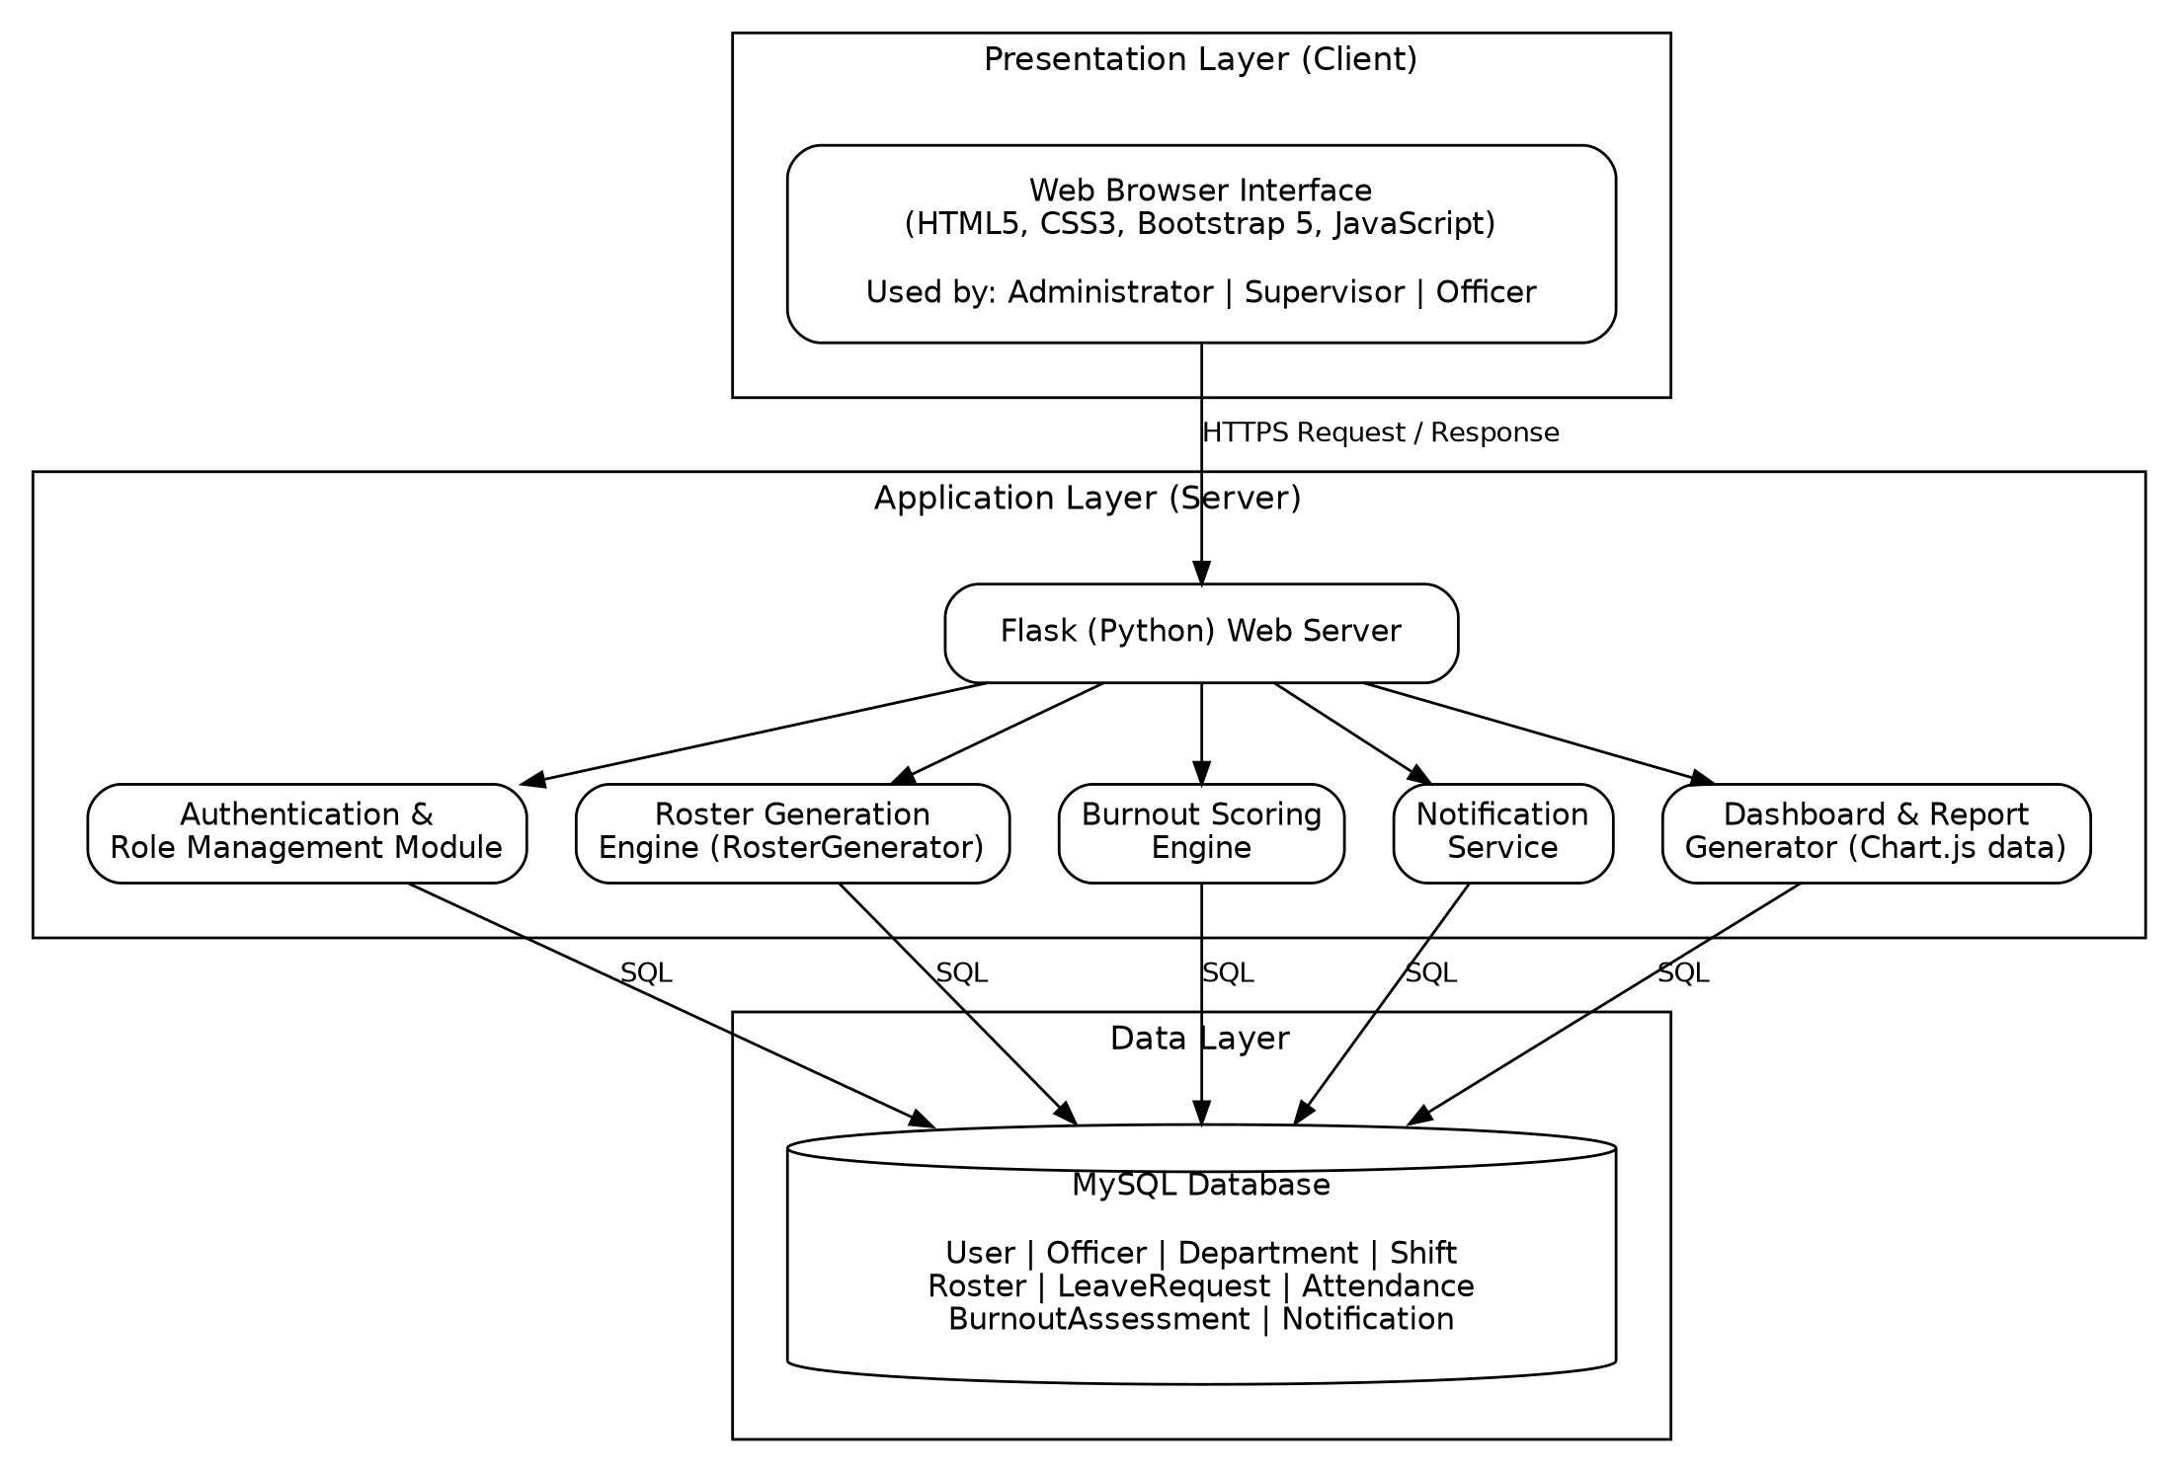
Fig. 5.1 Three-Tier Architecture of the Automated Police Roster and Burnout Management System
- Presentation Layer: a browser-rendered interface built with HTML5, CSS3, Bootstrap 5, and JavaScript, used by all three roles.
- Application Layer: a Flask (Python) server exposing the authentication and role-management module, the roster-generation engine, the burnout-scoring engine, the notification service, and the dashboard/report generator.
- Data Layer: a MySQL database that persists every entity shown in the class diagram below.

5.2 UML Class Diagram
The class diagram identifies the nine core data-holding classes of the system, User, Officer, Department, Shift, Roster, LeaveRequest, Attendance, BurnoutAssessment, and Notification, together with a tenth class, RosterGenerator, which is deliberately modelled as a service/controller rather than a stored entity, since it represents the automated scheduling logic rather than a database record. Attributes are marked private ("-") and methods are marked public ("+"), following standard UML convention and encapsulation principle.
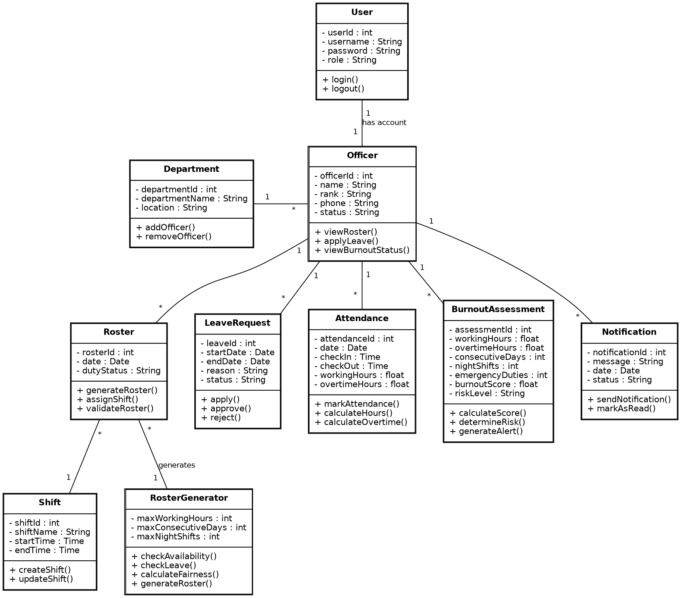
Fig. 5.2 UML Class Diagram - Automated Police Roster and Burnout Management System
The relationships and their cardinalities are summarised below.
Relationship | Cardinality | Meaning
User - Officer | 1 : 1 | Each officer has exactly one login account.
Department - Officer | 1 : * | One department can have many officers.
Officer - LeaveRequest | 1 : * | An officer can submit multiple leave requests.
Officer - Attendance | 1 : * | An officer has multiple attendance records.
Officer - BurnoutAssessment | 1 : * | An officer can have multiple burnout assessments over time.
Officer - Notification | 1 : * | An officer can receive multiple notifications.
Officer - Roster | 1 : * | An officer can have multiple duty assignments.
Roster - Shift | * : 1 | Multiple roster entries can use the same shift type.
RosterGenerator - Roster | 1 : * | The generator creates multiple roster records.

5.3 UML State Machine Diagram
The state machine diagram traces the complete lifecycle of a single officer's interaction with the system, from login through duty assignment, leave handling, active duty, and into the burnout-monitoring cycle that follows every completed duty. It is this last part, the loop from Workload Monitoring through the four risk levels and, where necessary, to Supervisor Alert and Workload Adjustment, that operationalises the burnout-management objective stated in Section 1.6.2: burnout is not a one-time check but a recurring evaluation that feeds back into the next duty assignment.
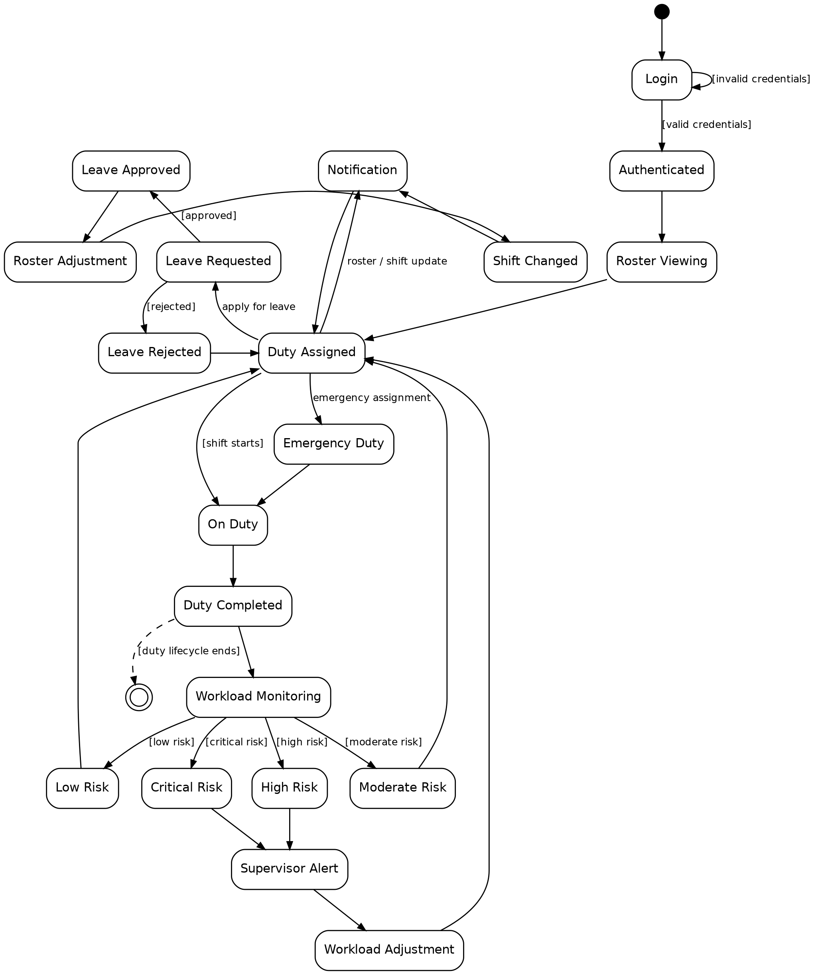
Fig. 5.3 UML State Machine Diagram - Automated Police Roster and Burnout Management System
A few transitions are worth calling out specifically, since they are commonly probed in a viva:
- The self-loop on Login with guard [invalid credentials] shows that repeated failed attempts keep the officer in the Login state rather than crashing or silently failing.
- Duty Assigned is the central hub state: it is re-entered from Leave Rejected, from Notification, from Low Risk and Moderate Risk (workload permits continued normal duty), and from Workload Adjustment (after a supervisor has intervened), which is why it has the highest fan-in of any state in the diagram.
- Low Risk and Moderate Risk both return directly to Duty Assigned, while High Risk and Critical Risk both route through Supervisor Alert, reflecting the policy stated in Section 1.6.2 that only the two higher risk bands require human intervention.
- Duty Completed has two outgoing transitions: one dashed transition to a Final state, [duty lifecycle ends], representing the end of a single duty instance, and one to Workload Monitoring, representing that the same completed duty simultaneously feeds the ongoing burnout-tracking process. Showing both is intentional: it distinguishes the end of one duty occurrence from the continuation of the officer's overall monitoring lifecycle.

5.4 Data Flow Diagrams (Level 0 to Level 2)

5.4.1 Theory and Notation
A data flow diagram (DFD) is the Data Flow Model of a system. It shows how data enters the system, which processes transform it, where it is stored while at rest, and where it leaves the system, but it deliberately does not show the order in which processes run or the conditions under which behaviour changes. That second concern belongs to the Control Flow Model, which this report represents with the state machine diagram in Section 5.3. The two models are complementary views of the same system and are the two analysis models studied in Unit 4 of the course syllabus.
The diagrams in this section use the Yourdon & DeMarco notation, summarised in the table below. A DFD is drawn in levels of increasing detail. Level 0, the context diagram, shows the whole system as a single process and fixes the data that crosses the system boundary. Level 1 decomposes that single process into its major functional processes and introduces the data stores. Level 2 decomposes the one Level-1 process that is complex enough to need it, here Process 2.0 (Roster Generation).
Symbol | Meaning | Used in this report for
Circle | Process: transforms incoming data into outgoing data. It carries a decimal number (1.0, 2.1, and so on) and a verb-phrase name. | 1.0 Authentication & Role Management; 2.0 Roster Generation; 2.4 Generate Draft Roster
Rectangle | External entity: a person or system outside the system boundary that supplies data to the system or receives data from it. | Administrator, Supervisor, Police Officer
Open-ended rectangle (two parallel lines) | Data store: data held at rest between processes. It carries an identifier (D1, D2, and so on). | D3 Rosters; D5 Burnout Assessments
Arrow | Data flow: named data moving in the direction of the arrowhead. A double-headed arrow is a flow that both reads from and writes to a data store. | login; generated roster; leave records

Three rules are applied to every diagram. First, every data flow starts or ends at a process, so data never moves directly between two external entities, between two data stores, or between an entity and a store. Second, every process has at least one input and at least one output. Third, adjacent levels must be balanced: the inputs and outputs of a parent process must reappear, with the same names and directions, around the child diagram that expands it. Balancing is verified for both decomposition steps in Section 5.4.5. Where drawing an external entity only once would force flow lines to cross, the entity is drawn more than once; each repeated copy carries a short diagonal stroke across its lower-left corner (the Administrator and the Police Officer in Fig. 5.5), and all copies stand for the same entity.

5.4.2 Level-0 DFD (Context Diagram)
The Level-0 diagram (Fig. 5.4) treats the entire system as a single process, numbered 0, and shows only the data that crosses its boundary to and from each external entity. It deliberately does not show internal processes such as roster generation or burnout scoring, since these are expanded in Level 1 and Level 2 below; its purpose at this level is only to confirm that every actor identified in Section 2.1 has a well-defined, two-way data exchange with the system.
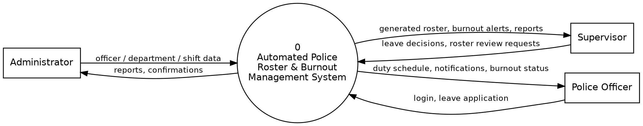
Fig. 5.4 Level-0 Data Flow Diagram (Context Diagram)
The data exchanged with each external entity at Level 0 is listed in the table below. These flows are the reference against which Level 1 is balanced in Section 5.4.5.
External entity | Data sent to the system | Data received from the system
Administrator | officer / department / shift data | reports, confirmations
Supervisor | leave decisions, roster review requests | generated roster, burnout alerts, reports
Police Officer | login, leave application | duty schedule, notifications, burnout status

5.4.3 Level-1 DFD
Level 1 (Fig. 5.5, on the following page) decomposes the single Level-0 process into five processes. They correspond one-to-one with the five modules of the Application Layer in the architecture diagram (Fig. 5.1): 1.0 Authentication & Role Management, 2.0 Roster Generation, 3.0 Burnout Scoring, 4.0 Notification Service, and 5.0 Dashboard & Reports. Level 1 also introduces the data stores: the nine tables of the database schema in Section 5.5 are grouped into six stores, listed in the table below.
Data store | Database tables (Section 5.5) | Accessed by (type of access)
D1 Users & Officers | users, officers | 1.0 (read, write); 2.0 (read)
D2 Depts. & Shifts | departments, shifts | 1.0 (write); 2.0 (read)
D3 Rosters | rosters, attendance | 2.0 (read, write); 3.0 (read); 5.0 (read)
D4 Leave Requests | leave_requests | 2.0 (read, write)
D5 Burnout Assessments | burnout_assessments | 3.0 (write); 4.0 (read); 5.0 (read)
D6 Notifications | notifications | 4.0 (read, write)

Rosters and attendance are grouped in D3 because both record an officer's duty by date; Process 3.0 reads them together as the duty and shift history from which working hours, overtime, consecutive duty days and night shifts are derived.
Every flow that crosses the system boundary in Level 0 reappears in Level 1, attached to the process that produces or consumes it, so the two levels are balanced. The Administrator's officer / department / shift data enters 1.0, which returns the confirmations, and the reports reach the Administrator from 5.0. The Supervisor's roster review requests and leave decisions enter 2.0, and the Supervisor receives the generated roster from 2.0, burnout alerts from 4.0, and reports from 5.0. The Police Officer's login enters 1.0 and the leave application enters 2.0, while the duty schedule, notifications, and burnout status returned to the Police Officer come from 2.0, 4.0, and 3.0 respectively. The data stores are internal to the system and therefore do not appear at Level 0.
Process 2.0 is the most complex process in Level 1: it exchanges data with two external entities in each direction and reads or writes four of the six data stores. For this reason it is decomposed further in Level 2 (Section 5.4.4). In Fig. 5.5 the Administrator and the Police Officer are each drawn twice so that no flow lines cross; the diagonal stroke at the lower-left corner of each such box marks the repeated copies. The inputs, outputs, and data stores of each Level-1 process are summarised in the table below.
Process | Inputs | Outputs | Data stores
1.0 Authentication & Role Management | login (Police Officer)  officer / department / shift data (Administrator) | confirmations (Administrator) | D1 (read, write)  D2 (write)
2.0 Roster Generation | roster review requests, leave decisions (Supervisor)  leave application (Police Officer)  officer availability data (D1)  shift / department data (D2)  duty & shift history (D3)  leave records (D4) | generated roster (Supervisor)  duty schedule (Police Officer)  validated roster (D3)  leave records (D4) | D1, D2 (read)  D3, D4 (read, write)
3.0 Burnout Scoring | duty & shift history (D3) | burnout assessment (D5)  burnout status (Police Officer) | D3 (read)  D5 (write)
4.0 Notification Service | risk level (D5)  notification record (D6) | burnout alerts (Supervisor)  notifications (Police Officer)  notification record (D6) | D5 (read)  D6 (read, write)
5.0 Dashboard & Reports | roster data (D3)  burnout data (D5) | reports (Administrator, Supervisor) | D3, D5 (read)

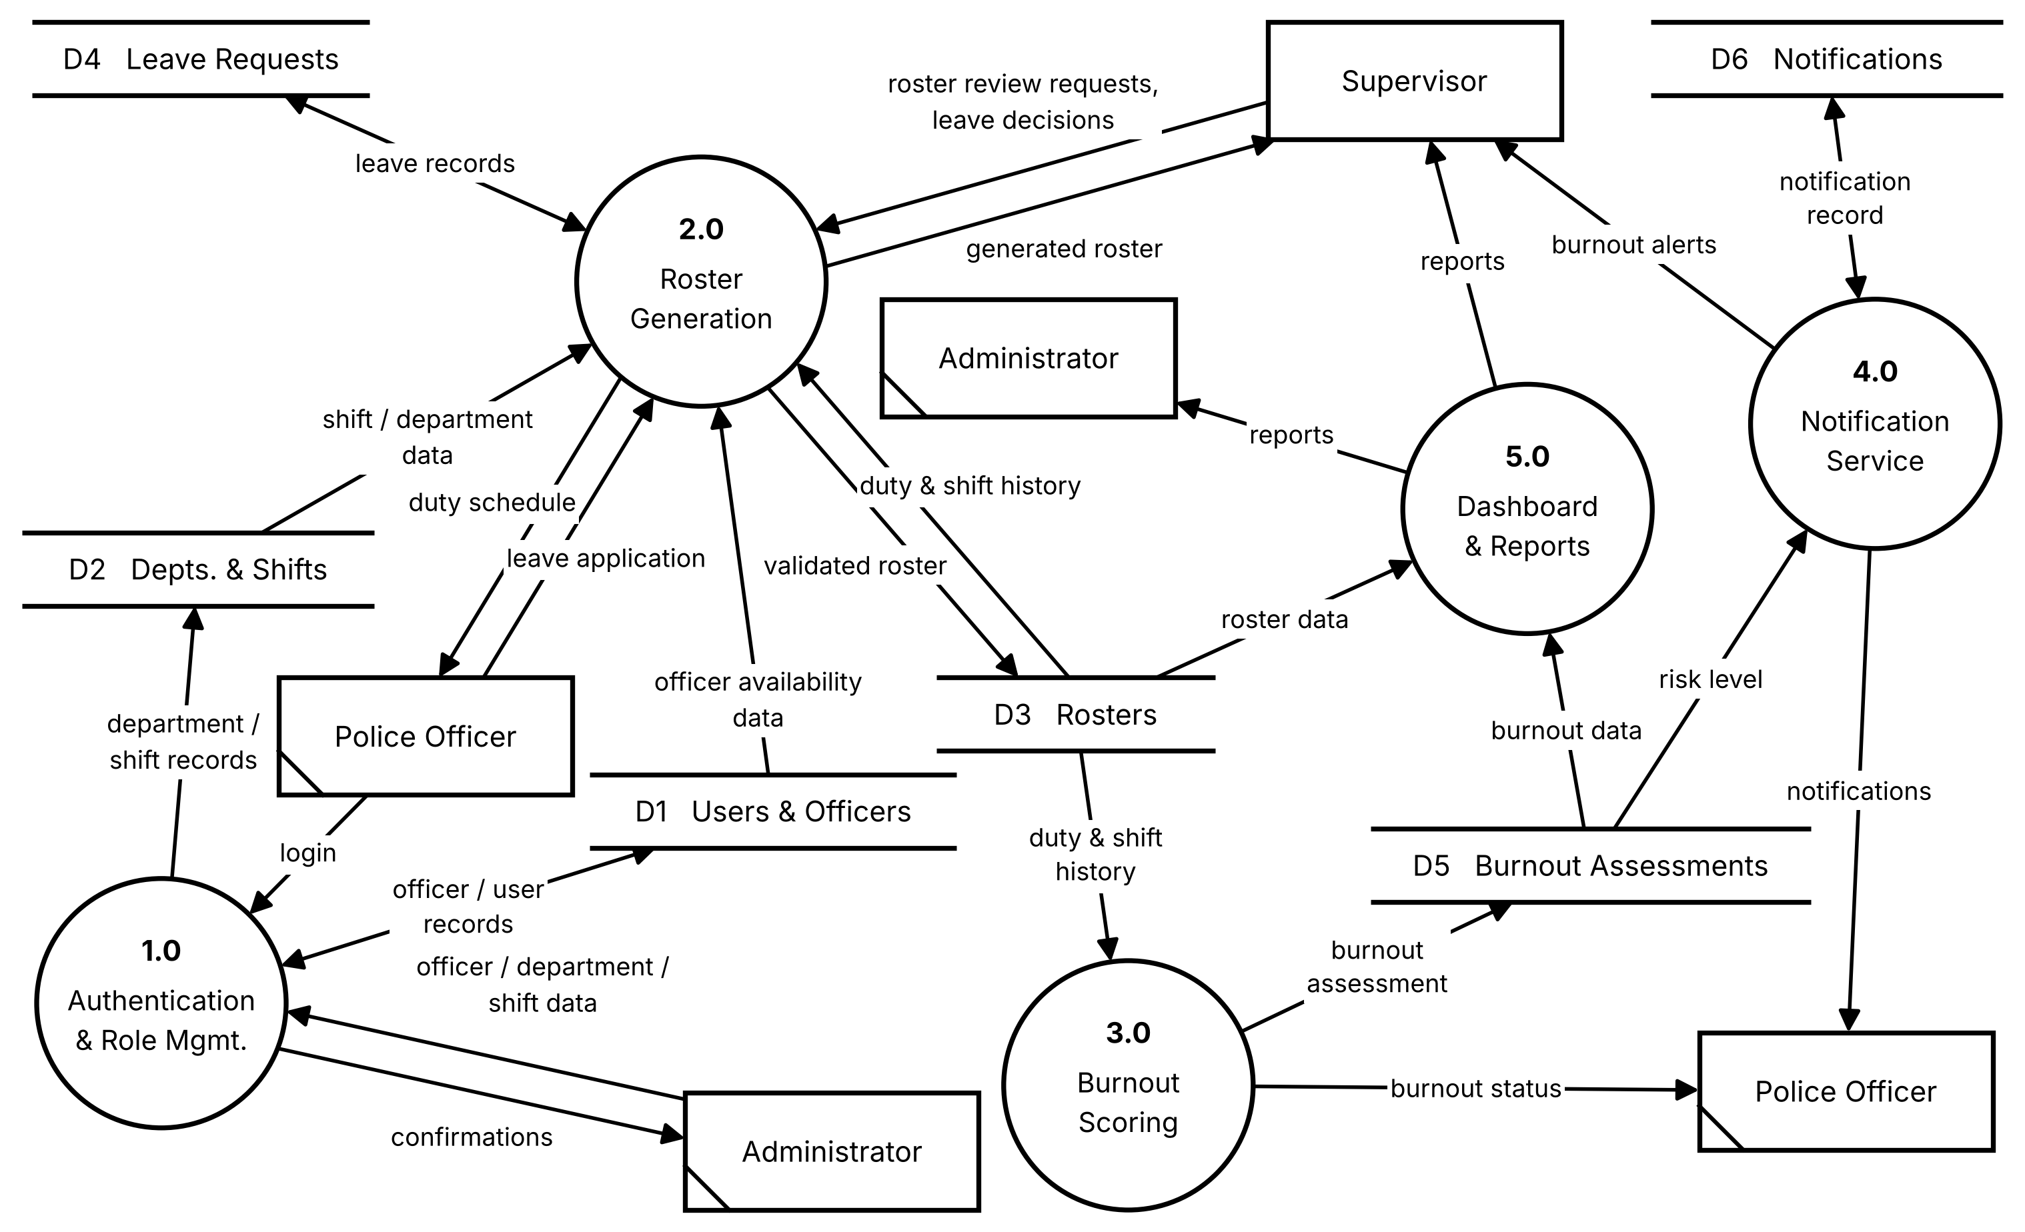
Fig. 5.5 DFD Level 1 (Five Processes and Six Data Stores)

5.4.4 Level-2 DFD (Process 2.0: Roster Generation)
Process 2.0 is expanded in Fig. 5.6 (on the following page) because it is the most complex Level-1 process and because its five sub-processes map directly onto methods already defined in the class diagram (Fig. 5.2). This gives a traceable link between the data-flow model and the static design, as the table below shows. Sub-process 2.2 also covers the LeaveRequest methods apply(), approve() and reject(), since it receives the Police Officer's leave application and the Supervisor's leave decision.
Sub-process | Class method (Fig. 5.2) | Data in | Data out
2.1 Check Availability | RosterGenerator.checkAvailability() | officer availability data (D1) | availability list (to 2.4)
2.2 Manage & Check Leave | RosterGenerator.checkLeave() | leave application (Police Officer)  leave decisions (Supervisor)  leave records (D4) | approved-leave list (to 2.4)  leave records (D4)
2.3 Calculate Fairness | RosterGenerator.calculateFairness() | duty & shift history (D3) | fairness ranking (to 2.4)
2.4 Generate Draft Roster | RosterGenerator.generateRoster() | roster review requests (Supervisor)  shift / department data (D2)  availability list (from 2.1)  approved-leave list (from 2.2)  fairness ranking (from 2.3) | draft roster (to 2.5)
2.5 Validate Roster | Roster.validateRoster() | draft roster (from 2.4) | generated roster (Supervisor)  duty schedule (Police Officer)  validated roster (D3)

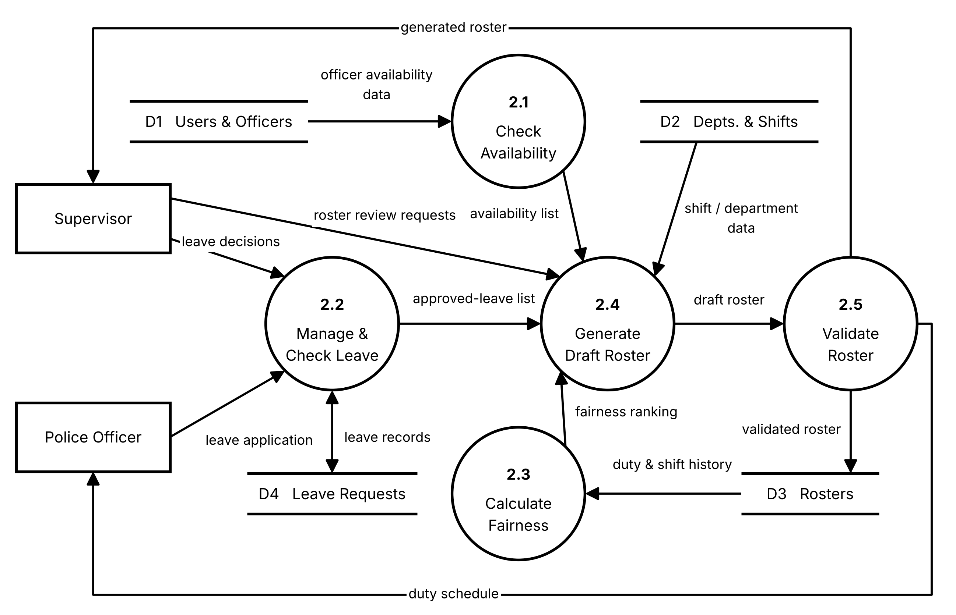
Fig. 5.6 DFD Level 2 (Process 2.0: Roster Generation)
The sub-processes in Fig. 5.6 work as a pipeline. Sub-process 2.1 reads officer availability data from D1 and passes an availability list to 2.4. Sub-process 2.2 receives the Police Officer's leave application and the Supervisor's leave decision, reads and updates the leave records in D4, and passes the approved-leave list to 2.4. Sub-process 2.3 reads the duty and shift history from D3 and passes a fairness ranking to 2.4, so that duties are spread evenly across officers. Sub-process 2.4 combines these three inputs with the shift and department data read from D2 and the Supervisor's roster review request to produce a draft roster. Sub-process 2.5 then validates the draft against the limits held by the RosterGenerator class (maximum working hours, maximum consecutive days, and maximum night shifts) before writing the validated roster to D3 and returning it to the Supervisor as the generated roster and to the Police Officer as the duty schedule.

5.4.5 Balancing Check
Balancing was verified at both decomposition steps. For Level 0 to Level 1, each of the thirteen data flows that cross the system boundary at Level 0 reappears at Level 1, attached to the single process that produces or consumes it.
No. | Level-0 flow | Level-1 flow
1 | officer / department / shift data: Administrator to system | Administrator to 1.0
2 | confirmations: system to Administrator | 1.0 to Administrator
3 | reports: system to Administrator | 5.0 to Administrator
4 | roster review requests: Supervisor to system | Supervisor to 2.0
5 | leave decisions: Supervisor to system | Supervisor to 2.0
6 | generated roster: system to Supervisor | 2.0 to Supervisor
7 | burnout alerts: system to Supervisor | 4.0 to Supervisor
8 | reports: system to Supervisor | 5.0 to Supervisor
9 | login: Police Officer to system | Police Officer to 1.0
10 | leave application: Police Officer to system | Police Officer to 2.0
11 | duty schedule: system to Police Officer | 2.0 to Police Officer
12 | notifications: system to Police Officer | 4.0 to Police Officer
13 | burnout status: system to Police Officer | 3.0 to Police Officer

For Level 1 to Level 2, the table below lists every named data flow that crosses the boundary of Process 2.0 in Fig. 5.5 and shows where it reappears in Fig. 5.6.
No. | Level-1 flow of Process 2.0 | Where it appears in Level 2
1 | roster review requests: Supervisor to 2.0 | Supervisor to 2.4
2 | leave decisions: Supervisor to 2.0 | Supervisor to 2.2
3 | generated roster: 2.0 to Supervisor | 2.5 to Supervisor
4 | leave application: Police Officer to 2.0 | Police Officer to 2.2
5 | duty schedule: 2.0 to Police Officer | 2.5 to Police Officer
6 | officer availability data: D1 to 2.0 | D1 to 2.1
7 | shift / department data: D2 to 2.0 | D2 to 2.4
8 | duty & shift history: D3 to 2.0 | D3 to 2.3
9 | validated roster: 2.0 to D3 | 2.5 to D3
10 | leave records: 2.0 and D4 (both directions) | 2.2 and D4 (both directions)

All ten named flows of Process 2.0 appear at Level 2 with unchanged names and directions. The only additional flows in Fig. 5.6 are the four flows between sub-processes (availability list, approved-leave list, fairness ranking, and draft roster), which lie wholly inside Process 2.0 and therefore do not appear at Level 1. Every process at every level also has at least one input and at least one output, so the three levels of the DFD are consistent with one another.

5.4.6 Data Dictionary
The data dictionary gives every named data flow and data store in Fig. 5.4 to Fig. 5.6 a single, unambiguous definition. The standard notation is used: = means "is composed of", + means "and", [ a | b ] means "either a or b", and ( x ) means "x is optional". The compositions are taken from the attributes of the classes in Fig. 5.2 and the columns of the tables in Section 5.5, so the dictionary also links the data-flow model to the static design. Flows are listed in the order in which they are met when reading Level 1 from the external entities inwards.
Data flow | Composition | From to To
login | username + password | Police Officer to 1.0
officer / department / shift data | officer details + department details + shift definition  officer details = name + rank + phone + status  department details = department name + location  shift definition = shift name + start time + end time | Administrator to 1.0
confirmations | confirmation message for each create, update, or remove action | 1.0 to Administrator
officer / user records | user record + officer record  user record = username + password + role  officer record = name + rank + phone + status | 1.0 and D1 (both directions)
department / shift records | department details + shift definition (as above) | 1.0 to D2
roster review requests | selected period + ( manual adjustment ) + ( validation decision )  selected period = start date + end date | Supervisor to 2.0
leave decisions | leave id + [ approve | reject ] | Supervisor to 2.0
leave application | start date + end date + reason | Police Officer to 2.0
officer availability data | officer id + status | D1 to 2.0 (2.1)
shift / department data | shift name + start time + end time + department name + location | D2 to 2.0 (2.4)
duty & shift history | { date + shift + duty status + check-in + check-out + working hours + overtime hours } | D3 to 2.0 (2.3) and to 3.0
leave records | leave id + start date + end date + reason + status  status = [ Pending | Approved | Rejected ] | 2.0 (2.2) and D4 (both directions)
availability list | officers available for duty on each date of the selected period | 2.1 to 2.4
approved-leave list | { officer + start date + end date } for every leave record with status Approved | 2.2 to 2.4
fairness ranking | officers in order of the duties and night shifts already assigned to them | 2.3 to 2.4
draft roster | { date + officer + shift + duty status } not yet validated | 2.4 to 2.5
validated roster | draft roster that has passed every validation check | 2.5 to D3
generated roster | { date + officer + shift + duty status } | 2.0 (2.5) to Supervisor
duty schedule | { date + shift + duty status } for one officer | 2.0 (2.5) to Police Officer
burnout assessment | working hours + overtime hours + consecutive days + night shifts + emergency duties + burnout score + risk level | 3.0 to D5
risk level | [ Low | Moderate | High | Critical ] | D5 to 4.0
burnout status | burnout score + risk level | 3.0 to Police Officer
burnout alerts | officer + burnout score + risk level [ High | Critical ] + alert message | 4.0 to Supervisor
notification record | notification id + message + date + status  status = [ Read | Unread ] | 4.0 and D6 (both directions)
notifications | message + date + status | 4.0 to Police Officer
roster data | { roster id + date + shift + duty status } | D3 to 5.0
burnout data | { burnout assessment } for every officer | D5 to 5.0
reports | [ attendance report | overtime report | shift-distribution report | burnout-trend report ] | 5.0 to Administrator and Supervisor

The braces { } in the table mean "one or more repetitions of" the enclosed items. Every name used in the Level-1 and Level-2 diagrams appears exactly once in the dictionary, so a reader can look up any arrow label and find out precisely which data it carries and between which two parts of the system it moves.

5.4.7 Process Specifications
A data flow diagram shows what data enters and leaves each process but not how the process turns one into the other. The table below therefore gives a short process specification, written in structured English, for each Level-1 process and for each sub-process of Process 2.0. Structured English uses only sequence, selection (IF, THEN, ELSE) and repetition (FOR EACH), so it can be read by a non-programmer and translated directly into code. Every rule is taken from the functional requirements in Section 2.3.1 or from the attributes of the classes in Fig. 5.2; parameters such as the maximum working hours are the limits held by the RosterGenerator class, and no numeric value has been assumed here.
Process | Specification (structured English)
1.0 Authentication & Role Management | ON login (username + password):  IF the pair matches a user record in D1 THEN  grant access to the functions permitted for the user's role  ELSE  refuse access  ON officer / department / shift data from the Administrator:  CREATE, UPDATE or REMOVE the matching record in D1 or D2  RETURN a confirmation to the Administrator
2.1 Check Availability | FOR EACH officer in D1:  IF the officer is available for duty THEN  ADD the officer to the availability list  RETURN the availability list to 2.4
2.2 Manage & Check Leave | ON leave application (start date, end date, reason):  CREATE a leave record in D4 with status Pending  ON leave decision from the Supervisor:  IF the decision is approve THEN set the status to Approved  ELSE set the status to Rejected  FOR EACH leave record in D4 with status Approved:  ADD the officer and the leave dates to the approved-leave list  RETURN the approved-leave list to 2.4
2.3 Calculate Fairness | FOR EACH officer in the duty & shift history read from D3:  COUNT the duties and night shifts already assigned  SORT the officers so that the officer with the lightest load comes first  RETURN the fairness ranking to 2.4
2.4 Generate Draft Roster | ON roster review request (selected period) from the Supervisor:  FOR EACH date in the selected period:  FOR EACH shift read from D2:  TAKE officers from the availability list who are not on approved leave, in fairness-ranking order  ASSIGN them to the shift  RETURN the draft roster to 2.5
2.5 Validate Roster | FOR EACH officer in the draft roster:  IF working hours exceed the maximum working hours, OR consecutive days exceed the maximum consecutive days, OR night shifts exceed the maximum night shifts, OR the rest period between two duties is too short, OR a duty falls on approved leave THEN  FLAG the violation  IF no violation is flagged THEN  WRITE the validated roster to D3  RETURN the generated roster to the Supervisor  RETURN the duty schedule to the Police Officer  ELSE  RETURN the generated roster with the flagged violations to the Supervisor for manual adjustment
3.0 Burnout Scoring | FOR EACH officer:  READ working hours, overtime hours, consecutive days, night shifts and emergency duties from the duty & shift history in D3  COMPUTE the burnout score (calculateScore)  SET the risk level to Low, Moderate, High or Critical from the score (determineRisk)  WRITE the burnout assessment to D5  RETURN the burnout status to the Police Officer
4.0 Notification Service | FOR EACH burnout assessment read from D5:  IF the risk level is High or Critical THEN  CREATE a burnout alert for the Supervisor (generateAlert)  STORE the notification record in D6 (sendNotification)  FOR EACH unread notification record in D6:  RETURN it to the Police Officer as a notification  SET its status to Read when it is opened (markAsRead)
5.0 Dashboard & Reports | READ the roster data from D3 and the burnout data from D5  COMPILE the attendance, overtime, shift-distribution and burnout-trend reports  RETURN the reports to the Administrator and the Supervisor

Specifications 2.1 to 2.5 together describe the whole of Process 2.0, so they can be read in order as a single algorithm for producing a roster: determine who is available, determine who is on leave, rank officers by how much duty they have already carried, assign officers to shifts, and finally check the result against the working-time limits before it is published.

5.5 Database Design
The relational schema below is derived directly from the class diagram in Section 5.2: every class becomes a table, every attribute becomes a column, and every one-to-many relationship becomes a foreign key on the "many" side. This traceability is intentional and is a common point of viva questioning, so it is worth being able to point, table by table, back to the corresponding class.
Table: users
Column | Data Type | Key / Constraint
user_id | INT | Primary Key
username | VARCHAR(50) | Unique, Not Null
password_hash | VARCHAR(255) | Not Null
role | ENUM('ADMIN','SUPERVISOR','OFFICER') | Not Null

Table: officers
Column | Data Type | Key / Constraint
officer_id | INT | Primary Key
user_id | INT | Foreign Key -> users.user_id
department_id | INT | Foreign Key -> departments.department_id
name | VARCHAR(100) | Not Null
rank | VARCHAR(50) | Not Null
phone | VARCHAR(15)
status | VARCHAR(20) | e.g. Active, On Leave

Table: departments
Column | Data Type | Key / Constraint
department_id | INT | Primary Key
department_name | VARCHAR(100) | Not Null
location | VARCHAR(100)

Table: shifts
Column | Data Type | Key / Constraint
shift_id | INT | Primary Key
shift_name | VARCHAR(30) | e.g. Morning, Evening, Night
start_time | TIME | Not Null
end_time | TIME | Not Null

Table: rosters
Column | Data Type | Key / Constraint
roster_id | INT | Primary Key
officer_id | INT | Foreign Key -> officers.officer_id
shift_id | INT | Foreign Key -> shifts.shift_id
date | DATE | Not Null
duty_status | VARCHAR(20) | e.g. Assigned, Completed

Table: leave_requests
Column | Data Type | Key / Constraint
leave_id | INT | Primary Key
officer_id | INT | Foreign Key -> officers.officer_id
start_date | DATE | Not Null
end_date | DATE | Not Null
reason | VARCHAR(255)
status | VARCHAR(20) | Pending / Approved / Rejected

Table: attendance
Column | Data Type | Key / Constraint
attendance_id | INT | Primary Key
officer_id | INT | Foreign Key -> officers.officer_id
date | DATE | Not Null
check_in | TIME
check_out | TIME
working_hours | DECIMAL(5,2) | Computed
overtime_hours | DECIMAL(5,2) | Computed

Table: burnout_assessments
Column | Data Type | Key / Constraint
assessment_id | INT | Primary Key
officer_id | INT | Foreign Key -> officers.officer_id
working_hours | DECIMAL(6,2) | Computed input
overtime_hours | DECIMAL(6,2) | Computed input
consecutive_days | INT | Computed input
night_shifts | INT | Computed input
emergency_duties | INT | Computed input
burnout_score | DECIMAL(5,2) | Computed output
risk_level | VARCHAR(20) | Low / Moderate / High / Critical

Table: notifications
Column | Data Type | Key / Constraint
notification_id | INT | Primary Key
officer_id | INT | Foreign Key -> officers.officer_id
message | VARCHAR(255) | Not Null
date | DATETIME | Not Null
status | VARCHAR(20) | Read / Unread

5.6 Mapping Data Flow into a Software Architecture
The mapping of a data flow diagram into a software architecture is the step that turns the analysis model into a design model, and it is covered in Unit 5 of the course syllabus. The technique has two variants. In transform analysis, a flow in which data enters along one or more incoming paths, is converted at a central transform, and leaves along one or more outgoing paths is mapped into a controller module that calls one subordinate module for each path. In transaction analysis, a single input is examined by a transaction centre that selects one of several action paths, and the centre is mapped into a dispatcher module that calls one subordinate module for each action. Both variants produce a structure chart, in which each box is a module and each line is a call from a superior module to a subordinate module. Fig. 5.7 applies both variants to the Level-1 and Level-2 diagrams of this report.
The mapping was carried out in the following order. First, the Level-1 and Level-2 diagrams were reviewed to make sure that every process and data flow is defined in the data dictionary. Second, the type of information flow was identified for each diagram: Level 1 is a transaction flow and Process 2.0 is a transform flow. Third, the boundaries of the flow were marked: the transaction centre for Level 1, and the incoming, central and outgoing parts for Process 2.0. Fourth, the first level of factoring produced a controller module and one subordinate module for each path. Fifth, the second level of factoring assigned each module to a class method of the class diagram. Finally, the structure was refined by checking the cohesion and coupling of every module, as discussed in Section 5.6.3.

5.6.1 Transaction Analysis of Level 1
At Level 1 the system has the shape of a transaction flow. All five processes are served by the single Flask server of the Application Layer (Fig. 5.1), which receives every request from the browser, identifies the user through Process 1.0, and passes the request to the module that serves it. The point at which the request is examined and one of several action paths is chosen is the transaction centre, and it maps to a Main Controller module whose five subordinates are the five Level-1 processes. This is the first level of factoring in the structure chart.

5.6.2 Transform Analysis of Process 2.0
Process 2.0 has the shape of a transform flow, and the Level-2 diagram makes its three parts easy to identify. The incoming paths are 2.1, 2.2 and 2.3, each of which collects one kind of input (the availability list, the approved-leave list and the fairness ranking). The central transform is 2.4 Generate Draft Roster, the process at which the data reaches its highest level of abstraction and is converted into the main output of the process. The outgoing path is 2.5 Validate Roster, which checks the draft and delivers it to its destinations. Process 2.0 therefore becomes a controller module whose subordinates are three input modules, one transform module and one output module. At the second level of factoring, each module is assigned to the class method that implements it, as shown in the table below.
Module | Derived from | Implementing class and methods (Fig. 5.2)
Main Controller | Transaction centre of Level 1 | Flask application (Application Layer, Fig. 5.1)
1.0 Authentication & Role Management | Level-1 process 1.0 | User.login(), User.logout(); Department.addOfficer(), removeOfficer(); Shift.createShift(), updateShift()
2.0 Roster Generation | Level-1 process 2.0 (controller of the transform flow) | RosterGenerator; Roster.assignShift()
2.1 Check Availability | Incoming path | RosterGenerator.checkAvailability()
2.2 Manage & Check Leave | Incoming path | RosterGenerator.checkLeave(); LeaveRequest.apply(), approve(), reject()
2.3 Calculate Fairness | Incoming path | RosterGenerator.calculateFairness()
2.4 Generate Draft Roster | Central transform | RosterGenerator.generateRoster()
2.5 Validate Roster | Outgoing path | Roster.validateRoster()
3.0 Burnout Scoring | Level-1 process 3.0 | BurnoutAssessment.calculateScore(), determineRisk(); Attendance.calculateHours(), calculateOvertime()
4.0 Notification Service | Level-1 process 4.0 | BurnoutAssessment.generateAlert(); Notification.sendNotification(), markAsRead()
5.0 Dashboard & Reports | Level-1 process 5.0 | Officer.viewRoster(), viewBurnoutStatus(); report compilation has no dedicated class in Fig. 5.2

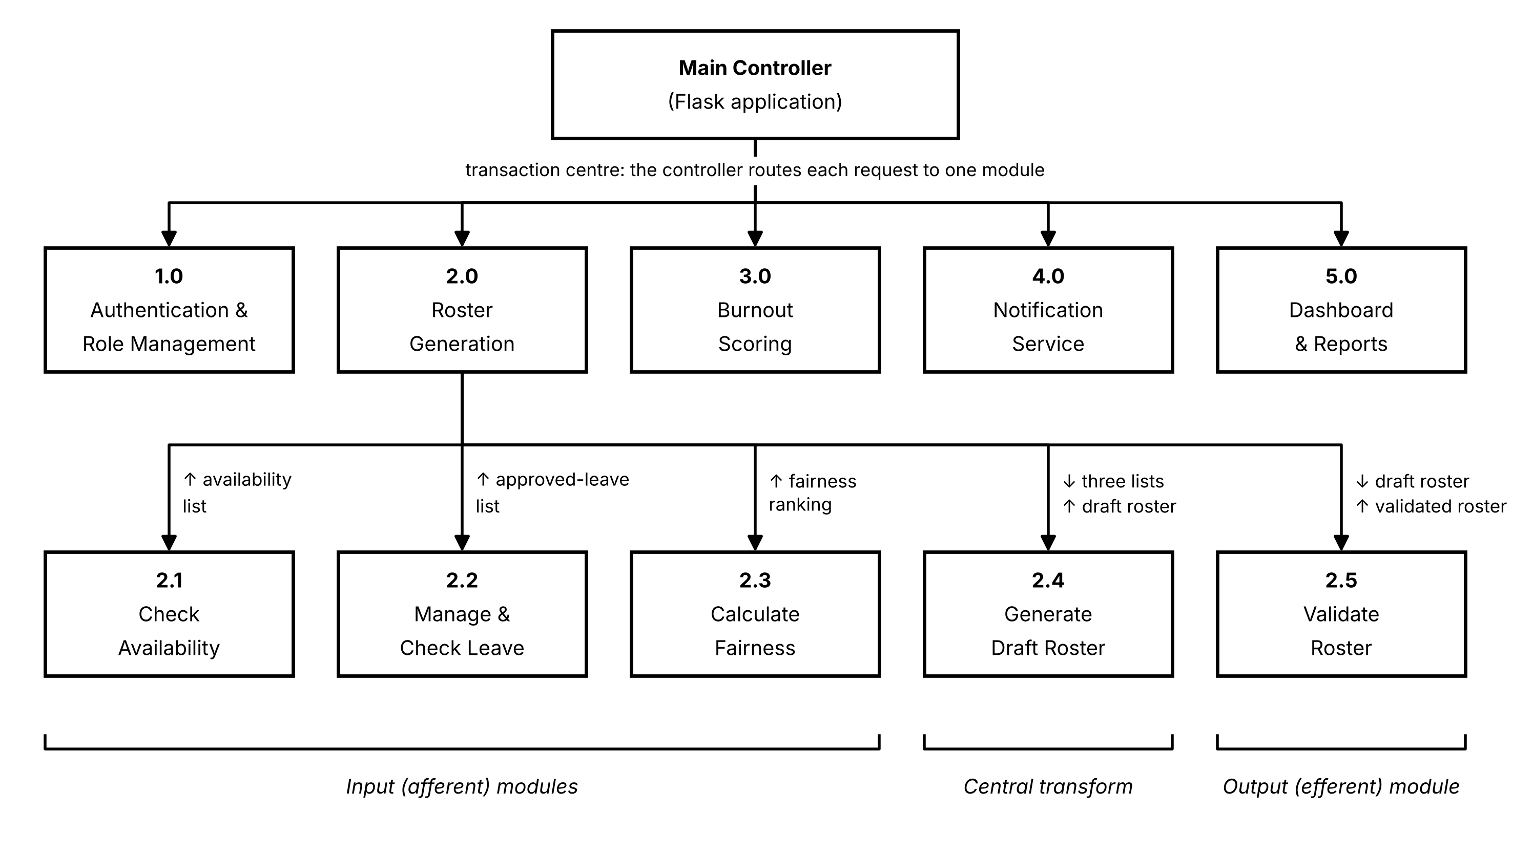
Fig. 5.7 Structure Chart Derived from the Level-1 and Level-2 Data Flow Diagrams

5.6.3 Cohesion and Coupling of the Resulting Design
Fig. 5.7 should be read from the top: the Main Controller calls the five Level-1 modules, and Process 2.0 calls its five sub-modules in the order input, transform, output. An upward arrow beside a line shows data returned to the calling module and a downward arrow shows data passed to the called module, so the arrows on the lines of 2.1 to 2.5 are exactly the internal flows of Fig. 5.6. Each module performs one function that corresponds to a single DFD process, so the cohesion of every module is functional, which is the strongest and most desirable form. Modules communicate only by passing the named data items defined in the data dictionary (Section 5.4.6), and they share data with one another only through the data stores D1 to D6 in the database, so the coupling between modules is data coupling, which is the weakest and most desirable form. Both the Main Controller and Process 2.0 have five subordinates, which keeps the span of control within the range of about seven that is commonly recommended for a structure chart.
The mapping also confirms that the design is traceable end to end. A requirement in Section 2.3.1 is realised by a DFD process, the process is a module in the structure chart, the module is implemented by a class method in the class diagram, and the data it handles is stored in a table of the database schema in Section 5.5. For example, FR3 (automatic roster generation) is realised by Process 2.0, which is the module 2.0 in Fig. 5.7, which is implemented by the RosterGenerator class, and which reads and writes the rosters and leave_requests tables.

6. Cost Estimation
The table below gives an estimated development cost for the project, covering a three-month development cycle carried out by a small team. It is included here to demonstrate economic feasibility (Section 2.6.4) with concrete figures rather than a general claim; the figures are planning estimates for an academic project scenario rather than actual incurred expenditure.
No. | Cost Component | Description | Estimated Cost (Rs.)
1 | Development System | Laptop/desktop for development and testing | 60,000
2 | Developer Salary | 2 developers x Rs.25,000/month x 3 months | 1,50,000
3 | UI/UX Designer | 1 designer x Rs.20,000/month x 1 month | 20,000
4 | Testing Personnel | 1 tester x Rs.20,000/month x 1 month | 20,000
5 | Project Supervisor/Manager | Part-time supervision for 3 months | 30,000
6 | Internet Charges | Internet connection for development/research, 3 months | 4,500
7 | Electricity | Computer, networking and development usage | 6,000
8 | Software & Tools | Python, Flask, MySQL, Bootstrap, Chart.js, VS Code | 0
9 | Cloud Hosting | Basic server hosting for deployment | 6,000
10 | Domain Name | One-year domain registration | 1,000
11 | Database/Backup Storage | Cloud/local backup and storage | 2,500
12 | Research & Documentation | Printing, report preparation, binding, etc. | 3,000
13 | Testing & Miscellaneous | Testing devices, maintenance and other expenses | 5,000
14 | Contingency | Unexpected expenses | 15,000
Total Estimated Cost |  |  | Rs. 4,23,000

Two points about this estimate are worth noting explicitly. First, the Software & Tools line is zero because every core technology in the stack, Python, Flask, MySQL, Bootstrap, and Chart.js, is free and open-source, which is a direct, quantifiable consequence of the technology choices justified in Section 2.5. Second, the largest single component by far is Developer Salary, which is typical for software projects generally: cost is dominated by people, not licences or infrastructure, which is why the economic feasibility argument in Section 2.6.4 rests on time saved rather than on licensing savings alone.

7. Testing Strategy
Testing is planned as a distinct phase in the project schedule (Section 2.6.1, weeks 10-13), but the levels of testing below are intended to be applied progressively as each module is completed, rather than saved entirely for the end, which is consistent with the Agile approach adopted in Section 4.1.4.

7.1 Levels of Testing

7.1.1 Unit Testing
Each method identified in the class diagram is tested in isolation with controlled inputs before it is integrated with the rest of the system. For example, BurnoutAssessment.calculateScore() is tested directly against known combinations of overtime hours, consecutive days, and night shifts, so that its output can be checked against a hand-calculated expected score before it is ever called by the roster-generation workflow.

7.1.2 Integration Testing
Once individual modules pass unit testing, they are tested together in the combinations in which they actually interact, for example confirming that an approved LeaveRequest correctly triggers a RosterAdjustment and that the adjusted Roster is reflected the next time the officer's schedule is queried.

7.1.3 System Testing
The complete, integrated system is tested end-to-end against the functional requirements listed in Section 2.3.1, exercising full user journeys, for example an Officer logging in, applying for leave, having it approved, and receiving a shift-change notification, exactly as this sequence appears in the state machine diagram in Section 5.3.

7.1.4 User Acceptance Testing (UAT)
Before the system is considered complete, representative users in each role, Administrator, Supervisor, and Officer, are asked to carry out their normal tasks using the system, and their feedback is used to confirm that the non-functional requirement of usability (Section 2.3.2) has actually been met in practice, not merely on paper.

7.2 Sample Test Cases
The table below lists a representative sample of planned test cases drawn from across the modules, covering both a straightforward positive path and the kind of edge case that is commonly probed in a viva. These are design-time planned test cases, to be executed during the Testing & Bug Fixing phase of the project schedule.
ID | Module | Test Description | Input | Expected Output
TC01 | Authentication | Login with valid credentials | Correct username and password for an Officer account | User is authenticated and redirected to the Officer dashboard
TC02 | Authentication | Login with invalid credentials | Correct username, incorrect password | Access denied; system remains in the Login state (self-loop, Fig. 5.3)
TC03 | Roster Generation | Roster respects approved leave | Officer O1 has approved leave on a given date; roster requested for that week | O1 is not assigned any shift on the date of approved leave
TC04 | Leave Management | Leave approval triggers roster adjustment | Supervisor approves a pending LeaveRequest | LeaveRequest.status becomes Approved; RosterAdjustment is triggered (Fig. 5.3)
TC05 | Burnout Management | High-overtime officer is flagged | Officer with 20+ overtime hours and 6 consecutive night shifts in the assessment window | System assigns High or Critical risk level and raises a Supervisor Alert
TC06 | Roster Generation | Duplicate / overlapping shift prevention | Attempt to assign one officer to two overlapping shifts on the same date | validateRoster() rejects the second assignment and flags a conflict
TC07 | Notifications | Shift change notifies the officer | A Supervisor changes an officer's assigned shift after roster publication | A Notification record is created and marked Unread for that officer

8. Expected Results and Discussion
As this report documents the analysis, design, and planning stage of the project (Sections 1-5) ahead of full implementation, this section describes the outcomes the system is expected to produce once built, module by module, rather than presenting screenshots or measured results from a completed system.

8.1 Roster Generation Module
Once implemented, the RosterGenerator is expected to produce a conflict-free weekly roster for a station of typical size within a few seconds, automatically honouring approved leave and rest-period constraints without a Supervisor having to check these manually, directly delivering on the time-saving objective stated in Section 1.5.

8.2 Burnout Management Module
The burnout-scoring engine is expected to correctly separate officers into the four risk levels defined in Section 5.2 when tested against sample data engineered to represent low-, moderate-, high-, and critical-load officers, and to raise a Supervisor Alert automatically whenever an officer's computed score crosses into the high or critical band, without requiring the officer to self-report fatigue first.

8.3 Dashboards and Reporting
The Chart.js-based dashboard is expected to give supervisors an at-a-glance view of shift distribution, overtime concentration, and the number of officers in each risk band, replacing the informal, memory-based sense of "who has been overworked lately" that a manual system relies on.

8.4 Overall Discussion
Taken together, the expected outcomes above directly answer the problem context set out in Section 1.4: automated, constraint-checked scheduling addresses the time and error problems of manual rostering, while continuous burnout scoring addresses the previously unmonitored fatigue-risk gap. The extent to which these expectations are met in practice will depend on real testing against the sample test cases in Section 7.2 once the modules are built, and any deviation from the expected behaviour described here should be treated as a defect to be corrected, not as a reason to revise the requirement itself.

9. Limitations and Future Scope

9.1 Limitations
- The burnout score is currently a rule-based calculation rather than a machine-learning model, so it reflects the specific weightings chosen by the team rather than weightings learned from real historical outcome data.
- The system does not yet integrate with biometric or GPS-based attendance hardware; attendance is recorded through manual check-in/check-out entry.
- The current scope covers a web interface only; no native mobile application is included.
- The system has not yet been tested with a real police department's live data, so its constraint rules are based on the domain research in Section 3.1 rather than on validated field data.
- The interface is designed for a single language; multi-language support has not been implemented.

9.2 Future Scope
- Replacing or augmenting the rule-based burnout score with a machine-learning model trained on historical workload and outcome data, made straightforward by the Python/Flask backend chosen in Section 2.5.
- Integrating biometric or GPS-based attendance capture to remove manual check-in/check-out entry.
- Developing a companion mobile application so officers can view schedules and apply for leave without needing a desktop browser.
- Adding multi-language support for wider deployment across different states.
- Adding SMS or WhatsApp-based notification delivery as an alternative to in-app notifications, for officers without constant data connectivity.
- Integrating with existing government HR or e-governance systems to avoid duplicate data entry.

10. Conclusion
The Automated Police Roster and Burnout Management System has been designed to address two problems that are usually treated separately but are, in practice, closely linked: the operational inefficiency of manual duty scheduling, and the lack of any systematic way to detect when an officer is being overworked. By combining constraint-based automated roster generation with a continuously updated burnout score and risk classification, the system gives supervisors both the scheduling tool and the workload visibility needed to act before fatigue becomes a safety concern, rather than after.
The design presented in this report, spanning the requirement analysis and feasibility study in Sections 1 and 2, the grounding in existing scheduling and occupational-health research in Section 3, the justified choice of an Agile development methodology in Section 4, and the detailed architecture, class, state, data-flow, and database design in Section 5, is intended to be directly implementable using the technology stack identified in Section 2.5, within the fifteen-week schedule set out in the Gantt chart. Subject to the limitations acknowledged in Section 9, which are reasonable for a first release, the system as designed is expected to meaningfully reduce administrative overhead in roster preparation while improving fairness, transparency, and, most importantly, the working conditions of the police officers it is built to serve.

References
Burke, E. K., De Causmaecker, P., Vanden Berghe, G., & Van Landeghem, H. (2004). The state of the art of nurse rostering. Journal of Scheduling, 7(6), 441-499.
Maslach, C., & Jackson, S. E. (1981). The measurement of experienced burnout. Journal of Occupational Behavior, 2(2), 99-113.
Vila, B. (2000). Tired Cops: The Importance of Managing Police Fatigue. Washington, D.C.: Police Executive Research Forum.
Sommerville, I. (2015). Software Engineering (10th ed.). Pearson Education.
Pallets Projects. Flask Documentation. Retrieved from https://flask.palletsprojects.com/
Oracle Corporation. MySQL 8.0 Reference Manual. Retrieved from https://dev.mysql.com/doc/
Bootstrap Documentation. Retrieved from https://getbootstrap.com/docs/
Chart.js Documentation. Retrieved from https://www.chartjs.org/docs/

