SOFTWARE ENGINEERING

Automated Police Roster & Burnout Management System
A fair, constraint-aware and explainable duty-roster system
Submitted by
ADIVYA KUMAR SINGH (Roll No. ______) | SAP ID ____________
B.Tech Artificial Intelligence & Information Technology
NMIMS Mukesh Patel School of Technology Management & Engineering
Shirpur Campus
Index
Exp. No. | Title | Main output
1 | Storytelling (User Stories) | 3 persona stories, 6 epics, 17 user stories, acceptance criteria
2 | Methodology Selection | Comparison of 4 SDLC models, Agile (Scrum) selected, sprint plan
3 | Use Case Diagram | 3 actors, 25 use cases, include / extend relationships
4 | Activity Diagram | 3 activity diagrams (roster generation, emergency duty, leave)
5 | Class Diagram | 3 class diagrams with 21 classes and relationships
6 | Sequence Diagram | 3 sequence diagrams (generate roster, emergency, override and publish)
7 | Collaboration Diagram | 3 collaboration diagrams of the same scenarios
8 | State Diagram and DFD | 2 state diagrams, DFD level 0, 1 and 2
9 | Test Cases | 30 test cases, boundary values, test execution flow, quality factors
10 | Case Study | Chapter 1 and 2 with requirements, architecture, schedule and design

Mapping of the File to the Course Syllabus
The experiments in this file cover the units of the Software Engineering syllabus (AY 2024-25) as shown below, each applied to the Automated Police Roster & Burnout Management System.
Unit | Syllabus topic | Where it is applied in this file
1 | Importance of Software Engineering | Experiment 1 (the story of a failing manual roster) and Case Study Section 1.1
2 | Prescriptive and Agile process models | Experiment 2 (comparison of models, Scrum, sprint plan)
3 | UML modelling: use case, class, state, activity, sequence, collaboration | Experiments 3 to 8
4 | Requirement analysis and design: data flow model, control flow model | Experiments 1 and 8 (DFD levels 0 to 2, state and activity diagrams), Case Study Chapter 1
5 | Architectural design | Case Study Section 2.4 (layered architecture, Fig 10.2) and Section 2.5 (data design)
6 | User interface design | Case Study Section 2.6 (golden rules, screens for the three roles)
7 | Testing strategies and software quality | Experiment 9 (test levels, boundary values, test cases, ISO 9126 and McCall factors, metrics)

Experiment 1: Storytelling (User Stories)

Aim
To understand the needs of the users of the Automated Police Roster & Burnout Management System by telling their story first, and then to turn that story into proper user stories with priorities and acceptance criteria.

Objectives
- To learn what storytelling means in requirement gathering and why agile teams prefer it to long requirement documents.
- To write user stories in the standard format for every type of user of the system (administrator, station supervisor and police officer).
- To prioritise the stories and give each one a rough size.
- To write acceptance criteria that can later be converted into test cases.

Theory
In software engineering, storytelling is a way of collecting requirements by describing real people trying to get something done. Instead of writing “the system shall…” for fifty pages, the team talks about a person, the problem that person has, and what a good day would look like for them. This keeps everyone focused on the user and not on the technology.
A user story is one small piece of that story written in a single line: As a <type of user>, I want <a goal>, so that <a benefit>. It is deliberately short. The details come later, through conversation and through acceptance criteria, which are a few clear conditions that must be true before the story is called done. A good story follows the INVEST rules: it is Independent, Negotiable, Valuable, Estimable, Small and Testable.
Stories that belong together are grouped under an epic (a large feature). Each story is given a priority (here we use the MoSCoW scale: Must, Should, Could) and a size in story points, which later helps in sprint planning (see Experiment 2).

Procedure
- Identify the people who will use or manage the system (administrator, station supervisor and police officers).
- Write a short narrative about typical users and the problems they face today.
- Group the needs that come out of the narrative into epics.
- Write each need as a user story in the As a / I want / So that format.
- Give every story a priority and story points.
- Choose the most important stories and write acceptance criteria for them in the Given / When / Then style.
- Check each story against the INVEST rules.

The Story: A Roster That Breaks on a Sunday Night
Inspector Officer 2 is the station supervisor of a busy city police station with about forty officers. Every Sunday night he sits for nearly three hours with a notebook and a spreadsheet to prepare the duty roster for the coming week. He has to remember who is on leave, who worked last night, who has already done too many night shifts and who has the right rank for the senior duty. Mistakes are common. Last month one officer was listed for two overlapping shifts, another was shown on duty while on approved leave, and one shift was left with fewer officers than required and nobody noticed until the morning.
Constable Officer 1 is one of the officers on that roster. In the last two weeks she was given five night shifts in a row and had only a few hours of rest before her next duty. She does not know how many hours she has worked this month and she cannot tell whether her colleagues are working as much as she is. She feels the roster is unfair, but she has no data to prove it. What she wants is simple: to see her duties on her phone, to submit her availability and leave requests easily, and to know that nights and weekends are shared fairly.
At 11 PM one Friday a road-blockade emergency is reported. The inspector starts phoning officers one by one. He does not know who is rested, who is already close to the weekly hour limit, and who has done the last two emergency duties. The officer he finally sends was on duty until 6 AM the same day.
Mr. System Administrator is the system administrator of the police department. He keeps the officer records, ranks and shift types up to date and decides the basic rules, such as the maximum weekly working hours and the minimum rest between two shifts. All three people lead to the same need: a system that builds a fair and conflict-free roster automatically, warns about workload and burnout risk, helps in emergencies and still leaves the final decision to the supervisor.

Epics
Epic | Name | What it covers
E1 | Accounts & Access | Login and role-based access for administrator, supervisor and officer.
E2 | Officer, Availability & Leave | Officer records, skills, availability, leave requests and leave approval.
E3 | Shift Management | Creating shifts with date, type, timing, required officers, rank / skill and priority.
E4 | Roster Generation & Validation | Automatic roster using hard constraints, penalty scoring and explanations.
E5 | Workload, Burnout & Emergency | Workload analysis, burnout risk indicator and emergency duty allocation.
E6 | Review, Publication & Reports | Supervisor override, approval, notifications, audit log and reports.

User Stories
ID | As a | I want to | So that | Priority | Pts
US1 | Administrator | add and manage officers with rank, unit and skills | the roster uses correct officer data.
US2 | Administrator | configure rules such as maximum weekly hours, minimum rest and penalty weights | the roster follows department policy without changing code.
US3 | Any user | log in and see only the screens for my role | sensitive data is protected.
US4 | Police Officer | submit my availability | I am not given duties when I cannot work.
US5 | Police Officer | apply for leave and track its status | my leave is recorded and respected.
US6 | Station Supervisor | approve or reject leave requests | leave and staffing needs stay balanced.
US7 | Station Supervisor | create shifts with date, time, required officers and rank / skill | the system knows what has to be covered.
US8 | Station Supervisor | generate the roster automatically | I save hours of manual work.
US9 | Station Supervisor | have rule-breaking assignments rejected automatically | the roster never has leave, overlap or rest conflicts.
US10 | Station Supervisor | see why an officer was assigned to a shift | I can trust and explain the roster.
US11 | Station Supervisor | see a workload / burnout risk level for each officer | I can protect officers from overload.
US12 | Station Supervisor | find suitable rested officers for an emergency | I can respond quickly and fairly.
US13 | Station Supervisor | change an assignment manually and get a warning if it breaks a rule | I stay in control but know the risk.
US14 | Station Supervisor | approve and publish the final roster | officers see only the approved version.
US15 | Police Officer | view my schedule, duty history, hours and workload level | I know where I stand.
US16 | Police Officer | receive a notification when my roster changes | I never miss a duty.
US17 | Administrator / Supervisor | view reports and an audit log of changes | decisions are transparent and traceable.

Acceptance Criteria for Key Stories
US8: Generate the roster automatically
- Given officers, availability, leave and shifts are entered, when the supervisor clicks Generate Roster, then the system assigns officers shift by shift and shows the draft roster with status Draft.
- Given a shift needs 6 officers but only 4 eligible officers exist, when the roster is generated, then the shift is marked Unfilled with a message such as “Required: 6, eligible: 4”, and the system never fails silently.
- Given the same input data, when the roster is generated twice, then the result is the same (consistent and repeatable).
US12: Find officers for an emergency
- Given an emergency at 11 PM, when the supervisor requests emergency officers, then the system lists only officers who are available, rested and within the hour limit, ordered by lowest penalty.
- Given an officer is chosen for the emergency, when the assignment is confirmed, then the officer's workload, hours and emergency-duty count are updated.
- Given no officer satisfies all rules, when the search is made, then the system states the reason for each rejected officer.
US13: Manual change with warning
- Given a draft roster, when the supervisor replaces an officer with someone who would get only 6 hours of rest, then a warning is displayed before the change is saved.
- Given the supervisor confirms the override, when the change is saved, then it is recorded in the audit log with user, time and reason.

INVEST Check
Each story talks about one goal, so the stories are small and independent. They are written from the user's side, so they are valuable and open to discussion. Story points make them estimable and the acceptance criteria make them testable. Larger stories such as US8 (automatic generation) can be split further during sprint planning, for example into “assign by hard constraints” and “rank by penalty score”.

Result
Three persona stories, six epics, seventeen prioritised user stories and acceptance criteria for the three most important stories were prepared for the Automated Police Roster & Burnout Management System.

Conclusion
Telling the story first made the real problem visible: the issue is not just making a timetable but making one that is fair, rule-safe, explainable and protective of officers' health. This is why automatic generation with hard-constraint checking (US8, US9), the workload / burnout indicator (US11) and supervisor control with warnings (US13) became Must-have stories. These stories are the base for the use case, activity and class diagrams in the next experiments.

Experiment 2: Methodology Selection

Aim
To study the common software development life cycle (SDLC) models, compare them against the needs of the Automated Police Roster & Burnout Management System, and select the most suitable one.

Objectives
- To understand how the Incremental, Prototype, Spiral and Agile models work.
- To compare them using criteria that come from the project itself.
- To select one methodology and justify the choice.
- To prepare a first sprint plan.

Theory
A software development methodology decides how requirements are collected, how the work is divided and scheduled, how risk is handled, and how often working software is shown to someone. Choosing it at the start matters here because some parts of this system cannot be fully fixed in advance. The weights of the penalty score, the limit of consecutive night shifts, the thresholds for Low / Medium / High burnout risk and the way explanations are worded can only be tuned after the team has seen the scheduler produce real rosters and the supervisor has reacted to them.
Many models exist: Waterfall, Incremental, Prototype, RAD, Spiral, Agile and DevOps. Waterfall was dropped early because it expects every requirement and rule to be known before coding starts. RAD needs a large application and several parallel teams, and DevOps is about deployment and operations rather than a complete life cycle. That leaves four models for a closer look.
Incremental Model
The system is built and delivered in parts. Each part goes through its own short design, build and test cycle. This suits the roster system because its modules (officers, leave, shifts, scheduling engine, workload analysis, emergency duty) are already separate pieces. The weakness is that it expects the architecture to be fixed early and does not make it easy to go back and change a finished increment, which will happen when the supervisor feedback changes the scoring rules.
Prototype Model
A quick partial version is built first to clear up doubts before the real design. A throw-away prototype of the roster screen and the burnout indicator, tried with a supervisor, would show which information is really useful. But it is not a complete life cycle: it does not tell us how to plan and track the whole system, and a quick prototype can slowly turn into the final code without a proper redesign.
Spiral Model
Work goes round in cycles of planning, risk analysis, engineering and evaluation. The system has real risks (unfair rosters, rule violations, missed emergencies), and Spiral is built to look at exactly this kind of risk. However, it is meant for large, long and well-funded projects. The paperwork of a risk review in every cycle is too heavy for a small student team working for one semester.
Agile Model (Scrum)
Work is divided into short sprints, and each sprint ends with something that runs. Requirements sit in a product backlog that can be re-ordered after every sprint, and progress is shown to the guide regularly. The weak point is discipline: sprints must be really time-boxed, and without a full-time product owner the priorities can drift. In an academic project the guide or mentor can act as the product owner.

Comparison of the Models
Criterion | Incremental | Prototype | Spiral | Agile (Scrum)
Flexibility to changing rules and weights | Medium | Medium to High | Medium | High
Fit for rules learnt from supervisor feedback | Medium | High | High | High
Early working increments | Yes | Partial (throw-away) | Yes (per cycle) | Yes (per sprint)
Emphasis on formal risk management | Low to Medium | Medium | High | Medium
Frequency of mentor feedback | Per increment | High, but front-loaded | Per cycle | Continuous (per sprint)
Fit for a small team | Good | Good | Poor (heavy overhead) | Excellent
Fit for a single semester (15 weeks) | Good | Moderate | Poor (too heavyweight) | Excellent
Overall suitability | Medium to High | Medium | Low to Medium | High

Selected Methodology: Agile (Scrum)
After the comparison, Agile with the Scrum framework was selected. The reasons are:
- It maps directly to the objectives. Each system objective becomes one or more backlog items, so the plan converts into a sprint backlog without rework.
- It handles uncertainty in the scheduling rules. The penalty weights, rest limits and risk thresholds can only be tuned by running the scheduler on sample data. Short sprints turn this into a regular activity.
- Feedback is frequent. Sprint reviews fit the guide meetings that already exist in the semester.
- Problems show up early. Each sprint ends with a testable increment, so a broken constraint check or an unfair roster is found within days and not at the very end.
- It suits the size of the team. Sprint planning, a short daily stand-up, a sprint review and a retrospective are light enough for a small team.
- It keeps the good parts of the others. The module-by-module build (Incremental) and the early try-out of the roster screen (Prototype) both happen naturally inside the sprints.
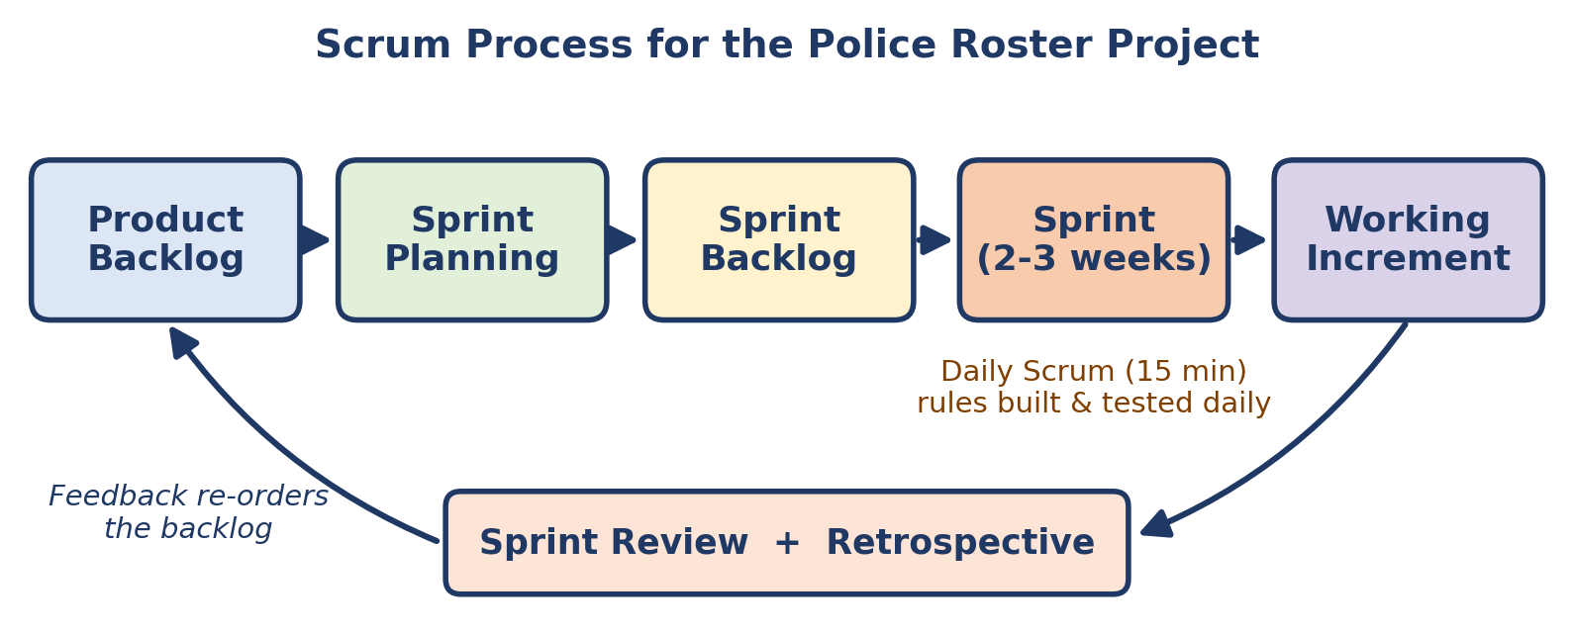
Fig 2.1: Scrum process followed in the project

System Objectives Used for Planning
The following six objectives are used throughout the file (they are listed again in Section 1.3 of the case study, Experiment 10).
No. | Objective
1 | To automatically generate a police duty roster from officer, availability, leave and shift data.
2 | To enforce hard constraints (leave, overlap, minimum rest, maximum hours, rank / skill, required strength).
3 | To balance workload fairly using a penalty score for night, consecutive, weekend and emergency duties.
4 | To calculate a workload / burnout risk indicator (Low, Medium, High) for every officer.
5 | To recommend suitable officers quickly for emergency duty and update their workload.
6 | To keep the supervisor in control with explanations, warnings on overrides, approval, notifications and an audit log.

Proposed Sprint Plan
The sprints follow a 15-week schedule. Weeks 1 to 3 are used for requirement study, SRS and design before the first sprint starts.
Sprint | Weeks | Deliverable | Objectives covered
Sprint 1 | W4 to W5 | Project setup, database, login with three roles, officer management, availability and leave requests | Objective 6
Sprint 2 | W5 to W7 | Shift management and the hard-constraint checker (leave, overlap, rest, maximum hours, rank / skill) | Objectives 1, 2
Sprint 3 | W7 to W9 | Greedy scheduling engine with penalty scoring, unfilled-shift messages and “why assigned” explanations | Objectives 1, 3, 6
Sprint 4 | W9 to W12 | Workload analysis, burnout risk indicator, emergency duty module, supervisor override with warnings, audit log | Objectives 4, 5, 6
Sprint 5 | W12 to W15 | Notifications, dashboard and reports, integration and system testing, acceptance test, documentation and final demo | All objectives
The objective numbers refer to the table above.

Result
Four methodologies were compared on eight criteria. Agile (Scrum) scored the highest overall and was selected. A five-sprint plan covering all six system objectives was prepared.

Conclusion
There is no single best methodology, only one that fits the project. For this roster system, where the right scoring weights and risk thresholds are learnt by trying the scheduler with realistic data, Scrum gives the right balance of flexibility, regular feedback and low overhead for a small student team.

Experiment 3: Use Case Diagram

Aim
To identify the actors and use cases of the Automated Police Roster & Burnout Management System and to draw its use case diagram.

Objectives
- To identify who interacts with the system and what each of them wants to do.
- To show the functions of the system inside a system boundary.
- To use the include and extend relationships for common and optional behaviour.

Tools Used
UML use case notation, a diagramming tool for the figure, and Microsoft Word for the report.

Theory
A use case diagram gives a bird's-eye view of what a system does, without going into how it does it. It is usually the first UML diagram drawn after the requirements are collected, and it is easy to show to a non-technical person such as a police supervisor.
- Actor: anyone or anything outside the system that interacts with it (drawn as a stick figure). A primary actor starts a use case; a secondary actor helps the system complete it.
- Use case: one complete function that gives value to an actor (drawn as an oval).
- System boundary: a rectangle that separates what is inside the system from the actors outside.
- Association: a plain line joining an actor to a use case.
- Include: a dashed arrow labelled «include» from a use case to another one that it always uses. Example: Generate Roster always validates hard constraints.
- Extend: a dashed arrow labelled «extend» from an optional use case to the base use case. Example: a warning appears only when a manual change breaks a rule.

Procedure
- Read the user stories from Experiment 1 and list the actors.
- Turn each important story into a use case with a short verb phrase name.
- Separate the use cases that a user starts directly from the ones that the system runs internally.
- Draw the system boundary and place the use cases inside it.
- Draw the actors outside the boundary and join them to their use cases.
- Add «include» and «extend» arrows where one use case always (or sometimes) needs another.

Actors
Actor | Role in the system
Administrator | Manages users, officers, station information, rules and shift types, and views system-wide reports.
Station Supervisor | Manages shifts and availability, approves leave, generates, reviews and publishes the roster, handles emergencies and watches workload and burnout indicators.
Police Officer | Views own schedule, submits availability, applies for leave, views duty history and workload level, and receives roster updates. Cannot change the official roster.

List of Use Cases
ID | Use case | Actor | Description
UC-01 | Login / Authenticate | All actors | Verify user ID and password and open the screens allowed for the role.
UC-02 | Manage Users | Administrator | Create, update, deactivate user accounts and assign roles.
UC-03 | Manage Officers | Administrator | Add or edit officer ID, name, rank, unit and skills.
UC-04 | Manage Station Info | Administrator | Maintain police station and department details.
UC-05 | Configure Rules & Shifts | Administrator | Set maximum hours, minimum rest, penalty weights and shift types.
UC-06 | View System Reports | Administrator | See system-wide staffing and workload reports.
UC-07 | Manage Shifts & Availability | Station Supervisor | Create shifts and record officer availability.
UC-08 | Approve Leave | Station Supervisor | Approve or reject leave requests from officers.
UC-09 | Generate Roster | Station Supervisor | Run the greedy scheduling algorithm and produce a draft roster.
UC-10 | Review & Modify Roster | Station Supervisor | Check the draft, replace officers or assign manually.
UC-11 | Handle Emergency Duty | Station Supervisor | Find and assign suitable officers for an unplanned emergency.
UC-12 | View Workload & Burnout | Station Supervisor | See hours, night shifts, rest and risk level of each officer.
UC-13 | Approve & Publish Roster | Station Supervisor | Approve the final roster and make it visible to officers.
UC-14 | View My Schedule | Police Officer | See assigned shifts and personal calendar.
UC-15 | Submit Availability | Police Officer | Enter days and times when available.
UC-16 | Apply for Leave | Police Officer | Send a leave request and track its status.
UC-17 | View Duty History | Police Officer | See past duties and total working hours.
UC-18 | View My Workload Level | Police Officer | See personal workload indicator (not a medical diagnosis).
UC-19 | Receive Roster Updates | Police Officer | Get notifications when the roster changes.
UC-20 | Validate Hard Constraints | System (included) | Reject assignments that break leave, overlap, rest, hours or rank rules.
UC-21 | Calculate Penalty Score | System (included) | Score each eligible officer on workload, nights, consecutive shifts and so on.
UC-22 | Explain Assignment | System (included) | Show the reason an officer was chosen for a shift.
UC-23 | Warn on Rule Violation | System (extension) | Warn the supervisor when a manual change breaks an important rule.
UC-24 | Find Eligible Officers | System (included) | Filter officers who can take an emergency duty right now.
UC-25 | Notify Officers | System (included) | Send roster or emergency updates to affected officers.
Login (UC-01) is needed by every actor, so it is shown as a note inside the diagram to keep the figure readable.

Figure 3.1
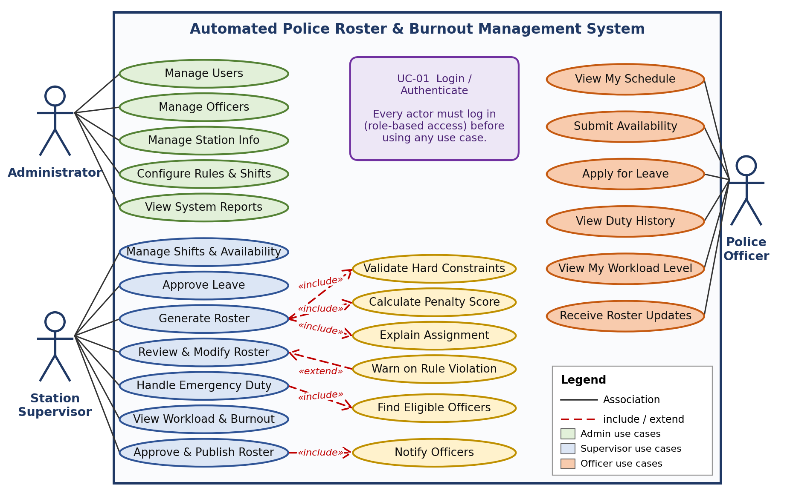
Fig 3.1: Use case diagram of the Automated Police Roster & Burnout Management System

Include and Extend Relationships
Base use case | Relation | Related use case | Why
Generate Roster | «include» | Validate Hard Constraints | Every assignment must be checked; it is never skipped.
Generate Roster | «include» | Calculate Penalty Score | Needed to pick the lowest-penalty eligible officer.
Generate Roster | «include» | Explain Assignment | The roster must be explainable.
Review & Modify Roster | «extend» | Warn on Rule Violation | Happens only when a manual change breaks a rule.
Handle Emergency Duty | «include» | Find Eligible Officers | Emergency search always filters available, rested officers.
Approve & Publish Roster | «include» | Notify Officers | Officers must be told after publication.

Explanation of the Diagram
The rectangle is the system boundary. The Administrator (green) works on master data and rules. The Station Supervisor (blue) has the most use cases because the supervisor controls the roster from creation to publication. The yellow ovals are supporting use cases that run inside the system, for example Generate Roster always includes validating hard constraints, calculating the penalty score and explaining the assignment, and Handle Emergency Duty always includes finding eligible officers. The Police Officer (orange) can only view information and submit availability or leave, so officers cannot change the official roster.

Result
The use case diagram of the system was drawn with three actors and twenty-five use cases, including include and extend relationships.

Conclusion
The diagram shows clearly that the Supervisor is the centre of the system and that human control stays in the process, while the heavy work of checking rules, scoring and explaining is handled by included use cases. This diagram is the base for the activity, class and sequence diagrams in the next experiments.

Experiment 4: Activity Diagram

Aim
To model the flow of work of the main processes of the Automated Police Roster & Burnout Management System using UML activity diagrams.

Objectives
- To understand the elements of an activity diagram: actions, decisions, merges and start / end nodes.
- To show how the roster generation algorithm moves from hard-constraint filtering to penalty scoring.
- To show how emergency duty and leave approval work step by step, including the “no officer available” and “leave rejected” paths.

Tools Used
UML activity diagram notation, a diagramming tool for the figures, and Microsoft Word for the report.

Theory
An activity diagram shows the flow of control from one activity to the next. It is like a flowchart, but it is part of UML and can also show parallel work and who does each step (swimlanes). It is the best diagram to explain an algorithm or a business process to a non-programmer, which is why it is useful for explaining the roster logic to a police supervisor.
- Initial node (filled circle): where the process starts.
- Action (rounded rectangle): one step of work, such as “Remove officers who break hard constraints”.
- Decision (diamond): a question with guarded outgoing flows such as Yes / No.
- Merge: several flows join into one again (used when the Unfilled path rejoins the main loop).
- Control flow (arrow): the order of the steps.
- Final node (circle with a dot): where the process ends.

Procedure
- Choose the processes that need explanation: roster generation (US8, US9), emergency duty (US12) and leave (US5, US6).
- List the steps of each process from the user stories and the algorithm in the project description.
- Mark every place where a decision is needed (for example: are there enough eligible officers?).
- Draw the start node, the actions in order, the decisions with Yes / No guards and the end node.
- Make sure that every path ends somewhere. A failing path, such as an unfilled shift, must never disappear silently.

Colour Key Used in the Diagrams
Colour | Meaning
Blue box | Step done by a user or a basic system step
Green box | Automatic rule checking or scoring by the scheduling engine
Orange box | Output, warning, alert or exceptional path
Yellow diamond | Decision

Figure 4.1
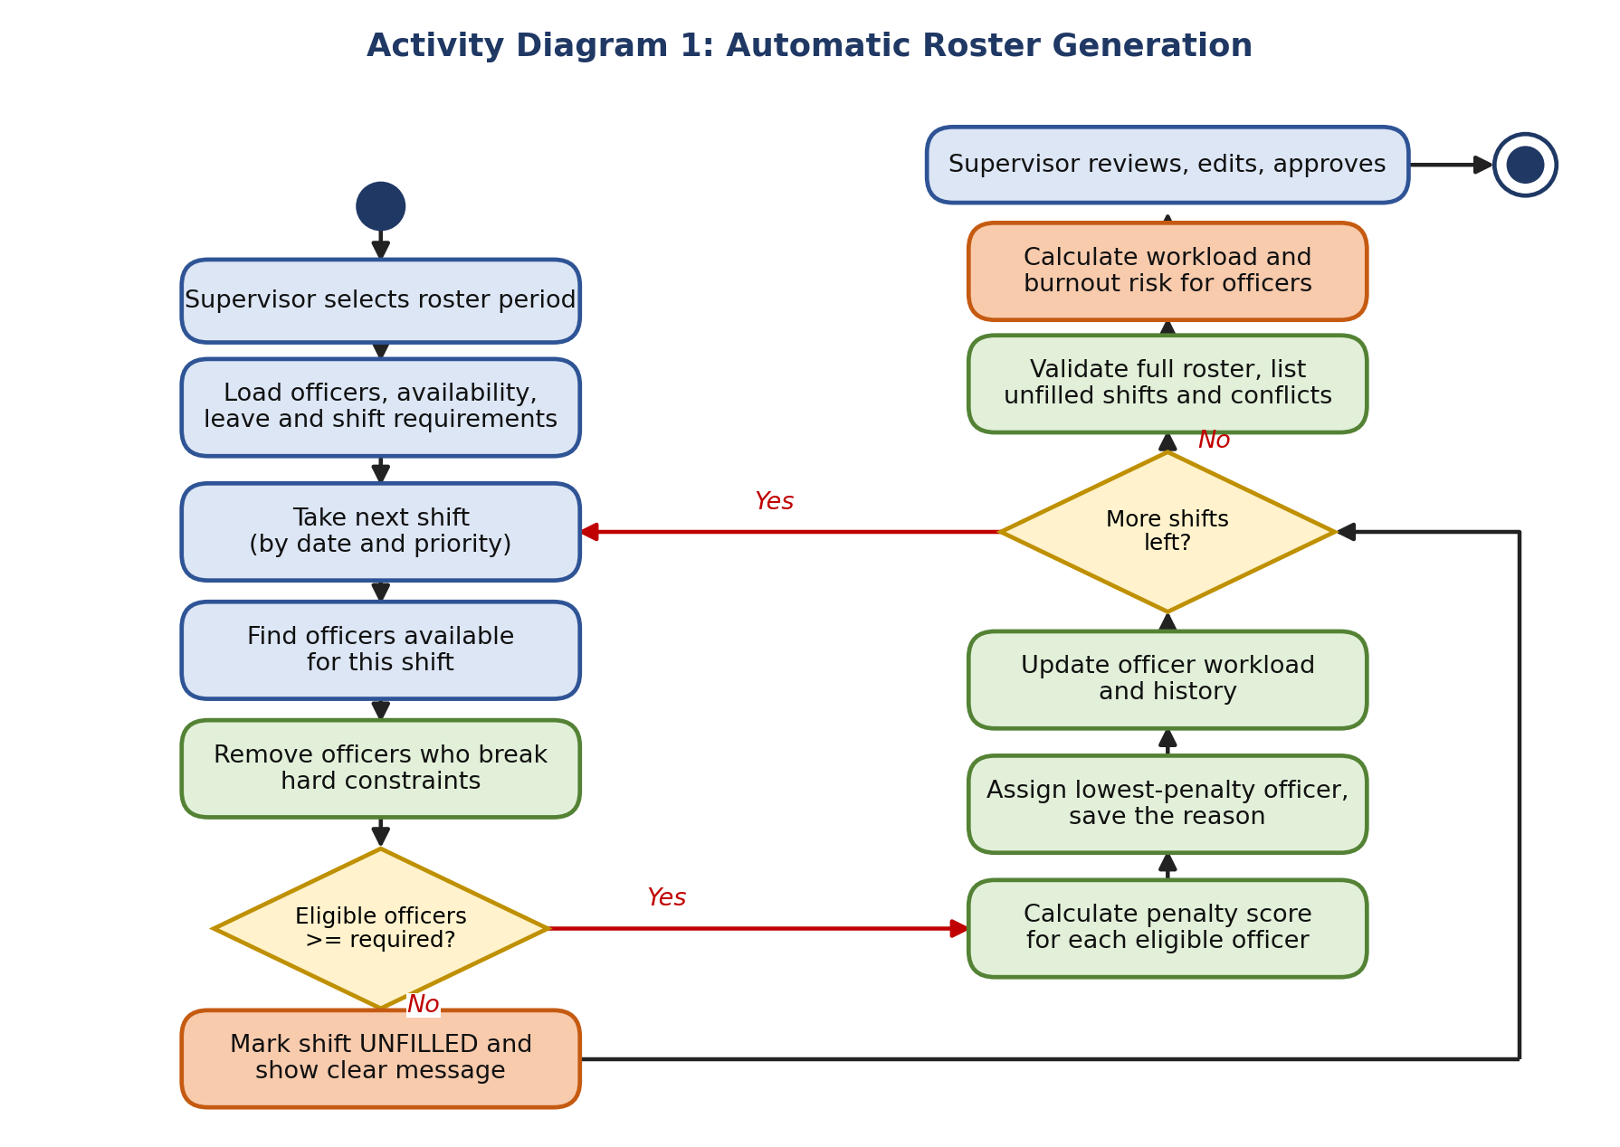
Fig 4.1: Activity diagram of automatic roster generation
Figure 4.2
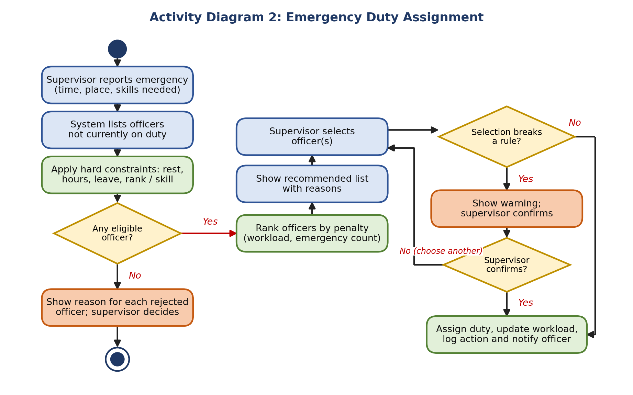
Fig 4.2: Activity diagram of emergency duty assignment
Figure 4.3
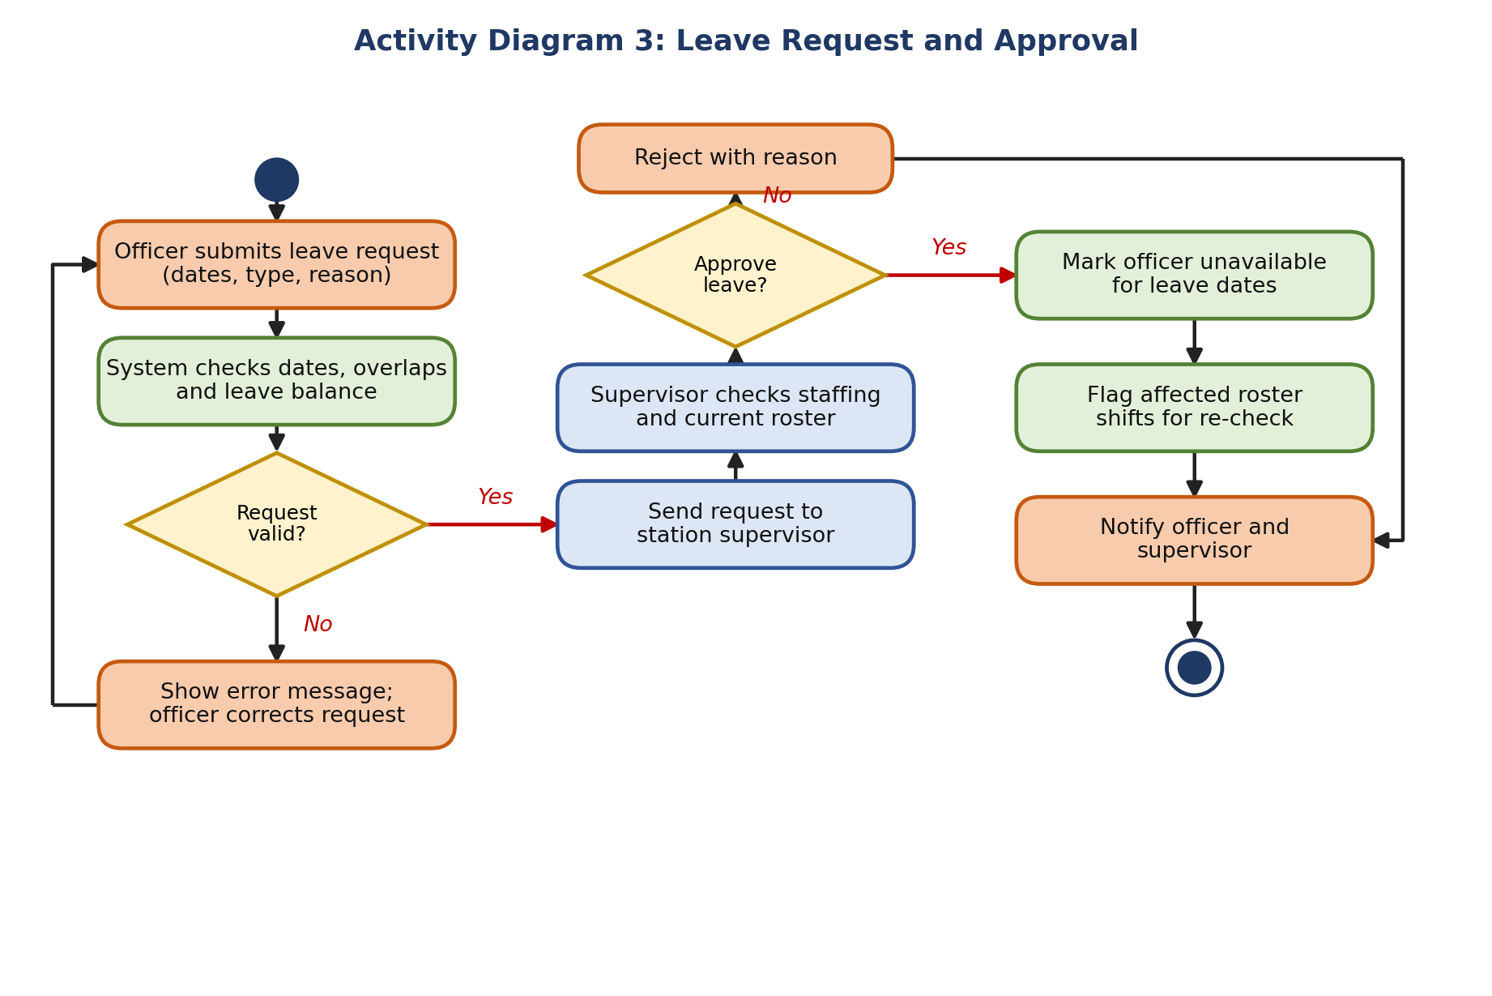
Fig 4.3: Activity diagram of leave request and approval

Explanation of the Diagrams
Activity Diagram 1: Roster Generation
The supervisor selects the roster period and the system loads officers, availability, leave and shifts. The system then handles one shift at a time. It first finds available officers and removes everyone who breaks a hard constraint. If there are enough eligible officers, it calculates the penalty score of each, assigns the one with the lowest penalty, saves the reason and updates the workload. If there are not enough, the shift is marked Unfilled with a clear message and the loop continues, so the problem is visible and nothing fails silently. When all shifts are done, the roster is validated, workload and burnout risk are calculated and the supervisor reviews, edits and approves.
Activity Diagram 2: Emergency Duty Assignment
The supervisor reports an emergency with time, place and skills needed. The system lists officers who are not on duty and applies the same hard constraints (rest, hours, leave, rank / skill). If nobody qualifies, the reason for each rejected officer is shown and the supervisor decides what to do. Otherwise officers are ranked by penalty, including the number of earlier emergency duties, and a recommended list is shown. If the chosen officer would break an important rule, a warning is shown and the supervisor must confirm or choose another. After confirmation the duty is assigned, the workload is updated, the action is logged and the officer is notified.
Activity Diagram 3: Leave Request and Approval
The officer submits a leave request and the system checks dates, overlaps and leave balance. A wrong request returns to the officer with an error message. A valid request goes to the supervisor, who checks staffing and the current roster. Rejection ends with a reason. Approval marks the officer unavailable for those dates, flags the roster shifts that are now affected for re-check, and notifies the officer and the supervisor.

Result
Three activity diagrams were drawn for roster generation, emergency duty assignment and leave approval. Every decision has both Yes and No paths and every path reaches a clear end or loops back.

Conclusion
Activity diagrams made the algorithm easy to read: hard constraints always come first and the penalty score only ranks the officers who are already allowed. The diagrams also show where the supervisor stays in control, which supports the human-in-the-loop design of the system.

Experiment 5: Class Diagram

Aim
To identify the classes of the Automated Police Roster & Burnout Management System and to draw class diagrams with attributes, operations and relationships.

Objectives
- To identify classes, attributes and operations from the project description and the user stories.
- To show relationships with multiplicity (for example one Officer has many RosterAssignments).
- To separate data classes (entities) from the classes that hold the scheduling rules (services).

Tools Used
UML class diagram notation, a diagramming tool for the figures, and Microsoft Word.

Theory
A class diagram shows the classes of a system and how they are related. Each class is a box with three parts: the name, the attributes (data) and the operations (behaviour). Visibility is shown by + (public) and - (private).
- Association: a plain line between classes, with multiplicity such as 1, 0..1 or * (many).
- Dependency: a dashed arrow, drawn here as «uses», meaning one class calls another.
- Multiplicity: how many objects take part. Example: one Officer – many LeaveRequests (1 to *).
- Generalisation / aggregation / composition: inheritance and whole-part relations. The roster design stays simple and mainly uses association and dependency, because the rules are kept in service classes and not in a deep inheritance tree.

Procedure
- Read the project description and underline all nouns: officer, rank, shift, roster, leave, emergency, notification. These are candidate classes.
- Underline the verbs: generate, validate, approve, assign, notify. These become operations.
- Collect the data that each noun needs (officer ID, name, skills). These become attributes.
- Remove duplicates and things that are only attributes (for example “night-shift count” is an attribute of WorkloadRecord).
- Add a separate class for each rule-based job (validation, scoring, analysis) so that rules are easy to change.
- Draw associations with multiplicity and dashed «uses» arrows for dependencies.

Classes Identified
Class | Type | Responsibility
User | Entity | Login account and role (Administrator, Station Supervisor, Police Officer).
Officer | Entity | Police officer profile: rank, unit, skills, maximum weekly hours.
Rank | Entity | Designation and seniority level used for rank-based duties.
Department | Entity | Unit and station to which officers and shifts belong.
Availability | Entity | Dates and times when an officer can or cannot work.
LeaveRequest | Entity | Leave dates, type and approval status.
Shift | Entity | Date, shift type, timing, required officers, rank / skill and priority.
Roster | Entity | A roster for a period with status Draft, Approved or Published.
RosterAssignment | Entity | One officer on one shift, with penalty score and the reason for assignment.
EmergencyDuty | Entity | An unplanned duty with time, place and required skill.
WorkloadRecord | Entity | Hours, night shifts, consecutive shifts, weekend and emergency counts and risk level.
Notification | Entity | Message sent to a user about roster changes.
AuditLog | Entity | Record of important changes (who, what, when).
SchedulingEngine | Service | Runs the greedy algorithm, selects the best officer and explains the choice.
ConstraintValidator | Service | Checks every hard constraint: leave, overlap, rest, hours, rank / skill.
PenaltyCalculator | Service | Calculates the weighted penalty score of an eligible officer.
WorkloadAnalyzer | Service | Calculates weekly hours and the Low / Medium / High risk level.
EmergencyService | Service | Finds, ranks and assigns officers for an emergency.
RosterService | Service | Modify, approve and publish a roster with warnings.
NotificationService | Service | Sends roster and emergency updates.
AuditService | Service | Writes entries to the audit log.
The role of a user is stored as an enumeration Role = {ADMINISTRATOR, STATION_SUPERVISOR, POLICE_OFFICER} inside the User class.

Relationships
Classes | Multiplicity | Meaning
User – Officer | 1 to 0..1 | Every officer has a login; an administrator or supervisor user need not be an officer.
User – Notification | 1 to * | A user receives many notifications.
User – AuditLog | 1 to * | A user performs many logged actions.
Officer – Rank | * to 1 | Many officers hold one rank.
Officer – Department | * to 1 | Many officers belong to one unit.
Officer – Availability | 1 to * | One officer has many availability records.
Officer – LeaveRequest | 1 to * | One officer has many leave requests.
Officer – RosterAssignment | 1 to * | One officer has many assignments.
Roster – RosterAssignment | 1 to * | One roster contains many assignments.
Shift – RosterAssignment | 1 to * | One shift is filled by one or more assignments.
Officer – EmergencyDuty | 1 to * | One officer can have many emergency duties.
Officer – WorkloadRecord | 1 to * | One officer has a workload record for each week.

Figure 5.1
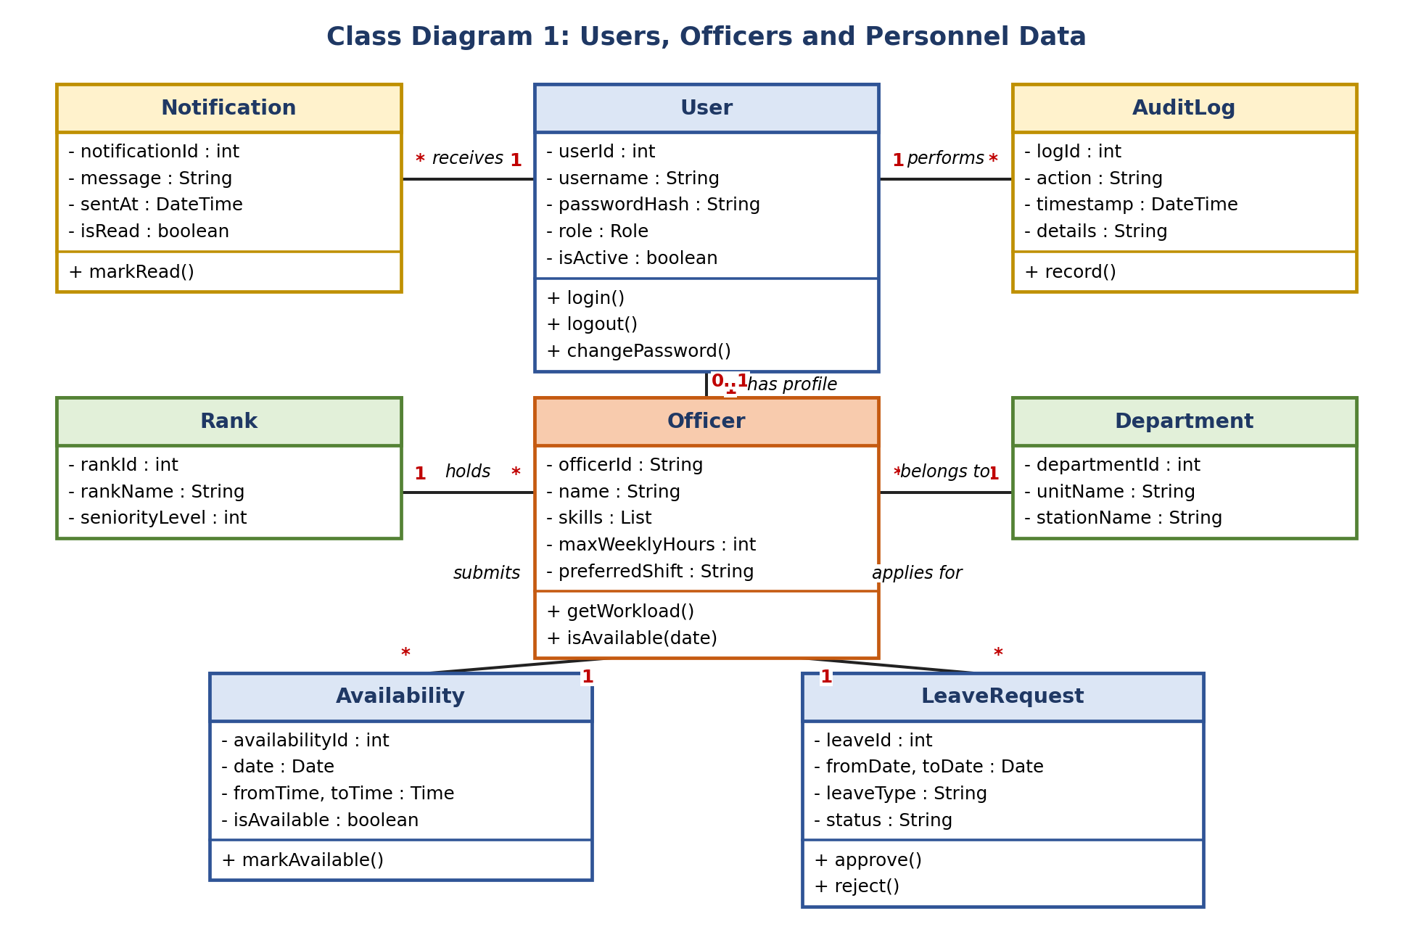
Fig 5.1: Class diagram of users, officers and personnel data
Figure 5.2
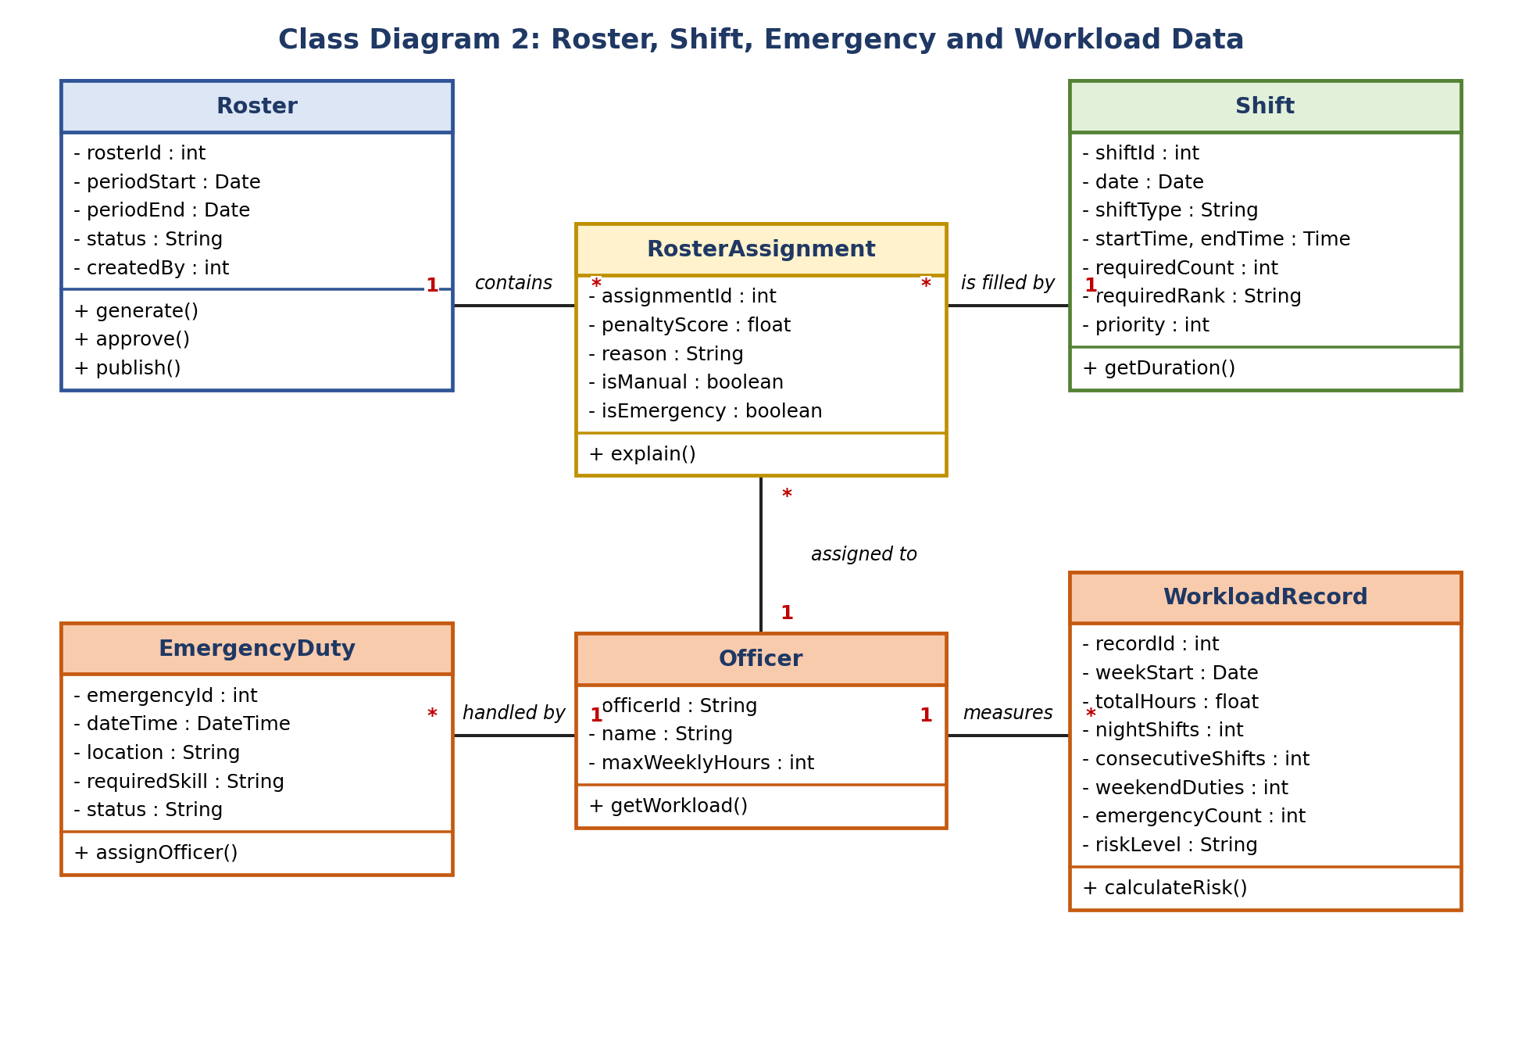
Fig 5.2: Class diagram of roster, shift, emergency and workload data
Figure 5.3
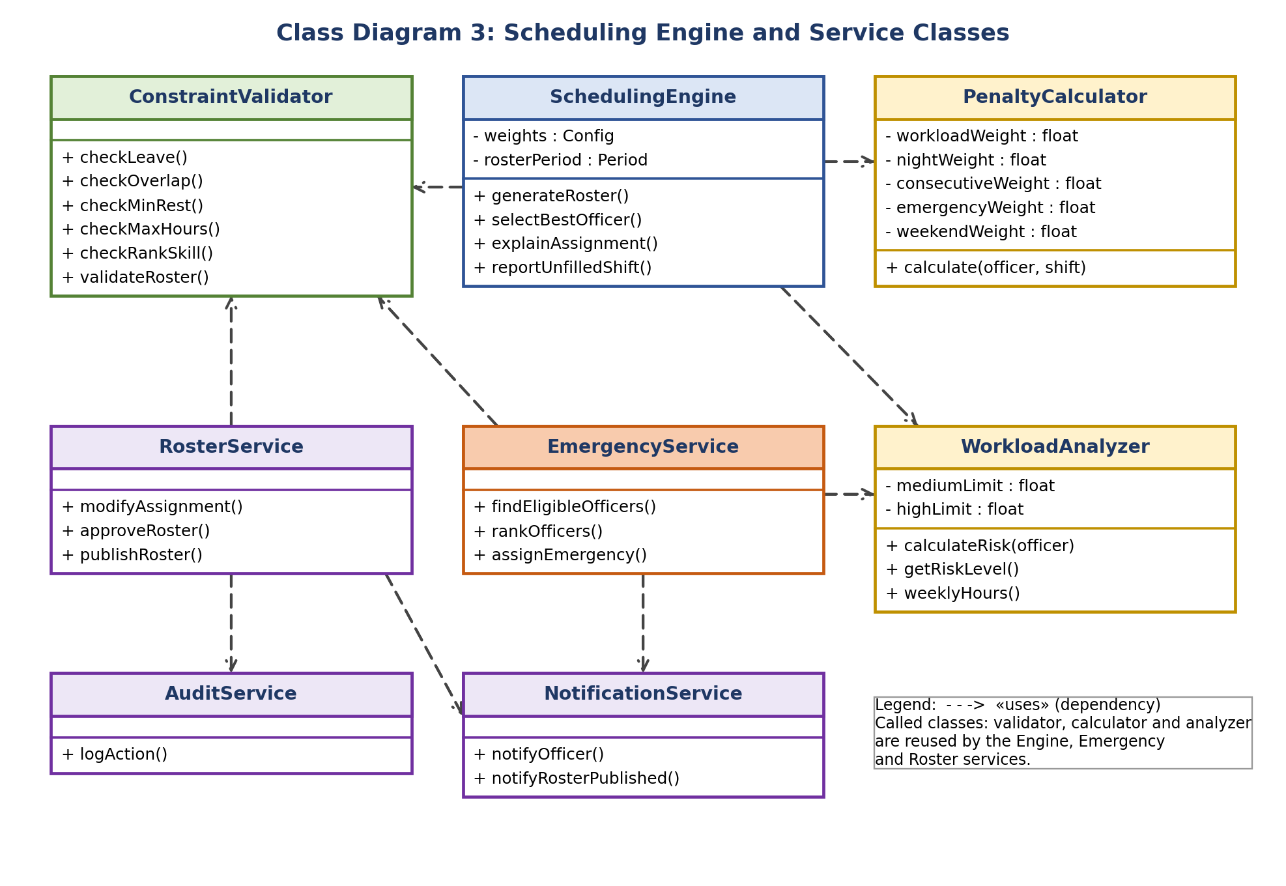
Fig 5.3: Class diagram of scheduling engine and service classes

Explanation of the Diagrams
Class Diagram 1 shows the people and personnel data. User is kept separate from Officer because the administrator and supervisor also log in but are not necessarily duty officers. Availability and LeaveRequest are both linked to Officer, which makes the hard constraints easy to check.
Class Diagram 2 shows the duty data. RosterAssignment is the centre: it links a Roster, a Shift and an Officer, and it stores the penalty score and the reason, which makes every assignment explainable. WorkloadRecord keeps the figures that are needed for the burnout risk indicator. EmergencyDuty is linked to the Officer who handles it.
Class Diagram 3 shows the service classes. The SchedulingEngine does not contain any rule itself; it calls ConstraintValidator for hard constraints, PenaltyCalculator for soft constraints and WorkloadAnalyzer for risk. EmergencyService and RosterService reuse the same validator, so an emergency assignment and a manual override follow the same rules as the automatic roster. Weights and limits are stored as attributes, so the rules can be changed without changing the algorithm (maintainability).

Result
Twenty-one classes (13 entity classes and 8 service classes) were identified and drawn in three class diagrams with multiplicities and dependencies.

Conclusion
Separating data classes from rule classes gives a design that is easy to explain, test and change. Each class has one clear job, and the same validator and calculator are reused by the automatic roster, the emergency module and the supervisor override.

Experiment 6: Sequence Diagram

Aim
To show how objects of the system exchange messages in time order for the most important scenarios, using sequence diagrams.

Objectives
- To understand lifelines, messages, activation bars and combined fragments such as loops.
- To model roster generation, emergency assignment and supervisor override with publication.

Tools Used
UML sequence diagram notation, a diagramming tool, and Microsoft Word.

Theory
A sequence diagram shows who talks to whom and in what order. Time runs from top to bottom.
- Lifeline: a box with a dashed vertical line for each object or actor.
- Message: a solid arrow for a call; a dashed arrow for a return.
- Activation bar: a thin rectangle showing when an object is busy.
- Self message: an object calling its own operation.
- Loop fragment: a frame with a guard such as [for each shift] that repeats the messages inside it.

Procedure
- Pick a scenario from the use cases (Generate Roster, Handle Emergency Duty, Review & Modify and Publish).
- List the actors and objects that take part, using the classes from Experiment 5.
- Write the messages in the order in which they happen and number them.
- Add return messages and place repeated steps inside a loop frame.

Figure 6.1
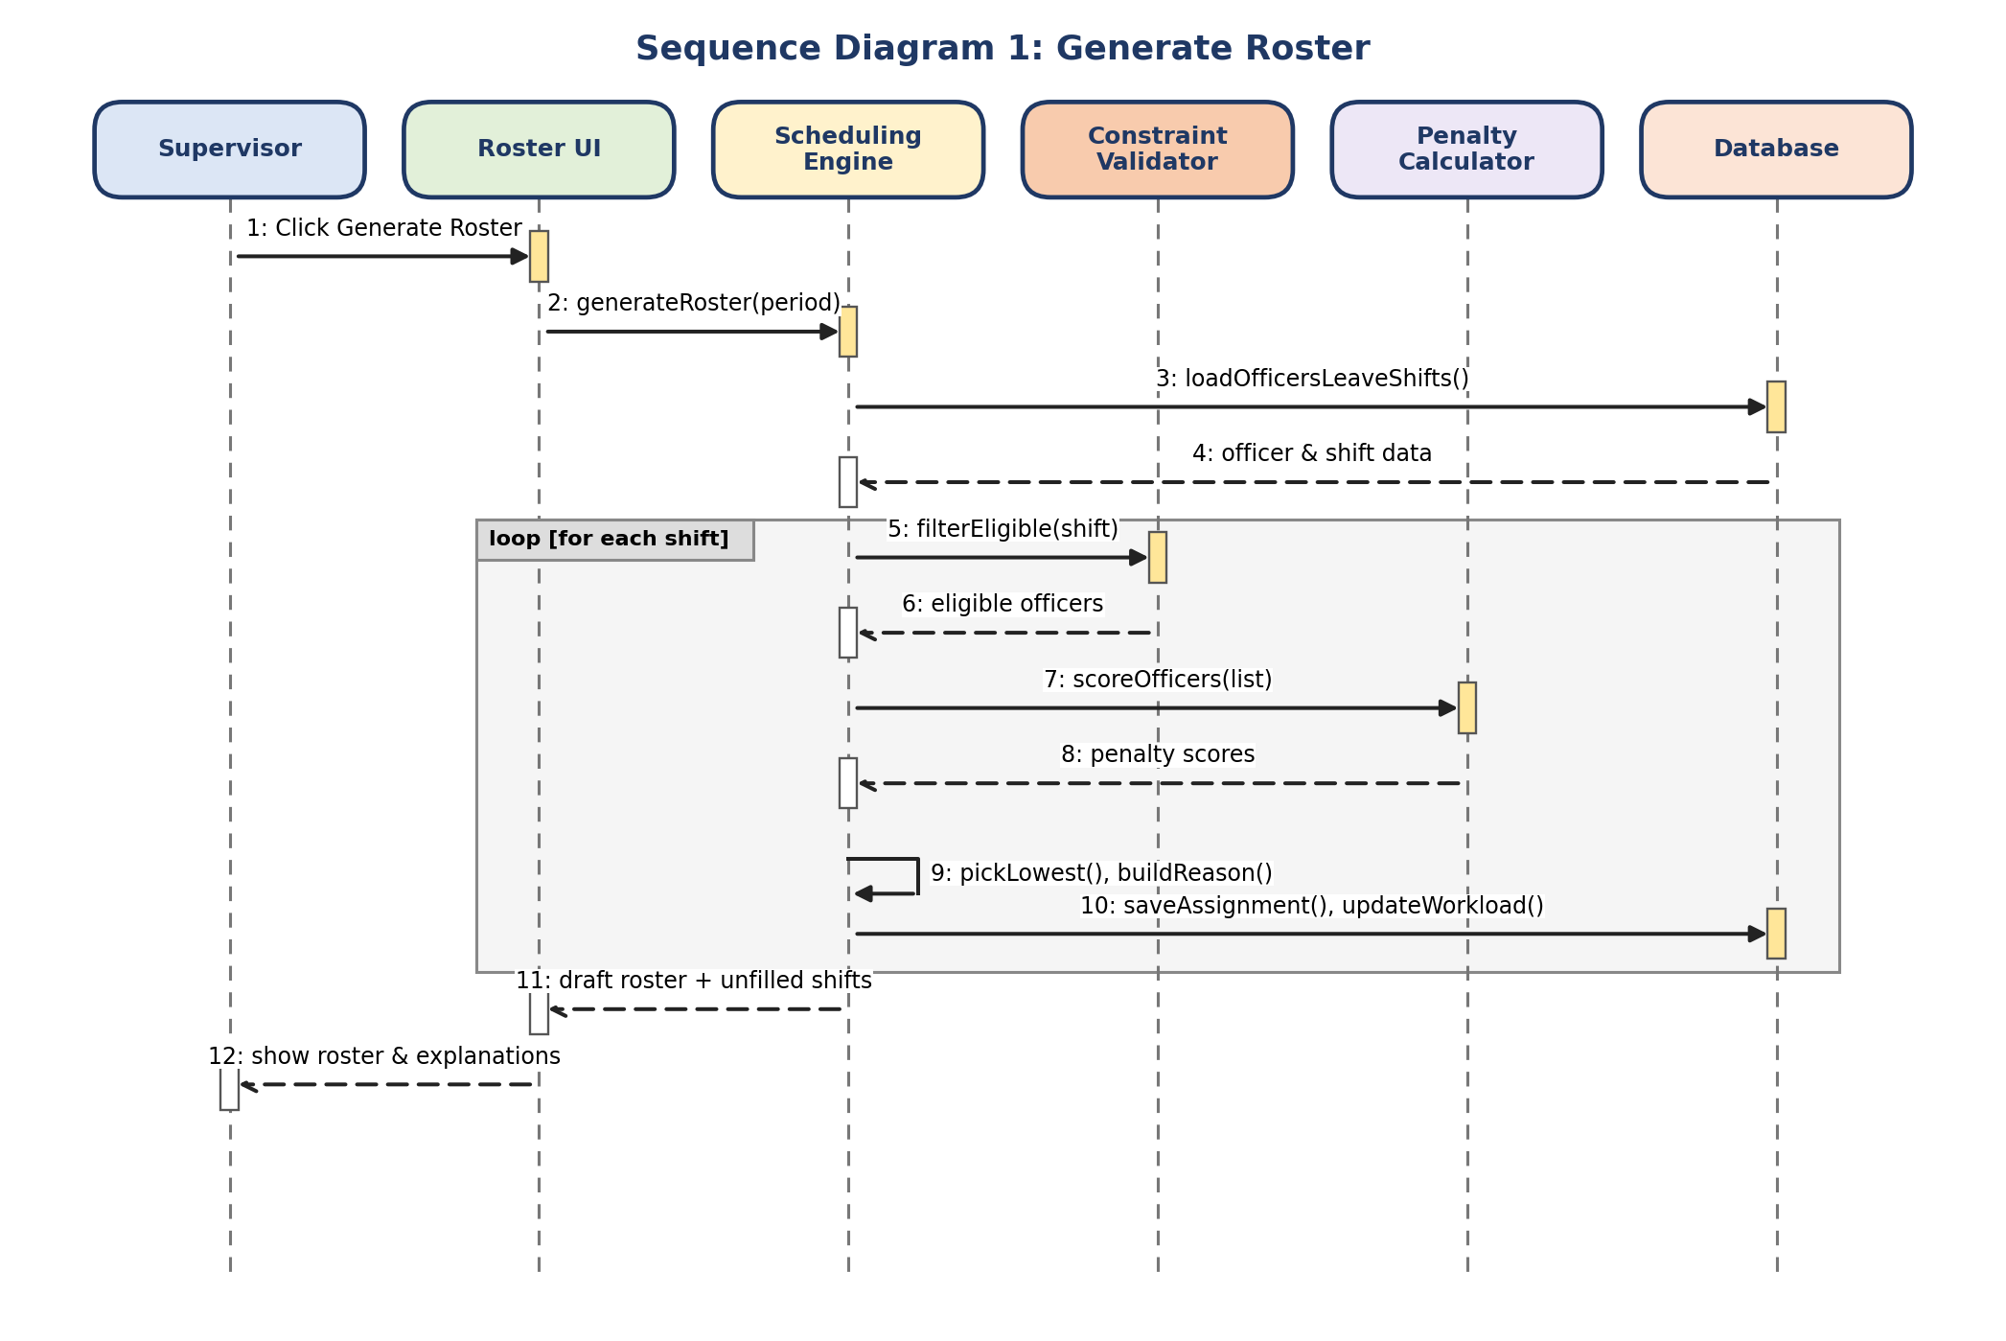
Fig 6.1: Sequence diagram of generate roster
Figure 6.2
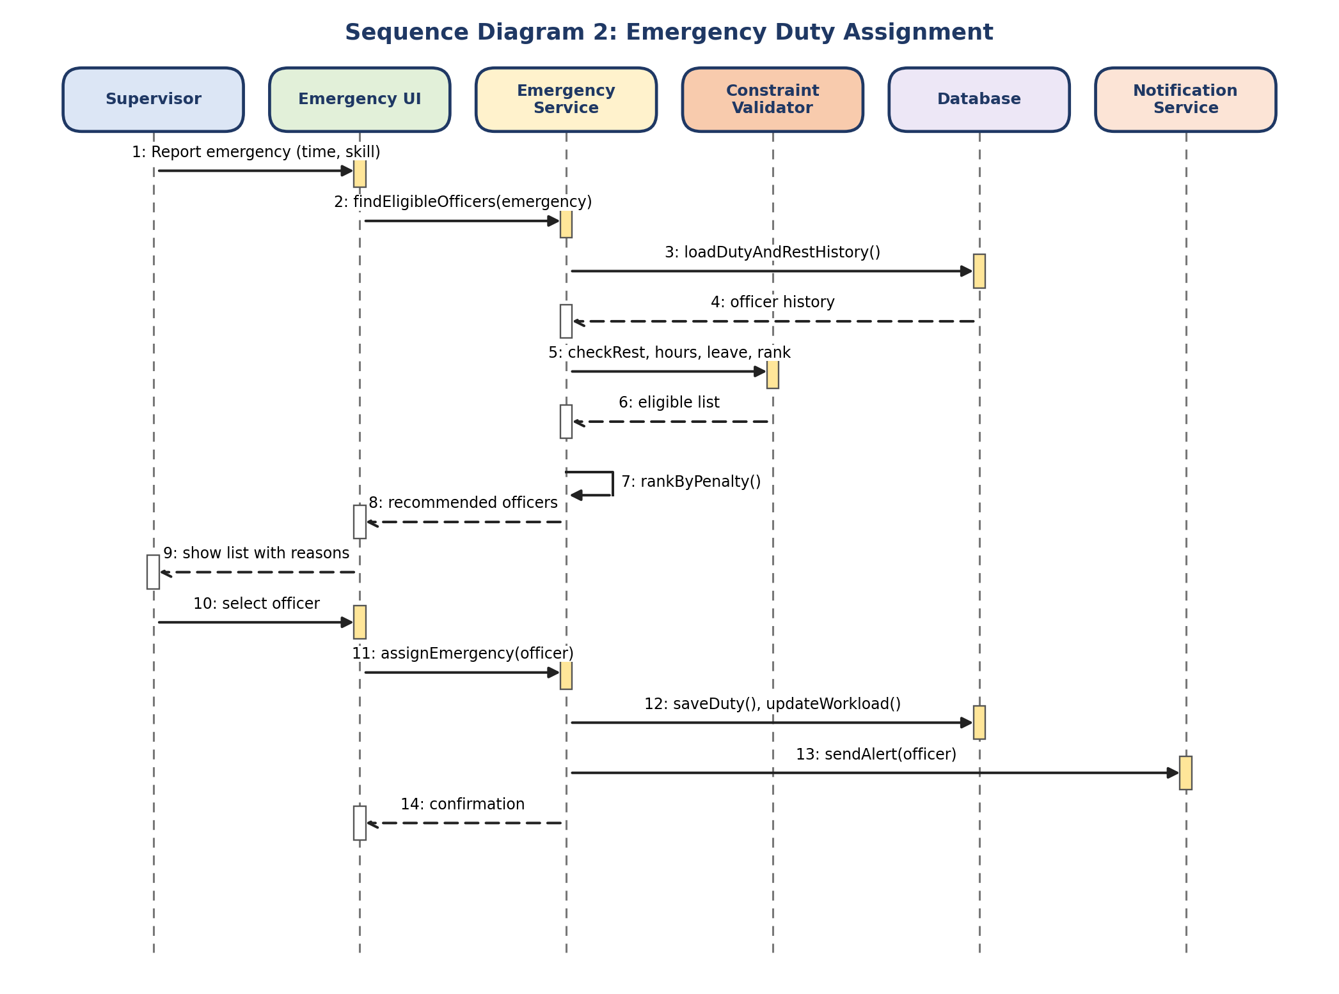
Fig 6.2: Sequence diagram of emergency duty assignment
Figure 6.3
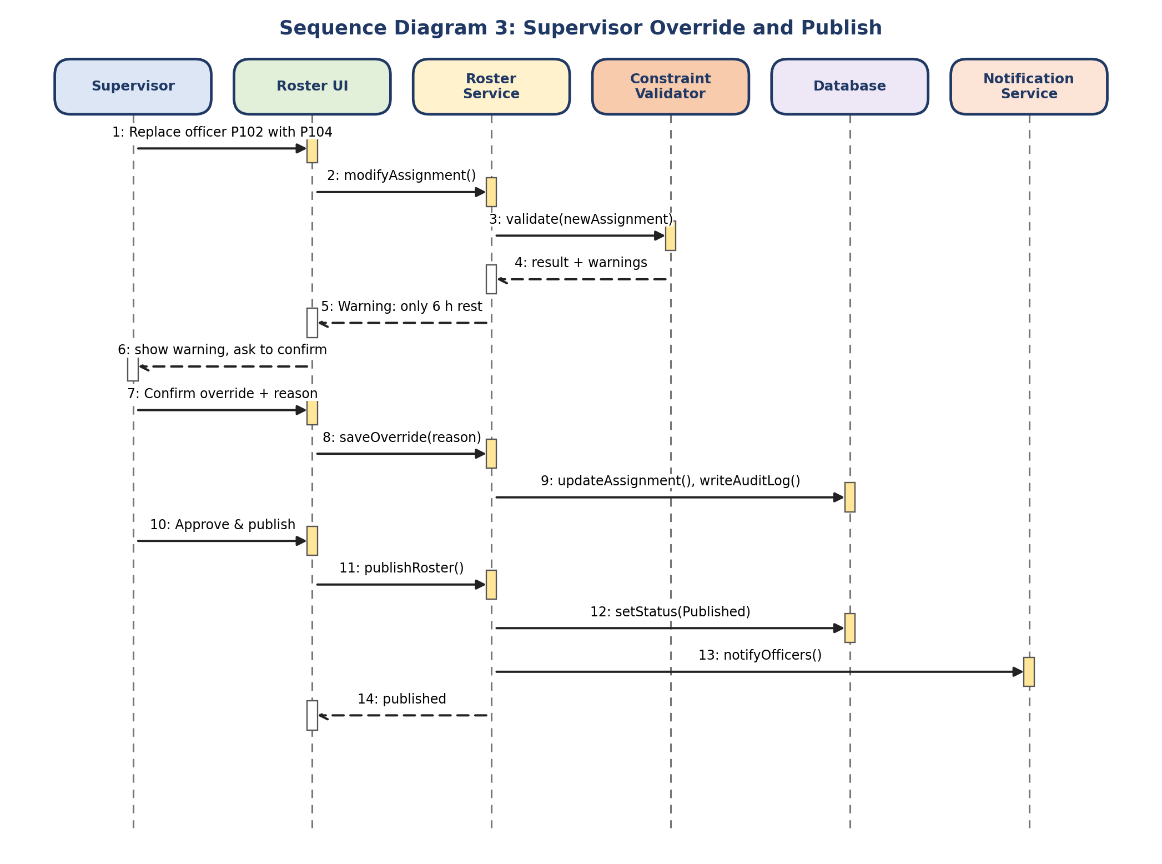
Fig 6.3: Sequence diagram of supervisor override and publish

Explanation of the Diagrams
Sequence Diagram 1 (Generate Roster): the supervisor clicks Generate Roster. The Scheduling Engine loads data from the Database, then, for each shift inside the loop, asks the Constraint Validator for eligible officers, asks the Penalty Calculator for scores, picks the lowest, builds the reason, and saves the assignment and the updated workload. At the end the draft roster and the list of unfilled shifts go back to the UI.
Sequence Diagram 2 (Emergency Duty): the supervisor reports an emergency. The Emergency Service loads duty and rest history, asks the Validator to check rest, hours, leave and rank, ranks the eligible officers by penalty and returns a recommended list with reasons. After the supervisor selects an officer, the duty is saved, workload is updated and the Notification Service sends an alert.
Sequence Diagram 3 (Override and Publish): the supervisor replaces an officer. The Roster Service asks the Validator to validate the new assignment and, because the officer would have only 6 hours of rest, a warning goes back to the supervisor. After the supervisor confirms with a reason, the change and an audit log entry are saved. The supervisor then approves and publishes the roster; the status changes to Published and officers are notified.

Result
Three sequence diagrams (14 messages in the longest) were drawn for the main scenarios, including a loop fragment for the per-shift algorithm.

Conclusion
The diagrams confirm that the Validator is called before any score is calculated, that every manual change passes through the same checks, and that every override is stored in the audit log. They also show which operations the classes in Experiment 5 must provide.

Experiment 7: Collaboration Diagram

Aim
To show the structural organisation of the objects that cooperate in a scenario, together with the numbered messages they send, using collaboration diagrams.

Objectives
- To understand objects, links and numbered messages.
- To redraw the three scenarios of Experiment 6 as collaboration diagrams.
- To compare collaboration and sequence diagrams.

Tools Used
UML collaboration (communication) diagram notation, a diagramming tool, and Microsoft Word.

Theory
A collaboration diagram (called a communication diagram in UML 2) shows the same information as a sequence diagram but emphasises which objects are connected instead of the time order. Objects are boxes such as :RosterUI, links are lines between objects, and every message is numbered to show its order.
Point | Sequence diagram | Collaboration diagram
Main focus | Order of messages in time | Links between objects
Layout | Objects in a row, time downward | Objects placed freely, numbers show order
Best for | Explaining one scenario step by step | Seeing which objects depend on each other
Gets crowded when | Many objects are involved | Many messages are involved

Procedure
- Take the objects from the sequence diagram and place them on the page.
- Draw a link between every two objects that exchange a message.
- Write the messages on the links with their sequence numbers.
- Show a message from an object to itself with a loop-back mark (↻).

Figure 7.1
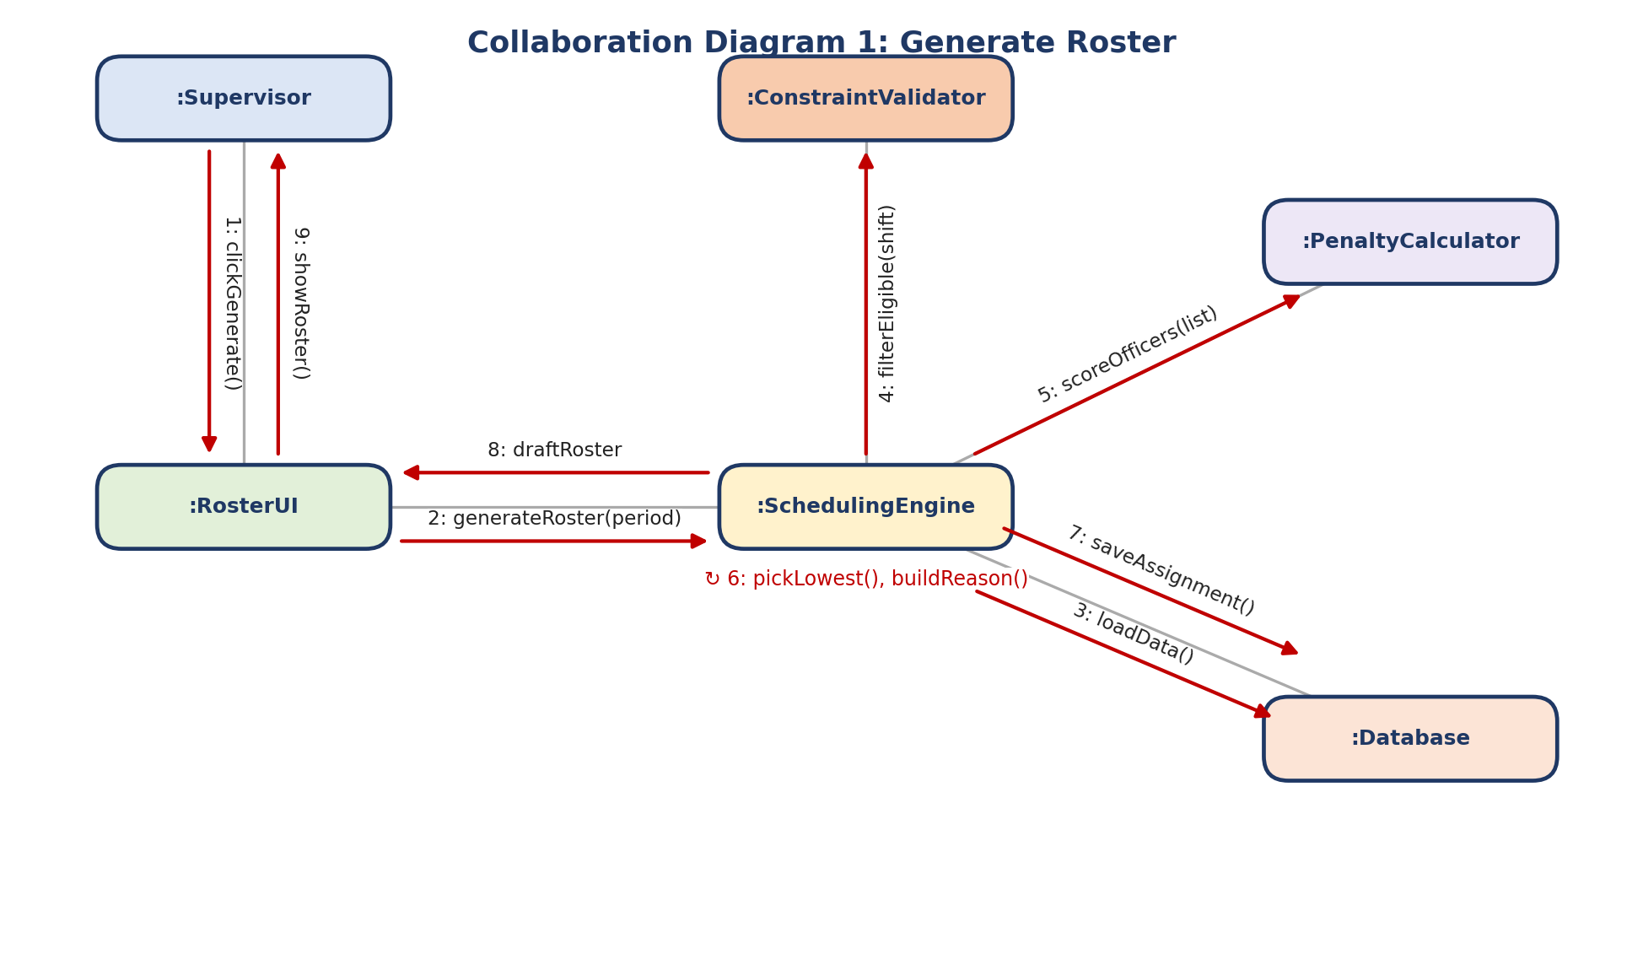
Fig 7.1: Collaboration diagram of generate roster
Figure 7.2
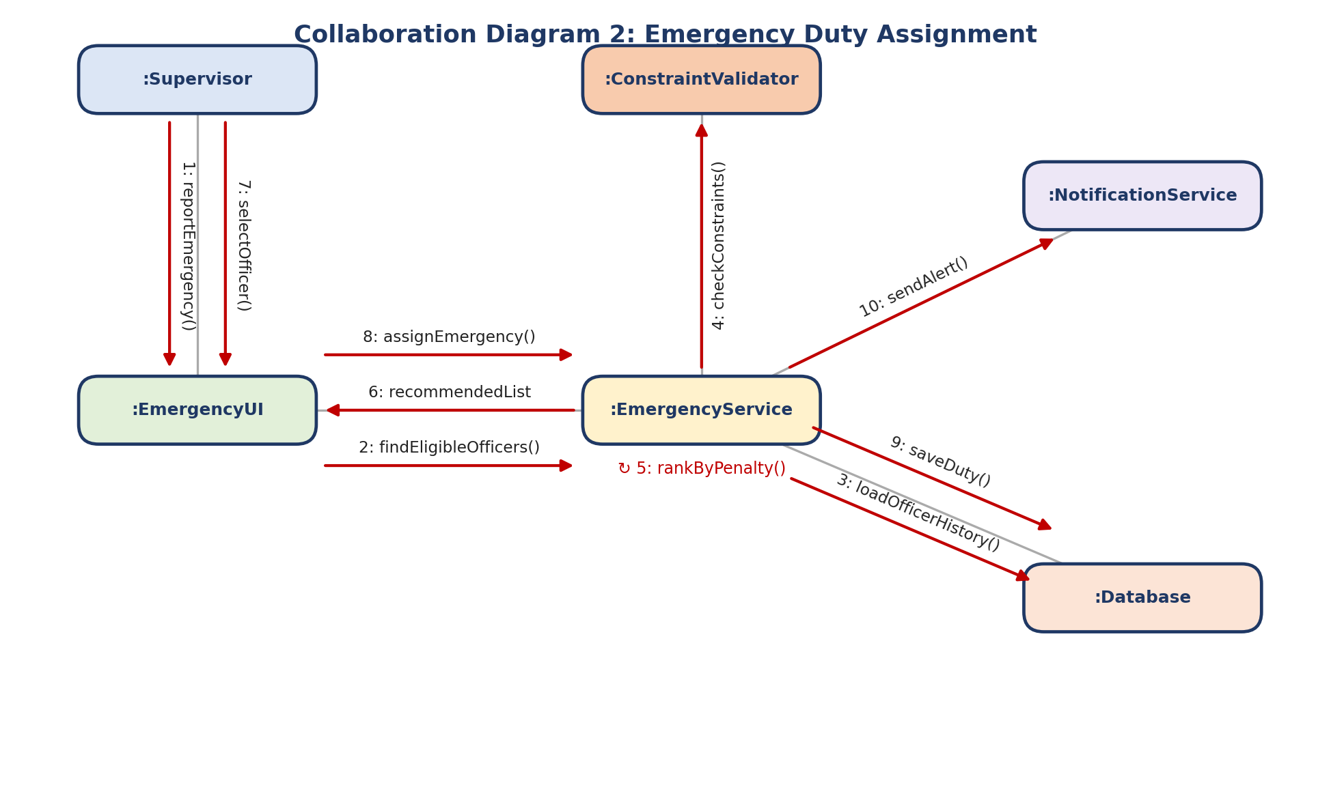
Fig 7.2: Collaboration diagram of emergency duty assignment
Figure 7.3
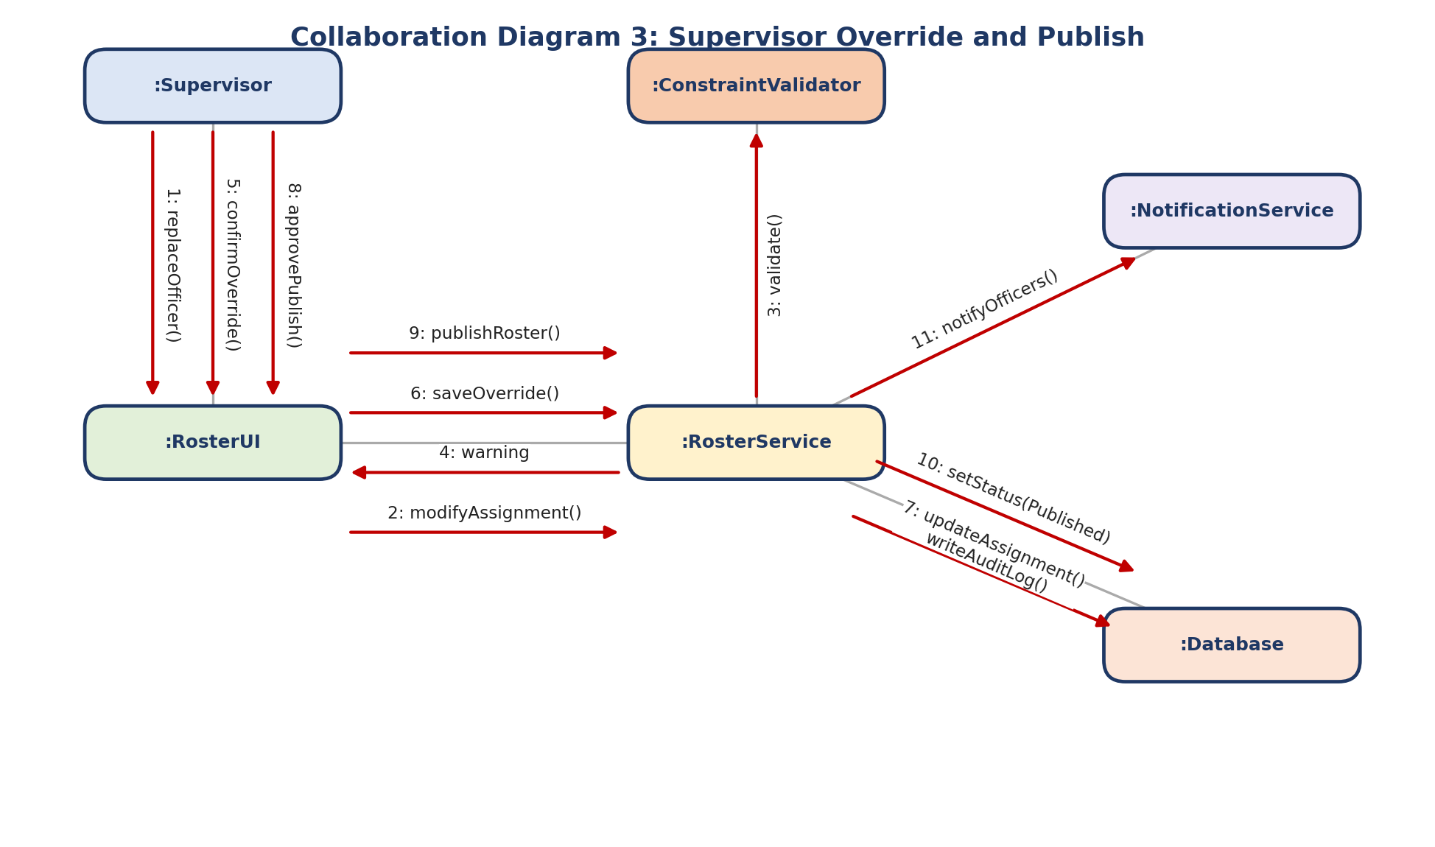
Fig 7.3: Collaboration diagram of supervisor override and publish

Explanation of the Diagrams
In Collaboration Diagram 1 the SchedulingEngine is the centre object. It is linked to the Supervisor's screen (:RosterUI), the ConstraintValidator, the PenaltyCalculator and the Database. The numbers 1 to 9 give the order: 1 and 2 start the generation, 3 loads data, 4 and 5 filter and score, 6 is a self message that picks the lowest-penalty officer, 7 saves the assignment and 8 and 9 show the draft roster.
In Collaboration Diagram 2 the EmergencyService is the centre. Its links to the ConstraintValidator, the Database and the NotificationService show that an emergency assignment depends on exactly the same helper objects as roster generation. In Collaboration Diagram 3 the RosterService is linked to the Validator, the Database and the NotificationService, and the four messages between :RosterUI and :RosterService show the warning, confirmation, saving and publication.

Result
Three collaboration diagrams were drawn with numbered messages that match the sequence diagrams of Experiment 6.

Conclusion
The collaboration diagrams show that all three services depend on the same few helper objects. This confirms that the design is consistent and that a change in the validator or the calculator will correctly affect the roster, the emergency module and manual overrides together.

Experiment 8: State Diagram and DFD

Aim
To model the life cycle of important objects using state diagrams and to model the flow of data through the system using data flow diagrams (DFD) at levels 0, 1 and 2.

Objectives
- To identify the states and transitions of a Roster and of a LeaveRequest.
- To draw the context diagram (level 0) and decompose it into level 1 and level 2.
- To check that the levels are balanced.

Tools Used
UML state diagram notation, DFD notation (Yourdon style), a diagramming tool, and Microsoft Word.

Theory
State diagram
A state diagram shows the states an object can be in and the events that move it from one state to another. It belongs to the control flow model of requirement analysis, because it shows when things may happen. The notation includes the initial state (filled circle), states (rounded boxes), transitions (arrows with event labels) and the final state.
Data flow diagram
A DFD belongs to the data flow model. It shows how data moves through the system and not the order of control. It uses four symbols:
- External entity (rectangle): a person or system outside, such as the Administrator.
- Process (circle): work that changes data, numbered 1.0, 2.0 and so on.
- Data store (open rectangle): where data rests, labelled D1, D2 and so on.
- Data flow (arrow): data moving between the above, named with a noun phrase.
The context diagram (level 0) shows the whole system as one process. Level 1 splits it into main processes. Level 2 splits one process again. The inputs and outputs of a parent process must match those of its children; this is called balancing.

Procedure
- List the states of a Roster and of a LeaveRequest and the events that change them.
- Draw the state diagrams and label every transition with its event.
- Draw the context diagram with the three external entities and their main data flows.
- Split the system into six main processes and identify the data stores.
- Expand process 3.0 (Generate & Validate Roster) into sub-processes and check balancing.

Figure 8.1
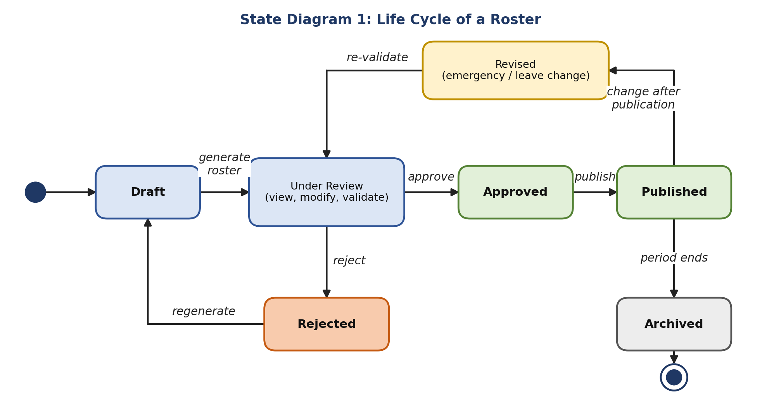
Fig 8.1: State diagram of a roster
Figure 8.2
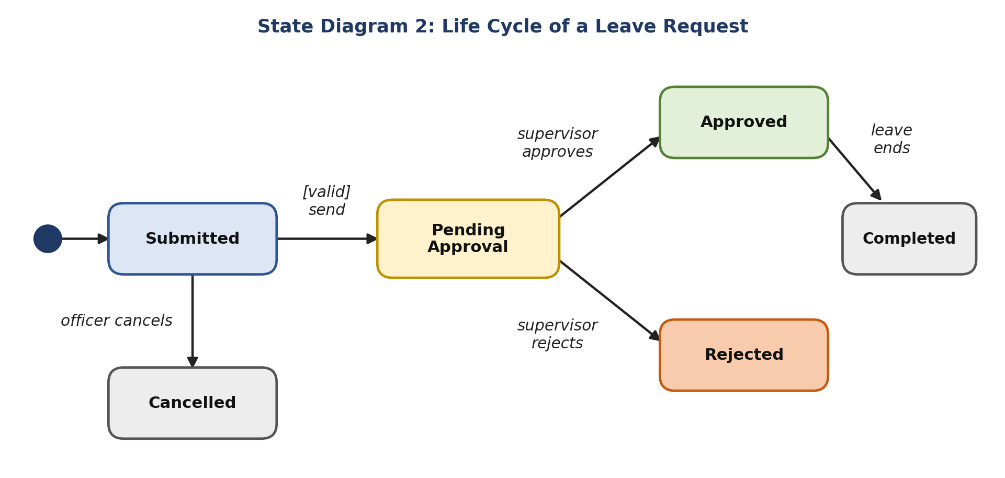
Fig 8.2: State diagram of a leave request
Figure 8.3
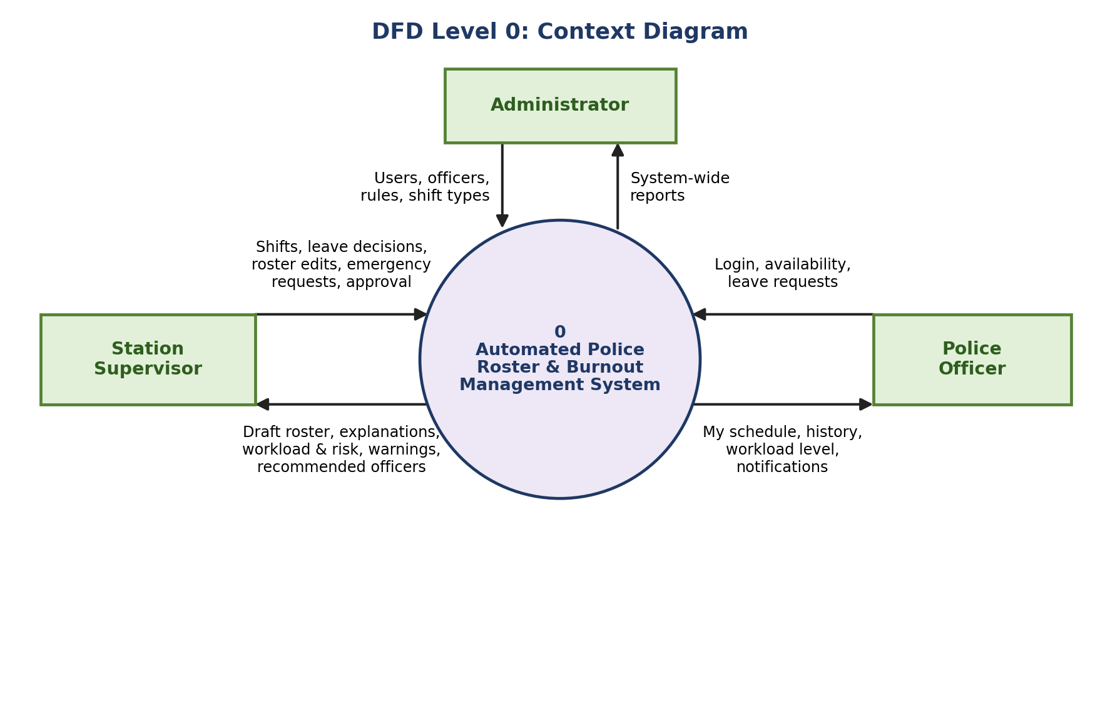
Fig 8.3: DFD level 0 (context diagram)
Figure 8.4
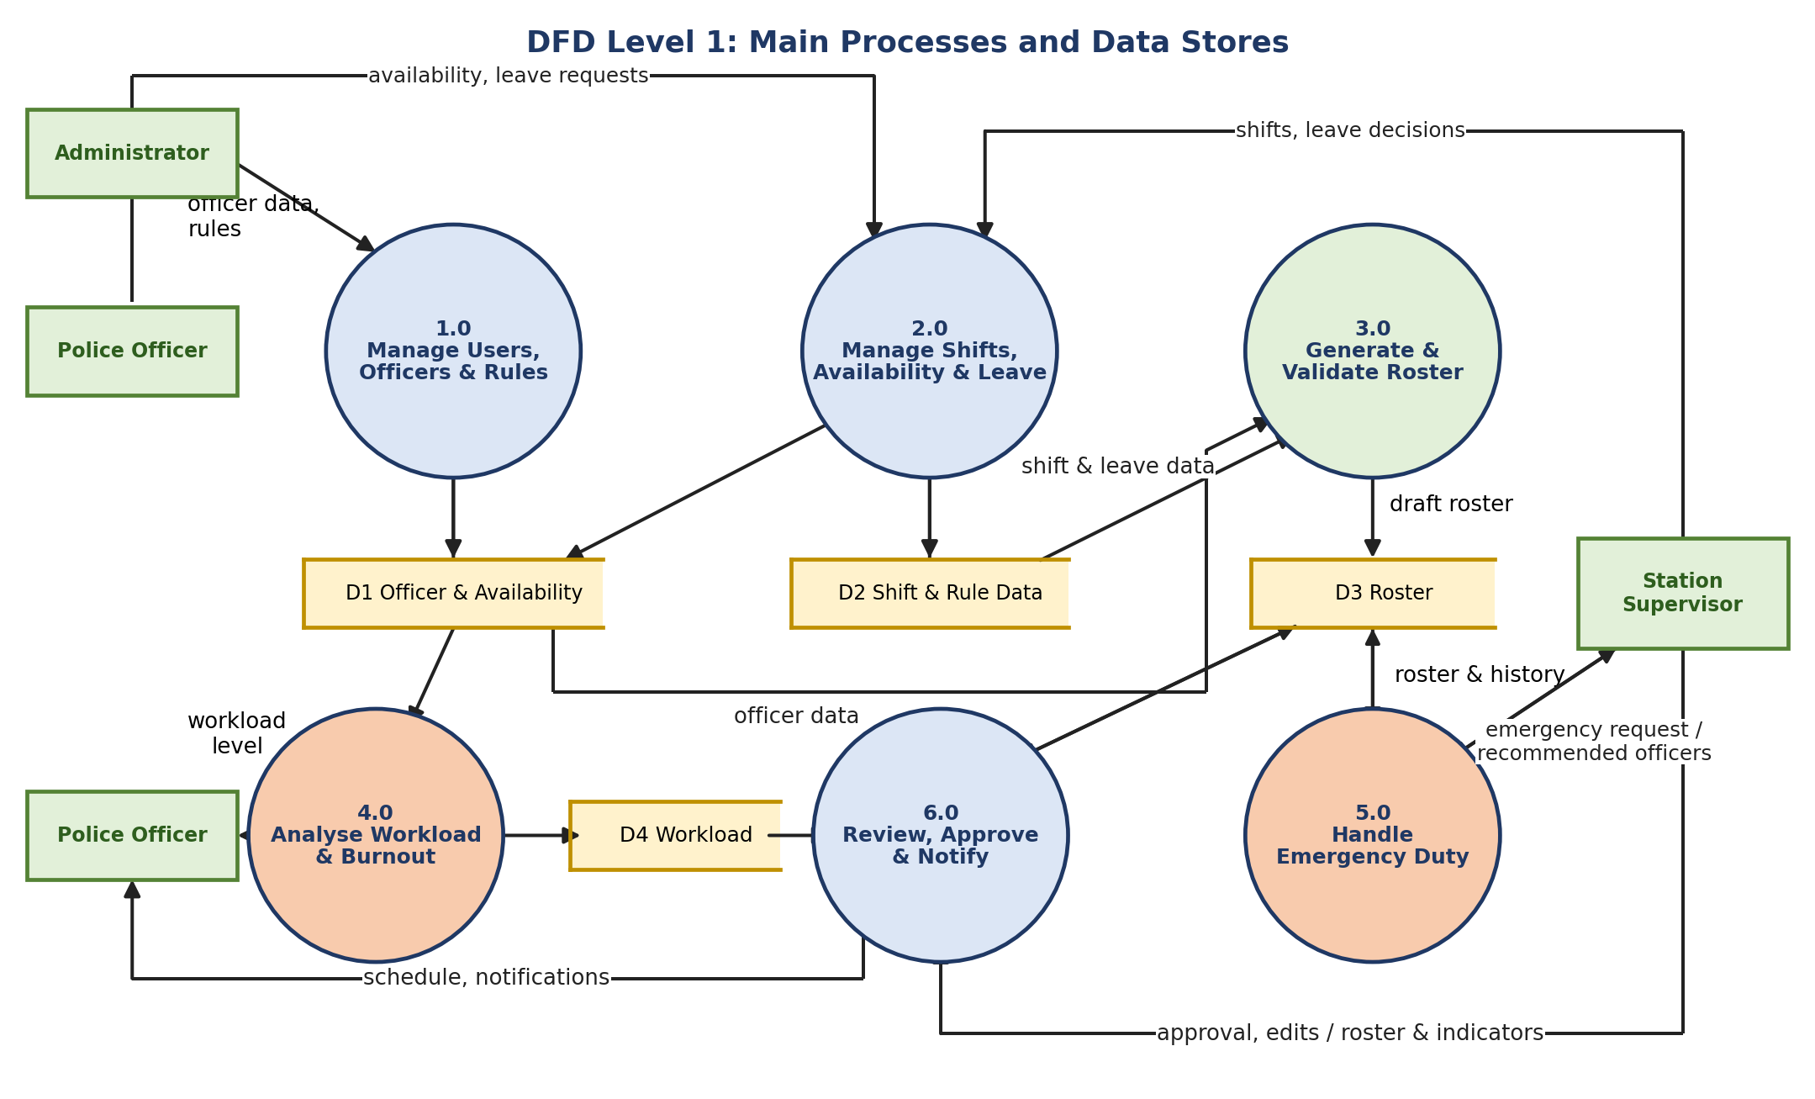
Fig 8.4: DFD level 1
Figure 8.5
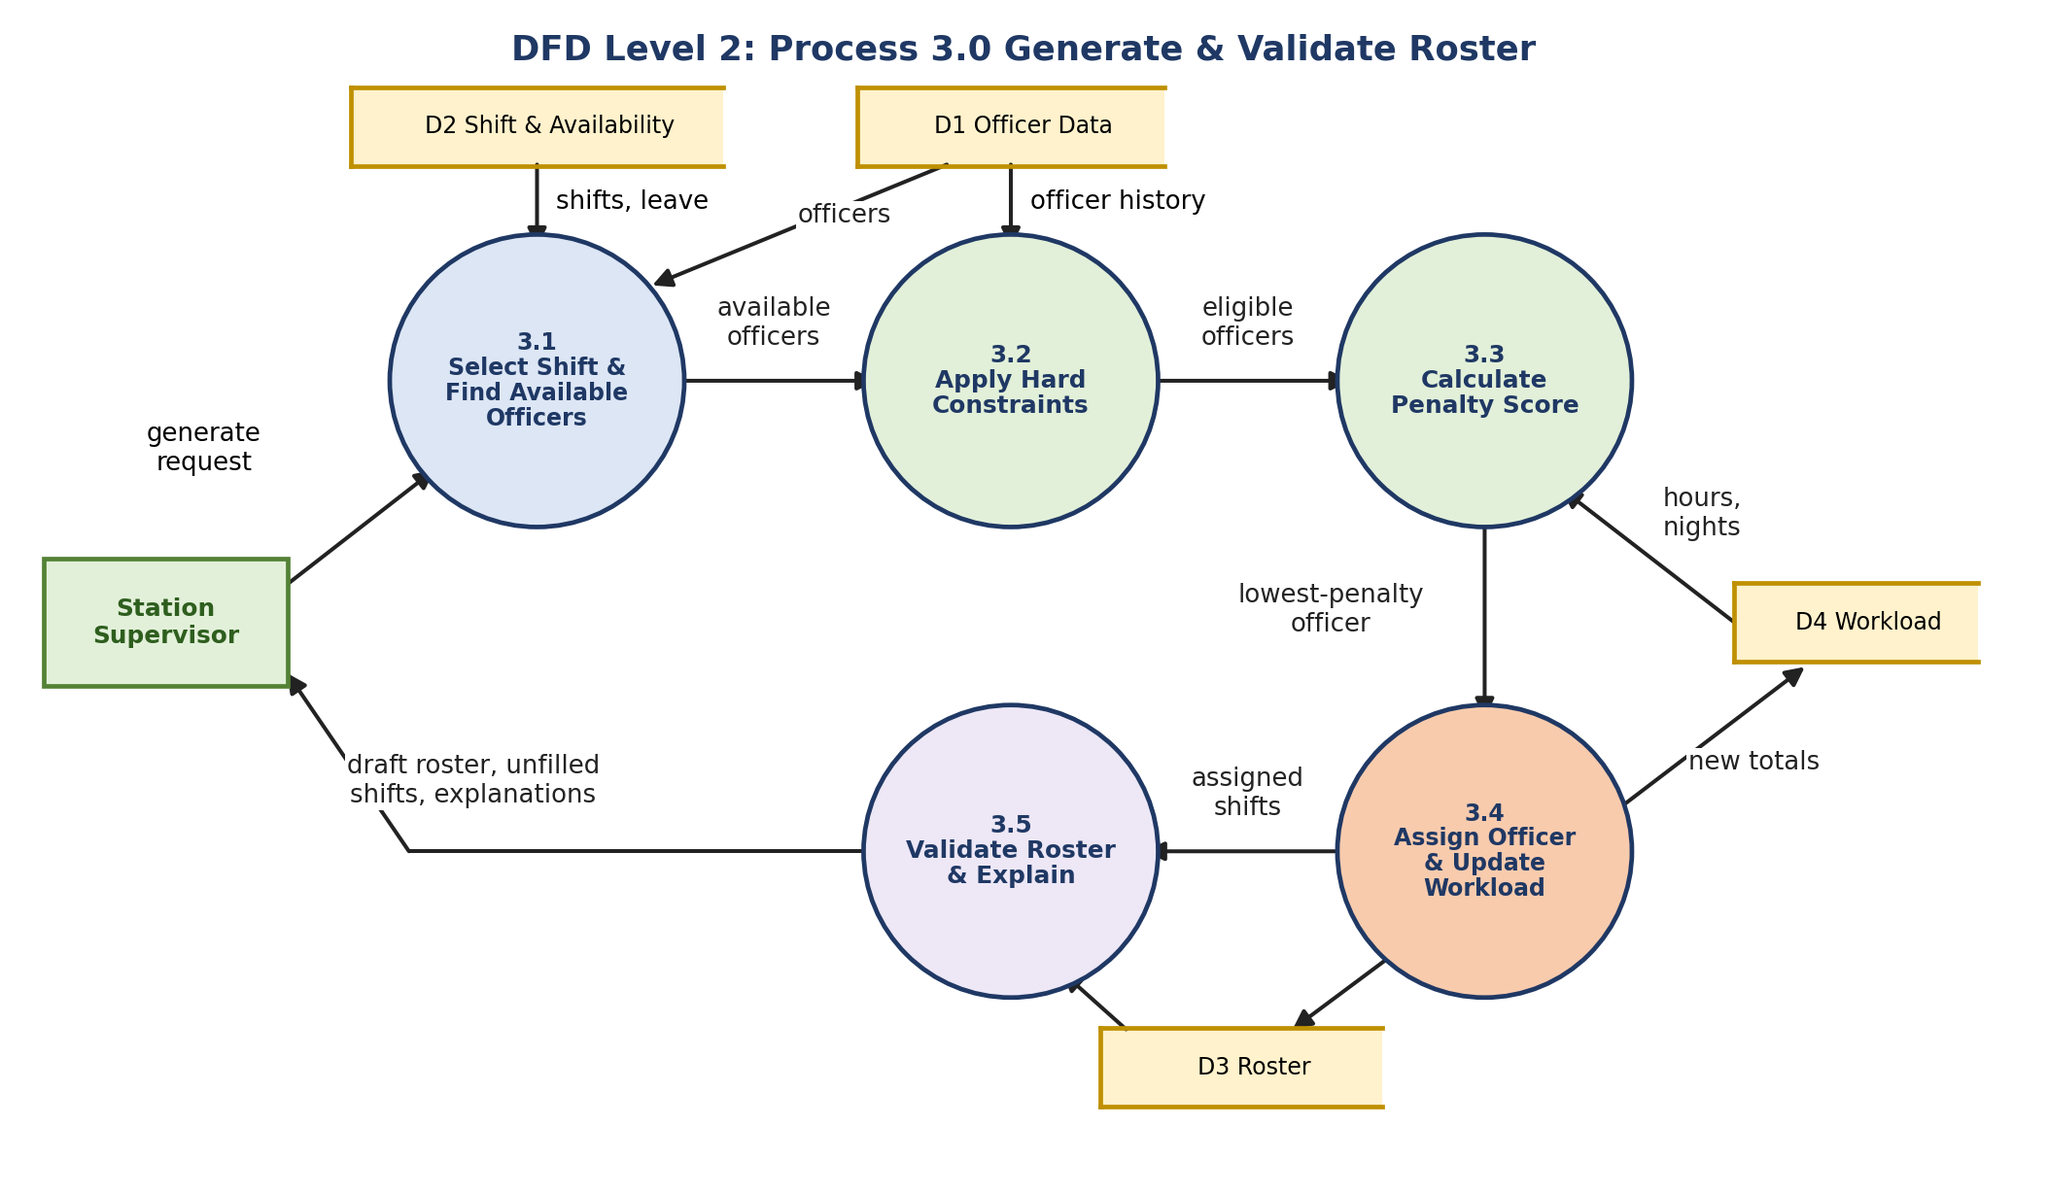
Fig 8.5: DFD level 2 of process 3.0

Roster State Transitions
From | Event | Condition | To
(start) | Supervisor creates roster | Period selected | Draft
Draft | Generate roster | Officers and shifts exist | Under Review
Under Review | Reject | Supervisor not satisfied | Rejected
Rejected | Regenerate | After adjusting data or rules | Draft
Under Review | Approve | No unresolved hard-constraint violation | Approved
Approved | Publish | Supervisor confirms | Published
Published | Emergency or leave change | After publication | Revised
Revised | Re-validate | Changes checked | Under Review
Published | Period ends | Last shift completed | Archived

Leave Request State Transitions
From | Event | Condition | To
(start) | Officer submits | Dates valid | Submitted
Submitted | Send to supervisor | Request valid | Pending Approval
Submitted | Officer cancels | Before sending | Cancelled
Pending Approval | Supervisor approves | Staffing allows | Approved
Pending Approval | Supervisor rejects | Reason recorded | Rejected
Approved | Leave ends | Last leave date passed | Completed

DFD Level 1: Processes
No. | Process | Main inputs | Main outputs
1.0 | Manage Users, Officers & Rules | Officer data, rules | Updated officer and rule data (D1, D2)
2.0 | Manage Shifts, Availability & Leave | Shifts, availability, leave requests, leave decisions | Shift, availability and leave data (D1, D2)
3.0 | Generate & Validate Roster | Officer, shift and leave data | Draft roster (D3), unfilled shifts, explanations
4.0 | Analyse Workload & Burnout | Officer data, assignments | Workload records (D4), workload level and risk
5.0 | Handle Emergency Duty | Emergency request, roster and history | Recommended officers, emergency assignment (D3)
6.0 | Review, Approve & Notify | Roster, workload, edits, approval | Approved roster, schedule and notifications to officers

Balancing and Notes
- Level 0 to Level 1: every flow on the context diagram appears again on level 1. The flows from the Administrator, Supervisor and Police Officer are split among processes 1.0 to 6.0. The system-wide reports for the Administrator are produced by reading D1, D3 and D4 and are not drawn on level 1 to keep the figure readable.
- Level 1 to Level 2: process 3.0 has the inputs generate request, officer data and shift and leave data, and the outputs draft roster, unfilled shifts and explanations. Level 2 shows exactly these flows at its border.
- Duplicate entities: the Police Officer and the Station Supervisor are drawn more than once on level 1 only to avoid crossing lines. They are the same entities.
- Login is left out of the DFDs for clarity. It is described in the use case diagram (Experiment 3).
- Data flow model and control flow model: the DFDs show the data flow model; the state and activity diagrams (Experiment 4 and this experiment) show the control flow model.

Result
Two state diagrams (Roster and LeaveRequest) and three levels of DFD (context, level 1 with six processes and four data stores, level 2 for process 3.0) were prepared.

Conclusion
The state diagram shows that a roster can reach Published only after Review and Approval, so officers never see an unchecked roster. The DFDs show that every input is stored once and reused, and that the scheduling process 3.0 is the only process that creates roster data apart from emergency changes handled by process 5.0.

Experiment 9: Test Cases

Aim
To design a test strategy and realistic test cases for the Automated Police Roster & Burnout Management System covering roster generation, constraints, leave, emergency duty, workload and security.

Objectives
- To understand testing levels: unit, integration, system and acceptance testing.
- To design black-box tests using equivalence classes and boundary-value analysis.
- To link software quality factors (ISO 9126, McCall) and metrics to the project.

Tools Used
Test case templates in Microsoft Word; for execution, Python with pytest for unit tests, and manual testing of the web screens.

Theory
- Unit testing: testing one function in isolation, for example check_min_rest().
- Integration testing: testing modules together, for example Leave Management with Roster Generation.
- System testing: testing the complete system against the requirements, including performance and security.
- Acceptance testing (UAT): the supervisor checks that the system does what is really needed.
- Verification and validation: verification asks “are we building the product right?”; validation asks “are we building the right product?”.
- Boundary-value analysis: errors often occur at the edge of a rule, so values just below, on and just above the limit are tested.

Test Strategy
Test type | What is tested | Example
Unit | Each rule and function alone | Minimum rest check, penalty calculation
Integration | Modules working together | Leave approval updates availability and flags shifts
System / functional | Complete workflows | Generate, review, approve and publish a roster
Boundary-value | Limits of the rules | Rest 9.99 h vs 10 h; hours 48 vs 49
Constraint | Hard constraint enforcement | No assignment ever violates leave or overlap
Algorithm | Selection, tie-break, repeatability | Lowest penalty chosen; same output for same input
Security | Role-based access | Officer cannot edit the roster
User acceptance | Usability for the supervisor | Weekly roster prepared in minutes, not hours

Boundary-Value Tests
Parameter | Rule (example default) | Test values | Expected
Rest between shifts | At least 10 hours | 9.0, 9.99, 10.0, 10.01, 24 | Reject, reject, accept, accept, accept
Weekly hours | At most 48 hours | 47, 48, 49 | Accept, accept, reject
Required officers | 6 required | 5, 6 and 7 eligible officers | 5: unfilled message; 6: filled; 7: lowest-penalty six chosen
Consecutive shifts | Risk rises at 4 and 6 | 3, 4, 5, 6 | Lower, medium, medium, high
The values 10 hours and 48 hours are example defaults. The administrator can configure them.

Sample Unit Test (Python, pytest)
def test_min_rest_boundary():
assert check_min_rest(rest_hours=10.0) is True # exactly on the limit
assert check_min_rest(rest_hours=9.99) is False # just below the limit

def test_lowest_penalty_is_selected():
scores = {'P101': 22, 'P102': 14, 'P103': 26}
assert select_best_officer(scores) == 'P102'

Test Cases
The status column is to be filled in after the tests are executed on the finished system.
ID | Type | Condition / input | Expected result | Status
TC01 | Unit | Officer has approved leave on the shift date | Officer rejected, reason “on leave” | To run
TC02 | Unit | Officer marked unavailable for the shift time | Officer rejected, reason “unavailable” | To run
TC03 | Unit | Officer already assigned to an overlapping shift | Officer rejected, reason “overlap” | To run
TC04 | Boundary | Rest before next shift is exactly 10 hours | Officer accepted | To run
TC05 | Boundary | Rest before next shift is 9 h 59 min | Officer rejected, reason “insufficient rest” | To run
TC06 | Boundary | Weekly hours 40 + new shift 8 h = 48 | Officer accepted | To run
TC07 | Boundary | Weekly hours 40 + new shift 9 h = 49 | Officer rejected, reason “maximum hours exceeded” | To run
TC08 | Constraint | Shift needs an Inspector; no Inspector is eligible | Shift marked Unfilled with a clear message | To run
TC09 | Algorithm | Three eligible officers with penalties 22, 14 and 26 | Officer with penalty 14 is assigned | To run
TC10 | Algorithm | Two officers with equal penalty | Tie broken by lower total hours, then officer ID | To run
TC11 | Algorithm | Same input data used to generate the roster twice | Both rosters are identical | To run
TC12 | Functional | Shift needs 6 officers, only 4 eligible | 4 assigned; message “Required: 6. Available eligible officers: 4.” | To run
TC13 | Functional | View explanation of an assignment | Text lists availability, rest, and lower workload compared with others | To run
TC14 | Workload | Officer with 5 consecutive night shifts and 8 h rest | Risk level High | To run
TC15 | Workload | Officer with 36 h in the week and one night shift | Risk level Low | To run
TC16 | Emergency | Emergency at 11 PM; 3 rested officers | List shown ordered by lowest penalty | To run
TC17 | Emergency | Emergency; every officer fails the rest rule | No list; reason shown for each officer | To run
TC18 | Emergency | Supervisor confirms an emergency officer | Hours and emergency count of that officer increase | To run
TC19 | Override | Supervisor replaces officer with one who gets only 6 h rest | Warning shown before saving | To run
TC20 | Override | Supervisor confirms the override | Change saved and audit log entry created | To run
TC21 | Security | Police Officer opens the roster edit page | Access denied | To run
TC22 | Security | Login with a wrong password | Error shown; no account details revealed | To run
TC23 | Integration | Leave approved after roster was generated | Affected shift flagged for re-check; supervisor notified | To run
TC24 | Integration | Roster published | All assigned officers receive a notification | To run
TC25 | System | Generate a 30-day roster for 40 officers | Roster generated within the agreed time target (e.g. 10 seconds) | To run
TC26 | UAT | Supervisor generates, reviews and publishes a week's roster | Completed without help within the agreed time (e.g. 15 minutes) | To run
TC27 | Functional | Leave request overlaps existing approved leave | Request rejected with an error message | To run
TC28 | Functional | Officer looks for edit controls on the published roster | No edit controls shown (view only) | To run
TC29 | Edge case | Officer becomes unavailable after roster generation | Conflict flagged; replacement suggestions offered | To run
TC30 | Edge case | Two emergencies at the same time | Different officers suggested; no double booking | To run

Figure 9.1
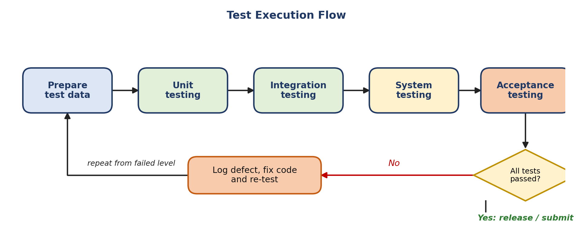
Fig 9.1: Test execution flow

Software Quality (ISO 9126 and McCall)
ISO 9126 describes six quality characteristics. McCall's factors (correctness, reliability, efficiency, integrity, usability, maintainability, flexibility, testability, portability, reusability and interoperability) cover similar ground from the viewpoint of product operation, revision and transition. The table maps them to the project.
Characteristic | Meaning for this project | How it is achieved | Tested by
Functionality | Roster satisfies all hard constraints; only authorised users access data | Constraint validator, role-based access | TC01-TC08, TC21
Reliability | Works consistently; never fails silently | Deterministic algorithm; unfilled-shift messages | TC11, TC12
Usability | Supervisor can review and modify easily | Dashboard, warnings, explanations | TC13, TC26
Efficiency | Roster is produced fast enough | Simple greedy algorithm | TC25
Maintainability | Rules and weights can be changed easily | Rules stored as configuration | Unit tests of PenaltyCalculator
Portability | Runs on any modern browser | Web-based design | System test on two browsers

Software Quality Assurance and Metrics
Metric | Use in the project
Test pass rate | Percentage of the 30 test cases that pass in each sprint.
Constraint violations in generated rosters | Must always be 0; this checks correctness.
Unfilled shifts | Number of shifts that could not be filled; shows staffing problems.
Fairness (standard deviation of weekly hours) | Lower value means more even workload between officers.
High-risk officers | Count of officers in the High risk level after generation; should reduce after supervisor review.
Defect density | Defects found per module, used in sprint retrospectives.
SQA activities include code reviews, running the unit tests before every merge, a test review at every sprint review and keeping the audit log of defects found and fixed. The process is improved sprint by sprint in the retrospectives, in the spirit of CMMI.

Result
A test strategy, boundary-value tests, thirty test cases, a test execution flow and a quality-factor mapping were prepared.

Conclusion
Testing for this system is not only about screens working. The most important tests check that no roster ever breaks a hard rule, that the algorithm gives the same answer every time, and that the supervisor is warned when a manual change creates a risk. The boundary-value tests focus on the limits of rest time and working hours, where mistakes are most likely.

Experiment 10: Case Study
This case study collects the work of the previous experiments in the form of a short project report. Chapter 1 explains the problem and the requirements. Chapter 2 explains the planning, architecture, design and the list of diagrams.

Chapter 1: Introduction and Requirement Analysis
1.1 Background
Software now supports nearly every public service, but many police stations still prepare duty rosters by hand on paper or in a spreadsheet. This is a typical example of software that is needed but missing: the work is repetitive, depends on many rules, and mistakes directly affect people. A poor roster can give one officer too many night shifts, too little rest or too many consecutive duties, and in the long run raises the risk of fatigue and burnout.
1.2 Problem Statement
Manual rostering leads to uneven shifts, consecutive and night duties, too little rest between shifts, leave and availability conflicts, staff shortages, difficulty in finding officers for emergencies, no record of who worked how many hours, and last-minute changes that are hard to manage. A tool is needed that creates a fair, conflict-free and workload-balanced roster automatically, but still lets the supervisor make the final decision.
1.3 Objectives
No. | Objective
1 | To automatically generate a police duty roster from officer, availability, leave and shift data.
2 | To enforce hard constraints (leave, overlap, minimum rest, maximum hours, rank / skill, required strength).
3 | To balance workload fairly using a penalty score for night, consecutive, weekend and emergency duties.
4 | To calculate a workload / burnout risk indicator (Low, Medium, High) for every officer.
5 | To recommend suitable officers quickly for emergency duty and update their workload.
6 | To keep the supervisor in control with explanations, warnings on overrides, approval, notifications and an audit log.
1.4 Scope
In scope | Out of scope
Roster generation, validation and explanation | Payroll and salary calculation
Leave, availability and shift management | Real-time GPS tracking of officers
Workload and burnout risk indicator | Medical diagnosis of any kind
Emergency duty recommendation | Dispatching of vehicles or case management
Supervisor override, approval and audit log | Complex AI / machine learning prediction
The burnout indicator is a workload warning based on rules. It is not a medical diagnosis.
1.5 Stakeholders
Stakeholder | Interest
Station Supervisor | Needs a fair, valid roster quickly and wants control over the final decision.
Police Officer | Wants fair shifts, visible schedule, rest and the ability to give availability and leave.
Administrator | Maintains data and rules for the department.
Senior police management | Wants transparent, auditable staffing and less officer fatigue.
Development team and guide | Wants a correct, testable and well-documented system.
1.6 Functional Requirements
ID | Requirement | Priority
FR1 | Role-based login for Administrator, Station Supervisor and Police Officer. | Must
FR2 | Administrator manages users, officers, ranks, departments and station information. | Must
FR3 | Administrator configures rules (maximum hours, minimum rest, penalty weights) and shift types. | Must
FR4 | Officers submit availability; supervisor can record it. | Must
FR5 | Officers apply for leave; supervisor approves or rejects. | Must
FR6 | Supervisor creates shifts with date, type, time, required officers, rank / skill and priority. | Must
FR7 | System generates a roster using hard-constraint filtering and penalty scoring. | Must
FR8 | System rejects any assignment that breaks a hard constraint. | Must
FR9 | System reports unfilled shifts with required and available numbers. | Must
FR10 | System explains why each officer was assigned. | Should
FR11 | System calculates workload indicators and a Low / Medium / High risk level for each officer. | Must
FR12 | System recommends eligible officers for emergency duty and updates workload after assignment. | Must
FR13 | Supervisor can view, modify, replace and manually assign officers. | Must
FR14 | System warns when a manual change breaks an important rule. | Must
FR15 | Supervisor approves and publishes the roster. | Must
FR16 | System notifies officers about roster changes. | Should
FR17 | Officers view their schedule, duty history, hours and workload level. | Should
FR18 | Supervisor dashboard shows KPIs and charts. | Should
FR19 | System keeps an audit log of important changes. | Should
FR20 | Reports on workload, staffing and shift distribution. | Could
1.7 Non-Functional Requirements
Quality | Requirement
Correctness | The roster must satisfy all mandatory constraints.
Fairness | Workload should be as evenly distributed as possible (measured by standard deviation of hours).
Explainability | Every assignment has a stored, readable reason.
Reliability | Roster generation gives the same result for the same input and never fails silently.
Security | Role-based access, password protection, officers cannot edit the roster.
Scalability | Works for a small police station and can grow to a larger department.
Maintainability | Rules and weights are configuration, not hard-coded.
Usability | A supervisor can understand and modify a roster without training in scheduling.
Auditability | Important changes (overrides, emergency assignments, approvals) are logged.
Performance | A monthly roster for a station of about 40 officers is generated within a few seconds (target).
1.8 Hard and Soft Constraints
Hard constraints must never be violated. An assignment that breaks one of them is rejected. Soft constraints are preferences that are scored as a penalty; a lower penalty is better.
Hard constraints (reject) | Soft constraints (penalty)
Officer on leave cannot be assigned | Spread night shifts fairly
Unavailable officer cannot be assigned | Avoid many consecutive shifts
No overlapping shifts | Balance total working hours
Minimum rest must be kept | Balance weekend duties
Maximum working hours must not be exceeded | Avoid repeated emergency duty for the same officer
Required rank / skill must be present | Consider officer preferences
Shift must get the required number of officers | Reduce workload imbalance and burnout risk
1.9 Scheduling Algorithm: Greedy Rule-Based with Penalty Scoring
For every shift the system (1) finds available officers, (2) removes officers who violate hard constraints, (3) calculates a penalty for each remaining officer, (4) selects the officer with the lowest penalty, (5) assigns the officer and (6) updates workload and history. The score is explainable because it is a plain weighted sum:
Penalty = 2 x (weekly hours / 8) + 3 x (night shifts in last 7 days) + 4 x (consecutive shifts) + 2 x (emergency duties in last 30 days) + 1 x (weekend duties this month)
The weights above are example values; the administrator can change them.
Worked example. Shift S104 is a night shift that needs one officer. Officer P104 would have only 6 hours of rest, so the hard constraint rejects P104. Three officers remain:
Officer | Weekly hours | Nights (7 d) | Consecutive | Emergency (30 d) | Weekend | Penalty
P101 | 40 | 1 | 2 | 0 | 1 | 22
P102 | 32 | 0 | 1 | 1 | 0 | 14
P103 | 24 | 2 | 3 | 0 | 2 | 26
P102 has the lowest penalty (14) and is assigned. The system stores this explanation: “Officer P102 was assigned because they were available, had sufficient rest, had lower weekly workload and fewer recent night shifts than the other eligible officers.”
1.10 Burnout / Workload Risk Indicator
Points are added for risk signs and the total decides the level. The limits below are example values that the administrator can change.
Indicator | Medium sign (+1) | High sign (+2)
Weekly working hours | over 40 | over 48
Night shifts in last 7 days | 2 or 3 | 4 or more
Consecutive shifts | 4 or 5 | 6 or more
Rest before next shift | none | under 10 hours
Emergency duties in last 14 days | 3 or more | -
Total points: 0 to 2 = Low, 3 to 4 = Medium, 5 or more = High.
1.11 Important Edge Cases
Case | Expected behaviour
Not enough officers available | Shift marked Unfilled; message states required and eligible numbers
Too many officers on leave | Supervisor warned about the staffing shortage
Officer becomes unavailable after generation | Conflict flagged; replacement suggested
Emergency after publication | Emergency module recommends officers; roster status becomes Revised
Required rank / skill unavailable | Shift stays Unfilled and the reason is shown
Multiple emergency duties | Different officers recommended; no double booking
Supervisor creates a conflict manually | Warning shown; override recorded with a reason in the audit log

Chapter 2: Planning, Design and Diagrams
2.1 Feasibility Study
Feasibility | Assessment
Technical | The scheduling logic is a deterministic rule-based algorithm that can be written in Python. Web technologies (React or HTML / JavaScript, Flask or FastAPI) and databases (PostgreSQL or SQLite) are mature and well documented. No complex AI is required.
Economic | All the proposed tools are free and open source (see table in 2.2). No licence cost; the system can run on an ordinary computer.
Operational | The workflow follows what supervisors do already, but with automation. Supervisors keep the final decision, which reduces resistance to change.
Schedule | A 15-week plan with five sprints is realistic for a small team (see 2.3).
Legal / ethical | Officer data is personal and sensitive, so role-based access and audit logging are required. The burnout indicator is clearly stated as a workload warning, not a medical diagnosis.
2.2 Technology Stack and Cost
Part | Choice (can be finalised later) | Cost
Frontend | React or HTML / CSS / JavaScript | Free, open source
Backend | Python with Flask or FastAPI | Free, open source
Database | PostgreSQL, MySQL or SQLite | Free, open source
Scheduling engine | Python | Free, open source
Charts | Chart.js or Recharts | Free, open source
Tools | VS Code, Git / GitHub, pytest | Free
2.3 Project Schedule
The schedule follows the sprint plan of Experiment 2. Weeks 1 to 3 are used for requirements and design and the five sprints deliver the working system (Figure 10.1).

Figure 10.1
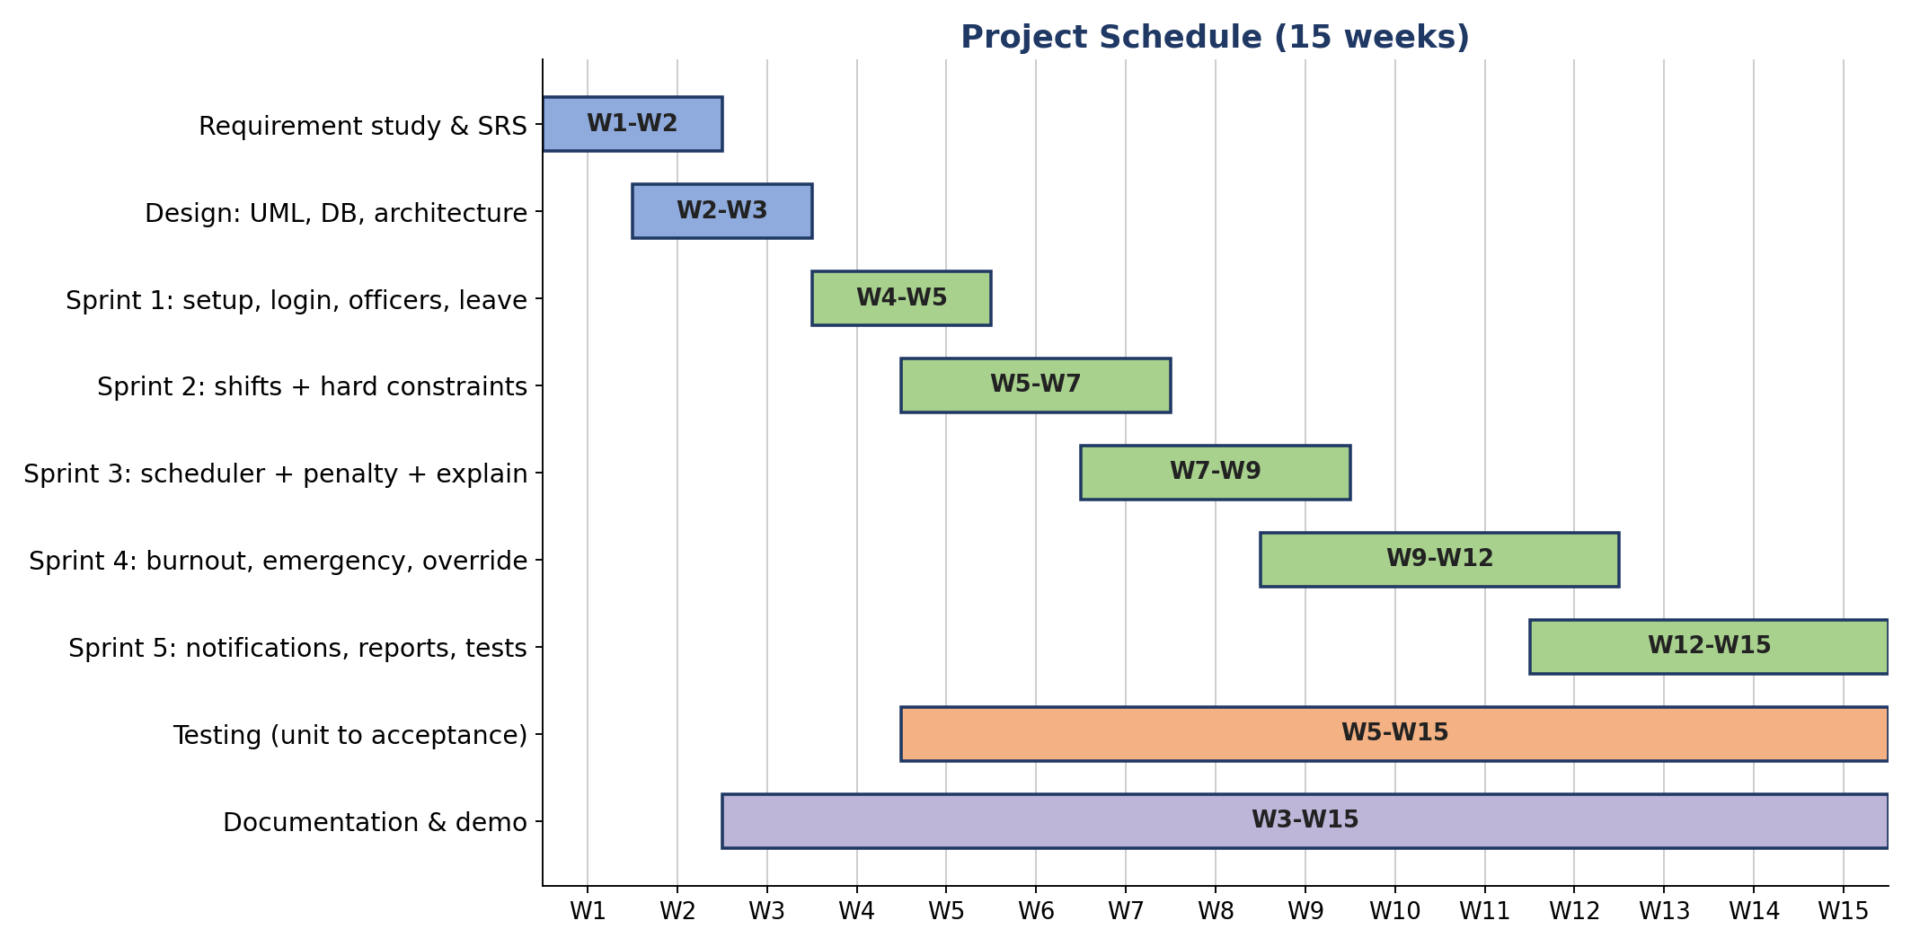
Fig 10.1: Project schedule (15 weeks)
Figure 10.2
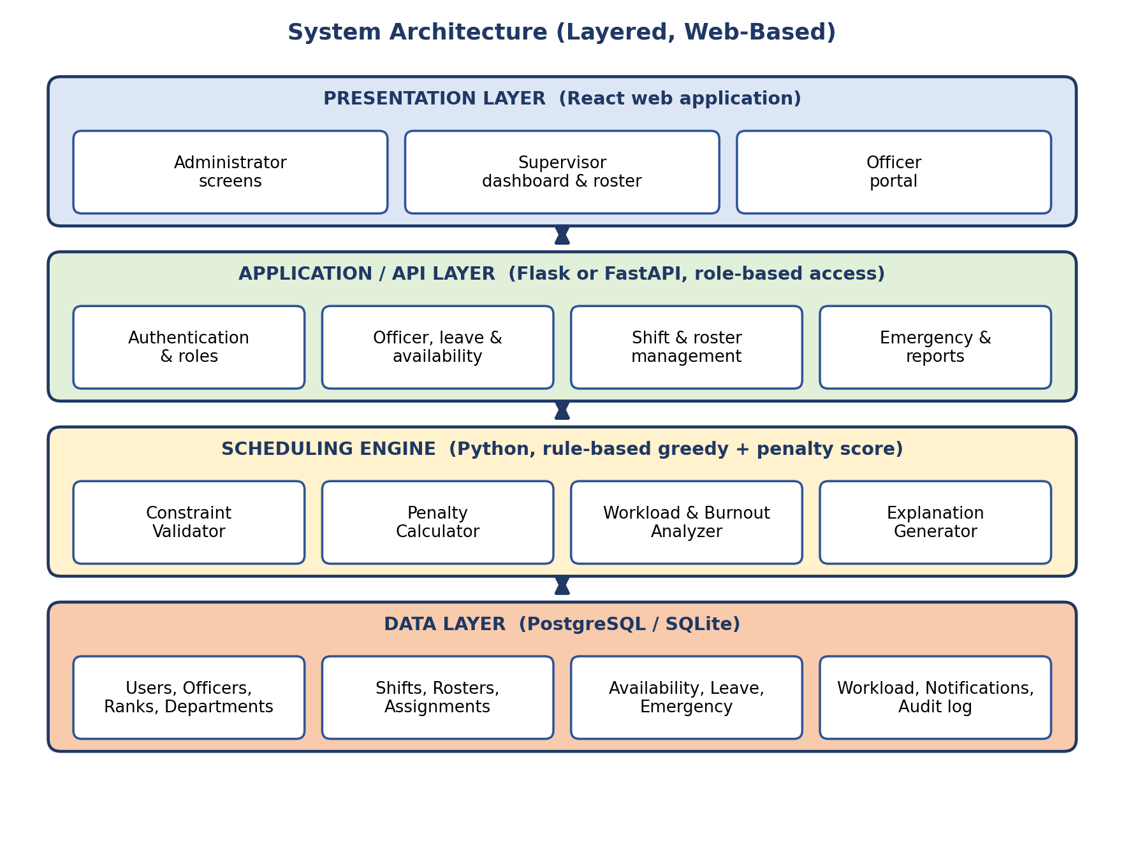
Fig 10.2: Layered system architecture

2.4 Architectural Design
The system uses a layered architecture (Figure 10.2). The presentation layer shows the three role-based screens. The application layer provides the REST API and enforces role-based access. The scheduling engine is a separate Python component containing the validator, the penalty calculator, the burnout analyser and the explanation generator. The data layer stores all entities. Keeping the engine separate means the rules can be tested and changed without touching the screens.
2.5 Data Design
The main entities are User, Officer, Rank, Department, Shift, Roster, RosterAssignment, Availability, LeaveRequest, EmergencyDuty, WorkloadRecord, Notification and AuditLog. Their attributes and multiplicities are shown in the class diagrams (Figures 5.1 and 5.2). Important relationships: one Officer has many RosterAssignments, many LeaveRequests, many Availability records and many EmergencyDuties; one Roster has many RosterAssignments. Each RosterAssignment stores the penalty score and the reason, and the AuditLog stores every override, approval and emergency assignment.
2.6 User Interface Design
The interface follows the three golden rules: place the user in control (the supervisor can always edit and override), reduce the user's memory load (colour-coded warnings and explanations are shown on screen) and make the interface consistent (the same layout, colours and terms in every screen). Warning colours follow one rule: green for safe, amber for a caution, red for a rule violation or high risk.
Screen | User | Main contents
Login | All | User ID, password, role-based redirection
User and officer management | Administrator | Add and edit users, officers, ranks, units, skills
Rules and shift types | Administrator | Maximum hours, minimum rest, penalty weights, shift types
Supervisor dashboard | Supervisor | KPIs: total officers, available, on leave, shifts today, unfilled shifts, average workload, high-risk officers, emergency duties, conflicts; charts of workload, night shifts and risk
Roster grid | Supervisor | Weekly grid by officer and day, colour-coded warnings, explanation on click, replace and assign buttons, approve and publish
Emergency panel | Supervisor | Emergency details, ranked list of eligible officers with reasons, confirm button
Leave approval | Supervisor | Pending requests, staffing impact, approve and reject
My schedule | Officer | Assigned shifts, calendar, duty history, hours, workload level, notifications
Availability and leave | Officer | Submit availability, apply for leave, request status
2.7 Software Quality and Testing
Quality factors, metrics and thirty test cases are given in Experiment 9. The key quality goals are correctness (no hard-constraint violation), fairness, explainability and auditability.
2.8 Risks and Mitigation
Risk | Mitigation
Greedy algorithm gives a locally good but not a perfect roster | Supervisor review and override; later versions can try improved search methods
Penalty weights feel unfair | Weights are configurable and tuned in sprint reviews with sample data
Not enough officers to fill all shifts | Clear unfilled-shift messages and staffing warnings
Sensitive officer data exposed | Role-based access, authentication, audit log
Scope creep | MoSCoW priorities and the sprint backlog
2.9 List of Diagrams in This File
Figure | Diagram | Experiment
Fig 2.1 | Scrum process | 2
Fig 3.1 | Use case diagram | 3
Fig 4.1 to 4.3 | Activity diagrams: roster generation, emergency duty, leave | 4
Fig 5.1 to 5.3 | Class diagrams: people, roster data, service classes | 5
Fig 6.1 to 6.3 | Sequence diagrams | 6
Fig 7.1 to 7.3 | Collaboration diagrams | 7
Fig 8.1, 8.2 | State diagrams: roster, leave request | 8
Fig 8.3 to 8.5 | DFD level 0, 1 and 2 | 8
Fig 9.1 | Test execution flow | 9
Fig 10.1, 10.2 | Project schedule, system architecture | 10

Result
The case study combines the problem statement, objectives, scope, requirements, algorithm, risk indicator, feasibility, architecture, interface design and the list of all diagrams of the project in one report.

Conclusion
The Automated Police Roster & Burnout Management System is technically feasible with free tools and a deterministic algorithm, and it addresses a real problem. Its strength is the combination of automation, hard-constraint checking, fair workload balancing, burnout risk indicators, emergency allocation, explainability and supervisor control. The set of requirements, UML models, DFDs, test cases and plans in this file is a complete base for the implementation.

