Basic Programming

1. What is the data-type usually used in arithmetic operation?

Answer: int, long, float, double

2. What is the data-type usually used in word and character?

Answer: string, char

3. What is the output of code below

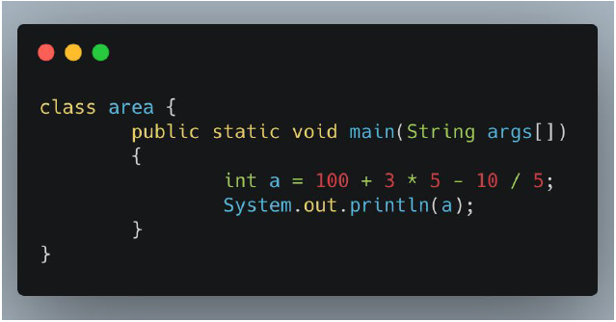

Answer: 113

4. What is the output of code below

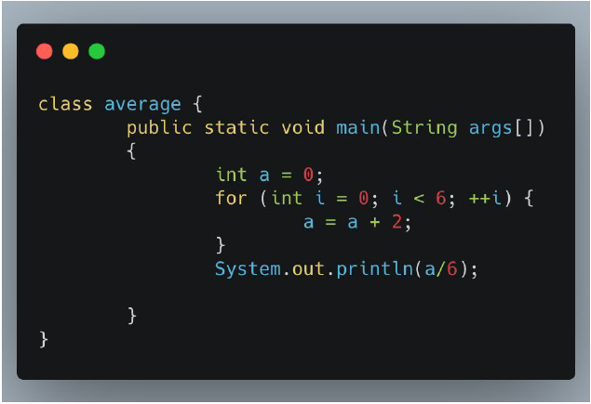

Answer: 2

5. What is the output of code below

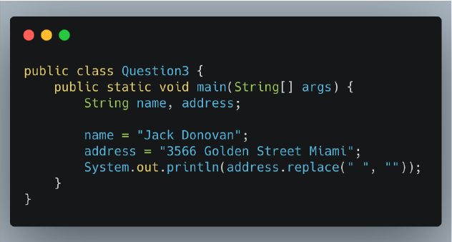

Answer: 3566GoldenStreetMiami

Flaky Test

1. What is a flaky test?

Answer: Flaky test is a test that passes and fails periodically or it can be called intermittent, without any differences or changes from the code developer side. Usually this is due to inaccurate testing time with the deployment of the dev machine to the test machine.

2. An element in a website is using ajax/javascript to show the data (processed as asynchronous). What do you do to test that element?

Answer: test with asynchronous too, put the code asynchronous at automation testing just like “wait until message box showed up” or “ wait 30 secs”

3. A website page can only be accessed with CAPTCHA. How do you test that page?

Answer: If im a manual tester, just write the answer on Captcha or click on the Captcha, meanwhile if im a automation tester I will talk to developer to turn off the Captcha at machine test, because the Captcha cannot be tested automation.

Essay Question Topic

We would be very appreciated if you answer the questions below by not using Katalon and

Postman

1. Create automation test script to test these end-point:

a. GET -> https://jsonplaceholder.typicode.com/posts -> To make sure this

end-point have a correct data-type below:

■ userId -> Integer

■ id -> Integer

■ title -> String

■ body -> String

Answer : 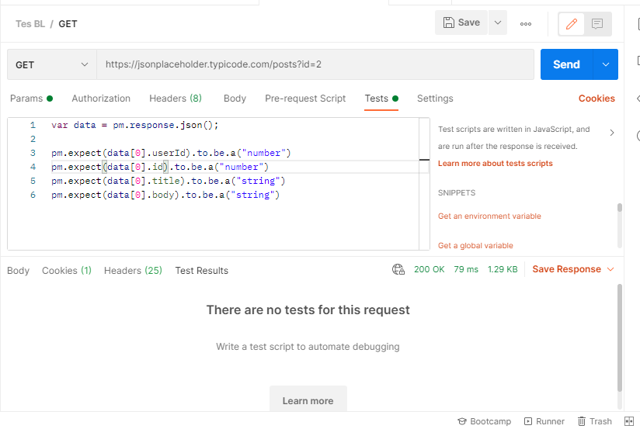

b. POST -> https://jsonplaceholder.typicode.com/posts -> To make sure this

end-point get a correct response compare with the input data:

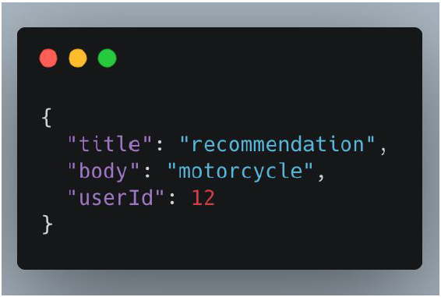

Answer: 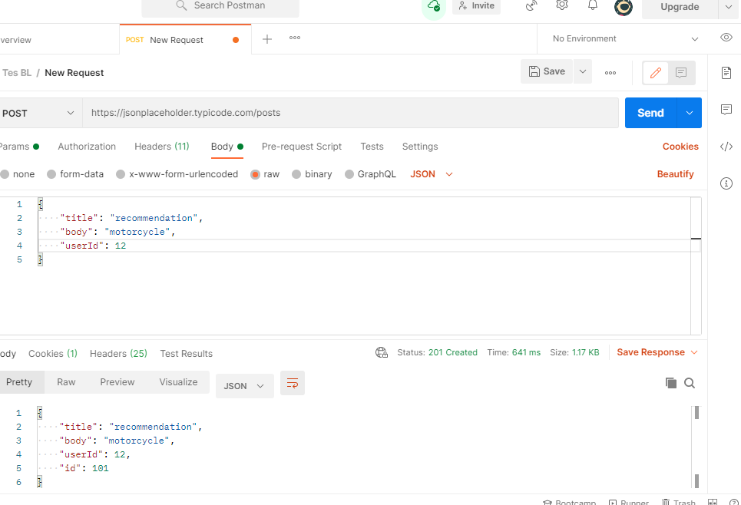

2. Create automation test script to test 1 of these scenarios using Bukalapak website:

a. Register

b. Login

c. Add to Cart

d. Search Product

3. Download this apk:

https://apkpure.com/sample-android-app-login-test/com.loginmodule.learning/download?

from=details

Create and automation test (positive and negative)for apps with 1 of these scenarios:

a. Register

b. Login