A Major Project Stage-I Report On

MULTILINGUAL NEWS GENERATION TEXT TO ENGAGING
VIDEO CONTENT
Submitted to CMREC (UGC Autonomous), Affiliated to JNTUH In Partial Fulfillment of the requirements for the Award of Degree of

BACHELOR OF TECHNOLOGY IN
COMPUTER SCIENCE AND ENGINEERING (AI&ML)

Submitted By

A S SIDHARTHA (218R1A6601)
DANDU NAGARAJU (218R1A6610) NOOKA HARSHAVARDHAN (218R1A6642) P VENKAT KRISHNA LOKESH (218R1A6643)
Under the Esteemed guidance of

Mr. R.S. Panda
Assistant Professor, Department of CSE (AI & ML)


Department of Computer Science & Engineering (AI&ML)
CMR ENGINEERING COLLEGE
UGC AUTONOMOUS
(Approved by AICTE, NEW DELHI, Affiliated to JNTU, Hyderabad, Kandlakoya, Medchal Road, R.R. Dist. Hyderabad-501 401)
2024-2025

CMR ENGINEERING COLLEGE

UGC AUTONOMOUS
(Accredited by NBA, Approved by AICTE NEW DELHI, Affiliated to JNTU, Hyderabad) Kandlakoya, Medchal Road, Hyderabad-501 401
Department of Computer Science & Engineering (AI & ML)

CERTIFICATE

This is to certify that the project entitled “Multilingual News Generation Text to Engaging Video Content ” is a bonafide work carried out by

A S SIDHARTHA (218R1A6601)
DANDU NAGARAJU (218R1A6610) NOOKA HARSHAVARDHAN (218R1A6642) P VENKAT KRISHNA LOKESH (218R1A6643)
in partial fulfillment of the requirement for the award of the degree of BACHELOR OF TECHNOLOGY in COMPUTER SCIENCE AND ENGINEERING (AI&ML) from
CMR Engineering College, under our guidance and supervision.

The results presented in this project have been verified and are found to be satisfactory. The results embodied in this project have not been submitted to any other university for the award of any other degree or diploma.

Internal Guide | Major Project Coordinator | Head of the Department
Mr. R.S. Panda | Mr. G. Venkateswarlu | Dr. M. Kumara Swamy
Assistant Professor | Assistant Professor | Professor & HOD
CSE (AI&ML) | CSE (AI&ML) | CSE (AI&ML)

DECLARATION
This is to certify that the work reported in the present Major project entitled “MULTILINGUAL NEWS GENERATION TEXT TO ENGAGING VIDEO CONTENT” is a record of bonafide work done by us in the Department of Computer Science and Engineering (AI&ML) , CMR Engineering College. The reports are based on the project work done entirely by us and not copied from any other source. We submit our project for further development by any interested students who share similar interests to improve the project in the future.
The results embodied in this Major project report have not been submitted to any other University or Institute for the award of any degree or diploma to the best of our knowledge and belief.

A S SIDHARTHA (218R1A6601)
DANDU NAGARAJU (218R1A6610)
NOOKA HARSHAVARDHAN (218R1A6642)
P VENKAT KRISHNA LOKESH (218R1A6643)

ACKNOWLEDGMENT

We are extremely grateful to Dr. A. Srinivasula Reddy, Principal and Dr. M. Kumara Swamy, HOD, Department of CSE (AI & ML), CMR Engineering College for their constant support.

We are extremely thankful to Mr. R.S. Panda, Assistant Professor, Internal Guide, Department of CSE (AI & ML), for his constant guidance, encouragement and moral support throughout the project.
We will be failing in duty if we do not acknowledge with grateful thanks to the authors of the references and other literatures referred in this Project.

We thank Mr. G. Venkateswarlu, Major Project Coordinator for his constant support in carrying out the project activities and reviews.

We express our thanks to all staff members and friends for all the help and co-ordination extended in bringing out this project successfully in time.

Finally, We are very much thankful to our parents who guided us for every step.

A S SIDHARTHA (218R1A6601)
DANDU NAGARAJU (218R1A6610)
NOOKA HARSHAVARDHAN (218R1A6642)
P VENKAT KRISHNA LOKESH (218R1A6643)

CONTENTS

TOPIC | PAGE NO
ABSTRACT | I
LIST OF FIGURES  LIST OF TABLES | II III

- INTRODUCTION 1
  - Introduction & Objectives 1
  - Purpose of the project 2
  - Existing System with Disadvantages 4
  - Proposed System with Features 5
2 . LITERATURE SURVEY 9
- SOFTWARE REQUIREMENT ANALYSIS 11
  - Modules and their Functionalities 11
  - Feasibility Study 12
- SOFTWARE AND HARDWARE REQUIREMENTS 14
  - Requirements 14
  - Hardware Requirements 14
- SYSTEM ARCHITECTURE 15
  - System Architecture 15
  - UML Diagrams 15-18

- CODING AND IMPLEMENTATION 19
  - Implementation 19
    - Introduction to Python 19
    - Machine Learning 22
    - Categories of Machine Learning 23
    - Need of Machine Learning 23
    - Challenges in Machine Learning 24
  - Project Methodology 29
    - Data Collection and Preprocessing 29
    - Text Summarization and classification 30
    - Text to speech 30
    - Image and video Generation 30
    - Anchor Lip-Sync Integration 30
    - Multilingual support Implementation 30
    - Web platform development and deployment 31
- CONCLUSION 57
- FUTURE ENHANCEMENTS 58

- REFERENCE 60

ABSTRACT

ABSTRACT

Multilingual news generation has emerged as a powerful solution to enhance content delivery across diverse audiences. This project presents a system designed to convert text-based news content into engaging video presentations. Leveraging advanced Natural Language Processing (NLP) techniques, the system extracts, classifies, and summarizes content from various sources such as government press releases and online news platforms. To ensure accessibility, the summarized text is converted into speech, supported by carefully selected visual content presented in a slideshow format. Additionally, a virtual anchor powered by lip-sync technology enhances engagement by delivering the content in a realistic and interactive manner. The system offers customization options, allowing users to select preferred languages, anchor types, and content categories. By addressing key challenges such as multilingual support, accurate summarization, and visual storytelling, this project aims to improve the accessibility, engagement, and understanding of news content.
The system is built with a focus on high-quality multilingual content generation, ensuring seamless adaptation to diverse linguistic regions. It employs state-of-the-art translation and speech synthesis models to maintain accuracy and naturalness in multiple languages. Additionally, the integration of dynamic visual storytelling elements enhances user engagement, making news consumption more interactive. To further improve accessibility, the project incorporates a personalization engine that tailors content based on user preferences and viewing history. By combining cutting-edge AI techniques with intuitive content presentation, this system redefines how news is delivered and consumed in a globalized digital landscape.

9
 | LIST OF FIGURES
FIG.NO | DESCRIPTION | PAGE NO
1.4.1 | Web Scraping Flowchart | 5
5.1 | System Architecture | 15
5.2 | Sequence diagram | 16
5.3 | Class diagram | 17
5.4 | Activity diagram | 18
8.1 | Working of video generation in VS Code | 47
8.2 | Execution of Modules | 47
8.3 | Output Video | 48
8.4 | Website with sports news | 48
8.5 | Website with latest news | 49
 | II

 | LIST OF TABLES
TABLE .NO | DESCRIPTION | PAGE NO
7.1 | Test cases | 53

INTRODUCTION

INTRODUCTION AND OBJECTIVES

In today's fast-paced digital landscape, the consumption of news has evolved significantly. As people seek quick and engaging content, traditional text-based news formats often struggle to retain audience attention. To bridge this gap, our project introduces a Multilingual News Generation System that transforms text-based content into engaging video presentations. This innovative approach combines Natural Language Processing (NLP), speech synthesis, and visual storytelling to enhance content delivery across diverse audiences.
The system is designed to process various content sources such as government press releases, online news platforms, and general news articles. Leveraging advanced NLP models, the system classifies and summarizes the extracted content, ensuring concise yet impactful delivery. To improve accessibility, the summarized text is converted into voice output, with users offered the flexibility to choose between male and female anchors. The inclusion of a slideshow feature enriches the viewing experience, enhancing visual engagement and improving information retention.
A key objective of the project is to provide content in multiple languages to cater to a broader audience. As of now, the system supports three languages, with plans to expand further. By ensuring multilingual support, the project aims to make news accessible to diverse linguistic communities, promoting inclusivity and awareness.
Another core objective is to enhance user personalization. Users can select their preferred language, anchor type, and content category to tailor their experience. This ensures that the system not only informs but also entertains its audience through engaging visuals and realistic virtual anchors using lip-sync technology.
Furthermore, the system is designed with scalability in mind, ensuring it can handle large volumes of news data efficiently. By automating content collection, summarization, and multimedia creation, the system minimizes manual intervention and accelerates the content production process.

PURPOSE OF THE PROJECT
The primary purpose of this project is to revolutionize the way news content is consumed by transforming text-based news into engaging, visual, and interactive video content. Traditional news formats often struggle to retain viewer attention, particularly in a fast-paced digital era where users prefer concise and engaging media. This project aims to address this gap by delivering news in a format that is both informative and visually captivating.
One of the key objectives is to improve accessibility. By supporting multiple languages, the system ensures that users from diverse linguistic backgrounds can access important news updates in their preferred language. This multilingual support is particularly crucial in regions with diverse populations, where language barriers often limit access to accurate information.
Another core goal is to enhance engagement. By incorporating a virtual anchor with realistic lip-sync technology, the system presents news in a more interactive and human-like manner. This feature not only attracts viewers but also makes the content easier to follow, especially for audiences who prefer visual and auditory learning.
The project also addresses the need for content customization. Users can personalize their experience by selecting their preferred language, anchor type, and content category. This flexibility ensures that users receive news tailored to their interests, promoting user satisfaction and improved retention.
In addition the system aims to streamline the content creation process. By automating tasks such as text summarization, voice synthesis, and video generation, the system minimizes manual effort while ensuring fast and efficient content production. This automation is particularly valuable for news agencies, educators, and social media platforms seeking to deliver content rapidly.
The system is also designed to support educational initiatives by simplifying complex topics through

visual storytelling. By converting educational content, government updates, or public awareness campaigns into engaging videos, the system can improve understanding and knowledge retention among viewers.
Furthermore, the project addresses the growing need for digital content marketing. By generating dynamic video content from text-based sources, businesses, media houses, and educational institutions can create compelling content that attracts and retains viewers on websites and social media platforms.
The project also aims to improve content filtering by allowing users to select specific news categories such as politics, health, sports, or technology. This ensures users receive content that matches their interests, improving the overall viewing experience.
By incorporating user-centered design principles, the system ensures intuitive navigation, personalized content delivery, and improved accessibility for users across different age groups and technological backgrounds.
Lastly, this project seeks to drive social impact by improving access to verified, summarized news content that is free from misinformation. By promoting reliable information through engaging formats, the system aims to educate, inform, and empower viewers globally.
Overall, this project strives to create an innovative, inclusive, and scalable solution for modern news consumption, enhancing both accessibility and engagement across diverse user groups.

EXISTING SYSTEM AND DISADVANTAGES

Several existing solutions address text summarization, text-to-video generation, and automated content delivery. While these systems offer valuable features, they also have significant limitations that our project aims to overcome by providing a more comprehensive, engaging, and accessible solution.
Inshorts is a widely recognized platform that specializes in delivering concise news summaries. It is designed to provide users with quick and clear updates on current events, making it an efficient tool for information consumption. However, despite its effectiveness in text-based summarization, Inshorts has notable limitations. It focuses solely on text-based content, which limits engagement for users who prefer visual or interactive media. The absence of audio and video components reduces the platform’s appeal to a broader audience, particularly those who consume content through auditory or visual means. Additionally, Inshorts provides uniform summaries without extensive customization based on user preferences or regional language support.
Deep Brain AI is a sophisticated text-to-video generation platform that utilizes artificial intelligence to create realistic avatars with automated lip-sync technology. It effectively transforms textual content into engaging video presentations. However, it has several limitations. The platform lacks the ability to integrate images into the video, restricting its potential for storytelling through visuals. It also supports a limited number of languages, making it less effective for multilingual content delivery. While the avatars enhance engagement, there are limited customization options for voice, tone, and delivery style to cater to different audience preferences.
Text2AV is an advanced model designed to convert text into synchronized audio and video. It leverages Wave2Lip for lip-syncing and WaveRN for text-to-speech (TTS), enabling the creation of dynamic

multimedia content. However, its functionality is constrained by the following issues. Text2AV currently supports only one language, which significantly reduces its accessibility in diverse linguistic regions. The platform focuses on direct text-to-video conversion but does not provide options for integrating images, animations, or additional visual elements.
While these existing platforms offer innovative features, they share common shortcomings, including restricted language support, limited multimedia integration, and minimal content customization. These gaps highlight the necessity for a more advanced solution that addresses these challenges holistically. Our proposed system aims to bridge these deficiencies by integrating a wide range of language options to enhance accessibility and engagement for global audiences. It will include slideshows, image-based storytelling, and dynamic visuals to create more immersive content. Additionally, it will offer enhanced customization options for avatars, voice, and presentation style to cater to different user preferences. By combining these elements, our system will redefine automated content delivery, ensuring greater reach, engagement, and adaptability across diverse user demographics.

PROPOSED SYSTEM WITH FEATURES
The proposed system automates news processing by extracting data from various sources using web scraping techniques. It categorizes news into relevant topics using machine learning models for better organization. Summarization techniques condense lengthy articles into concise, meaningful information. Keyword extraction helps in identifying core topics and improves search efficiency. Relevant images are fetched using keyword-based searches to enhance visual representation. Text-to-Speech (TTS) technology converts the summarized news into natural-sounding audio. A slideshow is generated, aligning images with the audio narration for better engagement. The Wav2Lip model is used to create a lip-synced virtual anchor for realistic video presentation. All components are integrated into a cohesive multimedia output, combining text, images, and speech. The final videos are accessible via a web platform, allowing users to customize their experience.

News Extraction Process
The system collects data from various sources like government press releases, news websites, and documents. Web scraping tools such as BeautifulSoup and Requests are employed to extract text content efficiently. This ensures the system can stay updated with the latest news. The extracted text is then cleaned using text preprocessing techniques such as removing unwanted tags, special characters, and stopwords to prepare it for further processing.
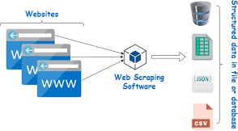

Fig 1.4.1 Webscraping Flow chart

NEWS CATEGORIZATION
To improve content organization, the system classifies news articles into relevant categories such as Politics, Health, Sports, etc. This is achieved using machine learning models like Naive Bayes, Random Forest, or BERT, ensuring high accuracy. Categorization improves searchability and helps users filter content based on their interests.

TEXT SUMMARIZATION PROCESS
The extracted content is often lengthy, making summarization essential. The system employs both Extractive and Abstractive summarization techniques. Extractive methods identify key sentences, while Abstractive techniques generate a concise summary using transformer models like T5 or BART. This ensures the user receives clear and meaningful information.

KEYWORD GENERATION

The system uses NLP models to extract essential keywords from the summarized content. This step helps identify core topics and improves image search accuracy. Techniques like TF-IDF or RAKE (Rapid Automatic Keyword Extraction) are employed to identify impactful words efficiently.

IMAGE COLLECTION

Using the generated keywords, the system fetches relevant images via Google Search APIs or similar tools. These visuals complement the content and make the final video more engaging. To ensure quality, images undergo automated verification to filter out irrelevant or low-quality visuals.

AUDIO GENERATION USING TTS
For audio creation, the system leverages WaveRNN or gTTS (Google Text-to-Speech) to convert the summarized text into clear, natural-sounding speech. This allows users to consume content audibly, improving accessibility for visually impaired individuals.

IMAGE SLIDESHOW GENERATION

The collected images are compiled into a slideshow format that aligns with the generated audio. Each image is displayed in sync with the corresponding content segment to enhance visual storytelling. Transitions, captions, and visual effects are applied for a polished result.

LIP-SYNC VIDEO GENERATION

The system uses the Wav2Lip model to generate a realistic virtual anchor that synchronizes lip movements with the TTS-generated audio. Users can select between male or female avatars to personalize the experience. This feature significantly enhances engagement and content delivery.

INTEGRATION OF COMPONENTS

The system merges the slideshow, audio narration, and lip-synced anchor video into a cohesive multimedia presentation. This final product is designed to deliver engaging and informative content in a visually appealing format.

WEB PLATFORM USER ACCESS

The generated video content is uploaded to a web platform where users can personalize their experience by selecting their preferred language, anchor type, and content category. The intuitive interface ensures seamless navigation and improved accessibility.

LITERATURE SURVEY
- The research presented by Wang et al. in their paper titled "Text2Video: Automatic Text-to-Video Synthesis Using Deep Learning", published in 2023 in the ICMPC journal, introduces an innovative approach to generating videos from textual content using deep learning techniques. The study addresses the growing demand for converting text-based information into engaging multimedia formats to improve content accessibility and user engagement. The proposed model, called Text2AV, utilizes state-of-the-art AI technologies to convert text into synchronized audio and video.
- The methodology employed in this research involves two key processes: Text-to-Speech (TTS) and Text-to-Video Generation. For text-to-speech conversion, the researchers utilized WaveRNN, a powerful neural network that generates high-quality audio from text input. This ensures clear, natural-sounding voice output that enhances user experience. Additionally, the system integrates the Wav2Lip model, which effectively synchronizes the generated audio with a digital avatar's lip movements, creating a realistic and immersive video presentation. This seamless lip-sync feature ensures the content appears human-like, improving engagement for viewers. The outcome of this research is an advanced multimedia generator capable of producing synchronized audio-video content, ideal for educational videos, news summaries, and interactive storytelling applications.
- Another notable research study by Jeelani Ahmed and Muqeem Ahmed, titled "Online News Classification Using Machine Learning Techniques", was published in 2021 in the IIUM journal. This study focuses on developing a robust method for classifying online news articles using machine learning techniques. The research addresses the challenge of efficiently categorizing news articles from various sources, ensuring accurate classification for improved content organization and retrieval.
- The authors adopted a supervised learning approach that incorporates a Bayesian classifier to classify news articles based on their textual content. The Bayesian classifier utilizes probabilistic models to predict the category of each article, achieving high accuracy through extensive experimentation. By analyzing content features such as keywords, sentence structure, and contextual relevance, the system effectively assigns appropriate categories to the news data. The experimental results demonstrated that this method achieves notable precision and recall, improving

the reliability of online news classification systems. This research significantly contributes to streamlining news delivery platforms by ensuring accurate content filtering, enhancing user experience, and minimizing misinformation.
- In the field of text summarization, the research conducted by J.N. Madhuri and Ganesh Kumar R, titled "Extractive Text Summarization Using Sentence Ranking", was published in 2019 in the IEEE journal. This study explores methods for generating concise summaries by extracting the most relevant sentences from lengthy textual content. The research emphasizes the importance of producing meaningful and informative summaries while ensuring computational efficiency.
- The proposed methodology involves two primary steps: Feature Extraction and Sentence Ranking. In the feature extraction phase, sentences are analyzed based on parameters such as term frequency, sentence position, and keyword density. These extracted features are then used to rank the sentences according to their importance. The top-ranked sentences are selected to generate the final summary. This method effectively retains essential information while significantly reducing content length. The outcome of this research is a summarization model that efficiently condenses information for applications such as document summarization, news aggregation, and research article reviews. The system's computational efficiency makes it suitable for large-scale content summarization tasks, improving accessibility for users seeking concise insights.
- Lastly, the paper by Shibo Ji and Bo Yang, titled "Abstractive Text Summarization Based on Long-Short Transformer", published in 2023 in the IEEE journal, introduces an advanced method for generating concise summaries through direct sentence transformation. Unlike extractive techniques, this method employs an abstractive approach that restructures and rewrites text to produce a coherent and well-organized summary.

SOFTWARE REQUIREMNET ANALYSIS

MODULES

  - Extraction of News: This module collects news data from various sources like websites, PDFs, and documents using web scraping techniques, ensuring continuous updates and relevant content delivery.
  - Categorization: The categorization module classifies extracted news into predefined categories such as Politics, Health, and Sports using machine learning models for better content organization.
  - Summarization of Text: Leveraging NLP techniques, this component condenses lengthy news articles into concise summaries while retaining key information for improved readability.
  - Keywords Generation: This module extracts essential keywords from summarized content to identify core topics and improve searchability, ensuring accurate content tagging.
  - Images Collection: Using keyword data, this component fetches relevant images via APIs to create engaging visuals that complement the generated content.
  - Generating of Audio: The audio generation module employs Text-to-Speech (TTS) models like WaveRNN to produce clear and natural-sounding audio from the summarized text.
  - Generating Slideshow of Images: This module compiles collected images into a dynamic slideshow synchronized with the generated audio to enhance visual storytelling.
  - Generation of Lip Sync Video: Using Wav2Lip, this component creates a realistic virtual anchor that lip-syncs with the generated audio, improving engagement and viewer connection.
  - Integration of Slideshow, Audio, and Lip Sync Video: The final integration stage combines the slideshow, audio narration, and lip-synced anchor video into a cohesive and engaging multimedia presentation.

FEASIBILITY STUDY
The Multilingual News Generation System is economically feasible due to its reliance on open-source tools like WaveRNN, Wav2Lip, and NLP models, minimizing licensing costs. Cloud platforms such as AWS or Google Cloud offer scalable solutions, reducing infrastructure expenses. Technically, the system leverages stable frameworks like Python, TensorFlow, and OpenCV, ensuring efficient integration of text, audio, and video modules. Its web-based design improves accessibility without requiring additional installations. Socially, the system enhances engagement through multilingual support, personalized content delivery, and improved accessibility for users with language barriers or low literacy levels. With cost-effective development, scalable infrastructure, and impactful user experience, the project is both viable and sustainable.
Three key considerations involved in the feasibility analysis are,

- Economic Feasibility

- Technical Feasibility

- Social Feasibility

ECONOMICAL FEASIBILITY

This study is carried out to check the economic impact that the system will have on the organization. The amount of fund that the company can pour into the research and development of the system is limited. The expenditures must be justified. Thus, the developed system as well within the budget and this was achieved because most of the technologies used are freely available. Only the customized products had to be purchased

TECHNICAL FEASIBILITY

This study is carried out to check the technical feasibility, that is, the technical requirements of the system. Any system developed must not have a high demand on the available technical resources. This will lead to high demands on the available technical resources. This will lead to high demands being placed on the client. The developed system must have a modest requirement, as only minimal or null changes are required for implementing this system.

SOCIAL FEASIBILITY

The aspect of study is to check the level of acceptance of the system by the user. This includes the process of training the user to use the system efficiently. The user must not feel threatened by the system, instead must accept it as a necessity. The level of acceptance by the users solely depends on the methods that are employed to educate the user about the system and to make him familiar with it. His level of confidence must be raised so that he is also able to make some constructive criticism, which is welcomed, as he is the final user of the system.

SOFTWARE AND HARDWARE REQUIREMENTS

SOFTWARE REQUIREMENTS
The functional requirements or the overall description documents include the product perspective and features, operating system and operating environment, graphics requirements, design constraints and user documentation. The appropriation of requirements and implementation constraints gives the general overview of the project in regard to what the areas of strength and deficit are and how to tackle them.
- Programming Languages: Python.
- Developer Tools: Visual Studio Code.
- Libraries: BeautifulSoup, Spacy, OpenCV, gTTS, FFMPEG.
- Algorithms: Naive Bayes Classifier.

HARDWARE REQUIREMENTS
Minimum hardware requirements are very dependent on the particular software being developed by a given Enthought Python / Canopy / VS Code user. Applications that need to store large arrays/objects in memory will require more RAM, whereas applications that need to perform numerous calculations or tasks more quickly will require a faster processor.
- Operating system : Windows
- Processor : Minimum intel i5
- RAM : Minimum 8 GB
- Hard disk : Minimum 500GB
- Graphic Card : Dedicated GPU Required

SYSTEM ARCHITECTURE

SYSTEM ARCHITECTURE
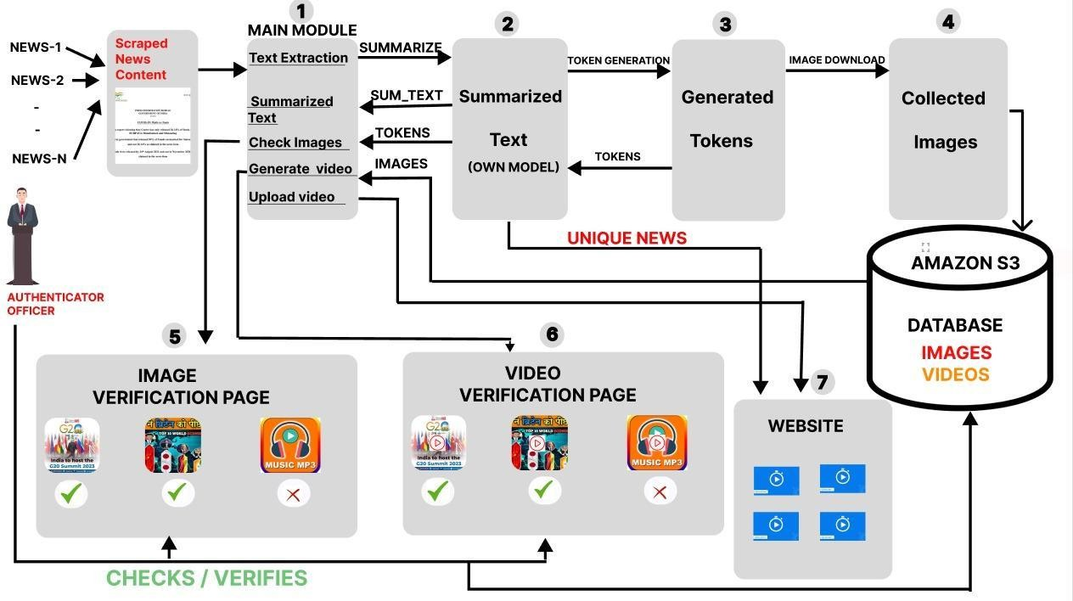
Fig. 5.1 System Architecture

UML DIAGRAMS

UML is a standard language for specifying, visualizing, constructing, and documenting the artifacts of software systems. UML was created by the Object Management Group (OMG) and UML 1.0 specification draft was proposed to the OMG in January 1997.
The two broadest categories that encompass all other types are:
- Behavioural UML diagram and
- Structural UML diagram.
As the name suggests, some UML diagrams try to analyses and depict the structure of a system or process, whereas other describe the behavior of the system, its actors, and its building components.

The different types are broken down as follows:
- Sequence diagram
- Use case Diagram
- Activity diagram

- SEQUENCE DIAGRAM
A sequence diagram simply depicts interaction between objects in a sequential order i.e., the order in which these interactions take place. We can also use the terms event diagrams or event scenarios to refer to a sequence diagram. Sequence diagrams describe how and in what order the objects in a system function. These diagrams are widely used by businessmen and software developers to document and understand requirements for new and existing systems.
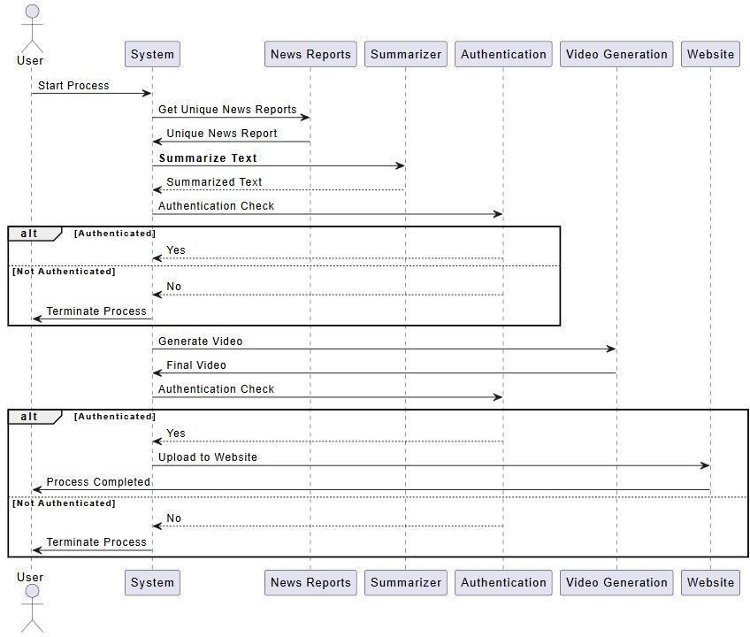

Fig 5.2 Sequence diagram

- USE CASE DIAGRAM
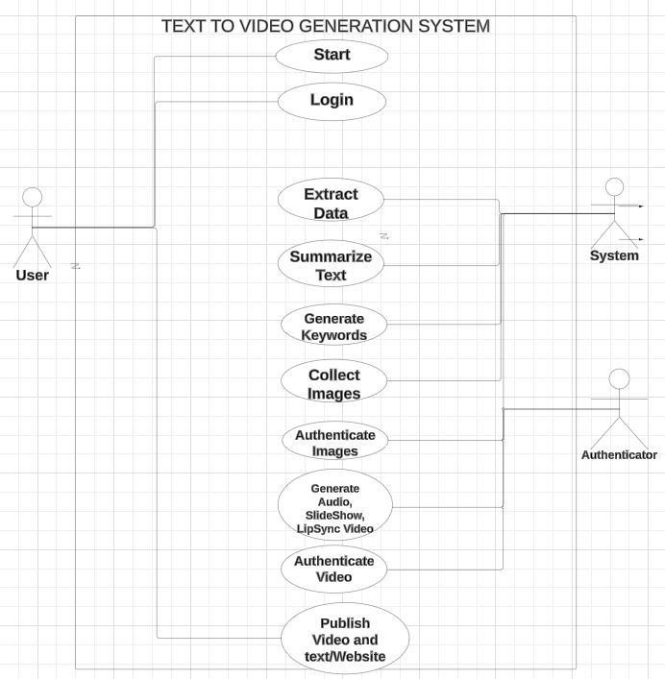
A use case diagram in the Unified Modeling Language (UML) is a type of behavioral diagram defined by and created from a Use-case analysis. Its purpose is to present a graphical overview of the functionality provided by a system in terms of actors, their goals (represented as use cases, and any dependencies between those use cases. The main purpose of a use case diagram is to show what system functions are performed for which actor. Roles of the actors in the system can be depicted.

Fig 5.3 Use case diagram

- ACTIVITY DIAGRAM
Activity diagram is another important diagram in UML to describe the dynamic aspects of the system. Activity diagram is basically a flowchart to represent the flow from one activity to another activity. This flow can be sequential, branched, or concurrent. Activity diagrams deal with all type of flow control by using different elements such as fork, join, etc.
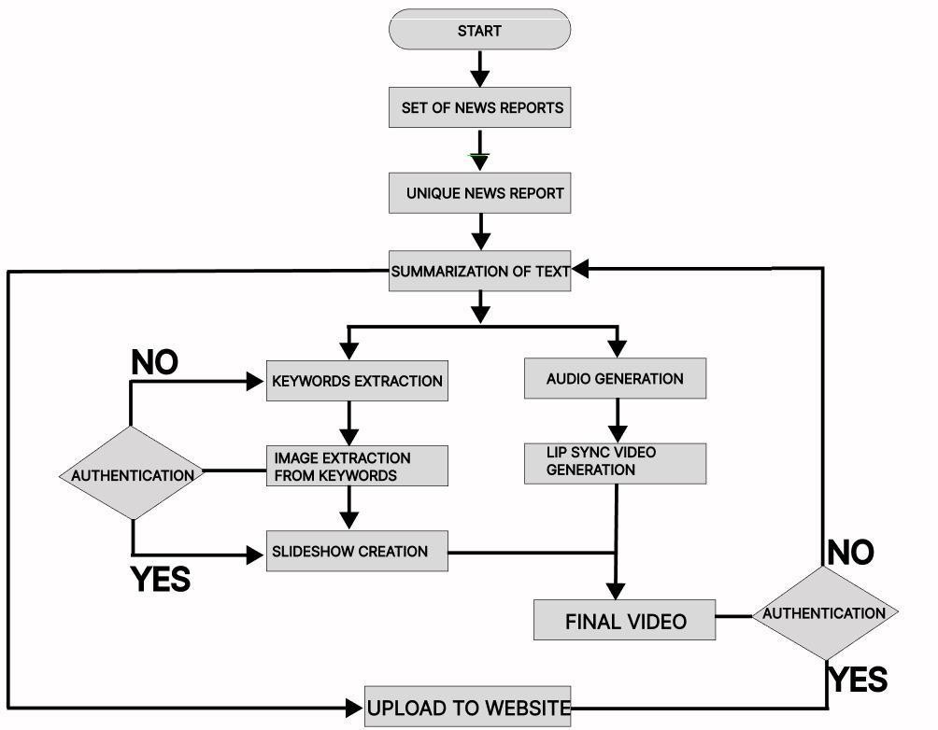

Fig 5.4 Activity diagram

IMPLEMENTATION AND CODING

IMPLEMENTATION
    - PYTHON

Python is a general-purpose interpreted, interactive, object-oriented, and high-level programming language. An Interpreted Language, Python has a design philosophy that emphasizes code readability (notably using whitespace indentation to delimit code blocks rather than curly brackets or keywords), and a syntax that allows programmers to express concepts in fewer lines of code than might be used in languages such as C++ or java. It provides constructs that enable clear programming on both small and large scales. Python interpreters are available for many operating systems. Python, the reference implementation of Python, is open-source software and has a community-based development model, as do nearly all of its variant implementations. Python is managed by the non - profit Python Software Foundation. Python features a dynamic type system and automatic memory management. It supports multiple programming paradigms, including object -oriented, imperative, functional and procedural, and has a large and comprehensive standard library.

Python language is being used by almost all tech-giant companies like – Google, Amazon, Facebook, Instagram, Dropbox, Uber etc.
The biggest strength of Python is huge collection of standard libraries which can be used for the following –
      - Speech Recognition

      - GUI Applications (like Kivy, Tkinter, PyQt etc.)
      - Machine Learning
      - Test frameworks
      - Multimedia

Advantages of Python
- Extensive Libraries:
Python downloads with an extensive library and it contain code for various purposes like regular expressions, Speech Recognition, documentation-generation, unit-testing, web browsers, threading, databases, CGI, email, and more. So, we don’t have to write the complete code for that manually.

Extensible:
As we have seen earlier, Python can be extended to other languages. You can write some of your code in languages like C++ or C. This comes in handy, especially in projects.

Embeddable:
Complimentary to extensibility, Python is embeddable as well. You can put your Python code in your source code of a different language, like C++. This lets us add scripting capabilities to our code in the other language.

Improved Productivity:
The language’s simplicity and extensive libraries render programmers more productive than languages like Java and C++ do. Also, the fact that you need to write less and get more things done.

IOT Opportunities:
Since Python forms the basis of new platforms like Raspberry Pi, it finds the future bright for the Internet of Things. This is a way to connect the language with the real world.

Simple and Easy:

When working with Java, you may have to create a class to print ‘Hello World’. But in Python, just a print statement will do. It is also quite easy to learn, understand, and code. This is why when people pick up Python, they have a hard time adjusting to other more verbose languages like Java.

Readable:
Because it is not such a verbose language, reading Python is much like reading English. This is the reason why it is so easy to learn, understand, and code. It also does not need curly braces to define blocks, and indentation is mandatory. These further aids the readability of the code.

Object-Oriented:
This language supports both the procedural and object-oriented programming paradigms. While functions help us with code reusability, classes and objects let us model the real world. A class allows the encapsulation of data and functions into one.

Free and Open-Source:
Like we said earlier, Python is freely available. But not only can you download Python for free, but you can also download its source code, make changes to it, and even distribute it. It downloads with an extensive collection of libraries to help you with your tasks.

Portable:
When you code your project in a language like C++, you may need to make some changes to it if you want to run it on another platform. But it isn’t the same with Python. Here, you need to code only once, and you can run it anywhere. This is called Write Once Run Anywhere (WORA).
However, you need to be careful enough not to include any system-dependent features.

Interpreted:
Lastly, we will say that it is an interpreted language. Since statements are executed one by one, debugging is easier than in compiled languages.

Disadvantages of Python
- Speed Limitations:
We have seen that Python code is executed line by line. But since Python is interpreted, it often results in slow execution. This, however, isn’t a problem unless speed is a focal point for the project. In other words, unless high speed is a requirement, the benefits offered by Python are enough to distract us from its speed limitations.

Weak in Mobile Computing and Browsers:
While it serves as an excellent server-side language, Python is much rarely seen on the client- side. Besides that, it is rarely ever used to implement smartphone-based applications. One such application is called Carbonnelle.
The reason it is not so famous despite the existence of Brython is that it isn’t that secure.

Design Restrictions:
As you know, Python is dynamically-typed. This means that you don’t need to declare the type of variable while writing the code. It uses duck-typing. While this is easy on the programmers during coding, it can raise run-time errors.

Underdeveloped Database Access Layers:
Compared to more widely used technologies like JDBC (Java Data Base Connectivity) and ODBC
(Open Data Base Connectivity), Python’s database access layers are a bit underdeveloped. Consequently, it is less often applied in huge enterprises.

    - MACHINE LEARNING
Machine learning models for speech recognition require a large amount of data for training. This data includes audio samples of different users speaking various phrases and commands that the voice assistant should recognize. But in this project machine learning is playing a role indirectly through the use of two specific libraries: spaCy and the Google Cloud Speech Recognition API. Here, spaCy is used for natural language processing (NLP). The nlp object is an instance of the spaCy language model, specifically the English language model (en_core_web_sm). When you process a text with nlp, it applies various machine learning models to tokenize, parse, and tag the input text. It identifies parts of speech, named entities, and other linguistic features.

The recognize_google method sends the recorded audio data to Google's servers, where machine learning models process the audio to transcribe it into text. This involves complex acoustic modeling and language modeling techniques. The Google Cloud Speech Recognition API uses machine learning models to handle various accents, intonations, and spoken language nuances, making it a powerful tool for speech recognition.

    - CATEGORIES OF MACHINE LEARNING

At the most fundamental level, machine learning can be categorized into two main types: supervised learning and unsupervised learning.

Supervised learning involves somehow modeling the relationship between measured features of data and some label associated with the data; once this model is determined, it can be used to apply labels to new, unknown data. This is further subdivided into classification tasks and regression tasks: in classification, the labels are discrete categories, while in regression, the labels are continuous quantities. We will see examples of both types of supervised learning in the following section.

Unsupervised learning involves modeling the features of a dataset without reference to any label, and is often described as "letting the dataset speak for itself." These models include tasks such as clustering and dimensionality reduction. Clustering algorithms identify distinct groups of data, while dimensionality reduction algorithms search for more succinct representations of the data. We will see examples of both types of unsupervised learning in the following section.

    - NEED FOR MACHINE LEARNING
Human beings, at this moment, are the most intelligent and advanced species on earth because they can think, evaluate and solve complex problems. On the other side, AI is still in its initial stage and haven’t surpassed human intelligence in many aspects. Then the question is that what is the need to make machine learn? The most suitable reason for doing this is, “to make decisions, based on data, with efficiency and scale”.

The most suitable reason for doing this is, “to make decisions, based on data, with efficiency and scale”. Lately, organizations are investing heavily in newer technologies like Artificial Intelligence, Machine Learning and Deep Learning to get the key information from data to perform several real-world tasks and solve problems. We can call it data-driven decisions taken by machines, particularly to automate the process. These data-driven decisions can be used, instead of using programing logic, in the problems that cannot be programmed inherently. The fact is that we can’t do without human intelligence, but other aspect is that we all need to solve real-world problems with efficiency at a huge scale. That is why the need for machine learning arises.

    - CHALLENGES IN MACHINE LEARNING

While Machine Learning is rapidly evolving, making significant strides with cybersecurity and autonomous cars, this segment of AI as whole still has a long way to go. The reason behind is that ML has not been able to overcome number of challenges. The challenges that ML is facing currently are −
Quality of data − Having good-quality data for ML algorithms is one of the biggest challenges. Use of low-quality data leads to the problems related to data preprocessing and feature extraction.
Time-Consuming task − Another challenge faced by ML models is the consumption of time especially for data acquisition, feature extraction and retrieval.
Lack of specialist persons − As ML technology is still in its infancy stage, availability of expert resources is a tough job.
No clear objective for formulating business problems − Having no clear objective and well- defined goal for business problems is another key challenge for ML because this technology is not that mature yet.
Issue of overfitting & underfitting − If the model is overfitting or underfitting, it cannot be represented well for the problem.

Curse of dimensionality − Another challenge ML model faces is too many features of data points. This can be a real hindrance.
Difficulty in deployment − Complexity of the ML model makes it quite difficult to be deployed in real life.

Applications of Machines Learning

Machine Learning is the most rapidly growing technology and according to researchers we are in the golden year of AI and ML. It is used to solve many real-world complex problems which cannot be solved with traditional approach. Following are some real-world applications of ML −
- Emotion analysis
- Sentiment analysis
- Error detection and prevention
- Weather forecasting and prediction
- Stock market analysis and forecasting
- Speech synthesis
- Speech recognition
- Customer segmentation
- Object recognition
- Fraud detection
- Fraud prevention

How to start learning ML?
This is a rough roadmap you can follow on your way to becoming an insanely talented Machine Learning Engineer. Of course, you can always modify the steps according to your needs to reach your desired end-goal!

Step 1 – Understand the Prerequisites
In case you are a genius, you could start ML directly but normally, there are some prerequisites that you need to know which include Linear Algebra, Multivariate Calculus, Statistics, and Python. And if you don’t know these, never fear! You don’t need a Ph.D. degree in these topics to get started but you do need a basic understanding.

Learn Linear Algebra and Multivariate Calculus:
Both Linear Algebra and Multivariate Calculus are important in Machine Learning. However, the extent to which you need them depends on your role as a data scientist. If you are more focused on application heavy machine learning, then you will not be that heavily focused on math as there are many common libraries available. But if you want to focus on R&D in Machine Learning, then mastery of Linear Algebra and Multivariate Calculus is very important as you will have to implement many ML algorithms from scratch.

Learn Statistics:
Data plays a huge role in Machine Learning. In fact, around 80% of your time as an ML expert will be spent collecting and cleaning data. And statistics is a field that handles the collection, analysis, and presentation of data. So it is no surprise that you need to learn it!!! Some of the key concepts in statistics that are important are Statistical Significance, Probability Distributions, Hypothesis Testing, Regression, etc. Also, Bayesian Thinking is also a very important part of ML which deals with various concepts like Conditional Probability, Priors, and Posteriors, Maximum Likelihood, etc.

Learn Python:
Some people prefer to skip Linear Algebra, Multivariate Calculus and Statistics and learn them as they go along with trial and error. But the one thing that you absolutely cannot skip is Python! While there are other languages you can use for Machine Learning like R, Scala, etc. Python is currently the most popular language for ML. In fact, there are many Python libraries that are specifically useful for Artificial Intelligence and Machine Learning such as Keras, TensorFlow, Scikit-learn, etc.
So, if you want to learn ML, it’s best if you learn Python! You can do that using various online resources and courses such as Fork Python available Free on Geeks for Geeks.

Step 2 – Learn Various ML Concepts
Now that you are done with the prerequisites, you can move on to actually learning ML (Which is the fun part!!!) It’s best to start with the basics and then move on to the more complicated stuff. Some of the basic concepts in ML are:

Terminologies of Machine Learning
- Model – A model is a specific representation learned from data by applying some machine learning algorithm. A model is also called a hypothesis.
- Feature – A feature is an individual measurable property of the data. A set of numeric features can be conveniently described by a feature vector. Feature vectors are fed as input to the model. For example, in order to predict a fruit, there may be features like color, smell, taste, etc.
- Target (Label) – A target variable or label is the value to be predicted by our model. For the fruit example discussed in the feature section, the label with each set of input would be the name of the fruit like apple, orange, banana, etc.
- Training – The idea is to give a set of inputs(features) and it’s expected outputs(labels), so after training, we will have a model (hypothesis) that will then map new data to one of the categories trained on.
- Prediction – Once our model is ready, it can be fed a set of inputs to which it will provide a predicted output(label).

Types of Machine Learning
- Supervised Learning – This involves learning from a training dataset with labeled data using classification and regression models. This learning process continues until the required level of performance is achieved.
- Unsupervised Learning – This involves using unlabeled data and then finding the underlying structure in the data in order to learn more and more about the data itself using factor and cluster analysis models.
- Semi-supervised Learning – This involves using unlabeled data like Unsupervised Learning with a small amount of labeled data. Using labeled data vastly increases the learning accuracy and is also more cost-effective than Supervised Learning.
- Reinforcement Learning – This involves learning optimal actions through trial and error. So, the next action is decided by learning behaviors that are based on the current state and that will maximize the reward in the future.

Advantages of Machine learning:
- Easily identifies trends and patterns -

Machine Learning can review large volumes of data and discover specific trends and patterns that would not be apparent to humans. For instance, for an e-commerce website like Amazon, it serves to understand the browsing behaviors and purchase histories of its users to help cater to the right products, deals, and reminders relevant to them. It uses the results to reveal relevant advertisements to them.

No human intervention needed (automation)

With ML, you don’t need to babysit your project every step of the way. Since it means giving machines the ability to learn, it lets them make predictions and also improve the algorithms on their own. A common example of this is anti-virus software; they learn to filter new threats as they are recognized. ML is also good at recognizing spam.

Continuous Improvement

As ML algorithms gain experience, they keep improving in accuracy and efficiency. This lets them make better decisions. Say you need to make a weather forecast model. As the amount of data you have keeps growing, your algorithms learn to make more accurate predictions faster.

Handling multi-dimensional and multi-variety data

Machine Learning algorithms are good at handling data that are multi-dimensional and multi- variety, and they can do this in dynamic or uncertain environments.

Wide Applications

You could be an e-tailer or a healthcare provider and make ML work for you. Where it does apply, it holds the capability to help deliver a much more personal experience to customers while also targeting the right customers.

Disadvantages of Machine Learning
- Data Acquisition:
Machine Learning requires massive data sets to train on, and these should be inclusive/unbiased, and of good quality. There can also be times where they must wait for new data to be generated.

Time and Resources
ML needs enough time to let the algorithms learn and develop enough to fulfill their purpose with a considerable amount of accuracy and relevancy. It also needs massive resources to function.
This can mean additional requirements of computer power for you.

Interpretation of Results
Another major challenge is the ability to accurately interpret results generated by the algorithms. You must also carefully choose the algorithms for your purpose.

High error-susceptibility
Machine Learning is autonomous but highly susceptible to errors. Suppose you train an algorithm with data sets small enough to not be inclusive. You end up with biased predictions coming from a biased training set. This leads to irrelevant advertisements being displayed to customers.

PROJECT METHODOLOGY
    - DATA COLLECTION AND PREPROCESSING
We began by collecting news content from multiple sources such as government press releases, news websites, and online media platforms. This data was extracted using web scraping techniques to ensure continuous updates. The collected text data underwent preprocessing steps, including removal of stopwords, tokenization, and cleaning unwanted symbols or HTML tags. This ensured the content was structured and ready for the subsequent steps like classification and summarization.

    - TEXT SUMMARIZATION AND CLASSIFICATION
To efficiently condense lengthy news articles, we implemented both extractive and abstractive summarization techniques. Extractive methods used sentence ranking to identify key points, while abstractive methods employed transformer models like BERT to generate concise yet meaningful summaries. Additionally, the content was classified into categories like Politics, Health, Sports, etc., ensuring that users could filter news content based on their interests.
    - TEXT-TO-SPEECH
For generating realistic audio, we employed WaveRNN to convert summarized text into natural-sounding speech. The model effectively handled various languages and accents, ensuring clear pronunciation and improved listening experiences. This step was crucial for enhancing content accessibility, especially for visually impaired users or those preferring audio content.
    - IMAGE AND VIDEO GENERATION
To create engaging visual presentations, relevant images were fetched using Google Search APIs based on extracted keywords from the summarized text. These images were organized into a slideshow format to visually represent the content. The slideshow was synchronized with the generated audio to maintain a smooth and coherent visual flow.
    - ANCHOR LIP-SYNC INTEGRATION
To enhance user engagement, we integrated a virtual anchor using the Wav2Lip model. This model allowed the digital anchor to synchronize its lip movements with the generated audio, creating a realistic and interactive presentation. Users could choose between male or female anchors to personalize their experience. This feature significantly improved the visual appeal and immersion of the video content.
    - MULTILINGUAL SUPPORT IMPLEMENTATION
To cater to a diverse audience, the system was designed to support multiple languages. We utilized translation APIs and multilingual TTS models to translate and generate content in various languages. This step ensured the platform’s inclusivity, expanding its reach across different regions.

    - WEB PLATFORM DEVELOPEMENT AND DEPLOYMENT
Finally, the complete system was integrated into a web platform where users could select their preferred language, anchor type, and content category. The platform’s front-end was developed using HTML, CSS, and JavaScript, while the back-end employed Flask to manage content generation requests. The system was hosted on cloud platforms like AWS for scalability and improved performance. By combining these steps, the Multilingual News Generation System successfully delivered engaging, accessible, and personalized video content, enhancing the way news is consumed.

Libraries installed in Project

- pip install pytextrank

- pip install spacy

- pip install requests

- pip install openpyxl

- pip install pygoogle_image

- pip install moviepy

- pip install gtts

- pip install pyttsx3

CONCLUSION
The Multilingual News Generation System effectively addresses the growing need for accessible and engaging news content by transforming text-based information into dynamic video presentations. By integrating advanced technologies such as Natural Language Processing (NLP), Text-to-Speech (TTS) models, and Wav2Lip for lip-syncing, the system enhances content delivery. This innovative approach improves information accessibility, ensuring users from diverse linguistic backgrounds can stay informed through audio-visual content.
The project demonstrates significant value in terms of usability and engagement. By offering customizable options such as language preferences, anchor selection, and content categories, the system caters to varied user needs. This personalization improves the user experience, making news consumption more interactive and appealing.
The integration of image slideshows further enhances storytelling, ensuring the visual representation aligns with the audio content. From a technical perspective, the project effectively combines multiple AI models, including WaveRNN for speech generation and Wav2Lip for precise lip-syncing, ensuring seamless video creation. The use of web scraping for content extraction and classification ensures the system stays updated with the latest news. Leveraging scalable cloud platforms further strengthens the system's ability to handle large datasets and deliver content efficiently.
In conclusion, the Multilingual News Generation System is an innovative solution that transforms traditional text-based news into engaging video content. With its robust technical design, personalized user experience the system has the potential to revolutionize digital content delivery. Future enhancements could involve expanding language support, improving avatar realism, and integrating real-time news updates for even greater impact.

FUTURE ENHANCEMENTS

The Multilingual News Generation System has promising potential for future improvements to enhance functionality and user experience. One key enhancement is enabling video generation from various content sources such as URLs, PDFs, and documents, allowing for greater flexibility in content creation.
This expansion would streamline the process of transforming diverse text formats into engaging visual content, increasing the system’s versatility. Additionally, introducing an automated image authentication system will ensure that the selected visuals maintain high quality and relevance, enhancing the overall credibility of the generated content. To improve the visual and audio experience, future upgrades will focus on enhancing image and video quality through advanced AI techniques.
This may involve utilizing super-resolution models to upscale image clarity and implementing improved text-to-speech (TTS) algorithms for more natural voice output. Expanding multilingual support will also be prioritized, ensuring the platform can cater to a wider audience by incorporating additional regional languages and dialects. These enhancements will strengthen the system’s ability to deliver clear, accurate, and engaging content across diverse user groups.
Future UI upgrades will focus on enhancing navigation, improving content customization options, and simplifying the content generation process.
Additionally, integrating interactive features such as voice commands and content previews will improve user engagement. By combining these advancements, the Multilingual News Generation System can evolve into a comprehensive and powerful platform that enhances information delivery through innovative audio-visual storytelling.

REFERENCES
- "NLP in Content Transformation" by Liu et al 2019 . provides a framework for applying NLP in media generation.
- "Lip-Syncing Deep Neural Networks for Video Synthesis" by Karras et al. focuses on the WAV2LIP model for accurate lip-syncing in video generation.
- "AI-Driven Personalized Video Generation" by Brown et al. explores methods for tailoring video content dynamically based on the target audience using AI algorithms.
- "Keyword Extraction from Text Using TF-IDF" by Ramos explains the TF-IDF method's efficiency in identifying important keywords.
- "AI-Driven Approaches to Multimedia Content Creation" by Smith et al. discusses the potential of AI in generating visual and auditory elements based on textual data.
- "Text Summarization Techniques: A Brief Survey" by Gabhir and Gupta outlines various summarization approaches and their applications
- "Lip Sync Expert Is All You Need for Speech to Lip Generation In The Wild" by Prajwal et al. presents Wav2Lip, a model that enhances lip-sync accuracy in arbitrary talking face videos using a powerful lip-sync discriminator.

