# Week 12 Application Question

|  |  |
| --- | --- |
| Team name: |  |
| Team members: |  |
|  |  |
|  |  |
|  |  |
|  |  |

Given this UML Class Diagram:

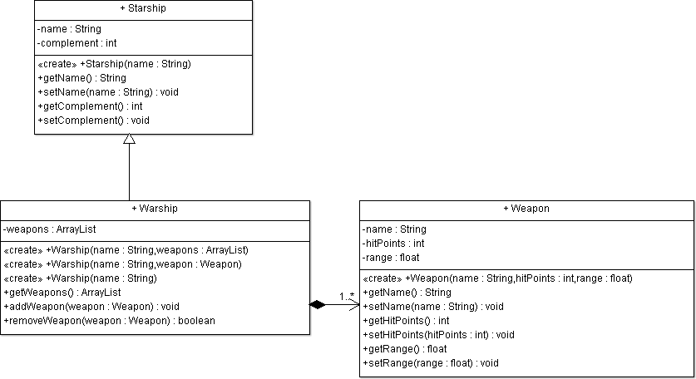

1. Implement the Starship class in Java.

|  |
| --- |
|  |

1. Implement the Weapon class in Java.

|  |
| --- |
|  |

1. Implement the Warship class in Java.

|  |
| --- |
|  |