S U R V E Y R E P O R T
A Survey of Low-Code Development Platforms
with a Detailed Study of Zoho Creator
Platform Landscape, Architecture, AI-Native Capabilities, Governance and the Direction of Enterprise Application Delivery
Prepared by
Adishwar Seelan
Roll Number: 241401004
B.Tech Computer Science and Business Systems
Rajalakshmi Engineering College, Chennai
3 August 2026

Table of Contents

1. Executive Summary 3
2. Introduction 3
3. The Market Landscape 4
4. A Taxonomy of Low-Code Platforms 5
5. Comparative Survey of Leading Platforms 6
6. Platform Study: Zoho Creator 7
7. Emerging Trend 1: AI-Native and Agentic Development 9
8. Emerging Trend 2: Citizen Development and Fusion Teams 9
9. Emerging Trend 3: Governance-by-Design 10
10. Emerging Trend 4: Vertical and Industry-Specific Platforms 10
11. Emerging Trend 5: Composable and Open Architecture 11
12. Comparative Trend Assessment 11
13. Challenges and Risks 12
14. Future Outlook 12
15. Conclusion 12
16. References 13

1. Executive Summary
Low-code development has changed character over the past three years. What was once a convenient way to assemble internal forms and departmental trackers is now a recognised layer of enterprise software delivery, sitting alongside — and increasingly interleaved with — conventional hand-written engineering. Analyst houses disagree on the exact size of the market, but they agree on its direction: every major forecast places compound annual growth in the region of twenty to thirty percent, and Gartner has projected that a large majority of new enterprise applications will involve low-code or no-code technology by 2026.
This report surveys the low-code platform landscape as it stands in mid-2026. It begins with the market picture, proposes a working taxonomy that separates enterprise platforms from no-code builders, internal-tool frameworks, AI-native generators and automation layers, and compares the leading products across the criteria that actually decide procurement — extensibility, governance, integration and cost.
A substantial portion of the report is devoted to a detailed study of Zoho Creator, examined first-hand through a trial account. Creator is a useful specimen because it occupies the middle of the market: more opinionated and more governed than a pure no-code builder, less demanding than the heavyweight enterprise platforms, and priced for teams rather than for programmes. Its architecture — forms, reports and pages over an auto-provisioned data store, with Deluge for logic and a Develop / Deploy / Manage administrative split — illustrates the structural choices every low-code vendor must make.
The survey then examines five trends reshaping the category: the absorption of generative and agentic AI into the build process, the formalisation of citizen development into fusion teams, the rise of governance-by-design, vertical specialisation, and the shift toward composable, exportable architectures. It closes with the risks that accompany rapid adoption and an outlook for the next three years.

2. Introduction
A low-code development platform allows an application to be assembled largely through visual construction — drag-and-drop layout, declarative data modelling, configured workflows — with hand-written code reserved for the logic that genuinely requires it. A no-code platform makes the stronger claim that no scripting is needed at all. In practice the boundary is porous: most serious platforms present a visual surface by default and allow a developer to drop into code for complex conditions, external integrations or custom interfaces, so the two labels describe a spectrum rather than two distinct product categories.
Three structural pressures explain why the category has grown as quickly as it has. The first is a persistent shortage of professional software engineers, which leaves enterprise IT unable to service the volume of internal application requests it receives. The second is the accumulated backlog that shortage produces: business teams wait months for tools they need in weeks. The third is the pressure to modernise ageing internal systems — spreadsheets, legacy desktop applications, paper processes — faster than a traditional development pipeline can manage. Low-code addresses all three by moving a portion of application construction closer to the people who understand the process being automated.
What makes 2026 an interesting moment to survey the category is that its centre of gravity has moved. The competitive questions are no longer about whether a platform can build an application quickly; almost all of them can. They are about what happens afterwards — how the application is governed, how its data integrates with the rest of the estate, whether its logic can be exported if the vendor relationship ends, and how much of it an AI assistant can now generate unaided.

2.1 Scope and Methodology
This survey draws on three kinds of source. The first is published market research and analyst commentary from Gartner, Grand View Research, Mordor Intelligence, Fortune Business Insights and Forrester, accessed through their public summaries. The second is vendor documentation — product pages, release notes and developer help material — which is the most reliable guide to what a platform actually does today, if read with an awareness of its promotional purpose. The third is direct hands-on examination: a Zoho Creator trial account was created and its administrative console explored module by module, and the observations from that exercise inform Section 6.
Market figures are reported as ranges rather than single values. Analyst definitions of "low-code" differ substantially — some include adjacent no-code and automation segments, others do not — and quoting a single number would give a false impression of precision. All figures should be read as indicators of direction and scale.

3. The Market Landscape
The low-code market has sustained double-digit growth for several consecutive years, and 2026 is the point at which analysts have largely stopped describing it as an emerging category. Estimates of its current size range from roughly USD 26 billion to nearly USD 49 billion depending on scope, with projections for the end of the decade spanning USD 67 billion to over USD 100 billion. The spread is wide, but every trajectory in the set is steep.
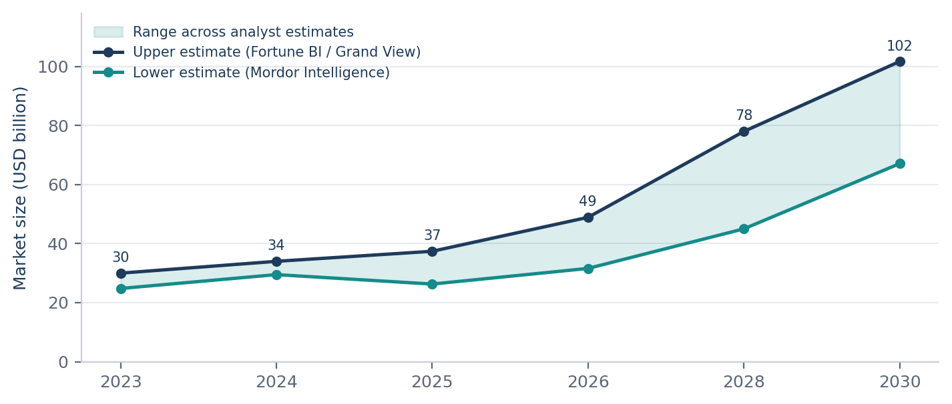
Figure 1: Global low-code platform market size, 2023-2030. Shaded band shows the range across published analyst estimates.
Beneath the headline numbers, three structural observations matter more than the exact dollar value. First, the services component of the market — implementation, integration and governance consulting — is growing faster than platform licence revenue, which tells us that organisations are deploying low-code into complex environments rather than isolated departments. Second, Asia-Pacific is the fastest-growing region, driven by large-scale digitalisation programmes in India and China. Third, vendor consolidation has begun: platform companies are acquiring data and integration assets rather than building them, which strengthens ecosystem lock-in at exactly the moment buyers have started worrying about it.

Key market indicators
70-75%  of new enterprise applications expected to involve low-code by 2026 | ~80%  of low-code builders sit outside formal IT departments | 20-29%  CAGR range across published forecasts | $67-102B  projected market size by 2030 (USD)
Blended from Gartner, Grand View Research, Mordor Intelligence and Fortune Business Insights, 2026.
The drivers organisations cite for adoption are consistent across surveys, and they are pragmatic rather than strategic. Speed of delivery dominates; cost reduction, though frequently mentioned in vendor marketing, ranks below the operational pressures of backlog and staffing.
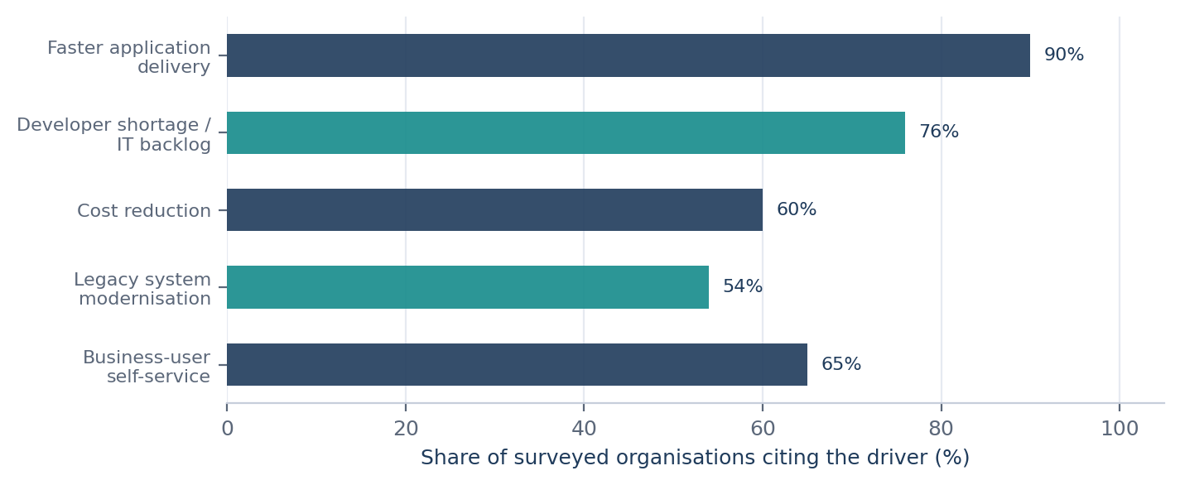
Figure 2: Primary drivers cited by enterprises adopting low-code platforms, 2026 (composite of published survey data).

4. A Taxonomy of Low-Code Platforms
Treating "low-code" as a single market obscures more than it reveals. A platform chosen to build a regulated claims-processing system and a platform chosen to build an internal approval tracker are competing in different markets even if both are described by the same phrase. The following taxonomy separates the category into five segments by the problem each is built to solve.
Segment | Representative platforms | Primary use case | Typical buyer
Enterprise low-code (pro-code capable) | Microsoft Power Apps, OutSystems, Mendix, ServiceNow, Appian, Salesforce | Complex, mission-critical, long-lived business applications | Enterprise IT / CIO
General-purpose business low-code | Zoho Creator, Kissflow, Bubble, Quickbase | Departmental workflow apps, operational tools, MVPs | Department head / SMB owner
Internal-tool builders | Retool, ToolJet, Budibase | Admin panels, dashboards, CRUD interfaces over existing databases | Engineering team
AI-native app generators | Prompt-to-app builders, agent-style scaffolding tools | Rapid prototyping, first-draft scaffolding, iteration | Individual developer / founder
Automation and orchestration layers | Power Automate, Zapier, n8n | Cross-system integration and event-driven workflows | Ops / RevOps teams
Table 1: Working taxonomy of the 2026 low-code landscape.
Two observations follow from this segmentation. The first is that the segments are converging at the edges: enterprise platforms are adding no-code surfaces to reach business users, while business-tier platforms are adding governance and environment management to reach enterprises. Zoho Creator is a clear example of the second movement — the administrative console studied in Section 6 contains a staged deployment pipeline, audit trails and directory integration that would once have been the preserve of an enterprise-only product.
The second observation is that the automation layer is quietly becoming the most consequential segment. As applications fragment across many platforms, the orchestration tool that connects them accumulates the business logic that used to live inside monolithic systems — and with it, a significant amount of undocumented institutional knowledge.

5. Comparative Survey of Leading Platforms
Gartner has consistently positioned Microsoft Power Apps, Mendix, OutSystems, ServiceNow, Appian and Salesforce as Leaders in its enterprise low-code evaluations across the 2025 and 2026 cycles, with AI-native capability emerging as a principal differentiator. That list, however, reflects enterprise procurement criteria; it does not capture the platforms most students, small teams and mid-market businesses will actually encounter. The comparison below spans both groups.
Platform | Scripting / extensibility | Notable strength | Principal limitation
Microsoft Power Apps | Power Fx, custom connectors, Azure functions | Depth of integration with Microsoft 365 and Dataverse | Licensing complexity; strong pull toward the Microsoft estate
OutSystems | Full-stack; C#/Java extensions | Handles large, complex, long-lived applications well | High cost; steeper learning curve for non-developers
Mendix | Java actions, model-driven SDK | Collaborative modelling for fusion teams; Siemens backing | Enterprise-oriented pricing and setup overhead
Appian | Expression rules, plug-ins | Process automation, case management, data fabric | Process-centric model fits some problems poorly
Zoho Creator | Deluge scripting; REST APIs; Zia AI tasks | Balanced capability at low cost; tight Zoho-suite integration | Deluge is proprietary; heavy customisation hits ceilings
Bubble | Visual logic; plugin ecosystem | Genuine no-code depth for consumer-facing web apps | Performance and cost at scale; hosting lock-in
Retool / ToolJet | JavaScript throughout; direct DB access | Fast internal tooling over existing data sources | Assumes an engineering audience; not for citizen developers
n8n / Zapier | JavaScript nodes; webhooks | Cross-system orchestration and agentic workflow chains | Not an application platform; no real UI layer
Table 2: Comparative survey of representative low-code platforms, 2026.
Reading across the table, the most useful distinction is not capability but exit cost. Platforms that express logic in a proprietary language and host it on proprietary infrastructure — which includes most of the general-purpose tier — make migration expensive in a way that is easy to underestimate at purchase time. Platforms that keep logic in a mainstream language and data in a database the customer controls trade some convenience for portability. Neither choice is wrong, but the trade-off should be made deliberately rather than discovered three years later.

6. Platform Study: Zoho Creator
Zoho Creator was selected for detailed study because it sits at the centre of the market and because it is accessible for first-hand examination: a fifteen-day trial provisions a full organisation with the complete administrative console. The observations in this section come from that trial account, supplemented by vendor documentation.

6.1 Architecture and Building Blocks
Creator organises an application into four visible constructs. Forms define the data model and the capture interface simultaneously — adding a field to a form adds a column to the underlying table, which is the central abstraction of the platform. Reports present stored records as lists, grids, calendars, kanban boards or maps, with filters and permissions attached. Pages assemble reports, charts and static content into dashboards. Workflows attach logic to events: record creation, field edit, scheduled time, or an explicit button press.
Underneath these sits Deluge, Zoho's proprietary scripting language. Deluge is deliberately close to natural language, and it is what makes Creator a low-code rather than a no-code platform: validation rules, integration calls through invokeUrl, record manipulation and custom functions are all written in it. Blueprint sits alongside workflows as a visual state-machine editor, used to model processes where a record moves through defined stages with different owners and permitted transitions at each — an approval chain, a service request, an onboarding sequence.
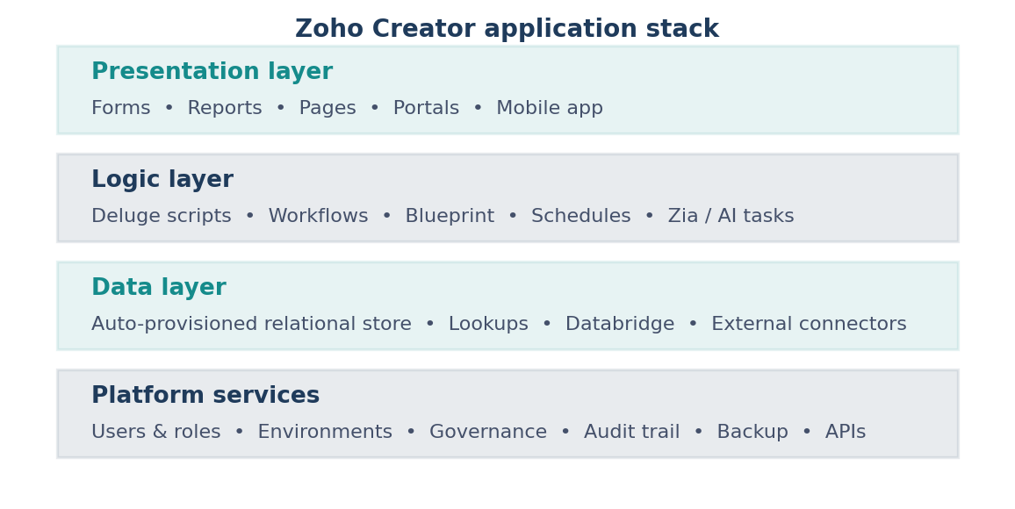
Figure 3: Layered view of the Zoho Creator application stack.

6.2 The Administrative Console: Develop, Deploy, Manage
Creator's administrative console divides platform functions into three categories that follow the application lifecycle. This structure is itself informative, because it shows which concerns the vendor considers distinct enough to warrant separate interfaces.
Category | Modules | Function
Develop | Applications, Microservices | Building the application and the reusable back-end services it calls
Deploy | Environments, Mobile, Portal | Releasing through a Development-Stage-Production pipeline, onto mobile devices, and to external users
Manage | Users, Organization, Governance, Metrics, Operations, Billing | Access control, identity, security policy, usage analytics, operational tooling and subscription
Table 3: Structure of the Zoho Creator administrative console.
The Environments module deserves particular attention, because a staged deployment pipeline is the single feature that most clearly separates a governed platform from an ungoverned one. Creator provides Development, Stage and Production environments with an explicit publish action between them and a version history that permits rollback. Without this, every edit a citizen developer makes is an edit to a live system — which is precisely the failure mode that gives low-code its reputation for fragility.
The Operations module aggregates the account-level tooling: backup, audit trail, logs, API management, email configuration, domain restriction, payment gateways, Databridge for synchronising with external databases, and the configuration entry point for Zia. Governance covers security policies, custom authentication, Active Directory synchronisation and custom domains. Together these two modules represent Zoho's answer to the governance question examined in Section 9.

6.3 AI Capabilities
Zoho has moved AI from a peripheral feature to a build-time capability. Zia, the platform-wide assistant, now spans several distinct functions in Creator. Application and form generation allow a schema and interface to be produced from a natural-language description. Zia's code assistance generates, annotates and optimises Deluge blocks from prompts. The Zia task in Deluge exposes large language models directly to application logic, so a workflow can summarise text, classify a support request or extract structured fields from an uploaded document as an ordinary step in a process.
Two design decisions are worth noting. First, Zia can be backed either by Zoho's own GenAI models or by external providers such as OpenAI, Gemini or Anthropic, configured per organisation — a meaningful choice for customers with data-residency constraints, though some assistance features have historically required an external provider. Second, AI configuration lives under Operations rather than inside the application builder, which places it under administrative control rather than developer discretion. That is a governance decision as much as a technical one.

6.4 Integration and Extensibility
Creator exposes REST APIs for record operations, supports webhooks in both directions, ships connectors for common third-party services, and integrates natively with the rest of the Zoho suite — CRM, Books, Desk, Analytics. Deluge's invokeUrl function makes any HTTP-accessible service reachable from within a workflow, which is the practical escape hatch for anything the connector library does not cover. Databridge synchronises with on-premises and external databases for organisations that cannot move their system of record into the platform.
The extensibility ceiling, when it is reached, is usually a matter of interface rather than logic. Creator's report and page layouts are configurable within limits; applications requiring a bespoke front-end experience will find those limits before they find any limitation in Deluge.

6.5 Editions and Cost
Creator is licensed per user across three published tiers — Standard, Professional and Enterprise — with a custom Flex tier for larger deployments, and a fifteen-day trial that defaults to Professional. Published rates place Standard in the region of USD 8-12 per user per month on annual billing, Professional around USD 20-25, and Enterprise around USD 25-37, with monthly billing carrying a substantial premium over annual. Higher tiers unlock custom domains, expanded Zia capabilities and additional environment and integration limits.
The commercially significant point is bundling: Zoho One includes Creator at Professional tier alongside the rest of the Zoho suite, which makes Creator effectively free for organisations already standardised on Zoho. This is a familiar competitive pattern — the same one Microsoft applies with Power Apps and Microsoft 365 — and it explains a good deal of Creator's market position independent of the product's technical merits.

6.6 Assessment
Strengths | Limitations
Low cost of entry relative to enterprise platforms; strong bundling with Zoho One | Deluge is proprietary, so logic does not port to another platform
Genuine governance tooling — environments, audit trail, security policies, directory sync | Interface customisation is limited compared with code-first frameworks
Deluge lowers the barrier to real logic without demanding a full programming background | Documentation quality is uneven across the more advanced modules
AI is integrated at build time and inside workflows, not bolted on as a chat sidebar | Some AI assistance features depend on configuring an external LLM provider
Mobile delivery and external portals are included rather than separate products | Heavy-scale or highly bespoke applications will reach platform ceilings
Table 4: Assessment of Zoho Creator as a low-code platform.

7. Emerging Trend 1: AI-Native and Agentic Development
The most consequential change in low-code for 2026 is that AI has moved from the finished application into the act of building it. The earlier generation of platforms offered AI as a feature you could add to an app — sentiment scoring, document extraction, a chatbot. The current generation uses AI to produce the app: a natural-language description yields a data model, a set of forms and a first draft of the workflow logic, which the builder then refines.
The distinction that matters is between assistive and agentic. Assistive AI completes a line of code or suggests a field type; the human remains the author. Agentic AI accepts an objective and executes a multi-step plan to reach it, calling tools and making intermediate decisions without per-step confirmation. Every major platform now ships assistive features; agentic execution is where they are competing, and where the risk profile changes materially, because an agent that misunderstands an objective can produce a large amount of plausible, wrong work quickly.
Three consequences follow. Platforms are building human-in-the-loop checkpoints as first-class workflow constructs rather than afterthoughts. Retrieval-augmented generation and vector storage are becoming standard platform services so AI features can be grounded in the organisation's own data. And review capacity is emerging as the real constraint on delivery speed — when generation becomes cheap, the bottleneck moves to verification.
- Prompt-to-application generation, compressing initial scaffolding from days to minutes for common patterns.
- AI assistance inside the scripting layer, generating and annotating code from natural-language intent.
- LLM calls as ordinary workflow steps, so classification, summarisation and extraction become configuration rather than integration projects.
- Agentic execution of multi-step tasks within defined guardrails, with explicit human review checkpoints.

8. Emerging Trend 2: Citizen Development and Fusion Teams
Citizen development — business users building their own applications — has shifted from an anomaly that IT tolerated to a formal operating model that IT designs. Estimates place roughly four in five low-code builders outside formal IT departments, and the direction of travel is clear even allowing for the softness of such figures.
The important development is not the raw numbers but the emergence of the fusion team as the organising unit: a cross-functional group combining domain experts who understand the process with professional developers who understand the architecture. The domain expert builds; the developer handles integration, performance and the parts of the system that must not fail. This structure resolves the tension that unstructured citizen development creates, where applications critical to a business function turn out to have been built by one person who has since changed roles.
The distinction between citizen development and shadow IT is entirely one of governance. Both describe business users building software outside the central development team. The first is sanctioned, bounded and visible; the second is none of those things. The practical difference lies in three questions: who is permitted to build, what data they may reach, and what an application must satisfy before it carries real work. Organisations that answer those questions in advance get citizen development; organisations that do not get shadow IT and discover it during an audit.

9. Emerging Trend 3: Governance-by-Design
Security and governance remain the largest barrier to enterprise low-code adoption, and the concern is well founded. A platform that makes application creation easy makes ungoverned application creation equally easy, and an application built by someone unfamiliar with data classification can move regulated information into an unmonitored store without anyone intending harm.
The pattern that has emerged in response is governance-by-design: rather than reviewing each application after it is built, the controls are embedded in the platform so that every application inherits a baseline security posture by default. Encryption, activity logging, role-based access, environment separation and data-source restrictions are configured once at the platform level and apply to everything built on it, regardless of who built it or whether they were thinking about security at the time.
Operationally this is usually delivered through a federated model. A central platform team defines standards and configures guardrails; trained champions within each business unit perform first-line review of applications in their own domain; only applications that touch sensitive data or reach production scale escalate to central review. This distributes the review burden without diluting the standard.
The most useful reframing to come out of this trend is that the remedy for shadow IT is substitution rather than prohibition. People route around IT because the sanctioned path is too slow, and blocking the alternatives without fixing the speed problem simply pushes the activity somewhere less visible. A governed platform that is genuinely fast removes the incentive.

61%  of IT leaders cite shadow IT as a top concern | 73%  of low-code adopters lack formal governance rules | 47%  report concerns about scalability limits | 39%  cite security as a direct barrier to adoption
Figure 4: Governance and risk concerns reported by enterprise IT leaders, 2026 survey composites.

10. Emerging Trend 4: Vertical and Industry-Specific Platforms
As the category matures, general-purpose platforms are increasingly joined by vertical products built for a single industry — healthcare, financial services, insurance, the public sector — shipping with pre-configured compliance controls, industry-standard data models and domain-specific templates. A general platform can be configured to satisfy healthcare privacy requirements; a vertical platform arrives already satisfying them, with the audit documentation prepared.
This follows a pattern common to maturing enterprise software categories. Once the core capability is broadly comparable across vendors, competitive advantage shifts to depth of fit for a particular regulatory and workflow context. The likely consequence over the next several years is segment consolidation: a small number of dominant vertical players per industry, with general-purpose platforms retaining the long tail of use cases that do not justify specialised tooling.

11. Emerging Trend 5: Composable and Open Architecture
Vendor lock-in has moved into the top tier of adoption concerns, and it is shaping product direction. Buyers increasingly favour platforms offering standard connectors, exportable logic, API-first design and integration with existing DevOps pipelines — treating low-code as one layer in a wider technology stack rather than a self-contained environment that owns everything it touches.
Composability also enables the hybrid model that is becoming the realistic end state for most organisations. Low-code and conventional engineering are not competing approaches to the same problem; they are appropriate to different problems, and a well-designed estate uses both. A low-code platform handles the operational application that needs to exist next month and will be rewritten in three years. Conventional engineering handles the core system that must run for a decade. The connective tissue between them — APIs, shared identity, common data contracts — determines whether the estate is coherent or merely adjacent.
It is worth noting the tension here. The composability trend runs directly against the bundling economics described in Section 6.5, where platforms compete by being deeply integrated with an ecosystem the customer already owns. Ecosystem integration is exactly what makes a platform difficult to leave. Buyers are, in practice, choosing between the convenience of integration and the optionality of portability, and most choose convenience while telling themselves otherwise.

12. Comparative Trend Assessment
The table below positions the five surveyed trends by their current maturity and expected trajectory. AI-native and agentic capabilities are the least mature but carry the highest projected impact; citizen development is already an operating norm in many organisations; governance-by-design is moving fastest from optional to mandatory.
Trend | Primary driver | Maturity (2026) | 3-year outlook
AI-native development | LLM-assisted generation of schema, UI and logic | Emerging | Baseline platform capability, not a differentiator
Agentic automation | Autonomous multi-step task execution | Early | Rapid uptake; review capacity becomes the constraint
Citizen development / fusion teams | Developer shortage and IT backlog | Maturing | Standard operating model in large organisations
Governance-by-design | Shadow IT and regulatory exposure | Early-growing | A procurement requirement rather than a feature
Vertical platforms | Compliance depth and domain templates | Growing | Consolidation around a few leaders per industry
Composable architecture | Vendor lock-in concerns | Growing | A differentiator among leaders; contested by bundling
Table 5: Comparative summary of emerging low-code trends, maturity and outlook.

13. Challenges and Risks
Rapid adoption has not resolved the tensions inherent in distributing software creation more widely. Five risk categories recur across the research and deserve explicit management.
- Scalability ceilings. An application designed for a department can behave badly under enterprise load. The failure is rarely dramatic; it is usually a gradual degradation that arrives after the application has become business-critical and after the person who built it has moved on.
- Vendor lock-in. Proprietary scripting languages and hosted data stores make migration expensive. The cost is invisible at purchase and becomes visible only when pricing or product direction changes, at which point the organisation has limited leverage.
- Security and compliance exposure. Citizen developers handling regulated data without adequate controls create genuine risk under frameworks such as GDPR, HIPAA or India's DPDP Act — usually through inadvertence rather than negligence.
- Integration and data fragmentation. Applications built in isolation duplicate data and processes rather than streamlining them, producing an estate that is individually convenient and collectively incoherent.
- Unreviewed AI output. As generation becomes cheaper, the volume of code and configuration entering production without meaningful review rises. Generated logic that is plausible but subtly wrong is harder to detect than logic that simply fails.
None of these argue against low-code adoption. They argue for establishing the governance structures described in Section 9 before citizen development scales rather than after — because retrofitting governance onto an existing estate of several hundred undocumented applications is a substantially harder problem than establishing it at the outset.

14. Future Outlook
Over the next three years the trends surveyed here are likely to converge rather than compete. AI-native generation and agentic execution will become baseline expectations, at which point they stop differentiating vendors and start differentiating the organisations that review their output well from those that do not. Governance-by-design will complete its migration from best practice to procurement checklist, and platforms without credible environment separation, audit trails and policy controls will be filtered out before evaluation begins.
Vertical platforms will consolidate as compliance depth becomes the primary competitive axis. Composable architecture will keep gaining ground rhetorically while bundling economics continue to pull in the opposite direction; the resolution will probably be partial, with organisations accepting lock-in for peripheral applications and insisting on portability for core ones.
The more interesting question concerns the developer role. If a platform can generate a working application from a description, the scarce skill is no longer construction — it is specification, judgement about what should be built, and the architectural discipline to keep a rapidly growing application estate coherent. That is a shift in what expertise means, not a reduction in the need for it.

15. Conclusion
Low-code development has crossed from emerging technology into enterprise infrastructure. The market survey in this report shows a category growing at twenty to thirty percent annually with the majority of new enterprise applications expected to involve low-code tooling, and the platform comparison shows a landscape that has segmented into distinct tiers serving genuinely different problems rather than a single undifferentiated market.
The detailed study of Zoho Creator illustrates what a mid-market platform looks like when it takes enterprise concerns seriously: a clear separation between building, deploying and administering; a staged release pipeline; governance tooling that would once have been enterprise-only; and AI integrated at build time under administrative control. Its principal weakness — a proprietary scripting language that makes exit expensive — is the same weakness shared by most of its segment, and is the specific thing the composability trend is reacting against.
The five trends surveyed are facets of a single underlying movement rather than independent developments. Software creation is being simultaneously democratised, accelerated by AI, and — necessarily — re-governed. Organisations that treat these as one coordinated shift capture the productivity gains. Organisations that pursue the first two while deferring the third accumulate an application estate they cannot account for, which is a slower and more expensive problem than the backlog they set out to solve.

16. References
Gartner. Magic Quadrant for Enterprise Low-Code Application Platforms, 2026.
Gartner. Forecast: Low-Code Development Technologies Market, 2026.
Grand View Research. Low-Code Application Development Platform Market Size, Share & Trends Report, 2024-2030.
Mordor Intelligence. Low-Code Development Platform Market - Growth, Trends and Forecasts (2026-2031).
Fortune Business Insights. Low-Code Development Platform Market Size, Share and Industry Analysis, 2026-2034.
Forrester Research. Enterprise Low-Code Adoption and Security Survey, 2026.
Kissflow. Low-Code Trends and Statistics Shaping Enterprise IT in 2026.
ToolJet. Low-Code Development Platforms: Statistics and Trends, 2026.
Zoho Corporation. Zoho Creator Product Documentation and Release Notes, 2026.
Zoho Corporation. Zoho Deluge Help - Zia Task and AI Tasks Reference, 2026.
Zoho Corporation. Zoho Creator Pricing Plans and FAQs, 2026.
Zoho Corporation. Zoho Adds Advanced AI Capabilities to its Low-Code Development Platform (press release).
Microsoft. Power Platform Governance Documentation, 2026.
Persistence Market Research. Low-Code Development Platform Market Share and Forecast, 2026-2033.
Primary observation: Zoho Creator trial account, administrative console walkthrough, July 2026.

