[NAME OF INSTITUTION]
[FACULTY / SCHOOL]
[DEPARTMENT]
[ INSERT INSTITUTION LOGO ]
PROJECT TOPIC:
SOCIETY ATTENDANT
A WEB-BASED STAFF ATTENDANCE MANAGEMENT SYSTEM FOR A HOSPITAL
PROJECT DOCUMENTATION
BY
[FULL NAME OF STUDENT]
[INDEX NUMBER]
Supervisor: [Name of supervisor]
September 2026

ABSTRACT
Accurate attendance records are central to running a hospital. Care is delivered around the clock in shifts, and staffing levels, payroll and professional accountability all depend on knowing who worked, when they started and when they left. Paper registers and shared spreadsheets cannot give managers that information reliably: entries are easy to forget, easy to alter and slow to summarise.
Society Attendant is a web-based staff attendance system built for a single hospital. Staff clock in and out at attendance terminals, which are computers registered at a physical location, by signing in with their own staff ID (or email) and password. For every attempt the server takes the time from its own clock, finds the staff member's rostered shift and works out whether the person was Present, Late or on a Half day, together with any overtime or early leave. Attempts that are refused are recorded too, with the reason. Administrators manage departments, staff accounts, shift templates, the roster, terminals and attendance rules; department heads oversee their own departments; and every staff member can review their own history and request a correction, with supporting evidence, when a recorded time is wrong.
The system is built with Next.js and TypeScript on the front end and Supabase (PostgreSQL, Authentication and Storage) on the back end. Authorization is enforced inside the database through row-level security and controlled database functions, so a mistake in the web application cannot expose or alter data that a role should not reach. Attendance events and audit entries are append-only. The project was delivered in eight phases and verified with 211 automated tests (81 unit tests and 130 database tests), all of which pass.
Keywords: attendance management, clock-in terminal, shift roster, hospital, row-level security, Next.js, Supabase, PostgreSQL.

ACKNOWLEDGEMENT
First, I am grateful to the Almighty God for good health, guidance and protection throughout this project.
My sincere thanks go to [Name and title of supervisor] for the guidance, corrections and encouragement that shaped this work, and to [Name and title of Head of Department] for keeping me on the right path throughout my studies.
I also thank [Name of host organisation / hospital, if applicable] and the staff who shared how attendance is currently recorded and who tested early versions of the system. Their feedback made the final design more practical.
Lastly, I thank my family and friends for their love, patience and support. May God bless you all.
TABLE OF CONTENTS

If the page numbers above are missing or out of date, right-click the table and choose Update Field, then Update entire table.

CHAPTER ONE: INTRODUCTION

1.1 Introduction
This chapter introduces the study. It gives the background to attendance management in hospitals, states the problem the project addresses, sets out the research questions and objectives, and defines the scope and significance of the work. It closes with a short guide to how the rest of the document is organised.
The project delivers Society Attendant, a clock-in and clock-out system for one hospital. Its purpose is to replace manual attendance registers with a system that records who worked, when and where, applies the hospital's rules consistently, and gives each kind of user only the information they are entitled to see.

1.2 Background of the Study
A hospital never closes. Nurses, doctors, laboratory staff, pharmacists, porters and administrative staff work in shifts that start in the morning, in the afternoon or late at night, and many shifts end on the following calendar day. Managers must know that each ward and unit is covered, and the payroll office must know how many hours each person actually worked, including late arrivals, early departures and overtime.
Many facilities still rely on paper attendance books or on spreadsheets updated by hand at the end of the day. These methods are cheap to start with, but they scale badly. A signature in a book says little about the exact time it was written. A spreadsheet can be edited without trace. Turning either into a monthly summary means re-typing and re-counting, which is slow and error-prone.
Digital attendance systems address these weaknesses by capturing the time automatically, linking each entry to an identified person and calculating results by rule. They differ mainly in how they identify the person and the place: punch cards and paper tickets, fingerprint or face readers, QR codes scanned with a phone, or a password entered at a fixed computer. Each choice carries trade-offs in cost, convenience and how easily it can be abused. Chapter Two compares them, and Chapter Three explains why Society Attendant records attendance at registered terminals.
Well-designed attendance software brings several benefits to a hospital:
- Reliable time records. The time comes from the server, not from the person clocking in, and cannot be typed in or edited by staff.
- Fair, consistent rules. Lateness, half days, overtime and early leave are computed by the same rules for everyone, and each record keeps the rules it was judged by.
- Visibility. Department heads and administrators see who is on duty, who is late and who is absent while the shift is still running.
- Accountability. Every change is logged with who made it and why, so disputes can be settled from evidence instead of memory.
- Less paperwork. Reports and exports are produced from the records directly, without re-entering data.

1.3 Statement of the Problem
Attendance in the hospital is currently recorded on paper or in loosely controlled spreadsheets. This creates the following problems:
- Unreliable times. Staff write their own arrival and departure times, often after the fact, so recorded times cannot be trusted for payroll or investigations.
- Proxy entries. One person can sign for another, and nothing shows that the person was actually present.
- No link to the roster. Whether someone was late, absent or worked overtime has to be worked out by hand by comparing the register with the duty roster, particularly for night shifts that cross midnight.
- Late and missing information. Department heads learn about absences after the shift is over, when it is too late to arrange cover.
- Uncontrolled corrections. When a time is wrong, it is overwritten in the book or the spreadsheet with no record of the original, who changed it or why.
- Weak privacy. A shared file or book exposes everyone's attendance to everyone who can open it, while a department head should see only their own department.
- Slow reporting. Summaries for payroll and management take days to prepare and are difficult to check.
There is therefore a need for a system that captures attendance in a way that identifies the person and the place, calculates outcomes automatically from the roster, controls who can see and change what, and preserves the original evidence when corrections are made.

1.4 Research Questions
- How can a clock-in be tied to a verified person and a verified place without requiring personal phones, location tracking or biometric hardware?
- How can the outcome of a shift (present, late, half day, absent, overtime, early leave) be calculated consistently for day shifts and for night shifts that cross midnight?
- How can access be limited by role and by department so that a mistake in the web application cannot expose or change data that a user should not reach?
- How can attendance records be corrected without destroying the original evidence?

1.5 Objectives of the Study

1.5.1 General Objective
To design, implement and test a web-based staff attendance system for a hospital that records verified clock-in and clock-out events, applies the hospital's attendance rules automatically and produces reliable attendance reports.

1.5.2 Specific Objectives
The specific objectives of the study are to:
- provide clock-in and clock-out at registered attendance terminals, where each person is identified by their own credentials;
- derive attendance status, lateness, worked time, overtime and early leave from the server clock and the rostered shift, including overnight shifts;
- manage departments, staff records and accounts, shift templates and rosters;
- restrict access by role and department, and enforce the restriction in the database itself;
- provide a correction workflow that requires a reason, allows supporting evidence, is reviewed by an administrator and keeps the original scan log intact;
- provide reports with CSV export, in-app notifications and a tamper-evident audit log; and
- verify the system with automated unit and database tests.

1.6 Scope of the Study
Society Attendant is designed for one hospital. It is used by four kinds of user: the super administrator (who sets up the hospital), hospital administrators, department heads and staff members. The system covers the following areas.
- Hospital set-up and settings – hospital details, time zone and attendance rules.
- Workforce – departments, staff records, staff accounts (invitation or administrator-created), suspension and termination.
- Scheduling – reusable shift templates and a dated roster, with support for overnight shifts.
- Attendance capture – locations, attendance terminals and the clock-in and clock-out screen.
- Attendance records – daily views for administrators and department heads, and personal history for staff.
- Corrections and notifications – correction requests with optional evidence, administrator review and in-app notifications.
- Insight and control – attendance reports with a daily chart and CSV export, and an audit log.
The following are outside the scope of the current version:
- leave management (leave types, requests and approvals were designed at first and then deliberately removed);
- QR-code and phone-based clock-in, and any recording of a phone's position;
- biometric identification and staff photographs (designed but not built);
- payroll calculation, although reports can be exported for payroll use;
- multiple hospitals in one installation (the database carries a hospital identifier on every table, but only one hospital can be created); and
- a native mobile application.

1.7 Significance of the Study
The study matters to several groups.
- Hospital management gains an accurate, timely view of staffing and can settle attendance disputes from evidence.
- The payroll and HR office receives consistent, rule-based figures for worked time, overtime and absence, and can export them without re-typing.
- Department heads see their own team's attendance while a shift is running, without seeing other departments.
- Staff get a fair and transparent record of their own attendance, and a clear route to correct mistakes.
- Future developers and researchers get a documented example of enforcing authorization in the database and of designing an attendance engine around server time, snapshots and append-only evidence.
Beyond attendance, the project shows how sensitive workplace data can be protected by several independent layers (interface checks, server checks and database rules), so that no single mistake exposes it.

1.8 Definition of Key Terms
Table 1.1: Key terms used in this document
Term | Meaning
Attendance terminal | A computer registered by an administrator at a location. It holds a secret key in its browser and shows the clock-in screen at /terminal.
Clock in / clock out | Recording the start and end of a working session at a terminal.
Staff ID | The employee number of a staff member; it can be used instead of an email address to sign in at a terminal.
Shift template | A reusable definition of a shift: start time, duration, break, grace periods and overtime threshold.
Roster (shift assignment) | A dated entry that gives a staff member a shift template on a particular day.
Attendance record | The business result for one shift session: times, status, late minutes, worked minutes, overtime and flags.
Attendance event | One entry in the append-only clock log, written for every attempt, accepted or rejected.
Grace period | Minutes after the start (or before the end) of a shift that are tolerated before a person counts as late or as leaving early.
Half day | A session in which less than a set percentage of the scheduled time was worked.
Correction | A request to change the recorded clock-in or clock-out time, reviewed by an administrator.
Row-level security (RLS) | PostgreSQL feature that decides, row by row, which rows each database user may read or change.
RPC (database function) | A named database function called by the application to perform a controlled action, such as check_in.
Audit log | An append-only record of changes to important data, with the acting user, time, changed fields and reason.
Super admin | The account that sets up the hospital and can edit its details; it also holds every hospital admin capability.
Hospital admin | An administrator who manages staff, roster, terminals, settings, reports and corrections.
Department head | A staff member who heads a department; this is derived from the department record, not stored as a separate role.

1.9 Organization of the Study
Chapter One introduces the study: background, problem statement, research questions, objectives, scope, significance and key terms.
Chapter Two reviews related literature. It compares ways of capturing attendance, discusses the strengths and limitations of digital attendance systems, and describes the tools and technologies used to build the system.
Chapter Three presents the analysis and design: the development approach, requirements, design decisions, architecture, roles and access control, database design, the attendance engine, security design and user interaction.
Chapter Four describes the implementation, the system interfaces and the testing carried out, including the automated test results and the error messages shown for invalid actions.
Chapter Five summarises the work, analyses the implemented system against the objectives, states its strengths and limitations, and makes recommendations for future work.
References and appendices follow. The appendices contain the screenshot checklist, the set-up and deployment guide and a command reference.

CHAPTER TWO: LITERATURE REVIEW

2.0 Introduction
This chapter reviews the ideas and technologies on which Society Attendant is built. It traces how attendance has been recorded, compares the main capture methods, discusses the strengths and limitations of digital attendance systems, explains the security concepts that shaped the design and describes the development tools used.

2.1 Overview
Recording attendance is one of the oldest administrative tasks in organised work. Early systems were paper registers signed by the worker or a supervisor. Mechanical time clocks and punch cards later stamped the time automatically. Electronic badge readers and biometric devices followed, and today web and mobile applications can record attendance from almost any device.
Whatever the technology, an attendance system has to answer three questions. Who is clocking in? Where are they? When is it happening? A paper register answers none of them reliably: the signature can be forged, nothing proves the place, and the time is whatever the person writes. Each later technology improves on one or more of the answers, and each introduces new costs and new ways to cheat.
Hospitals add two further requirements. First, work is organised in shifts that often cross midnight, so "the day" of an attendance record cannot simply be the calendar date of the clock-out. Second, attendance data feeds payroll and staffing decisions, so corrections must be possible but traceable. A system that forbids corrections will be bypassed, and one that allows silent corrections cannot be trusted.

2.2 Ways of Capturing Attendance
Table 2.1 compares the approaches most commonly used. The comparison is qualitative and reflects the trade-offs considered during the design of Society Attendant.
Table 2.1: Comparison of attendance capture methods
Method | How the person is identified | How presence is established | Strengths | Weaknesses
Paper register | Signature | None; relies on trust | No cost; no training | Proxy signing; times are self-reported; manual summaries; no audit trail
Punch card or time clock | Card or ticket | Device on site | Simple and familiar | Cards can be punched by colleagues; hardware and maintenance; no roster logic
Biometric reader | Fingerprint or face | Device on site | Hard to share | Hardware cost; false rejections; hygiene concerns; heavy privacy obligations for biometric data
QR code scanned on a phone | Logged-in account on the phone | The code has been seen; optional phone location | No dedicated hardware | A photographed code can be scanned from anywhere; phone location is reported by the phone and can be faked; needs a smartphone for every user
Password at a registered terminal (chosen) | Staff's own ID or email and password | A registered computer's secret key | No special hardware; no phones; no location data; every rule checked on the server | A typed password can be given to a colleague; the terminal's key must be protected

Society Attendant was first designed around a static QR code posted at each location, with optional recording of the phone's position. The design review recognised the limits of that approach: a static code proves only that its holder has seen the code, and the position a browser reports is supplied by the client and can be faked. In the final phase the QR mechanism, the location recording and the leave module were removed, and clock-in moved to registered terminals. A clock-in now needs both a valid password sign-in for the person and the secret key of a registered terminal. Someone at home has a password but no key; someone at the terminal has the key but can clock in only the person whose password they type.
Honest limitation. No password-based system can stop a person from typing a colleague's password. The system records the terminal and time of every attempt so that such cases can be investigated, but it does not claim to prevent them. Chapter Five returns to this limitation.

2.3 Related Systems and the Gap
Commercial human-resource suites and dedicated time-and-attendance products are widely available. They offer rich feature sets, including payroll integration, leave accrual and analytics. For a single hospital wanting straightforward, trustworthy clock-in records they can also bring high subscription costs, complex configuration and data hosted outside the organisation. General-purpose task and project tools, which are commonly cited in the literature on workplace productivity, are not built around shifts, server-side time or evidence-preserving corrections.
The gap that Society Attendant addresses is a focused, hospital-shaped attendance system that (a) understands rostered and overnight shifts, (b) takes time only from the server, (c) enforces who may see and change what inside the database and (d) keeps immutable evidence of every attempt while still allowing controlled corrections.

2.4 Strengths and Limitations of Digital Attendance Systems

2.4.1 Strengths
- Objective time stamps. The server clock removes self-reported times.
- Automatic calculation. Lateness, half days, overtime and absences are derived from the roster by the same rules for everyone.
- Real-time visibility. Managers can see who has clocked in while the shift is still running.
- Audit trails. Every change can be attributed to a person and a reason.
- Reduced administration. Reports and exports are produced directly from the data.
- Fine-grained access. Each user sees only what their role allows.

2.4.2 Limitations
- Adoption effort. Staff must learn a new routine, and terminals must be installed and kept locked down.
- Dependence on infrastructure. If the network or the hosted database is unavailable, clock-in is unavailable.
- Residual cheating. Any method that identifies people by something they know or hold can be shared.
- Data protection duties. Attendance records are personal data and must be protected and retained responsibly.
- Roster quality. Automatic results are only as good as the roster; a missing roster entry produces a rejection or a flagged, unscheduled record.
In summary, digital attendance systems deliver reliable, timely records when they are combined with sound security, a well-maintained roster and clear procedures for corrections (Sommerville, 2016).

2.5 Concepts Behind the Design

2.5.1 Role-based Access Control and Least Privilege
Role-based access control grants permissions to roles rather than to individuals, and the principle of least privilege says that each role should hold only the permissions it needs. Society Attendant defines a small set of named capabilities (for example staff.manage, attendance.viewDepartment or corrections.review) and grants them to the super admin, hospital admin, department head and staff roles. The department head role is derived from the department record rather than stored, so changing a head changes their access immediately.

2.5.2 Row-Level Security and Defence in Depth
Row-level security (RLS) is a PostgreSQL feature in which policies attached to a table decide, for each row, whether the current database user may read or change it (PostgreSQL Global Development Group, n.d.). Because the rule lives in the database, it applies whether the request comes from the application, a script or a mistaken query. Security guidance such as the OWASP Application Security Verification Standard recommends enforcing access control on a trusted server-side layer rather than trusting the client (OWASP, 2021). Society Attendant applies defence in depth: the interface hides what a user should not see, the server re-checks every request, and the database enforces the rule finally.

2.5.3 Append-only Logs and Audit Trails
An audit trail is only valuable if it cannot be edited. Two append-only stores are used: the attendance event log, which records every clock attempt, and the audit log, which records changes to important tables. Database triggers reject updates and deletes, and privileges are revoked from the application roles, so even a compromised application role cannot rewrite history.

2.5.4 Server-authoritative Time and Snapshots
Anything a browser sends can be forged, including the current time. The attendance engine therefore ignores client time entirely and uses the database clock. Each attendance record also stores a snapshot of the shift times and policy values it was judged by, so changing a shift template later never silently changes past results.

2.5.5 Separating Identity from Employment
A person's login (identity) and their employment record are different things. Staff may be added to the system before they have an account, and some accounts, such as the super admin's, have no staff record. Society Attendant therefore keeps profiles (login and authorization) apart from staff (the employment record) and links them only when an account is created for a staff member.

2.6 Development Tools and Technologies
Table 2.2 lists the main technologies. The sub-sections that follow explain the role each plays in the system.
Table 2.2: Technologies used in Society Attendant
Layer | Technology | Version | Role in the system
Language | TypeScript | 5.x | Type-safe code for the application, scripts and tests
Front end and server | Next.js (App Router) | 16.3 | Routing, server-rendered pages, server actions, session proxy
UI library | React | 19.2 | Component-based user interface
Database | PostgreSQL via Supabase | 15+ | Tables, row-level security, functions, views, scheduled job
Authentication | Supabase Auth | supabase-js 2.x | Invite-only accounts, password sign-in, recovery
File storage | Supabase Storage | – | Private bucket for correction evidence
Validation | Zod | 4.x | Input validation and response-shape checks on the server
Forms | React Hook Form | 7.x | Form state with Zod resolvers
Charts | Recharts | 3.x | Daily attendance chart in reports
Dates | date-fns | 4.x | Date arithmetic and formatting
Styling | CSS Modules and custom design tokens | – | Consistent teal-and-white interface without a UI framework
Icons | lucide-react | 1.x | Navigation and status icons
Testing | Node.js test runner and PGlite | Node 22 | Unit tests, and database tests against an in-memory PostgreSQL
Quality | ESLint and the TypeScript compiler | 9.x / 5.x | Static analysis and type checking

2.6.1 TypeScript
TypeScript adds static types to JavaScript. In this project the database types are generated from the migration files (npm run db:types), so the application is checked against the real schema and a change to a table shows up as a compile error instead of a runtime failure.

2.6.2 Next.js and React
Next.js is a React framework that provides file-based routing, server components and server actions, which are functions that run only on the server and are called from forms. Society Attendant uses the App Router with three route groups: public authentication pages, signed-in application pages and the public terminal page. A request proxy refreshes the session and redirects unauthenticated visitors. React builds the interface from small reusable components such as tables, panels, badges and form fields.

2.6.3 Supabase and PostgreSQL
Supabase provides a managed PostgreSQL database with authentication and file storage. PostgreSQL does most of the work in this system: it enforces row-level security, holds the attendance engine as functions, stores generated columns that keep lateness and overtime consistent, uses an exclusion constraint to reject overlapping shifts for the same person, and, through the pg_cron extension, runs a job every ten minutes that marks missed shifts as absent and closes forgotten sessions.

2.6.4 Zod and React Hook Form
Zod describes the expected shape of each input (for example a password of at least twelve characters or a correction reason of at least ten). The same schemas validate form input on the server and check the shape of results returned by the database, so unexpected data is rejected early. React Hook Form manages form state in the browser and uses Zod for client-side messages. The database still repeats the rules that must hold whoever calls it.

2.6.5 Recharts, date-fns and the interface layer
Recharts draws the daily attendance chart in the reports page. date-fns performs date arithmetic, and the application takes care to use the hospital's calendar day and time zone rather than the server's. The interface is styled with CSS Modules and a small set of design tokens (a teal primary colour on a light canvas), and icons come from lucide-react.

2.6.6 Testing tools
Unit tests run on Node's built-in test runner, which executes TypeScript directly. Database tests use PGlite, an in-memory build of PostgreSQL, so the migrations and every security policy can be tested without Docker or a database server. Each test runs as a specific role inside a transaction that is rolled back afterwards.

CHAPTER THREE: SYSTEM ANALYSIS AND DESIGN
This chapter explains how Society Attendant was analysed and designed. It uses tables, an architecture diagram, an entity-relationship diagram, a use case diagram and a flowchart to describe the components and how they interact.

3.1 Software Development Methodology
The project followed an iterative, phase-based approach in which a written design came first and each phase built a working increment on top of the last. Incremental delivery lets the developer test each part and adjust the design as understanding grows (Sommerville, 2016). Eight phases were completed, and each ended with passing automated tests before the next began (Figure 3.1).
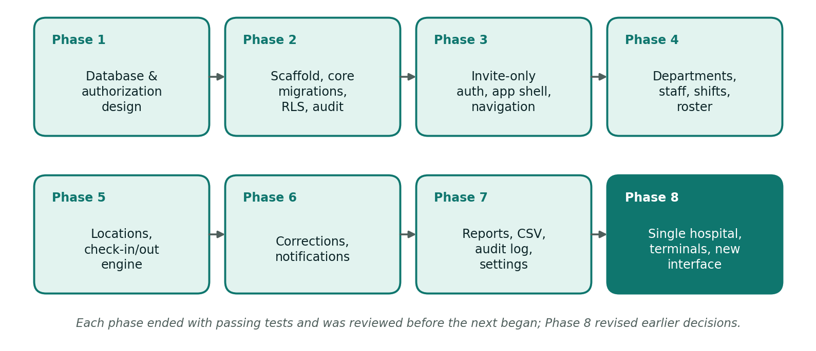
Figure 3.1: The eight development phases of Society Attendant
Table 3.1: Development phases and what each delivered
Phase | Scope | Outcome
1 | Database and authorization design | Written design of tables, roles, the attendance engine, storage and a threat model
2 | Scaffold, core migrations (tenancy, identity, organization, scheduling), RLS, audit, database tests | Secure foundation with tests before any interface existed
3 | Invite-only authentication, application shell, role-aware navigation | Users can sign in and see only the menu items their role allows
4 | Departments, staff (with account invitations), shift templates, roster | Workforce and scheduling modules
5 | Attendance locations, check-in and check-out engine, attendance views | Attendance recorded and judged by rule
6 | Attendance corrections and notifications | Controlled corrections with review and notifications
7 | Reports and CSV export, audit log viewer, settings, attachments | Insight, control and evidence uploads
8 | Single hospital, attendance terminals (replacing QR codes), leave removed, new interface | Simplified scope and a stronger clock-in mechanism

Phase 8 shows why an iterative approach suited the project. After review, the multi-hospital design, QR-code clock-in, location recording and leave module were judged either unnecessary or too easy to abuse, and they were replaced or removed. The change was made through new, additive migrations and the tests were updated with it, which is only practical when design, code and tests are kept together.

3.2 Requirements

3.2.1 Functional Requirements
Table 3.2: Functional requirements
ID | Requirement
FR1 | Accounts are created by invitation or by an administrator only; public sign-up is disabled. Passwords have at least 12 characters.
FR2 | Administrators create staff records, invite staff or create accounts with a password, and can suspend, terminate or reactivate staff. Deactivation removes access on the next request.
FR3 | Administrators manage departments and appoint a head for each.
FR4 | Administrators define shift templates (start time, duration, break, late and early-leave grace, overtime threshold, how early clock-in opens), including shifts that cross midnight.
FR5 | Administrators assign shifts to staff for a date range and chosen weekdays; overlapping shifts for one person are rejected.
FR6 | Administrators create attendance locations, register a computer as a terminal at a location, and switch terminals off.
FR7 | Staff clock in and out at a terminal using their staff ID or email and password.
FR8 | The system decides Present, Late, Half day or Absent, and calculates worked time, overtime and early leave, from the server clock and the rostered shift.
FR9 | Every clock attempt, accepted or rejected, is written to an append-only event log with its reason and terminal.
FR10 | A scheduled job records absences for shifts that ended with no clock-in and closes sessions that were never clocked out, without inventing a clock-out time.
FR11 | Staff see their own roster and attendance; department heads see their departments; administrators see the whole hospital.
FR12 | Staff request corrections to clock times with a reason and optional evidence (image or PDF up to 6 MB). Only administrators decide them, and never their own.
FR13 | Users receive in-app notifications when a correction is submitted (reviewers) or decided (requester).
FR14 | Authorized users produce attendance reports for a date range and department, with a daily chart and CSV export.
FR15 | Administrators read an audit log of changes with actor, time, reason and changed fields.
FR16 | Administrators configure attendance rules: minimum time between clock-in and clock-out, clock-out window, half-day threshold and whether unscheduled clock-in is allowed.
FR17 | Accounts created with an administrator-supplied password must choose their own at first sign-in; administrators can reset a forgotten password; users can request a reset link by email.

3.2.2 Non-functional Requirements
Table 3.3: Non-functional requirements
Quality | Requirement | How the design meets it
Security | Only authorized users see or change data; no silent tampering | Row-level security on every table, controlled database functions, append-only logs, server-only secret key
Integrity | Attendance results are consistent and explainable | One calculation function; snapshots of shift and policy values in each record; generated columns for late, early and overtime flags
Reliability | Concurrent or repeated clock-ins cannot corrupt data | Row locking, a unique index allowing one open session per person, and an idempotent scheduled job
Privacy | Collect the minimum personal data | No phone location, no biometrics, no staff photos; evidence stored in a private bucket with signed links
Usability | Staff can clock in quickly and understand any refusal | A single short form; plain-language error messages; the screen clears itself for the next person
Maintainability | Code is easy to extend and check | Feature modules with schemas, queries and actions; generated database types; migrations as the single source of truth
Testability | Rules can be verified automatically | 81 unit tests and 130 database tests that need no external services
Portability | Deployable on common infrastructure | Any host that runs Next.js plus a Supabase project

3.3 Design Philosophy and Key Decisions
The design follows five principles: keep it simple, enforce rules where they cannot be bypassed, record evidence rather than overwrite it, give every role the least access it needs, and make results explain themselves. Table 3.4 lists the decisions that follow from them.
Table 3.4: Key design decisions and their rationale
# | Decision | Rationale
D1 | The database carries a hospital_id on every table, but the system serves one hospital. | Keeps every access rule and test simple. The single-hospital rule is enforced where a hospital is created: the database refuses a second one.
D2 | Composite foreign keys tie child rows to the same hospital as their parent. | The database itself rejects, for example, a staff member being given another hospital's shift, even if the application has a bug.
D3 | Login (profiles) and employment (staff) are separate tables. | Staff can exist before they have an account, and a super admin needs no staff record.
D4 | Department head is derived from the department record, not stored as a role. | One source of truth; changing the head changes access immediately.
D5 | Attendance is split into attendance_records (business result) and attendance_events (append-only clock log). | Original clock times survive any correction.
D6 | The clock-in engine is a set of database functions. | A clock-in must validate, lock, check duplicates, compute and insert atomically. The database is the last security boundary, so calling the function directly cannot bypass a rule.
D7 | No client role writes attendance, corrections, notifications or audit rows directly. State changes go through functions; plain master data is written under RLS. | Keeps the function surface small and workflows impossible to bypass.
D8 | Shifts are stored as start time plus duration. | Removes the ambiguity of overnight shifts (a shift from 23:00 to 07:00).
D9 | Roster rows store computed start and end instants in the hospital's time zone. | The engine never does date arithmetic at clock-in time; an overnight shift is just a time range.
D10 | Each attendance record snapshots the shift times and policy values it was judged by. | Editing a template later never changes history.
D11 | Status is never set by hand; corrections change times, and the engine recomputes status. | Prevents "just mark them present" edits.
D12 | Audit logging uses a generic row trigger plus a transaction-local reason. | Every change to a sensitive table is captured automatically.
D13 | The secret (service-role) key is used only in one server-only module, only for Auth admin calls. | Everything else runs with the user's own session, so RLS always applies.
D14 | Staff clock in at registered terminals; no QR codes, no location recording, no leave. | A stronger and simpler mechanism after design review (see Section 2.2).

3.4 System Architecture
Society Attendant is a three-tier web application (Figure 3.2). Browsers talk to a Next.js application server, which talks to Supabase. There are three kinds of client: the staff portal (any device), administrators using the same portal, and attendance terminals, which open only the clock-in screen.
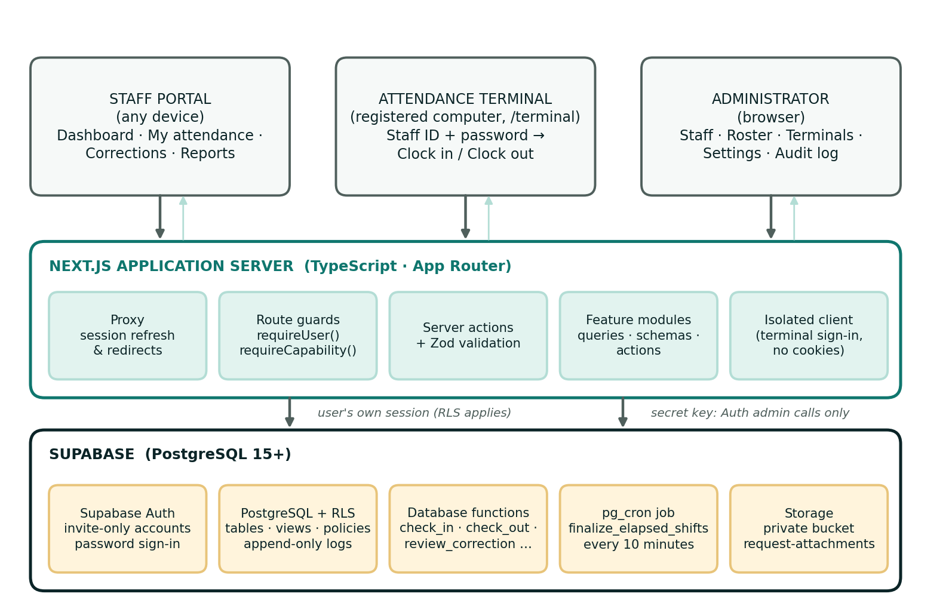
Figure 3.2: System architecture of Society Attendant

3.4.1 Application Server
- Proxy (src/proxy.ts) refreshes the session on every request and redirects visitors who are not signed in. This is a convenience; it is not the security control.
- Route guards requireUser() and requireCapability() protect every page and server action. The user's profile, staff record and headed departments are read under RLS, so deactivation takes effect on the next request.
- Server actions receive form data, validate it with Zod and call the database with the user's own session. The hospital identifier always comes from the server, never from the browser.
- Feature modules hold each area's schemas, queries and actions.
- Isolated client signs a person in at a terminal without touching the browser's cookies, calls the clock function as that person and revokes the session immediately.

3.4.2 Supabase
- Auth creates accounts (invite-only) and verifies passwords.
- PostgreSQL holds the tables, RLS policies, views, the attendance engine and the scheduled job.
- Storage keeps correction evidence in the private request-attachments bucket, organised by hospital and staff member, and served through short-lived signed links.

3.4.3 Feature Modules
Table 3.5: Feature modules under src/features
Module | Responsibility
auth | Sign-in, forgot password, set password, invitation confirmation
hospitals, settings | Hospital set-up and attendance rules
departments, staff | Departments and heads; staff records, accounts, status changes, password provisioning and reset
shifts, roster | Shift templates; roster grid and bulk assignment
locations, terminals | Attendance locations; terminal registration, switch-off and the clock-in screen
attendance | Attendance queries, labels and clock-in response contracts
corrections, attachments | Correction requests and review; evidence upload and signed links
notifications | In-app notification queries and read state
reports | Attendance summary, daily totals, chart and CSV export
audit | Audit log queries and readable labels

3.5 Roles and Access Control
There are three account roles stored in the database (super_admin, hospital_admin and staff), plus one derived role. A person's effective capabilities are the union of what their account role, their staff record and any department they head allow. An inactive account has no capabilities at all.
Table 3.6: Access by role
Function | Super admin | Hospital admin | Department head | Staff
Set up and edit the hospital | Yes | – | – | –
Attendance rules (settings) | Yes | Yes | – | –
Departments | Manage | Manage | View | View
Staff records and accounts | Manage | Manage | View own department | Own record
Shift templates | Manage | Manage | – | –
Roster | Manage | Manage | View own department | View own
Locations and terminals | Manage | Manage | – | –
Attendance records | Whole hospital | Whole hospital | Own department | Own
Clock in and out at a terminal | If a staff record exists | If a staff record exists | Yes | Yes
Request a correction | – | – | Yes (as staff) | Yes
Review a correction | Yes (not own) | Yes (not own) | View only | –
Reports and CSV export | Whole hospital | Whole hospital | Own department | –
Audit log | Yes | Yes | – | –

The navigation menu is built from the same capabilities, so each user sees only the sections they may use. The menu is grouped as Overview, My work, Attendance, Workforce, Insights and Administration. Navigation only shapes the interface; the database remains the enforcement point.

3.6 Database Design
The schema is defined by fourteen ordered migration files and is the single source of truth. It has fifteen application tables, one private table for short-lived super admin grants, six read-only views and a private schema for helper functions that is never exposed through the Data API.

3.6.1 Tables
Table 3.7: Application tables
Table | Purpose | Key points
hospitals | The one hospital | Unique code; IANA time zone validated; a second row is refused
hospital_settings | Attendance rules | Typed columns with range checks; created with the hospital
profiles | Login and authorization | One per Auth user; role, active flag, activation time, must-change-password flag
account_invitations | Authorizes an account before Auth creates it | Short-lived; append-only; readable by administrators only
departments | Organisational units | Unique name and code per hospital; optional head (a staff member)
staff | Employment records | Unique employee number and email; status active, suspended or terminated; optional link to a profile
shifts | Shift templates | Start time, duration, break, grace periods, overtime threshold, check-in opening; generated "crosses midnight" flag
shift_assignments | The roster | Work date with computed start and end instants; exclusion constraint rejects overlaps for one person
attendance_locations | Places where terminals stand | Unique name; active flag
attendance_terminals | Registered computers | Only the hash of the secret key is stored; revocable; last-used time
attendance_records | One row per shift session | Snapshot of shift and policy values; generated late, early-leave and overtime flags; one open session per person
attendance_events | Append-only clock log | Every attempt with outcome, rejection code, terminal and location
attendance_corrections | Correction requests | Requested times, reason, optional evidence path, status, reviewer; one pending request per record
notifications | In-app notifications | Recipient, type, title, link, read time
audit_logs | Append-only change history | Actor, role, table, row, old and new data, reason, source

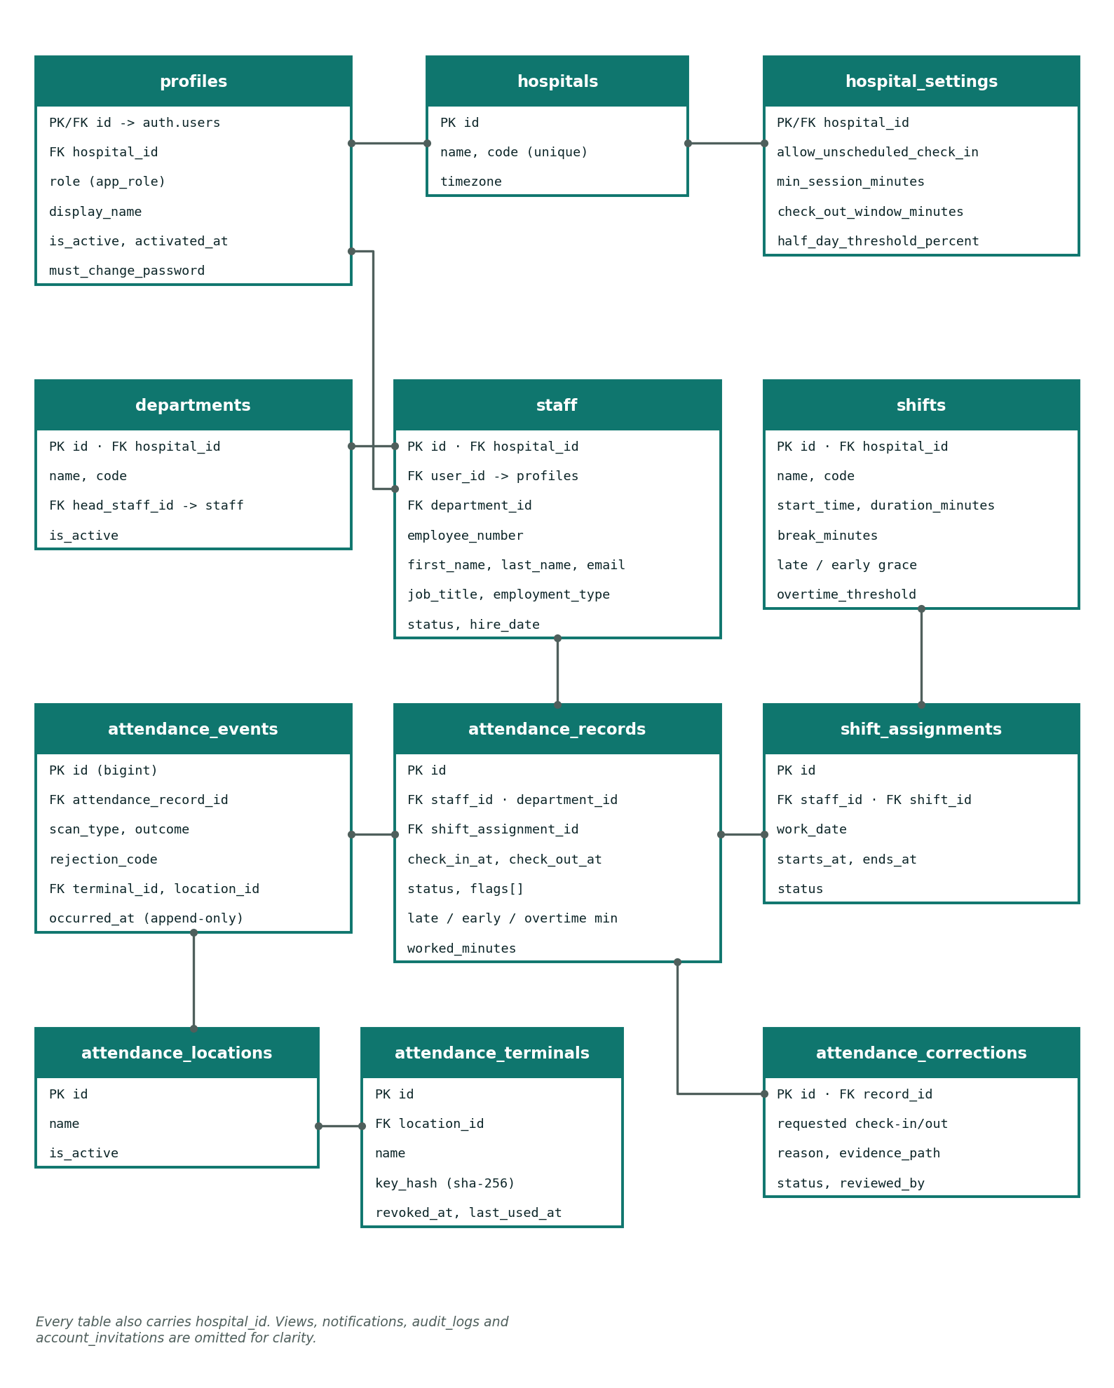
Figure 3.3: Entity-relationship diagram of the core tables
The diagram shows the core relationships. Staff belong to a department and may be linked to a login profile; shifts are assigned to staff on dated roster rows; each attendance record belongs to a staff member and, when the shift was rostered, to a shift assignment; events and corrections point to the record they concern; and terminals belong to a location. Every table also carries the hospital identifier.

3.6.2 Enumerations
Table 3.8: Enumerated types
Type | Values
app_role | super_admin, hospital_admin, staff
staff_status | active, suspended, terminated
employment_type | full_time, part_time, contract, locum, intern
assignment_status | scheduled, cancelled
attendance_status | present, late, absent, half_day, off_day (report only); on_leave is kept only so older records still load
attendance_flag | unscheduled, missed_check_out (two older flags remain for legacy records)
scan_type / scan_outcome | check_in, check_out / accepted, rejected
request_status | pending, approved, rejected, cancelled
notification_type | correction_submitted, correction_reviewed

3.6.3 Integrity Rules Enforced by the Database
- Composite foreign keys keep child rows in the same hospital as their parent.
- One open session per person is guaranteed by a partial unique index, the final defence against double clock-ins.
- No overlapping shifts for a person, by an exclusion constraint on the time range (double shifts and back-to-back shifts are allowed).
- Generated columns derive the late, early-leave and overtime flags from stored minutes so they can never disagree.
- Check constraints tie a record's status to its times, for example an absent record has no clock-in.
- Append-only tables: attendance events, audit logs and account invitations reject update and delete, even for the table owner.
- Views with ~security_invoker~ apply the caller's row-level security, so list pages cannot leak data through a view.

3.6.4 Views
Six read-only views join related tables for list pages while keeping RLS in force: attendance_overview, attendance_corrections_overview, attendance_terminals_overview, audit_log_entries, department_directory and staff_directory. The terminal overview shows when each terminal was last used and never exposes the key hash.

3.7 The Attendance Engine
The engine lives in PostgreSQL. A single shared calculation produces every outcome, and it is used by clock-out, by correction approval and by the scheduled job.

3.7.1 Calculation Rules
net_scheduled = (scheduled_end - scheduled_start) - break_minutes
late_minutes = max(0, check_in_at - scheduled_start) (minutes)
early_leave_minutes = max(0, scheduled_end - check_out_at) (minutes)
overtime_minutes = max(0, check_out_at - scheduled_end) (minutes)
worked_minutes = max(0, (check_out_at - check_in_at) - break_minutes)

status = absent if there is no check_in_at
half_day if worked_minutes < net_scheduled x half_day_threshold%
late if late_minutes > late_grace_minutes
present otherwise

Arriving early counts towards worked time but not towards overtime, and overtime counts only after the scheduled end. A person can be late and still work overtime, or arrive on time and leave early, so those facts are stored as separate minutes with generated flags instead of being squeezed into one status.

3.7.2 Clock-in and Clock-out Steps
- Identify the person from the session (auth.uid()) and reject if there is none.
- Resolve the terminal key to an active terminal, location and hospital; reject unknown, switched-off or wrong-hospital terminals.
- Load the active staff record and lock it so simultaneous attempts by the same person are handled one at a time.
- For a clock-in, refuse if a session is already open; otherwise find the rostered shift that is open for clock-in and closest to now. If none exists, reject with NO_SHIFT, unless the hospital allows unscheduled clock-in, in which case the record is flagged for review.
- For a clock-out, find the open session; refuse if it is too soon after clock-in or if the clock-out window has closed.
- Take the time from the database clock, compute the outcome, save the record and write the event.
- On any refusal, write a rejected event with the reason code and return the code to the application.

3.7.3 Worked Example: an Overnight Shift
A night shift starts at 23:00, lasts 480 minutes with a 30-minute break, allows 10 minutes of grace and counts overtime after 30 minutes. The hospital time zone is Africa/Accra.
Table 3.9: Overnight shift example
Step | Value
Roster row | Work date 2026-09-14; starts 2026-09-14 23:00; ends 2026-09-15 07:00
Clock-in accepted from | 2026-09-14 22:00 (60 minutes before the start)
Clock-in at 23:07 | Late by 7 minutes, which is within the grace period, so the status is Present
Clock-out at 07:40 next day | The open session is found regardless of calendar date; overtime is 40 minutes; worked time is 483 minutes
Reported under | 2026-09-14, the date the shift started

3.7.4 The Scheduled Job
A pg_cron job runs finalize_elapsed_shifts() every ten minutes. It creates an Absent record for each rostered shift that ended with no clock-in, and it closes each open session whose clock-out window has passed, adding the missed_check_out flag. It does not invent a clock-out time. The job is safe to re-run because unique constraints make repeated runs harmless, and its writes are audited as system actions.

3.7.5 Corrections
A correction proposes times, never a status. On approval the engine applies the times, recomputes status, worked minutes, overtime and early leave with the same rules, clears the missed-clock-out flag if a clock-out time is now present and links the record to the correction. The reviewer must be an administrator and cannot be the subject of the correction. The original clock times remain untouched in the event log.

3.8 Security Design

3.8.1 Authentication and Accounts
Public sign-up is disabled. Every account is authorized in advance. A hospital administrator's request is checked by the database function prepare_account_invitation, which confirms that the caller administers the hospital and that the staff record is active, has an email address and has no account. It records a short-lived row in account_invitations. Only then does the server ask Supabase Auth to send the invitation or create the user. When Auth inserts the user, a database trigger accepts the account only if it matches a valid invitation (or, for the first super admin, a short-lived grant that only the secret key can create). Role information is never taken from user-editable metadata.
An administrator can instead create the account with a generated or typed password. The account is then flagged so every signed-in page redirects to /set-password until the person chooses their own. Administrators can reset a forgotten password, but never their own.

3.8.2 Authorization in Layers
- Interface: navigation and buttons follow the user's capabilities.
- Server: every page and server action calls a guard before doing any work.
- Database: row-level security policies and function checks give the final answer, and no role has DELETE on any table. Deactivation, cancellation and revocation are state changes.

3.8.3 Terminal Security
Registering a terminal generates a random key, returns it once, and stores only its SHA-256 hash. The server places the key in an HTTP-only, same-site strict cookie (secure in production) that lasts 400 days, so page scripts cannot read it. Registering the same browser again switches off the terminal it replaces, and an administrator can switch off any terminal, which stops working immediately. Recommended hardening is to run the terminal in a locked-down kiosk browser profile with the password manager and developer tools disabled.

3.8.4 Threat Model
Table 3.10: Threats considered and mitigations
Threat | Mitigation | Residual risk
Clock-in from outside the hospital | Requires a registered terminal's key as well as the person's password | Someone who copies a terminal's key from its browser tools; mitigated by kiosk lock-down and by switching the terminal off
Buddy punching (typing a colleague's password) | Every attempt records terminal and time for review | Not preventable with passwords alone
Forged time or payload | Time is the database clock; the client sends only credentials and the action | None identified
Double clock-in or race conditions | Row lock plus a unique index on open sessions | None identified
Privilege escalation | No direct writes to profile roles; administrators cannot grant super admin or edit themselves; roles never come from user metadata | None identified
Misuse of the secret key | Used in one server-only module, only for Auth admin calls, never exposed to the browser | Server compromise
Access after deactivation | Every access rule checks the active flag on each request; the Auth account is banned | None identified
Silent changes to attendance | No client write privileges; audited functions; append-only event and audit logs | A database superuser can bypass; stream logs to external storage if regulation demands
Password guessing at terminals | Sign-ins are rate limited by Supabase; the limit must be sized for the busiest shift change | Configuration must be kept correct
Self-approval of corrections | The database refuses a reviewer who is the subject; reviews are audited | Collusion is detectable, not preventable
Compromised administrator account | Password length rules; audit trail | Multi-factor authentication is recommended but not yet implemented

3.9 Process Design

3.9.1 Clock-in and Clock-out Flow
Figure 3.4 shows what happens when a staff member uses a terminal. The server reads the terminal key from the cookie, signs the person in on a throw-away client that never touches the browser's cookies, calls the database function as that person, and revokes the session straight away. The result is shown for a few seconds and the screen then clears for the next person. A half-typed sign-in is cleared after 45 seconds without input.
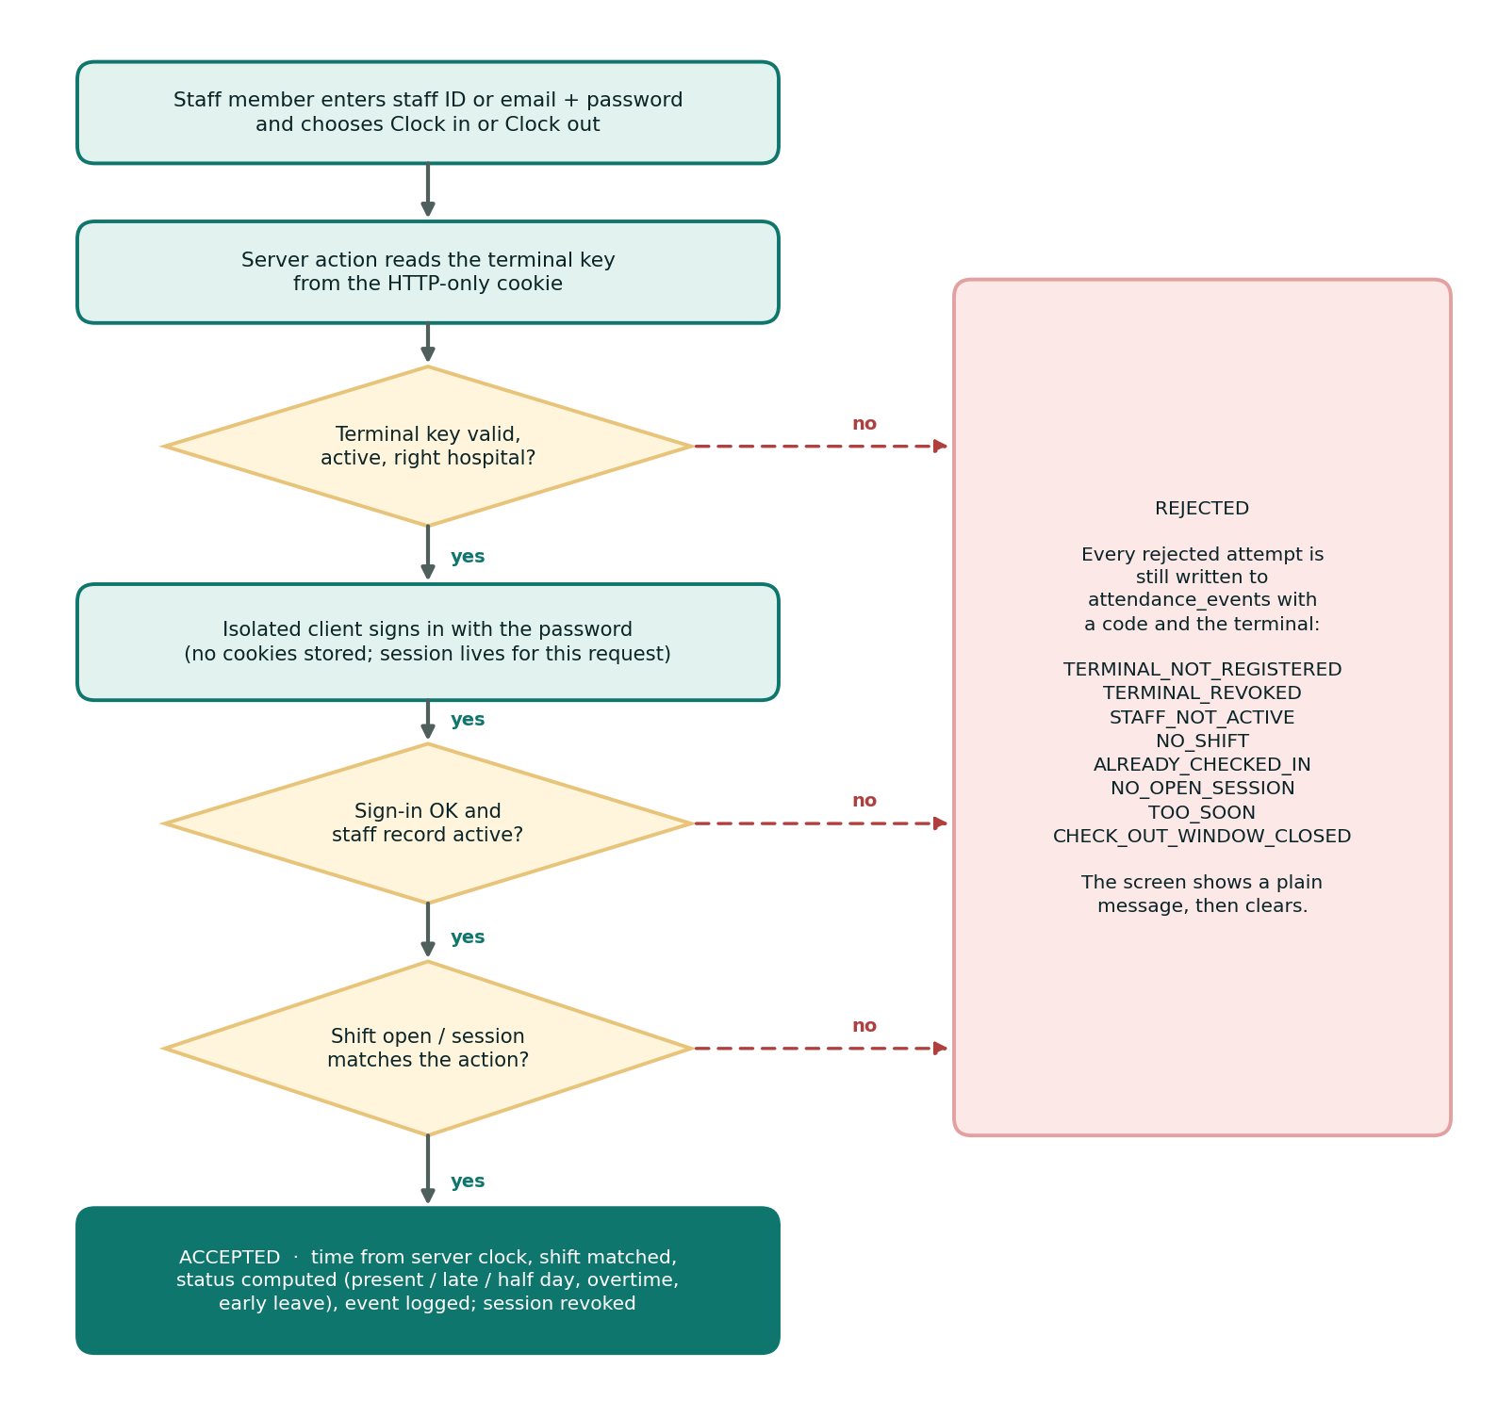
Figure 3.4: Clock-in and clock-out flow at an attendance terminal

3.9.2 Correction Workflow
- A staff member opens one of their attendance records and requests a correction, entering the corrected clock-in time, clock-out time or both, a reason of at least ten characters and, optionally, a photo or PDF as evidence.
- The database validates the request (possible times, no other pending request for the record) and notifies the reviewers.
- An administrator other than the subject reviews it. A rejection needs a note.
- If approved, the engine applies the times and recomputes the outcome. The requester is notified either way.
- The requester can withdraw the request while it is pending. Everything is written to the audit log.

3.10 User–System Interaction
A use case diagram identifies the actors, the functions they use and the relationships between them. Society Attendant has four actors. The department head is also a staff member, and the super admin holds every hospital administrator function and additionally sets up the hospital.
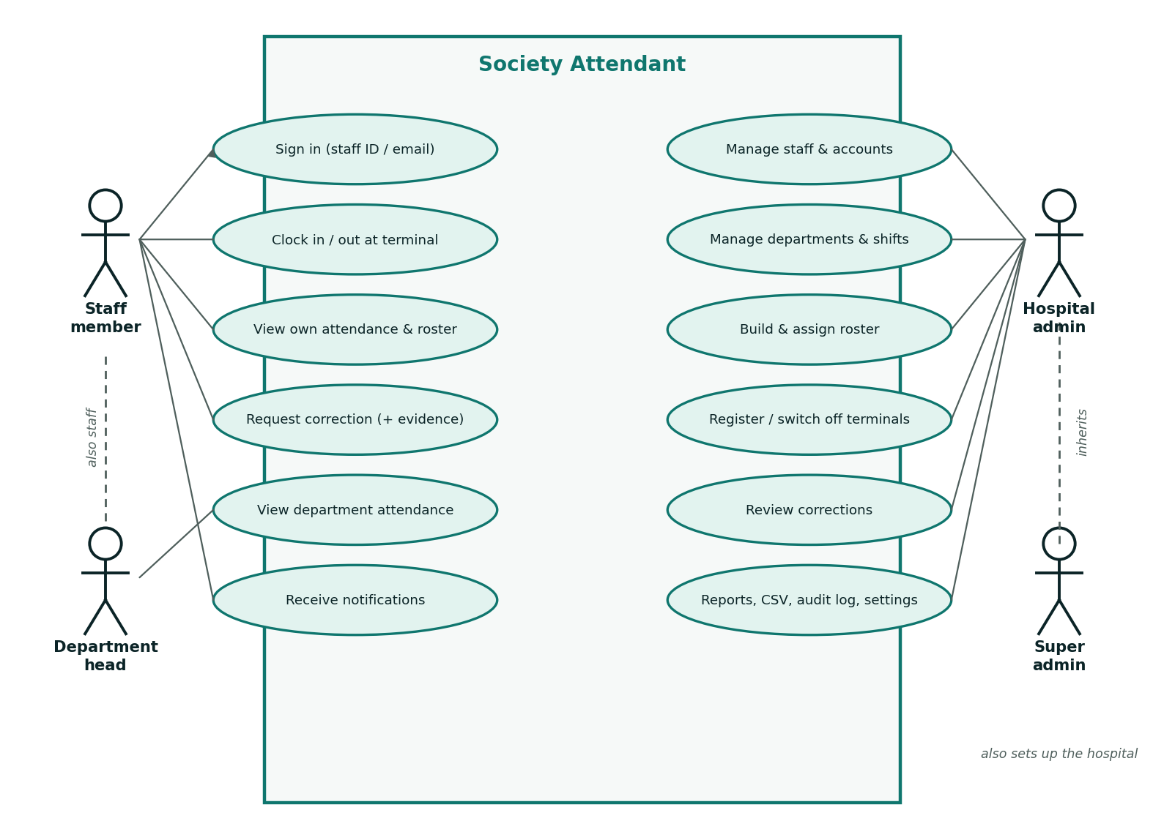
Figure 3.5: Use case diagram of Society Attendant
Table 3.11: Principal use cases
Use case | Actor | Summary
Sign in | All | Enter email and password; accounts flagged must-change-password are sent to choose a new one
Clock in / out | Staff | At a registered terminal, enter staff ID or email and password and choose the action
View own attendance and roster | Staff | See shifts, times, status and worked time, newest first
Request correction | Staff | Propose corrected times with a reason and optional evidence
View department attendance | Department head | See staff, roster, attendance and reports for the departments they head
Manage staff and accounts | Hospital admin | Create staff, invite or create accounts, suspend, terminate, reset passwords
Manage departments, shifts and roster | Hospital admin | Maintain departments, shift templates and assign shifts in bulk
Register or switch off terminals | Hospital admin | Create locations, register a computer, revoke a terminal
Review corrections | Hospital admin | Approve or reject, with a note when rejecting
View reports and audit log | Hospital admin | Summaries, chart, CSV export, change history
Set up the hospital | Super admin | One-time creation of the hospital, then edits to its details

3.11 Data Protection Considerations
Attendance records are personal data. The Data Protection Act, 2012 (Act 843) of Ghana requires personal data to be processed lawfully, collected for a specific purpose, kept only as long as needed and protected against loss or unauthorized access. The design supports these duties in several ways: it collects the minimum data (no biometrics, photographs or phone location); it limits each user to the data their role needs; it stores evidence files in a private bucket served through short-lived links; and it keeps an audit trail of who changed what. Retention periods and lawful-basis documentation are organisational decisions that the hospital must set.

CHAPTER FOUR: SYSTEM IMPLEMENTATION AND TESTING
This chapter describes how the design was implemented, presents the system interfaces and reports the testing carried out. It also lists the messages shown when an action is refused.

4.1 Implementation Environment

4.1.1 Requirements
- Node.js 22.18 or later (tests run TypeScript directly through Node's type stripping).
- A Supabase project for running the application (not needed for the database tests).
- psql on the path if migrations are applied with the supplied script.
- A modern web browser; terminals should run a locked-down browser profile.

4.1.2 Configuration
Configuration is supplied through environment variables (.env.local, created from .env.example). The secret key is used only on the server.
Table 4.1: Environment variables
Variable | Purpose | Exposed to browser?
NEXT_PUBLIC_SUPABASE_URL | Supabase project URL | Yes
NEXT_PUBLIC_SUPABASE_PUBLISHABLE_KEY | Publishable (anon) key | Yes
SUPABASE_SECRET_KEY | Service-role key, used only for Auth admin operations | No
SUPABASE_DB_URL | Session-pooler connection string used only by the migration script | No (local or CI only)

4.1.3 Project Structure
docs/ Design documents
scripts/ Migrations, database types, admin account tools
supabase/migrations/ Schema, RLS policies, functions (source of truth)
tests/db/ Database tests (RLS, constraints, triggers, engine)
tests/unit/ Unit tests for pure application logic
src/app/ Routes: (auth) public pages, (app) signed-in pages,
terminal/ the clock-in screen
src/components/ Shared UI components and the application shell
src/features/<module>/ Schemas, queries, server actions, components
src/lib/ Auth, Supabase clients, navigation, dates, forms
src/proxy.ts Session refresh and sign-in redirect
src/types/database.ts Generated database types

4.1.4 Database Migrations
The schema is built by applying fourteen migrations in order (Table 4.2). Each migration runs in its own transaction, and each table's policies are created in the same migration as the table, so a table never exists without its security rules.
Table 4.2: Migrations
Migration | Content
20260915120000_foundation | Extensions, enumerations, private schema, audit and timestamp triggers
20260915120100_tenancy_identity | Hospitals, settings, profiles, the account-creation trigger and access helper functions
20260915120200_organization | Departments and staff
20260915120300_scheduling | Shift templates and roster with computed times
20260916090000_workforce_management | Account invitations, staff status changes, bulk rostering, directory views
20260917090000_attendance | Locations, attendance records and events, the clock-in engine and the scheduled job
20260918090000_leave_and_corrections | Corrections and notifications (leave, later removed)
20260919090000_reporting_and_attachments | Report functions, audit log view and the evidence storage bucket
20260920090000_super_admin_bootstrap | Short-lived grant for creating the first super admin
20260921090000_password_provisioning | Administrator-created accounts and forced first password change
20260921120000_password_reset_by_admin | Administrator password reset
20260922090000_single_hospital | Restricts the system to one hospital
20260922090100_remove_leave | Removes leave types, requests and related functions
20260922090200_attendance_terminals | Attendance terminals replace QR codes

Caution. The three migrations dated 2026-09-22 delete leave types, leave requests, leave notifications, QR codes and the phone positions recorded with past scans. Back up the database before upgrading an installation that holds such data.

4.2 Implementation of the Main Modules

4.2.1 Authentication and Account Provisioning
Sign-in, forgot-password and set-password pages live under the public (auth) route group. Invitation and recovery links point to a confirmation page that verifies the token only after the user clicks Continue, so email security scanners that open links automatically cannot use the token up. Accounts are created either by invitation or with an administrator-supplied password, both authorized first by the database function prepare_account_invitation. An account created with a password is flagged so that every signed-in page redirects to /set-password until the person chooses their own.

4.2.2 Access Control in the Application
The application derives what a user may do from three facts about the account: its role, whether it has an active staff record and how many departments it heads. The function below (from src/lib/auth/permissions.ts) shows the union rule in code.
export function capabilitiesFor(access: AccessProfile): ReadonlySet<Capability> {
if (!access.isActive) return new Set();

const granted: Capability[] = [];
if (access.role === "super_admin") granted.push(...SUPER_ADMIN);
if (access.role === "hospital_admin") granted.push(...HOSPITAL_ADMIN);
if (access.headedDepartmentCount > 0) granted.push(...DEPARTMENT_HEAD);
if (access.hasStaffRecord) granted.push(...STAFF_MEMBER);
return new Set(granted);
}

The navigation menu, page guards and buttons all read from these capabilities. The database applies its own policies independently, so a missing check in the interface can never grant access.

4.2.3 Workforce and Scheduling
Administrators maintain departments, staff records and shift templates through forms validated by Zod schemas. The shift form accepts a start and end time and derives the duration, treating an end at or before the start as the next day. The roster page shows a weekly grid per department, and the bulk-assign form creates assignments for chosen staff, weekdays and a date range through the database function create_shift_assignments, which runs as the caller so row-level security authorizes each row and reports the overlaps it skipped. Terminating a staff member deactivates their account, cancels their future rostered shifts and records the reason.

4.2.4 Terminals and Clock-in
A terminal is registered by opening a location's page on the computer that will be used and choosing Register this computer. The database function register_attendance_terminal returns a random key once and stores only its hash; the server places the key in an HTTP-only cookie. Sign out and start the terminal then signs the administrator out of that browser and opens the clock-in screen at /terminal.
At the terminal a staff member enters their staff ID or email and password and chooses Clock in or Clock out. The server action resolves a staff ID to the sign-in email (only for an active terminal of the same hospital), signs in on an isolated client that never stores cookies, calls check_in or check_out as that person, and revokes the session immediately. The screen shows the result for a few seconds and then clears. If the account was created with an administrator-supplied password, the terminal reminds the person to choose their own.

4.2.5 The Scheduled Job
The job that records absences and closes forgotten sessions is scheduled automatically by the migration when the pg_cron extension is already installed. Otherwise it is scheduled once by hand:
select cron.schedule('finalize-attendance', '*/10 * * * *',
$$select private.finalize_elapsed_shifts()$$);

Without this job, absences are never recorded.

4.2.6 Corrections and Evidence
From a record's page, staff propose corrected times with a reason and an optional photo or PDF up to 6 MB. Files are uploaded through a server action using the user's own session to the private request-attachments bucket under {hospital_id}/{staff_id}/. The browser's file name is never used as a path, storage policies apply the same access rules as the database, and evidence is read back through short-lived signed links. Approving or rejecting is done only through the database function review_attendance_correction.

4.2.7 Reports, Audit Log and Settings
The reports page summarises a date range by staff member (present, late, absent, half days, worked time and overtime), draws a daily chart and offers CSV export. The reporting functions run as the caller, so an administrator sees the hospital, a department head sees their departments and a staff member sees only themselves; the CSV route re-checks access itself instead of trusting the page that linked to it. The audit log lists every recorded change with actor, reason and changed fields, and cannot be edited. The settings page holds the hospital's details (editable by a super admin) and the attendance rules.

4.3 System Interfaces
This section presents the user interface of Society Attendant. The interface uses a light canvas with a teal primary colour, consistent panels, tables and badges, and plain-language empty states. Each figure below is a placeholder for a screenshot, and Appendix A lists exactly what to capture and which account to use.

4.3.1 Authentication Pages
The Sign in page asks for the email address registered with the hospital and a password. The Forgot password page sends a reset link. Accounts created with an administrator-supplied password are taken to the Choose your own password page at first sign-in and cannot continue until they have done so. When no hospital exists yet, the super admin is asked to set up the hospital (name, code and time zone); the database allows this only once.

[ INSERT SCREENSHOT HERE ]
Figure 4.1: Sign-in page
Capture: Not signed in → /login. The Sign in form with the email and password fields, the sign-in button and the forgot-password link.
Figure 4.1: Sign-in page

[ INSERT SCREENSHOT HERE ]
Figure 4.2: Forgot-password page
Capture: Not signed in → /forgot-password. The form that asks for the email address to send a reset link to.
Figure 4.2: Forgot-password page

[ INSERT SCREENSHOT HERE ]
Figure 4.3: Choose-your-own-password page
Capture: An account created with an administrator-supplied password → /set-password. The page shown at first sign-in that forces a new password to be chosen.
Figure 4.3: Choose-your-own-password page

[ INSERT SCREENSHOT HERE ]
Figure 4.4: Hospital set-up page
Capture: Super admin, before a hospital exists → /setup. The one-time form for hospital name, code and time zone.
Figure 4.4: Hospital set-up page

4.3.2 Dashboard and Navigation
The dashboard adapts to the user. Administrators and department heads see today's counts (on duty, clocked in, late, absent, not yet clocked in), recent clock activity and, for administrators, corrections waiting for review. Staff see their next shift, whether a session is open and a summary of their access. The sidebar groups its links into Overview, My work, Attendance, Workforce, Insights and Administration, and shows only the sections the user's capabilities allow. The bell in the top bar shows the number of unread notifications.

[ INSERT SCREENSHOT HERE ]
Figure 4.5: Administrator dashboard
Capture: Hospital admin → /dashboard. Today's counts (on duty, clocked in, late, absent, not yet clocked in), recent activity and pending corrections.
Figure 4.5: Administrator dashboard

[ INSERT SCREENSHOT HERE ]
Figure 4.6: Staff member dashboard
Capture: Staff member (or department head) → /dashboard. The personal view: next shift, open session, access summary.
Figure 4.6: Staff member dashboard

[ INSERT SCREENSHOT HERE ]
Figure 4.7: Application shell and navigation
Capture: Hospital admin → any page. The sidebar with its grouped sections and the notification bell in the top bar.
Figure 4.7: Application shell and navigation

4.3.3 Workforce Pages
The Staff page lists staff with Search, Department and Status filters and shows whether each account is invited or active. The Add staff form creates the employment record. A staff record's page holds the account panel, where an administrator invites the person by email or creates the account with a generated or typed password, resets a forgotten password, and suspends, terminates or reactivates the person with a reason. The Departments pages list departments with their heads and active staff counts and let administrators create departments and change heads.

[ INSERT SCREENSHOT HERE ]
Figure 4.8: Staff list with filters
Capture: Hospital admin → /staff. The staff table with Search, Department and Status filters and account states (Invited / Active).
Figure 4.8: Staff list with filters

[ INSERT SCREENSHOT HERE ]
Figure 4.9: Add staff form
Capture: Hospital admin → /staff/new. The form for a new staff record (employee number, name, email, job title, employment type, department, hire date).
Figure 4.9: Add staff form

[ INSERT SCREENSHOT HERE ]
Figure 4.10: Staff record and account panel
Capture: Hospital admin → /staff/[id]. A staff record showing the account panel: invite, create with password, reset password and status change.
Figure 4.10: Staff record and account panel

[ INSERT SCREENSHOT HERE ]
Figure 4.11: Departments list
Capture: Hospital admin → /departments. The departments table showing heads and active staff counts.
Figure 4.11: Departments list

[ INSERT SCREENSHOT HERE ]
Figure 4.12: Department form or detail
Capture: Hospital admin → /departments/new or /departments/[id]. Creating a department or changing its head.
Figure 4.12: Department form or detail

4.3.4 Scheduling Pages
Shift templates are listed with their times and codes and created with a form for start and end time, break, grace periods and the overtime threshold. The Roster page shows a weekly grid for one department using the shift codes as chips, and Assign shifts creates assignments in bulk and reports the overlaps it skipped.

[ INSERT SCREENSHOT HERE ]
Figure 4.13: Shift templates list
Capture: Hospital admin → /shifts. The list of shift templates with times, durations and codes.
Figure 4.13: Shift templates list

[ INSERT SCREENSHOT HERE ]
Figure 4.14: New shift template form
Capture: Hospital admin → /shifts/new. Start time, end time or duration, break, grace periods and overtime threshold.
Figure 4.14: New shift template form

[ INSERT SCREENSHOT HERE ]
Figure 4.15: Roster grid
Capture: Hospital admin → /roster. The weekly grid for one department with assignment chips and the shift code legend.
Figure 4.15: Roster grid

[ INSERT SCREENSHOT HERE ]
Figure 4.16: Assign shifts form
Capture: Hospital admin → /roster/assign. Selecting a shift, staff, date range and weekdays, and the result summary listing skipped overlaps.
Figure 4.16: Assign shifts form

4.3.5 Terminals and the Clock-in Screen
The Terminals page lists locations and every registered terminal with the time it was last used, and lets an administrator switch a terminal off. On a location's page, Register this computer registers the browser in use, and Sign out and start the terminal opens the clock-in screen. The clock-in screen is deliberately minimal: staff ID or email, password and two buttons. After each attempt it shows the outcome for a few seconds, either a confirmation with the status and time, or a plain-language reason for the refusal (Section 4.5), and then clears itself.

[ INSERT SCREENSHOT HERE ]
Figure 4.17: Terminals and locations
Capture: Hospital admin → /locations. The list of locations and all registered terminals with last-used times.
Figure 4.17: Terminals and locations

[ INSERT SCREENSHOT HERE ]
Figure 4.18: Register this computer
Capture: Hospital admin, on the computer that will be the terminal → /locations/[id]. The location page with the Register this computer form and the Sign out and start the terminal button.
Figure 4.18: Register this computer

[ INSERT SCREENSHOT HERE ]
Figure 4.19: Terminal clock-in screen
Capture: Registered terminal (no one signed in) → /terminal. The Clock in or out form with staff ID or email, password and the two action buttons.
Figure 4.19: Terminal clock-in screen

[ INSERT SCREENSHOT HERE ]
Figure 4.20: Terminal: successful clock-in
Capture: Registered terminal → /terminal. The result screen after an accepted clock-in (name, status, time).
Figure 4.20: Terminal: successful clock-in

[ INSERT SCREENSHOT HERE ]
Figure 4.21: Terminal: refused clock-in
Capture: Registered terminal → /terminal. A plain-language refusal, for example the message for no open shift or already clocked in.
Figure 4.21: Terminal: refused clock-in

4.3.6 Attendance Views
The Attendance records page shows the chosen day for administrators (whole hospital) or department heads (their departments), including rostered staff who have not yet clocked in. Status badges show Present, Late, Half day or Absent, and flags mark unscheduled attendance and missing clock-outs. Staff use My attendance to see their own recorded shifts, newest first, and open a record to request a correction.

[ INSERT SCREENSHOT HERE ]
Figure 4.22: Attendance records for a day
Capture: Hospital admin or department head → /attendance. The daily table with Date and Department filters showing status badges, times and worked time.
Figure 4.22: Attendance records for a day

[ INSERT SCREENSHOT HERE ]
Figure 4.23: My attendance
Capture: Staff member → /my-attendance. The personal list of recorded shifts, newest first.
Figure 4.23: My attendance

[ INSERT SCREENSHOT HERE ]
Figure 4.24: Attendance record detail and correction request
Capture: Staff member → /my-attendance/[id]. One record with the correction request form (times, reason, evidence upload).
Figure 4.24: Attendance record detail and correction request

4.3.7 Corrections and Notifications
The Corrections page lists requests filtered by status (Awaiting review, Approved, Not approved, Withdrawn or all). Opening a pending request shows the requested times, the reason and the evidence link, and lets an administrator approve or reject it; a rejection needs a note. The Notifications page and the bell tell reviewers when a correction is submitted and tell requesters when it is decided.

[ INSERT SCREENSHOT HERE ]
Figure 4.25: Corrections list
Capture: Hospital admin → /corrections. The corrections table with the Status filter (Awaiting review, Approved, Not approved, Withdrawn).
Figure 4.25: Corrections list

[ INSERT SCREENSHOT HERE ]
Figure 4.26: Correction review
Capture: Hospital admin → /corrections/[id]. A pending correction with requested times, reason, evidence link and the approve or reject form.
Figure 4.26: Correction review

[ INSERT SCREENSHOT HERE ]
Figure 4.27: Notifications
Capture: Hospital admin or staff member → /notifications. The notification list and the unread count on the bell.
Figure 4.27: Notifications

4.3.8 Reports, Audit Log and Settings
Reports takes a date range and an optional department and returns the summary table, the daily chart and a CSV download. The Audit log can be filtered by record type and by kind of change (created, changed, deleted). Settings shows the hospital's details and the four attendance rules: the minimum time between clock-in and clock-out, how long clock-out stays allowed after the shift ends, the half-day threshold as a percentage of the scheduled shift, and whether clock-in without a rostered shift is allowed (flagged for review).

[ INSERT SCREENSHOT HERE ]
Figure 4.28: Reports
Capture: Hospital admin → /reports. The date-range and department filters, summary table, daily chart and CSV export button.
Figure 4.28: Reports

[ INSERT SCREENSHOT HERE ]
Figure 4.29: Audit log
Capture: Hospital admin → /audit-log. The audit table with Record type and Change filters and the changed-fields summary.
Figure 4.29: Audit log

[ INSERT SCREENSHOT HERE ]
Figure 4.30: Settings
Capture: Hospital admin or super admin → /settings. Hospital details and the four attendance rules.
Figure 4.30: Settings

4.4 Testing of the Implemented System
Testing confirms that the system behaves as specified and that its security rules hold. The aims were to find errors and omissions, to check each objective against evidence and to make sure the rules that protect data cannot be bypassed. Testing was carried out at four levels: unit tests, database tests, static analysis and system (manual) tests.

4.4.1 Automated Test Results
The complete automated suite was executed on 28 September 2026 with Node.js 22.23.2. All 211 tests passed with no failures, cancellations or skips.
Table 4.3: Summary of automated test results
Suite | Tests | Passed | Failed | What it verifies
Unit tests (npm run test:unit) | 81 | 81 | 0 | Permissions, navigation, validation schemas, dates, shift times, labels, redirects, password rules
Database tests (npm run test:db) | 130 | 130 | 0 | Migrations, row-level security per role, provisioning, terminals, the clock-in engine, scheduling, corrections, reporting, audit
Total | 211 | 211 | 0

The type checker (tsc --noEmit) also completed without errors.
Table 4.4: Database test files
File | Tests | Main areas
tenancy-identity.test.ts | 27 | Account provisioning rules, super admin grant, single-hospital rule, settings, profile visibility, deactivation, append-only audit log
workforce.test.ts | 28 | Invitations and expiry, forced password change, administrator reset, staff status changes, directory views, bulk rostering
organization.test.ts | 17 | Visibility by role and department, head changes, cross-hospital references, unique employee numbers, audit of changes
scheduling.test.ts | 13 | Overnight shifts, time zones and DST, overlap rules, rescheduling, roster visibility
attendance.test.ts | 27 | Terminals and keys, clock-in and clock-out outcomes, every rejection code, overnight clock-out, absences, forgotten sessions, append-only event log
corrections.test.ts | 8 | Request, approval and recomputation, rejection, reviewer rules, withdrawal, notifications
reporting.test.ts | 10 | Summary counts and totals, scope by caller, filters, daily totals, audit view, evidence path rules

Table 4.5: Unit test files
File | Tests | Main areas
attendance-labels | 9 | Status labels, clock-in error messages, terminal form and response contracts
audit-labels | 5 | Readable audit entries
auth-schemas | 6 | Email normalisation, 12-character passwords, matching passwords, allowed link types
dates | 8 | Calendar validity, day arithmetic, week start, weekday selection, the hospital's calendar day
hospital-schemas | 4 | Hospital details validation
navigation | 7 | Menu contents per role, active link matching
permissions | 6 | Capabilities per role, inactive accounts, department headship
reports-schemas | 4 | Report result contracts and setting bounds
roster-schemas | 7 | Date ranges, weekdays, batch limits, result contracts
routes | 5 | Safe redirects, public paths
shift-time | 9 | Time parsing, overnight rule, durations, break and length limits
staff-account | 6 | Account situations, termination rules, filters
staff-password | 5 | Generated and typed password rules, grantable roles

Each database test file starts an in-memory PostgreSQL (PGlite), loads a shim that reproduces the Supabase roles and auth.uid(), applies every migration in order and runs each test as a specific role and user inside a transaction that is rolled back. The fixtures deliberately seed two hospitals, so the tests also prove that one hospital's data never reaches another's even though the running system serves only one.

4.4.2 Functional Testing
Functional testing checks that each feature works as required. Table 4.6 maps each area to its evidence. Rows marked Automated were verified by the test suites above. Rows marked Manual must be executed in a running installation and recorded in the highlighted cells.
Table 4.6: Functional test cases
ID | Test area | Steps and expected result | Evidence | Status
F1 | Sign-in validation | Invalid emails and empty passwords are rejected; passwords need at least 12 characters | Automated (auth-schemas) | Pass
F2 | Account provisioning | Accounts without prior authorization are refused; an authorized invitation creates the profile and links the staff record | Automated (tenancy-identity, workforce) | Pass
F3 | Password rules | An administrator-created account must choose its own password; administrators cannot reset their own | Automated (workforce) | Pass
F4 | Staff management | Administrators create staff in their hospital only; employee numbers are unique; staff cannot edit records | Automated (organization) | Pass
F5 | Termination | Termination needs a date and reason, deactivates the account and cancels future shifts | Automated (workforce, organization) | Pass
F6 | Roster rules | Overlapping shifts are rejected; back-to-back and double shifts are allowed; night shifts end the next day; DST handled | Automated (scheduling) | Pass
F7 | Bulk rostering | Assignments are created; skipped overlaps are reported; inactive staff are skipped; batch size is limited | Automated (workforce) | Pass
F8 | Terminal registration | The key is returned once and only its hash stored; only administrators can register or switch off terminals | Automated (attendance) | Pass
F9 | Clock-in on time | Status Present; the event log records the terminal | Automated (attendance) | Pass
F10 | Late clock-in | After the grace period the status is Late with the minutes | Automated (attendance) | Pass
F11 | Duplicate clock-in | A second clock-in is rejected and the attempt is logged | Automated (attendance) | Pass
F12 | Invalid terminals | Unknown, switched-off and other-hospital terminals and inactive locations are rejected | Automated (attendance) | Pass
F13 | No rostered shift | Rejected, unless the hospital allows unscheduled attendance (then flagged) | Automated (attendance) | Pass
F14 | Early clock-in | Rejected before the check-in window opens | Automated (attendance) | Pass
F15 | Key without password | A terminal key alone cannot clock anyone in; suspended staff cannot clock in | Automated (attendance) | Pass
F16 | Clock-out outcomes | Worked time, overtime, early leave and half day are computed correctly | Automated (attendance) | Pass
F17 | Clock-out limits | Clock-out without a session, too soon or after the window is rejected | Automated (attendance) | Pass
F18 | Overnight shift | Clock-out on the next calendar day closes the same session | Automated (attendance) | Pass
F19 | Scheduled job | Elapsed shifts without clock-in become Absent; forgotten sessions close without an invented clock-out time | Automated (attendance) | Pass
F20 | Corrections | Request notifies administrators; approval applies times and recomputes; rejection leaves the record untouched; heads cannot review; requester can withdraw | Automated (corrections) | Pass
F21 | Reports | Counts by status and total minutes are correct, scoped by caller, filterable, and empty ranges return an empty report | Automated (reporting) | Pass
F22 | Evidence files | Only paths in the requester's own folder are accepted | Automated (reporting) | Pass
F23 | Audit trail | Audit and event logs are append-only and scoped by role | Automated (tenancy-identity, attendance) | Pass
M1 | Browser sign-in and sign-out | Sign in with valid and invalid credentials; sign out; try to open a protected URL | Manual | [Pass / Fail]
M2 | Terminal set-up end to end | Register a computer, start the terminal, clock in and out as two staff members | Manual | [Pass / Fail]
M3 | Refusal messages on screen | Trigger each message in Table 4.8 and confirm it is displayed | Manual | [Pass / Fail]
M4 | Correction with evidence | Upload a photo or PDF, submit, approve as an administrator, confirm the record changes | Manual | [Pass / Fail]
M5 | Report and CSV | Run a report, download the CSV and open it in a spreadsheet; compare totals with the screen | Manual | [Pass / Fail]
M6 | Role views | Sign in as staff, department head and administrator and confirm each menu and page | Manual | [Pass / Fail]

4.4.3 Non-functional Testing
Table 4.7: Non-functional test summary
Quality | Method | Result
Security | Database tests run every policy as each role, including anonymous callers; two-hospital fixtures prove isolation; the key hash is unreadable; logs reject updates and deletes | Passed (automated)
Reliability | Tests for duplicate clock-ins, the one-open-session rule and releasing a closed session; the scheduled job is idempotent | Passed (automated)
Data integrity | Constraint tests for overlaps, cross-hospital references, unique keys and status rules | Passed (automated)
Performance | Record page load time and clock-in response time on the deployed system with realistic data; confirm sign-in rate limits cover the busiest shift change | [Record measurements]
Usability | Ask several staff to clock in and out and an administrator to add a staff member and roster them; note errors and time taken | [Record observations]
Compatibility | Open the application on the browsers and devices used at the hospital | [List browsers and versions]

4.5 Messages Shown for Invalid Actions
Errors are written in plain language and say what the person should do next. Table 4.8 lists the messages shown at the terminal, each mapped to the reason code recorded in the event log. Any code not in the list produces a generic message.
Table 4.8: Clock-in and clock-out messages
Code | Message shown
NOT_AUTHENTICATED | You could not be signed in. Try again.
STAFF_NOT_ACTIVE | Your account has no active staff record, so it cannot clock in. Contact your HR office.
HOSPITAL_NOT_ACTIVE | The hospital is not active in the system.
TERMINAL_NOT_REGISTERED | This computer is not registered as a terminal. Ask an administrator to register it.
TERMINAL_REVOKED | This terminal has been switched off by an administrator.
WRONG_HOSPITAL | This terminal belongs to another hospital.
LOCATION_NOT_ACTIVE | This terminal's location is not in use.
NO_SHIFT | You have no shift open for clock-in right now. If you are working, ask your manager to add it to the roster.
ALREADY_CHECKED_IN | You are already clocked in. Choose Clock out when your shift ends.
NO_OPEN_SESSION | You are not clocked in, so there is nothing to clock out of.
TOO_SOON | You have only just clocked in. Try again in a few minutes.
CHECK_OUT_WINDOW_CLOSED | The time allowed for clocking out has passed. Ask your manager to correct this attendance record.
(any other) | That could not be recorded. Try again, or contact your manager.

Forms show field-level messages from the Zod schemas. For example, a correction needs a reason of at least 10 characters ("Explain what happened, in at least 10 characters."), at least one corrected time ("Give the corrected check-in time, check-out time, or both.") and a check-out after the check-in ("The check-out time must be after the check-in time.").

CHAPTER FIVE: CONCLUSION AND FUTURE WORK
This final chapter summarises the work, analyses the implemented system against the objectives, states its strengths and weaknesses, and recommends improvements.

5.1 Summary of the Work
The project set out to replace paper attendance registers in a hospital with a system that identifies the person, the place and the time of every clock-in, judges each shift by the hospital's rules and controls who may see and change the data.
Chapter One described the problem and set seven objectives. Chapter Two compared ways of capturing attendance and explained the concepts and tools used. Chapter Three presented the design: an iterative eight-phase method; requirements; fourteen design decisions; a three-tier architecture on Next.js and Supabase; a role model that combines account role, staff record and department headship; a fifteen-table database with integrity rules enforced by the database itself; an attendance engine that takes time only from the server and judges each shift from a snapshot of its own rules; and a layered security design.
Chapter Four described the implementation and the interfaces and reported testing. All 211 automated tests passed (81 unit and 130 database tests), covering role-based access, account provisioning, terminals, every clock-in and clock-out outcome and rejection, overnight shifts, absences, corrections, reports and the append-only logs.

5.2 Analysis of the Implemented System
Table 5.1 compares each objective with what was delivered and the evidence.
Table 5.1: Objectives against results
Objective | Result | Evidence
1. Clock in and out at registered terminals with the person's own credentials | Met. A clock-in needs both a valid password sign-in and a registered terminal's key. | Sections 3.8.3 and 3.9.1; tests F8 to F15
2. Derive status, lateness, worked time, overtime and early leave from the server clock and roster, including overnight shifts | Met. One shared calculation; time from the database clock; shift snapshots. | Section 3.7; tests F9, F10, F16, F18
3. Manage departments, staff, accounts, shift templates and rosters | Met. Modules for each, with bulk rostering and account provisioning. | Sections 4.2.3 and 4.3.3 to 4.3.4; tests F2 to F7
4. Restrict access by role and department, enforced in the database | Met. Row-level security on every table; capability-driven interface. | Sections 3.5 and 3.8.2; Table 4.7 (security)
5. Provide a controlled correction workflow that keeps the original scan log | Met. Reason required; evidence optional; reviewer cannot be the subject; originals kept. | Sections 3.7.5 and 3.9.2; test F20
6. Provide reports with CSV export, notifications and a tamper-evident audit log | Met. Reports run as the caller; append-only audit and event logs; in-app notifications. | Section 4.2.7; tests F21 and F23
7. Verify the system with automated tests | Met. 211 tests, all passing; type checking clean. | Section 4.4.1

The research questions from Chapter One can now be answered. (1) Person and place are tied to a clock-in by requiring both the person's password and the secret key of a registered terminal, with no phones, location tracking or biometrics. (2) Outcomes are consistent because a single calculation is used everywhere and shift times are stored as instants in the hospital's time zone, which makes overnight shifts ordinary time ranges. (3) Access is limited by row-level security and controlled database functions, with the interface and server acting as earlier layers, so a mistake in the application cannot expose data. (4) Corrections propose times, are reviewed and audited, and the original scan log is never changed.

5.2.1 Strengths of the System
- Rules are enforced where they cannot be bypassed. The clock-in engine and access rules live in the database, so calling it directly does not avoid them.
- Trustworthy evidence. Time comes only from the server, every attempt is logged (including rejected ones) and the logs cannot be edited.
- Explainable results. Each record keeps the shift and policy values it was judged by, so a result can be reproduced later.
- Fair and controlled corrections. Corrections change times, never status, and are reviewed by someone other than the subject.
- Least privilege. Each role sees only what it needs, and department heads see only their departments.
- Low cost and low privacy risk. No special hardware, no personal phones and no location or biometric data are needed.
- Well tested and maintainable. A typed schema, feature modules and 211 automated tests that need no external services make change safer.

5.2.2 Weaknesses and Limitations
- Shared passwords. As with any password-based method, a person can type a colleague's password. The system records the terminal and time so this can be investigated but cannot prevent it.
- Terminal key protection. A terminal's protection is the key held in its browser. It can be copied by someone with access to that browser's developer tools, so terminals need a locked-down profile. A terminal also cannot be restricted to a network address.
- No multi-factor authentication. It is recommended for administrator accounts but is not implemented.
- Staff photographs were designed but not built.
- In-app notifications only. There is no email, SMS or push notification for corrections or absences.
- No leave module. Leave was removed from scope, so approved leave is not reflected in attendance.
- One hospital. The design keeps a hospital identifier on every table, but the system serves a single hospital.
- Shared sign-in rate limit. Every clock-in is a password sign-in made from the application server, so all terminals count against one limit that must be sized for the busiest shift change.
- Connectivity. Clock-in is unavailable if the network or database is unavailable; there is no offline mode.
- Testing gaps. There are no automated browser (end-to-end) tests, and performance and usability results are still to be recorded (Table 4.7).

5.3 Conclusion
Society Attendant shows that a hospital can capture attendance reliably without special hardware or personal phones, provided that identity, place and time are each established by something the person cannot easily fake, and provided that the rules are enforced in a layer that the application cannot bypass. By storing evidence in append-only logs, judging each shift from a snapshot of its own rules and allowing only reviewed, audited corrections, the system produces records that managers, payroll staff and employees can all trust.
The project also shows the value of iterating on a written design. Reviewing the first design led to the removal of QR codes, location recording, multi-hospital operation and leave, leaving a smaller system that is easier to secure, test and explain. With the recommendations below, the system can grow into a complete workforce-attendance platform for the hospital.

5.4 Recommendations and Future Work
- Multi-factor authentication for super admin and hospital admin accounts.
- Staff photographs shown at the terminal, to make proxy clock-ins easier for colleagues to notice.
- Network restrictions so that a terminal works only from the hospital's network.
- Notifications by email, SMS or push for absences, missed clock-outs and correction decisions.
- Leave management, reinstated with a clear design, so that approved leave feeds attendance.
- Payroll integration and additional export formats, with an optional overtime approval step.
- Department hierarchy (for example Nursing then Ward 3) for larger hospitals.
- Multiple hospitals, using the hospital identifier that every table already carries.
- End-to-end browser tests and load tests to complement the unit and database tests.
- Log streaming of audit entries to external append-only storage if a regulator requires protection from database superusers.
- Retention and data-protection procedures agreed with the hospital, including how long attendance data is kept.

REFERENCES
OWASP. (2021). Application Security Verification Standard, version 4.0.3. OWASP Foundation. https://owasp.org/www-project-application-security-verification-standard/
PostgreSQL Global Development Group. (n.d.). PostgreSQL documentation: Row security policies. https://www.postgresql.org/docs/current/ddl-rowsecurity.html
Republic of Ghana. (2012). Data Protection Act, 2012 (Act 843). Accra: Government of Ghana.
Sommerville, I. (2016). Software engineering (10th ed.). Pearson.
Supabase. (n.d.). Supabase documentation: Auth, Row Level Security and Storage. https://supabase.com/docs
Vercel. (n.d.). Next.js documentation. https://nextjs.org/docs
Meta Platforms. (n.d.). React documentation. https://react.dev
Zod contributors. (n.d.). Zod documentation. https://zod.dev
Note to author. These are the sources consulted for the concepts and tools described. Please check them against your department's required citation style and add any further literature your supervisor expects.

APPENDIX A: SCREENSHOT CHECKLIST
Use this checklist to capture the screenshots for Section 4.3. For each figure, sign in as the account shown, open the page and capture the whole browser window. Then delete the placeholder frame and insert the image at the same position, keeping the caption. Use realistic but non-sensitive demonstration data, because screenshots of real staff records are personal data.
Tip. Before capturing, create a small set of demonstration data: one department with a head, a few staff, one shift template, a week's roster, one location with a registered terminal, and a few attendance records including a late one and one correction.

Table A.1: Screenshots to capture
Figure | Page | Route | Sign in as | Show
4.1 | Sign-in page | /login | Not signed in | The Sign in form with the email and password fields, the sign-in button and the forgot-password link.
4.2 | Forgot-password page | /forgot-password | Not signed in | The form that asks for the email address to send a reset link to.
4.3 | Choose-your-own-password page | /set-password | An account created with an administrator-supplied password | The page shown at first sign-in that forces a new password to be chosen.
4.4 | Hospital set-up page | /setup | Super admin, before a hospital exists | The one-time form for hospital name, code and time zone.
4.5 | Administrator dashboard | /dashboard | Hospital admin | Today's counts (on duty, clocked in, late, absent, not yet clocked in), recent activity and pending corrections.
4.6 | Staff member dashboard | /dashboard | Staff member (or department head) | The personal view: next shift, open session, access summary.
4.7 | Application shell and navigation | any page | Hospital admin | The sidebar with its grouped sections and the notification bell in the top bar.
4.8 | Staff list with filters | /staff | Hospital admin | The staff table with Search, Department and Status filters and account states (Invited / Active).
4.9 | Add staff form | /staff/new | Hospital admin | The form for a new staff record (employee number, name, email, job title, employment type, department, hire date).
4.10 | Staff record and account panel | /staff/[id] | Hospital admin | A staff record showing the account panel: invite, create with password, reset password and status change.
4.11 | Departments list | /departments | Hospital admin | The departments table showing heads and active staff counts.
4.12 | Department form or detail | /departments/new or /departments/[id] | Hospital admin | Creating a department or changing its head.
4.13 | Shift templates list | /shifts | Hospital admin | The list of shift templates with times, durations and codes.
4.14 | New shift template form | /shifts/new | Hospital admin | Start time, end time or duration, break, grace periods and overtime threshold.
4.15 | Roster grid | /roster | Hospital admin | The weekly grid for one department with assignment chips and the shift code legend.
4.16 | Assign shifts form | /roster/assign | Hospital admin | Selecting a shift, staff, date range and weekdays, and the result summary listing skipped overlaps.
4.17 | Terminals and locations | /locations | Hospital admin | The list of locations and all registered terminals with last-used times.
4.18 | Register this computer | /locations/[id] | Hospital admin, on the computer that will be the terminal | The location page with the Register this computer form and the Sign out and start the terminal button.
4.19 | Terminal clock-in screen | /terminal | Registered terminal (no one signed in) | The Clock in or out form with staff ID or email, password and the two action buttons.
4.20 | Terminal: successful clock-in | /terminal | Registered terminal | The result screen after an accepted clock-in (name, status, time).
4.21 | Terminal: refused clock-in | /terminal | Registered terminal | A plain-language refusal, for example the message for no open shift or already clocked in.
4.22 | Attendance records for a day | /attendance | Hospital admin or department head | The daily table with Date and Department filters showing status badges, times and worked time.
4.23 | My attendance | /my-attendance | Staff member | The personal list of recorded shifts, newest first.
4.24 | Attendance record detail and correction request | /my-attendance/[id] | Staff member | One record with the correction request form (times, reason, evidence upload).
4.25 | Corrections list | /corrections | Hospital admin | The corrections table with the Status filter (Awaiting review, Approved, Not approved, Withdrawn).
4.26 | Correction review | /corrections/[id] | Hospital admin | A pending correction with requested times, reason, evidence link and the approve or reject form.
4.27 | Notifications | /notifications | Hospital admin or staff member | The notification list and the unread count on the bell.
4.28 | Reports | /reports | Hospital admin | The date-range and department filters, summary table, daily chart and CSV export button.
4.29 | Audit log | /audit-log | Hospital admin | The audit table with Record type and Change filters and the changed-fields summary.
4.30 | Settings | /settings | Hospital admin or super admin | Hospital details and the four attendance rules.

APPENDIX B: SET-UP AND DEPLOYMENT GUIDE

B.1 Install
npm install
cp .env.example .env.local # then fill in the values

B.2 Supabase Project Settings
- Authentication, Sign In / Providers: disable "Allow new users to sign up". Accounts are created by invitation only.
- Authentication, URL Configuration: set the Site URL to the application URL.
- Authentication, Email Templates: point the links at the confirmation page, using the two templates shown after this list.
- Authentication, Passwords: set the minimum length to 12 and enable leaked-password protection where the plan allows it.
- Authentication, Rate Limits: raise sign-ups and sign-ins to cover the busiest shift change (for example 300 per 5 minutes), because all terminals share one limit.
- API settings: keep only the public schema exposed. The private schema must never be exposed.
- Database, Extensions: enable pg_cron and make sure the finalize-attendance job is scheduled (Section 4.2.5).
Email template links (invite and reset password):
Invite: {{ .SiteURL }}/auth/confirm?token_hash={{ .TokenHash }}&type=invite
Reset password: {{ .SiteURL }}/auth/confirm?token_hash={{ .TokenHash }}&type=recovery

B.3 Apply the Migrations
Set SUPABASE_DB_URL to the session-pooler connection string (port 5432), then run:
npm run db:migrate:status # list applied and pending migrations
npm run db:migrate # apply pending migrations, each in its own transaction

B.4 Create the First Super Admin
npm run admin:create -- admin@example.org "Platform Administrator"

The script prompts for the password without echoing it. Sign in as that account and complete Set up the hospital (name, code, time zone). This can be done only once. Then add departments, shift templates and staff, create a location and register its terminals.

B.5 Set Up a Terminal
- An administrator creates a location (for example Main Staff Entrance) under Terminals.
- On the computer that will be the terminal, the administrator signs in, opens the location and chooses Register this computer, giving it a name such as Front desk PC.
- Sign out and start the terminal signs the administrator out of that browser and opens the clock-in screen.
Recommended hardening:
- Serve the application over HTTPS so that the terminal cookie is marked Secure.
- Use a dedicated operating-system account that opens the browser full-screen on the terminal page, for example chrome --kiosk https://<host>/terminal.
- Turn off the browser's password manager for that profile and do not clear site data on exit, or the terminal forgets its key.
- Restrict developer tools for that profile, because the key is readable there. If a key may have leaked, switch the terminal off and register it again.

B.6 Running the Application
npm run dev # development server
npm run build # production build
npm run start # serve the production build

APPENDIX C: COMMAND REFERENCE
Table C.1: npm scripts
Command | Purpose
npm run dev | Start the development server
npm run build / npm run start | Production build / serve the build
npm run lint | ESLint
npm run typecheck | TypeScript type checking
npm test | Unit tests, then database tests
npm run test:unit | Unit tests for pure application logic
npm run test:db | Apply all migrations to an in-memory PostgreSQL and run the database tests
npm run db:types | Regenerate src/types/database.ts from the migrations
npm run db:types:check | Fail if the generated types are out of date
npm run db:migrate / db:migrate:status | Apply / list migrations on the database in SUPABASE_DB_URL
npm run admin:create -- <email> ["Name"] | Create a super admin account
npm run admin:password -- <email> | Set the password of an existing account

