**4627318**

**What is a DMA Controller?**

The term DMA stands for direct memory access. The hardware device used for direct memory access is called the DMA controller. DMA [controller is a **control** unit](https://www.elprocus.com/arm7-based-lpc2148-microcontroller-pin-configuration/), part of I/O device’s [interface circuit](https://www.elprocus.com/led-interfacing-with-8051-microcontroller/), which can transfer blocks of data between I/O devices and main memory with minimal intervention from the processor.

**DMA Controller Diagram in Computer Architecture**

DMA controller provides an interface between the bus and the input-output devices. Although it transfers data without intervention of processor, it is controlled by the processor. The processor initiates the DMA controller by sending the starting address, Number of words in the data block and direction of transfer of data .i.e. from I/O devices to the memory or from main memory to I/O devices. More than one external device can be connected to the DMA controller.

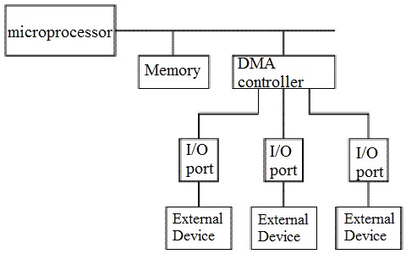DMA in Computer Architecture

DMA controller contains an address unit, for generating addresses and selecting I/O device for transfer. It also contains the control unit and data count for keeping counts of the number of blocks transferred and indicating the direction of transfer of data. When the transfer is completed, DMA informs the processor by raising an interrupt. The typical block diagram of the DMA controller is shown in the figure below.

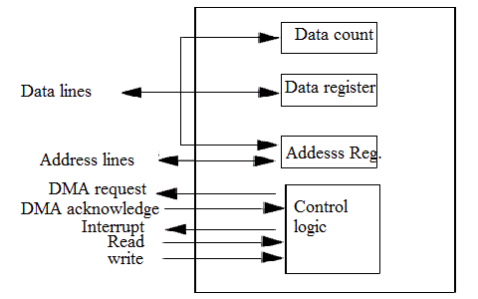Typical Block Diagram of DMA Controller

**Working of DMA Controller**

DMA controller has to share the bus with the processor to make the data transfer. The device that holds the bus at a given time is called bus master. When a transfer from I/O device to the memory or vice verse has to be made, the processor stops the execution of the current program, increments [the program](https://www.elprocus.com/8086-assembly-language-programs-explanation/) counter, moves data over stack then sends a DMA select signal to DMA controller over the address bus.

If the DMA controller is free, it requests the control of bus from the processor by raising the bus request signal. Processor grants the bus to the controller by raising the bus grant signal, now DMA controller is the bus master. The processor initiates the DMA controller by sending the memory addresses, number of blocks of data to be transferred and direction of data transfer. After assigning the data transfer task to the DMA controller, instead of waiting ideally till completion of data transfer, the processor resumes the execution of the program after retrieving instructions from the stack.

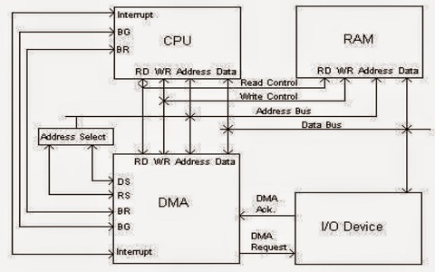

Transfer Of Data in Computer By DMA Controller

DMA controller now has the full control of buses and can interact directly with memory and I/O devices independent of CPU. It makes the data transfer according to the control instructions received by the processor. After completion of data transfer, it disables the bus request signal and CPU disables the bus grant signal thereby moving control of buses to the CPU.

When an I/O device wants to initiate the transfer then it sends a DMA request signal to the DMA controller, for which the controller acknowledges if it is free. Then the controller requests the processor for the bus, raising the bus request signal. After receiving the bus grant signal it transfers the data from the device. For n channeled DMA controller n number of external devices can be connected.

The DMA transfers the data in three modes which include the following.

a) **Burst Mode**: In this mode DMA handover the buses to CPU only after completion of whole data transfer. Meanwhile, if the CPU requires the bus it has to stay ideal and wait for data transfer.

b) **Cycle Stealing Mode**: In this mode, DMA gives control of buses to CPU after transfer of every byte. It continuously issues a request for bus control, makes the transfer of one byte and returns the bus. By this CPU doesn’t have to wait for a long time if it needs a bus for higher priority task.

c) **Transparent Mode:** Here, DMA transfers data only when CPU is executing the instruction which does not require the use of buses.