|  |
| --- |
| UNIT: ADVANCED PROGRAMMING |
| Ass1 Mobile Phone Shop |
| CTEC2902 (ADVANCED PROGRAMMING) |
|  |
| **WRITER: ADJETE ADJEVI** |
| **YEARS: 2017-2018** |

|  |
| --- |
| Tutor: **Salim Hasshu** |

# THE CONCEPT OF THE MOBILE PHONE SOFTWARE APPLICATION

In this report I will present a windows forms program that stores information for a small shop about the second-hand smart phones that would be available in stock. During this creation and implementation I used Visual Studio software which is one of the Object Oriented programming languages Tool adequate for the coursework.

Below are the screen shot compile in a documentation illustrating how the user interface will display to the end-user and the purpose of the software application in ‘Mobile Phone Shop app’ (refer to graphic1) implemented to perform a series of tasks by the end-user. These tasks are mainly Add, Delete, Find, Save, Sort and Load functions. Moreover the end-user should be able to evaluate the current value of the second hand phone on sale due to its age in year compare to its original value when released.

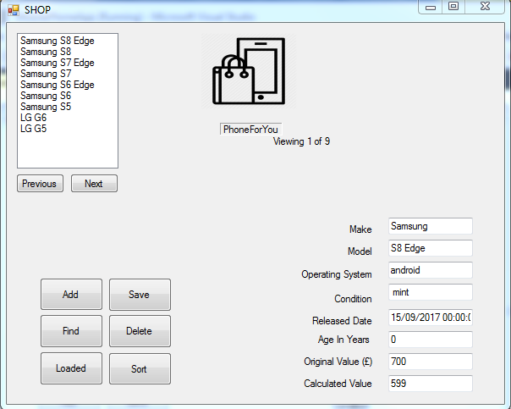

Graphic1 – Shop Application user interface

Ideally the program will be installed on a computer system for a well trained end-user who should be able to click on:

* “Add” a mobile phone to the list for sale

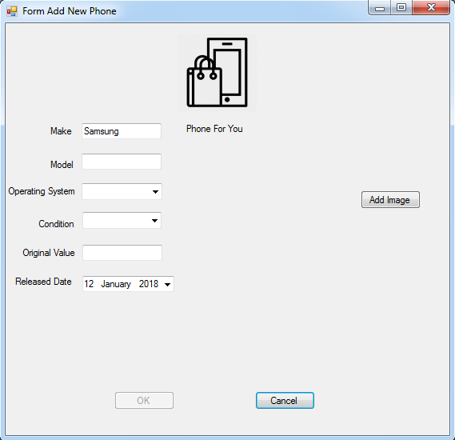

Graphic2- Shows “Add”

* a quick Search by using “Find” button to target a specific mobile phone

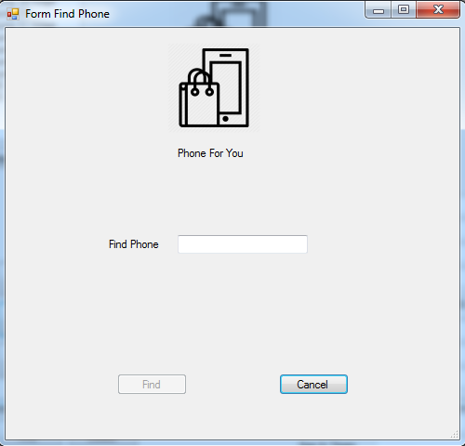

Graphic3- Shows “Find”

* To “save” a newly mobile phone that has been added to the list

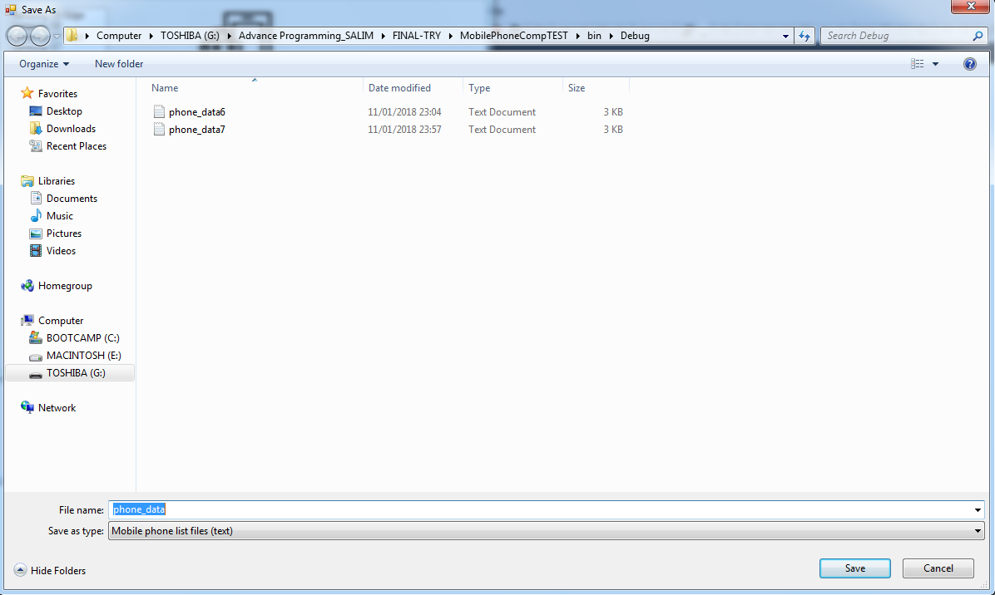

Graphic4-Shows “Save”

* “Remove” a mobile phone from the list that is out of stock

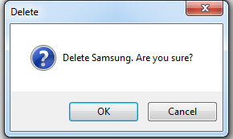

Graphic5-Shows “Delete”

* To “Load” an existing mobile phone that has been archived previously

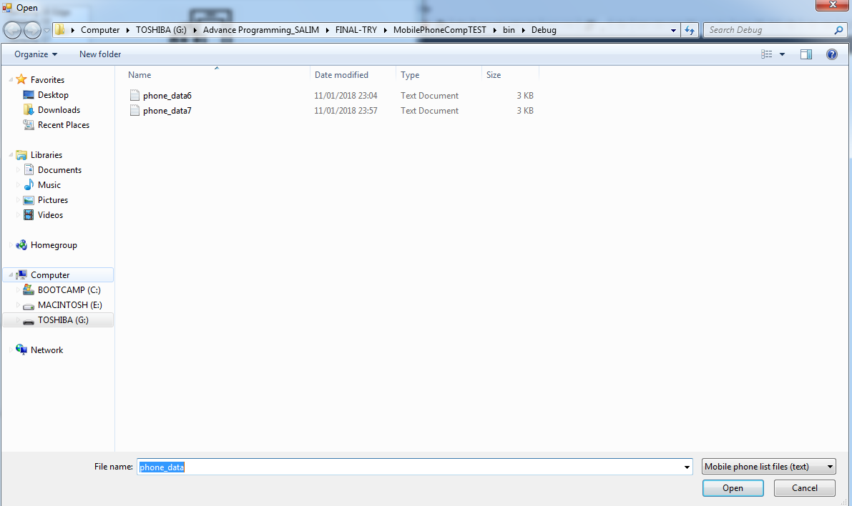

Graphic6-Shows “Load”

However to be able to achieve this, I have used UML software in Enterprise Architecture tools to creates the structural view (class diagrams) and Behavioural view (Sequence diagram and entity relationship between classes) of the system to be implemented.

As follow:

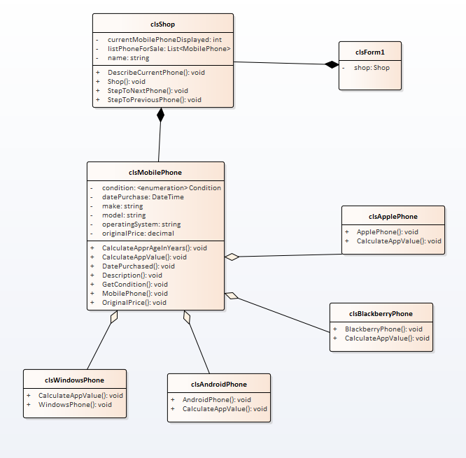

Graphic7- showing the whole system (every class involve interacting with each other through their proprieties and methods)

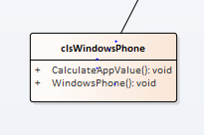

Graphic8-Shows “class Windows Phone”

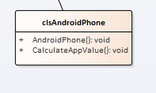

Graphic9- Shows “class Android Phone”

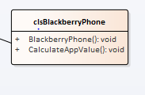

Graphic10-Shows “class Blackberry”

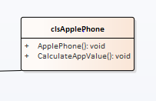

Graphic11-Shows “class Apple Phone”

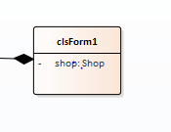

Graphic12- Show “class Main Form”

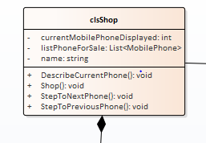

Graphic13- Shows “class Shop”

# My evaluation

I have decided to add in my project extra classes (Windows Phone and Blackberry Phone) to make a bit challenging and also I would have like the end-user to use “Sort” button as well as be able to add picture against each mobile phone added to the list but the time was against me. I will take this as my low point on the assessment which if I was given a second chance for sure I will achieve successfully.

# Conclusion

During this process I must admit that I have had some low and high moments particularly having being away from studying since I left it in June 2012 then suddenly come back this year to complete it in Computing course.

However take away of the context, I eventually finds my pace gradually as time’s moving on and obviously the help of the course tutor at time. Overall I enjoy the module because it gives me as a student a glimpse of idea what the employer are looking for in a job market and what individual skills it requires.