# CASE DATABASE DESIGN

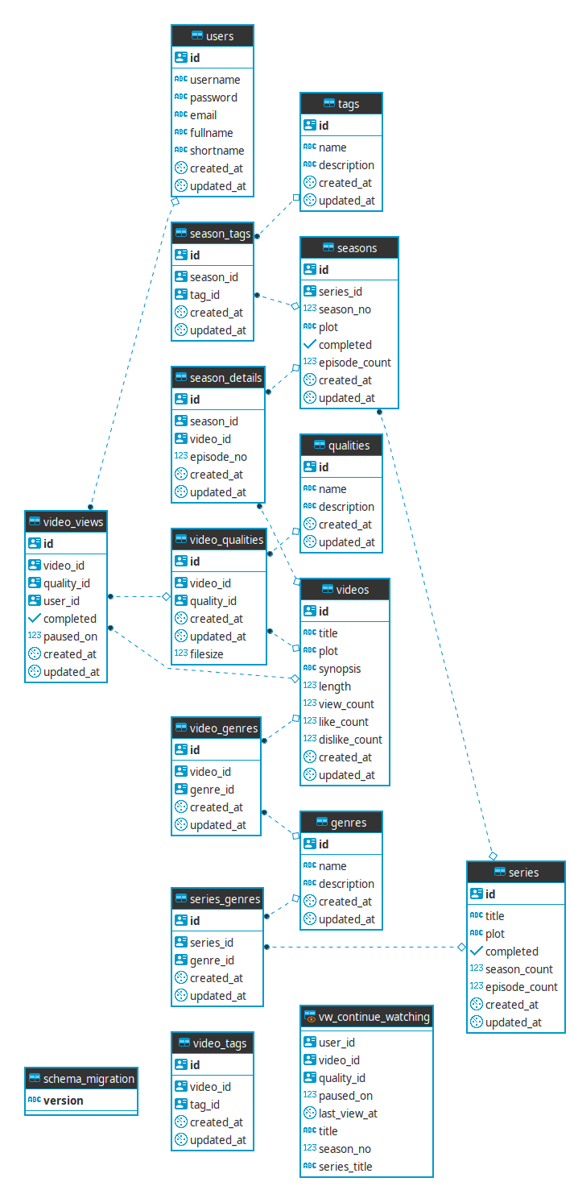The Entity Relationship Diagram for the CASE Database is given as follows:

The followings details are Table Details used for CASE platform:

Tablename: USERS

|  |  |  |  |
| --- | --- | --- | --- |
| **Attribute** | **Description** | **Type** | **Length** |
| id | User’s primary key | UUID |  |
| username | Username | varchar | 255 |
| password | Username password | varchar | 255 |
| email | Username email | Varchar | 255 |
| fullname | User’s fullname | Varchar | 255 |
| shortname | Name used to greet the user | Varchar | 255 |
| created_at | Timestamp Details Creation | Timestamp |  |
| updated_at | Timestamp Details Creation | Timestamp |  |

Tablename: VIDEOS

|  |  |  |  |
| --- | --- | --- | --- |
| **Attribute** | **Description** | **Type** | **Length** |
| Id | Video’s primary key | UUID |  |
| Title |  | Varchar | 255 |
| Plot | Major plot of the video | Varchar | Max |
| Synopsis | Short summary of the video | Varchar | Max |
| Length | How long the video in minutes | Int |  |
| View_Count | A quick way to store how many times the Video is viewed | Int |  |
| like_count | A quick way to store how many times the video is liked | Int |  |
| dislike_count | A quick way to store how many times the video is disliked | Int |  |
| CreatedAt | Timestamp Details Creation | Timestamp |  |
| UpdatedAt | Timestamp Details Creation | Timestamp |  |

Tablename: QUALITY

|  |  |  |  |
| --- | --- | --- | --- |
| **Attribute** | **Description** | **Type** | **Length** |
| Id | Primary key | UUID |  |
| name | e.g. SD | varchar | 255 |
| description | e.g. size 480x640 | varchar | 255 |
| CreatedAt | Timestamp Details Creation | Timestamp |  |
| UpdatedAt | Timestamp Details Creation | Timestamp |  |

Tablename: VIDEO_QUALITY

|  |  |  |  |
| --- | --- | --- | --- |
| **Attribute** | **Description** | **Type** | **Length** |
| Id | Primary key | UUID |  |
| video_id | FK to Video Table | UUID |  |
| quality_id | FK to Quality table | UUID |  |
| Filesize | Filesize in MB | int |  |
| CreatedAt | Timestamp Details Creation | Timestamp |  |
| UpdatedAt | Timestamp Details Creation | Timestamp |  |

Tablename: TAG

|  |  |  |  |
| --- | --- | --- | --- |
| **Attribute** | **Description** | **Type** | **Length** |
| Id | Primary key | UUID |  |
| name | Tag name | varchar | 255 |
| description | Tag Description | varchar | 255 |
| CreatedAt | Timestamp Details Creation | Timestamp |  |
| UpdatedAt | Timestamp Details Creation | Timestamp |  |

Tablename: VIDEO_TAG

|  |  |  |  |
| --- | --- | --- | --- |
| **Attribute** | **Description** | **Type** | **Length** |
| Id | Primary key | UUID |  |
| video_id | FK to Video Table | UUID |  |
| tag_id | FK to TAG Table | UUID |  |
| CreatedAt | Timestamp Details Creation | Timestamp |  |
| UpdatedAt | Timestamp Details Creation | Timestamp |  |

Tablename: GENRE

|  |  |  |  |
| --- | --- | --- | --- |
| **Attribute** | **Description** | **Type** | **Length** |
| Id | Primary key | UUID |  |
| name | Genre name | varchar | 255 |
| description | Genre Description | varchar | 255 |
| CreatedAt | Timestamp Details Creation | Timestamp |  |
| UpdatedAt | Timestamp Details Creation | Timestamp |  |

Tablename: VIDEO_GENRE

|  |  |  |  |
| --- | --- | --- | --- |
| **Attribute** | **Description** | **Type** | **Length** |
| Id | Primary key | UUID |  |
| video_id | FK to Video Table | UUID |  |
| genre_id | FK to TAG Table | UUID |  |
| CreatedAt | Timestamp Details Creation | Timestamp |  |
| UpdatedAt | Timestamp Details Creation | Timestamp |  |

Tablename: VIDEO_VIEW

|  |  |  |  |
| --- | --- | --- | --- |
| **Attribute** | **Description** | **Type** | **Length** |
| Id | Primary key | UUID |  |
| video_id | FK to Video Table, what video is being watched | UUID |  |
| quality_id | FK to TAG Table, what’s the quality of the video | UUID |  |
| user_id | FK to User Table, which user is watching the video | UUID |  |
| completed | Did user finished the video | Bool |  |
| paused_on | At which minute did the user paused the video | Int |  |
| CreatedAt | Timestamp Details Creation | Timestamp |  |
| UpdatedAt | Timestamp Details Creation | Timestamp |  |

Tablename: VIDEO_TAG

|  |  |  |  |
| --- | --- | --- | --- |
| **Attribute** | **Description** | **Type** | **Length** |
| Id | Primary key | UUID |  |
| video_id | FK to Video Table | UUID |  |
| tag_id | FK to TAG Table | UUID |  |
| CreatedAt | Timestamp Details Creation | Timestamp |  |
| UpdatedAt | Timestamp Details Creation | Timestamp |  |

Tablename: SERIES

|  |  |  |  |
| --- | --- | --- | --- |
| **Attribute** | **Description** | **Type** | **Length** |
| Id | primary key | UUID |  |
| Title | Title of the series | Varchar | 255 |
| Plot | Major plot of the series | Varchar | Max |
| Completed | Is the broadcast of this series is completed? | Bool |  |
| Season_Count | A quick way to store how many seasons the series has so far | Int |  |
| Episode_Count | A quick way to store how many episodes the series has so far | Int |  |
| CreatedAt | Timestamp Details Creation | Timestamp |  |
| UpdatedAt | Timestamp Details Creation | Timestamp |  |

Tablename: SERIES_GENRE

|  |  |  |  |
| --- | --- | --- | --- |
| **Attribute** | **Description** | **Type** | **Length** |
| Id | Primary key | UUID |  |
| series_id | FK to Series Table | UUID |  |
| genre_id | FK to TAG Table | UUID |  |
| CreatedAt | Timestamp Details Creation | Timestamp |  |
| UpdatedAt | Timestamp Details Creation | Timestamp |  |

Tablename: SERIES_TAG

|  |  |  |  |
| --- | --- | --- | --- |
| **Attribute** | **Description** | **Type** | **Length** |
| Id | Primary key | UUID |  |
| series_id | FK to Series Table | UUID |  |
| tag_id | FK to TAG Table | UUID |  |
| CreatedAt | Timestamp Details Creation | Timestamp |  |
| UpdatedAt | Timestamp Details Creation | Timestamp |  |

Tablename: SEASONS

|  |  |  |  |
| --- | --- | --- | --- |
| **Attribute** | **Description** | **Type** | **Length** |
| Id | Primary key | UUID |  |
| series_id | FK to Series Table | UUID |  |
| Season_No | Season number | int |  |
| Plot | Main plot of this season | Varchar | MAX |
| Completed | Is season completed? | Bool |  |
| Episoded_count | How many episodes this season has so far | int |  |
| CreatedAt | Timestamp Details Creation | Timestamp |  |
| UpdatedAt | Timestamp Details Creation | Timestamp |  |

Tablename: SEASON_DETAILS

|  |  |  |  |
| --- | --- | --- | --- |
| **Attribute** | **Description** | **Type** | **Length** |
| Id | Primary key | UUID |  |
| season_id | FK to Season Table | UUID |  |
| video_id | FK to Video table | UUID |  |
| episode_no | Episode number of this season | Varchar | MAX |
| CreatedAt | Timestamp Details Creation | Timestamp |  |
| UpdatedAt | Timestamp Details Creation | Timestamp |  |

Tablename: SEASON_TAG

|  |  |  |  |
| --- | --- | --- | --- |
| **Attribute** | **Description** | **Type** | **Length** |
| Id | Primary key | UUID |  |
| season_id | FK to Season Table | UUID |  |
| tag_id | FK to TAG Table | UUID |  |
| CreatedAt | Timestamp Details Creation | Timestamp |  |
| UpdatedAt | Timestamp Details Creation | Timestamp |  |

VIEW vw_continue_watching

|  |  |  |  |
| --- | --- | --- | --- |
| **Attribute** | **Description** | **Type** | **Length** |
| user_id | FK to User Table | UUID |  |
| video_id | FK to Video Table | UUID |  |
| quality_id | FK to VIDEO_QUALITY Table, what quality did the user was watching | UUID |  |
| Paused_on | The minute the video was paused | Int |  |
| last_view_at | When was the last time user viewing this video | Timestamp |  |
| Title | Title of the video | Varchar | 255 |
| Season_No | Season number of this video | int |  |
| Episode_No | Episode number of this video | Int |  |
| Series_Title | Title of the Series | Varchar | 255 |