# Download

<https://pub.dev/packages/flame>

# 在线文档

<https://docs.flame-engine.org/1.6.0/>

# 在线案例

<https://github.com/flame-engine/flame/tree/main/doc/tutorials>

<https://github.com/flame-engine/flame/tree/main/doc/tutorials>

## Building Doodle Dash with Flutter & Flame | Learning to Fly

### Play game

<https://www.youtube.com/watch?v=ILTx1Wa33Z0>

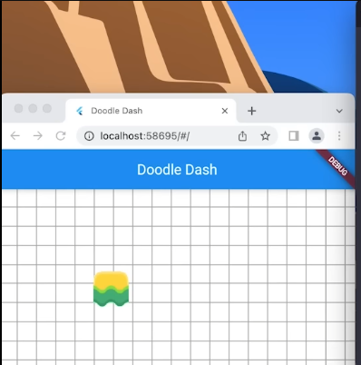

### code

<https://codelabs.developers.google.com/codelabs/flutter-flame-game#0>

## [已过时] Game 3 年前的代码

<https://github.com/WallachiaAcademy/chester_jet_pack/tree/master/lib/screens>

<https://www.youtube.com/watch?v=XfZG-SKYE3Y&list=PLed3DrfS7NflAQC4a6aoesqobHsO1BXoT&index=2>



<https://bonfire-engine.github.io/#/examples>

# 瓦片地图编辑器

<https://www.mapeditor.org/>