Flutter

# Go Install Protocol Buffers plugin

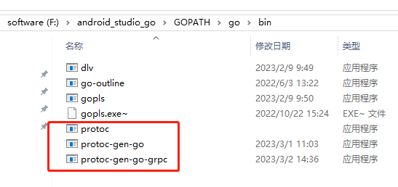

## protoc-gen-go-grpc

GOPROXY=https://goproxy.cn,direct

PS E:\data\flutter_rpg_data_studio\game_quantum_service\proto> go install google.golang.org/grpc/cmd/protoc-gen-go-grpc@latest

go: downloading google.golang.org/grpc/cmd/protoc-gen-go-grpc v1.3.0

go: downloading google.golang.org/grpc v1.53.0

go: downloading google.golang.org/protobuf v1.28.1

PS E:\data\flutter_rpg_data_studio\game_quantum_service\proto>

# 定义协议

## Go

syntax = "proto3";

package GameData;

// go_package 使用 go mod 需要的路径即可，也可以是私有 gitlab package

option go_package = "./grpc_go";

// The greeting service definition.

service Greeter {

  // Sends a greeting

  rpc SayHello (HelloRequest) returns (HelloReply) {}

}

import (

_ "github.com/grpc/grpc-go/encoding/gzip"

)

<https://protobuf.dev/getting-started/darttutorial/>

## 1 安装 Protobuf 编译器protoc-22.0-win64.zip

<https://github.com/protocolbuffers/protobuf/releases/tag/v22.0>

protoc-22.0-win64

是个protoc.exe

配置环境变量：

系统变量 path add

D:\android_studio_go\protoc-22.0-win64\bin

# 2 flutter protoc_plugin/install

## 在线文档

<https://grpc.io/docs/languages/dart/quickstart/>

<https://pub.dev/packages/protoc_plugin>

<https://pub.dev/packages/protoc_plugin/install>

pubspec.yaml

protoc_plugin: ^20.0.1

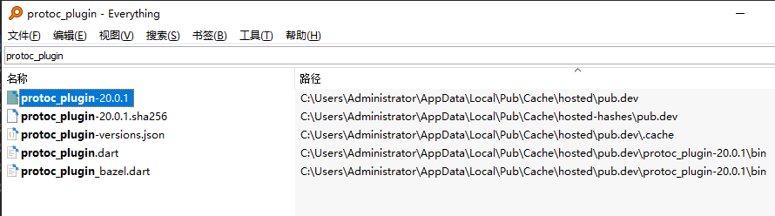

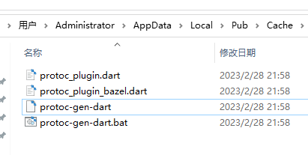

## Windows path

C:\Users\Administrator\AppData\Local\Pub\Cache\hosted\pub.dev\protoc_plugin-20.0.1\bin

## 运行激活命令

> dart pub global activate protoc_plugin

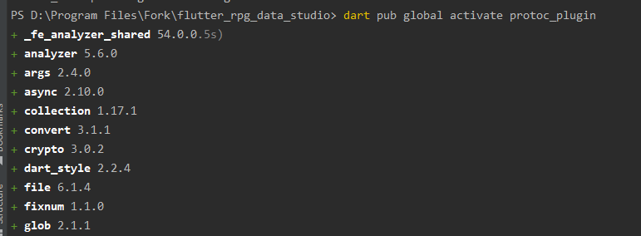

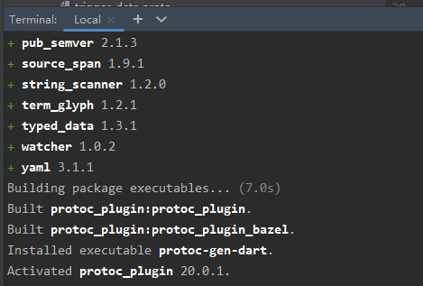

# 3 运行命令生成dart代码文件

Android Studio

|  |
| --- |
| > protoc --dart_out=grpc:lib/src/generated -Iprotos protos/trigger_data.proto |



## Online doc

<https://pub.dev/documentation/grpc/latest/>

# Error list

## 'protoc-gen-dart' 不是内部或外部命令，也不是可运行的程序

'protoc-gen-dart' 不是内部或外部命令，也不是可运行的程序 或批处理文件。

> protoc --dart_out=grpc:lib/src/generated -Iprotos protos/trigger_data.proto

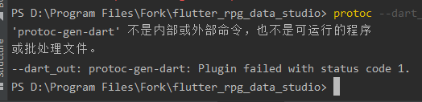



系统变量-path

F:\android_studio_go\GOPATH\go\bin

<https://github.com/google/protobuf.dart>

<https://github.com/google/protobuf.dart/tree/master/protoc_plugin>

## flutter: Caught error: gRPC Error

Building Windows application...

Debug service listening on ws://127.0.0.1:51216/XyjmHVW64B0=/ws

Syncing files to device Windows...

flutter: Caught error: gRPC Error (code: 12, codeName: UNIMPLEMENTED, message: grpc: Decompressor is not installed for grpc-encoding "gzip", details: [], rawResponse: null, trailers: {})

删除客户端 gzip code, Go服务器端没有使用gzip

## gRPC Error (code: 14, codeName: UNAVAILABLE,

Launching lib\main.dart on Windows in debug mode...

Building Windows application...

Debug service listening on ws://127.0.0.1:52016/_5MW56M9wQs=/ws

Syncing files to device Windows...

flutter: Caught error: gRPC Error (code: 14, codeName: UNAVAILABLE, message: Error connecting: HandshakeException: Handshake error in client (OS Error:

WRONG_VERSION_NUMBER(../../third_party/boringssl/src/ssl/tls_record.cc:242)), details: null, rawResponse: null, trailers: {})

### 解决：

需要下面代码

options: ChannelOptions(  
 credentials: ChannelCredentials.insecure(),  
),

不安全选项，开发阶段时可以不需要HTTPS 证书

# Go version and Flutter

## Go grpc

go: downloading google.golang.org/grpc v1.53.0

## Flutter grpc

grpc: ^3.1.0

# Run Success Info

Flutter:

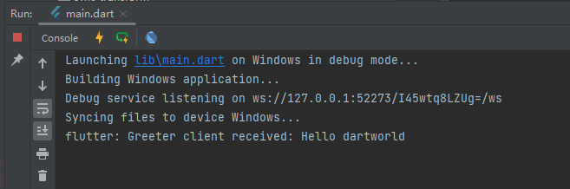

Go:

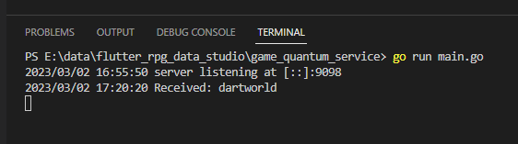

# Other

## Working With gRPC in Flutter on Top of a Go Service

<https://www.youtube.com/watch?v=Vd9sV8_uDrQ>

<https://developer.android.com/studio/preview>