<https://github.com/protocolbuffers/protobuf/releases/tag/v22.0>

<https://grpc.io/docs/languages/go/quickstart/>

go install [google.golang.org/protobuf/cmd/protoc-gen-go@v1.28](mailto:google.golang.org/protobuf/cmd/protoc-gen-go@v1.28)

go install [google.golang.org/grpc/cmd/protoc-gen-go-grpc@v1.2](mailto:google.golang.org/grpc/cmd/protoc-gen-go-grpc@v1.2)

下载不了

<https://pkg.go.dev/google.golang.org/grpc/cmd/protoc-gen-go-grpc@v1.2.0>

<https://github.com/grpc/grpc-go/releases>

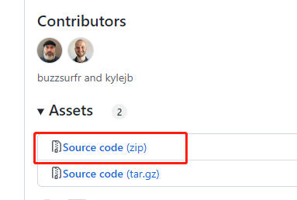

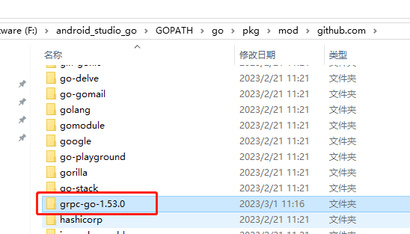

解压后，复制粘贴到包目录下

F:\android_studio_go\GOPATH\go\pkg\mod\github.com

<https://cloud.google.com/go/google.golang.org>

# Protoc-gen-go 代码生成器

<https://github.com/protocolbuffers/protobuf-go>

<https://github.com/protocolbuffers/protobuf-go/releases>

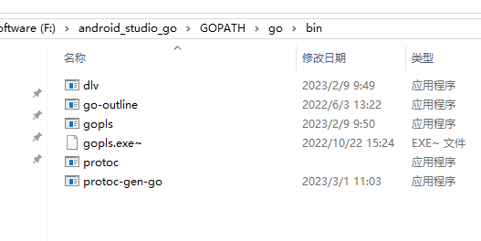

## From vs code TERMINAL

PS E:\data\flutter_rpg_data_studio\game_quantum_service> go install google.golang.org/protobuf/cmd/protoc-gen-go@latest

go: google.golang.org/protobuf/cmd/protoc-gen-go@latest: module google.golang.org/protobuf/cmd/protoc-gen-go: Get "https://proxy.golang.org/google.golang.org/protobuf/cmd/protoc-gen-go/@v/list": dial tcp 172.217.163.49:443: connectex: A connection attempt failed because the connected party did not properly respond after a period of time, or established connection failed because connected host has failed to respond.

<https://golang.google.cn/>

# protobuf v1.28.1

<https://github.com/protocolbuffers/protobuf-go>

克隆

git clone -b v1.28.1 --depth 1 <https://github.com/protocolbuffers/protobuf-go>

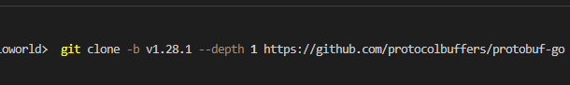

# Vs code

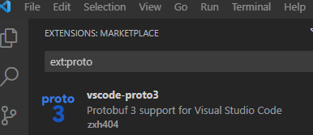

<https://pkg.go.dev/google.golang.org/protobuf>

<https://github.com/protocolbuffers/protobuf-go>

<https://brew.sh/index_zh-cn>

# protoc-gen-go-grpc.exe插件

<https://github.com/grpc/grpc-go>

grpc-go-1.53.0 源代码

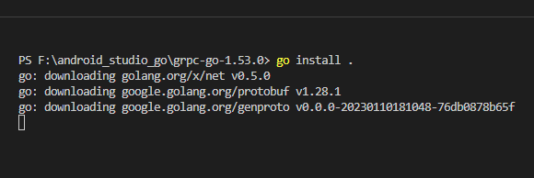

编译，连不上网。

指定proto文件路径可以加“-I”来指定，“-I”是“–proto_path”的简写

即可发现在$GOPATH\bin目录下产生一个protoc-gen-go-grpc.exe插件

插件准备好后，就可以生成代码了，准备好定义的proto文件，执行如下一条命令：

## 修改go.mod 配置

    google.golang.org/protobuf v1.28.1

这个下载不了。

修改为：

replace(

    google.golang.org/protobuf v1.28.1 => github.com/protocolbuffers/protobuf-go v1.28.1

)