1 <https://partner.steamgames.com/>

# 上传EXE 包

<https://partner.steamgames.com/doc/sdk?l=schinese>

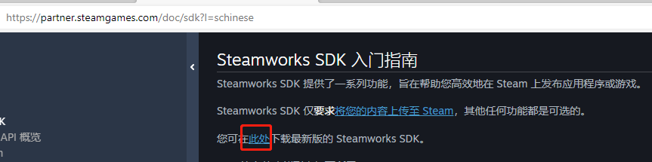

steamworks_sdk_157\sdk\tools\ContentBuilder\content

<https://blog.csdn.net/Lu1030017255/article/details/119598856>

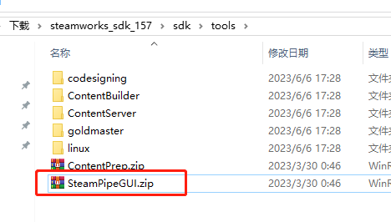

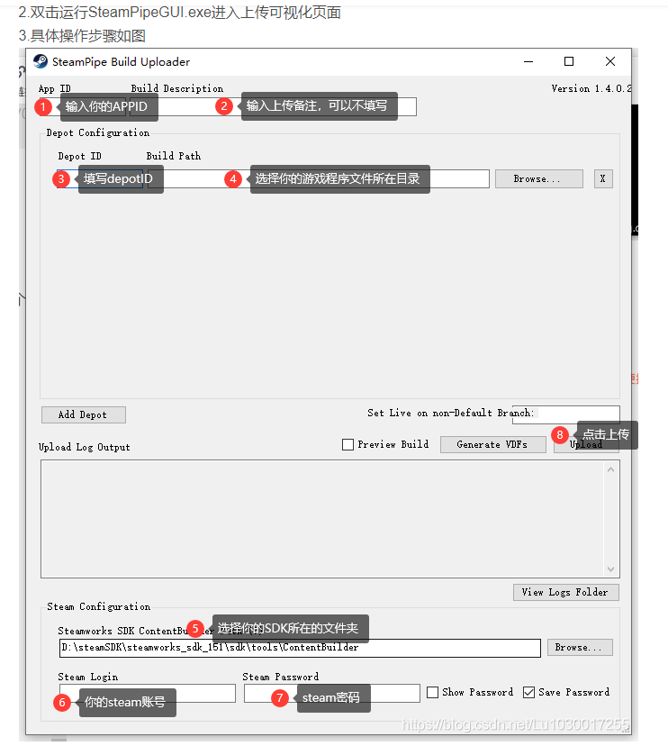

C:\Users\Administrator\Downloads\steamworks_sdk_157\sdk\tools\ContentBuilder