Khalid Mahmoud Mohamed Ahmed

Personal Data

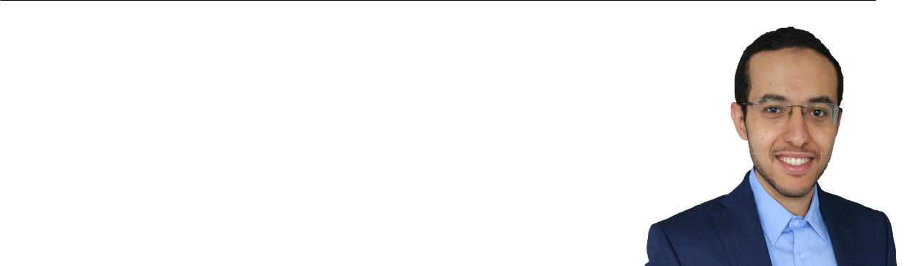

|  |  |
| --- | --- |
| Date of Birth: | 23.07.1992 |
| Nationality: | Egyptian |
| Marital Status: | Married |
| Address: | Markweg 9, |
|  | 91056 Erlangen, Germany |
| Phone: | +4917669463160 |
| email: | engkhalid.mahmoud92@gmail.com |

Education

Oct. 2014 - June 2017 Masters of Science student in Communication and Multi-media Engineering at the **Friedrich-Alexander-University**, Erlangen, Germany (GPA 1.6/1.0).

July 2014 Bachelor of Science in Information Engineering and Tech-nology with High Honors at the **German University in** **Cairo**, Egypt (GPA 1.08/0.7)

Sept. 2007 - July 2009 **Dr.Mahmoud Omar Secondary School**, Egypt

Work Experience

|  |  |
| --- | --- |
| June 2017 - still running | Research engineer at **Fraunhofer für Integrierte Schaltun-** |
|  | **gen IIS**. |
|  | Implementing short transmission time interval (sTTI) |
|  | physical layer features for LTE release 15 on openairinter- |
|  | face (OAI) -open source- platform. |
|  | Implementing a New Radio/5G (NR) uplink system level |
|  | simulator with a focus on Ultra Reliable Low Latency Com- |
|  | munication (URLLC) use case. The implementation is done |
|  | using MATLAB object oriented programming. |
| January 2015 - April 2016 | Student research assistant (Hiwi) in RFID Project at LIKE, |
|  | **Friedrich-Alexander-University**. |
|  | Implementing a maximum likelihood (ML) receiver for |
|  | RFID tag reader using multiple receive antennas using |
|  | MATLAB. |
|  | Validating the performance of ML receiver in a multiple |
|  | input-multiple output (MIMO) double rayleigh backscat- |
|  | ter channel. |
|  |  |

Internships

May 2016 – Oct. 2016 Internship at **Fraunhofer IIS**. The task was to develop and enhance the OAI simulation environment to allow for shorter transmission time in-tervals (TTI) in LTE release 15 on the physical layer in the downlink using **C** programming language. The task was a step towards develop-ment of 5G NR. A 7-OFDM symbol downlink sTTI was developed and tested using OAI simulation environment.

Oct. 2012 – Jan. 2013 Junior teaching assistant at the **German university in Cairo** teaching CSIS104 for pharmacy students and CSEN102 for engineering students.

August 2012 ”Wireless communication” internship at the **German University in** **Cairo** learning to work on tinyos to program mib510 motes using **nesC** programing language on ubuntu then implementing a simple applica-tion about indoor localization using Finger Printing algorithm.

July 2012 ”Radio Frequency” (RF) internship at the **German University in Cairo**, designing and simulating RF couplers ,filters and phase shifter using Computer Simulation Technology (CST).

July 2011 Summer Internship at the **Biomedical Inistitute, Technical University** **in Ilmenua**, Germany, designing a flash-light control system by pro-gramming Texas micro controller using **C** language.

July 2010 Summer Internship at the **Biomedical Inistitute, Technical University** **in Ilmenua**, Germany, designing and fabricating simple printed circuitboards (PCBs).

Research

March 2018 - Sept. 2018 Supervision of a bachelor thesis student at **Fraunhofer-Institut IIS**. ”Uplink grant free transmission for reliablecommunications”, New features were added to the system level simulator which was implemented during my master thesis, to evaluate collision probability and blind detection in NR grant free scheme.

Oct. 2016 - May 2017 Master Thesis at the **Friedrich-Alexander-University**, Er-langen, Germany in collaboration with **Fraunhofer-Institut für Integrierte Schaltungen IIS**. ”Uplink Multi-ple Access Schemes for Ultra-Low Latency Transmission”, A system-level simulator is implemented using MATLAB object oriented programming simulation environment to test different proposals to guarantee fast access and high reliability to low latency users in LTE.

March 2013 - Sept. 2013 Bachelor Project at the **Technical University in Ilmenau**, Germany. ”Wireless Health Monitoring System Based on Fiber-Optic Sensors”, a wireless portable system to mea-sure the respiratory rate using a fiber Bragg grating (FBG) optical sensor is established. Analyzing and filtering the output data is explained and compared with the output data of a commercial piezoelectric sensor.

Languages

Arabic: Mother Tongue

English: Fluent

German: B1.2

Computer Skills

|  |  |
| --- | --- |
| Very Good Knowledge: | MATLAB |
| Intermediate Knowledge: | C and Version Control Systems: git |
| Basic Knowledge: | Linux, java, CST - Computer Simulation Technology and Mathematica |

Interests and Activities

**Interests**

Wireless communications , cellular networks and software development.

**Activities**

Football, Tennis and Cycling