**Create Repository: Name as Aakash**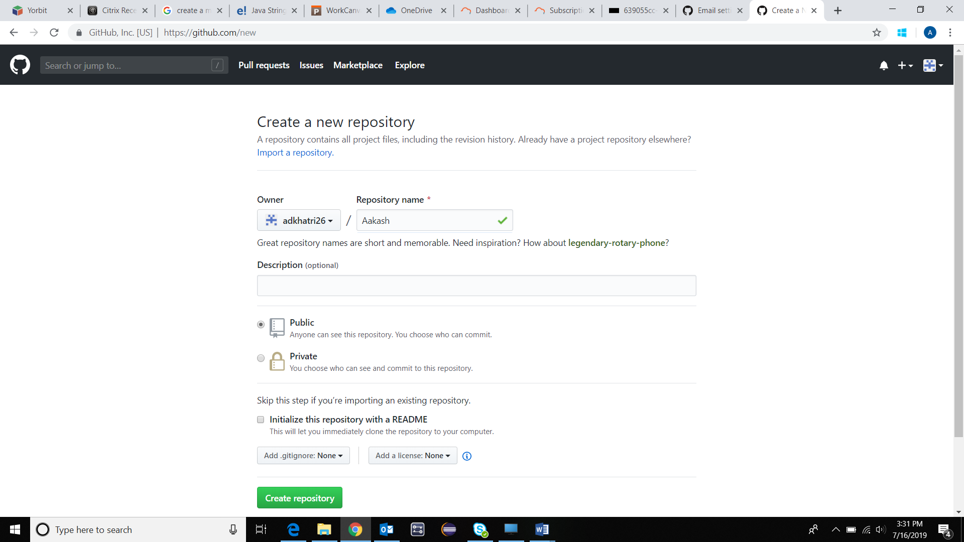

**Click on Create Repository**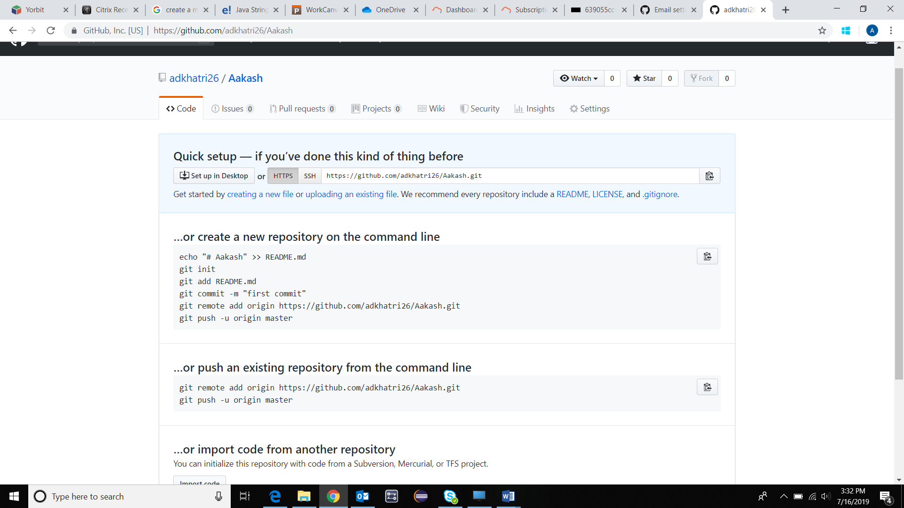

**Initiate GIT Bash**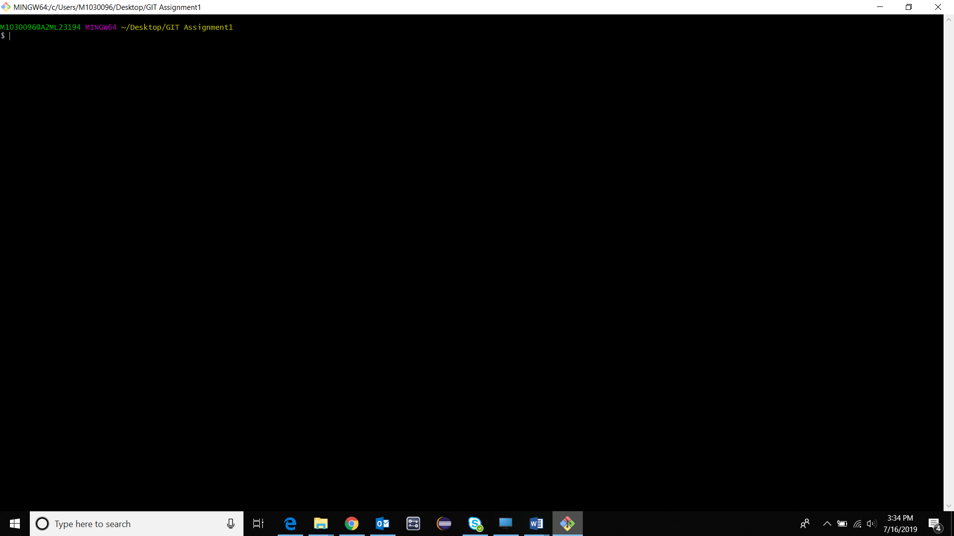

$ git init

$ echo “My First README file”>README.md

$ git add README.md

$ git commit –am”My first commit on Master branch in README file” 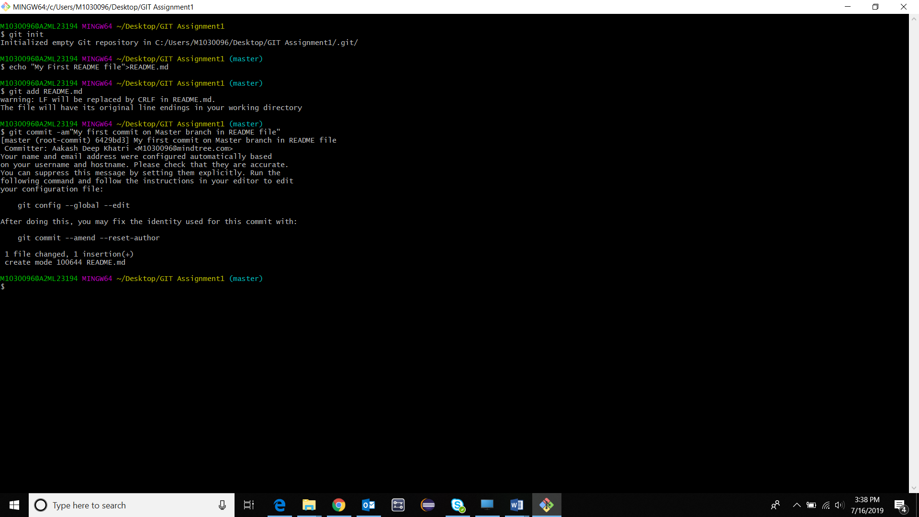

$ git remote add origin <https://github.com/adkhatri26/Aakash.git>

$ git push –u origin master

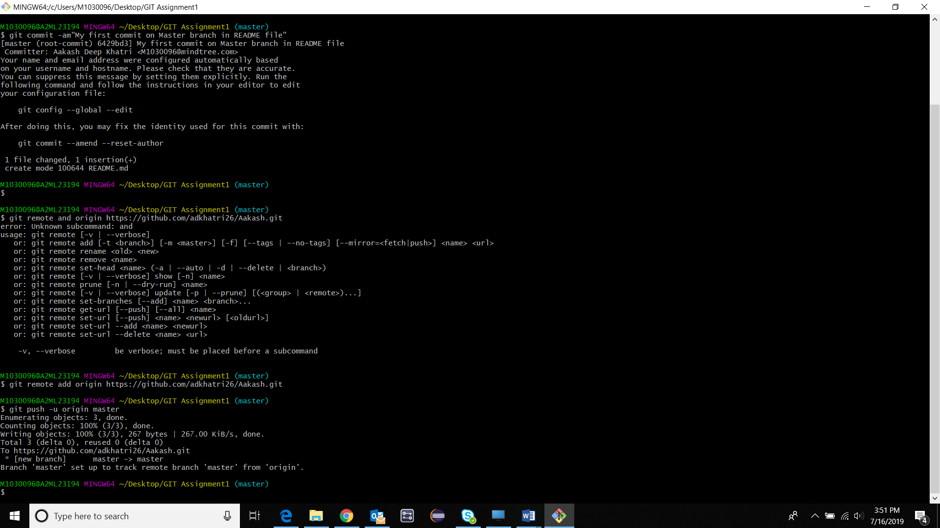

**README.md file added to the Repository**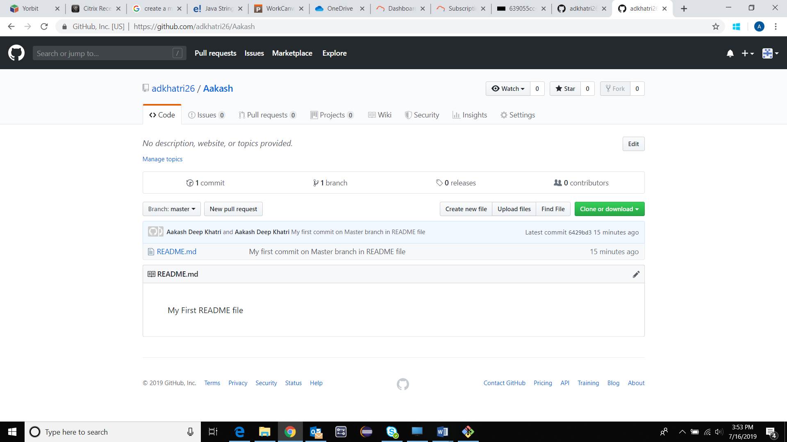

**Create 2 new branches DEV & QA**

**$ git branch DEV**

**$ git branch QA**

**$ git branch**

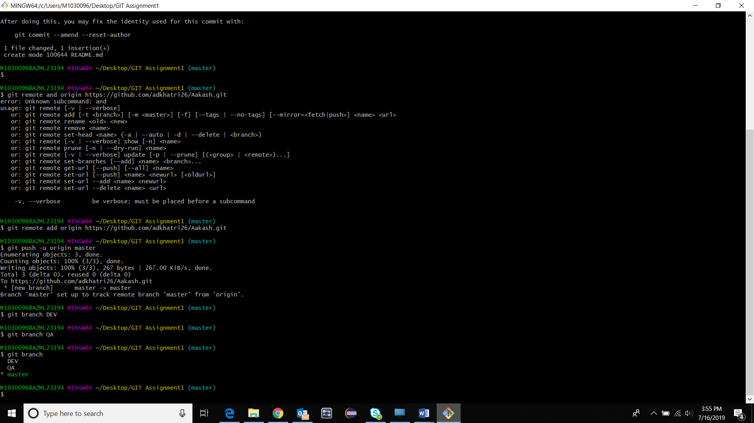

**Add new file to the newly created branch**

**$ git checkout DEV**

**$ echo “This README file is appended from the DEV Branch”>README.md**

**$ git add README.md**

**$ git commit –am “This is my First Commit from DEV Branch”**

**$ git push –u origin master**

**$ git push –u origin DEV**

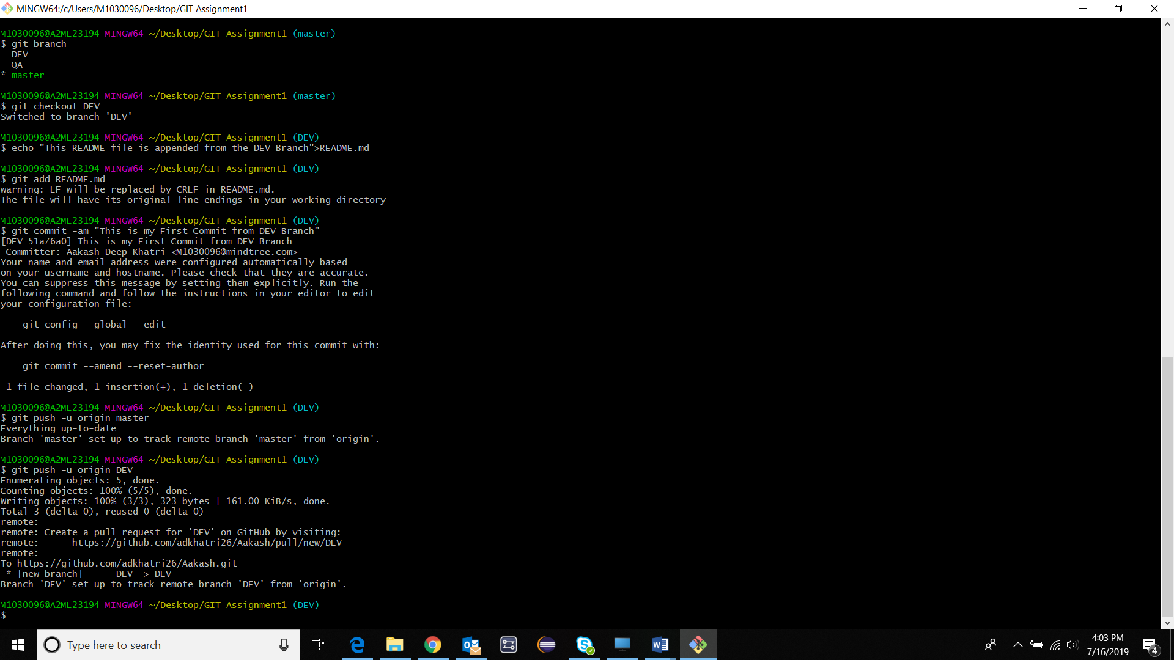

**Validate: DEV Branch in GITHUB** 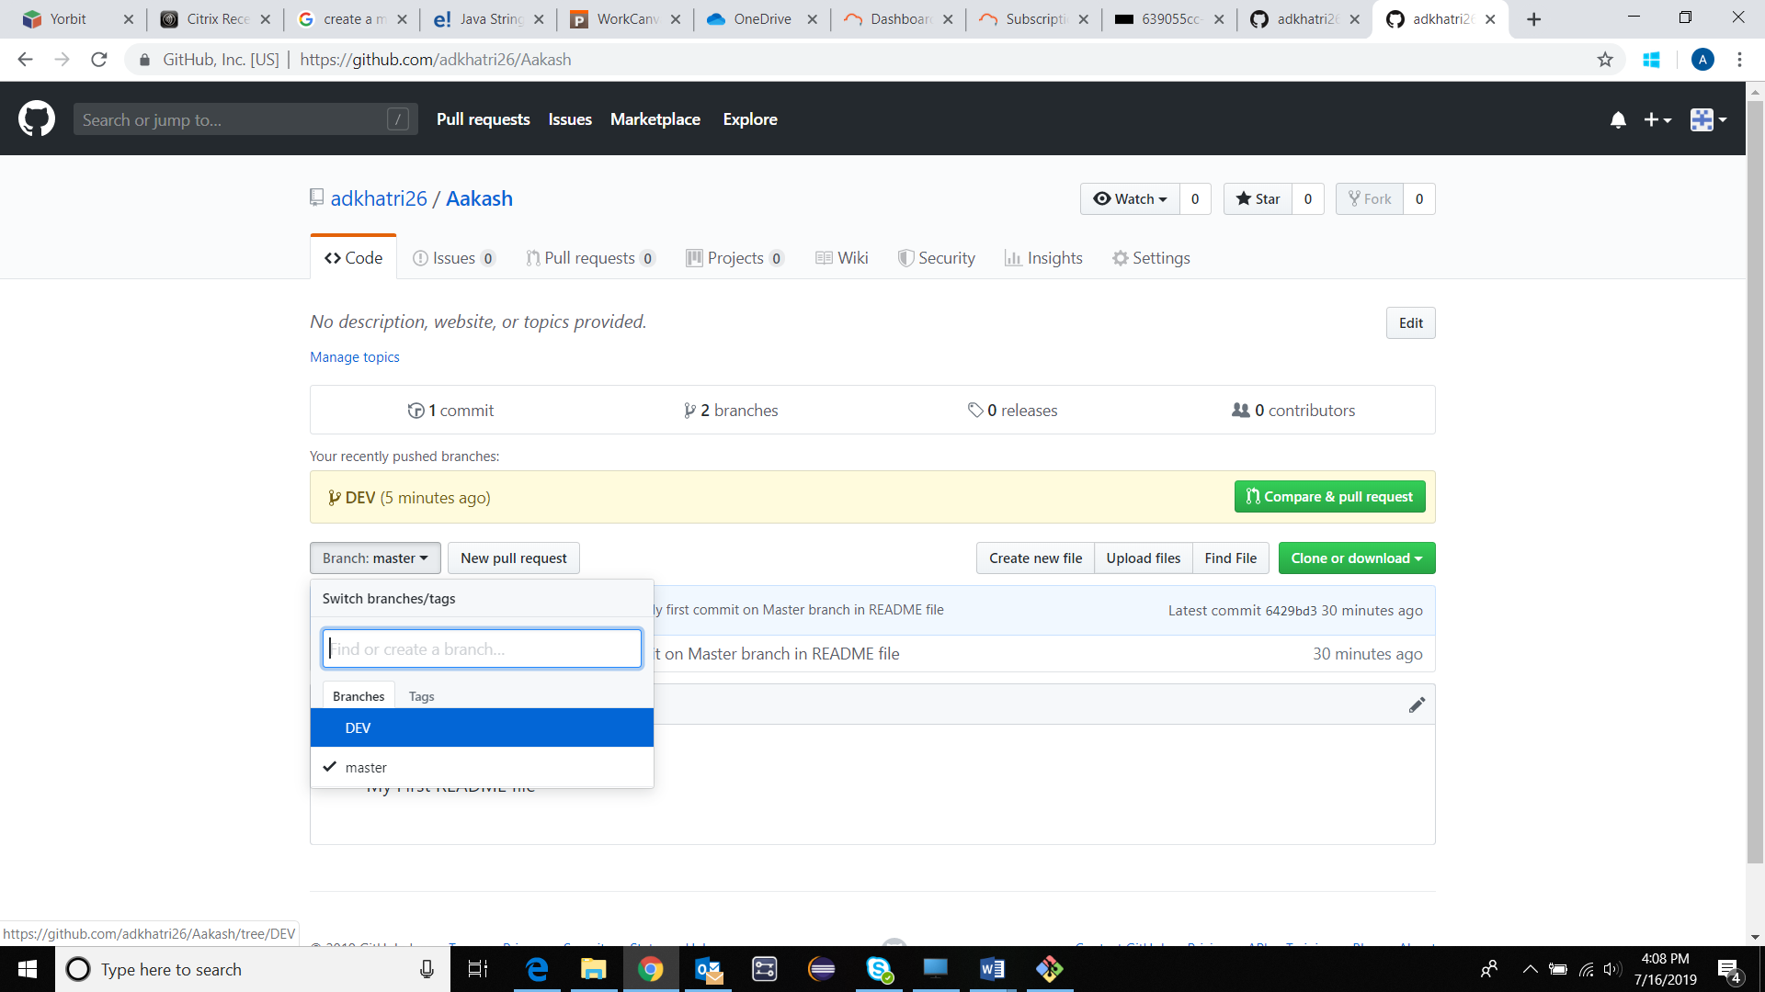

**Validate: README file added to the DEV Branch** 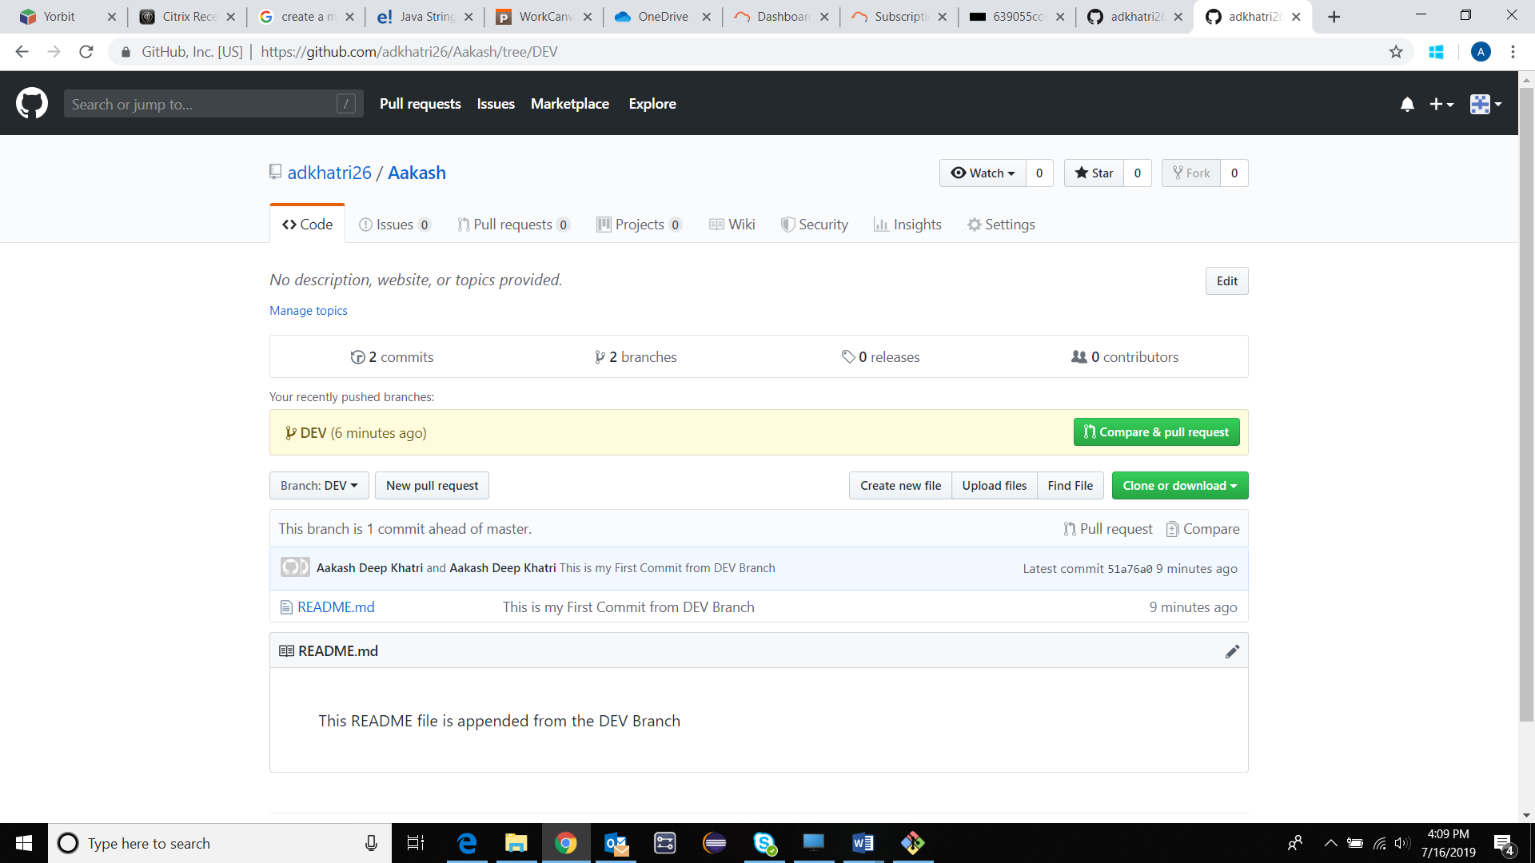

**Creating a Conflict**

**$ git checkout master**

**$ echo “WELCOME TO THE GITHUB”>README.md**

**$ git add README.md**

**$ git commit –am”My second commit on Master branch in README file”**

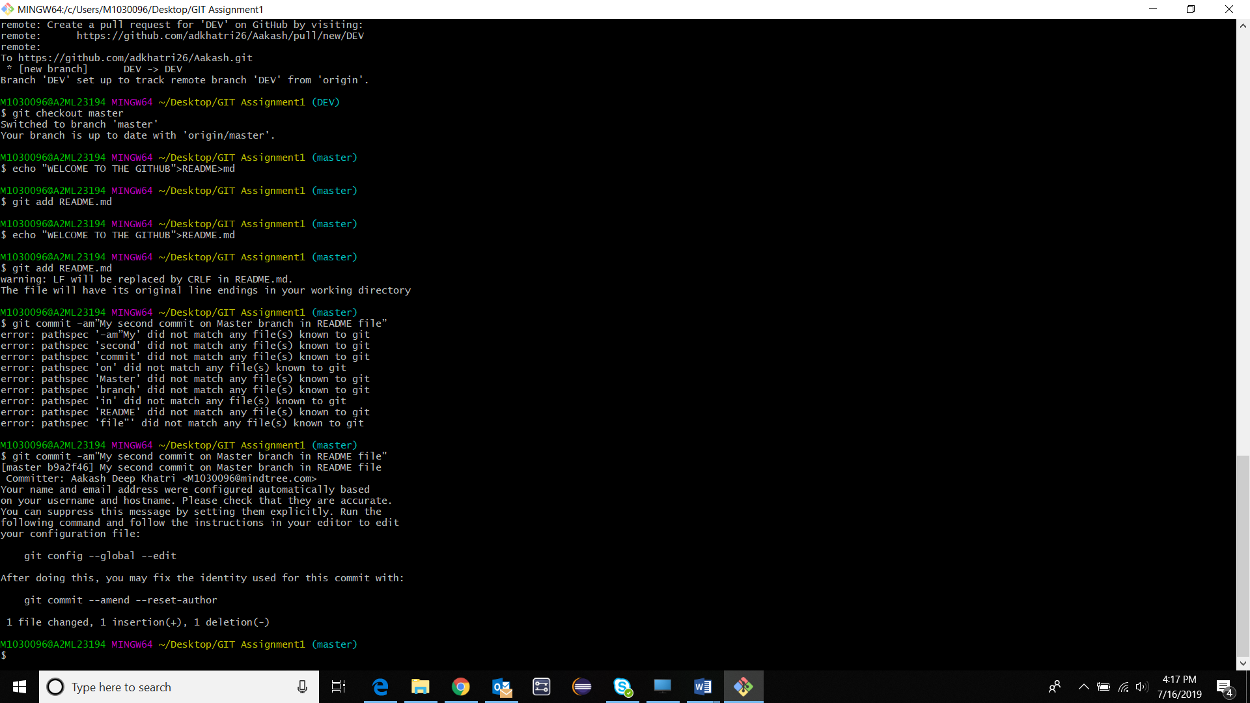

**$ git push –u origin master**

**$ git merge DEV**

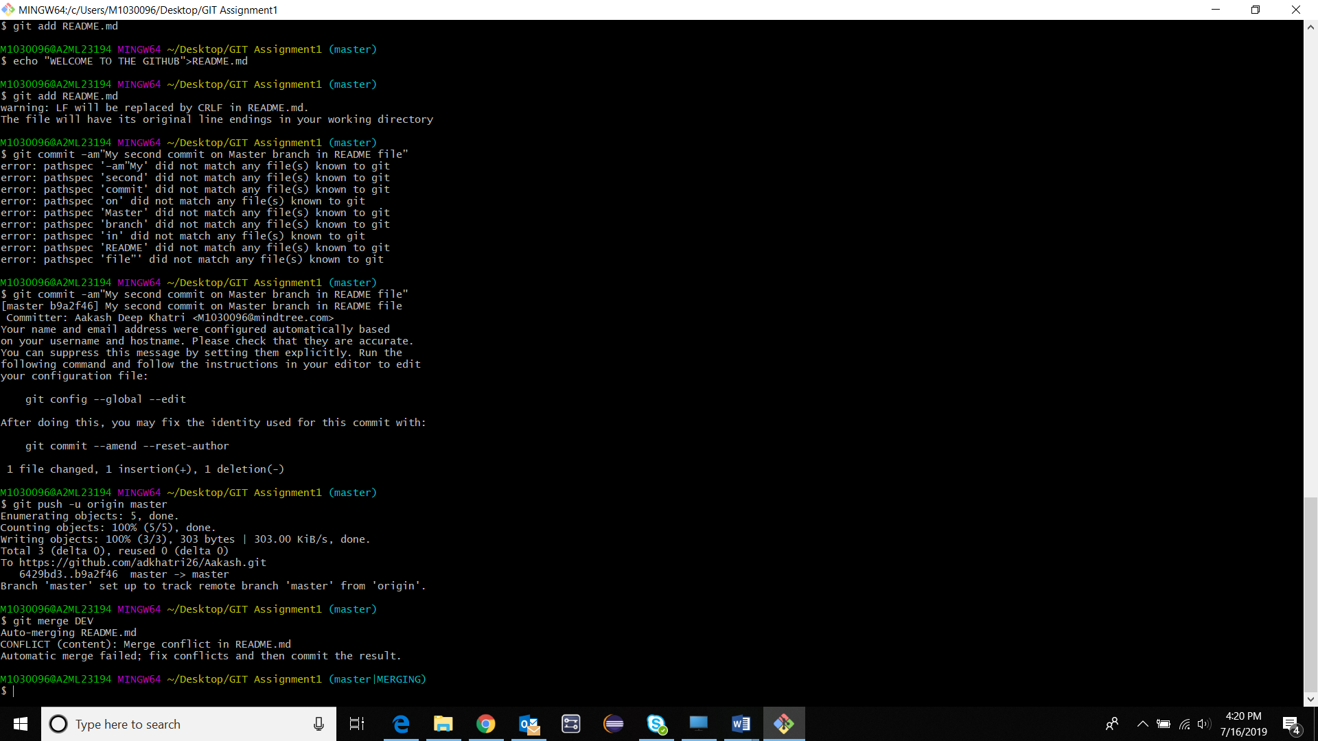

**Resolving Conflict**

**$ git status**

**$ cat README.md (CTRL + Z to come out of command)**

**$ vi README.md**

**$ git add README.md**

**$ git commit –am”RESOLVING THE CONFLICTS”**

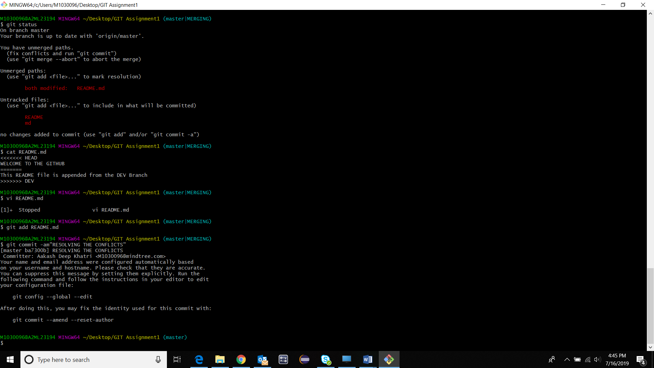

**$ git push –u origin master**

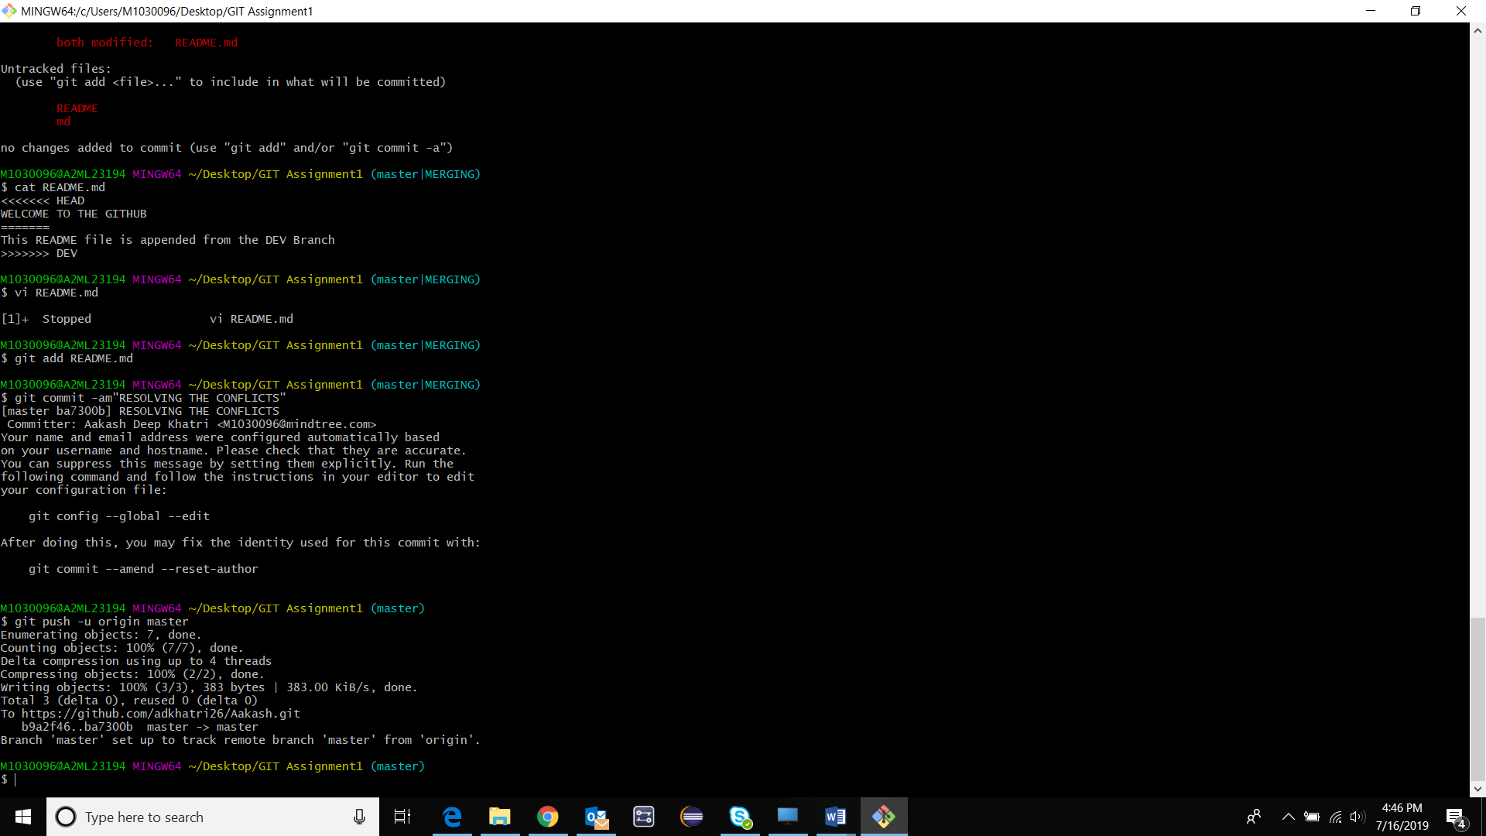

**Merged File in GIT HUB** 