THESIS

AN APPLICATION ORIENTED STUDY OF OFFLOADING IN MOBILES

AND

MACHINE LEARNING TECHNIQUES FOR CHOOSING BETWEEN AVAILABLE

NETWORK (3G, 4G and Wi-Fi) WHILE OFFLOADING

Submitted by

Aditya Dilip Khune

Department of Electrical and Computer Engineering

In partial fulfillment of the requirements

For the Degree of Master of Science

Colorado State University

Fort Collins, Colorado

Master’s Committee:

Advisor: Sudeep Pasricha

Anura P. Jayasumana

Sangmi Pallickara

Copyright by Aditya Dilip Khune

All Rights Reserved

ABSTRACT

AN APPLICATION ORIENTED STUDY OF OFFLOADING IN MOBILES AND MACHINE LEARNING TECHNIQUES FOR CHOOSING BETWEEN AVAILABLE

NETWORK (3G, 4G and Wi-Fi) WHILE OFFLOADING

The users of Smartphones demand longer battery life today. Low-power Software and Hardware design has been an active research topic for many years. Offloading applications on a surrogate machine is an innovative technique in this area. Offloading or Cyber foraging has been widely considered for saving energy and increasing responsiveness of mobile devices in the past. Due to the advancement in Cloud Computing and high speed mobile networks such as 4G, Offloading has generated a renewed interest in Smartphone Research community.

In the offloading model, a mobile application is analyzed so that the most computational expensive operations can be identified and offloaded for remote processing. However, there are many challenges in this domain that are not dealt with effectively yet and thus Offloading is far from being adopted in the design of current mobile architectures. There is a need to verify the effectiveness of offloading so that real potential of offloading for mobiles can be highlighted in real time applications.

In this work, we have done a study on some of the widely used smartphone apps in both Local and Offloaded processing modes. Our results are helpful to identify the advantages and disadvantages of Offloading with varying mobile networks.

Further we have presented a Reinforcement Learning (RL) based strategy to enhance the Offloading System; our strategy helps smartphone make decision of choosing between available networks (3G, 4G or Wi-Fi) while offloading mode is active. Our System considers suitable information on the device to make accurate Offloading decision in order to get optimized energy consumption.

Reinforcement Learning is an approach where an RL agent learns by interacting with its environment and observing the results of these interactions. The reinforcement signal that the RL-agent receives is a numerical reward, which encodes the success of an actions outcome, and the agent seeks to learn to select actions that maximize the accumulated reward over time.

In our strategy, we propose an application and user interaction aware middleware framework that uses Reinforcement Learning (RL) and Fuzzy Logic methods for making Offloading decisions. We have also used Neural Network to test our Reward based Machine Learning mechanism in a Simulated environment. We have analyzed the validity of our algorithm with the help of compute intensive Benchmark applications. Together these techniques allow minimization of energy consumption in mobile Offloading systems.

**TABLE OF CONTENTS**

ABSTRACT vii

CHAPTER 1 INTRODUCTION 2

1.1 Background 4

1.2 Challenges in Code Offloading 5

1.3 Contributions 6

1.4 Outline 7

CHAPTER 2 LITERATURE REVIEW 8

CHAPTER 3 OVERVIEW OF MACHINE LEARNING TECHNIQUES 11

3.1 Reinforcement Learning (RL) 11

3.2 RL with Neural Networks 15

3.3 Fuzzy Logic 17

3.4 Linear Discriminant Analysis (LDA) 18

CHAPTER 4 APPLICATION ORIENTED STUDY OF OFFLOADING 19

4.1 Experimental Setup 20

4.2 Smartphone Applications which use Offloading 21

4.3 Findings from the Experimentations 28

CHAPTER5 SMART OFFLOADING DECISION ENGINES TO CHOOSE BETWEEN AVAILABLE NETWORKS AND COUNTER NETWORK INCONSISTENCY 29

5.1 Need to choose right network while offloading because of Network Inconsistency 29

5.2 Reinforcement Learning (RL) Decision Engine 30

5.3 RL with Neural Network 34

5.4 Fuzzy Logic Decision Engine 36

5.5 Comparing our Algorithms with previous works 40

CHAPTER 6 CONCLUSION 42

6.1 Future Work 43

REFERENCES 44

Appendix A 46

A1. MainOffloadingAppActivity.java 46

A2. FuzzyLogicDisplay.java 49

A3. Reinforcement_Strategy.py 50

A4. RLwithNeuralNetwork.py 55

A5. Cloud Interaction with Pyton code 59

A6. AWS Cloud Interaction with Shell script 60

**LIST OF FIGURES**

Figure 1.1 : Offloading System Model 3

Figure 1.2 : Offloading is beneficial when large amounts of computation C are needed with relatively small amounts of communication D 4

Figure 3.1 : Choose from available actions with best Reinforcement History 13

Figure 3.2: Neural network perceptron model 15

Figure 3.3 Fuzzy Logic Decision Engine 17

Figure 4.1 Power Monitor Setup 20

Figure 4.2: Battery Consumption for Matrix Inverse Calculation 21

Figure 4.3: Response Time for Matrix Inverse Calculation 22

Figure 4.4 Battery Consumption for Web Browsers 23

Figure 4.5 Response Time for page loading in Web Browsers 24

Figure 4.6 Battery Consumption while zipping files 24

Figure 4.7 Response Time while zipping Files 25

Figure 4.8 Battery Consumption while Voice Recognition and Translation App 26

Figure 4.9 Battery Consumption while Torrent downloading 27

Figure 4.10: Response Time while Torrent downloading 27

Figure 5.1 Representing the Q Table with Penalty values 32

Figure 5.2 Reinforcement Learning (RL) with Neural Network (NN) 35

Figure 5.3 Classifying with Fuzzy Logic 39

Figure 5.4 Offloading Decision Engine in Android 39

Figure 5.5 Energy Consumption by Different Models with Varying percentage of Training for Matrix Operation 40

Figure 5.6 Energy Consumption by Different Models with Varying percentage of Training for Torrent file download App 41

CHAPTER 1   
INTRODUCTION

Faster network speeds and rapid innovations in Mobile technologies have changed the way we used our computers. Thanks to new operating system architectures such as Android and iOS, the number of applications on our smartphones have literally exploded. Smartphones are widely used for navigating numerous important life activities, from researching a health condition to accessing educational resources and unfortunately, most of the time smartphone users face an annoying situation where they have to recharge their handsets twice per day.

Today's smartphones offer variety of complex applications, larger communication bandwidth and more processing power. However, this has increased the burden on its energy usage; while it is seen that advances in battery capacity do not keep up with the requirements of the modern user.

Cloud Computing has drawn attention of Mobile technologies due to the increasing demand of applications, for processing power, storage place, and energy. Cloud computing promises the availability of infinite resources, and it mainly operates with utility computing model, where consumers pay on the basis of their usage. Vast amount of applications such as social networks, location based services, sensor based health-care apps, gaming apps etc. can benefit from mobile Cloud Computing.

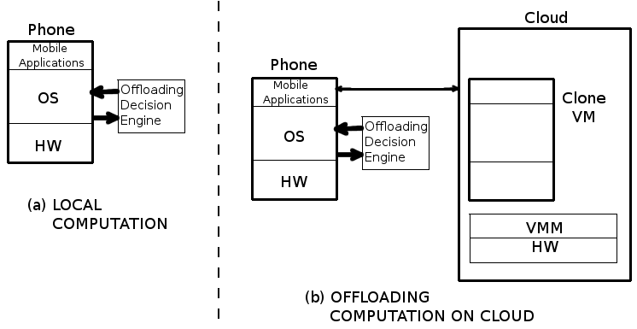

#### Figure 1.1 : Offloading System Model

Offloading Mobile computation on cloud is being widely considered for saving energy and increasing responsiveness of mobile devices. The potential of code offloading lies in the ability to sustain power hungry applications by identifying and managing energy consuming resources of the mobile device by offloading them onto cloud.

Currently most of the research work in this area is focused on providing the device with an offloading logic based on its local context. In this work, we have done application-oriented study of offloading in smartphones to gain insights of energy consumption and response time with both Offloading and Local modes active each at a time. Our study also involves the results of smartphone app offloading with different available networks (3G, 4G and Wi-Fi). Finally, we have proposed a Reinforcement Learning (RL) based system that will help smartphone choose the right network to do offloading in order to reduce battery consumption.

### 1.1 Background

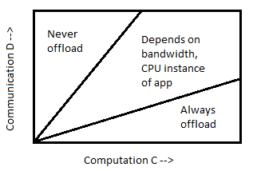The energy saved by computation offloading depends on the amount of computation to be performed C, the amount of data to be transmitted D and the wireless bandwidth B. Existing studies thus focus on determining whether to offload computation by predicting the relationships among these three factors [2].

#### Figure 1.2 : Offloading is beneficial when large amounts of computation C are needed with relatively small amounts of communication D

Multiple research works have proposed different strategies to empower mobile devices with Intelligent Offloading System. We have shown a basic offloading architecture in the Fig. 1.1. Offloading relies on remote servers to execute code delegated by a mobile device.

In the architecture that is presented in [3] the client is composed of a *code profiler*, *system profilers*, and *a decision engine*. The server contains the surrogate platform to invoke and execute code.

The code profiler determines what to offload (portions of code: Method, Thread, or Class). Code partitioning requires the selection of the code to be offloaded. Code can be partitioned through different strategies; for instance, in [4] special static annotations are used by a software developer to select the code that should be offloaded. In [5] authors have presented an automated mechanism, which analyzes the code during runtime. Automated mechanisms are preferable over static ones as they can adapt the code to be executed in different devices.

*System profilers* monitor multiple parameters of the smartphone, such as available bandwidth, data size to transmit, and energy to execute the code. We look to these parameters to know *when to offload* to the cloud.

*The decision engine* analyzes the parameters from System and code profilers and applies certain logic over them to deduce when to offload. If the engine concludes a positive outcome, the offloading system is activated, which sends the required data and the code is invoked remotely on the cloud; otherwise, the processing is performed locally.

### 1.2 Challenges in Code Offloading

The offloading technique is far from being adopted in the design of current mobile architectures; this is because utilization of code offloading in real scenarios proves to be mostly negative [6], which means that the device spends more energy in the Offloading process than the actual energy that is saved. In this section, we highlight the challenges and obstacles in deploying code Offloading.

We found out that Network Inconsistency is one of the major concern while we want to make a correct offloading decision to offload the processing on cloud. Network Inconsistency is studied in detail in Chapter 5.

It is very difficult to evaluate runtime properties of code, the code will have non-deterministic behavior during runtime, it is difficult to estimate the running cost of a piece of code considered for Offloading [3]. The code in consideration of Offloading might become intensive based on factors such as the user input, type of application, execution environment, available memory, etc. [6].

Code partitioning is one of the mechanisms considered by researchers. Code partitioning relies on the expertise of the software developer; the main idea is to annotate portions of code statically. These annotations can cause poor flexibility to execute the app in different mobile devices, it can cause unnecessary code Offloading that drains energy. Automated strategies are shown to be ineffective, and need a major low-level modification in the core system of the mobile platform, which lead to privacy issues [3].

The Offloading Decision engine in the mobile device should consider not only the potential energy savings, but also the response time of the request. It can also be argued that, as the computational capabilities of the latest smartphones are comparable to some servers running in the cloud, in such case why to offload. In this work, we have tried to address some of these challenges by using Reinforcement Learning (RL) Decision Engine for Offloading Process.

### 1.3 Contributions

* In this Thesis, we have studied the viability of offloading solutions in great details, with the help of benchmark applications to know right kind of applications that may benefit from effective offloading Architecture. During the evaluation, we run these applications using all available networks (3G, 4G, and Wi-Fi).
* In this work, we present a novel adaptive offloading technique called Reward Based Offloading System that uses Reinforcement Learning (RL) and Fuzzy Logic to deduce right offloading decision. The decision is taken so that offloading is guaranteed to optimize both the response time and energy consumption. This method is classified as an 'Unsupervised learning' method. We have also used Neural Network to test our Reward based Machine Learning mechanism in a Simulated environment.
* Further, we have used 'Supervised learning' methods such as Linear Discriminant Analysis to create the offloading decision engines.
* We have also compared our proposed techniques with prior work in the offloading domain that propose to empower Decision Engines with offloading logic for instance Decision Engine with Fuzzy Logic Engine, SVR and other supervised

Learning techniques.

### 1.4 Outline

The rest of the thesis is organized as follows. Chapter 2 provides an overview of prior works in offloading domain. Chapter 3 gives overview of Machine Learning Techniques used for in this thesis to create an offloading decision engine. In Chapter 4, we have done an application-oriented study of offloading using available networks such as 3G. 4G and Wi-Fi. In Chapter 5, we have presented Smart Offloading Decision Engines to Choose between Available networks and Counter Network Inconsistency. Chapter 6 concludes the thesis with a summary and future work. The appendix offers the source code of the strategies presented in our thesis.

CHAPTER 2   
LITERATURE REVIEW

A large amount of work has been done in the area of Smartphone Offloading for mobile devices in recent years. Since advances in smartphone processing and storage technology outpaces the advances in the battery technology, computation offloading has been seen as a potential solution for the smartphone’s energy bottleneck problem. In this Chapter, we give an overview of the research in computation offloading and energy efficiency of Smartphones.

In [4] authors have proposed a system called MAUI, it has a strategy based on code annotations to determine which methods from a Class must be offloaded. Annotations are introduced within the source code by the developer at development phase itself. At runtime, methods are identified by the MAUI profiler, which performs the offloading over the methods, if bandwidth of the network and data transfer conditions are ideal. MAUI optimizes both the energy consumption and execution time using an optimization solver.

In [5] authors have proposed CloneCloud, which is a system for elastic execution between mobile and cloud through dynamic application partitioning, where a thread of the application is migrated to a clone of the smartphone in the cloud. CloneCloud uses dynamic profiling and optimization solver. In CloneCloud partitioning takes place without the developer intervention and application partitioning is based on static analysis to specify the migration and reintegration points in the application.

In [2] authors have proposed an equation with several parameters to measure whether computation offloading to cloud would save energy or not. These parameters are in this paper, the authors discussed various parameters such as network bandwidth, cloud-processing speed, device processing speed, the number of transferred bytes, and the energy consumption of a smartphone when it is in idle, processing and communicating states. However, we found that authors did not experiment their work in a real offloading framework.

In paper [7] authors proposed ThinkAir which is a computation offloading system that is similar to MAUI and Cloudclone. ThinkAir does not only focus on the offloading efficiency but also on the elasticity and scalability of the cloud side; it boosts the power of mobile cloud computing through parallelizing method execution using multiple virtual machine images. In Papers [8], [9] and [10] Authors have concentrated on Adaptive Learning of Offloading Decision Engines. We will study some of their strategies in later part of this report.

Smartphone Energizer [9] is a supervised learning-based technique for energy efficient computation offloading. In this work, authors propose an adaptive, and context-aware offloading technique that uses Support Vector Regression (SVR) and several contextual features to predict the remote execution time and energy consumption then takes the offloading decision. The decision is taken so that offloading is guaranteed to optimize both the response time and energy consumption. Smartphone Energizer Client (SEC) initially starts in the learning mode, in which it extracts the different network, device, and application features and stores them after each service invocation. After each local service invocation, the Smartphone Energizers profiler stores the context parameters, which include the service identifier, input size, and output size along with the consumed energy and time during service execution. When the number of local service invocations exceeds the local learning capacity, the SEC switches to the remote execution by checking if there's a reachable offloading server, then the service will be installed on the server (for the first time only) and will be executed remotely, otherwise it will be executed locally.

In [8] the authors have proposed fuzzy decision engine for code offloading, that considers both mobile and cloud variables. At the mobile platform level, the device uses a decision engine based on fuzzy logic, which is utilized to combine n number of variables, which are to be obtained from the overall mobile cloud architecture. Fuzzy Logic Decision Engine works in three steps namely: Fuzzyfication, Inference and Defuzzification. The distribution of different technologies around the world varies significantly. In India, a country with limited broadband infrastructure, 2G remains in active use, while the U.S. and Mexico lean heavily on Wi-Fi connections. Because of such variations in the different technologies around the world, it is difficult to rely on the fuzzy logic decision engine presented in [8]. This is because the app developers will have to customize the decision engines depending upon which part of the world the device lies.

CHAPTER 3   
OVERVIEW OF MACHINE LEARNING TECHNIQUES

Machine learning algorithms search for patterns and regularities in any given data and have found wide usage across various application domains. They automatically learn from data by generalizing from examples. As more data becomes available, problems that are more ambitious can be tackled. These algorithms are typically implemented in two phases. In the first phase, called ***training phase***, data is gathered and provided to the algorithm, so it can learn patterns and create a model to classify data or predict data properties. In the second phase, called ***testing phase***, new data is tested against the model that was built during the training phase, and the effectiveness of the model is revealed. Such two-phase learning algorithms are called *supervised* learning algorithms. There are also algorithms in which the testing phase is not used, and such algorithms are called *unsupervised* learning algorithms. These algorithms use unlabeled data to cluster the data in different classes. Machine learning algorithms can be used for classification or regression. In *classification,* the machine-learning algorithm learns to classify the data in different classes while in *regression* it predicts a continuous variable by learning from the train data. To improve Offloading decision accuracy over prior work, we propose to integrate machine-learning techniques that intelligently make use of different modules in our Offloading framework.

### 3.1 Reinforcement Learning (RL)

Reinforcement learning is learning by interacting with an environment. An RL agent learns from the consequences of its actions, rather than from being explicitly taught and it selects its actions on basis of its past experiences (exploitation) and also by new choices (exploration), which is essentially trial and error learning. The reinforcement signal that the RL-agent receives is a numerical reward, which encodes the success of an action's outcome, and the agent seeks to learn to select actions that maximize the accumulated reward over time.

A reinforcement-learning engine interacts with its environment in discrete time steps. At each time t, the agent receives an observation *Ot*, which typically includes the reward rt. It then chooses an action at from the set of actions available, which is subsequently sent to the environment. The environment moves to a new state *st+1* and the reward *rt+1* associated with the transition *(st, at, st+1)* is determined. The goal of a reinforcement-learning agent is to collect as much reward as possible. The agent can choose any action as a function of the history and it can even randomize its action selection.

Reinforcement learning is particularly well suited to problems, which include a long-term versus short-term reward tradeoff. It has been applied successfully to various problems, including robot control, elevator scheduling, telecommunications, etc.

The basic reinforcement-learning model consists of:

* a set of environment states S;
* a set of actions A;
* rules of transitioning between states;
* rules that determine the scalar immediate reward of a transition

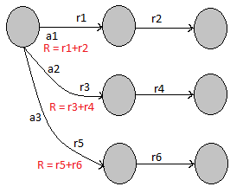

#### Figure 3.1 : Choose from available actions with best Reinforcement History

We want to choose the action that we predict will result in the best possible future from the current state in Figure 3.1. Need a value that represents the future outcome. With the correct values, multi-step decision problems are reduced to single-step decision problems. Just pick action with best value and it has guaranteed to find optimal multi-step solution! The utility or cost of a single action taken from a state is the reinforcement for that action from that state. The value of that state-action is the expected value of the full return or the sum of reinforcements that will follow when that action is taken.

Say we are in state *st* at time *t*. Upon taking action at from that state we observe the one-step reinforcement *rt+1*, and the next state *st+1*. Say this continues until we reach a goal state, *K* steps later we have return as:

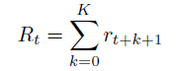

(3.1)

So the aim of Reinforcement Learning algorithm generally is either to maximize or minimize the reinforcements *Rt* depending upon our Reinforcement function.

###### 3.1.1 Q Function

A function called *Q* function stores the reinforcement values for each case it encounters, some more mathematics about this *Q* function which is used in RL algorithm is shown here:

The state-action value function is a function of both state and action and its value is a prediction of the expected sum of future reinforcements. We will call the state-action value function Q.

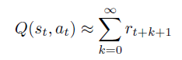

(3.2)

Here, *st* = state, *at* = actions, and *rt* = reinforcements received.

###### 3.1.2 Reinforcement Learning Objective

The objective for any reinforcement learning problem is to find the sequence of actions that maximizes (or minimizes) the sum of reinforcements along the sequence. This is reduced to the objective of acquiring the Q function, which predicts the expected sum of future reinforcements, because the correct Q function determines the optimal next action.

Therefore, the RL objective is to make this approximation as accurate as possible:



(3.3)

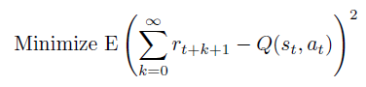This is usually formulated as the least squares objective:

(3.4)

### 3.2 RL with Neural Networks

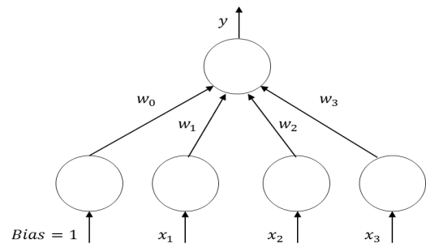Neural network models, also known as *Artificial Neural Networks*, are inspired by the way the human brain is believed to function. Many of the normal basic everyday information processing requirements handled by the brain, for example sensory processing, cognition, and learning, surpass any capable computing system out there today. Although a human brain is quite different than today’s computing hardware, it is believed that the basic concepts still apply in that there is a computational unit, known as a *neuron*, and connections to memory stored in *synapses*. The main difference being that the human brain consists of billions of these simple parallel processing units, neurons, which are interconnected in a massive multi-layered distributive network of synapsesand

#### Figure 3.2: Neural network perceptron model

neurons*.*In machine learning, these concepts are modeled as what is called a *perceptron*, the basic processing element, connected by other *perceptrons* through weighted connections, as illustrated in Figure 5.3. The output of a perceptron is simply a weighted sum of its inputs including a weighted bias, as shown in following equation.

|  |  |
| --- | --- |
|  | (3.5) |

To compute the output *y*given a sample *xi*, *backpropagation* using the gradient with respect to the weights is performed using a training dataset to find the weight parameters, *wi*, that minimize the mean squared error between the neural network outputs, *yi*, and the target outputs, *ti*. By default, the neural network consists of a hyperplane (for multiple perceptrons) that can be used as a linear discriminant to linearly separate the classes. To improve prediction accuracy, we make it non-linear, by applying a sigmoidal or hyperbolic tangent to hidden unit layer perceptrons, as denoted in equation below. This allows for non-linear boundaries with the output of the neural network being linear in the weights, but non-linear in the inputs.

|  |  |
| --- | --- |
|  | (3.6) |

For classification with a neural network (non-linear logistic regression), the number of parallel output perceptrons is equal to the number of classes. The output from each perceptron, *yi*, is then sent to post processing as in equation below to determine the respective class by taking the maximum of the post-processed outputs:

|  |  |
| --- | --- |
|  | (3.7) |

One of the biggest criticisms about the use of neural networks is the time required for training. Although this can be a major issue if using a simple gradient descent approach, newer training techniques, such as the scaled conjugate gradient (SCG) [50], can greatly minimize the time required for training. SCG, a method for efficiently training feed-forward neural networks, was used for training the neural networks in this thesis.

### 3.3 Fuzzy Logic

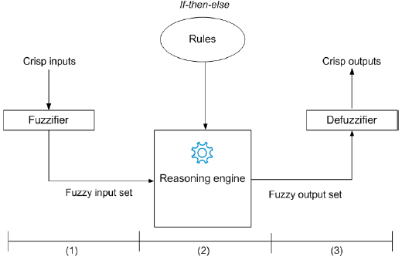Fuzzy Logic deals with approximate rather than fixed reasoning, and it has capabilities to react to continuous changes of the dependent variables. The decision of offloading processing components to cloud becomes a variable, and controlling this variable can be a complex task due to many real-time constraints of the overall mobile and cloud system parameters.

#### Figure 3.3 Fuzzy Logic Decision Engine

Fuzzy Logic Decision Engine works in three steps namely: Fuzzyfication, Inference and Defuzzification. Let us see these steps in detail: 1) In Fuzzification, input data is converted into linguistic variables, which are assigned to a specific membership function. 2) A reasoning engine is applied to the variables, which makes an inference based on a set of rules. Finally, 3) The output from reasoning engine are mapped to linguistic variable sets again (aka defuzzyification).

### 3.4 Linear Discriminant Analysis (LDA)

In machine learning, classification is the problem of identifying to which of a set of categories a new observation belongs, on the basis of a training set of data containing observations (or instances) whose category membership is known. Classification is considered an instance of supervised learning, i.e. learning where a training set of correctly identified observations is available. An algorithm that implements classification, especially in a concrete implementation, is known as a classifier. Linear discriminant analysis (LDA) makes use of a Bayesian approach to classification in which parameters are considered as random variables of a prior distribution. This concept is fundamentally different from data-driven linear and non-linear discriminant analyses in which what is learned is a function that maps or separates samples to a class. Bayesian estimation and the application of LDA is also known as generative modeling.

CHAPTER 4   
APPLICATION ORIENTED STUDY OF OFFLOADING

In this chapter, we have surveyed various applications that are likely to benefit from Offloading as suggested by important publications in this area. Here is a list of types of applications as follows: applications with matrix calculations, image processing, Web-browsers, Torrent downloads, image search, file compressors, online games, language translators, speech recognizers, optical character recognizers, video processing and editing, navigation, face recognition, augmented reality, etc. These applications consume large mobile battery, memory, and computational resources. Out of those, we have selected out five applications for experimentations as follows:

1. Matrix Operations

2. Internet Browsers

3. Zipper

4. Voice Recognition and Translation

5. Torrents

After doing rigorous experimentations we have done energy and response time analysis of all the applications, we have compared the results obtained with each of available network 3G, 4G and Wi-Fi in order to know which is the best possible option for the offloading data/processing on cloud. In the end of this chapter, we have listed out my findings based on the results obtained with all the experimentations. To decrease the interference of the screen while doing energy analysis we run the applications with minimum brightness. Power consumption is measured by monsoon power analysis tool.

### 4.1 Experimental Setup

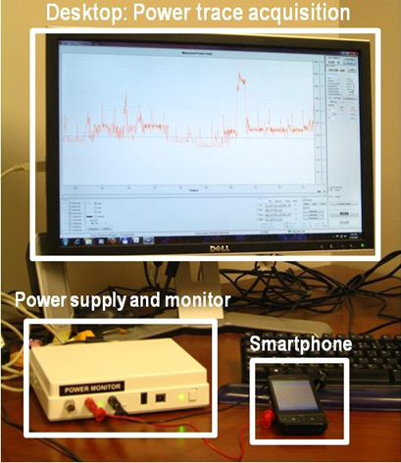The power estimation models were built using real power measurements on the Samsung S3 and LG G3 devices. The contact between the smartphone and the battery was instrumented, and current was measured using the Monsoon Solutions power monitor [20]. The monitor connects to a PC running the Monsoon Solutions power tool software that allows real-time current/power measurements over time. The power monitor setup is shown in Figure 4.1.

#### Figure 4.1 Power Monitor Setup

We have run each experiment 10 times on each handsets mentioned above, and then averaged out the readings obtained. All the experiments are done using AT & T's 3G, 4G (HSPA+) Network and Comcast's Wi-Fi Network separately in order to understand the effect of choosing the right network while offloading the tasks and data onto cloud.

### 4.2 Smartphone Applications which use Offloading

In this section we have done detailed experimentations on the five smartphone applications.

###### 4.2.1 Matrix Operations

Numerous applications involve some kind of large or small matrix operations, for an instance image-processing app. ‘Matrix calculator’ is a popular android app to do matrix calculations. In this experiment, this application calculates values of an Inverse Matrix.

In figure 4.1, we can see the battery consumption of smartphone increases manifolds as the size of Matrix increases, largely because there is an increase in CPU's energy consumption as number of floating point operations increase. This application calculates Matrix inverse using Adjoint Method. As we can see in the Figure 4.1, offloading the processing for matrix calculation on Cloud saves energy as the matrix size increases, but for small matrix operations (i.e. 3X3 and 4X4), the local processing is suitable as it saves both energy and time.

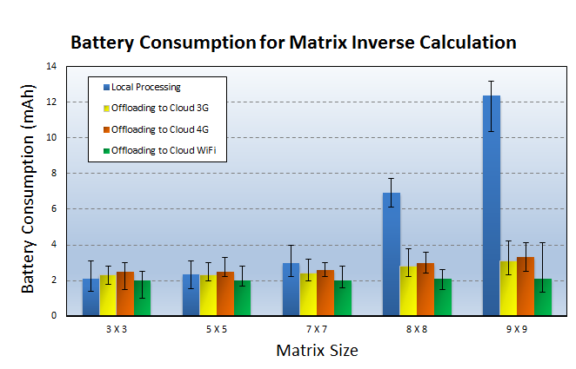

#### Figure 4.2: Battery Consumption for Matrix Inverse Calculation

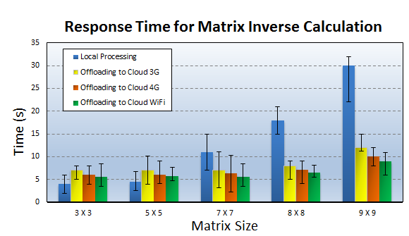

#### Figure 4.3: Response Time for Matrix Inverse Calculation

#### Figure 4.4 Battery Consumption for Web BrowsersFigure 4.3: Response Time for Matrix Inverse Calculation

###### 4.2.2 Internet Browsers

Cloud based Internet Browsers were introduced in order to overcome the processing and energy limitations of mobile devices. Already there are a number of cloud-based mobile web browsers that are available in the industry e.g. Amazon Silk [11], Opera Mini [12], Chrome beta [13] etc. Let us understand more about these browsers first. Cloud-based Web browsers([11], [13], [12], [14]) use a split architecture where processing of a Mobile web browser is offloaded to cloud partially, it involves cloud support for most browsing functionalities such as execution of JavaScript (JS), image transcoding and compression, parsing and rendering web pages. Prior research in this area such as [15] shows that CB does not provide clear benefits over Local or device-based browser (e.g. Local Processing) either in energy or download time. Offloading JS to the cloud is not always beneficial, especially when user interactivity is involved [15].

We have chosen one of the commercially available Cloud based mobile browser (puffin) and a Local browser (Firefox) for our experiments. In Figure 4.3 and 4.4, we have plotted the smartphone readings that we have obtained by measuring data transfer and response time required by these browsers for following websites: 1. www.yahoo.com, 2. www.wikipedia.org, 3. www.amazon.com, 4. www.google.com, 5. www.facebook.com.

We have obtained our readings for a data range starting as low as 150 Kib to a session involving 5 MBs of data transfer to load the webpages. We have observed here that Cloud based web browsers are faster but expensive in terms of energy consumption. For small data transfers it is always suitable to use Local web browser to save both time and battery consumption. For a normal user overall data transfer during the browsing session does not go beyond 5-6 MBs for single session, which means we always will have small data transfers to the cloud and Local browsers show better results for those cases and that's why Cloud based web-browsers aren't very popular.

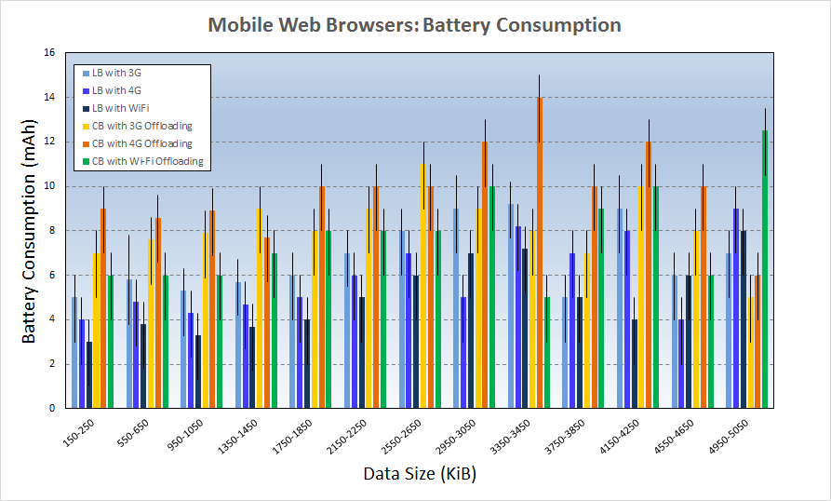

#### Figure 4.4 Battery Consumption for Web Browsers

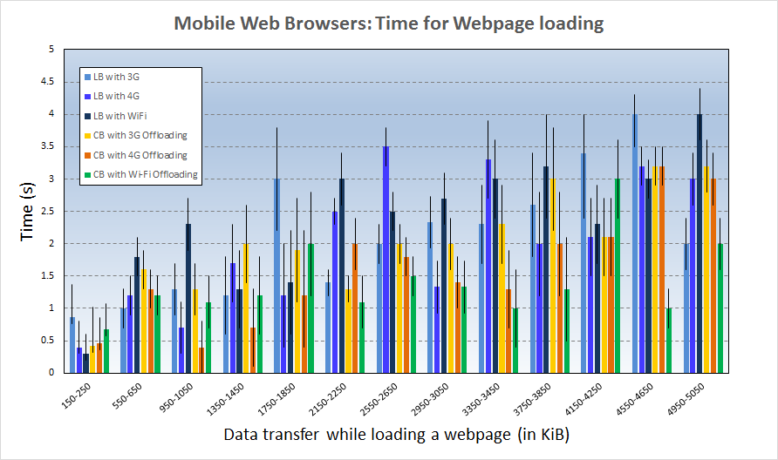

#### Figure 4.5 Response Time for page loading in Web Browsers

###### 4.2.3 Zipper

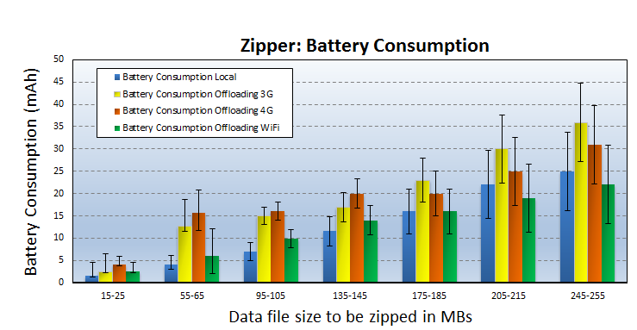Here the idea is the processing of zipping the files will be done either locally or on the cloud as directed by the Decision engines. The Zipper is an Android app that we used to compress the files locally. For Cloud based file compression, we have used online zipping tools such as [16] and [17].

#### Figure 4.6 Battery Consumption while zipping files

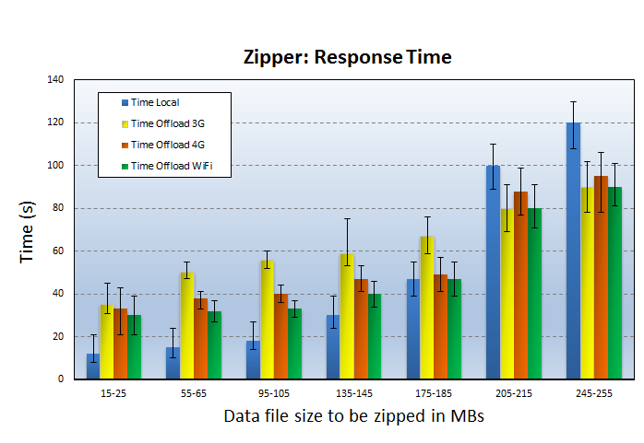In Figure 4.5 and Figure 4.6, we have given a comparison of energy consumption and Response Time while doing Local Processing and Offloaded Processing with varying file sizes. For compressing files, we have used pdf and word documents and also MP3 music files in equal size distribution.

#### Figure 4.7 Response Time while zipping Files

###### 4.2.4 Voice Recognition and Translation

Google translate is one of the app which uses cloud to do the voice recognition and translation. It also has an offline translation mode that does local processing on the device with small a Neural Network. In Figure 4.7, we can see the energy consumption of this app on our devices for a range of words. We have done our experimentations on our handsets using 3G, 4G and Wi-Fi networks for recognizing and translating 20-140 words from English to Marathi translations.

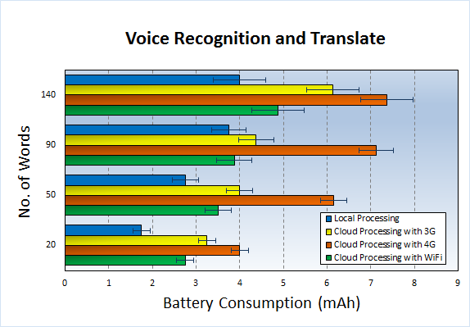

#### Figure 4.8 Battery Consumption while Voice Recognition and Translation App

###### 4.2.5 Torrents

In this strategy, the cloud servers are used as a BitTorrent client to download torrent pieces on behalf of a mobile handheld device. While the cloud server downloading the torrent pieces, the mobile handheld device switch to sleep mode until the cloud finishes the torrent processes and upload the torrent file in one shot to the handheld device. This strategy saves Energy of smartphones because downloading torrent pieces from torrent peers consumes more energy than downloading a one burst of pieces from the cloud. Similar strategy is proposed by Kelenyi et al. in [18].

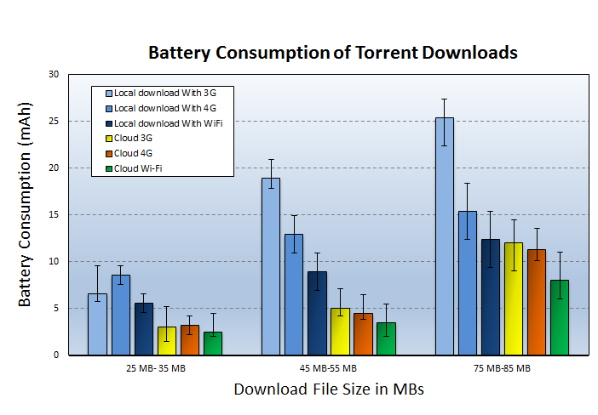

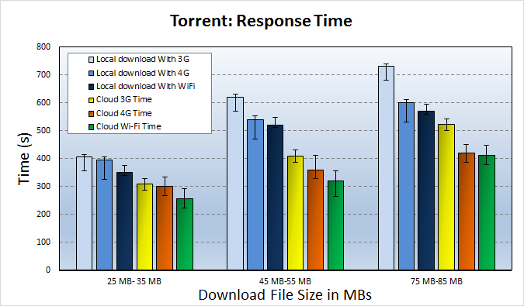

#### Figure 4.10: Response Time while Torrent downloading

#### Figure 4.9 Battery Consumption while Torrent downloading

### 4.3 Findings from the Experimentations

To make Offloading more practical it is important to reduce the energy spent in the communication between mobiles and the cloud. In order to do so it is crucial to manage the process of choosing best possible network. Therefore it is important to compare energy consumption in mobiles with varying networks like 4G vs Wi-Fi or even 4G Vs 3G. One may assume that because 4G is fastest and we can always rely on it for Offloading; however our results clearly indicate that it is not always the case. Surely, it depends on 4G band, carrier and device.

If you have a perfect 3G coverage as opposed to poor 4G than 3G would perform far better than 4G and vice versa. If you live between cell edges or where a coverage of 3G/4G ends then handovers will kill your battery. 4G generally means faster data rates and as a result user tend to consume more data; this could lead to battery draining much more. Depends on the amount and type of usage, signal strength in the area and the kind of apps that are being used. Some apps require a channel to be established between the base station and the mobile phone at regular intervals, which drains the battery.

Your phone is constantly pining for the network. That means it periodically scans the airwaves around it to determine which tower it should tether itself to. The more networks there are to choose from the more scans it must make. 4G phones are fast, but they can also suck a battery dry in a few hours. The radio in the 4G or LTE device is doing a lot more than it ever did in your old 3G handset. The radio is the single biggest source of power drain in any device apart from the LED screen, but unlike the display, the radio is always on. And LTE is particularly hungry. Most of the 4G devices sold today use a technology called MIMO, which doesn’t just send or receive a single signal, but rather has multiple parallel transmissions. Each phone has two antennas, each of which requires its own power amplifier.

CHAPTER5   
SMART OFFLOADING DECISION ENGINES TO CHOOSE BETWEEN AVAILABLE NETWORKS AND COUNTER NETWORK INCONSISTENCY

In this chapter we have presented machine learning based offloading decision engines and their purpose. Many prior works in Offloading have proposed an offloading decision engine that will consider the parameters on the device and on cloud to make a correct offloading decision. In the end of this chapter we have compared the energy consumption for different techniques.

An Offloading Decision Engine requires a consistent network performance for offloading. However, such consistency is difficult to achieve because of frequent mobile user movements and unstable network quality, which varies, depending upon the Location of the device, load on the network. The power consumed by the network radio interface is known to contribute a considerable fraction of the total device power.

With recent advent of 4G networks, there has been increased interest in the offloading domain, but our results show that 4G is less power efficient compared to Wi-Fi, and even less power efficient than 3G which is also confirmed in some of the prior works [19]. 4G phones are supposed to be faster, but that is not always the case.

### 5.1 Need to choose right network while offloading because of Network Inconsistency

With the advances in networking technology, we have 4G available to us, but it is seen that 4G consumes more energy than 3G and Wi-Fi.

In general, anything involving transferring large amounts of data gets a big boost from 4G. If the device is in an area that doesn't have 4G coverage, there is no advantage to a 4G phone, and if we do not disable 4G LTE, the radio's search for a non-existent signal will drain the battery quickly.

Level of connection on 4g at your current location will greatly affect your battery life. Meaning, if you have a weak signal, your device will be using more power to get data sent and received to and from the network, which will eat your battery up. A strong 4g signal will of course use less battery; the biggest problem is the constant switching from 4G to 3G and back again. On the other hand different network carriers have varying performances even if they are of the same category as 3G or 4G. Not only that even with changing time the performace of the network varies because of changing load on network traffic. We can call all these problems as ‘Network Inconsistency’.

To counter such Network Inconsistency to some extent on the device and to optimize the offloading experience we have proposed a novel offloading technique based on Machine Learning which helps a device choose between the available networks with varying conditions, so that we get consistent results in offloading as far as possible. In the next Section, we have described this system in detail.

### 5.2 Reinforcement Learning (RL) Decision Engine

In this section, we have explored Reinforcement Learning to create a decision engine for the offloading process. Reinforcement learning is learning by interacting with an environment. Reinforcement Learning (RL) differs from standard supervised learning in that correct input/output pairs are never presented. We have described about Reinforcement Learning in detail in the Chapter 3 of this thesis.

Here we are using RL for a Single-step decision problem; RL can be used for Multi-Step decision problems. we have explained how the offloading decision process can benefit from Reinforcement Learning and presented different scenarios where it can used to improve the overall offloading decision process.

###### 5.2.1 State-Action Value Function

The state-action value function is a function of both state and action and its value is a prediction of the expected sum of future reinforcements.

a) Set of Possible State Values

In our Algorithm State Values are discrete values.

* Location = Home, Office, Traveling
* Data Transferred = Data_Small, Data_Medium, Data_Large
* Time = Morning, Afternoon, Evening, Night

The offloading system extracts the above parameters (such as Location, Time) from the contextual information of the Smartphone device.

b) Set of Action Values

Values of Possible Actions are also discrete values.

* Offload using 3G
* Offload using 4G
* Offload using Wi-Fi

c) Representing the Q Table with Penalty values

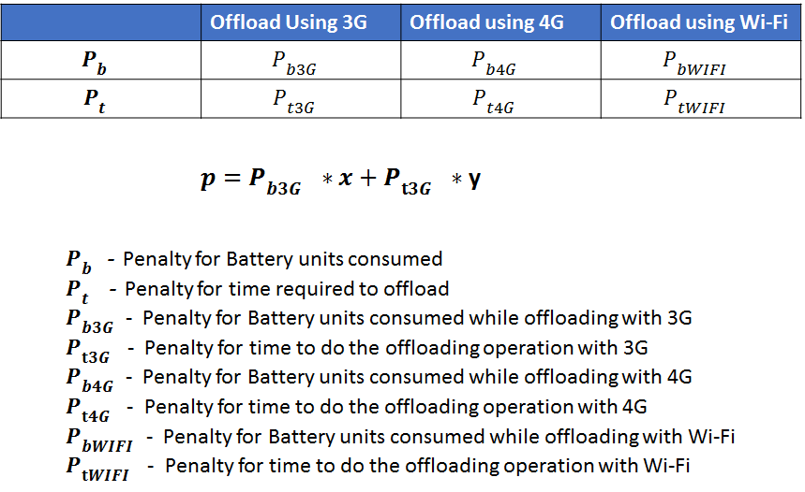Say we are in state *St* at time *t*. Upon taking action at from that state, we observe the one-step reinforcement *p*. After this we choose another action *at+1* in the same state, this continues until we have explored all the Actions. The cost or Penalty of an action taken from a state is the reinforcement for that action from that state. Use the returned Penalty value to choose best Action, where we want to minimize the Penalty. When there is a change in User's Location, for instance User moves from Home to Office, We continue the same steps mentioned above.

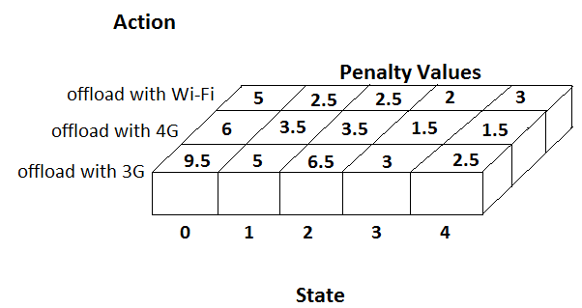

#### Figure 5.1 Representing the Q Table with Penalty values

RL Algorithm:

1. Detect change in the Device's contextual information (Parameters such as Location (Home, Office, etc.) and Time-Period (Morning, Afternoon, Evening and Night))

2. Activate 3G radio interface of the device.

3. Download a file (data_size = data_small) from the Cloud. Measure the Battery and time consumed for the operation.

4. Upload same file on the cloud. Measure the Battery and time consumed for the operation.

5. Calculate the penalty p with the help of equation in figure 5.1

6. Form a Key-Value pair as follows:

{Location-TimePeriod-data_size: penalty} where

Key = Location-TimePeriod-data size

Value = Calculated penalty p

7. Update the Q-table with the calculated penalty values as shown in figure 5.2.

8. Repeat steps 2-7 above for (data_size = data_medium and data_large)

9. Repeat steps 2-8 above for 4G and Wi-Fi connection if available.

The application with offloading mechanism will refer to the updated Q-table to make a right decision of choosing the network for offloading the required computing and data on the cloud. The application will look for the minimum penalty values available in the Q-table. The values of constants are x = 0.5 and y = 0.5 for both optimized battery and performance time, if user prefers better battery performance than elapsed processing time of the application then we change the values to x = 0.9 and y = 0.1. For example when the user is traveling he might prefer to save his battery power than worrying about the processing time; whereas when the battery charge isn't a sudden problem for the user then he might choose for optimized performance time, in that case we need to change the constant value to x = 0.1 and y = 0.9. The Network Inconsistency is also taken care in our Algorithm as we have included the Location parameters in the state values to train our Q - function.

### 5.3 RL with Neural Network

In this section we have used Neural Network to test our Reward based Machine Learning mechanism in a simulated environment. we have developed a Neural Network code in Python and have demonstrated results. In this algorithm we have simulated 10 different locations a user goes through (Locations 0-9) as shown in the x-axis of topmost figure in 5.3; on Y-axis we have shown the Reinforcements received by the offloading system, for '-1' the system decides to do local processing because the conditions are not suitable, for '0' we offload the processing on Local servers, and for '1' we offload on remote cloud servers; On Z axis we have shown The Reinforcements of Response Time of the app processing. As we can see these locations have certain attributes assigned to them with random values. For instance as the user goes from location 0 to 9, the network bandwidth available to him increases. We can specify for how many iterations we want to train our Q - function and also the hidden layers of the Neural Network is customizable. After sufficient training the 3-D Contour of QModel looks as shown in the middle-right portion of the figure 5.3, below that is just the top view of the contour. On the middle-left figure are the different trials of the action taken by the offloading system while going from Location 0-9.

* -1 for Local processing
* 0 for Offloading on Local Servers
* 1 for Offloading on Remote Servers

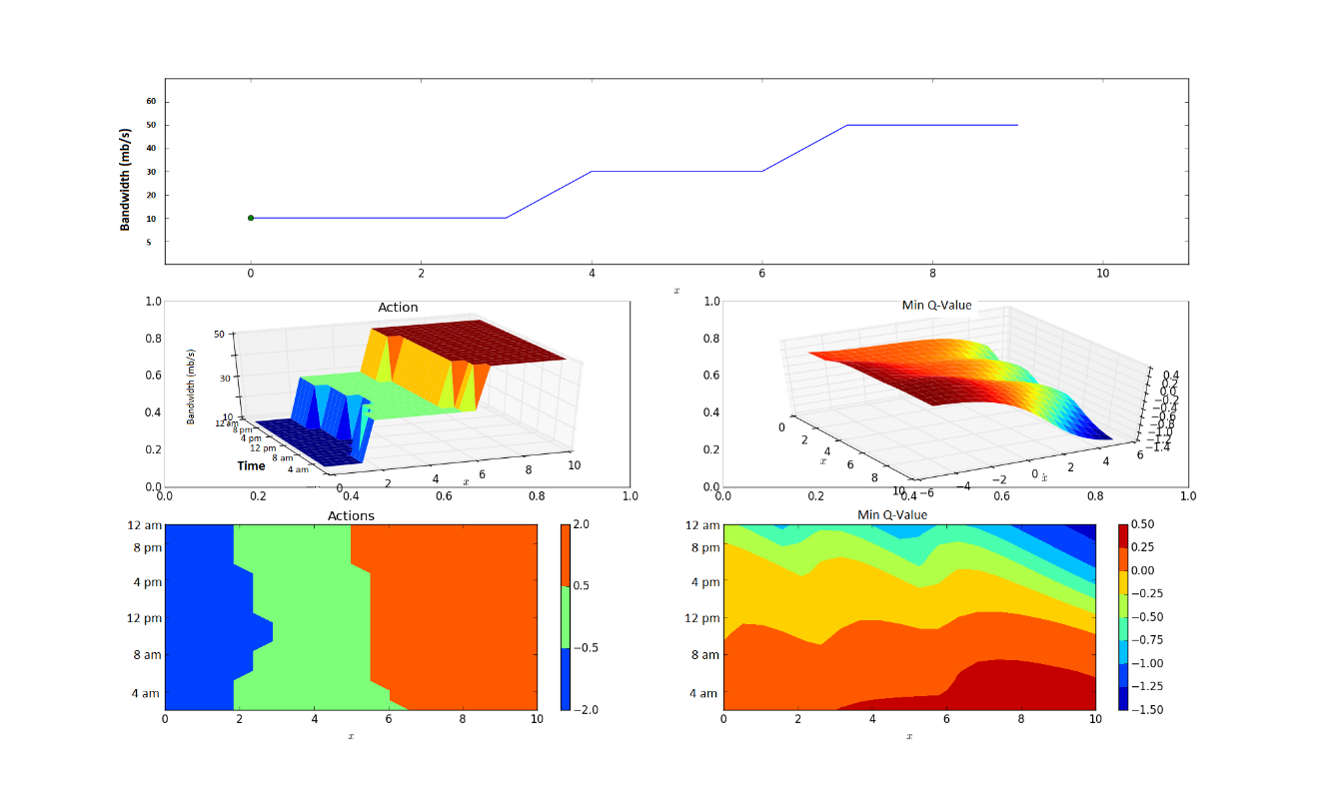In the figure 5.3, we can see the surface plot of our trained Q function. For these set of results we have customized my Neural Network with no. of hidden layers as (nh) = 5, run for trials (nTrials) = 100 and Steps per trial (nStepsPerTrial) = 10. In the first plot on x - axis we have different locations where the devices is in and location point varies from 0 - 10; on y - axis we have plotted the actions recommended by the Q function depending upon the best scenario to save the battery power. Therefore, we can see that for location 0, 2 and 3 Local processing is favored by our Q function. When the user moves to different locations between 4 - 6 the Q functions choose to offload the processing on Local servers whereas for locations 6 - 10 we should offload on remote servers. This decision is based on various parameters values present in that location such as `bandwidth available'.

#### Figure 5.2 Reinforcement Learning (RL) with Neural Network (NN)

In the ‘Actions' plot we can see 3-D plot with location and Bandwidth parameters. In the ‘Max Q' plot we can see the maximum values that our Q function has for various locations, the Red part is where we got maximum Reinforcement values.

Reinforcement Learning (RL) is an Unsupervised Learning method, our Algorithm is simplistic in comparison to other works like Smartphone Energizer (SE) [9], which is a supervised learning method. Our results show that we can save up to 20%-30% battery power in the proposed Offloading system while we compare it with prior works ([9], [8]).

### 5.4 Fuzzy Logic Decision Engine

Fuzzy Logic deals with approximate rather than fixed reasoning, and it has capabilities to react to continuous changes of the dependent variables. The decision of offloading processing components to cloud becomes a variable, and controlling this variable can be a complex task due to many real-time constraints of the overall mobile and cloud system parameters.

In [8] the authors have proposed fuzzy decision engine for code offloading, that considers both mobile and cloud variables. We have implemented a similar engine with relevant parameters and with slightly different rules. We have demonstrated the working of the app in Figure 5.5. Java code that was developed for the app is shown in the end. In this section a Fuzzy Logic Decision Engine Implementation is discussed.

###### 5.4.1 Mobile Offloading Logic

At the mobile platform level, the device uses a decision engine based on fuzzy logic, which is utilized to combine n number of variables, which are to be obtained from the overall mobile cloud architecture. Fuzzy Logic Decision Engine works in three steps namely: Fuzzification, Inference and Defuzzification. Let us see these steps in detail:

1) In Fuzzyfication input data is converted into linguistic variables, which are assigned to a specific membership function. 2) A reasoning engine is applied to the variables, which makes an inference based on a set of rules. Finally 3) The output from reasoning engine are mapped to linguistic variable sets again (aka defuzzification).

The Engine considers input parameters from smartphone and cloud, these inputs are divided into intervals. For Example Network Bandwidth is a variable, it is divided into intervals low speed, normal speed and high speed with values (0, 30), (30, 70), (70, 120) in mbps respectively. Other variables are also divided into similar intervals. Fuzzy rules are created based on best experimented resulted variables. For instance a fuzzy rule to offload to remote processing is constructed by combining high speed, normal data, and high CPU instance with an AND operation.

a) Fuzzy sets considered

* Bandwidth = Speed_Low, Speed_Normal, Speed_High
* WiFi = available, not available
* Data transfered = Data_Small, Data_Medium, Data_Big
* CPU instance = CPU_Low, CPU_Normal, CPU_High

Let us see what these parameters define. Bandwidth available to user device can be Low, Normal or High. Data that is used by the application can affect the decision of offloading if the Data is too big the offloading can be expensive. CPU instance required by the application can be Low, Normal and High depending upon the computational requirements of a particular application. If the WiFi is available to the user then it makes more sense to offload on the local servers rather than the remote servers. So here we am assuming there are multiple locations available with the user where he can offload his application processing and data. After defining these parameters we have assigned grade of truth values to each of the set considered which fuzzy logic uses to classify the outputs.

b) Rules Considered

* Remote Processing = Speed High AND Data Small AND CPU Normal
* Local Processing = Speed Low AND Data Small AND CPU High
* Remote Processing = Speed Normal AND Data Small AND CPU High
* Local Processing = Speed High AND Data Small AND CPU Low
* Local Processing = Speed Low AND Data Medium AND CPU Normal
* Offload on Local Servers = Remote Processing AND WiFi ON
* Offload on Remote Servers = Remote Processing AND WiFi OFF

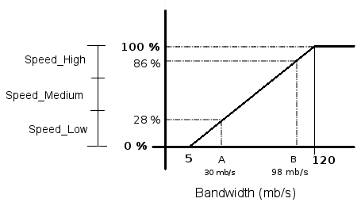

#### Figure 5.3 Classifying with Fuzzy Logic

A Fuzzy Logic system infers a decision expressed as the degree of truth to a specific criteria. The Grade of truth is the percentage value which helps us classify variables into a specific group. fuzzy logic engine is fed by information extracted from the code offloading traces. The grade of truth is computed by applying center of mass formula to the decision.

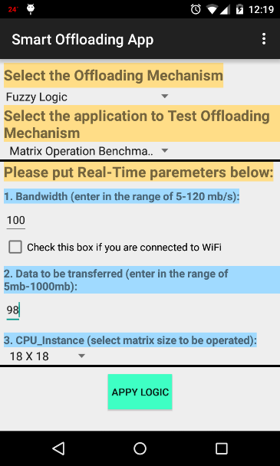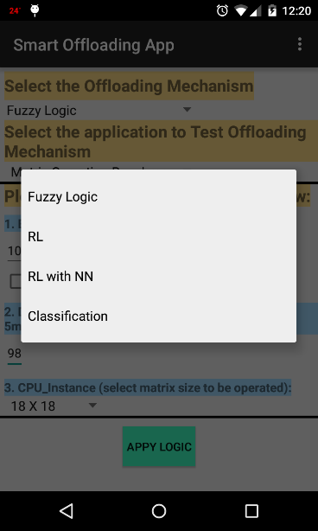

#### Figure 5.4 Offloading Decision Engine in Android

### 5.5 Comparing our Algorithms with previous works

In this section we have done a comparison between our strtaegies and other prior works. We have chosen a compute intensive app Matrix Inverse Calculator and a Data intensive app such as Torrent to compare the results as shown in Figure 5.5 and 5.6. We have done our analysis for the Torrent download of a 25 MB file and for 9X9 Matrix Inverse calculator instances.

Our results indicate that the Offloading is beneficial for Data Intensive applications such as Torents. Moreover it is seen Local processing proves to be beneficial in the Matrix inverse calculator app; whereas the Learning strategies like Reinforcement Learning after an suitable initial training time, can improve the Offloading performace to some extent in Compute Intensive applications and to a larger extent in Data intensive applications.

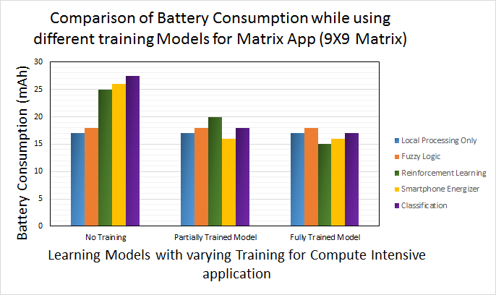

#### Figure 5.5 Energy Consumption by Different Models with Varying percentage of Training for Matrix Operation

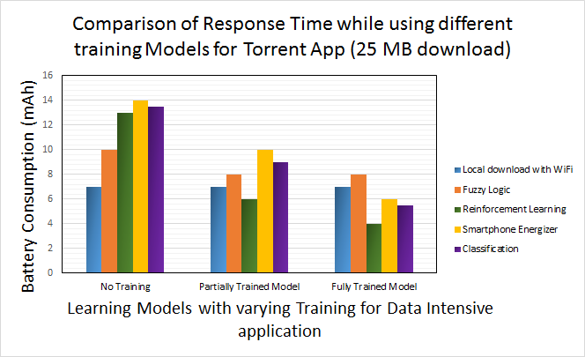

#### Figure 5.6 Energy Consumption by Different Models with Varying percentage of Training for Torrent file download App

CHAPTER 6   
CONCLUSION

We have presented both positive and negative sides of offloading solution with the help of experimental results obtained with a large set of applications on two different Smartphones (LG G4 and Samsung S3). While we do believe that Cloud applications have great advantages; but when it comes to energy savings, our results indicate that Offloading does not provide clear benefits over local processing always and we think that use of offloading should be restricted to a small set of applications. We support this claim with the help of two different applications namely: Cloud-based Web Browser, Voice Recognition and Translation. In the previous research works we have studied that the Offloading is useful when an application is compute intensive at the same time not data intensive because then the data need to be transferred will cost more energy to the device. In our experiments we have shown how the cloud computing is more beneficial for the applications which may not be compute intensive but data intensive, for example Torrent downloads app. On the other hand offloading can be beneficial for the compute intensive and data intensive applications such as Machine Learning (for Face Recognition, Health monitoring applications). Image processing applications like face recognition require large data sets to train the learning models, which costs energy. Therefore, such applications are very likely to benefit from the offloading process, when the data is already present in the cloud. Image Searching on Cloud Data is such another task that might need large computation given the huge image data collected by the users is already on the cloud, for instance Google Photos which claims to give the users unlimited image and video storage.

### 6.1 Future Work

Both of strategies the described in this thesis show promising energy saving. However, much work can be done to improve the strategies. This section discusses some of the future work that will enable these smart machine learning energy optimization strategies to reach their full potential.

In this thesis we have used only one network carrier to obtain the offloading results, it will be interesting to see the comparison between multiple network carriers. Even in 4G there are different types such as HSPA+ and LTE, in this thesis we have used AT n T’s HSPA+. Also there are different technologies in implementing 4G LTE for different network carriers. This study can be further extended to test the results with all variations of 4G network.

Plans for future work include implementation of the energy-saving machine learning techniques on a real mobile device. The results in Chapter 5 were obtained using a Python implementation of the algorithms on a 2.6 GHz Intel® Core i5™ processor. Learning algorithm training is an important consideration when considering a real-world implementation. There are several approaches to when and how the algorithms can be trained quickly and in an energy-efficient manner without affecting user QoS on a real mobile platform. One possibility is to train only while the mobile device is plugged in and charging. Another solution would be to offload the training computations to a network server or a cloud computing service.

Finally, we would like to implement and test more machine learning algorithms, such as a Support Vector Machine (SVM). Although there are always improvements to be made in the field of software and energy optimization for mobile embedded systems, the work presented in this thesis brings us one step closer to being able to improve the performance and battery lifetime of smartphone while Offloading.

REFERENCES

1. MobiThinking, “Global mobile statistics 2011,” http://mobithinking.com, April 2011.
2. K. Kumar and Y.-H. Lu, “Cloud computing for mobile users: Can offloading computation save energy?”, *Computer*, vol. 43, no. 4, pp. 51-56, 2010.
3. H. Flores, P. Hui, S. Tarkoma, Y. Li, S. Srirama, and R. Buyya, “Mobile code offloading: from concept to practice and beyond,” *Communications Magazine, IEEE*, vol. 53, no. 3, pp. 80-88, 2015.
4. E. Cuervo, A. Balasubramanian, D. K. Cho, A.Wolman, S. Saroiu, R. Chandra, and P. Bahl, “Maui: making smartphones last longer with code offload,” in *Proceedings of the 8th international conference on Mobile systems, applications*, and services, pp. 49-62, ACM, 2010.
5. B. G. Chun, S. Ihm, P. Maniatis, M. Naik, and A. Patti, “Clonecloud: elastic execution between mobile device and cloud,” in *Proceedings of the sixth conference on Computer systems*, pp. 301-314, ACM, 2011.
6. H. Flores and S. Srirama, “Mobile code offloading: should it be a local decision or global inference?,” in *Proceeding of the 11th annual international conference on Mobile systems, applications, and services*, pp. 539-540, ACM, 2013.
7. S. Kosta, A. Aucinas, P. Hui, R. Mortier, and X. Zhang, “Thinkair: Dynamic resource allocation and parallel execution in the cloud for mobile code offloading,” in *INFOCOM, 2012 Proceedings IEEE*, pp. 945-953, IEEE, 2012.
8. H. R. Flores Macario and S. Srirama, “Adaptive code offloading for mobile cloud applications: Exploiting fuzzy sets and evidence-based learning,” in *Proceeding of the fourth ACM workshop on Mobile cloud computing and services*, pp. 9-16, ACM, 2013.
9. A. Khairy, H. H. Ammar, and R. Bahgat, “Smartphone energizer: Extending smartphone's battery life with smart offloading,” in *Wireless Communications and Mobile Computing Conference (IWCMC), 2013 9th International*, pp. 329-336, IEEE, 2013.
10. R. Kemp, N. Palmer, T. Kielmann, and H. Bal, “Cuckoo: a computation offloading framework for smartphones,” in *Mobile Computing, Applications, and Services*, pp. 59-79, Springer, 2012.
11. “Amazon silk split browser architecture" https://s3.amazonaws.com/awsdocs/AmazonSilk/latest/silk-dg.pdf.
12. “Opera mini architecture and JavaScript” http://dev.opera.com/articles/view/opera-mini-and-javascript/.
13. “Data compression proxy in android chrome beta” https://developers.google.com/chrome/mobile/docs/ data-compression.
14. X. S. Wang, H. Shen, and D. Wetherall, “Accelerating the mobile web with selective offloading,” in *Proceedings of the second ACM SIGCOMM workshop on Mobile cloud computing*, pp. 45-50, ACM, 2013.
15. A. Sivakumar, V. Gopalakrishnan, S. Lee, S. Rao, S. Sen, and O. Spatscheck, “Cloud is not a silver bullet: A case study of cloud-based mobile browsing,” in *Proceedings of the 15th Workshop on Mobile Computing Systems and Applications*, p. 21, ACM, 2014.
16. “ezyzip: The simple online zip tool.” http://www.ezyzip.com/.
17. “Online-conver.com.” http://archive.online-convert.com/convert-to-zip.
18. I. Kelenyi and J. K. Nurminen, “Cloudtorrent-energy-efficient bittorrent content sharing for mobile devices via cloud services,” in *Proceedings of the 7th IEEE on Consumer Communications and Networking Conference* (CCNC), vol. 1, 2010.
19. J. Huang, F. Qian, A. Gerber, Z. M. Mao, S. Sen, and O. Spatscheck, “A close examination of performance and power characteristics of 4g lte networks,” in *Proceedings of the 10th international conference on Mobile systems, applications, and services*, pp. 225-238, ACM, 2012.
20. Monsoon Solutions Inc., official website, http://www.msoon.com/ LabEquipment/PowerMonitor, 2008.

Appendix A

Source Code

This section presents the majority of the source code for the implementation of the two strategies namely Reinforcement Learning and Fuzzy Logic Decision Engine. Sections A.1 provide the source code file for the Offloading Decision Engine in Android, Section A.2 provide the source code file for Fuzzy Logic and Sections A.3 provide the source code files for the Reinforcement Learning Python code.

### A1. MainOffloadingAppActivity.java

package com.example.aditya.smartoffloadingapp;

import android.content.Intent;

import android.support.v7.app.ActionBarActivity;

import android.os.Bundle;

import android.view.Menu;

import android.view.MenuItem;

import android.view.View;

import android.widget.ArrayAdapter;

import android.widget.CheckBox;

import android.widget.EditText;

import android.widget.LinearLayout;

import android.widget.Spinner;

import android.widget.TextView;

import static com.example.aditya.smartoffloadingapp.R.id.MLAlgorithm;

public class MainOffloadingAppActivity extends ActionBarActivity {

public final static String EXTRA_MESSAGE = "com.example.aditya.smartoffloadingapp.MESSAGE";

public final static String EXTRA_MESSAGE1 = "com.example.aditya.smartoffloadingapp.MESSAGE1";

/* private Spinner spinner, spinnerApp, spinnerCPU;

private static final String[]paths = {"Fuzzy Logic", "RL", "RL with NN", "Classification"};

private static final String[]pathsApp = {"Fuzzy Logic", "RL", "RL with NN", "Classification"};

private static final String[]pathsCPU = {"Fuzzy Logic", "RL", "RL with NN", "Classification"};

**/

@Override

protected void onCreate(Bundle savedInstanceState) {

super.onCreate(savedInstanceState);

setContentView(R.layout.activity_main_offloading_app);

/* Spinner spinner, spinnerApp, spinnerCPU;

String[]paths = {"Fuzzy Logic", "RL", "RL with NN", "Classification"};

String[]pathsApp = {"Fuzzy Logic", "RL", "RL with NN", "Classification"};

String[]pathsCPU = {"Fuzzy Logic", "RL", "RL with NN", "Classification"};

**/

/* spinner = (Spinner)findViewById(R.id.spinner);

spinnerApp = (Spinner)findViewById(R.id.spinnerApp);

spinnerCPU = (Spinner)findViewById(R.id.spinnerCPU);

ArrayAdapter<String>adapter = new ArrayAdapter<String>(MainOffloadingAppActivity.this,

android.R.layout.simple_spinner_item,paths);

ArrayAdapter<String>adapterApp = new ArrayAdapter<String>(MainOffloadingAppActivity.this,

android.R.layout.simple_spinner_item,pathsApp);

ArrayAdapter<String>adapterCPU = new ArrayAdapter<String>(MainOffloadingAppActivity.this,

android.R.layout.simple_spinner_item,pathsCPU);

adapter.setDropDownViewResource(android.R.layout.simple_spinner_dropdown_item);

adapterApp.setDropDownViewResource(android.R.layout.simple_spinner_dropdown_item);

adapterCPU.setDropDownViewResource(android.R.layout.simple_spinner_dropdown_item);

spinner.setAdapter(adapter);

spinnerApp.setAdapter(adapterApp);

spinnerCPU.setAdapter(adapterCPU);

**/

/* spinner.setOnItemSelectedListener(this); **/

}

public void onButtonClick(View view) {

Spinner spinner = (Spinner)findViewById(R.id.spinner); //offloading mechanism

String offloadingMechanismType = spinner.getSelectedItem().toString();

CheckBox responseCheckbox = (CheckBox) findViewById(R.id.CheckBoxResponse);//checkbox

boolean bRequiresResponse = responseCheckbox.isChecked();

Spinner spinnerApp = (Spinner)findViewById(R.id.spinnerApp);//Select Application

String appType = spinnerApp.getSelectedItem().toString();

Spinner spinnerLocation = (Spinner)findViewById(R.id.spinnerLocation); //Matrix operation

String LocationType = spinnerLocation.getSelectedItem().toString();

Spinner spinnerCPU = (Spinner)findViewById(R.id.spinnerCPU); //Matrix operation

String CPUinstanceType = spinnerCPU.getSelectedItem().toString();

/* ArrayAdapter<String>adapter = new ArrayAdapter<String>(MainOffloadingAppActivity.this,

android.R.layout.simple_spinner_item,paths);

ArrayAdapter<String>adapterApp = new ArrayAdapter<String>(MainOffloadingAppActivity.this,

android.R.layout.simple_spinner_item,pathsApp);

ArrayAdapter<String>adapterCPU = new ArrayAdapter<String>(MainOffloadingAppActivity.this,

android.R.layout.simple_spinner_item,pathsCPU);

adapter.setDropDownViewResource(android.R.layout.simple_spinner_dropdown_item);

adapterApp.setDropDownViewResource(android.R.layout.simple_spinner_dropdown_item);

adapterCPU.setDropDownViewResource(android.R.layout.simple_spinner_dropdown_item);

spinner.setAdapter(adapter);

spinnerApp.setAdapter(adapterApp);

spinnerCPU.setAdapter(adapterCPU);

**/

if(offloadingMechanismType.equals("Fuzzy Logic")) {

Intent fuzzyscreen = new Intent(this, FuzzyLogicDisplay.class);

/* EditText editText = (EditText) findViewById(R.id.dataEdit); **/

Spinner spinnerMechanismText = (Spinner)findViewById(R.id.spinner);

Spinner spinnerAppText = (Spinner)findViewById(R.id.spinnerApp);

String messageMechanism = spinnerMechanismText.getSelectedItem().toString();

fuzzyscreen.putExtra(EXTRA_MESSAGE, messageMechanism);

String messageApp = spinnerAppText.getSelectedItem().toString();

fuzzyscreen.putExtra(EXTRA_MESSAGE1,messageApp);

startActivity(fuzzyscreen);

}

}

@Override

public boolean onCreateOptionsMenu(Menu menu) {

// Inflate the menu; this adds items to the action bar if it is present.

getMenuInflater().inflate(R.menu.menu_main_offloading_app, menu);

return true;

}

@Override

public boolean onOptionsItemSelected(MenuItem item) {

// Handle action bar item clicks here. The action bar will

// automatically handle clicks on the Home/Up button, so long

// as you specify a parent activity in AndroidManifest.xml.

int id = item.getItemId();

//noinspection SimplifiableIfStatement

if (id == R.id.action_settings) {

return true;

}

return super.onOptionsItemSelected(item);

}

}

### A2. FuzzyLogicDisplay.java

package com.example.aditya.smartoffloadingapp;

import android.content.Intent;

import android.support.v7.app.ActionBarActivity;

import android.os.Bundle;

import android.view.Menu;

import android.view.MenuItem;

import android.widget.TextView;

public class FuzzyLogicDisplay extends ActionBarActivity {

@Override

protected void onCreate(Bundle savedInstanceState) {

super.onCreate(savedInstanceState);

setContentView(R.layout.activity_fuzzy_logic_display);

Intent fuzzyintent = getIntent();

String message = fuzzyintent.getStringExtra(MainOffloadingAppActivity.EXTRA_MESSAGE);

String message1 = fuzzyintent.getStringExtra(MainOffloadingAppActivity.EXTRA_MESSAGE1);

TextView t1 = (TextView) findViewById(R.id.FuzzyAlgorithmDisplay);

t1.setText(message);

TextView t2 = (TextView) findViewById(R.id.FuzzyAppDisplay);

t2.setText(message1);

/* create TextView Object **/

/* TextView textView = new TextView(this); */

/* Set the text size and message */

/* textView.setTextSize(40); */

/* textView.setText(message); */

/*add the TextView as the root view of the activity’s layout by passing it to setContentView()**/

/* setContentView(textView); */

/* setContentView(R.layout.activity_fuzzy_logic_display); **/

}

/*

@Override

public boolean onCreateOptionsMenu(Menu menu) {

// Inflate the menu; this adds items to the action bar if it is present.

getMenuInflater().inflate(R.menu.menu_fuzzy_logic_display, menu);

return true;

}

**/

@Override

public boolean onOptionsItemSelected(MenuItem item) {

// Handle action bar item clicks here. The action bar will

// automatically handle clicks on the Home/Up button, so long

// as you specify a parent activity in AndroidManifest.xml.

int id = item.getItemId();

//noinspection SimplifiableIfStatement

if (id == R.id.action_settings) {

return true;

}

return super.onOptionsItemSelected(item);

}

}

### A3. Reinforcement_Strategy.py

import numpy as np

import random as rm

import matplotlib.pyplot as plt

from copy import copy

from IPython.display import display, clear_output

def printBoard(board):

print('''

bandwidth={} |Data={} |CPU_Instance={}

-----

app={} |Cloud_Vendor_Available={} |Location={}

-----

'''.format(*tuple(board)))

def printBoardQs(board,Q):

#printBoard(board)

printParameters(board)

Qs = [Q.get((tuple(board),m), 0) for m in range(3)]

print('Reinforcements Received:')

print('''Local Processing:{:.2f} | Offload on Local Servers:{:.2f} | Offload on Remote Servers:{:.2f}

'''.format(*Qs))

def printParameters(board):

print('''

bandwidth= {} |Data= {} |CPU_Instance= {} |Wifi= {}

'''.format(*tuple(board)))

print('let\'s see what are my state parameters')

#printBoard(np.array(['1','0','1','1','5','9']))

printParameters(np.array(['Speed_Low','Data_Small','CPU_Low','On']))

#print('okay now let\'s genearete a random number geneartor for each of these parameters')

#bandwidth = rm.randint(1,10)

#bandwidth = np.random.randint(1,10,size=60)

#data = np.random.randint(1,10, size = 60)

#cpu = np.random.randint(1,10, size = 60)

#app = np.random.randint(1,10, size = 60)

#cloud_vendor = np.random.randint(1,10, size = 60)

#location = rm.randint(1,10)

#location = np.random.randint(1,10, size =60)

Bandwidth = np.array(['Speed_Low','Speed_Normal','Speed_High'])

Data = np.array(['Data_Small','Data_Medium','Data_Big'])

CPU = np.array(['CPU_Low','CPU_Normal','CPU_High'])

Wifi = np.array(['On','Off'])

Out = np.array(['Local_Procssing','Offload_Local','Offload_Remote'])

#print("location=",location)

#board = np.array(['X',' ','O', ' ','X','O', 'X',' ',' '])

#board1 = np.array([bandwidth,data,cpu,app,cloud_vendor,location])

board2 = np.array([rm.choice(Bandwidth),rm.choice(Data),rm.choice(CPU),rm.choice(Wifi)])

print('print parameters')

printParameters(board2)

#print('print board1')

#printBoard(board1)

#Q = {} #empty table

#Q[(tuple(board2),1)] = 4

#print("Q:",Q)

#print("Q[(tuple(board2),1)]:",Q[(tuple(board2),1)])

#print("Q.get((tuple(board2),1),42):",Q.get((tuple(board2),1),42))

#rho = 0.1 # learning rate

#Q[(tuple(board),1)] += rho * (-1 - Q[(tuple(board),1)])

#print("after Q[(tuple(board),1)] += rho * (-1 - Q[(tuple(board),1)]):", Q[(tuple(board),1)])

#print('rm.choice(list(enumerate(Out))):',rm.choice(list(enumerate(Out))))

#print('rm.choice(list(enumerate(Out)))[0]:',rm.choice(list(enumerate(Out)))[0])

#print('list(enumerate(Out)):',list(enumerate(Out)))

#print('list(Out):',list(Out))

#print('Out:',Out)

#print('list(enumerate(Out)):',list(enumerate(Out)))

#print('list(enumerate(Out))[:0]:',list(enumerate(Out))[:0])

#print('np.random.uniform():',np.random.uniform())

#random_index = rm.randrange(0,len(Out))

#print ('Out[random_index]:',Out[random_index])

def epsilonGreedy(epsilon, Q, board, Out):

#validMoves = np.where(board == ' ')[0]

validMoves = np.array([0,1,2])

#print('validMoves:',validMoves)

if np.random.uniform() < epsilon:

# Random Move

tp = rm.choice(list(enumerate(Out)))[0]

print('tp:',tp)

return tp

#return rm.choice(list(enumerate(Out)))[0]

#return np.random.choice(validMoves)

else:

# Greedy Move

Qs = np.array([Q.get((tuple(board),m), 0) for m in validMoves])

tp = validMoves[ np.argmax(Qs) ]

print('tp:',tp)

return tp

#return validMoves[ np.argmax(Qs) ]

#print('epsilonGreedy(0.8,Q,board2,Out):',epsilonGreedy(0.8,Q,board2,Out))

print('here goes part before for loop')

maxGames = 200

rho = 0.2

epsilonDecayRate = 0.99

epsilon = 0.8

graphics = True

showMoves = not graphics

outcomes = np.zeros(maxGames)

epsilons = np.zeros(maxGames)

Q = {}

if graphics:

fig = plt.figure(figsize=(10,10))

print('here goes a for loop')

#for i in range(60):

#print (i)

#location = np.random.randint(1,10, size =1)

# print("location=",location[i])

# board2 = np.array([bandwidth[i],data[i],cpu[i],app[i],cloud_vendor[i],location[i]])

# printBoard(board2)

#board2 = np.array([rm.choice(Bandwidth),rm.choice(Data),rm.choice(CPU),rm.choice(Wifi)])

for nGames in range(maxGames):

epsilon *= epsilonDecayRate

epsilons[nGames] = epsilon

step = 0

move = epsilonGreedy(epsilon, Q, board2, Out)

board2_all = {}

board2 = np.array([rm.choice(Bandwidth),rm.choice(Data),rm.choice(CPU),rm.choice(Wifi)])

board2_all[nGames] = board2

if (tuple(board2),move) not in Q:

Q[(tuple(board2),move)] = 0 # initial Q value for new board,move

if board2[3] == 'On':

print('Wifi is ON')

#if board2[0] == 'Speed_Low' and 'Speed_Normal':

if board2[0] == 'Speed_Low' or board2[0] == 'Speed_Normal':

print('Bandwidth = Speed_Low or Speed_Normal')

if board2[1] == 'Data_Small' and board2[2] == 'CPU_High':

print('Data_Small and CPU_High so you can offload')

Q[(tuple(board2),1)] = 1

Q[(tuple(board2),2)] = 0

Q[(tuple(board2),0)] = -1

else:

print('Don\'t offload')

Q[(tuple(board2),1)] = 0

Q[(tuple(board2),2)] = -1

Q[(tuple(board2),0)] = 1

else:

if board2[2] == 'CPU_Normal' or board2[2] == 'CPU_High':

print('CPU_Normal or CPU_High so you can offload')

Q[(tuple(board2),1)] = 1

Q[(tuple(board2),2)] = 0

Q[(tuple(board2),0)] = -1

else:

print('Don\'t offload (this is second if loop)')

Q[(tuple(board2),1)] = 0

Q[(tuple(board2),2)] = -1

Q[(tuple(board2),0)] = 1

else:

print('Wifi is OFF')

if board2[0] == 'Speed_Low' or board2[0] == 'Speed_Normal':

print('Bandwidth = Speed_Low or Speed_Normal when wifi is off')

if board2[1] == 'Data_Small' and board2[2] == 'CPU_High':

print('Data_Small and CPU_High so you can offload:Out2')

Q[(tuple(board2),1)] = 0

Q[(tuple(board2),2)] = 1

Q[(tuple(board2),0)] = -1

else:

print('Don\'t offload when wifi is off')

Q[(tuple(board2),1)] = -1

Q[(tuple(board2),2)] = -1

Q[(tuple(board2),0)] = 1

else:

if board2[2] == 'CPU_Normal' or board2[2] == 'CPU_High':

print('CPU_Normal or CPU_High so you can offload:Out2')

Q[(tuple(board2),1)] = 0

Q[(tuple(board2),2)] = 1

Q[(tuple(board2),0)] = -1

else:

print('Don\'t offload (this is second if loop when wifi is off)')

Q[(tuple(board2),1)] = -1

Q[(tuple(board2),2)] = -1

Q[(tuple(board2),0)] = 1

#print (i)

#location = np.random.randint(1,10, size =1)

# print("location=",location[i])

# board2 = np.array([bandwidth[i],data[i],cpu[i],app[i],cloud_vendor[i],location[i]])

# printBoard(board2)

#--------------------------Just For Plotting the outcomes---------------

print('after for loop')

printBoardQs(board2,Q)

outcomes = np.random.choice([-1,0,1],replace=True,size=(1000))

#print('outcomes[:10]:',outcomes[:10])

#print('Q:',Q)

#print('Q.shape:',Q.shape) //did not work

#print('Q.values():\n',Q.values())

#print('Q.keys():\n\n',Q.keys())

#print('Q.items():\n\n',Q.items())

#for k in Q.keys():

# print(k, Q[k])

#outcomes = np.array[Q.values()]

#print('outcomes[:10]:',outcomes[:10])

names = ['id','data']

formats = ['f8','f8']

dtype = dict(names = names, formats=formats)

array=np.array([[key,val] for (key,val) in Q.iteritems()],dtype)

print(repr(array))

#plt.plot(Q)

def plotOutcomes(outcomes,epsilons,maxGames,nGames):

if nGames==0:

return

nBins = 100

nPer = int(maxGames/nBins)

outcomeRows = outcomes.reshape((-1,nPer))

outcomeRows = outcomeRows[:int(nGames/float(nPer))+1,:]

avgs = np.mean(outcomeRows,axis=1)

plt.subplot(3,1,1)

xs = np.linspace(nPer,nGames,len(avgs))

plt.plot(xs, avgs)

plt.xlabel('Games')

plt.ylabel('Mean of Outcomes (0=draw, 1=X win, -1=O win)')

plt.title('Bins of {:d} Games'.format(nPer))

plt.subplot(3,1,2)

plt.plot(xs,np.sum(outcomeRows==-1,axis=1),'r-',label='Losses')

plt.plot(xs,np.sum(outcomeRows==0,axis=1),'b-',label='Draws')

plt.plot(xs,np.sum(outcomeRows==1,axis=1),'g-',label='Wins')

plt.legend(loc="center")

plt.ylabel('Number of Games in Bins of {:d}'.format(nPer))

plt.subplot(3,1,3)

plt.plot(epsilons[:nGames])

plt.ylabel('$\epsilon$')

#plt.figure(figsize=(8,8))

#plotOutcomes(outcomes,np.zeros(1000),1000,1000)

#plt.show()

#--------------------------Just For Plotting the outcomes---------------

### A4. RLwithNeuralNetwork.py

import numpy as np

import random as rm

import neuralnetworkQ as nn

import numpy as np

import matplotlib.pyplot as plt

from mpl_toolkits.mplot3d import Axes3D

from matplotlib import cm

import copy

print( '\n------------------------------------------------------------')

print( "Reinforcement Learning Example: Dynamic Marble on a Track")

# Define the problem

def reinforcement(s,sn):

goal = 5

return 0 if abs(sn[0]-goal) < 1 else -1

def initialState():

return np.array([10*np.random.random_sample(), 0.0])

def nextState(s,a):

s = copy.copy(s) # s[0] is position, s[1] is velocity. a is -1, 0 or 1

deltaT = 0.1 # Euler integration time step

s[0] += deltaT * s[1] # Update position

s[1] += deltaT * (2 * a - 0.2 * s[1]) # Update velocity. Includes friction

if s[0] < 0: # Bound next position. If at limits, set velocity to 0.

s = [0,0]

elif s[0] > 10:

s = [10,0]

return s

validActions = (-1,0,1)

# training Loop

gamma = 0.5

nh = 5

nTrials = 50

nStepsPerTrial = 1000

nSCGIterations = 10

finalEpsilon = 0.01

epsilonDecay = np.exp(np.log(finalEpsilon)/(nTrials)) # to produce this final value

nnet = nn.NeuralNetworkQ(3,nh,1,((0,10), (-3,3), (-1,1)))

epsilon = 1

epsilonTrace = np.zeros(nTrials)

rtrace = np.zeros(nTrials)

for trial in range(nTrials):

# Collect nStepsPerRep samples of X, R, Qn, and Q, and update epsilon

X,R,Qn,Q,epsilon = nnet.makeSamples(initialState,nextState,reinforcement,

validActions,nStepsPerTrial,epsilon)

# Update the Q neural network.

nnet.train(X,R,Qn,Q,gamma=gamma, nIterations=nSCGIterations) # weightPrecision=1e-8, errorPrecision=1e-10)

epsilon *= epsilonDecay

# Rest is for plotting

epsilonTrace[trial] = epsilon

rtrace[trial] = np.mean(R)

print('Trial',trial,'mean R',np.mean(R))

## Plotting functions

def plotStatus(net,trial,epsilonTrace,rtrace):

plt.subplot(4,3,1)

plt.plot(epsilonTrace[:trial+1])

plt.ylabel("Random Action Probability ($\epsilon$)")

plt.ylim(0,1)

plt.subplot(4,3,2)

plt.plot(X[:,0])

plt.plot([0,X.shape[0]], [5,5],'--',alpha=0.5,lw=5)

plt.ylabel("$x$")

plt.ylim(-1,11)

#qs = [[net.use([s,0,a]) for a in actions] for s in range(11)]

qs = net.use(np.array([[s,0,a] for a in validActions for s in range(11)]))

#print np.hstack((qs,-1+np.argmax(qs,axis=1).reshape((-1,1))))

plt.subplot(4,3,3)

acts = ["L","0","R"]

actsiByState = np.argmax(qs.reshape((len(validActions),-1)),axis=0)

for i in range(11):

plt.text(i,0,acts[actsiByState[i]])

plt.xlim(-1,11)

plt.ylim(-1,1)

plt.text(2,0.2,"Policy for Zero Velocity")

plt.axis("off")

plt.subplot(4,3,4)

plt.plot(rtrace[:trial+1],alpha=0.5)

#plt.plot(np.convolve(rtrace[:trial+1],np.array([0.02]*50),mode='valid'))

binSize = 20

if trial+1 > binSize:

# Calculate mean of every bin of binSize reinforcement values

smoothed = np.mean(rtrace[:int(trial/binSize)*binSize].reshape((int(trial/binSize),binSize)),axis=1)

plt.plot(np.arange(1,1+int(trial/binSize))*binSize,smoothed)

plt.ylabel("Mean reinforcement")

plt.subplot(4,3,5)

plt.plot(X[:,0],X[:,1])

plt.plot(X[0,0],X[0,1],'o')

plt.xlabel("$x$")

plt.ylabel("$\dot{x}$")

plt.fill_between([4,6],[-5,-5],[5,5],color="red",alpha=0.3)

plt.xlim(-1,11)

plt.ylim(-5,5)

plt.subplot(4,3,6)

net.draw(["$x$","$\dot{x}$","$a$"],["Q"])

plt.subplot(4,3,7)

n = 20

positions = np.linspace(0,10,n)

velocities = np.linspace(-5,5,n)

xs,ys = np.meshgrid(positions,velocities)

#states = np.vstack((xs.flat,ys.flat)).T

#qs = [net.use(np.hstack((states,np.ones((states.shape[0],1))*act))) for act in actions]

xsflat = xs.flat

ysflat = ys.flat

qs = net.use(np.array([[xsflat[i],ysflat[i],a] for a in validActions for i in range(len(xsflat))]))

#qs = np.array(qs).squeeze().T

qs = qs.reshape((len(validActions),-1)).T

qsmax = np.max(qs,axis=1).reshape(xs.shape)

cs = plt.contourf(xs,ys,qsmax)

plt.colorbar(cs)

plt.xlabel("$x$")

plt.ylabel("$\dot{x}$")

plt.title("Max Q")

plt.subplot(4,3,8)

acts = np.array(validActions)[np.argmax(qs,axis=1)].reshape(xs.shape)

cs = plt.contourf(xs,ys,acts,[-2, -0.5, 0.5, 2])

plt.colorbar(cs)

plt.xlabel("$x$")

plt.ylabel("$\dot{x}$")

plt.title("Actions")

s = plt.subplot(4,3,10)

rect = s.get_position()

ax = Axes3D(plt.gcf(),rect=rect)

ax.plot_surface(xs,ys,qsmax,cstride=1,rstride=1,cmap=cm.jet,linewidth=0)

ax.set_xlabel("$x$")

ax.set_ylabel("$\dot{x}$")

#ax.set_zlabel("Max Q")

plt.title("Max Q")

s = plt.subplot(4,3,11)

rect = s.get_position()

ax = Axes3D(plt.gcf(),rect=rect)

ax.plot_surface(xs,ys,acts,cstride=1,rstride=1,cmap=cm.jet,linewidth=0)

ax.set_xlabel("$x$")

ax.set_ylabel("$\dot{x}$")

#ax.set_zlabel("Action")

plt.title("Action")

def testIt(Qnet,nTrials,nStepsPerTrial):

xs = np.linspace(0,10,nTrials)

plt.subplot(4,3,12)

for x in xs:

s = [x,0] ## 0 velocity

xtrace = np.zeros((nStepsPerTrial,2))

for step in range(nStepsPerTrial):

a,_ = Qnet.epsilonGreedy(s,validActions,0.0) # epsilon = 0

s = nextState(s,a)

xtrace[step,:] = s

plt.plot(xtrace[:,0],xtrace[:,1])

plt.xlim(-1,11)

plt.ylim(-5,5)

plt.plot([5,5],[-5,5],'--',alpha=0.5,lw=5)

plt.ylabel('$\dot{x}$')

plt.xlabel('$x$')

plt.title('State Trajectories for $\epsilon=0$')

plotStatus(nnet,nTrials,epsilonTrace,rtrace)

testIt(nnet,10,500)

plt.show()

### A5. Cloud Interaction with Pyton code

**Upload to S3**

Here is the code we use to upload the picture files:

def push_picture_to_s3(id):

try:

import boto

from offloading.s3.key import Key

# set offloading lib debug to critical

logging.getLogger('offloading').setLevel(logging.CRITICAL)

bucket_name = settings.MyCloudBucketOffloading

# connect to the bucket

conn = boto.connect_s3(settings.AWS_ACCESS_KEY_ID,

settings.AWS_SECRET_ACCESS_KEY)

bucket = conn.get_bucket(bucket_name)

# go through each version of the file

key = '%s.png' % id

fn = '/var/www/data/%s.png' % id

# create a key to keep track of our file in the storage

k = Key(bucket)

k.key = key

k.set_contents_from_filename(fn)

# we need to make it public so it can be accessed publicly

# using a URL like http://s3.amazonaws.com/bucket_name/key

k.make_public()

# remove the file from the web server

os.remove(fn)

except:

**Download from S3**

We can access the file using the URL: http://s3.amazonaws.com/bucket_name/key

Here is the script to do that:

import boto

import sys, os

from offloading.s3.key import Key

LOCAL_PATH = '/backup/s3/'

AWS_ACCESS_KEY_ID = some_key

AWS_SECRET_ACCESS_KEY = some_secret_key

bucket_name = 'MyCloudBucketOffloading'

# connect to the bucket

conn = Offloading.connect_s3(AWS_ACCESS_KEY_ID,

AWS_SECRET_ACCESS_KEY)

bucket = conn.get_bucket(bucket_name)

# go through the list of files

bucket_list = bucket.list()

for l in bucket_list:

keyString = str(l.key)

# check if file exists locally, if not: download it

if not os.path.exists(LOCAL_PATH+keyString):

l.get_contents_to_filename(LOCAL_PATH+keyString)

### A6. AWS Cloud Interaction with Shell script

aws s3 mb s3://MyCloudBucketOffloading // create a bucket on AWS cloud

aws s3 cp stuff/firstfile.txt s3://MyCloudBucketOffloading // upload the file on AWS cloud

aws s3 ls s3://MyCloudBucketOffloading // see all the file which are present in Bucket

aws s3 sync . s3://MyCloudBucketOffloading/stuff – - delete //sync files on cloud bucket

aws s3 rb s3://MyCloudBucketOffloading - - force // delete the bucket

ABBREVIATIONS

3D 3-Dimensional

3G/4G 3rd and 4th Generation (of cellular mobile networks)

AP Access Point

API Application Programming Interface

ARM Advanced RISC Machine

AURA Application and User interaction Aware (framework)

CHBL Change Blindness

CPU Central Processing Unit

D(V)FS Dynamic (Voltage) Frequency Scaling

EDGE Enhanced Data rates for GSM Evolution

GPS Global Positioning System

GPU Graphics Processing Unit

GSM Global System for Mobile communications

HBLP High Burst Long Pause

HTC High Tech Computer corporation

KNN K-Nearest Neighbor

LBA Location-Based Application

LCD Liquid Crystal Display

LDA Linear Discriminant Analysis

LLR Linear Logistic Regression

MDP Markov Decision Process

MEMS MicroElectroMechanical System

MHz/GHz MegaHertz/GigaHertz

MVSOM Missing Values Self-Organizing Map

mW milliWatts

NN Neural Network

OLED Organic Light-Emitting Diode

OS Operating System

PC Personal Computer

PCA Principle Component Analysis

PCB Printed Circuit Board

PCM Phase Change Memory

PDA Personal Digital Assistant

QoS Quality of Service

RAM Random Access Memory

RIM Research In Motion

RISC Reduced Instruction Set

RSSI Received Signal Strength Indicator

SCG Scaled Conjugate Gradient

SDK Software Development Kit

SMS Short Message Service

SVM Support Vector Machine

UI User Interface

UMTS Universal Mobile Telecommunications System

VM Virtual Machine

VRL Variable Rate Logging

WiFi Wireless Fidelity