How to Measure an Earthquake

Living on a trembling earth
There are always some earthquakes occurring somewhere on our globe. But although they can release an enormous amount of energy, most earthquakes are so weak that we cannot feel them. This energy travels through the body of the earth or on the earth's surface as different types of waves (P-, S- and surface waves).
Seismometers are very sensitive instruments and can record even the faintest tremor. But what are these instruments recording and how are they working?

Seismometers and Seismographs
Seismometers are instruments that measure ground movement. The seismometer is to the Earth scientist what the telescope is to the astronomer – a tool for peering into inaccessible regions. The ideal seismometer would be a "skyhook," a device fixed to a frame outside of the Earth so that when the ground shakes, the seismic vibrations can be measured by the changing distance between the fixed device and the ground. Because this fixed base is impossible to achieve, a compromise is struck by coupling a mass so loosely to the Earth that the ground can vibrate without causing much motion of the mass.
The mass is coupled to the Earth through a pendulum (fig.1) or by suspending it from a spring (fig.2). When the ground moves, the mass tends to remain stationary because of its inertia, and the displacement of the Earth relative to the stationary mass is used to sense ground movement.
The most advanced technology is used to magnify this motion, so that modern instruments can detect ground displacements as small as 10-8 Å - an astounding feat, considering that such small displacements are of atomic size. This is far more sensitive than can be used on Earth because the ground moves continuously, shaken by the winds, ocean waves, or human activity like cars or trains. In most places, such sensitive seismometers would be driven off the scale by the Earth's “noise“. The moon is the perfect place for such a sensitive instrument. Lunar seismometers left behind by the astronauts can detect the seismic waves triggered by the impact of a 1-kilogram meteor striking anywhere on the Moon's surface.
The signals recorded with a seismometer will either be directly stored and plotted or transmitted to some seismological service, like the Swiss seismological service at ETH Zürich. The term seismograph therefore refers to a device that detects, stores, and plots seismic signals.

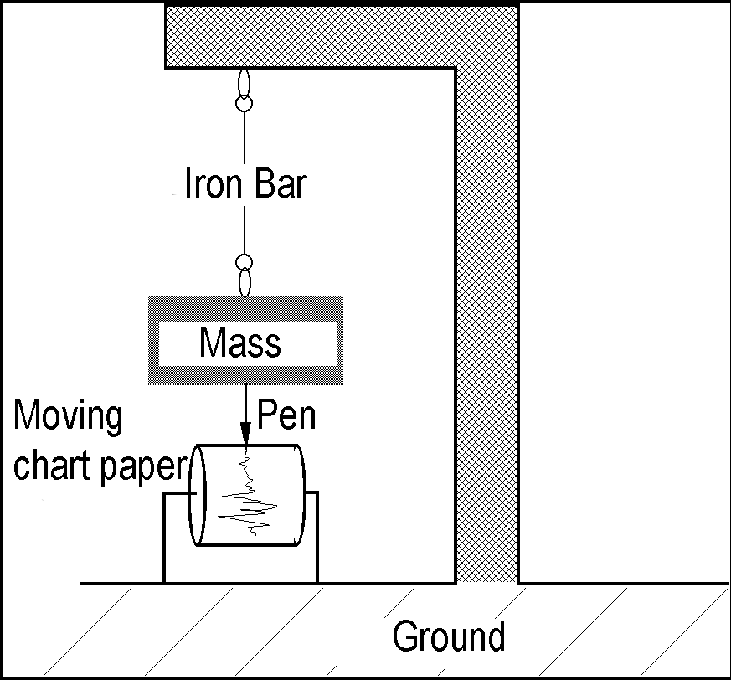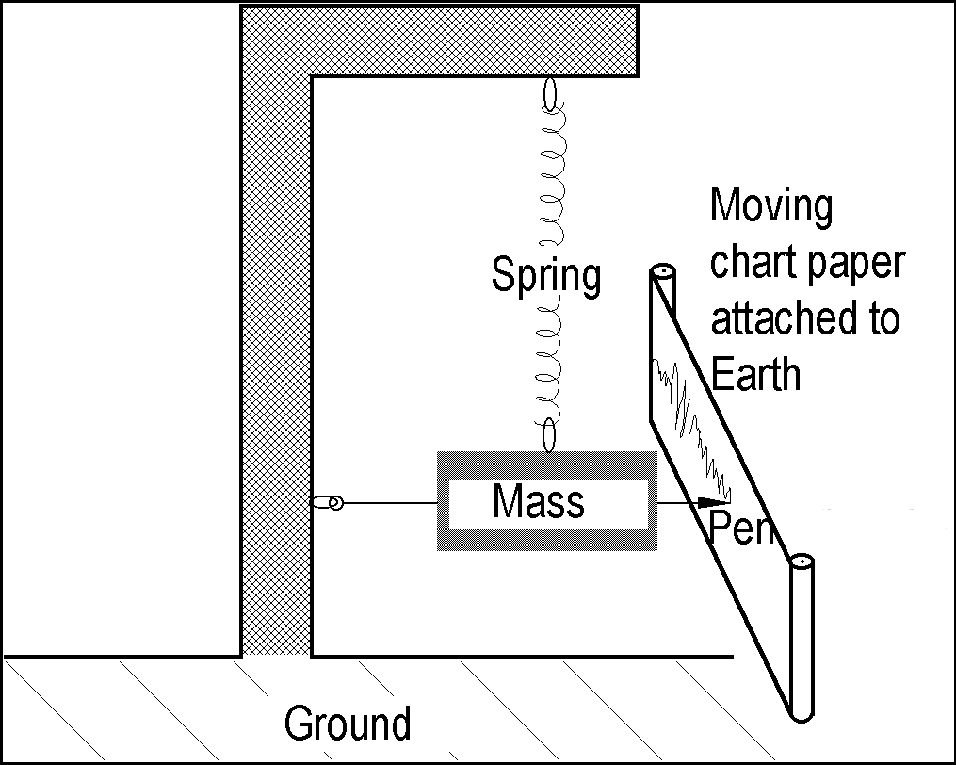
Fig 1: Seismograph „h-type“ Fig. 2: Seismograph „v-type“
Seismograms
After the signal is measured and recorded it will be analyzed on screen or paper. It is a record of the ground motion at a measuring station as a function of time. Seismograms typically record motions in three cartesian axes (x, y, and z), with the z-axis perpendicular to the Earth's surface and the x- and y-axes parallel to the surface. Historically, seismograms were recorded on paper attached to rotating drums. Some used pens on ordinary paper, while others used light beams to expose photosensitive paper. Today, practically all seismograms are recorded digitally to make analysis by computers easier.
Typically, the first well-discernible oscillations are caused by the arrival of the P-waves (primary waves) followed by the S-waves (secondary waves) and the subsequent surface waves which cause much larger ground movement, resulting in a large amplitude on the seismogram. The most pronounced amplitude in the seismogram is then used to determine the magnitude (a measure of the strength) of the earthquake.

Data processing
Seismograms are frequently treated with different kinds of data processing techniques. To achieve a better signal-to-noise ratio, seismograms are summed. This technique is known as “signal stacking“ and enhances the strong signals whereas the weaker noise remains small. If two seismograms of the same earthquake are stacked, an amplitude of 1 cm will be enhanced up to 2 cm, while noise of 1 mm will result in a 2 mm amplitude. The difference between the two signals - the signal-to-noise ratio - was 9 mm before the stacking and increased to 18 mm after the processing.

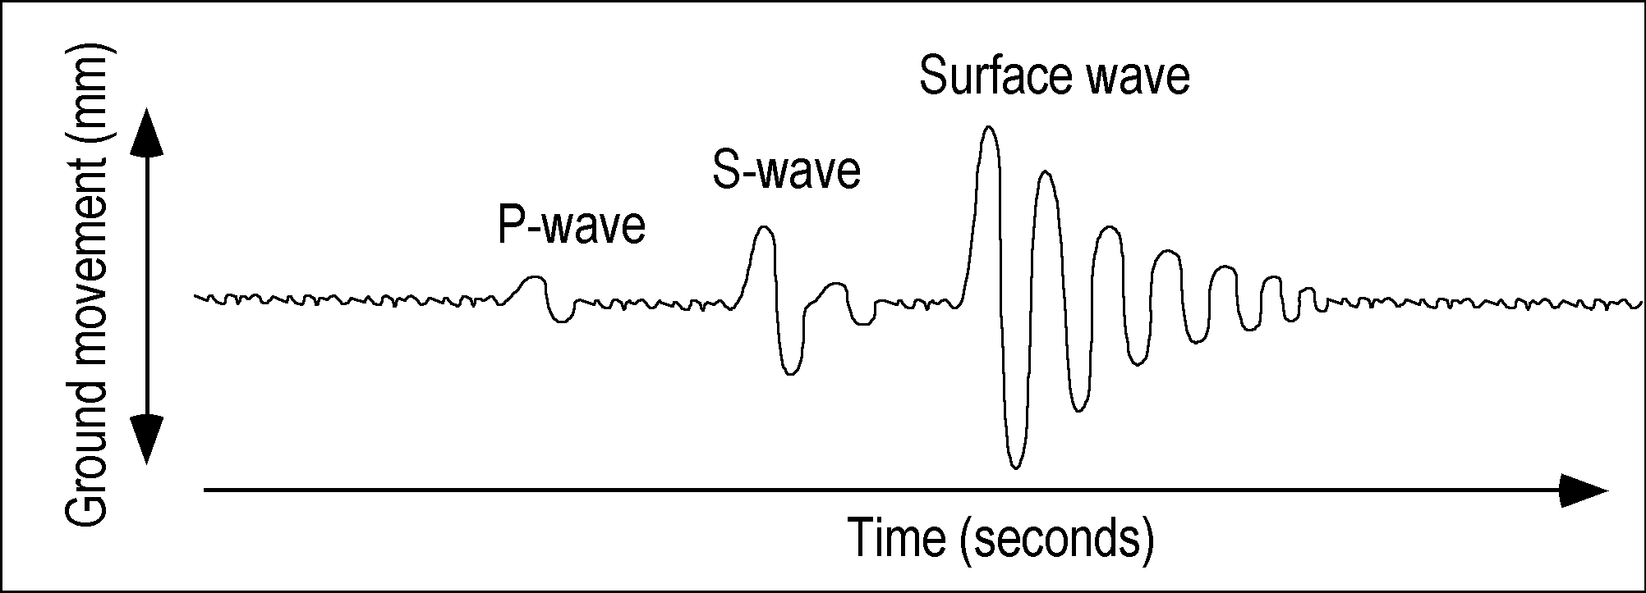
Fig. 3: Schematic plot of a seismogram (textbook example) originating from an earthquake. In reality, seismograms are often rather complex, and the onset of different wave types is not as obvious.

Exercises
- Seismometer
Two different types of seismometers are shown in Fig 1 and 2.
a) What is the main difference between these two? (also see animations!) The first one is for motion parallel to the earth and the second one is for motion perpendicular to the earth.
b) Why should we have a third seismometer to record a quake properly? One needs one seismometer for every axis in the cartesian cordinate system.

2. Data processing and dampening
Because ground movements occur as oscillations, seismometers must be damped. The basic idea is very similar to that used in the suspension of cars. A spring and a shock absorber or damper are used together to smooth out road bumps. Why is it crucial to dampen a seismometer? Explain in your own words and draw a schematic sketch of two seismograms, one that is damped and one that isn't.
Hint: What do we want the seismometer to record or not record? Hint: Watch out for Resonance!

3. The speed of body waves and surface waves
(Average propagation velocity p-wave = 8 km/sec; s-wave = 4.5 km/s; surface waves = 3 km/sec)
a) Calculate the time for a P-wave to travel through the Earth's center from the north pole to the south pole. 26.5 min
b) How long would it take for a surface wave originating from the same quake, to travel along the surface from the north to the south pole? 111 min
c) How much time would pass between the first arrival of the p-wave and the s-wave at your station? 20.6min

4. Amplitude
Determine the largest amplitude (in mm) of the Earthquake recorded in Fig. 3. Find the zero line (no ground movement) and start measuring from there!

5. Focal distance and Magnitude (☞ To do after finishing “B. The Strength of an Earthquake“)
On the time axis in Fig.3 one centimeter corresponds to 4 seconds. Use the chart in Fig. 1 from “The Strength of an Earthquake“ to determine the focal distance and magnitude of this Earthquake.

