Dynamic Earth

Introduction
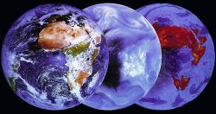
After the liberation of the mind and rejection of the dogmas of the Biblical creation story in the mid-19th century, the dynamics of planet Earth remained an unsolved mystery for over 100 years. The rapid development of science in the 20th century enabled measurements and sampling with submarines, boreholes, and magnetic methods. A gigantic measurement campaign was carried out during the years following World War II, resulting in a huge amount of data about our planet.

What to do?
The maps and charts in this exercise represent a compilation of some of the most important scientific data about the dynamics of the Earth. This will enable you to find answers to the questions posed at the beginning and thus reveal the secrets of the Earth's geological processes to some extent. You must describe the data in the first step and interpret it to find possible correlations and explanations in the second step. Always go through both steps: description and interpretation/explanation!

Goals:
- You can describe and interpret the information on various maps precisely.
- You can discover obvious relationships.
- You develop possible geological processes explaining the data and its relationships.

Instructions
Work in Teams of two. I expect the exercise to take about 20 - 30 minutes. We will discuss your observations and ideas together later.
→ Important:
Answer in written form! You may use keywords.

Exercises:
1. Description (What do you see?)
Scrutinize each data (map, atlas sheet, diagram) first. What is shown here? What is strange, striking, unexpected?
Try to describe as objectively as possible in this first step. Do not make any statements or speculations about possible causes!
2. Interpret and explain (Why is it so?)
Interpret the maps or charts: Search for correlations between the individual facts and develop a possible explanation for the observed phenomena.
3. Develop a theory and verify it!
Can you answer these questions?
–> Why are volcanoes not evenly distributed?
–> Why do earthquakes occur only in certain regions?
–> How are mountains formed?
–> Why is the sea floor so young?
–> Why can we find oceanic rocks on the continents
Earthquakes

Explanation
The map shows the distribution of earthquakes on the globe. The black dots represent some 30'000 earthquake epicenters, which were located between the years 1961-1967. (Depth of the earthquake epicenters 0 - 700 km).

☞ Describe the distribution of earthquakes around the globe.

☞ What is unexpected/striking?

☞ Do you see links to other maps?

Volcanoes
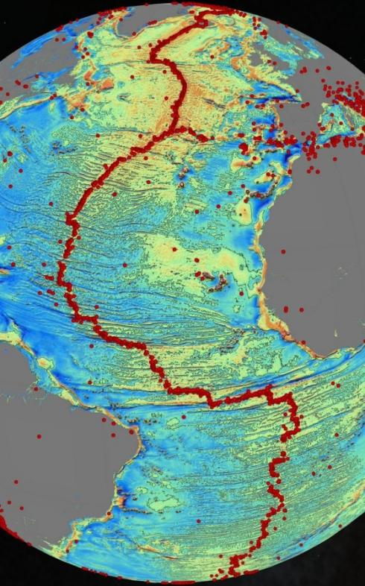
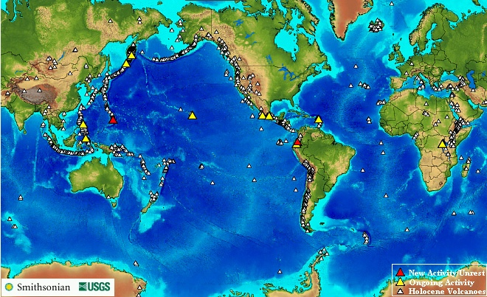
Explanation
The Smithsonian USGS map shows the global distribution of volcanoes above sea level. The larger triangles represent currently active volcanoes, the smaller triangles depict volcanoes that were formed in the Holocene (Holocene = geological term for the period from 11,500 years ago to today) but are dormant.
The second map on the right focuses on the Atlantic Ocean and shows all underwater volcanoes in red dots.
Both maps also show the relief of the ocean floors (the lighter the color the deeper the ocean floor).

☞ Describe the distribution of volcanoes around the globe.

☞ What is unexpected/striking?

☞ Do you see links to other maps?

Topography of the sea floor

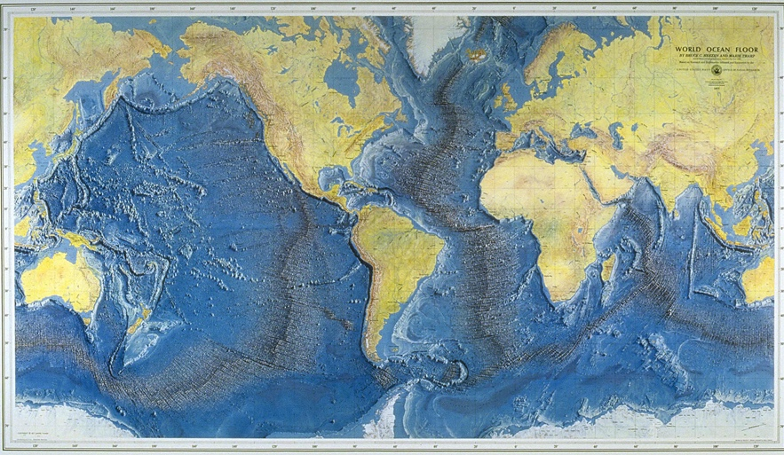
Explanation
This beautiful map shows the topography of the sea floor on the globe. From "World Ocean Floor Panorama", Authors Marie Tharp and Bruce C. Heezen, 1977.

☞ Describe the topography of the Ocean Floor. Hint: Focus first on the Atlantic.

We can see that the atlantic is devided vertically into two parts by a ridge which goes up. In addition one can also see such a ridge south of

☞ What is unexpected/striking?

The the ocena floor is not smooth that it has montains and ridges which where probably formed by tectonic activity.

☞ Do you see links to other maps?

Volcanic activity and earthquakes happen exactly in the region of the ridges. We could suspect a correlation here.

The age of the Atlantic and eastern Pacific

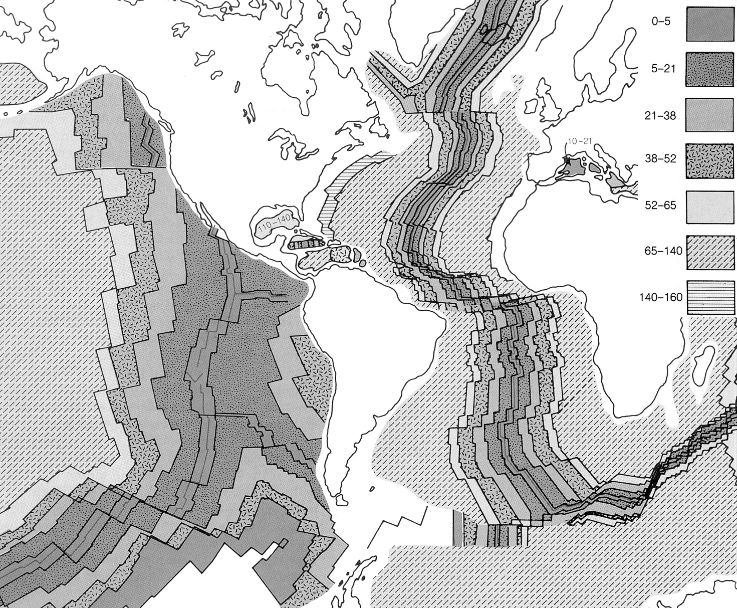
Explanation
The map shows the age of the Atlantic and part of the Pacific sea floor. The individual strips represent different ages. The numbers indicate the age of the strips in million years. A line is called an Isochrone (= line of the same age). The Pacific ages also apply to the Atlantic Ocean.

This is most certainly a key map!

☞ Describe the Age of the Ocean Floor. Hint: Focus first on the Atlantic.

It can observe that the age is proportional to the depth, therefore the ridges in the atlatic and pacific oceans are younger the the rest which would imply that they were created by tectonic activity which released new magma.

☞ What is unexpected/striking?

☞ Do you see links to other maps?

The age of global ocean floor

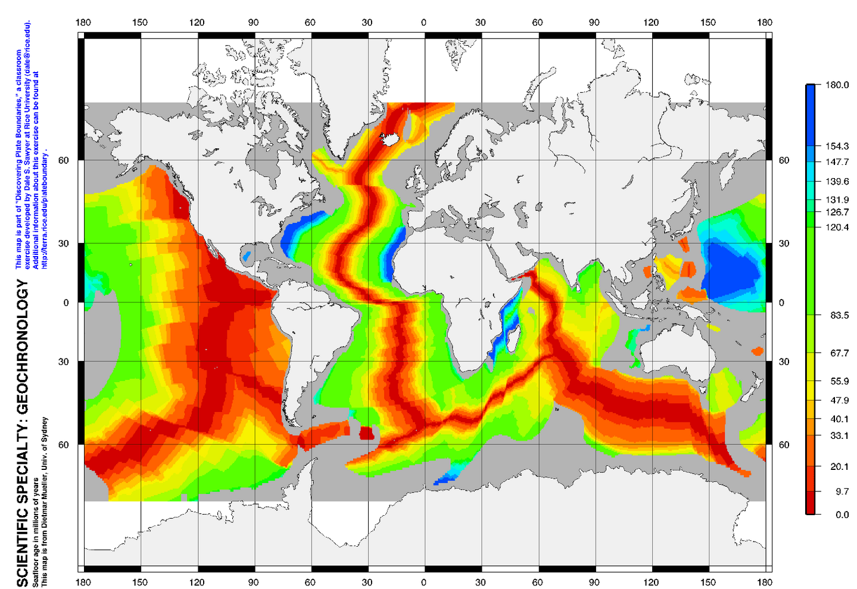
Explanation
The map shows the age of the sea floor of the earth. The individual colors represent different ages in millions of years. See the legend to the right. A line delimiting one age color from another is called an Isochrone (= line of the same age).

This is most certainly a key map!

☞ Describe the Age of the Ocean Floor. Hint: Focus first on the Atlantic.

☞ What is unexpected/striking?

☞ Do you see links to other maps?

Ophiolites

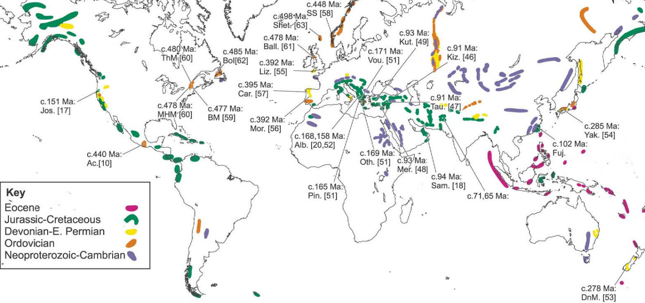
Explanation
The map shows the distribution of ophiolites on the globe. They once formed the ocean floor (a combination of deep-sea sediments, submarine lavas, and igneous intrusions). The colored lines represent Ophiolite zones with corresponding ages.

☞ Describe the occurrence of Ophiolites on the Map.

☞ What is unexpected/striking?

☞ Do you see links to other maps?

