Geological Processes ("The Earth is changing")

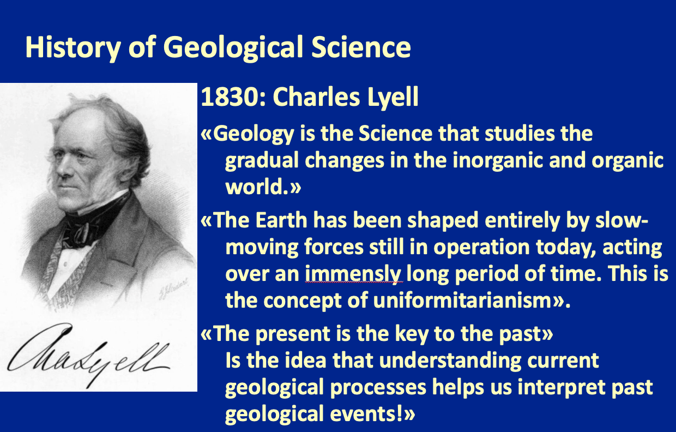
Exercise:
a) Look at the pictures of the geological processes and complete the table.
b) Briefly research about the last column (AI, Internet). Briefly describe how the process works.

Learning goals:
- You know important geological processes and can explain how they work.
- You can recognize these geological processes in pictures (and in nature).

Picture | Geological Process  (dominant) | Specific Example | Process Description: How does it work?
1 | Erosion | aeolian erosion, abrasion | The grains of sand transported by the wind grind and polish the surface of rocks and other materials. Coarse grained sand stays close to the surface and grinds strongly.
2 | Erosion | Frost Spliting | Water in the rock fills it self with water and freezes and expands which splits the rocks. This boulders fall down and form gravel. One can tell how far gravel has travelled based on its size and shape.
3 | Erosion | glacier | Claciers melt at the bottom and are being pushed downaard by their weight. This process expoeses rocks under the ice and pushes rocks with it causign massive changes to the environment with the climate change.
4 | Transportation | Traction, Saltation, Suspension, Solution | Braided rivers systems form in falt areas and transport a lot of mountain sediments.
5 | Transportation | Traction, Saltation, Suspension, Solution | A delta forms a delta where the river flows into the lake. The sediments is tranportet inforn of the already created delta.
6 | Sedimentation | Deep Sea deposition | Plankton with limestone shells die and sink to the bottom of the ocean where there bind together under preassure to limestone. The organism inside the shell stays behin under the right conditino as fossile fule.
7 | Sedimentation | Salt deposition | Oceans evaporate over time and the salt which lower evaporation temperature stays behind as sediment.
8 | Erruption | Vulcanic Magma | A vulcano exploded and then magma flowed down the already present rocks solidifiing and forming a new rock layer over time.
9 | Depostion | layering | Over years oceans have deposited hugee amounts of sediment where layers can be observed due to the changes in the sedimentation material in the past.
10 | Folding | layering | Under intense preassure and high heat under the earth rocks become elastic and can be formed into differet kinds of shapes.
11 | Crystalization |  | Plutanic rocks are formed when magma flows from the earths deeper crust into the upper crust and solidifies in the other rocks on the surfuce under high preassure and heat.

