Absolute Dating
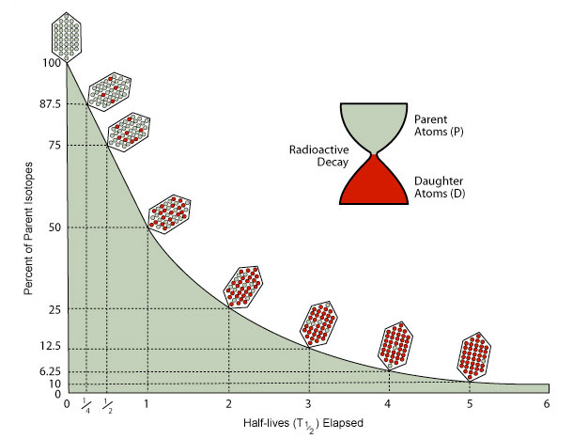Fig.1: Radioactive decay curve and half-life

The constant decay rate
Radiometric dating is based on the known and constant rate at which radioactive isotopes decay into their radiogenic daughter isotopes. Different isotopic systems are used for dating depending on the chemical composition and age of the material.
For example, techniques with a short half-life (the time required for half of the unstable radioactive atoms to decay) are not suitable for dating materials that are billions of years old.
The reason is that the remaining amount of the radioactive parent isotope becomes too small to measure reliably with current analytical instruments.

Radiocarbon dating (¹⁴C decay)
One of the most widely used and well-known absolute dating techniques is carbon-14 (radiocarbon) dating, which is used to date organic remains. Carbon has two stable, non-radioactive isotopes: carbon-12 (¹²C) and carbon-13 (¹³C). It also has a radioactive isotope, carbon-14 (¹⁴C), also known as radiocarbon.
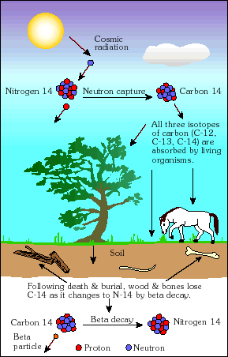Fig.2: Production of carbon-14 in the atmosphere
The half-life of ¹⁴C (the time it takes for half of a given amount of ¹⁴C to decay) is 5,700 ± 30 years, so its concentration in the atmosphere might be expected to decrease over thousands of years. However, ¹⁴C is constantly produced in the lower stratosphere and upper troposphere by cosmic rays, which generate secondary neutrons (n). When these neutrons collide with nitrogen (¹⁴N) atoms in the atmosphere, the neutrons are captured and a proton (p) is released. This ongoing process produces ¹⁴C (Fig. 2). ¹⁴N + n –> ¹⁴C + p
Plants incorporate carbon-14 through photosynthesis. Carbon-14 then moves up the food chain as animals eat plants and predators eat other animals. When an organism dies, it contains the typical atmospheric ratio of ¹⁴C to ¹²C. After death, however, the ¹⁴C begins to decay and can no longer be replenished, so the proportion of carbon-14 decreases at a known and constant rate. During this process it emits beta radiation.
The amount of ¹⁴C remaining is measured indirectly by counting the activity emitted by the ¹⁴C (beta particles, i.e. electrons) still present in the sample. This count - called ¹⁴C activity - can be used to calculate the age of the sample, because the number of decay particles produced is proportional to the number of ¹⁴C atoms still present.
It is assumed that the initial ¹⁴C/¹²C ratio of the organism was equal to the atmospheric ratio at the time the organism was alive. The measured activity is therefore compared with the activity of a modern reference sample. Until a few decades ago, it was difficult to apply this method to samples older than about 50,000 years.
Very old fossils or rocks are dated using other isotopes that decay much more slowly, such as rubidium-87, which decays to strontium-87 with a half-life of 4.92 × 10¹⁰ years.
Instructions
Discuss with your neighbor and answer in written form. Time 20 Minutes

Learning Goals
– You can explain how absolute dating works in general
– You know the limitations and reliability of radiocarbon dating
– You can make logical interpretations about past geological events using absolute and relative dating methods

Exercises
1. Basics
a) What exactly is "Radiocarbon" and how does it form? Explain!

Radiocarbon is an isotope of carbon, specifically C-14, so carbon containing 6 Protons and 8 Neutrons which is naturally unstable. It is formed in the upper Stratosphere and lower Troposphere where a Nitrogen (N-14) carbon captures a free neutron, which is created by a solar ray, and release a proton making them into C-14. The unstable isotope decay so decrease the amount of C-14 but then also new is constantly produced which leads to a balance in the amount of C-14.
As the sun activity can vary this also affects the amount of C-14 being produced, we can compensate for this by including the information about solar activity over time.

b) Why is it impossible to date lava directly with this method?

Lava is not a living organism so it does not exchange C-14 with the atmosphere and it does not have a point where it stops exchanging carbon with the atmosphere from where one could measure the carbon decay.

c) Why is it possible to date lava flows indirectly with this method? –> see the link. USGS: Volcano Watch

One can not date the lava but organic material which burned to organic material making it into charcoal which is deposited in the lava.

2. Age limits
a) Until recently it was impossible to use radiocarbon dating for materials older than approximately 50'000 years. Why?

Radiocarbon has a halftime of around 5700 years so statistically most of the C-14 decays nearly completely in around 50’000 years. So to date older specimens one would use isotopes with a longer halftime.

b) Why has it become possible to extend the method for ages up to 50'000 years?

As the amount of C-14 decreases exponentially it is nearly impossible to notice a radioactive decay in old specimens. New technology (Mass spectrometry) has allowed to count the atoms of C-14 directly.

3. Reliability
How reliable is radiocarbon dating? Hints:
- Consider the assumptions made to calculate the age.
- What kind of contamination could take place in a sample taken e.g. from an ancient tree?

The assumption for carbon dating is that the ratio of the stable C-12 to the unstable C-14 has not changed over time. If this ratio is very small combined with measurement errors could lead to potential big errors in carbon dating if the assumption were not true.
Living organisms which have a exchange with the atmosphere like moss and roots can contaminate an ancient tree.
By burning fossil fuels we change the ratio of C-14 to C-12 by creating more C-12 in the atmosphere.

4. Age Interpretation
A crack that was most likely caused by an earthquake was discovered within a layered sandstone. A piece of wood was found stuck in the crack for which radiocarbon dating yielded an age of +/- 25'000 years. Absolute dating on the sandstone – using the rubidium-strontium method – resulted in an age of 1 Mil. years at the bottom (10 m below the surface) and 500'000 years at the surface.
- Draw a sketch of the situation described.

b) How do you interpret these different ages? What happened when?
The wood was the last object that ended up in this place formed by the much older sandstone so trivially absolute dating yields the smallest number as the crack also had to form after the creation of the sandstone.
The interesting fact is that the sandstone that is 10 m below the surface is twice as old as the sandstone on the top. This can be explained by how the sandstone formed because it was created by very slow layering of sand.

5. Example: (“brain teaser“)
Wood remains were discovered in a borehole at a depth of 100 m in a clay layer. You suspect that they stem from a climatically warmer period, during the last ice age. Laboratory measurements with the mass spectrometer showed that the ¹⁴ C activity is 35% of the activity of contemporary living plants. How old are these bits of wood?

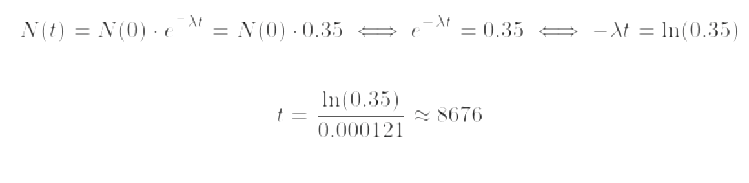

Equation radioactive decay: N(t) = N(0).e-λt
N(t) = number of atoms remaining after a certain time
N(0) = original number of atoms in a sample
t = time elapsed
λ = decay constant (¹⁴C = 0.000121)

