Population Growth

A. Fundamental Terms
Populations undergo continuous changes in size. These changes are caused by the number of births, deaths, emigrants and immigrants, occurring within a specific period. Growth rates are generally calculated annually. You should know the following fundamental terms and apply them correctly for basic calculations.

Birth Rate (%): childbirths per year, divided by the mean annual total population.
Death Rate (%): deaths per year, divided by the mean annual total population.
Natural Increase (%): birth rate – death rate
Immigration Rate (%): immigrants per year, divided by the mean annual total population.
Emigration Rate (%): emigrants per year, divided by the mean annual total population.
Net Migration Rate (%): immigrant rate – emigrant rate.
Growth Rate (%): natural increase + net migration rate.

B. Exponential growth of the world’s population
Fears of a "population explosion" were widespread in the 1950s and 60s. «The Population Bomb» was a best-selling book written by Paul R. Ehrlich and his wife in 1968. Today the world’s population is still growing each year. Until recently the growth trend was not linear but exponential. That means that the world’s population was not only growing by the same amount of people each year but by more people than the year before. For example: The world’s population grew by approximately 80 Million from 1999 to 2000 but with 81 Million from 2000 to 2001.
This non-linear trend can be described in mathematical terms with the “interest on interest” formula. Although the interest (%) stays the same you will get more (in absolute terms) each year.

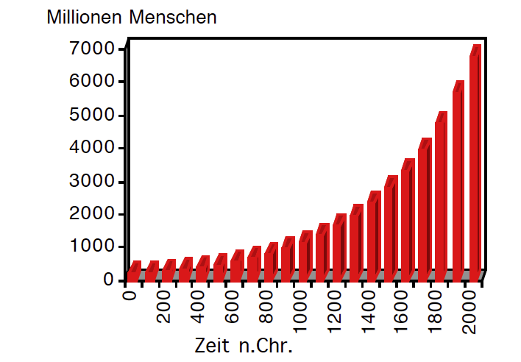
$$P_{t }=P_{0}{\left(1+\frac{g}{100}\right)}^{t}$$

P_{t} = population in t years
P₀ = actual population
g = growth rate (%)
t = years

The “doubling time” (= DT) is the time interval wherein the population will grow to double its original size. It and can be approximated with the following equation (rule of thumb):

$$DT = \frac{70}{g}$$

☞ Assuming an exponential growth trend, the future size of a population can be forecasted.

C. Exercises
General Information:
Your results should be rounded to one decimal place (round only at the end of the calculations). It is recommended to compare your results with your neighbors (teamwork encouraged!).
Time: app. 30 Minutes

Goals:
- Execute calculations with demographic data correctly.
- Design simple population forecasts using the exponential approach.
3. Interpret and judge the validity of the forecast model.

1. Switzerland
In 2023 the mean annual population of Switzerland amounted to 8888093
During that year 80024 children were born, 71822 deaths occurred, 263100 people immigrated and 123963 emigrated.
Calculate: birth rate, death rate, natural increase, immigration rate, emigration rate, net migration rate, growth rate and doubling time.

2. California (USA)
In California the mean annual population of the year 2023 amounted to 39128162.
During that year 400108 children were born, 340526 deaths occurred, 134370 people immigrated and 144472 emigrated.
Calculate: birth rate, death rate, natural increase, immigration rate, emigration rate, net migration rate, growth rate and doubling time.

3. Nigeria
In Nigeria the mean annual population of the year 2023 amounted to 227883000.
During that year 7510000 children were born, 2675000 deaths occurred, 1308568 people immigrated and 1366504 emigrated (estimates from https://openknowledge.worldbank.org/).
Calculate: birth rate, death rate, natural increase, immigration rate, emigration rate, net migration rate, growth rate and doubling time.

4. Senegal
In Senegal the mean annual population of the year 2023 amounted to 18077573.
During that year 560000 children were born, 91000 deaths occurred, 270000 people (estimated data) immigrated and 693765 emigrated (estimates from https://openknowledge.worldbank.org/).
Calculate: birth rate, death rate, natural increase, immigration rate, emigration rate, net migration rate, growth rate and doubling time.

5. Exponential Growth with a spreadsheet program
Spreadsheet programs such as “Excel” enable the input of formulas. By typing the correct formula into the appropriate spreadsheet cells, you can model the estimated future population.

Switzerland’s population since 1850
In the following exercise you will simulate Switzerland’s population from 1850 to 2050 assuming an exponential growth. You will use different growth rates and find out which one matches the real data best.
These data are given:
– Population 1850: 2.3927 million
– Growth rates: 0.4%, 0.7%, 1.2% (per year)
– Time: 1850 = start = 0 years
2050 = stop = 200 years
– exponential growth formula: $P_{t }=P_{0}{\left(1+\frac{g}{100}\right)}^{t}$

Exercises
a) Interpretation of the growth trends
Which of the three growth rates is most reasonable? Why? Explain!
Change the growth rates slightly and try to find a best fit!
b) Model and reality
Compare your exponential forecast model with the real data from the population census. What do you find? How reliable is the model? On what assumption is it based?
c) Forecasting populations
Try to forecast the figures from example no 2 on page 2 for 2050. How realistic is your result? Explain your answer!
d) Supplement: Annual growth rates
Calculate the annual growth rates of Switzerland using the spread sheet program and draw a new XY-chart that relates time and annual growth rates. What do you find?

