The Demographic Transition Model (DTM)

Introduction
Demographic transition (DT) refers to the gradual change in birth and death rates as a country develops from a pre-industrial to a post-industrial economic system. This is typically demonstrated through a demographic transition model (DTM). The theory is based on an interpretation of demographic history developed in 1929 by the American demographer Warren Thompson (1887–1973). Thompson observed changes, or transitions, in birth and death rates in industrialized societies over the previous 200 years. In countries that are now advanced economies, this demographic transition began in the 18th century and continues until today.
Important: A correlation matching the demographic transition has been established; however, it is not certain whether industrialization and higher incomes lead to lower populations or if lower populations lead to industrialization and higher incomes.

Learning Goals
– You can explain the basic principle of the demographic transition model
– You can apply the model to specific examples (e.g. countries)
– You can judge the model in general and its predictive value specifically

Instructions
Read the introduction and watch the short video "What is the Demographic Transition"
Read the exercises and interpret the charts from four different countries.
Discuss and phrase your answers using relevant terms!

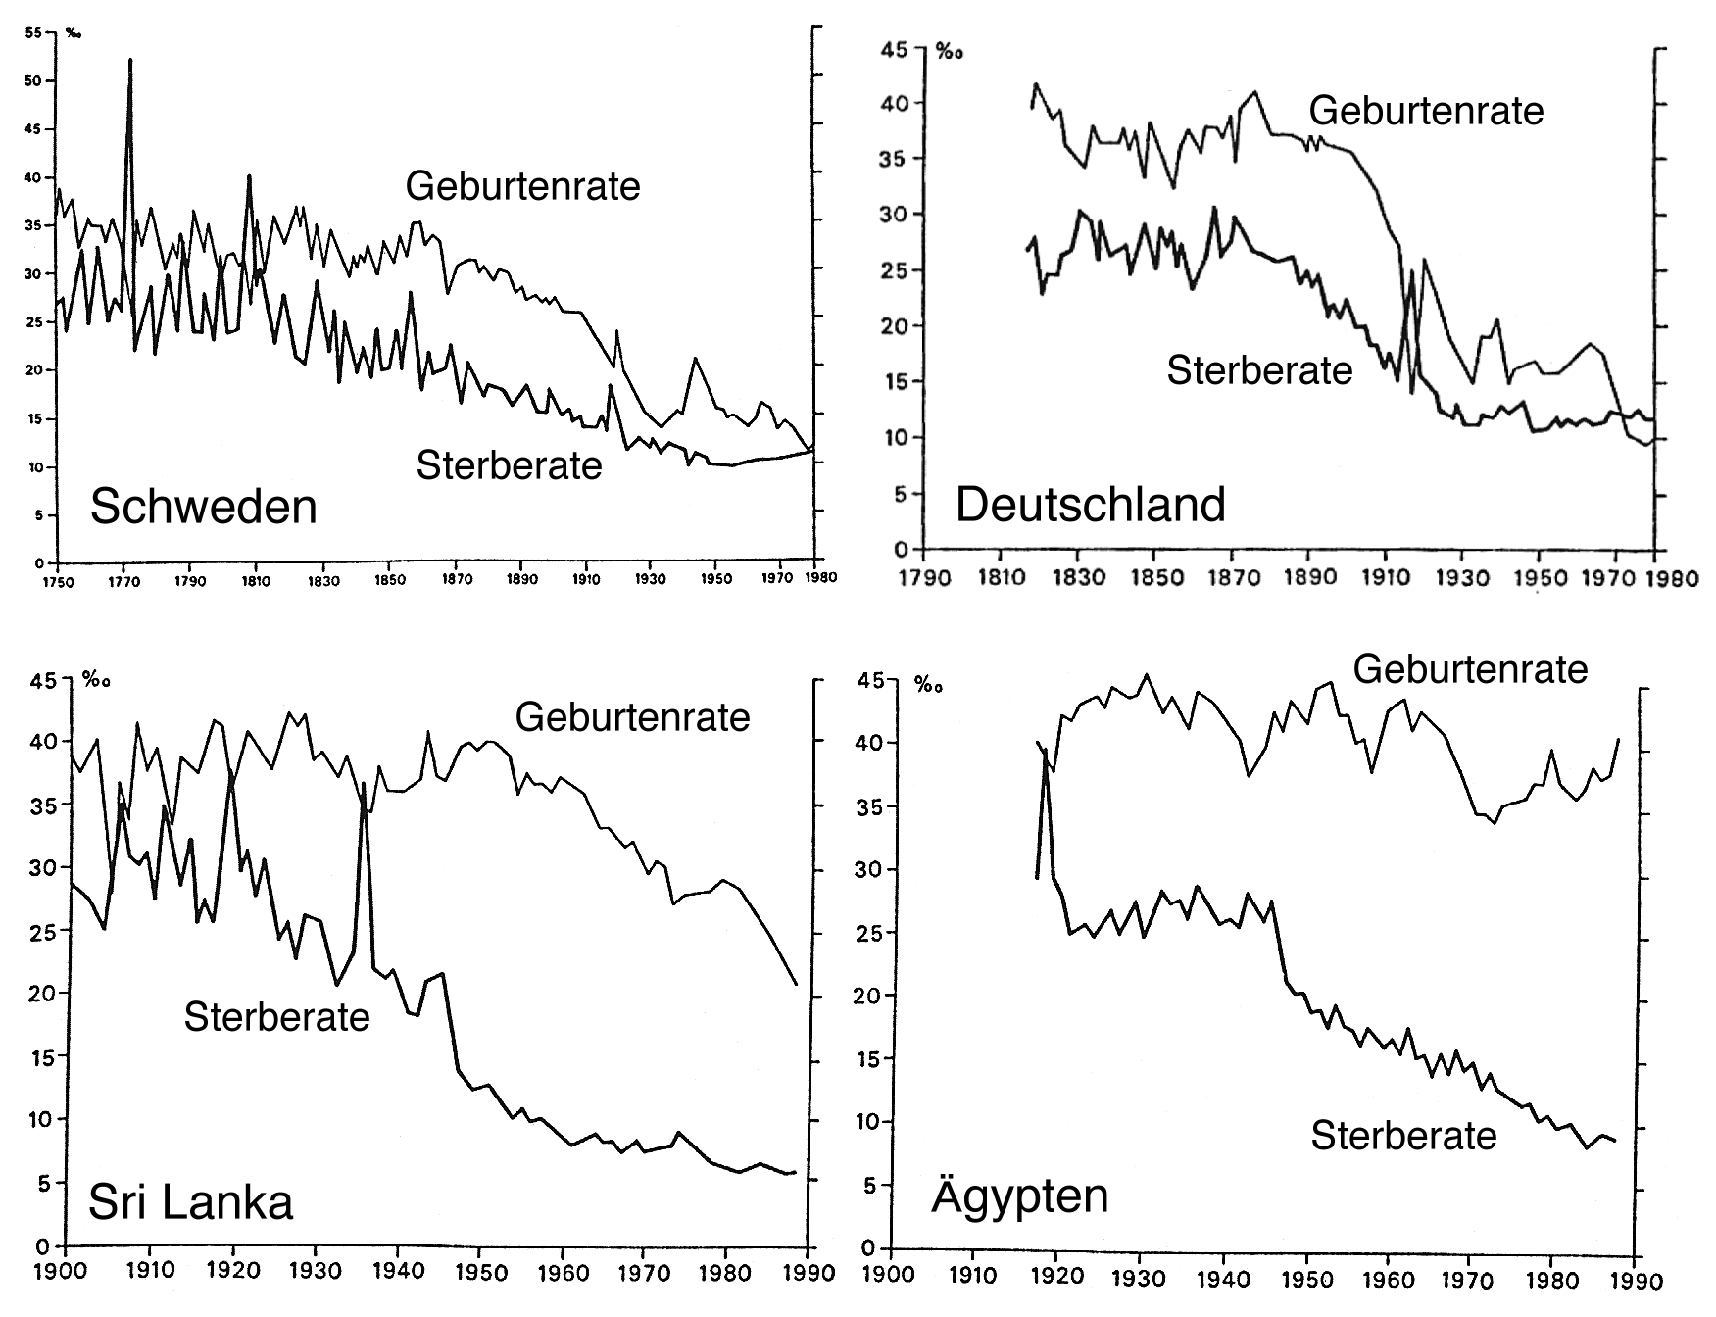
Exercises

1. Natural population growth during the demographic transition
a) Plot the total natural population growth (‰) of Sweden and Sri Lanka directly into the corresponding diagram with a pen and comment on the result (When did it start growing/shrinking? Why? etc.)

The popultion of sweeden grew gradually untill 1980 and started to fall afterwards which is same case for Sri Lanka just in 1970.

b) Why do the charts above yield only limited information about total population growth?

The net migration is not included.

2. Application of the DTM
To which stage of the DTM would you assign Sri Lanka and Egypt in 1990? Explain your answer!

In 1990 Sri Lanka was in the industrial stage and Egypt was in the transitional stage.

3. Is the DTM applicable/transferable to developing countries?
a) Compare the change in birth and death rates over time in Germany/Sweden to that of Sri Lanka/Egypt. Scrutinize the charts! What are the similarities and/or differences?

They both show the same DTM trend just shifted in thme (faster for Germany/Sweeden) and much less extreme by around 20% then Sri Lanka/Egypt.

b) Does the DTM have a predictive value? In other words, can it be used for predicting the sequence through which developing countries will pass?
–> Hint: What is – according to the DTM – the general cause leading to the observed change in birth/death rates?
...

