Thomas Robert Malthus (1766- )
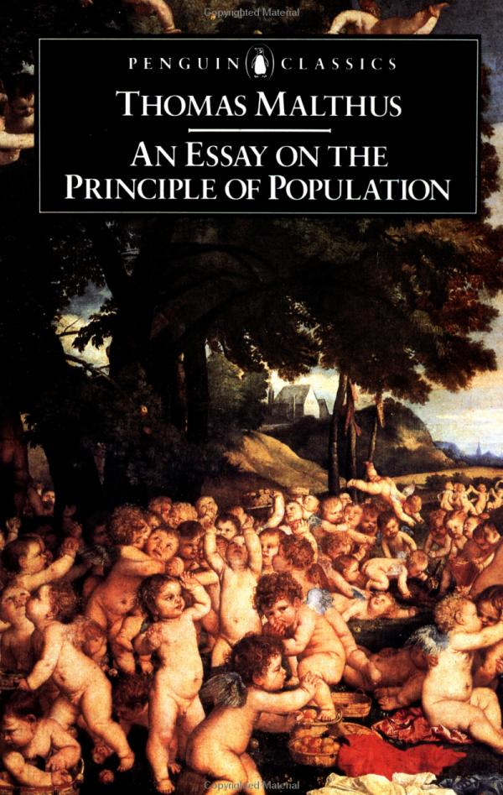

In the Essay on the Principle of Population (1798) Malthus observed that in nature plants and animals produce far more offspring than can survive, and that Man too is capable of overproducing if left unchecked. Malthus concluded that unless family size was regulated, man's misery of famine would become globally epidemic and eventually consume Man. Malthus' view that poverty and famine were natural outcomes of population growth and food supply was not popular among social reformers who believed that with proper social structures, all ills of man could be eradicated.
Although Malthus thought of famine and poverty as natural outcomes, the ultimate reason for those outcomes was divine institution. He believed that such natural outcomes were God's way of preventing man from being lazy. Both Darwin and Wallace independently arrived at similar theories of Natural Selection after reading Malthus. Unlike Malthus, they framed his principle in purely natural terms both in outcome and in ultimate reason. By so doing, they extended Malthus' logic further than Malthus himself could ever take it. They realized that producing more offspring than can survive establishes a competitive environment among siblings, and that the variation among siblings would produce some individuals with a slightly greater chance of survival.
Malthus was a political economist who was concerned about, what he saw as, the decline of living conditions in nineteenth century England. He blamed this decline on three elements: The overproduction of young; the inability of resources to keep up with the rising human population; and the irresponsibility of the lower classes. To combat this, Malthus suggested the family size of the lower class ought to be regulated such that poor families do not produce more children than they can support. Does this sound familiar? China has implemented a policy of one child per family (though this applies to all families, not just those of the lower class).

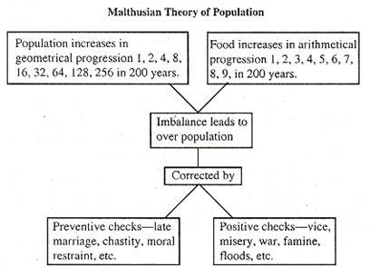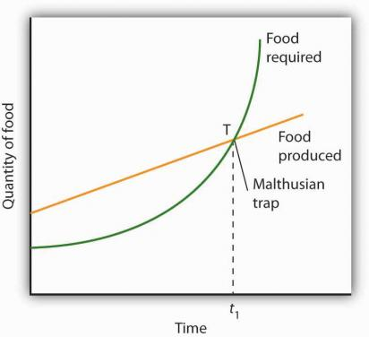
http://www.yourarticlelibrary.com/wp-content/uploads/2013/10/clip_image004_thumb24.jpg

Learning Goals
– You can evaluate Malthus' ideas in relation to China's one-child policy in a well-founded manner.

Short Exercises (discuss in teams)
1. Was Malthus right in the end?
Looking back, can we say that Malthus’s ideas were broadly correct?

No because Maltus did not account for the development in agriculture technology that allowed for exponential invrease in food production. Mehr Menschen erlauben auch mer Essen anyubauen. The populatio forecast was correct.

2. Malthus & China
What is the link between Malthus's ideas and Chinas one-child policy.

Maltus was as well afraid of overpopulatio and famines. And presented the same implementation to solve the problem. The differenz was that Maltus only wanted to targed the lower class. Maltus did not say that the government should interveen in the process.

3. Criticism
Why is the Chinese one-child policy criticized? What are some hard arguments?

- Ratio to old and yound changes to fast and the older population can not be sustained
- Against human rights
- Vieweing the DTM, this was just an acceleration of a trend that would have happend anyway.

