Demography in Europe: Ageing society

General
A. Read the exercises before you read the text. Try to determine the general meaning of the text and look for answers while reading. Discuss your results with your neighbors and write them down.
B. Team up with someone who was working on the second issue. Explain your answers to each other and write them down. The goal is that both of you are on the same (high) level of knowledge!

Exercises
1. Which factors determine life-expectancy in general?
Summarize: Which factors contributed to raise life-expectancy (LE)? Explain them briefly.
–> Hint: Draw a concept map!
2. Development of life-expectancy (LE)
a) What caused LE improvements until the 1920's and since approximately 1970? Explain your answer regarding possible causes.
b) What is very surprising regarding the development of life-expectancy?
What do the authors claim to observe? (–> Fig. 1,2)
3. Consequences
What are reasonable strategies – according to the authors – about how to deal with these developments? Do you agree? Support your answer with plausible arguments.

Ageing populations: the challenges ahead
Authors: Kaare Christensen, Gabriele Doblhammer, Roland Rau, James W Vaupel
If the pace of increase in life expectancy in developed countries over the past two centuries continues through the 21st century, most babies born since 2000 in France, Germany, Italy, the UK, the USA, Canada, Japan, and other countries with long life expectancies will celebrate their 100th birthdays. Although trends differ between countries, populations of nearly all such countries are ageing because of low fertility, low immigration, and long lives. A key question is: are increases in life expectancy accompanied by a concurrent postponement of functional limitations and disability? The answer is still open, but research suggests that ageing processes are modifiable, and that people are living longer without severe disability. This finding, together with technological and medical development and redistribution of work, will be important for our chances to meet the challenges of ageing populations.
Introduction
The remarkable gain of about 30 years in life expectancy in western Europe, the USA, Canada, Australia, and New Zealand – and even larger gains in Japan and some western European countries, such as Spain and Italy – stands out as one of the most important accomplishments of the 20th century. According to the Human Mortality Database, death rates in life-expectancy leaders such as Japan, Spain, and Sweden imply that even if health conditions do not improve, three-quarters of babies will survive to celebrate their 75th birthdays. Most babies born since 2000 in countries with long-lived residents will celebrate their 100th birthdays if the present yearly growth in life expectancy continues through the 21st century. This forecast assumes that mortality before age 50 years will remain at 2006 levels. At age 50 years and older, probability of dying decreases by a rate that yields yearly improvements in period life expectancy of 0.2 years. More complex methods can be developed based on the assumption that life expectancies will increase linearly; however, such models produce similar estimates […].
These scenarios are projections, but we do not have to look to the future for challenges of an ageing population: the oldest-old group (aged >85 years) have over past decades been the most rapidly expanding segment of the population in developed countries. This group is also the most susceptible to disease and disability. Development of mortality, disease, and disability rates in elderly people will therefore have a fundamental effect on sustainability of modern society.

Mortality
Life expectancy is lengthening almost linearly in most developed countries, with no sign of deceleration. […] In the record- holding country, Japan, female life expectancy was 86.0 years in 2007, surpassing the 85-year limit to human life expectancy that was proposed by Fries in 1980, and later elaborated on by Olshansky and colleagues. Although with lower life expectancies than that of Japan, most developed countries have had similar yearly increases in life expectancy since 1950 (figure 1). The linear increase in record life expectancy for more than 165 years does not suggest a looming limit to human lifespan. If life expectancy were approaching a limit, some deceleration of progress would probably occur. Continued progress in the longest living populations suggests that we are not close to a limit, and further rise in life expectancy seems likely.
Life-expectancy improvements over the past 165 years were not propelled by uniform reductions in mortality at all ages. Until the 1920s, improvements in infant and childhood survival contributed most to the increase in record life expectancies. After successful combating of infectious diseases at young ages, gains in record life expectancy were fuelled by progress at older ages. This reduction in old-age mortality was unprecedented and unexpected. Since the 1950s, and especially since the 1970s, mortality at ages 80 years and older has continued to fall, in some countries even at an accelerating pace.
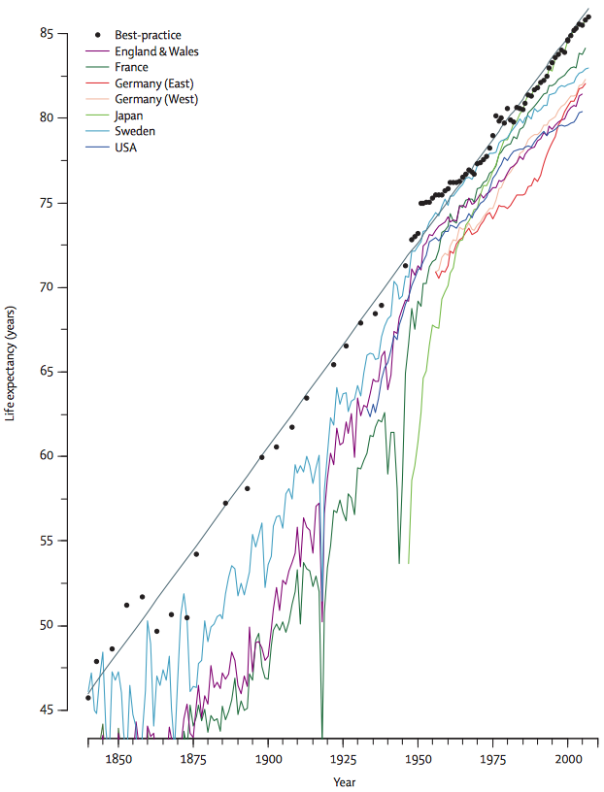
Figure 1: Best-practice life expectancy and life expectancy for women in selected countries from 1840 to 2007 Linear regression trend depicted by solid grey line with a slope of 0·24 per year. Data from supplementary material of reference 12 and the Human Mortality Database.
Data from more than 30 developed countries showed that in 1950 the probability of survival from age 80 years to 90 years was on average 15–16% for women and 12% for men. In 2002, these values were 37% and 25%. Even in the country with the lowest probability (the Czech Republic), the situation improved remarkably. In Japan—which is the country with residents having the best chances of survival—the probability of surviving from age 80 years to 90 years now exceeds 50% for women. Figure 2 plots the probabilities of survival to their next birthday of people who lived to age 80 or 90 years in seven large, developed countries. With a few exceptions, mortality generally keeps falling in all selected countries for both sexes at both ages. […]

Consequences
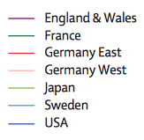
A reasonable strategy to cope with the economic implications of population ageing is to raise the typical age of retirement, and most governments are moving in this direction. Improvements in health and functioning along with shifting of employment from jobs that need strength to jobs needing knowledge imply that a rising proportion of people in their 60s and 70s can contribute to the economy.
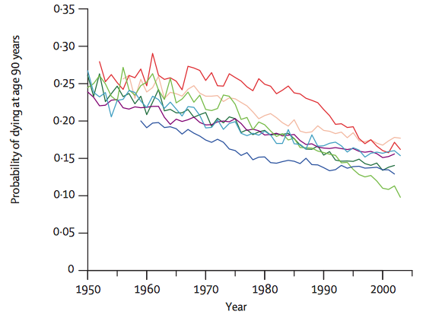
Figure 2: Probability of dying for elderly women aged 90 years in selected countries from 1950 to 2003.
Because many people in their 60s and 70s would prefer part-time work to full-time labour, an increase in jobs that need 15, 20, or 25 h of work per week seems likely. If part-time work becomes common for elderly people, then more opportunities for part-time work might open for young people. If people in their 60s and early 70s worked much more than they do nowadays, then most people could work fewer hours per week than is currently common – if they worked correspondingly more years of their longer lives. The average amount of work per year of life could stay at about the same as it is at present.
The 20th century was a century of redistribution of income. The 21st century could be a century of redistribution of work. Redistribution would spread work more evenly across populations and over the ages of life. Individuals could combine work, education, leisure, and child-rearing in varying amounts at different ages. This vision is starting to receive some preliminary attention. Preliminary evidence suggests that shortened working weeks over extended working lives might further contribute to increases in life expectancy and health. Redistribution of work will, however, not be sufficient to meet the coming challenges. Even if the health of individuals at any age improves, there could be an increased total burden if the number of individuals at that age rises sufficiently. Health care often needs service sector or family-member labour by individuals; this labour is not easily substituted by machines, although assistive technology is likely to reduce the need for personal care in high-income countries.
Very long lives are not the distant privilege of remote future generations – very long lives are the probable destiny of most people alive now in developed countries. Increasing numbers of people at old and very old ages will pose major challenges for health-care systems. Present evidence, however, suggests that people are not only living longer than they did previously, but also, they are living longer, with less disability and fewer functional limitations.
Source: Excerpts from; Lancet 2009; 374: 1196–208

