Earthquakes in Japan

Japan quakes
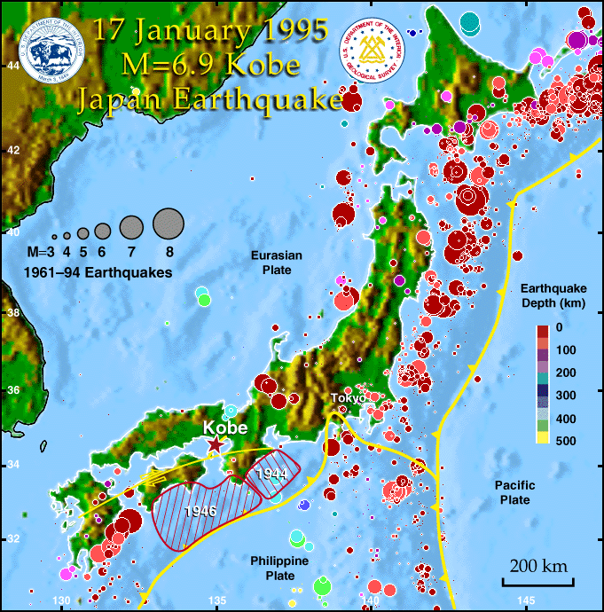
Fig.1: Distribution of Epicenters, registered 1961-1994 Japan,
Circle area represents Magnitude, Color for depth of focus.
To this day, earthquakes cannot be reliably predicted, and it is questionable whether it will ever be possible. However geographic regions, with significantly increased earthquake risks are quite well known. The east coast of Japan represents such an exceptionally active.
Japan has had a long history of earthquakes and seismic activity. This is because it is located near tectonic plate boundaries which form a part of the so-called "pacific ring of fire".
The 30-million mega city of Tokyo suffered a terrible quake in 1923 where 142'000 people died. Since then, no major quakes occurred and for almost 100 years strain has been building up in the fault zone 120 kilometers off the coast of the city. Seismologists are expecting a severe blow at any time.
A study showed that Tokyo would have to cope with approximately 10'000 dead - despite advances in modern construction technology. Insurances estimated damages in the order of US$ 3000 billion. Although modern skyscrapers are supposedly earthquake-proof, there are many narrow streets with old buildings and wooden houses, that will almost certainly be massively damaged.
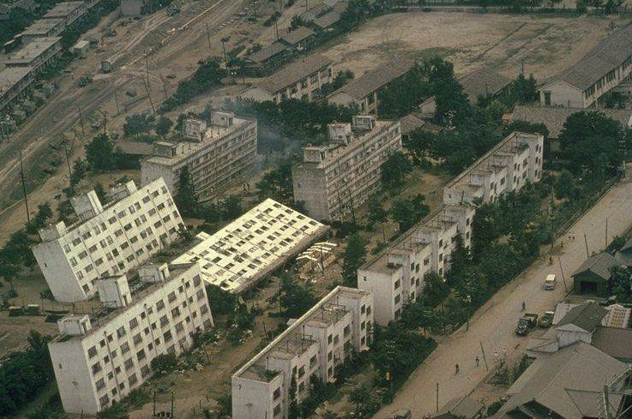
Fig. 2.: Aerial view of leaning apartment houses in Niigata 1964, produced by soil liquefaction and the behavior of poor foundations. Most of the damage was caused by cracking and unequal settlement of the ground such as is shown here. About 1/3 of the city subsided by as much as 2 meters because of sand compaction.
Photo Credit: National Geophysical Data Center
Eventually, it will happen, but the state of the earth's crust can only be estimated by seismologists and so the Japanese simply must live with an ever-looming threat.

The Earthquake of Kobe 1995
The Great Hanshin earthquake occurred at 5:46 a.m. on Tuesday, January 17, 1995. This earthquake is also called by the following names: Kobe, South Hyogo, Hyogo-ken Nanbu.
The documentary shows the disastrous impact of the quake and analyses some of the major causes.

General info
The documentary lasts about 15 minutes. Read through the exercises below and answer in written form.

Learning Goals
– You know what happened during the Great Hanshin Earthquake in Kobe in 1995 (impacts, causes, etc.).
– You can explain how the composition of the ground affects the impact of an Earthquake.
– You can explain the phenomenon of liquefaction and assess its effects.
– You can explain some earthquake engineering approaches.

Exercises
1. Why so much destruction?
Why did the earthquake cause such terrible damage? Summarize all important reasons. Which reason do you find most important?

2. The composition of the ground is important!
a) How does the ground affect the impact of an Earthquake? Explain!
–> Documentary
–> Text: "The Effects of Soil Type on Earthquake Damage"
–> See Chapter 1.2 "Liquefaction"
b) Do you know what type of soil your building is standing on?
–> AGIS online Karten: –> Search maps for "Erdbeben" –> Seismische Baugrundklassen AG Datenebene
3. Buildings and the importance of earthquake engineering
a) Many old houses in Kobe did not withstand the quake. Explain why!
b) Modern engineering would enable the construction of earthquake-resistant buildings. On what basic principles are these solutions based? Explain some technical approaches.
–> See Chapter 1.3 "Earthquake Engineering"
c) Why were many of the houses in Kobe not built to resist earthquakes?

4. What lessons were learned?
Kobe recovered relatively rapidly from the disaster. What kind of lessons were learned from the disaster in Kobe?

The Effects of Soil Type on Earthquake Damage
June 18, 2012, Article by: April LaRita Green, Social Media Marketing and Project Specialist

Site Effects
When thinking about the spread of the effects of an earthquake, many people think of it like dropping a pebble in a lake. The pebble hits the water, and it creates a uniform ripple effect getting weaker as it travels away from the center.
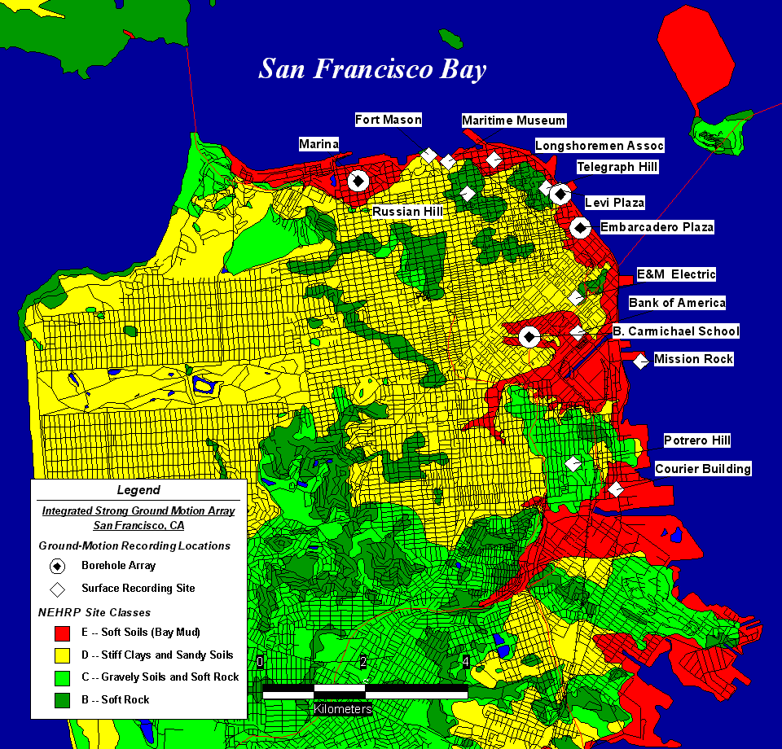

Figure 1a.
Map showing location of borehole arrays and complementary surface installations superimposed on map of San Francisco, California showing streets and the NEHRP site classes recently adopted for recommended U.S. building code provisions.
https://escweb.wr.usgs.gov/nsmp-data/Presentations/san_francisco_array/san_francisco_array_presentation_s.html
The earth’s surface, however, is not uniform like the water in this comparison. During an earthquake, one area can experience over ten times the effects of a neighboring area that is at the same distance from the Epicenter. This is because of what is called «site effects». Site effects are variations that occur in the geologic conditions of a particular location (See Figure 1a).

Soil Softness and Thickness
There are two main conditions that account for these variations: The softness of the soil or rock, and the total thickness of the sediment above the bedrock. The softer and thicker the sediment is, the greater the effects of an earthquake will be amplified.
Seismic waves travel through the ground faster in hard rock than in soft soil. As a result of the transition from hard rock to soft soil, the amplitude (max. wave height) of the waves will increase to preserve the energy, creating stronger shaking. This same principle accounts for the site effects in terms of sediment thickness. The thicker the sediment above the bedrock, the more soft soil there is for seismic waves to travel through, therefore creating stronger amplifications.

Soil Classes
The National Earthquake Hazards Reduction Program (NEHRP) has defined six different soil and rock types based on their shear-wave velocity, to determine amplification effects:
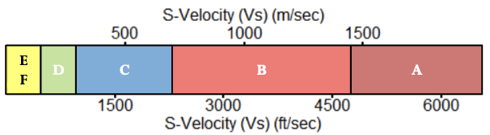
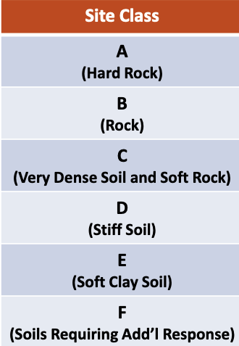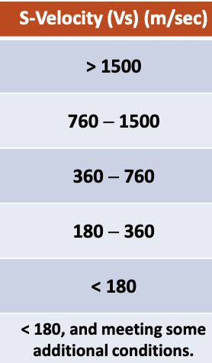
Figure 2. Site Classes NEHRP
Type A has the least amplification with the highest S-wave velocity. Type E shows the highest amplification with the lowest S-wave velocity.
http://www.masw.com/files/NEHRP.pdf

Hotspots
Although soil type is a significant indicator of how specific locations will be affected by an earthquake, other factors can also contribute to «hotspots», which are unique to each earthquake. These hotspots depend on specific details of the earthquake and the affected site, such as:
– Orientation of the fault
– Irregularities of the fault surface
– Scattering of waves as they bounce off subsurface structures.

