Seismic Waves and the Earth's interior

Wave properties
There are different types of waves occurring in nature, but they all follow the same basic laws. Waves transmit movement (up-down, compression-dilatation) over a certain distance. Some waves use material such as rocks, water, or air as a medium, others – such as light – travel through a vacuum.
V_{p} =$\sqrt{\frac{K +\frac{4}{3}∙µ}{ρ}}$
V_{s} =$\sqrt{\frac{µ}{ρ}}$
The velocity (V_{p} or V_{s}) at which seismic waves travel increases with the elasticity of the material and decreases with its density. (K = compressional elasticity, µ = shear elasticity, rho = density).

Additionally, waves are both reflected and transmitted when they encounter a boundary («density jump»), just as light may be partly reflected and transmitted at a water surface. If the speed in the new medium is different, the waves are bent or refracted according to the law of refraction:

V₁ / V₂ = sin(i) / sin(r)

V₁,₂ = Velocity of the seismic Wave in Layer 1,2
i = arrival angle; r = refracted angle
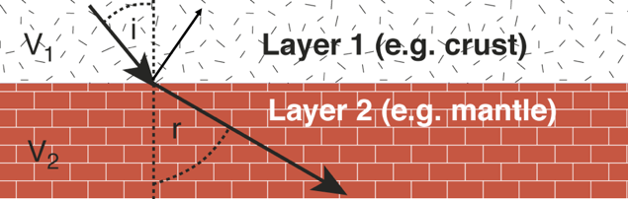
Types of seismic waves
The faster-traveling P-waves compress the rock parallel to the direction of propagation (compression-dilatation). In contrast, the slower-traveling S-waves shear the material perpendicular to the direction of propagation (shearing). Seismologists found that P-waves can travel through liquids, whereas S-waves are stopped by liquid-like materials. This is because fluids elastically resist and recover from the compressing motion of the P-waves but do not resist the shearing motion of S-waves (shear elasticity = 0)
(Light waves can be regarded as exceptional as they travel fastest in a vacuum and are slowed down in air or water. Thus a light beam is refracted as it hits the air/water boundary (r < i).)

Discovering the Earth's interior: Shadow zones (s. Fig.1)
Analyzing the paths and travel times of P and S-waves showed that at epicentral distances of 105° – 140° no direct P-waves were registered (shadow zone for P-waves) and those few P-waves detected arrived later than expected. Additionally, no direct S-waves arrived at epicentral distances greater 105° (shadow zone for S-waves).
These findings suggest that:
1. P-Wave speed is lowered in the outer core (refraction of P-waves; r < i)
2. The outer core is less elastic than the lower mantle (density increases with depth because of the pressure).
3. S-waves do not penetrate this region –> shear elasticity is zero
4. Liquid-like material allows no shearing –> outer core is in a liquid like state.

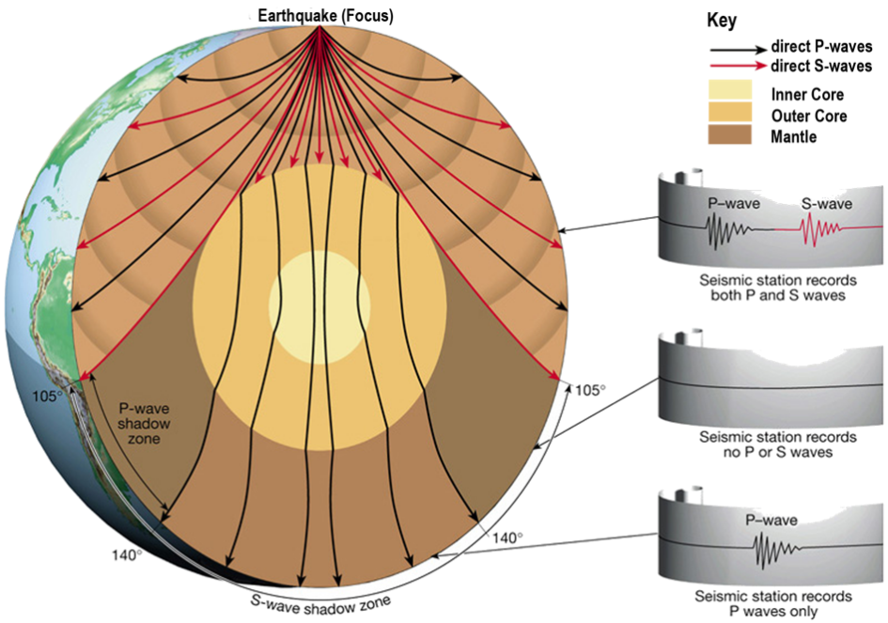

Fig 1:
Direct P and S-waves travel through the Earth's Interior: Shadow zones for P-waves at 105° – 140° epicentral distance. No S-waves are registered after 105°. Note that the body waves propagate from the Focus (= Hypocenter) while the distance in degrees is calculated from the Epicenter (point on the Earth's surface vertically above the Focus).
Exercises:
Watch the short video about seismic shadow zones. Discuss your answers with a classmate and write down your solutions. Time ca. 15-20 minutes.

Goals
– You can describe and explain the reflection and refraction of seismic body waves.
– You can apply Snell’s law to explain the bending of seismic waves within the Earth.
– You can explain the formation of seismic shadow zones and infer that the Earth’s outer core is liquid.

1. Velocity of Seismic waves
Why does the velocity of seismic waves increase with depth in the Earth‘s mantle? Because the velocity is porportional to the elastisity of the mantel which changes as a function of depth faster then the inversly propo

2. Shadow Zone of p-waves
Why do direct p-waves reoccur after 140°? Because this is the angle that can be reached by including the refraction at the second boundry at the criticle angles.

3. Outer core
Why is it reasonable to assume that the outer core is made up of molten rock? Because the body waves are refracted at the boundtry which implies that the elacticities differ which implies different matter states. The S waves do not travel through the core wich happens when they hit a fluid which also implies that the matter states differs.q

4. Shadow Zones
Why are shadow zones not complete shadow zones? Because diffuse waves can reach tem and rays which are refleced at the core.

