Discovering Rocks: Exercises
Slide | Description  Layering? Grains? (rounded/big/small/sorted/elongated) Crystals? Fossils? Homogenuous? Holes (bubbles)? Light/Dark? Loose/Compact? Hard/Soft  looks weathered? | Rock Cycle | Why? | Rock Name
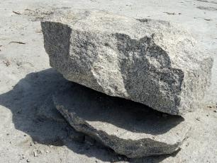 | No layers, big grains which are a few millimeters, it has no fossils, not homogeneous, no holes, light with colorful grains, compact and hart | Plutonic Rock | It has no lime nor clay but grains which implies crystalization | Granite
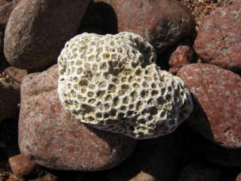 |  |  |  | Coral Limestone
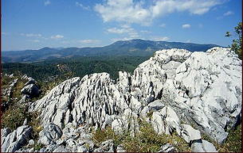 | No layering, very small grains less 1mm, no crystals, can have fosilles, porouse, light, compact, medium to hard softzfire | sedimentory rocks | It has a hich lime content, | Limestone
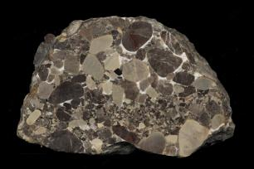 |  |  |  | Conglomerate
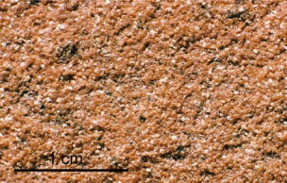  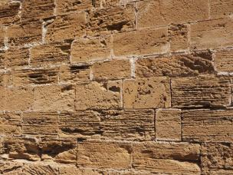 |  |  |  | Sandstone
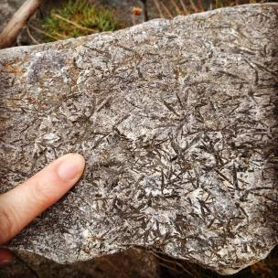 |  |  |  | Hornblendegar slate
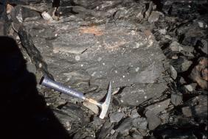 |  |  |  | Slate
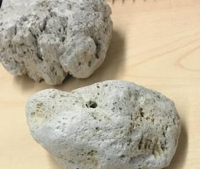 | Porous, sharp, smooth, not layered, no crystals, no fossils, homogenous, holes, Ligh, Compact, soft. | Vulcanic Rock | It has no lime nor clay in it | Pumice
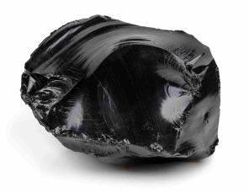 | Sharp edges, shiny, no crystals, smooth, layered, homogenous, hard, compact, heavy | Vulcanic Rock | It has no lime nor clay nor crystals and one can see the lava layers. | Obsidian

