Digital Image Processing

Semester Project

Adeel Ahmad

Roll No. 14I-0169

Project Report

Instructor: Adeel Mumtaz

**Introduction**

**Problem Statement**

To mark a MCQ type question paper. Assumption is that a student has marked a question by circling the correct option.

**Importance**

Marking of a question paper is a tedious task. It involves 3 major steps,

1. Read student's answer
2. Match the answer with the provided solution sheet
3. Mark question as right or wrong

**Methodology**

* Apply a gaussian blur to image containing all questions
* Extract edges using Canny Edge Detection algorithm
* Create a reference table for template circle image
* Apply generalized hough transform and match a template circle image and extract column containing all MCQs
* Extract individual MCQs from the extracted column and store its co-ordinates for later use
* Read letter from circled MCQ using cross correlation

**Gaussian Blur**

Applying a gaussian blur smooths out the image and thus reduces noise when an edge detection algorithm is applied. It is a low-pass filter therefore is attenuates high frequency signals.

Mathematics

Gaussian blur makes use of the gaussian function to smooth out an image. It calculates the transformation to apply for each pixel. The equation for a 2D gaussian function is given below:

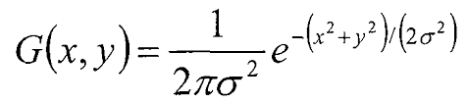

**Advantages**

As mentioned above a gaussian blur is used to remove noise from an image. If this noise is not removed, all the noise pixels are compared with our reference table which causes a drastic increase in computation time.

**Disadvantages**

Applying a gaussian blur reduces information in an image but this does not cause any problem in our case.

**Canny Edge Detection**

As evident from its name canny edge detector detects edges from an image. The algorithm involves five major steps:

1. Applying Gaussian filter to smooth out the image
2. Finding intensity gradients of the image
3. Applying non-maximum suppression to filter out useless edges
4. Applying double thresholding
5. Suppressing edges that are weak and not connected to strong edges

Advantages

Applying a canny edges detection on an image produces thin edges thus there are much fewer pixels to perform operations on. Thus, when we build our reference table for Generalized Hough Transform the execution time is reduced. Another advantage is that the image is binarized.

**Generalized Hough Transform**

GHT is used to detect an arbitrary object defined by its model. It works on the priciple of template matching. It is an extension of the Hough Transform which can only detect shapes that can be defined by an arbitrary function.

To generalize the Hough algorithm to non-analytic curves, we define the following parameters for a generalized shape

a = {y, s, *θ*}

y = our reference origin for the shape

s = (sx, sy) describe two ortogonal shape vectors

*θ* = orientation for the object

Reference table

We choose the mid point for our reference image and compute r = y – x (distance) for each boundary point from the origin. We also store the tangential angle between the point joining the two lines, also referred to as the gradient direction *ɸ(x)*

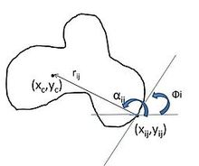

Advantages

* It is robust to partial or slightly deformed shapes
* It is tolerant to noise.
* It can find multiple occurrences of a shape during the same processing pass.

Disadvantages

* It has substantial computational and storage requirements which become acute when object orientation and scale have to be considered.

## **Normalized Cross Correlation**

Cross correlation is a measure of similarity of two series as a function of the displacement of one relative to the other. It is widely used for pattern recognition. The cross-correlation of a template, t(x,y) with a subimage f(x,y) is



**Experimental Setup**

The data was provided in the form of images. Initially, the images were large therefore I scaled them down by a factor of 3. After this, I extracted template images from the original image, these images were used to build up the reference table. I then extracted columns from the image containing all MCQs, after this individual MCQs were extracted. The next step was to identify the letter inside the circled MCQ. For this, I used 2D cross-correlation which finds similarities between two images.

Results

The steps followed were very robust, but there were some mismatches during hough transform application. In my case, there was 1 MCQ that was incorrectly matched. Therefore the accuracy for all four papers was 93%. Letter recognition was very robust. 14/15 letters were correctly identified.

**Final Output**

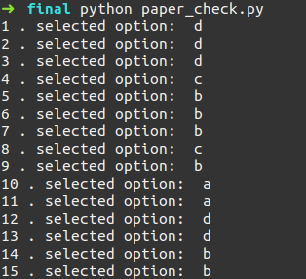

**Third party code**

The code for generalized hough transform was written by me. Functions used from other libraries are mentioned below

* scipy.ndimage.gaussian_filter()
* skimage.filter.canny()
* scipy.signal.signaltools.correlate2d()

Libraries

* NumPy
* SciPy
* Skimage
* Matplotlib

**Limitations**

The only limitation to the paper checking algorithm is to specify the total number of questions on a single page.