April 04, 2011
Dear Professional Colleagues,

EXCLUSIVE OFFER FOR ICSI MEMBERS FROM EJURIX & ICSI-KP

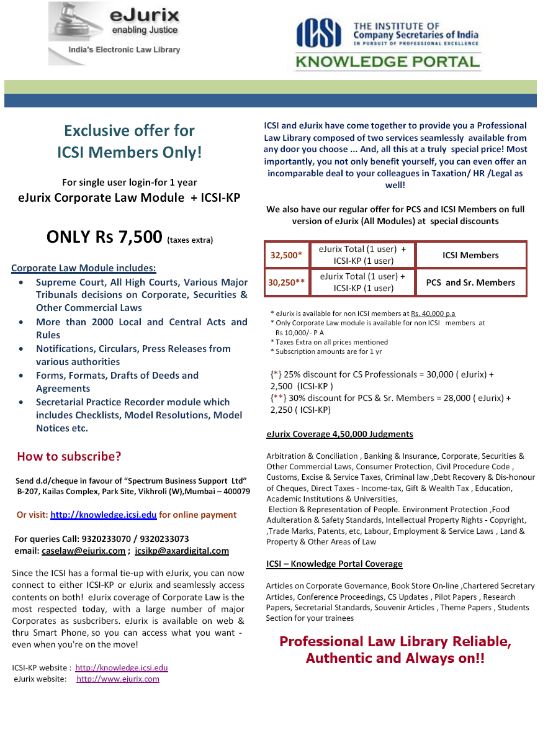

Regards,
CS N K Jain
Secretary & CEO

