

**4 PCH for Members of ICSI**

ANNOUNCEMENT

6th INTERNATIONAL PROFESSIONAL DEVELOPMENT FELLOWSHIP PROGRAMME – 2011 OF THE INSTITUTE OF COMPANY SECRETARIES OF INDIA

08 NIGHTS AND 09 DAYS AT AUSTRALIA

The Institute of Company Secretaries of India (ICS)) is organizing an International Professional Development Fellowship Programme - 2011 from Friday, the 18th November, 2011 to Sunday, the 27th November, 2011.

* **International Conference will be held on Friday, the 25th November 2011, at Sydney.**
* **The participating Members will be entitled to Four Programme Credit Hours.**
* **Package covers return airfare, hotel accommodation, travel insurance, visa fee, sightseeing, etc. as mentioned under the head “Package cost includes”.**
* **All domestic transfer within Australia would be by Qantas Airlines Domestic Flights.**

**Registration**

The number of Delegate is limited to sixty only on first paid first admitted basis as per terms of payment of delegate fee. In case, number of delegates exceeds sixty, such delegate registration requests received afterwards may be charged with enhanced charges of the Airline, Hotel and other expenses. Such further applications will be processed for registration after getting confirmation from the Tour Operator on a case to case basis in seriatim.

**Travel and other administrative arrangements:**

**PLACES TO BE COVERED : GOLD COAST, CAIRNS, MELBOURNE & SYDNEY in Australia.**

**DATES : From Friday, the 18th November, 2011**

**: To Sunday, the 27th November, 2011**

**DEPARTURE : Mumbai on Qantas Airways**

**TOUR OPERATOR : Thomas Cook India Ltd,**

**Plot No. 520, Udyog Vihar,**

**Phase - 3, Gurgaon, India -122016**

|  |
| --- |
| FLIGHT DETAILS:  **Ex- MUMBAI: (60 Seats)**  QF 052 18NOV MUMBAI BRISBANE (Friday)1030 / 0710 (Saturday)                     (Via- Singapore) QF 782 21NOV BRISBANE – CAIRNS (Monday) 1000 / 1220                     QF 703 23NOV CAIRNS – MELBOURNE (Wednesday) 1240/1700  QF 418 25NOV MELBOURNE -SYDNEY (Friday) 0900 / 1025  QF 575 27NOV SYDNEY - PERTH (Sunday) 0810 / 1005                     QF 077 27NOV PERTH -SINGAPORE (Sunday) 1220 / 1735 9W 011 27NOV SINGAPORE – MUMBAI (Sunday) 1905 / 2200 (30 PAX)  9W 017 27NOV SINGAPORE – DELHI (Sunday) 2310 / 0220 (28 NOV) (30 PAX)  **Please Note:**   1. Domestic flights will be provided to Passengers at additional cost from Delhi, Bangalore, Chennai and Hyderabad as per the onward flight connections from Mumbai. 2. For the return journey, 30 seats each for Mumbai and Delhi from Singapore on 27th November would be available. Thereafter passengers travelling to Bangalore, Chennai and Hyderabad from Mumbai would also be provided domestic connection.   Throughout the International Journey the Airlines will be Qantas or Code Share of Qantas Airlines. |

DOMESTIC FLIGHT CONNECTIONS:

**HYDERABAD – MUMBAI 18th Nov INDIGO 0600 / 0710hrs**

**MUMBAI – HYDERABAD 28th Nov JET CONNECT 0410 / 0525hrs**

**CHENNAI – MUMBAI 18th Nov INDIGO 0540 / 0720hrs**

**MUMBAI – CHENNAI 28th Nov SPICEJET 0605 / 0755hrs**

**DELHI – MUMBAI 18th Nov SPICEJET 0555 / 0750hrs**

**BANGALORE – MUMBAI 18th Nov INDIGO 0610 / 0735hrs**

**MUMBAI – BANGALORE 28th Nov JET CONNECT 0315 / 0450hrs**

**Minimum Number of Delegates : 60 (Sixty)**

**The number of Delegate is limited to sixty only on first paid first admitted basis as per terms of payment of delegate fee. In case, number of delegates exceeds sixty, such delegate registration requests received afterwards may be charged with enhanced charges of the Airline, Hotel and other expenses. Such further applications will also be confirmed by the Tour Operator on a case to case basis in seriatim.**

**TRAVEL ITINERARY SPECIALLY DESIGNED FOR ICSI**

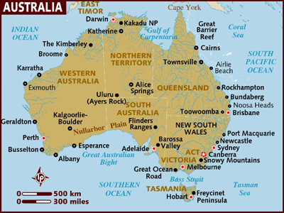

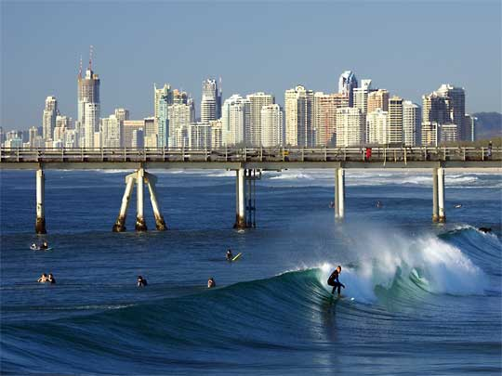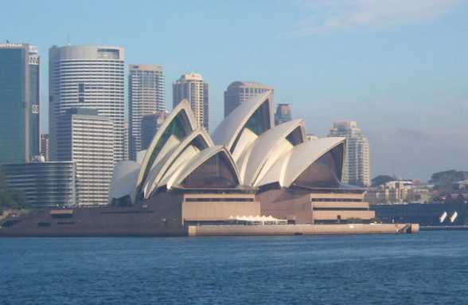

SUGGESTED ITINERARY:

DAY 00 (18th Nov)

* Arrival in Chatrapati Shivaji International Terminal as per the schedule given above
* Meet & Assist by Thomas Cook representative at the Airport
* 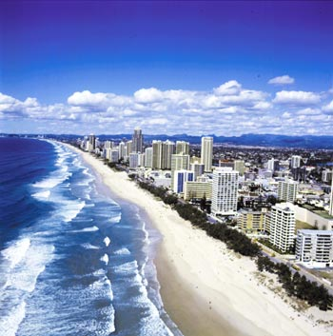Complete Check in and immigration formalities
* Board your QF 052 flight scheduled at 1030hrs to Brisbane.

DAY 01 (19th Nov)

* Arrival in Brisbane Airport at 0710hrs
* Meet & Assist by Thomas Cook representative at the Airport
* Transfer to Gold Coast by 45 seater AC Coaches
* Enroute orientation tour of Brisbane
* Arrive Gold Coast and Check – In to hotel (Check – In time is 1400hrs)
* Buffet Indian Lunch at local restaurant (by Walk)
* Proceed for Orientation tour of Gold Coast
* Buffet Indian Dinner at Restaurant (by Walk)
* Overnight at hotel

DAY 02: (20th Nov)

* 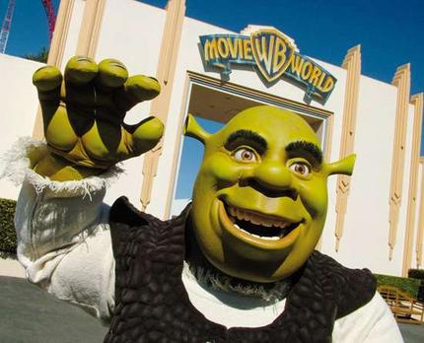Breakfast at hotel
* **1000hrs:** Proceed for Theme Park ***Movie world / Sea world*** (Any one of the theme park offered may be chosen)
* Coupon will be provided for lunch in your choice of Theme Park-International (Both Veg/Non-Veg).
* **1700 – 1900hrs:** Time free for shopping at ***Harbor Town***
* **1930hrs:** Return to hotel
* **2000hrs:** Proceed for buffet Indian Dinner at local restaurant (by Walk)
* Overnight at hotel

DAY 03: (21st Nov)

* **0700hrs:** Departure at **0700hrs** from Hotel to catch flight QF 782 at 1000hrs from Brisbane and arriving at Cairns at 1220hrs.
* 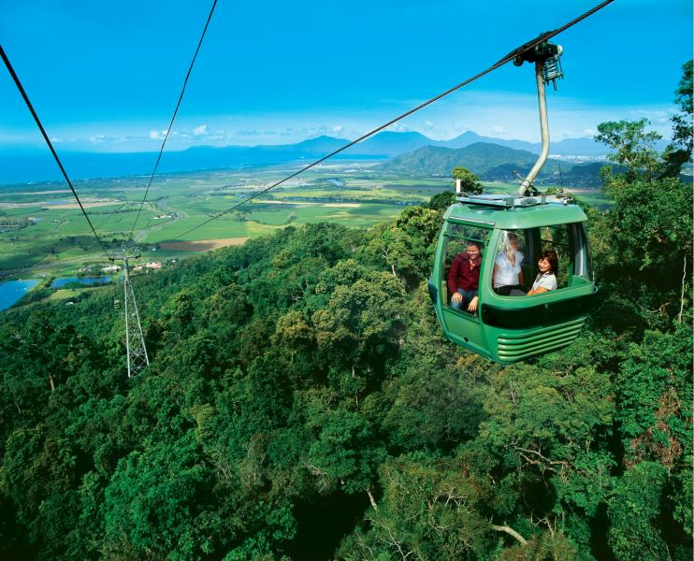**1300hrs:** Meet & Assist at the Airport
* **1315hrs:** Transfer to Caravonica station for Sky

Rail. The scenic beauty of the rain forest from sky rail is

the major attraction. Luggage will be transferred separately by the coach to the Hotel. ([www.skyrail.com.au](http://www.skyrail.com.au))

* **1530hrs:** Arrive and Transfer to hotel (Normal Check – in time at 1400hrs)
* En route buffet lunch (by walk)
* Evening free at leisure in local markets to explore Cairns at your own
* Buffet Indian Dinner in Restaurant (by walk)
* Overnight at hotel

DAY 04: (22nd Nov)

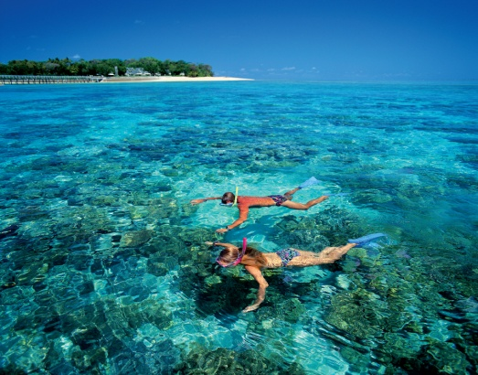

* Breakfast at hotel
* 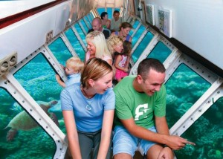Proceed for Great Barrier Reef tour (Big Cat) with Green Island
* Buffet International mix Indian Lunch
* Enjoy ***Semi Submarine***
* Return to hotel by evening
* Buffet Indian Dinner at Restaurant (by Walk)
* Overnight at hotel

DAY 05: (23rd Nov)

* Breakfast at hotel
* Check – Out from hotel and transfer to Cairns Airport to catch next flight to Melbourne
* Board your flight QF 703 to Melbourne at 1240PM
* Arrive at Melbourne
* Meet and Greet with Thomas Cook representative at the Airport
* Transfer to hotel in AC Coach
* Buffet Indian Dinner at Restaurant (by Walk)
* Night Orientation Tour of Melbourne City
* Overnight at hotel

DAY 06: (24th Nov)

* Breakfast at hotel
* **1000hrs:** Proceed for half day orientation tour of Melbourne (2 to 2 and1/2 hrs)
* **1400hrs**: Buffet Indian Lunch at restaurant
* **1500hrs to 1600hrs** Time free at leisure to explore the city and some shopping at local markets 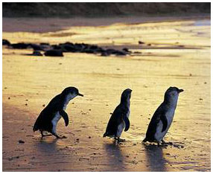
* **1600hrs:** Evening Visit to ***Philip Island along with Penguin Parade***
* **2000hrs:** Buffet Indian Dinner at Restaurant
* Overnight at hotel

DAY 07: (25th Nov)

* Early breakfast at hotel
* 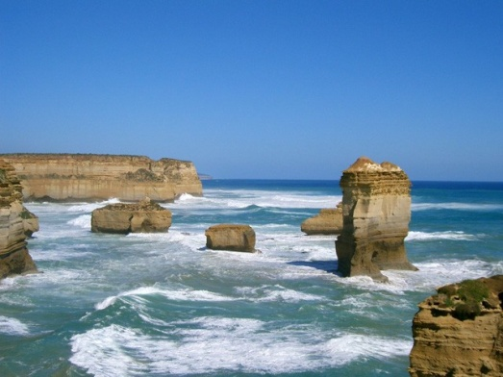**0700hrs:** Proceed for airport to board the flight QF 418 at 0900hrs to Sydney
* Arrive Sydney at 1020hrs
* Meet and assist services at airport
* Transfer to hotel
* Check – In to hotel
* Buffet International Lunch with some Indian items
* Proceed for half day conference from 1400hrs to 1800hrs

(All who are not going for conference will proceed for Sydney Aquarium)

* Buffet Dinner at local restaurant (by walk)
* Overnight at hotel

DAY 08: (26th Nov)

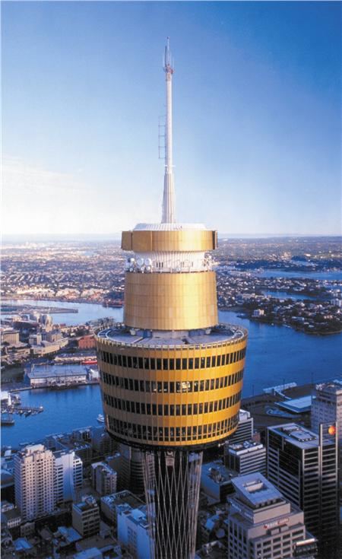

* Buffet breakfast at hotel
* Proceed for orientation tour of Sydney
* Buffet Indian Lunch at local Indian restaurant
* Admission to Sydney Tower with OZ Trek
* Drop for shopping at Paddy’s market
* Buffet Gala Dinner in Indian restaurant.
* Overnight at hotel

DAY 09: (26th Nov)

* Departure at 0600hrs for Airport to catch flight back to India

Package cost: (per person)

The cost of the tour per person on the basis of twin/multiple sharing/single occupancy, all inclusive are as follows:

|  |  |  |  |  |
| --- | --- | --- | --- | --- |
| Sl | Particulars | Package Cost Per Person | | |
| Ex-Mumbai | Ex-Delhi (departure Mumbai, Arrival Delhi) | Ex-Chennai/  Hyd/Bangalore via Mumbai |
| A | Cost Per Adult (Twin / Double) Sharing basis | Rs.1,59,700/-(One Lakh Fifty Nine Thousand Seven Hundred Only) | Rs.1,63,200/-(One Lakh Sixty Three Thousand Two Hundred Only) | Rs. 1, 66,700/-(One Lakh Sixty Six Thousand Seven Hundred Only) |
| B | Child without bed (Age 2 – 12 yrs) | Rs. 1,35,500/- (One Lakh Thirty Five Thousand Five hundred only) | Rs. 1,39,000/- (One Lakh Thirty Nine Thousand only) | Rs. 1,42,500/- (One Lakh Forty Two Thousand Five hundred only) |
| C | Child with bed (Age 2- 12) | Rs.1,53,000/- (One Lakh Fifty Three Thousand only) | Rs.1,56,500/- (One Lakh Fifty Six Thousand, Five Hundred only) | Rs.1,60,000/- (One Lakh Sixty Thousand only) |
| D | Infant (upto – 2 Yrs) | Rs.27,800/- per infant (Twenty Seven Thousand and Eight Hundred only) | Rs.27,800/- per infant (Twenty Seven Thousand and Eight Hundred only) | Rs.27,800/- per infant (Twenty Seven Thousand and Eight Hundred only) |
| E | Single Occupancy | Rs.1,99,000/- (Rupees One Lakh Ninety Nine Thousand only) | Rs.2,02,500/- (Rupees Two Lakhs Two Thousand and Five Hundred only | Rs. 2, 06,000/- (Rupees Two Lakhs Six Thousand only) |

Package cost Includes:

* Return Economy class airfare as on date using Qantas Airways or their code share associate(s) as per details mentioned above
* Airport taxes, Visa charges & other Administrative Charges for processing Visa, Medical Insurance coverage of USD 50000 and service taxes as on date for the traveling period.
* Eight night’s accommodation in 4 star category hotels as mentioned above
* All Meals (Continental breakfast, Indian lunch & Indian dinner- both Veg / Non-veg), Transfers, Sightseeing as per the itinerary mentioned above.
* One Buffet Gala Dinner in Local Indian Restaurant
* One liter mineral water bottle per day per person.
* Service of Professional Tour Manager per bus and also during entire tour
* Tips to the coach driver
* Half day conference 1400hrs to 1800hrs with one tea / coffee in Sydney on 25th November, 2011
* All entrances as per sightseeing mentioned above in “package includes”.
* All applicable taxes as on date.

Package Cost excludes:

1- Anything not specifically mentioned in the “Tour price includes” as above.

1. Any other expenses of personal nature.

Payment Terms:

Mode of Payment for Delegates:

Booking amount of Rs.1,00,000/- before 25th Sep’11

Balance amount by 18th Oct’11

Cancellation charges:

Before issue of ticket and filing of Visa application - Rs.15,000.00

(i.e. before the date when non-refundable air ticket

payment is made by the tour operator to the Airlines

* *up to 1500hrs on 30th Sep’11)

After issue of the ticket - 55% of the Tour Price

*(I.e. up to 1500hrs on 30th Sep’11)

Cancelled on or after 25th Oct - 60% of the tour price

(I.e. before 1500hrs)

Cancelled on or after 01st Nov - 75% of the tour price

(I.e. before 1500hrs)

Cancelled on or after 10th Nov - 100 % of the tour price

(I.e. before 1500hrs)

* Determination date for cancellation charges would be subject to actual date of procurement of air ticket and filing of application for visa.

Special Note:

1. No refund on air ticket once booked. Incase of cancellation the refund will be applicable only on Airport tax i.e. Rs.9, 870/- (incase of adult and child) and Rs.1780/- (incase of Infant) per person for return sector. This is included in the cancellation charges above.
2. Please note the above costs are based on a minimum of 60 adult passengers, traveling as per the travel period mentioned above. In case the group size reduces / increases, the cost will change accordingly. It will be paid by the individual passengers.
3. The prices are based on the airfare calculated as on date. In an event of any increase in the airport taxes, M/S Thomas Cook shall revert to ICSI for recovery from delegates. The revised charges will be payable accordingly. The same will be paid by the individual delegate/traveller.
4. Early check-in is subject to availability. In case of confirmed early check-in are required, extra charges payable to the hotel will be applicable and the same be borne by the delegate.
5. The price is inclusive and based on current taxes and levies in force. Any variance in the price would be discussed and the supporting documents will be submitted for the same.
6. Tour itinerary will be as mentioned above. Any modification in the terms of itinerary is not allowed unilaterally. Amendment in the same need to be mutually agreed.
7. If the delegate does not arrive or depart in time with the group as per the itinerary, any additional charges for the transfer will be incurred by the delegate only.
8. If groups arrive from different hubs and separate transfers are required or incase of any additional services required, then the applicable cost would be advised & charged.
9. Accommodation, meals and sightseeing/tour as per Hub wise itinerary.
10. No refund or reduction will be given for any services, which are not utilized, mentioned in the Tour inclusions.
11. All arrangements made by THOMAS COOK are in the capacity of an agent only. THOMAS COOK will not be liable for claims or expenses arising from circumstances beyond our control such as accidents, injuries delayed or cancelled flights & acts or forces of nature. All passengers must be covered by suitable travel/health insurance prior to departure from the country of origin.
12. In the event of any changes in the flight schedule, the itinerary will change.
13. All timings are subject to local road and traffic conditions.
14. Thomas cook reserves the right to alter the itinerary with consent of the ICSI, without altering the services.
15. All specified guide/assistant/interpreter languages are subject to availability.
16. Porterage & Room drop is not included in the cost
17. Any payments through credit card will attract bank charges to be paid to Thomas Cook India Limited additionally.
18. Kindly note that advance paid to the airlines to hold inventory is non refundable
19. Any incidental or actual expenses to be paid over and above the tour price to be borne by the individual delegate/traveller.
20. In case of change / extension of tickets, delegate/ traveller will incur the cost individually.
21. Please provide your meal request (Vegetarian/Non-vegetarian/Jain Meals) well in advance, at least 30 days prior to the departure.
22. All the delegates/travelers are requested not to shift from allocated seats because crew supply special meals on the bases of seats allocated as per the seat chart.

REGISTRATION PROCEDURE

Members of ICSI are requested to confirm their participation, with / without spouse, children or co-delegates, by sending a covering letter accompanied by the photocopies of the passport and an initial amount of Rs.1,00,000 per person travelling by way of Demand Draft only issued in favour of the **“Institute of Company Secretaries of India”** payable at New Delhi and has **to reach the Director (Academics & Professional Development), ICSI House, 22 Institutional Area, Lodi Road, New Delhi 110 003 on or before 25thSeptember, 2011 positively**. Registration may however be withdrawn by a delegate subject to cancellation charges mentioned above. Any request received for withdrawal after this date shall attract forfeiture of said registration charges.

The **balance payment** be made by the member/delegate **on or before 18th October, 2011** by Demand Draft only issued in favour of the Institute of Company Secretaries of India payable at New Delhi.

Please note that joining to this program is limited to members and others accompanying the members of the Institute.

It may further be noted that considering limited number of seats, the registration for this international program will be made on first-paid -first-admitted basis.

VISA PROCESS TO BE FOLLOWED

* Thomas cook will undertake the entire Visa Process for each and every registered delegate
* Upon receipt of Delegate Registration Confirmation from ICSI, the delegate will send the requisite documents to ***Thomas Cook India Ltd*** office before the deadlines mentioned below. The name of concerned Thomas Cook Coordinator will be announced later.
* Please note documents must be couriered to Thomas Cook office at the address mentioned below through **BLUEDART / DHL** couriers ONLY.

DEADLINES TO SEND DOCUMENTS TO THOMAS COOK

* First cut off – 25th Sep’11
* Second cut off – 10th Oct’11

**Deadlines will not be extended after this.**

Couriers should be sent on the below name and address:

THOMAS COOK CONTACT

**DELHI:**

**ICSI AUSTRALIA TOUR (18 -27 Nov)**

MICE Department

Thomas Cook (India) Ltd

Plot No - 520, Third Floor

Udyog Vihar, Phase III Gurgaon 122016

Phone No:+919818829144

Concerned Email ID [**ghanendra.gupta@in.thomascook.com**](mailto:ghanendra.gupta@in.thomascook.com)

TOURIST VISA DOCUMENT CHECKLIST

* The passport should be valid for at least six months from the date of submission of the visa application.
* **One Visa Application Form 48R** to be filled- in completely and signed by the applicant.
* **One Authorization Form 956** to be filled in completely and signed by the applicant.
* **Family Detail Form M67** to be filled in completely and signed by the applicant.
* One recent front face coloured **photograph**, 35x45 mm in size with white background.
* Covering letter from the applicant stating the purpose and duration of stay.
* If aged over 75 years DIAC will request for evidence of health insurance for entire period of stay and medical fitness certificate completed by DIAC appointed panel of doctor. Applicants falling in this age group need to fill the form 11631 as well.
* **A no objection certificate** from the current employer.
* **Proof of airline reservation** for a round trip e.g. reservation slip.
* **Proof of sufficient funds (Rs.2,00,000/- minimum)**
* Bank statement for last 6 months including address and telephone number of the bank, A/C holder’s name & address with stamp and signature of bank.
* Income tax returns for last 3 year.
* 3 months salary slips.
* If you are **self employed,** registration of the company, partnership deed and Memorandum of Article (MOA) is required.
* Two copies of passport first and last page to be submitted.
* **Proof of accommodation**: hotel reservation including the name and phone number of hotel.(tour operator to provide)
* In case of minor (**form 1229** Consent Form to be filled)
* A no objection certificate should be produced by parents in case minor is traveling alone. NOC should be signed by both parents.
* A minor traveling with one of the parents, the other parent should issue NOC.
* **Approximate Processing Time (In addition to time taken by courier and post):-**

|  |  |
| --- | --- |
| **Location** | **Tourist visa working days** |
| **New Delhi** | **3 weeks** |
| **Mumbai** | **3 weeks** |
| **Chennai** | **3 weeks** |

**Note- Actual processing time may vary on a case to case basis and is at discretion of Embassy/Consulate. Also please note that no. of days given above are working days (exclusive of Embassy/ Government Holidays).**

***For any query, you may please feel free to contact:***

|  |  |
| --- | --- |
| **Sutanu Sinha**  **Director (Academics & Professional Development)**  The Institute of Company Secretaries of India  ‘ICSI HOUSE’, 22 Institutional Area,  Lodi Road, New Delhi – 110003  Tel. No.011-45341014 (0)  Cell No. 9818840751 E-mail: [sutanu.sinha@icsi.edu](mailto:sutanu.sinha@icsi.edu) | **S N Mishra**  **Assistant Director (Administration)** The Institute of Company Secretaries of India  ICSI HOUSE’, 22 Institutional Area,  Lodi Road, New Delhi – 110003  Tel.No.011-45341023 E-mail:  [surya.mishra@icsi.edu](mailto:%20surya.mishra@icsi.edu) |

06th September 2011