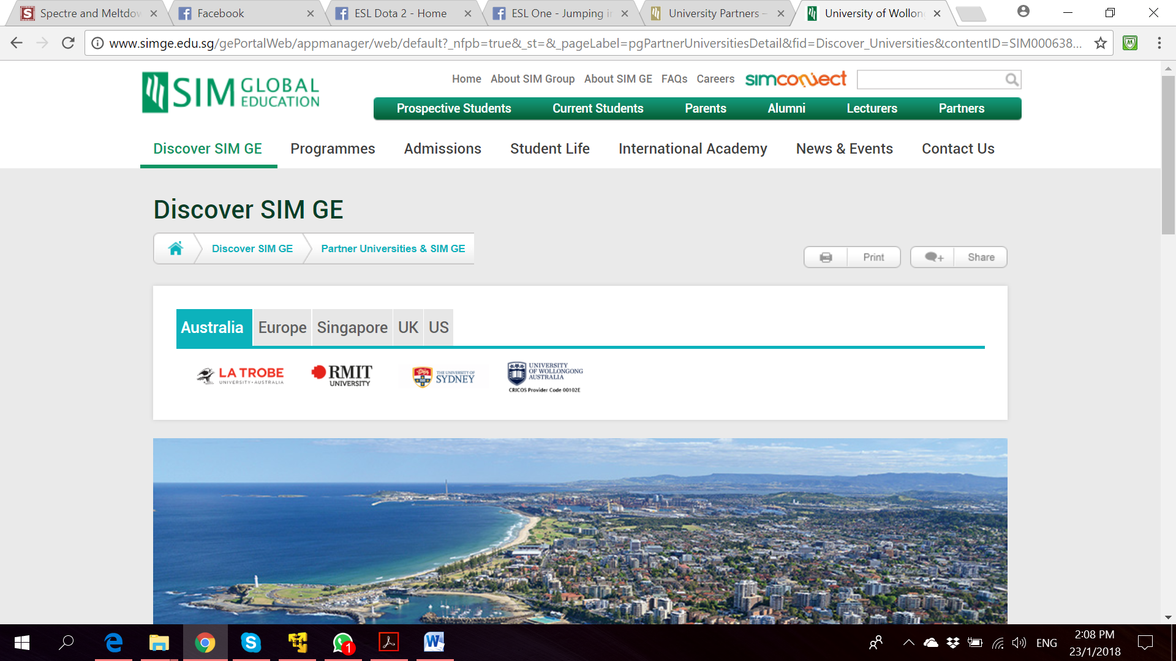

**Bachelor of Computer Science**

**(Digital System Security)**

CSCI321 – Final Year Project

Project Proposal

**Project Particulars**

|  |  |
| --- | --- |
| Supervisor | Dr Ta Nguyen Binh Duong |
| Project Group | SS18/1F |
| Project Title | Two Factor Authentication |

**Project Team’s Particulars**

|  |  |  |
| --- | --- | --- |
| Student Number | Student Name | Email Address |
| 5363536 | Koh Hong Wei | hwkoh003@mymail.sim.edu.sg |
| 5710923 | Chua Han Ming Adler | hmachua002@mymail.sim.edu.sg |
| 5711356 | Ong Wei Hao | whong012@mymail.sim.edu.sg |

Table of Contents

Project Team Structure 1

Project Gantt chart 1

1. Introduction 2

1.1. Background 2

1.2. Scope 2

2. Market Survey 2

2.1. Market Research and Current Products 2

2.1.1. Fingerprint Authentication 2

2.1.2. Keys and Tokens 2

2.1.3. QR Code 2

2.2. Target User 2

2.3. Proposed Features 2

# Project Team Structure

|  |  |  |
| --- | --- | --- |
| Name | Email | Roles |
| Koh Hong Wei | hwkoh003@mymail.sim.edu.sg |  |
| Chua Han Ming Adler | hmachua002@mymail.sim.edu.sg |  |
| Ong Wei Hao | whong012@mymail.sim.edu.sg |  |

The above team structure is implemented to clearly distinguish the area each member of the team is to focus on but it does not infer that he/she will be the only one involved in doing that task.

SmartSVN and a private GitHub repository will be use as version controlling and team collaboration tool. Each team member will have local repository which will then be merged with the central repository. All members will be working on different part of the project at a given point in time to prevent clashes when committing to central repository. All documents and source codes will be stored in this central repository.

Meeting minutes will be noted down during every meeting summarising the content of the meeting and what actions to be taken.

# Project Gantt chart

# 1. Introduction

## 1.1. Background

This project proposal was written to document the research and proposed idea for the Final Year Project entitled “Two Factor Authentication”. Impersonating others has always been an issue when it comes to cyber security. Password alone is no longer as effective as before as more and more ways of attacks, like brute force attack, will allow malicious attacker obtain a password.

The Final Year Project group is tasked to create a two factor authentication to enhance current security authentication that are already implemented in current applications, systems or devices.

## 1.2. Scope

# 2. Market Survey

## 2.1. Market Research and Current Products

Below are a few ways of user authentication that are already in the market and example of products in the market that are using them.

### 

|  |  |  |  |  |
| --- | --- | --- | --- | --- |
| Application | Platform | Description | Security | Features |
| 1Password | Android | This application remembers all your passwords for the user, the user would need a master password or using fingerprint authentication before being able to access the rest of the passwords | Login using master password or fingerprint authentication  Lock the app automatically to ensure data is protected, even if device is lost or stolen | Create strong, unique passwords for all online accounts  Fill usernames and passwords into websites and apps  Access information on all user’s mobile devices and computers  Share passwords securely with family or company  Unlock using fingerprint unlock |
| Authenticator Plus | Android | Authenticator Plus generates 2-step verification to protect accounts with your password and phone/tablet | Secure – 256-bit AES encryption and Pin lock for security  Automatic back/restore- accounts are automatically backed up to cloud  Fingerprint support – Unlock the app through fingerprint | Generates a 6 digit OTP after scanning QR code generate from facebook or other site. This OTP serves as a second authentication factor before being able to access to the account  Organize – group accounts with categories and re-order frequently used accounts to top |
| App Lock: Fingerprint Password | Android | A secure and easy-to-use application locker with pin, pattern or fingerprint password protection | Second authentication factor even though the user’s phone is unlock.  App Lock able to prevent others from opening locked apps, deleting or purchasing anything while on the user’s phone | Put a Pin, Pattern or fingerprint lock in front of any app on your phone like Facebook, Snapchat. When opening a protected app, App Lock will ask to confirm password the user have set to let the user in |
|  |  |  |  |  |
|  |  |  |  |  |

## 2.2. Target User

## 2.3. Proposed Features