BrainBlast
Project Documentation
Project Title:
BrainBlast – Interactive Quiz Application
Submitted By:
Adlin A
Intern ID:
CITS3666
Organization:
Codtech IT Solutions Pvt. Ltd.
Domain:
Frontend Web Development
Duration:
4 Weeks

Submitted as part of the
Frontend Web Development Internship
at
Codtech IT Solutions Pvt. Ltd.

Project Overview
BrainBlast is a modern and interactive quiz application developed using HTML, CSS, and JavaScript. The application offers an engaging quiz experience through Solo and Multiplayer game modes, multiple difficulty levels, immersive background music, sound effects, animated user interfaces, educational fun facts, and intelligent BrainBot commentary. With ten carefully designed quiz categories and hundreds of handcrafted questions, BrainBlast provides an entertaining way to test knowledge while learning something new after every question.

Objectives
- Develop an engaging quiz application using HTML, CSS, and JavaScript.
- Provide both Solo and Multiplayer gameplay experiences.
- Create an attractive and responsive user interface.
- Improve JavaScript programming and DOM manipulation skills.
- Implement dynamic scoring and difficulty-based gameplay.
- Deliver an enjoyable learning experience through educational fun facts.

Technologies Used
- HTML5
- CSS3
- JavaScript
- Local Storage
- Responsive Web Design

Features
- Interactive Landing Page
- Solo Mode
- Multiplayer Mode
- 10 Quiz Categories
- Three Difficulty Levels
- Dynamic Question System
- 30-Second Question Timer
- Animated Progress Indicators
- BrainBot Commentary
- Fun Facts After Every Question
- Difficulty-Based Scoring
- Background Music System
- Sound Effects
- Avatar Selection
- Pause & Resume Gameplay
- Responsive Design
- Modern Glassmorphism UI

Project Scope
BrainBlast serves as a complete quiz and party game platform designed for both individual learning and friendly competition. The application demonstrates frontend development concepts including DOM manipulation, modular JavaScript architecture, local storage management, responsive design principles, interactive animations, audio management, and dynamic game logic. It combines education and entertainment through engaging gameplay and informative fun facts presented after each question.

Screenshots

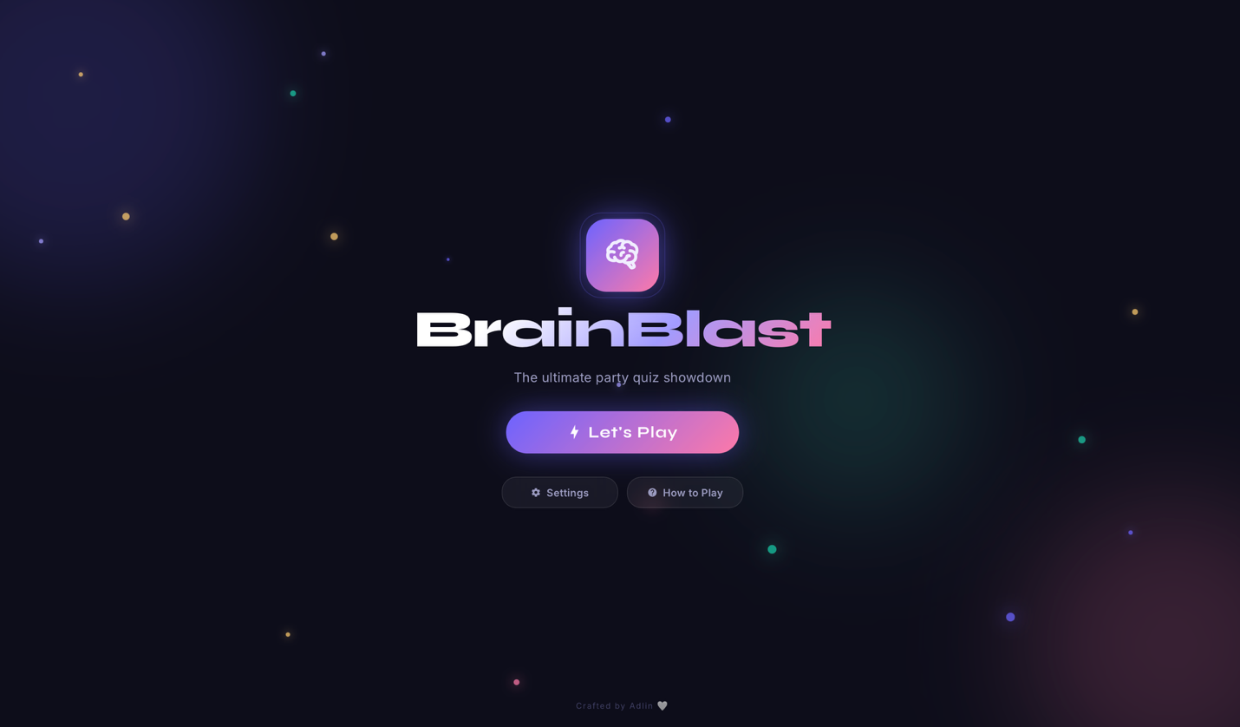

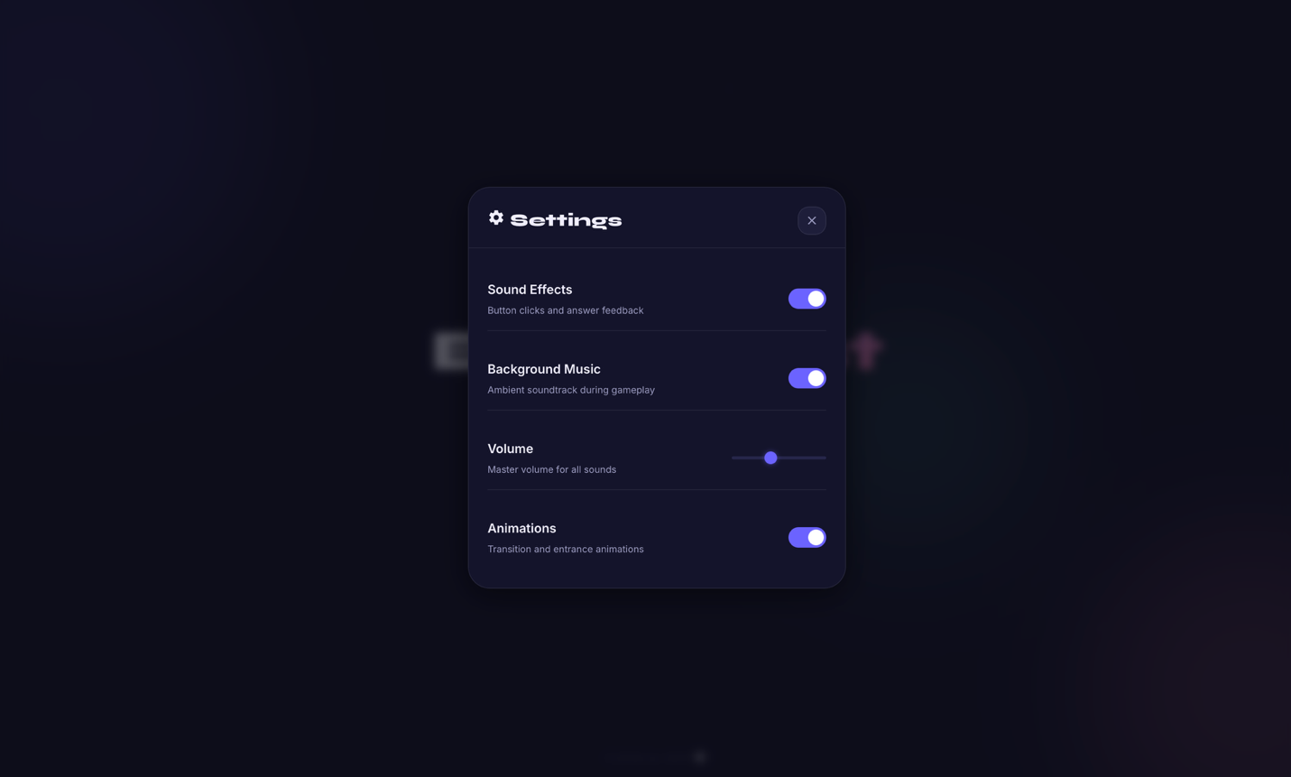

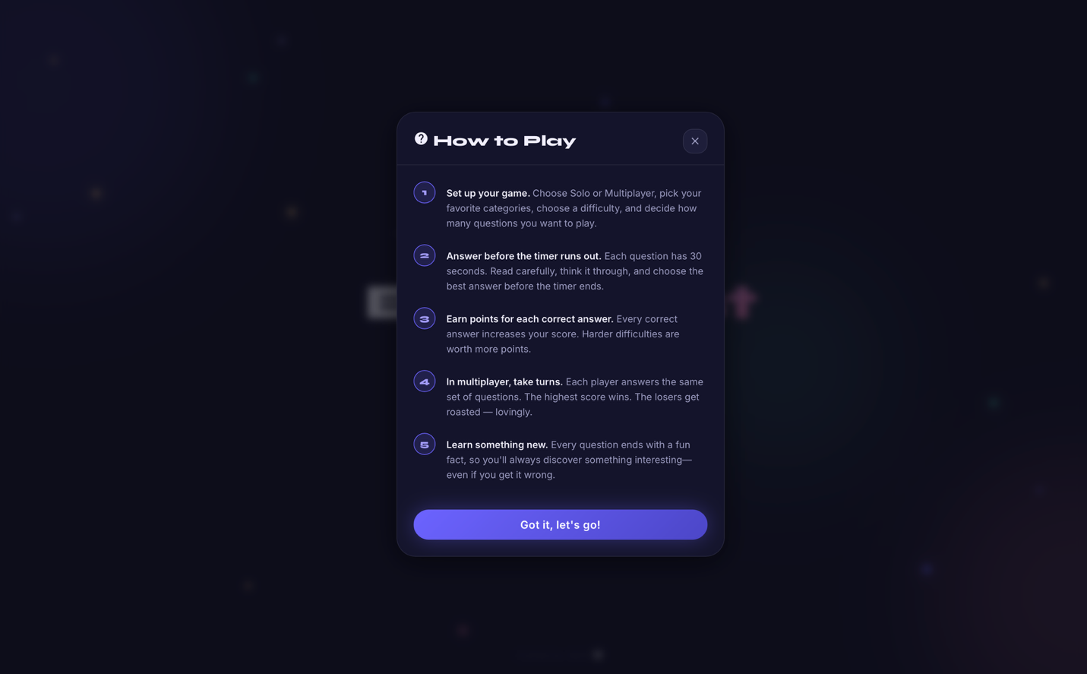

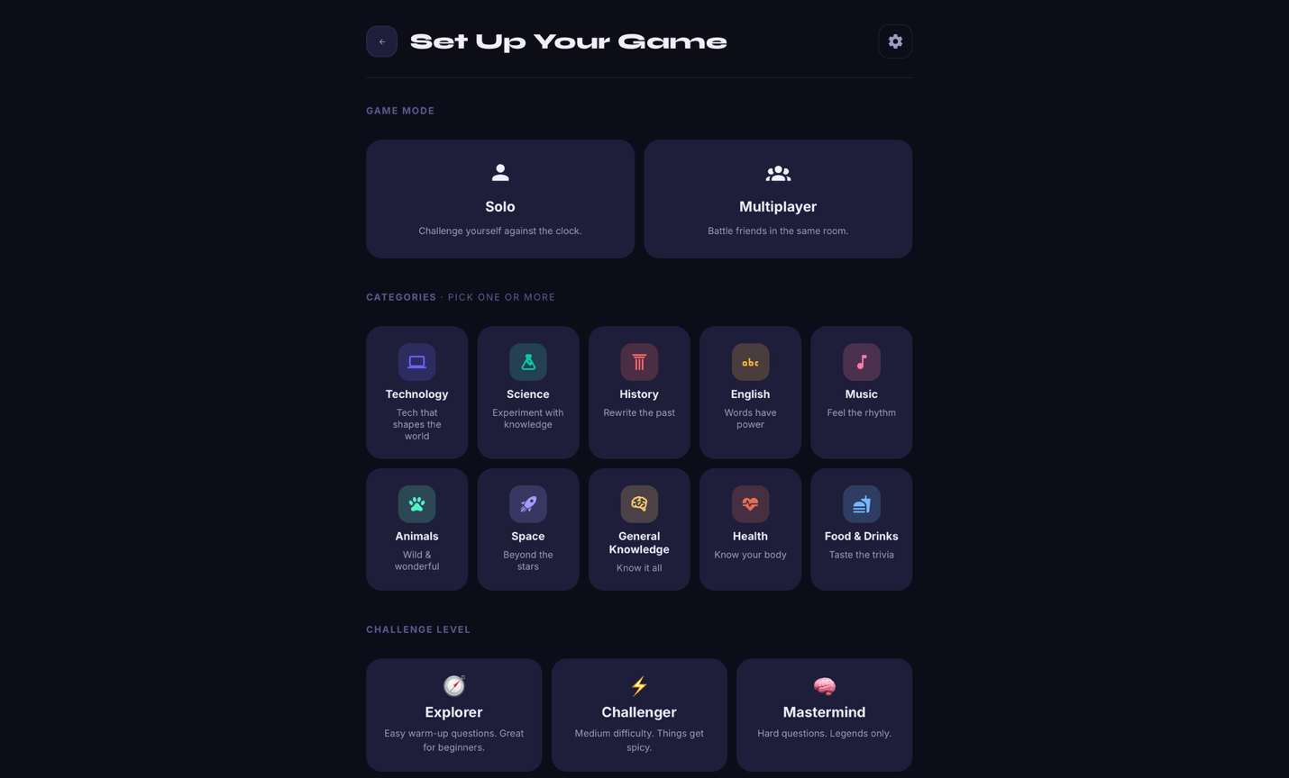

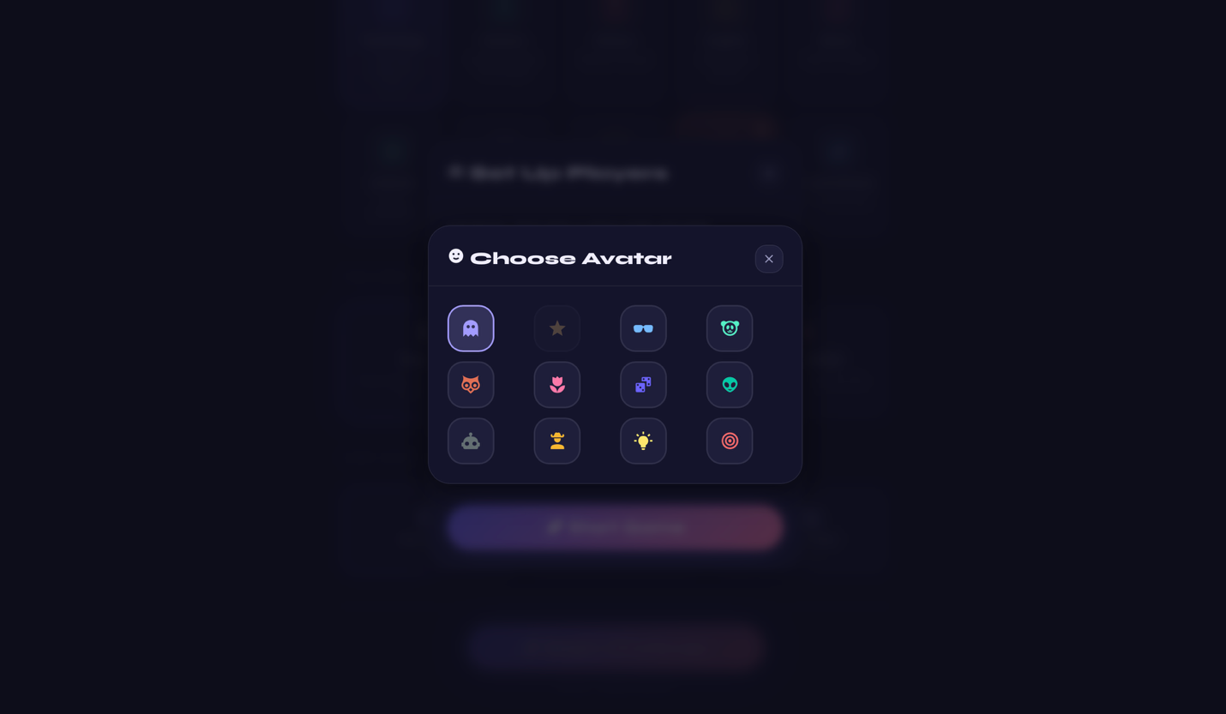

Solo game:

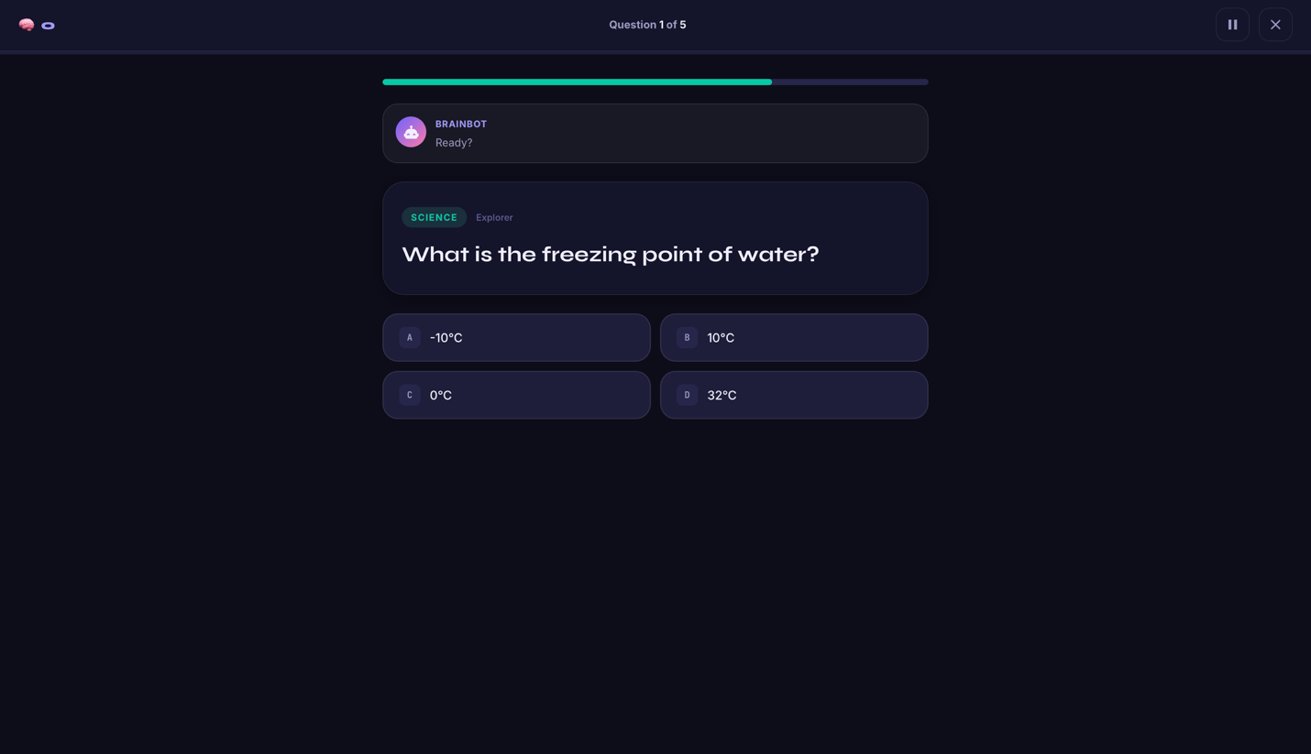

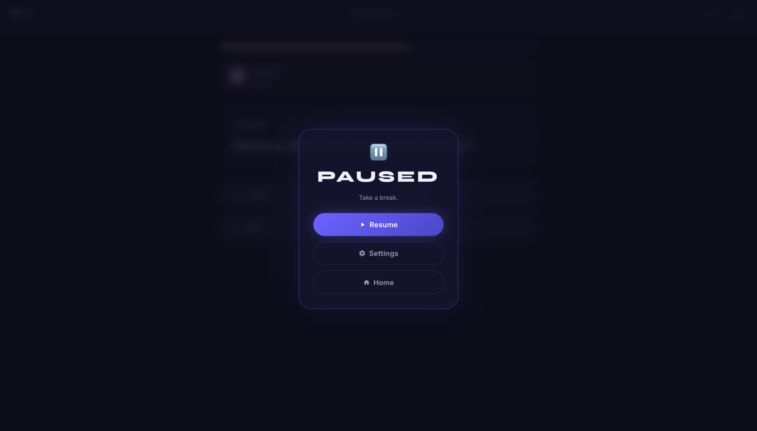

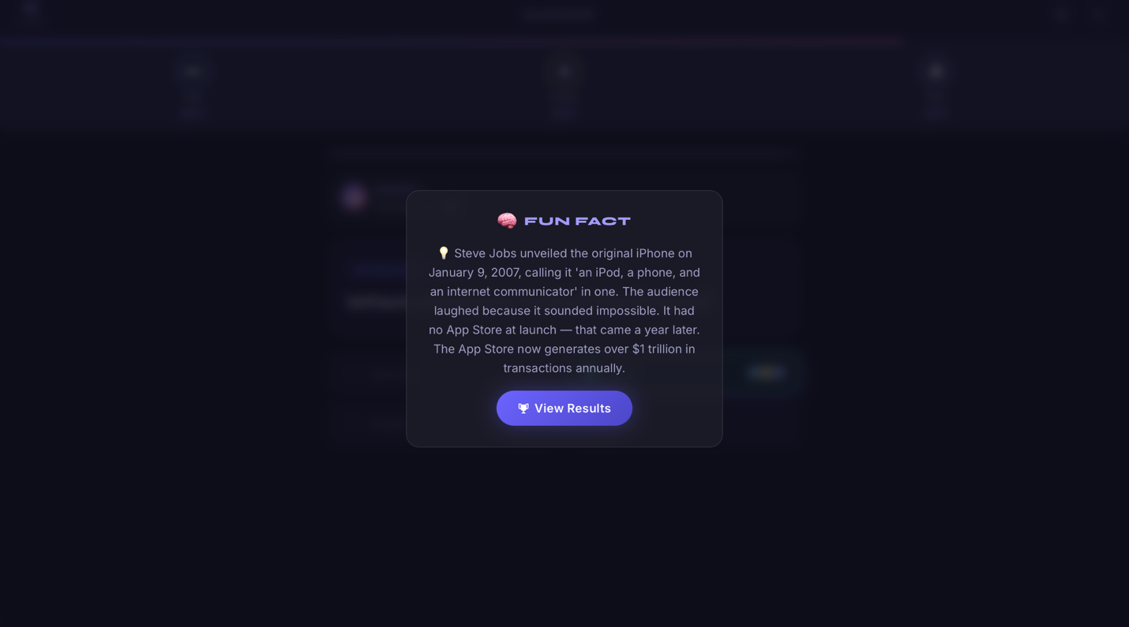

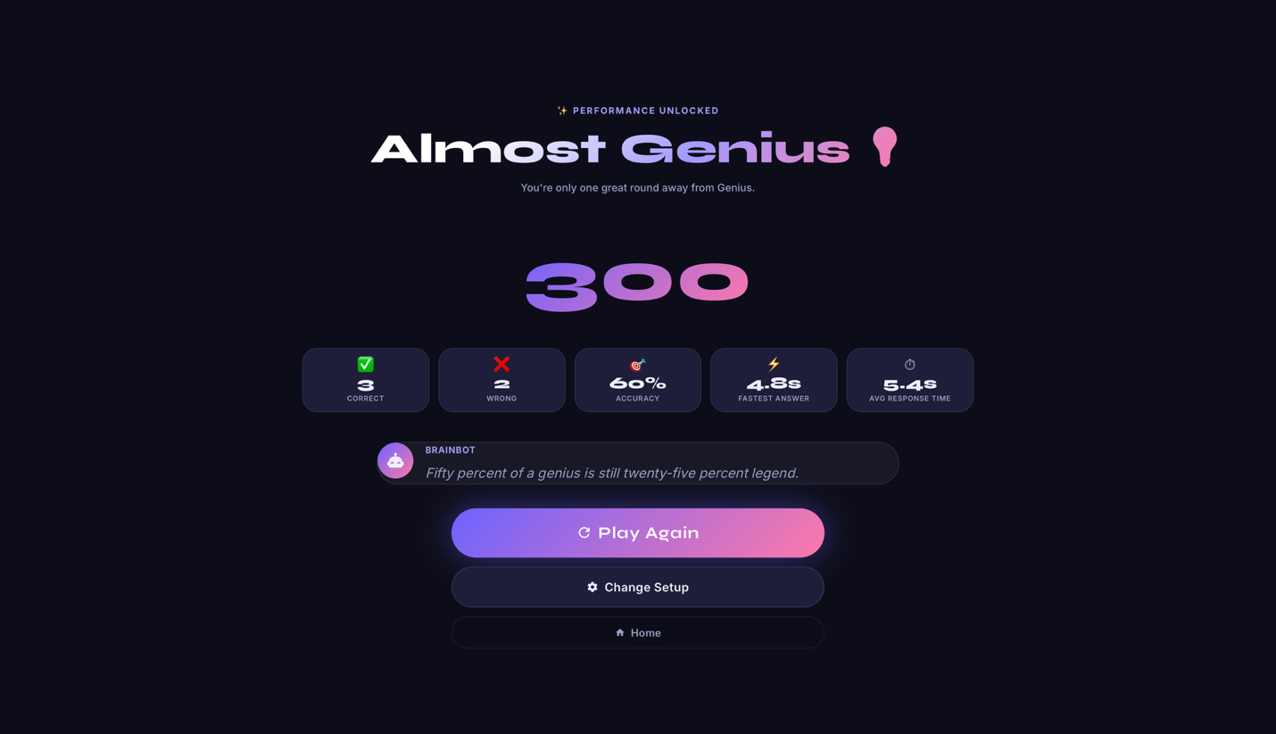

Multiplayer game:

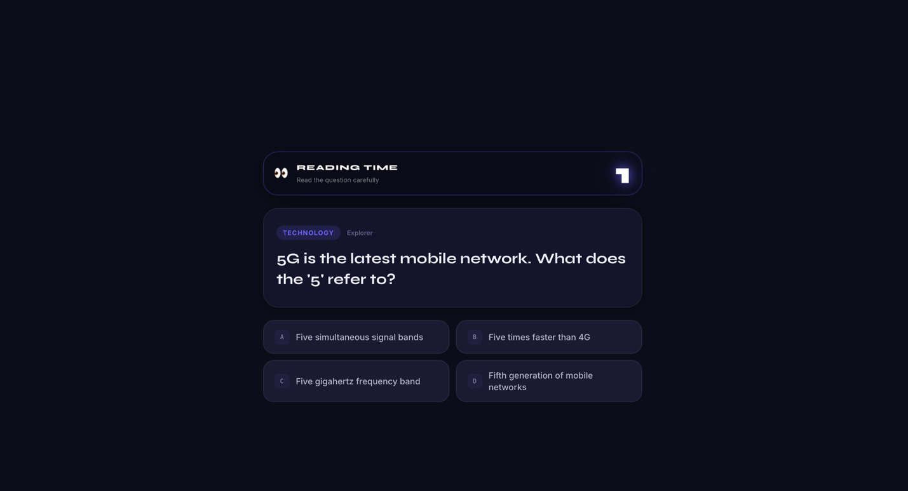

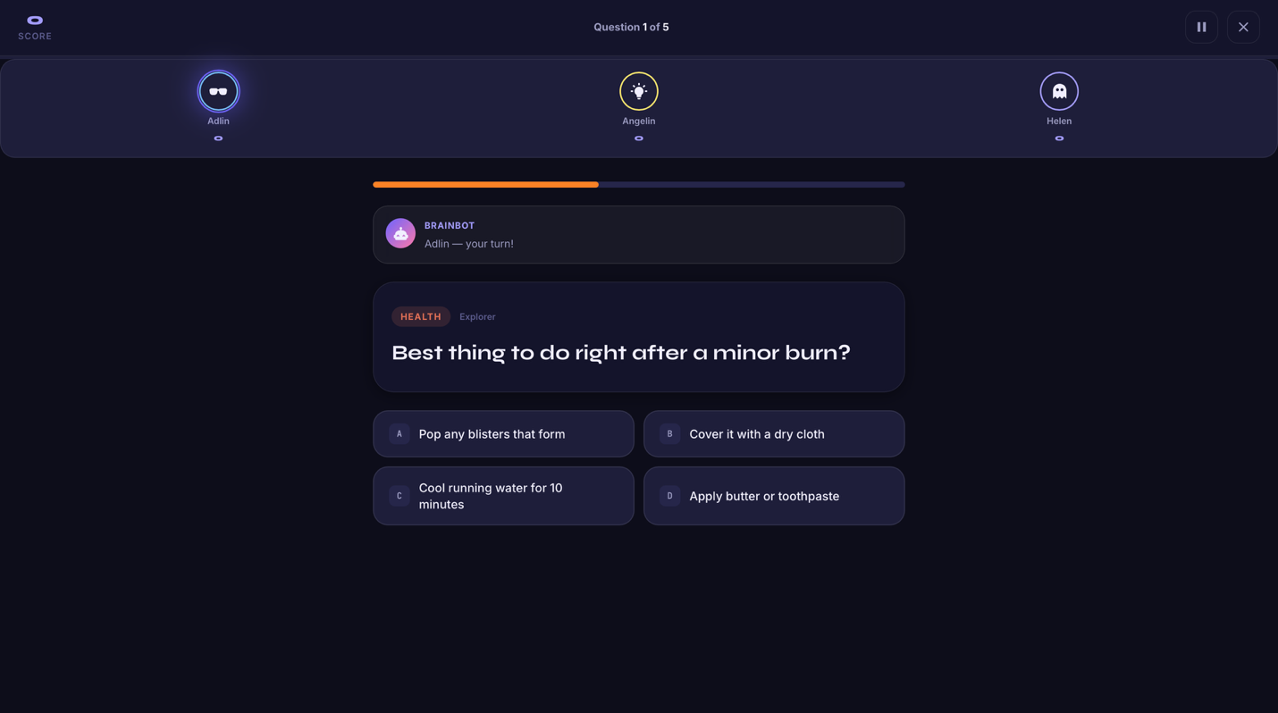

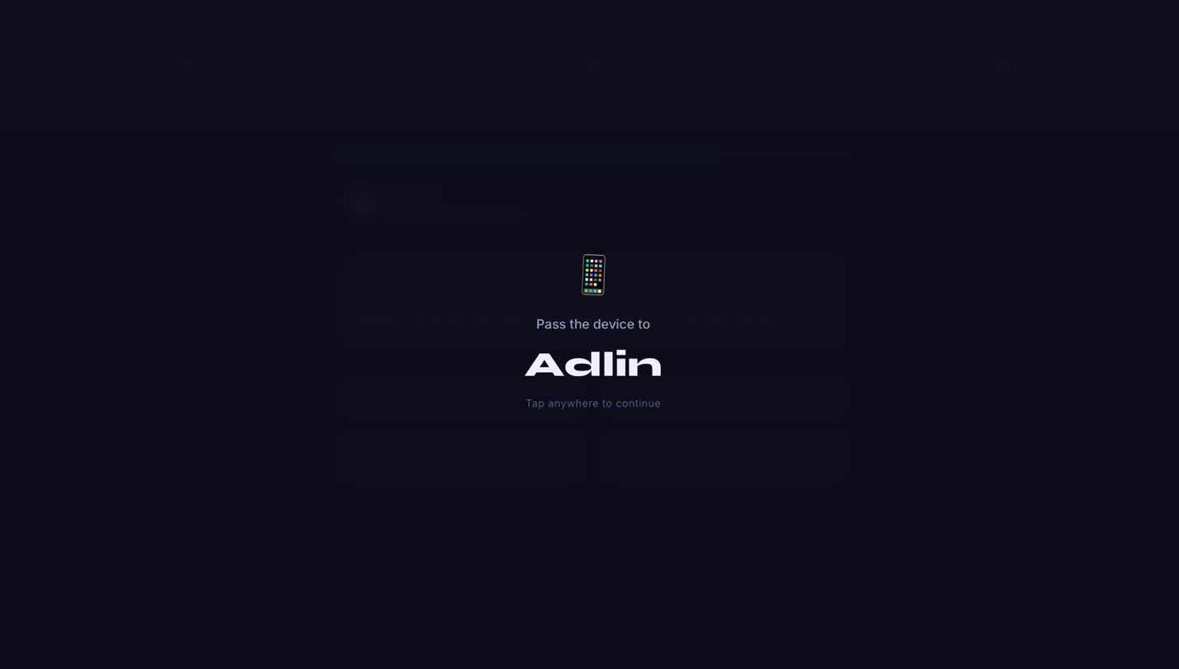

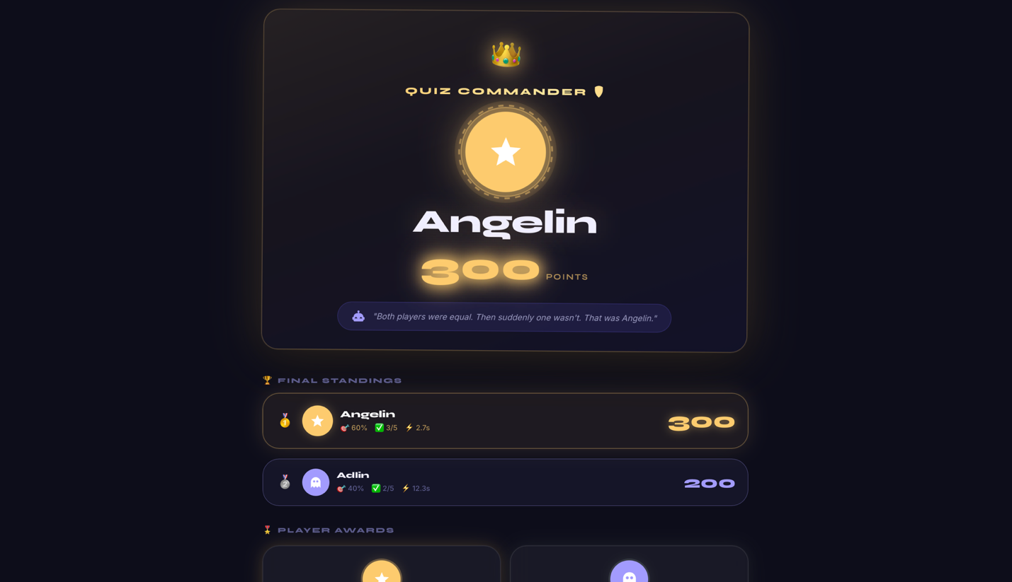

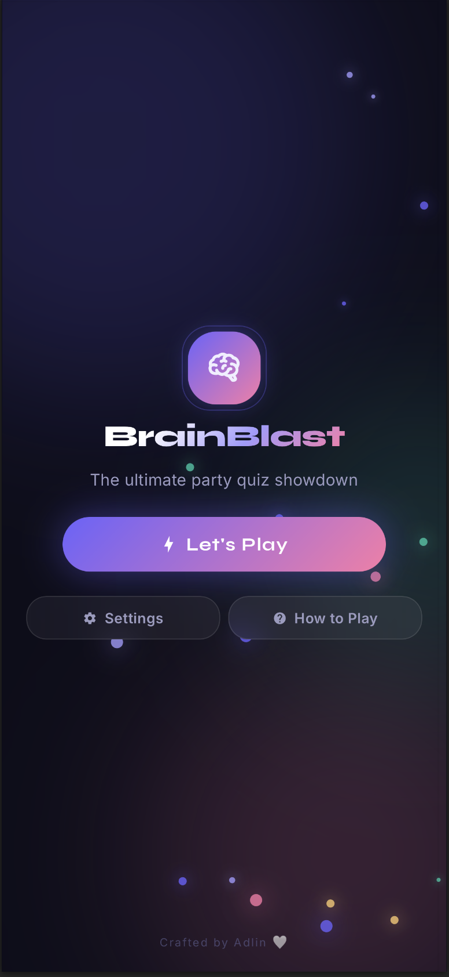
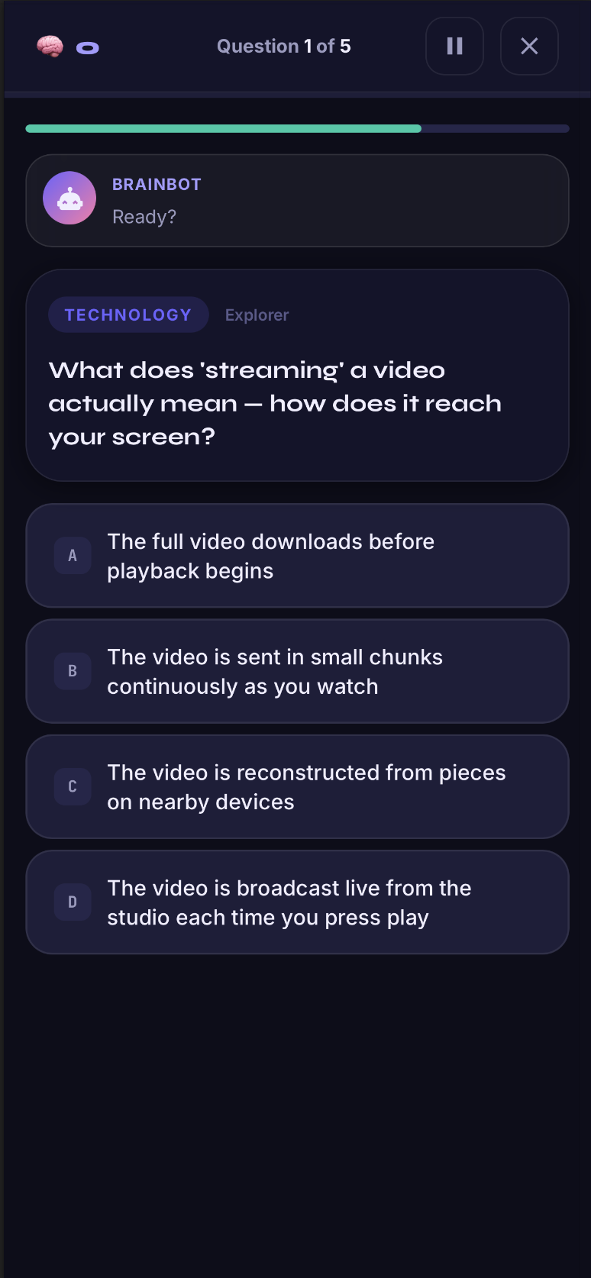

Future Enhancements
- Online Multiplayer Support
- Player Profiles & Statistics
- Global Leaderboards
- Additional Quiz Categories
- Daily Challenges
- Achievement System
- Multiple Language Support
- Progressive Web App (PWA)

Conclusion
The BrainBlast project successfully demonstrates the development of a modern and interactive quiz application using HTML, CSS, and JavaScript. By combining responsive user interface design, modular JavaScript architecture, immersive audio, multiplayer gameplay, educational fun facts, and dynamic scoring mechanisms, the application delivers an engaging and enjoyable learning experience. Throughout this project, I strengthened my understanding of JavaScript programming, DOM manipulation, event handling, responsive web design, local storage management, and frontend development best practices. BrainBlast showcases a polished, feature-rich, and user-friendly quiz platform suitable for both entertainment and educational purposes.

