SkyCast
Project Documentation
Project Title:
SkyCast – Live Weather Forecast Application
Submitted By:
Adlin A
Intern ID:
CITS3666
Organization:
Codtech IT Solutions Pvt. Ltd.
Domain:
Frontend Web Development
Duration:
4 Weeks

Submitted as part of the
Frontend Web Development Internship
at
Codtech IT Solutions Pvt. Ltd.

Project Overview
SkyCast is a responsive weather forecasting web application developed using HTML, CSS, and JavaScript. The application provides real-time weather information for cities around the world through OpenWeatherMap API integration. It features an interactive and modern interface with live weather updates, hourly and weekly forecasts, weather insights, customizable settings, and an interactive world map. The application is designed to deliver an engaging, informative, and user-friendly weather experience across desktop and mobile devices.

Objectives
- Develop a modern weather forecasting web application.
- Display accurate real-time weather information.
- Integrate live weather data using external APIs.
- Provide hourly and weekly weather forecasts.
- Create a responsive and visually appealing interface.
- Improve frontend development and JavaScript skills.

Technologies Used
- HTML5
- CSS3
- JavaScript
- OpenWeatherMap API
- Leaflet.js
- Chart.js
- Local Storage
- Responsive Web Design

Features
- Modern Landing Page
- Real-Time Weather Search
- Current Weather Dashboard
- Hourly Weather Forecast
- Five-Day Forecast
- Interactive Forecast Popups
- Dynamic Weather Icons
- Weather Insights
- Temperature Unit Toggle (°C / °F)
- Light & Dark Theme
- Interactive Weather Map
- City Search History
- Search Suggestions
- Today's Moment Recommendations
- Did You Know? Weather Facts
- Weather Effects Toggle
- Map Style Toggle
- Responsive Design
- User Settings Panel

Project Scope
The project serves as a complete weather forecasting platform that allows users to search weather information for cities worldwide. It provides real-time weather conditions, interactive forecasts, weather insights, and customization options within a modern user interface. The project demonstrates API integration, DOM manipulation, responsive web design, local storage management, and interactive frontend development techniques.
Screenshots
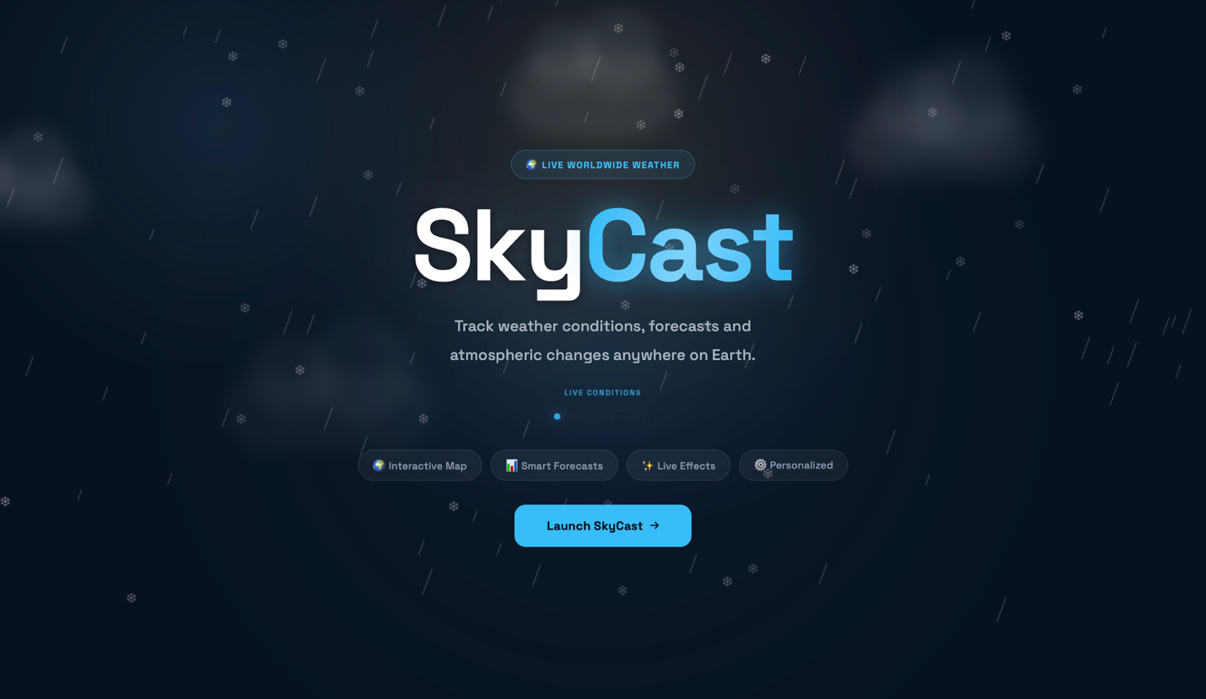

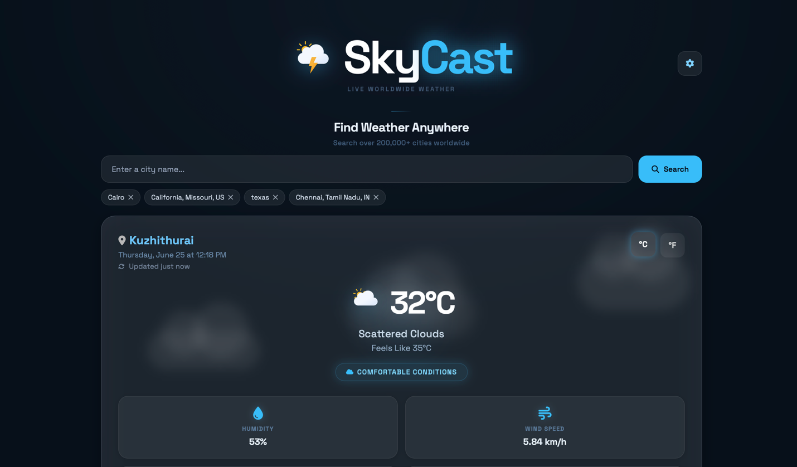

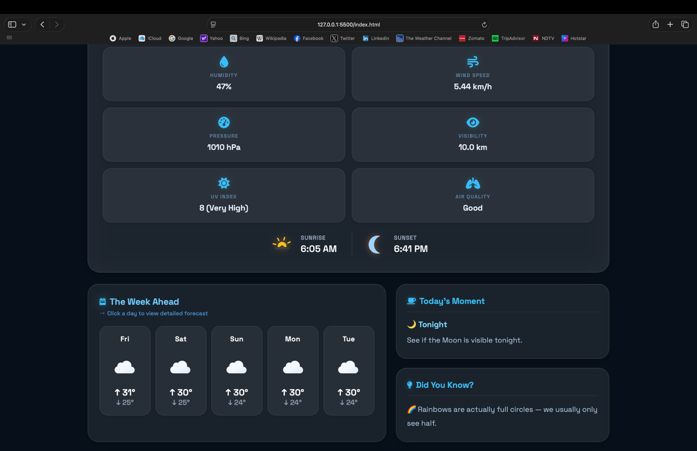
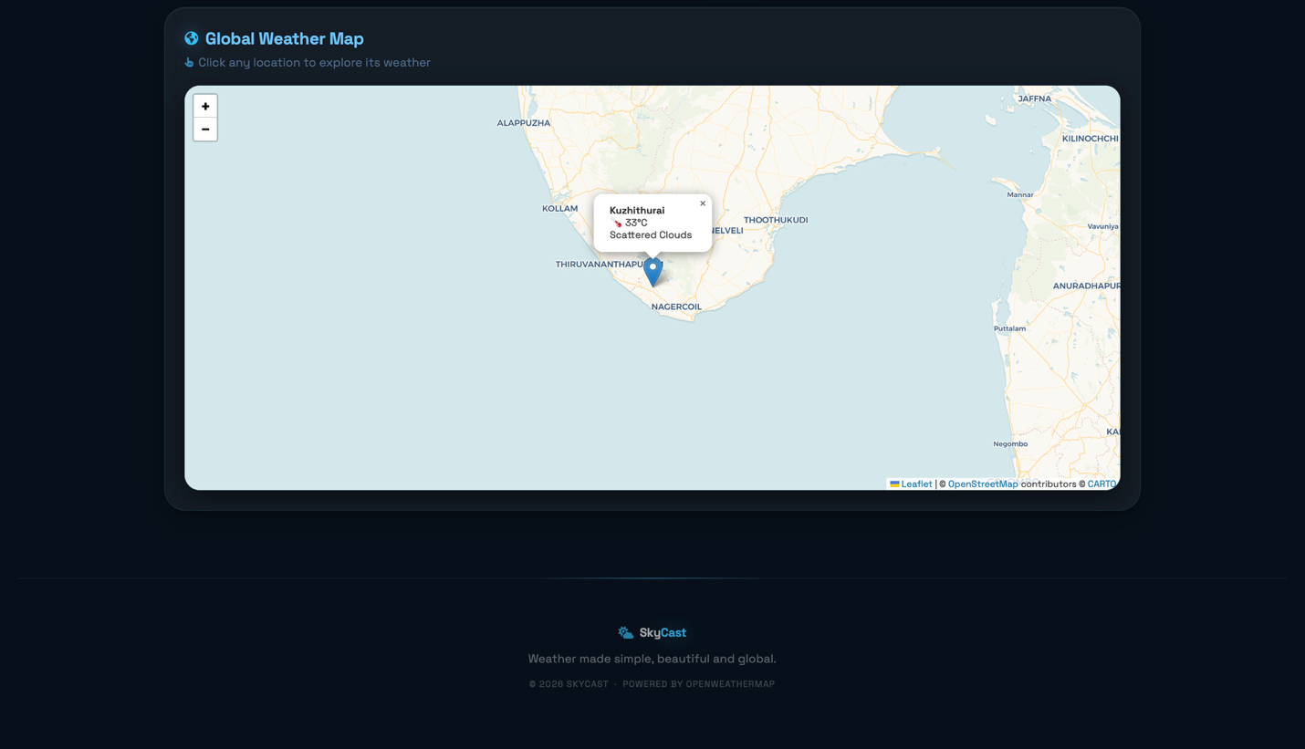

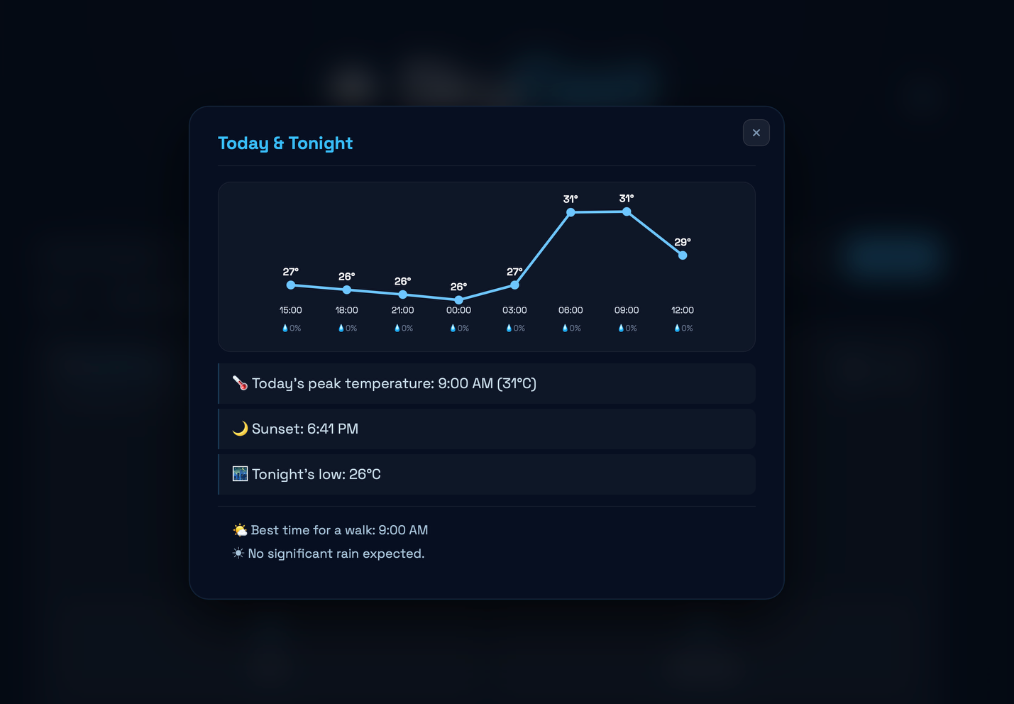
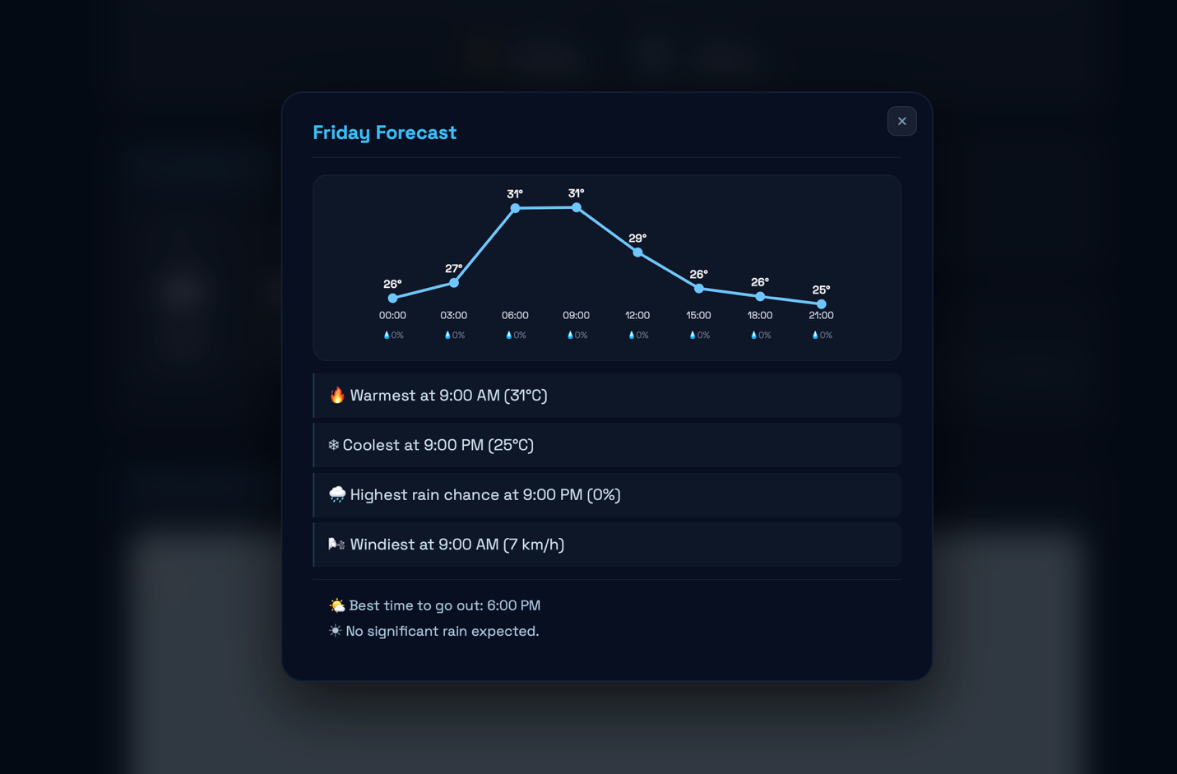
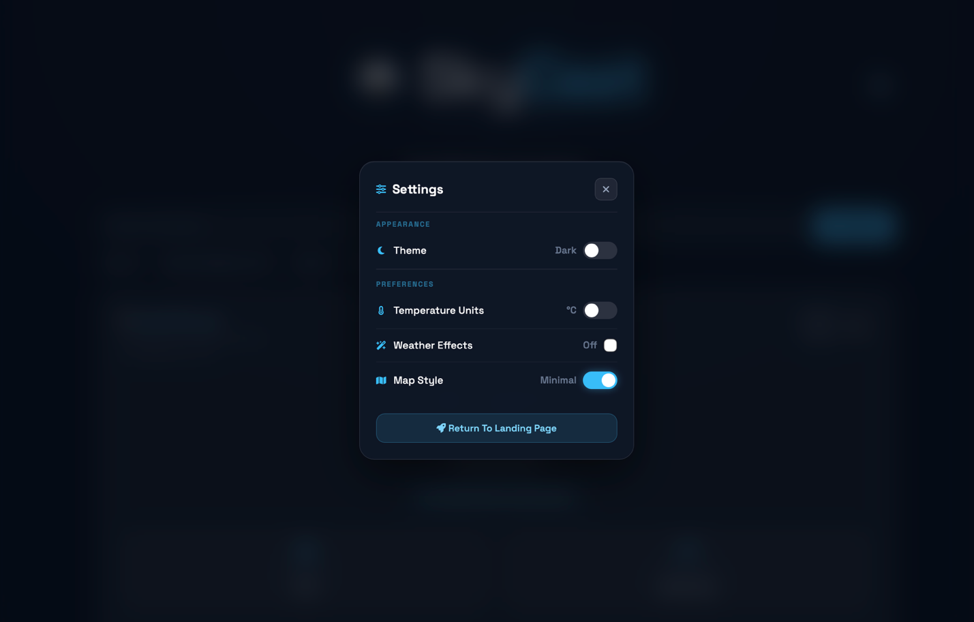
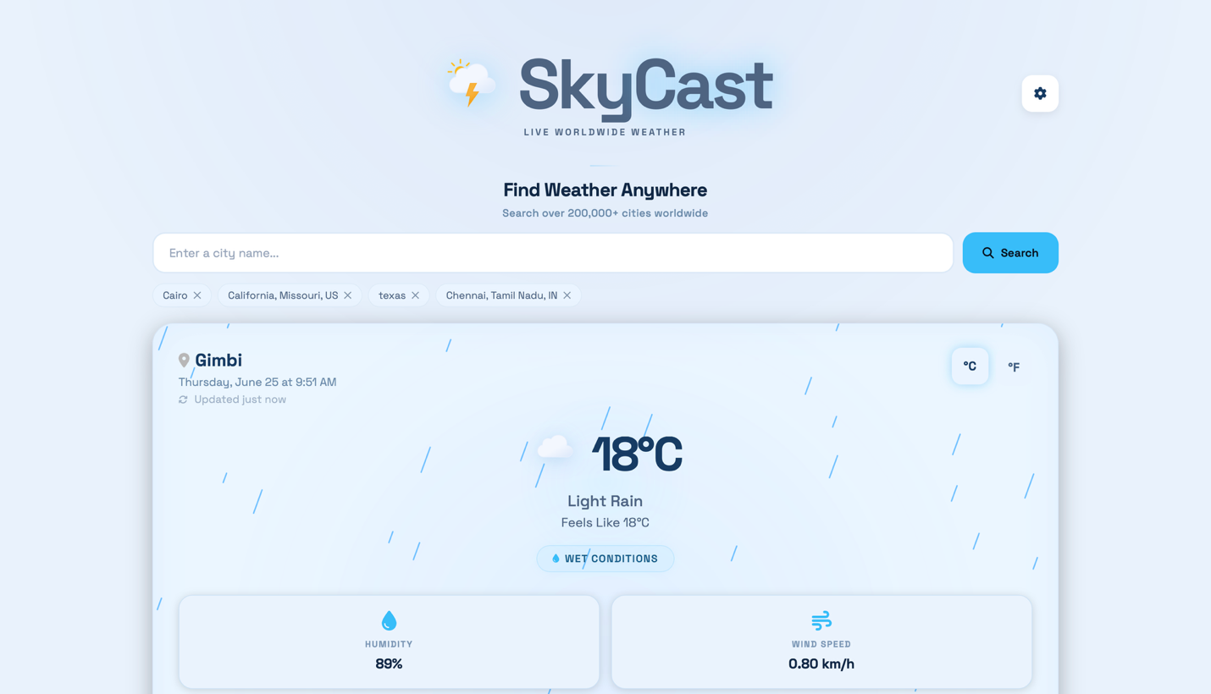
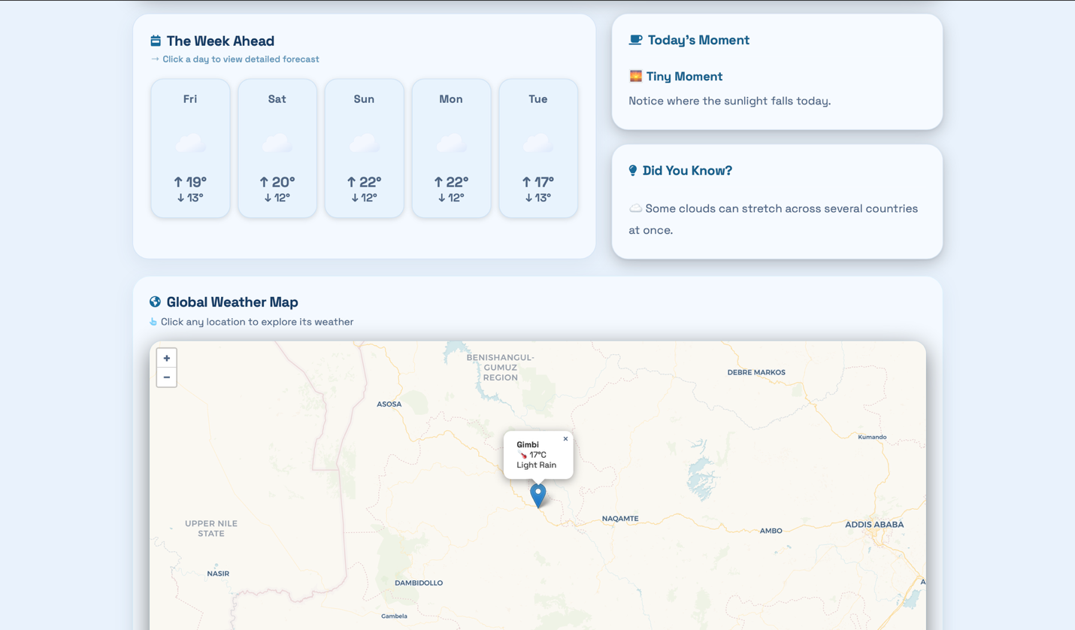
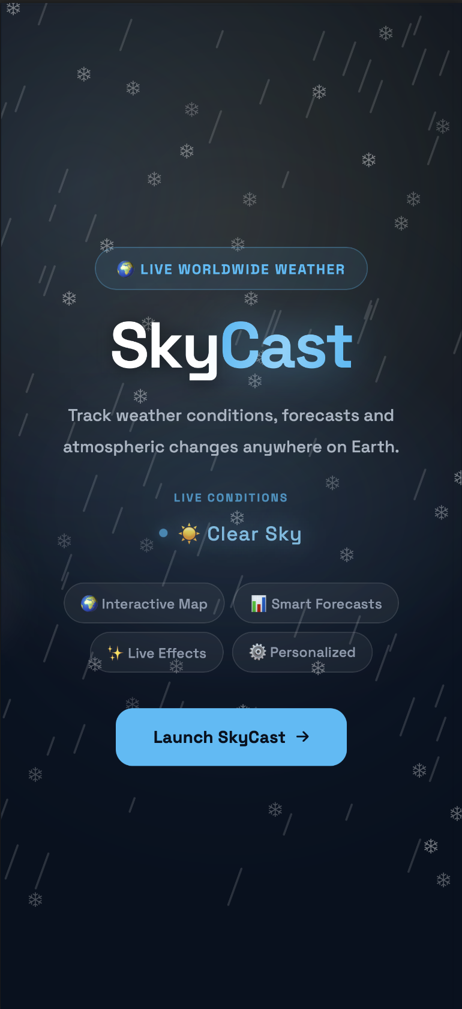
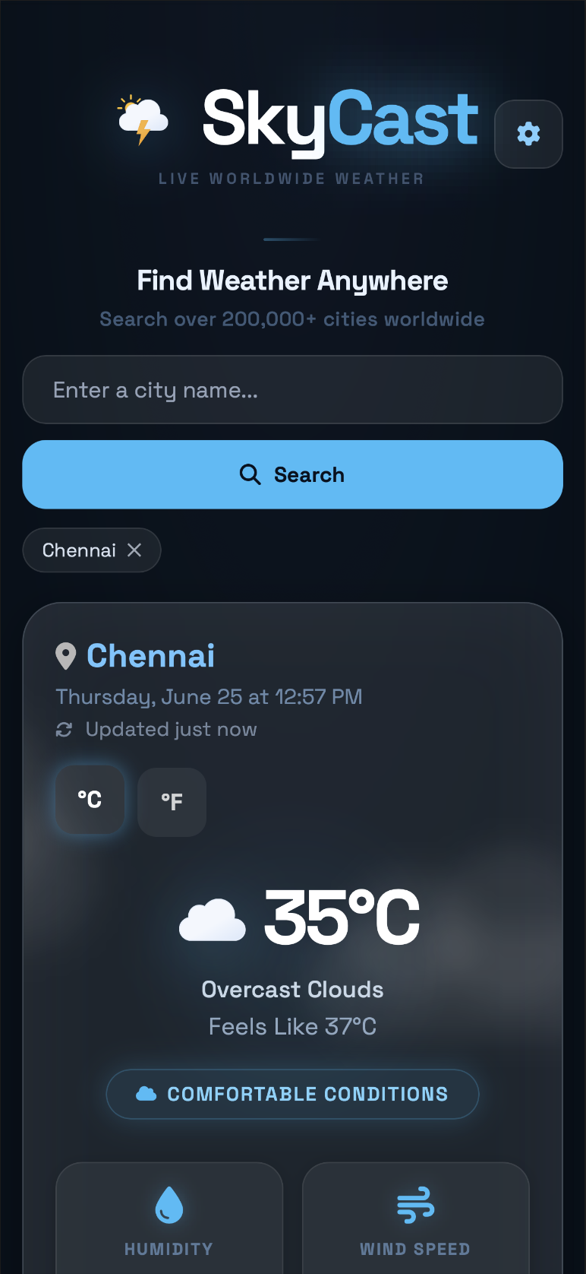

Future Enhancements
- Severe weather alerts and notifications.
- Weather widgets for the home screen.
- Offline weather caching.
- Weather sharing through social media.
- Progressive Web App (PWA) support.

Conclusion
The SkyCast project successfully demonstrates the development of a modern, responsive weather forecasting web application using HTML, CSS, and JavaScript. By integrating real-time weather APIs, interactive maps, charts, customizable themes, and dynamic user interface components, the application delivers an engaging and informative user experience. Through this project, I strengthened my understanding of JavaScript, API integration, asynchronous programming, DOM manipulation, local storage, responsive web design, and frontend development best practices. SkyCast provides a clean, feature-rich, and user-friendly platform for accessing weather information worldwide.

