Tunelin

**Game Design Document**

**Prepared by:**

**The Tunelins**

# OVERVIEWOVERVEWTalk GAMEPLAY

1. An endless-runner style
   1. Game will start always from the beginning. There will be no saving nor checkpoints in the basic game model.
2. Game start

2-1 After starting the game a player will be placed in a square, hexagon or octagon shaped tunnel.

2-2 The target of the game will be to gather the most points possible by getting as far as he can with the difficulty level constantly increasing.

2-3 A player will be able change walls either by going right/left, or by jumping to the one above him.

2-4 No movement besides the forced move forwards will be allowed inside the wall the player is currently in.

2-5 The tunnel will have obstacles on it’s walls that will kill the player if a collision occurs.

1. Nice-To-Haves

3-1 Ability to speed-up that would get you more points as long as you use it and allow you to get to the difficult parts faster if you’re an experienced player already.

3-2 Additional items to be gathered during the run that get you additional points.

## Target Platform:

The game will be created using Unity Engine. The game will be originally created for desktops, but with mobiles (Android and iOS) port kept in mind at all times.

## Visual Style

The game should be kept in a cyberpunk style.

The character: https://www.assetstore.unity3d.com/en/#!/content/52064

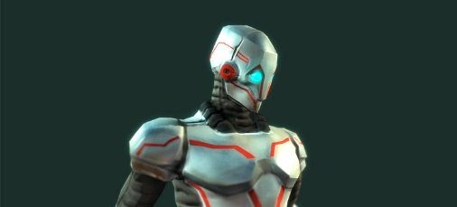

The obstacles: https://www.assetstore.unity3d.com/en/#!/content/29160

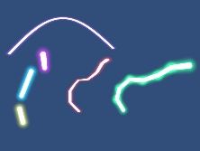

## Audio Style

The audio should be dynamic and engaging, helping to focus. See the following example:

https://www.youtube.com/watch?v=R8MWKsheHxk

# Starting Out

## Game start – Main Menu – Character Selection/Creation

* When the game loads up, you should see your character waiting to start with a screen dimmed gray and a visible text saying: “press any key to start” on PC or “tap the screen to start” on a mobile device.
* On the top of the screen there should be your current top score.
* After death, the game should reload.

## Game Start and Intro

* If this is the first time the player plays the game, tips for the basic controls (left, right, jump) should be provided depending on the platform (desktop, mobile).

## In-Game HUD & Menus

* Your current score should be displayed in the top of the screen.
* If you’re on a mobile, transparent buttons for left, right, jump (and preferably a speed-up) should be displayed. If you’re on a PC, buttons with corresponding actions should be shown in the right bottom corner of the screen.

## Gameplay

* You are a robot that runs down a tunnel (a square, hexagon or octagon shaped one) that cannot stop, and can only change the walls he runs on to the one on the left, the one on the right and the one directly above him.
* You are faced with more and more obstacles (laser barriers) that either make it impossible to go further on the wall you’re currently on, or make it impossible to change the wall you’re on to the one right/left from you.

## Mechanics

Mechanics are simple. The only thins you can do, are:

* Jump left – Changes the wall you’re on to the one on your left.
* Jump right – Changes the wall you’re on to the one on your right.
* Jump up – Changes the wall you’re on to the one directly above you.
* Speed up – Game gets faster and faster as long as you hold this button. It also gets you more points.

You die or loose every and each time you collide with an obstacle.

## Controls

On a mobile:

## 

On a PC:

Left Arrow or A – Jump Left

Right Arrow or D – Jump Right

Up arrow or W – Jump up

Space – Speedup!

## WINNING THE MATCH

You can’t.

### Score

The score is calculated to be 1 per each millisecond in the game multiplied by your current speed squared (default is 1).

## Challenges of importance

* Jumping up will be one of them – When you jump up everything rotates, so what was right, is now left. And what was left is now right. Your top is now your bottom.
* Speeding up is a very lucrative way to get more points. The faster you go – the more points you get.
* The further you go, the more obstacles there are, and they are placed more trickily.