Table of Contents
PID 2
How It works 3
Our Implementation 3
How we tuned it 3

PID

How It works

Most robots use a form of a control loop to move efficiently and accurately rather than using a proportional statement at max speed because that can overshoot by large amounts. So we opted for one of the most common forms of a control loop, The PID loop. PID standing for Proportional Integral Derivative. The proportional element is what defines how fast it will move depending on the difference between the target and its current position which we call error in this scenario. So the robot moves at a speed which is the product of the error and the proportional element (also called KP). Next is the integral element which is a sum of all the previous loop’s errors. This element controls the steady acceleration so that when the robot is almost at it’s destination but not quite this can close the gap that the proportional element usually doesn’t. Finally the derivative element which is used to predict the future error and correct for it to prevent overshooting your final destination. All of these elements are put together in a formula with constants so that you can tune the PID loop to fit your robot.

Our Implementation
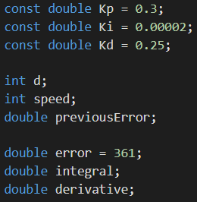
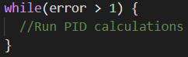
The following code snippets are from our PID turning and driving functions which can be found in full at the end of this section. First we started out by defining our variables (shown on the left) that are used in the PID loop itself. The first three variables are the constants that are mentioned above (Kp, Ki, and Kd). The next variable with the name d is simply the unsigned error and only exists for neatness. The variable speed is used to store the result from the PID equation to be used in the statements that tell the motors to move. The previous error variable is used for storing the error from the previous loop to be used in the integral element of the equation. Next are the variables that will be multiplied by the first three constants above then added to generate the speed to be used for the motors. Error is set to a value of 361 due to the condition for the while loop below requiring a value of greater than one to continue looping so I picked the arbitrary value of 361. The following code snippets shown in images are inside a while loop that looks like what is shown on the right.

How we tuned it
The Tuning is still a WIP

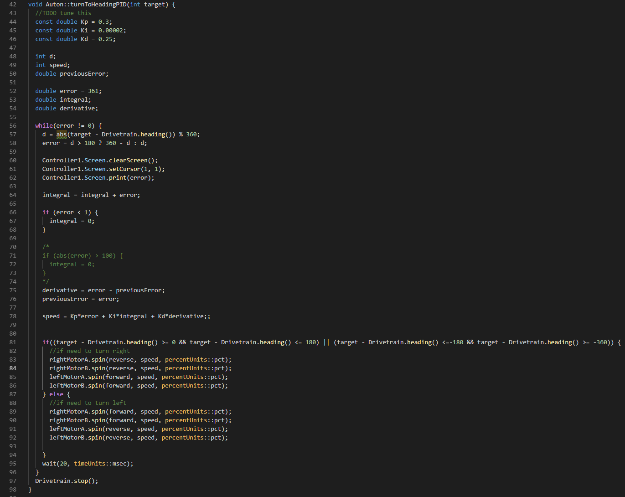
Implementation of PID Turning with line by line explanation of PID loops and how I implemented it.

