**Running head: Allometric equation for cheatgrass**

**Title: Cover-based allometric estimate of aboveground biomass of a non-native, invasive annual grass (*Bromus tectorum* L.) in the Great Basin, USA**

Adam Mahood1,2,*, Erica Fleishman3,4, Jennifer Balch1,2, Frank Fogarty4, Ned Horning5, Matthias Leu6, Martha Zillig3, Bethany A. Bradley7.

1. University of Colorado Boulder, Geography Department, Boulder, CO, 80309
2. Earth Lab, CIRES, University of Colorado Boulder, Boulder, CO 80309
3. Department of Environmental Science and Policy, University of California, Davis, CA, ZIP
4. College of Earth, Ocean, and Atmospheric Sciences, Oregon State University, Corvallis, OR, ZIP
5. Center for Biodiversity and Conservation, American Museum of Natural History, New York, NY, **10024-5102**
6. College of William and Mary, Williamsburg, VA, **ZIP**
7. Department of Environmental Conservation, University of Massachusetts, Amherst, MA, 01003

* Correspondence: [adam.mahood@colorado.edu](mailto:adam.mahood@colorado.edu)

Keywords: Cheatgrass, *Bromus tectorum*, Allometric equation, annual grass, invasive species

Competing interests: None declared

Target journal: [J. Arid Environments](https://www.elsevier.com/journals/journal-of-arid-environments/0140-1963/guide-for-authors)

**Abstract**

Cheatgrass (*Bromus tectorum* L.) presence in the Great Basin is associated with an increase in fire frequency and size, likely due to increased spatial continuity of fine fuel biomass. Measurements of the extent and cover of cheatgrass steadily are improving, but the strength of the correlation between cover and aboveground biomass (AGB) is unclear. A reliable relationship between cover and AGB of cheatgrass would allow for improved incorporation of regional estimates of cover into models of fire activity, carbon storage, and net primary productivity, all of which rely on biomass. We measured cover and AGB of cheatgrass at 60 locations in the north-central Great Basin and used these measurements to model the relationship. We also explored the effects of sample aggregation on this relationship with samples from 320 additional locations in the central, northern, western, and eastern Great Basin. We found a strong linear relationship (*b* = 6.94; pseudo R2 = 0.81) between percent cover and AGB. These results show that cheatgrass cover can reliably predict AGB. Given the strong, linear relationship between cover and biomass for this annual grass, it is likely that allometric equations based on cover will also apply to other grass species.

**Introduction**

The aboveground biomass (AGB) of plants is an important ecological property and a key indicator of how terrestrial ecosystem function responds to global change. Invasions of non-native grasses have altered the abundance and spatial distribution of AGB in many areas across the United States (Fusco et al., 2019) and other parts of the world (Miller et al., 2010; Milton, 2004; Setterfield et al., 2010). This can lead to the modification of fire activity, often leading to loss of human life and property, substantial financial costs, and loss of ecosystem function (Brooks et al., 2004; D’Antonio and Vitousek, 1992). One of the most well-documented examples of a fire-prone, non-native grass is cheatgrass (*Bromus tectorum* L.). Cheatgrass has colonized much of the western United States, and is particularly damaging in the Great Basin. In the Great Basin, cheatgrass increases the horizontal fuel continuity such that fire spreads through colonized landscapes more readily than through native, perennial-dominated landscapes (Davies and Nafus, 2013). As a result, in areas dominated by cheatgrass, fires are twice as likely to occur and to become much larger than in the native vegetation (Balch et al., 2013; Bradley et al., 2018). This has disrupted ecosystem functioning (Turnbull et al., 2012; Wilcox et al., 2012) and led to a loss of biodiversity (Mahood & Balch 2019). Cover is a measure of abundance that is much faster to measure than AGB and does not require destructive sampling. Cover of cheatgrass has been modelled throughout the Great Basin (Boyte et al., 2019; Boyte and Wylie, 2016; Bradley et al., 2018; Bradley and Mustard, 2006; Peterson, 2005). However, AGB is a more directly informative ecological property than cover, a more accurate proxy of carbon storage and net primary productivity than cover, and necessary for modelling fire occurrence (Hantson et al., 2016; Pilliod et al., 2017) and emissions (Kennedy et al., 2020). Nevertheless, the relationship between cover and AGB of cheatgrass remains largely unexplored.

Annual estimates of cheatgrass cover at regional extents have been derived from remotely sensed images (e.g., Peterson 2005; Bradley & Mustard 2006; Boyte & Wylie 2016; Bradley et al*.* 2018; Boyte et al. 2019). The accuracy and spatial and temporal resolution of these estimates is increasing consistently. For example, Boyte et al. (2019) modeled cheatgrass cover across the Great Basin at 250 m resolution with a mean absolute error of 12.6%. These approaches (Peterson 2005; Bradley & Mustard 2006; Boyte & Wylie 2016; Bradley et al.2018) suggest that regional estimates of cheatgrass cover can be derived from remotely sensed data in near real time (Boyte et al., 2019). If these models of cover could be reliably converted to AGB with an allometric equation, fire risk assessment could be improved, and the outputs of these models could more easily transfer to models of net primary productivity and carbon storage, and perhaps be integrated into global dynamic vegetation models.

The main question about the relationship between AGB and cover is whether it is linear or exponential. For many species of herbaceous plants, when cover is low, the relationship appears to be linear (Axmanová et al., 2012; Chieppa et al., 2020; Flombaum and Sala, 2007; Muukkonen et al., 2006). As cover approaches 100%, the relationship can become asymptotic (**Figure 1**) while AGB increases linearly (Axmanová et al., 2012; Marushia and Allen, 2011). This behaviour is more likely when plant height varies considerably, creating a complex canopy with many layers, which is more likely to occur when there are many species, or perennial plants of different ages. Species-specific allometric equations may be more accurate than allometric equations for functional groups or for total cover of all species (Chieppa et al., 2020). Annual plants, in particular, are more likely to grow to similar heights and have a simple canopy. In our case, cheatgrass often occurs in a near monoculture, with a single canopy layer. Therefore, the AGB to cover relationship may remain linear even as cover approaches 100%.

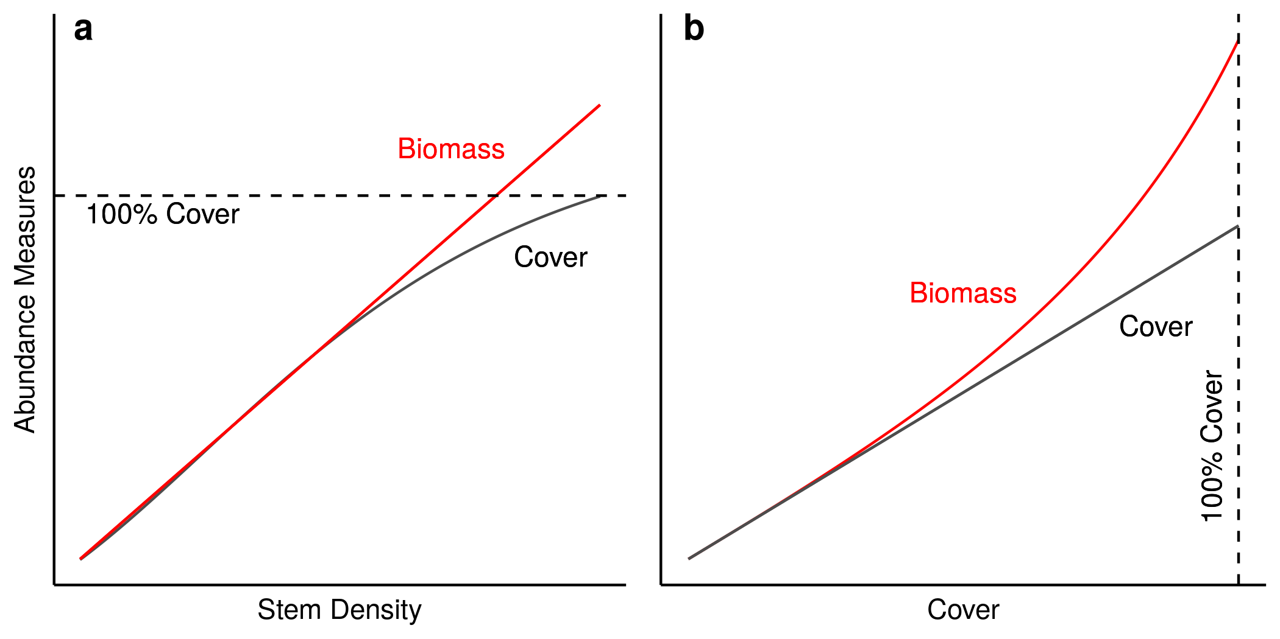

**Figure 1**. The saturation effect, where aboveground biomass increases linearly with stem density, but cover becomes asymptotic as it approaches 100 percent (panel a), and the expected appearance of the cover to biomass relationship with this effect (panel b). This relationship would lead to greater inherent sampling error at higher values of cover.

One possible confounding factor in the relationship between cover and AGB is the response of annual plants to interannual climatic variations. Annual plants in the Great Basin, especially cheatgrass, are highly responsive to precipitation, aridity, and temperature (Larson et al., 2017; Mangla et al., 2011). Not only is the abundance of cheatgrass responsive to interannual variation, but the specific leaf area, or biomass per unit leaf area, has also been shown to vary as a function of moisture availability (Butterfield et al., 2017; Fernández and Reynolds, 2000; Poulin et al., 2007; Sandel and Low, 2019; Tardella et al., 2017). If the relationship between cover and AGB is highly variable among years, predicting AGB as a function of cover may require accounting for functional trait response to interannual climate variability.

Here, we sampled cover and AGB of cheatgrass, and modeled the relationship, at 380 locations across the Great Basin from 2016-2019. We hypothesized that at low cover values, the relationship between cover and biomass is linear, but could become non-linear at high cover values if high cover also relates to greater height. We also examined the effect of sample size and aggregation on estimates of AGB. At 60 locations, we aggregated samples from 1 m2 quadrats to represent cover at the level of 30-50 m transects. At 320 locations, we collected and processed samples at the level of the individual 1 m2 quadrat to represent the full range of cover values.

**Methods**

We used two sampling methods to measure cover and AGB of cheatgrass. The first method aimed to capture the variation of cover and AGB approximating the scale of a Landsat pixel by measuring cover using ocular estimates and clipping all standing cheatgrass biomass in multiple 0.1 m2 quadrats along 30-50 m transects. Cover data were averaged and biomass aggregated for this method (hereafter, transect-level). The second method aimed to encompass the full range of possible cover values up to 100% by measuring cover using ocular estimates in individual 1 m2 quadrats, and clipping a 0.1 m2 subset that appeared to be representative of the 1 m2 quadrat (hereafter, quadrat-level). We dried all biomass samples at 60˚ C and weighed them when the mass stabilized.

*Transect-level sampling design*

We implemented two different designs for sampling along transects. In June 2016, we sampled cheatgrass at its peak AGB at 20 locations in the north-central Great Basin (**Figure 2**). We selected locations after reviewing fire and soil maps from the US Bureau of Land Management (BLM) and consulting with land managers from the BLM’s Winnemucca Field Office. The slopes (0-5%) and elevations (1297-1607 m) of the locations were similar, and locations were separated by at least 1.5 km. Eleven locations were dominated by sagebrush (*Artemisia tridentata*). Cheatgrass cover in the understory of six of these sites was <5%. Native shrubs were not present in nine sites, which instead were dominated by cheatgrass (>5% cover) and annual forbs. Permitted levels of livestock grazing in summer and autumn were similar among locations.

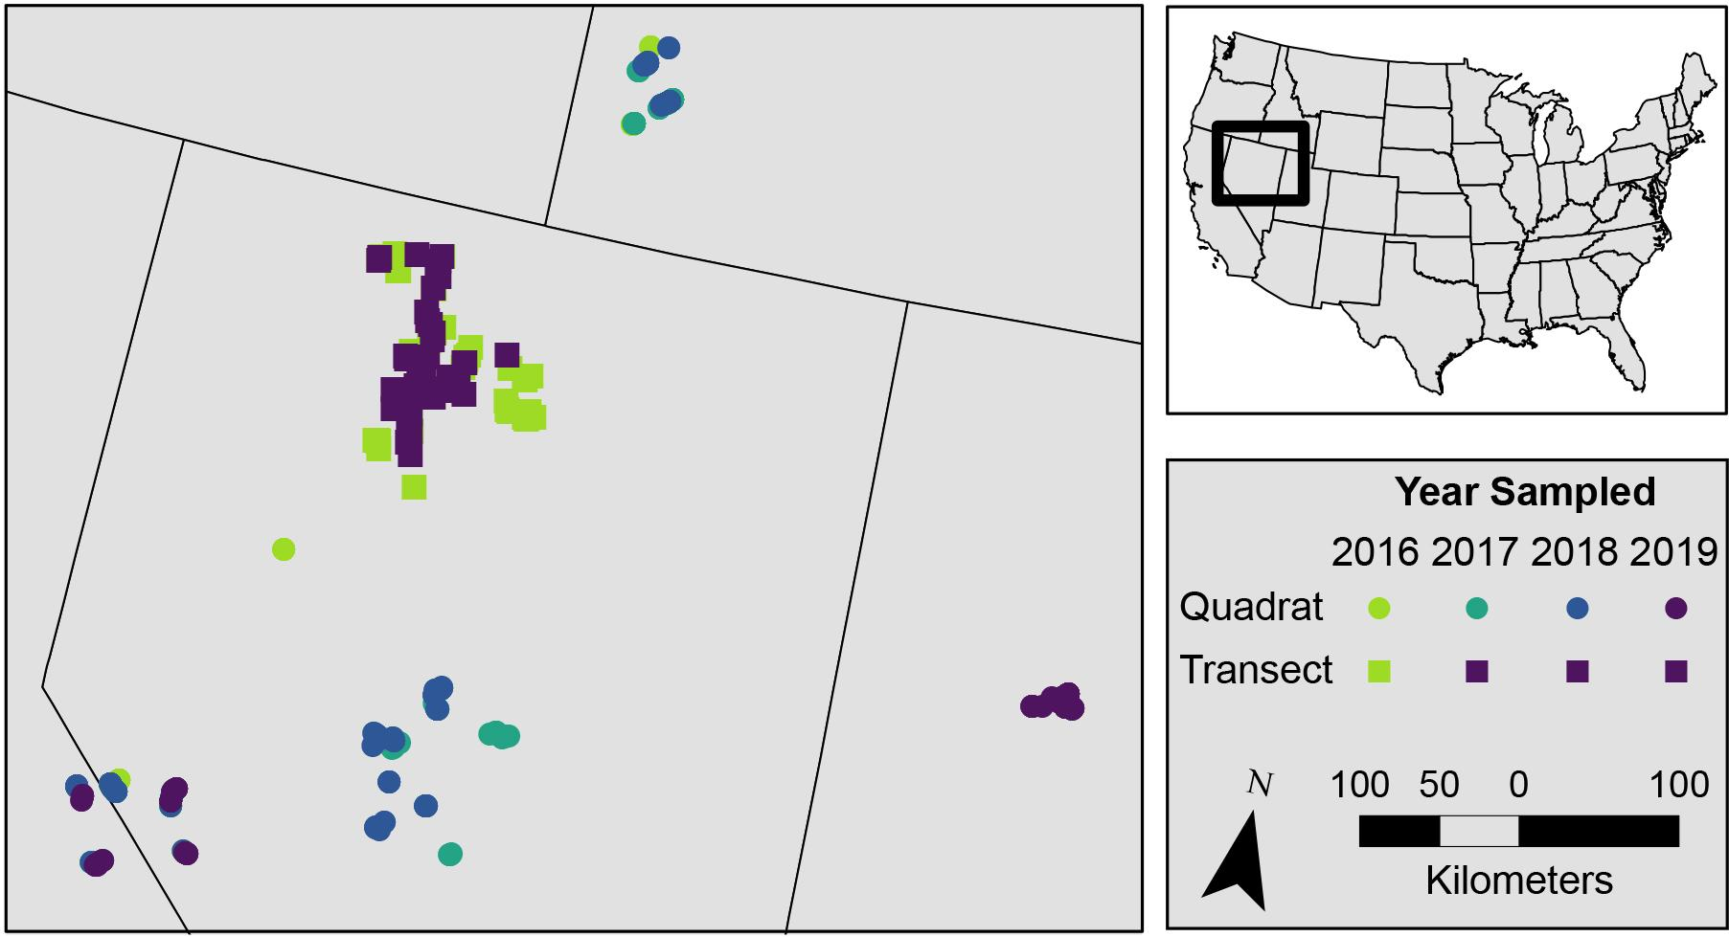

**Figure 2**. Study area and sampling sites. Circles represent the locations of 1m2 quadrat-level samples, which were collected from 2016-2019. Squares represent the locations of transect-level samples collected from 2016-2019. T (note that the same transect sites were resampled from 2017-2019).

At each location, we established three pairs of parallel, 50-m transects separated by 20 m. We sampled 0.1 m2 quadrats every 5 m along each transect, for a total of 60 transects each composed of 22 quadrats measurements of cover (averaged for each transect) and biomass (aggregated for each transect).

In the first week of July in 2017 and 2018, and in September 2019, we sampled 40 locations in the north-central Great Basin (**Figure 2**). Sampling in 2017 and 2018 coincided with peak AGB of cheatgrass. Sampling in 2019 followed senescence and seed dispersal. Half of the sites were dominated by sagebrush and half were dominated by cheatgrass and annual forbs. Elevations ranged from 1200-1700 m, and all locations had a history of livestock grazing. At each location, we established one 30-m transect with five 0.1 m2 quadrats randomly located along the transect. In 2017-2018, we averaged cover and aggregated biomass across the five quadrats to calculate transect-level cover and biomass. For locations sampled in 2019, we recorded cover and AGB from each quadrat separately. This allowed us to evaluate whether aggregation affected the relationship between AGB and cover.

*Quadrat-level sampling design*

We sampled quadrats at 90 locations in the northern Great Basin (Owyhee County, Idaho; 30 in late June and early July 2016, 20 in late June and early-mid July 2017, and 40 in June 2018), 33 locations in the eastern Great Basin (Tooele County, Utah) in June 2017, 90 locations in the central Great Basin (Lander, Nye, and Eureka Counties, Nevada; 40 in June and early July 2018 and 50 in June and early July 2019), and 124 locations in the western Great Basin (Mono and Alpine Counties, California and Mineral, Lyon, and Douglas Counties, Nevada; 50 in June-August 2016, 34 in June 2017, and 40 in June-July 2018; **Figure 2**). Many locations were tens of km apart (e.g., some locations in the central Great Basin were 90 km apart).

*Statistical Modeling*

We used linear models to estimate the relationship between percent cover and AGB from the transect-level samples collected at peak AGB (June 2016, July 2017, and July 2018). First, we created a set of ordinary least squares (OLS) models, each with data from one year, and another OLS model with the data from all three years. Cover was the predictor and AGB was the dependent variable. Next, we created a linear mixed model using the data from all three years, with the year of sampling as a random effect, with a random slope, and the intercept fixed at zero. To determine if this mixed model was a better fit than the simple OLS model with all of the years aggregated, we compared the models with Akaike’s Information Criterion (AIC) and selected the mixed model if its AIC was ≤ 2 that of the OLS model.

To evaluate whether aggregating the AGB collected in individual quadrats affected the relationship between percent cover and AGB, we aggregated the data collected in September 2019 by location, and created separate OLS models with the aggregated and unaggregated data. Because the two OLS models were not nested, we compared them by examining R2 and standard errors of the coefficients.

We also created linear models from the samples collected at the quadrat level, but the coefficients appeared to be unrealistically low, and many models did not pass diagnostic tests, even when restricted to low cover values (**Figure S1**). Exponential and non-linear models had similar problems. There are at least three possible reasons for this. First, samples were not consistently collected at peak biomass. Second, estimating cover at 1 m2 while collecting AGB in a 0.1 m2 subset of that square meter led to high levels of sampling error. Third, as indicated in an exploratory analysis in which we included the identity of the observer as a random effect in a mixed model, there was strong among-observer variation in cover estimates. Therefore, we were concerned that these data were not reliable, and excluded them from the final estimation of the relationship between biomass and cover.

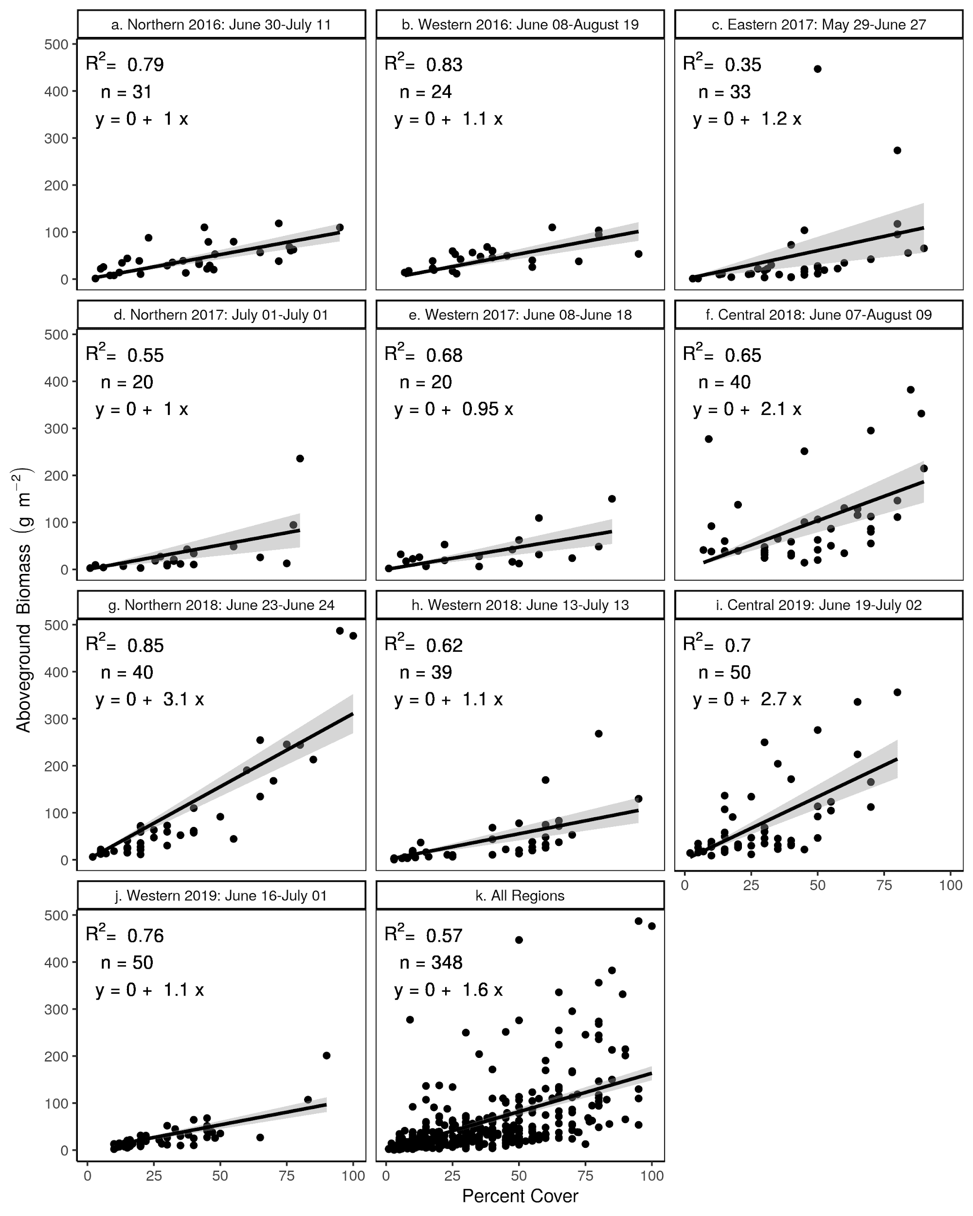

**Figure S1.** Aboveground biomass collected within 0.1 m2 of a 1 m2 quadrat within which we estimated percent cover. All relationships were statistically significant (p < 0.05). Samples captured the full gradient of percent cover. The lower coefficients may reflect the difficulty of collecting a representative sample of biomass within 1 m2 given the high spatial heterogeneity of biomass at that resolution.

Data and code to reproduce the analysis is at [www.github.com/admahood/cg_biomass](http://www.github.com/admahood/cg_biomass) and on [www.figshare.com](http://www.figshare.com/)/admahood/cg_biomass.

**Results**

We found statistically significant, linear relationships between percent cover and AGB of cheatgrass. For transect-level samples collected from 2016-2019, coefficients ranged from 3.3-7.8 g m-2 per 1% (**Figure 3**). However, because the 2019 sample was collected in September, cheatgrass seeds already had shed, and so the model does not represent the relationship at peak AGB. Accordingly, we used our transect-level measurements from 2016-2018 to estimate the allometric equation for calculating AGB from cover at peak biomass. We used the mixed model because the AIC of the OLS model was >2 than that of the mixed model. The allometric equation we estimated was

AGB (g m-2) = 6.94 (±0.5) * cover (%)

The linear mixed model we used to estimate this relationship had a pseudo R2 value of 0.81 (**Figure 4**).

For our comparison of aggregated versus unaggregated samples, the coefficients were the same, but the variance explained was greater when samples were aggregated by transects (R2 = 0.89, p < 0.05) than when samples were not aggregated (R2 = 0.84, p < 0.05; **Figure S2**).

**Figure 3.** Percent cover and aboveground biomass of cheatgrass were linearly related. Lines are estimates from ordinary least squares regression models. The shaded area is the 95% confidence interval. Data in 2016-2018 were collected at peak biomass. Data in, whereasile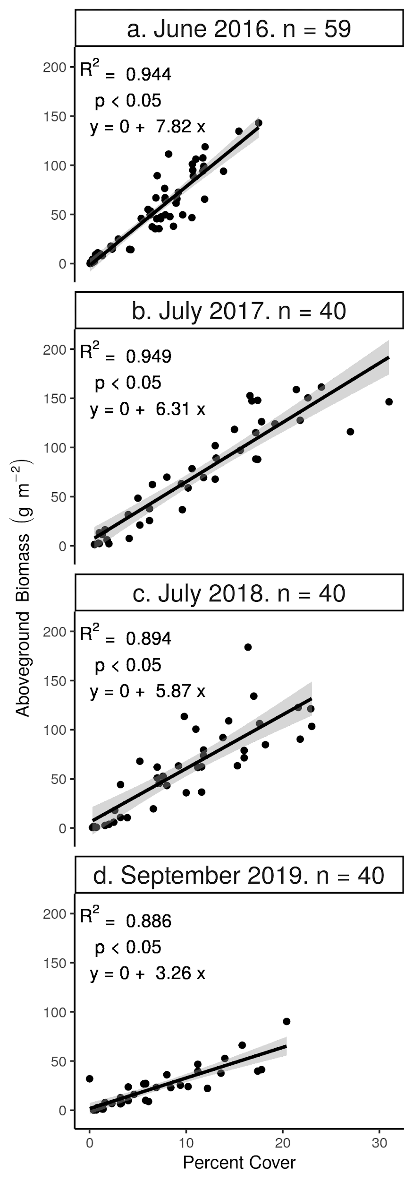 2019 were collected in September, which was at the end of the growing season and well past peak biomass.

For the samples collected at the quadrat level, we also found significant relationships between cover and AGB of cheatgrass in all cases. However, although in some cases the linear models fit well, in most cases the models did not pass diagnostic tests for homoscedasticity or normally distributed residuals. In addition, the estimated coefficients were much lower, ranging from 0.95 - 3.1 across years and locations, (**Figure S1**) and variance explained was lower (overall R2 = 0.57). Nevertheless, there is some visual evidence of a saturation effect (higher than expected biomass at high cover values; **Figure 1)**, with more outliers at high cover values (e.g,. **Figure S1g**).

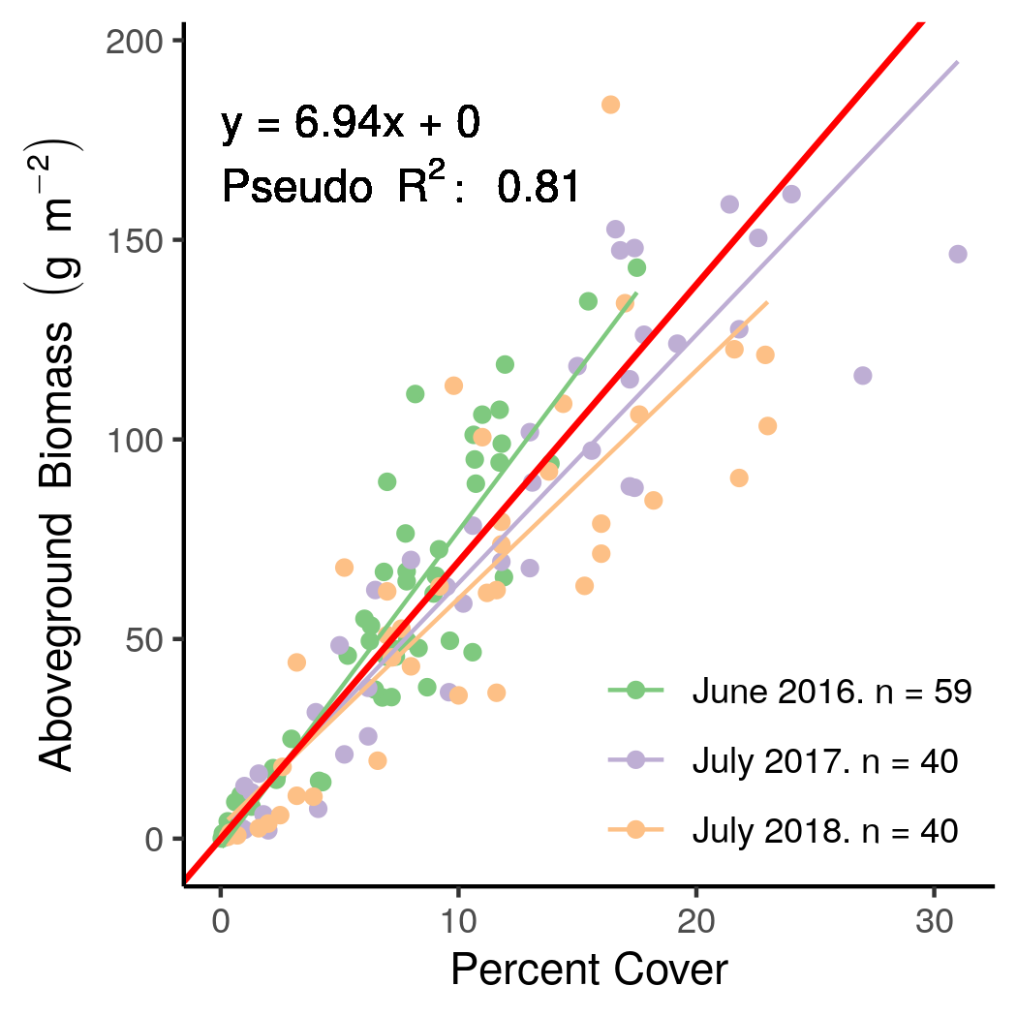

**Figure 4.** Results of a linear mixed model with random slopes and the intercept fixed at zero for the three years of transect-level data collected at peak biomass. Finer lines are the predicted values grouped by year. The bold red line is the overall relationship.

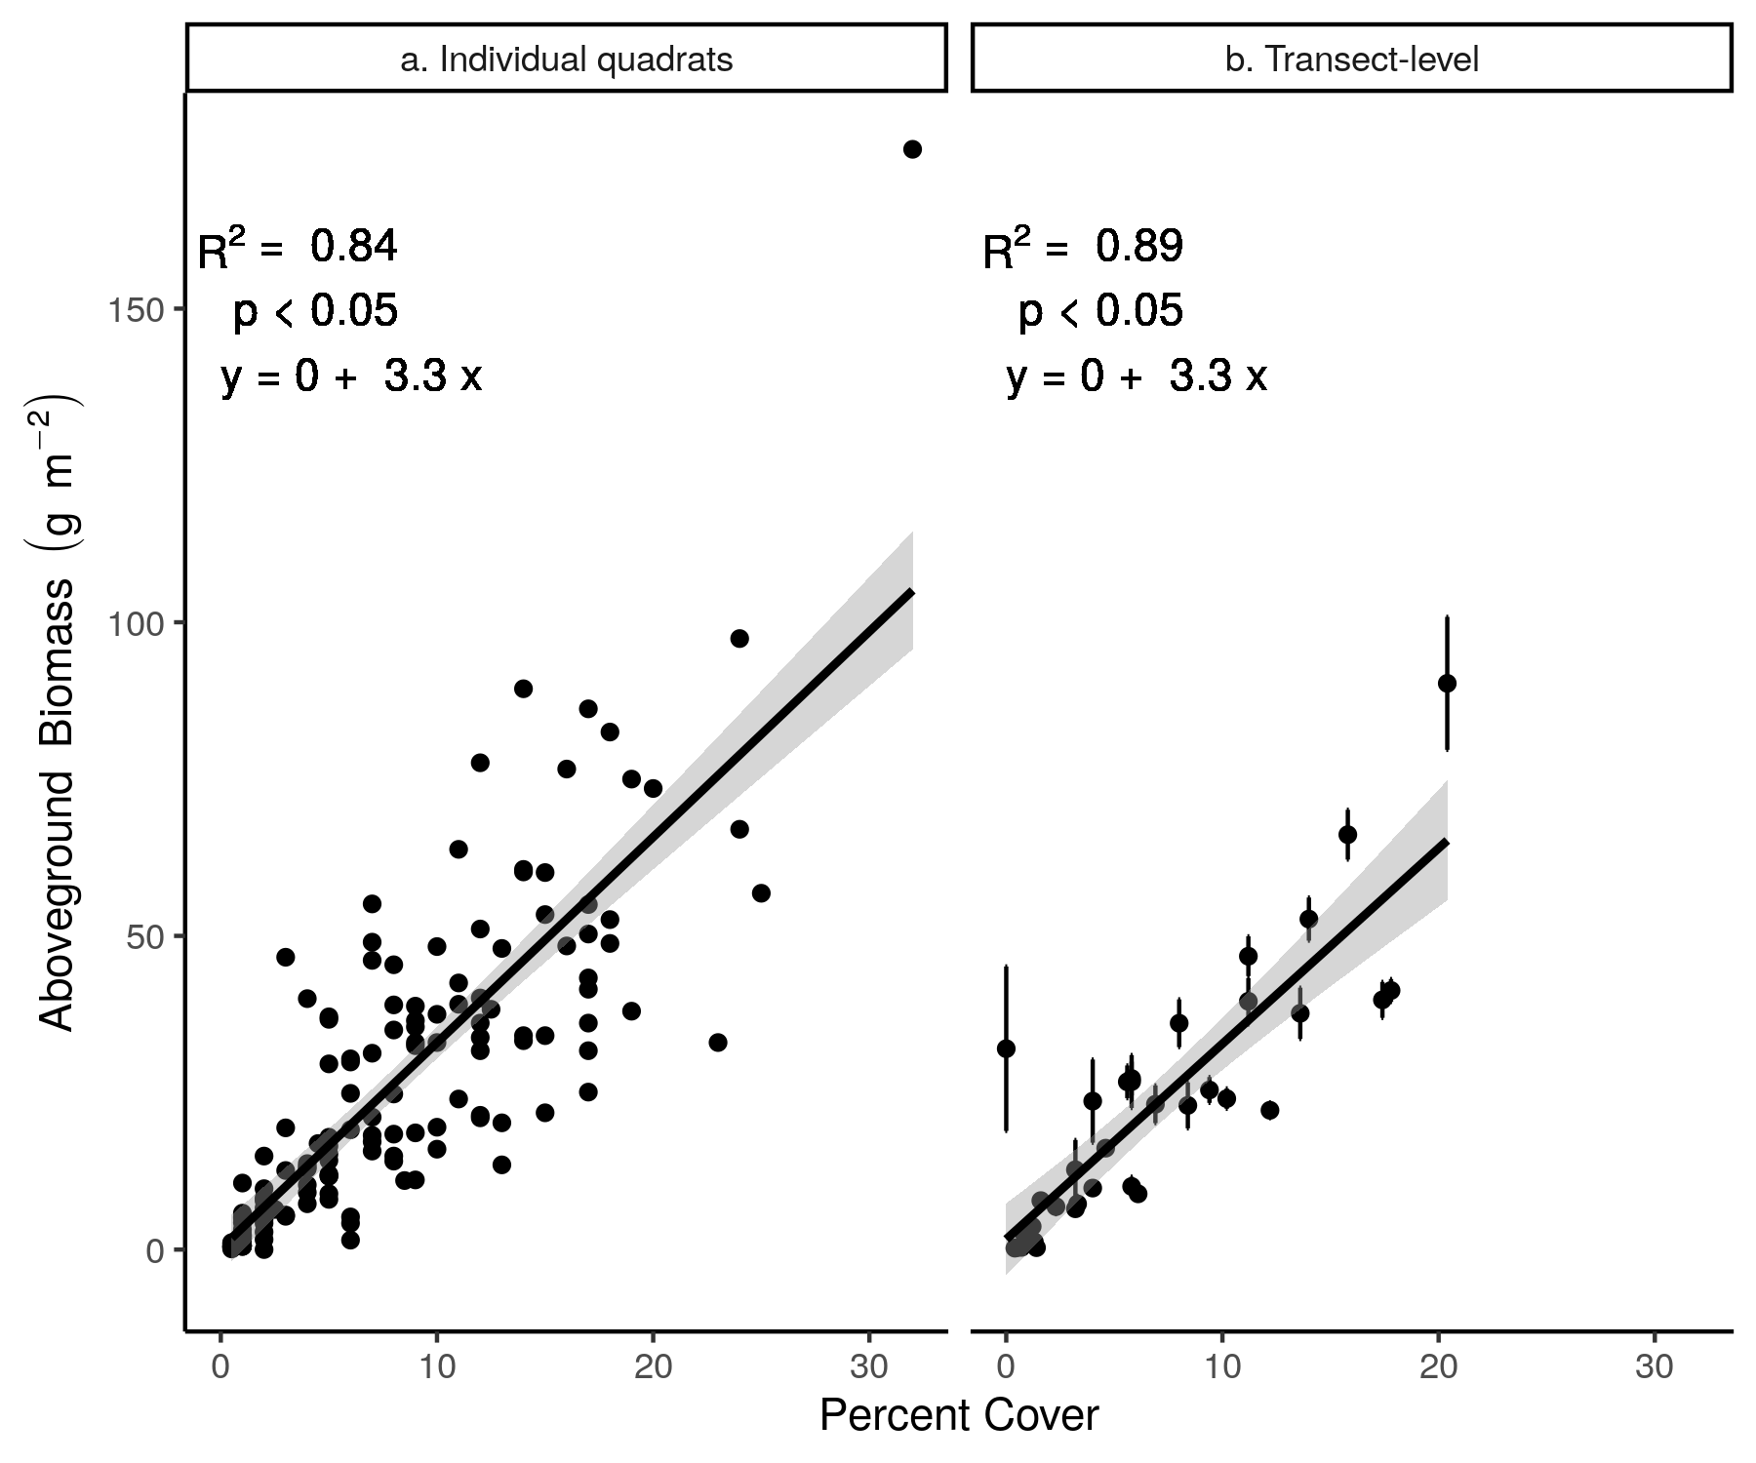

**Figure S2.** The effect of sample aggregation on the relationship between cover and AGB of cheatgrass for samples collected in September 2019. In panel a, each point represents the cover and AGB measured within a single 0.1 m2 quadrat. In panel b, each point represents the mean percent cover and AGB of five 0.1 m2 samples collected along each 30 m transect. The shaded areas represent 95% confidence intervals. Vertical lines in panel b represent the 95% confidence interval of the mean. The model that was based on the aggregated data had the same coefficient, but explained more variation.

**Discussion**

The relationship between AGB and cover of cheatgrass appeared to be linear and quite strong at the transect level, where all cover values were less than 40% (**Figures 3 and 4**). Our allometric equation of a 6.94 g m-2 increase in AGB for a 1% increase in cover is similar to the equations estimated by Chieppa et al. (2020) for short-lived grasses (6.06) and long-lived grasses (6.54).

We found suggestive evidence that biomass continued to increase as cover values approached 100% (e.g **Figure s1g**). However, our inferences from those data are tentative for the reasons outlined above (see Methods). Biomass may increase as cover saturates, leading to higher sampling error at higher cover values (as in Boyte et al. 2019). However, because cheatgrass cover rarely exceeds 50% at the resolution of a 30-m Landsat pixel, even where it grows in dense monocultures (Boyte et al., 2019), this phenomenon may not be problematic for regional biomass modelling for most areas.

Despite high variability in cover among years (Bradley and Mustard, 2006), the relationship between cover and AGB at the time of peak biomass appears to be relatively stable. However, because our random effects model explained more variation than a global OLS model, there may still be subtle interannual differences in the relationship. The model could be made more universally applicable by accounting for the drivers of these differences. One such driver may be intraspecific variation in plant functional traits. These traits vary spatially along topographic and moisture gradients (measured as soil moisture, supplemental watering, climatic water deficit, topographic position, and precipitation, respectively; Butterfield et al., 2017; Fernández and Reynolds, 2000; Poulin et al., 2007; Sandel and Low, 2019; Tardella et al., 2017), and temporally throughout the growing season (Svejcar, 1990). If one considers percent cover to be a function of leaf area, then the relationship between AGB and percent cover would be a function of specific leaf area (SLA; leaf area divided by leaf dry mass). SLA and leaf area can vary among individuals of the same species, and within and among communities. If SLA is higher, a given cover value would predict a lower AGB value, so the cover to AGB coefficient would be lower.

Cheatgrass SLA has been documented to be higher at lower elevations (Ziska et al., 2005), and SLA within individual cheatgrass plants reaches a maximum at peak biomass and then declines as the growing season progresses (Svejcar 1990). We explored the first effect by extracting elevation from a 10-m digital elevation model at each transect-level sampling location and adding it to our transect-level model from **Figure 4**. We found that elevation was not statistically significant. With respect to the second effect, we found that the coefficient of the cover to biomass relationship was lower in samples collected later in the growing season (**Figure 3d**) than at beak biomass (**Figure 3a-c**), the opposite of what one would expect if SLA was the principal driver of changes in the cover-biomass relationship as the growing season progresses. Rather, this variation is likely to be more strongly influenced by seed shedding.

The SLAs of grass species in general have also been observed to be sensitive to interannual variation in precipitation. As precipitation increases, SLA tends to increase (Butterfield et al., 2017; Fernández and Reynolds, 2000; Poulin et al., 2007; Sandel and Low, 2019; Tardella et al., 2017). Therefore, one would expect a higher slope of the cover to AGB relationship in dry years. However, we detected only slight (but not negligible) interannual differences in the coefficients for samples collected at peak biomass (**Figures 3 and 4**). The discrepancy between the documented variation in SLA in other studies and our results might be due to differences among species in strategies for surviving drought. Cheatgrass mitigates the effects of seasonal drought by avoiding it altogether. Cheatgrass germinates in early spring as soon as moisture is available and completes its life cycle before soil moisture decreases, and atmospheric vapor pressure deficit increases, during summer. Perennial grasses, in contrast, must allocate fewer resources to aboveground growth during the period when moisture availability is high, and more to underground carbon storage to survive the summer drought. These differences in resource allocation strategies may explain why the SLA of cheatgrass, unlike the SLA of other grasses, does not appear to be sensitive to precipitation.

Height may be another confounding factor, especially at high values of cover. Estimating AGB as cover approaches 100% is challenging because plant height still can increase after canopy cover reaches a maximum. One could incorporate vegetation height into a model of AGB, but several of the largest existing sets of training data, which include tens of thousands of data points, do not include measurements of height (see Boyte et al. 2019). Models of canopy height derived from remote sensing typically focus on tree or shrub cover (Alonzo et al., 2018; Narine et al., 2019). Annual grass height is much more difficult to model with satellite remote sensing. Therefore, there are trade-offs between increases in model accuracy and the prompt availability of data. It may be possible to model cheatgrass height on the basis of topography and current year climate, and incorporate those values into models of AGB. These concerns may be moot, however, given that Chieppa et al. (2020) found no improvement in model accuracy when they added height to models of AGB predicted by cover for grass species.

Several other annual grass species have become dominant in other areas of the west. These include various species of *Bromus* and *Avena* throughout California, red brome (*Bromus rubens* L.) in the Mojave Desert, and Medusahead (*Taeniatherum caput-medusae* (L.) Nevski) in the northern Great Basin. Like cheatgrass, these species generally have a simple, single-layer canopy. We believe that AGB of these species likely also could be estimated from allometric equations based on cover. Differences among species in, for example, SLA, height, and seed mass may prevent application of the identical equation. However, we believe that a linear allometric equation between biomass and cover is likely to be consistently applicable, and that it may be possible to apply allometric equations within functional groups more generally.

**Acknowledgments**

We are grateful to Dylan Murphy, Nick Whittemore, and Julia Lopez for their tireless efforts under the hot sun. We also would be remiss if we did not thank Kathleen Weimer, Brittany Mullane and Andrea Harmon for their help in the lab drying and weighing many, many bags of cheatgrass. The people at the BLM office in Winnemucca, Nevada, in particular Robert Burton, were very gracious in assisting us with anything we needed. We are also eternally grateful to the Central Nevada Interagency Dispatch Center for their concern with our safety. This research was supported by the Joint Fire Science Program (15-1-03-6); the US Geological Survey’s Northwest and Southwest Climate Science Centers (F16AC00025); the National Science Foundation (BCS 1740267); the University of Colorado, Boulder’s Undergraduate Research Opportunities Program and Beverly Sears Graduate Research Award; and the University of Colorado, Boulder Geography Department’s Adam Kolff Memorial and Jennifer Dinaburg Memorial Research Awards.

**Literature Cited**

Alonzo, M., Andersen, H.E., Morton, D.C., Cook, B.D., 2018. Quantifying boreal forest structure and composition using UAV structure from motion. Forests 9, 1–15. https://doi.org/10.3390/f9030119

Axmanová, I., Tichý, L., Fajmonová, Z., Hájková, P., Hettenbergerová, E., Li, C.F., Merunková, K., Nejezchlebová, M., Otýpková, Z., Vymazalová, M., Zelený, D., 2012. Estimation of herbaceous biomass from species composition and cover. Applied Vegetation Science 15, 580–589. https://doi.org/10.1111/j.1654-109X.2012.01191.x

Balch, J.K., Bradley, B.A., D’Antonio, C.M., Gómez-Dans, J., 2013. Introduced annual grass increases regional fire activity across the arid western USA (1980-2009). Global Change Biology 19, 173–183. https://doi.org/10.1111/gcb.12046

Boyte, S.P., Wylie, B.K., 2016. Near-Real-Time Cheatgrass Percent Cover in the Northern Great Basin, USA, 2015. Rangelands 38, 278–284. https://doi.org/10.1016/j.rala.2016.08.002

Boyte, S.P., Wylie, B.K., Major, D.J., 2019. Validating a Time Series of Annual Grass Percent Cover in the Sagebrush Ecosystem. Rangeland Ecology and Management 72, 347–359. https://doi.org/10.1016/j.rama.2018.09.004

Bradley, B.A., Curtis, C.A., Fusco, E.J., Abatzoglou, J.T., Balch, J.K., Dadashi, S., Tuanmu, M.-N., 2018. Cheatgrass (Bromus tectorum) distribution in the intermountain Western United States and its relationship to fire frequency, seasonality, and ignitions. Biological invasions 20, 1493–1506.

Bradley, B.A., Mustard, J.F., 2006. Characterizing the landscape dynamics of an invasive plant and risk of invasion using remote sensing. Ecological Applications 16, 1132–1147. https://doi.org/10.1890/1051-0761(2006)016[1132:CTLDOA]2.0.CO;2

Brooks, M.L., D’Antonio, C.M., Richardson, D.M., Grace, J.B., Keeley, J.E., DiTomaso, J.M., Hobbs, R.J., Pellant, M., Pyke, D., 2004. Effects of Invasive Alien Plants on Fire Regimes. BioScience 54, 677–688.

Butterfield, B.J., Bradford, J.B., Munson, S.M., Gremer, J.R., 2017. Aridity increases below-ground niche breadth in grass communities. Plant Ecology 218, 385–394. https://doi.org/10.1007/s11258-016-0696-4

Chieppa, J., Power, S.A., Tissue, D.T., Nielsen, U.N., 2020. Allometric Estimates of Aboveground Biomass Using Cover and Height Are Improved by Increasing Specificity of Plant Functional Groups in Eastern Australian Rangelands. Rangeland Ecology and Management 73, 375–383. https://doi.org/10.1016/j.rama.2020.01.009

D’Antonio, C.M., Vitousek, P.M., 1992. Biological invasions by exotic grasses, the grass/fire cycle, and global change. Annual Review of Ecological Systems 23, 63–87.

Davies, K.W., Nafus, A.M., 2013. Exotic annual grass invasion alters fuel amounts, continuity and moisture content. International Journal of Wildland Fire 22, 353–358. https://doi.org/10.1071/WF11161

Fernández, R.J., Reynolds, J.F., 2000. Potential growth and drought tolerance of eight desert grasses: Lack of a trade-off? Oecologia 123, 90–98. https://doi.org/10.1007/s004420050993

Flombaum, P., Sala, O.E., 2007. A non-destructive and rapid method to estimate biomass and aboveground net primary production in arid environments. Journal of Arid Environments 69, 352–358. https://doi.org/10.1016/j.jaridenv.2006.09.008

Fusco, E.J., Finn, J.T., Balch, J.K., Nagy, R.C., Bradley, B.A., 2019. Invasive grasses increase fire occurrence and frequency across US ecoregions. Proceedings of the National Academy of Science 1–6. https://doi.org/10.1073/pnas.1908253116

Hantson, S., Arneth, A., Harrison, S.P., Kelley, D.I., Prentice, I.C., Rabin, S.S., Archibald, S., Mouillot, F., Arnold, S.R., Artaxo, P., Bachelet, D., Ciais, P., Forrest, M., Friedlingstein, P., Hickler, T., Kaplan, J.O., Kloster, S., Knorr, W., Lasslop, G., Li, F., Mangeon, S., Melton, J.R., Meyn, A., Sitch, S., Spessa, A., van der Werf, G.R., Voulgarakis, A., Yue, C., 2016. The status and challenge of global fire modelling. Biogeosciences 13, 3359–3375. https://doi.org/10.5194/bg-2016-17

Kennedy, M.C., French, N.H.F., B, S.J.P., B, D.M., 2020. Quantifying how sources of uncertainty in combustible biomass propagate to prediction of wildland fire emissions. International Journal of Wildland Fire. https://doi.org/10.1071/WF19160

Larson, C.D., Lehnhoff, E.A., Rew, L.J., 2017. A warmer and drier climate in the northern sagebrush biome does not promote cheatgrass invasion or change its response to fire. Oecologia 185, 763–774. https://doi.org/10.1007/s00442-017-3976-3

Mangla, S., Sheley, R.L., James, J.J., 2011. Field growth comparisons of invasive alien annual and native perennial grasses in monocultures. Journal of Arid Environments 75, 206–210. https://doi.org/10.1016/j.jaridenv.2010.09.015

Marushia, R.G., Allen, E.B., 2011. Control of Exotic Annual Grasses to Restore Native Forbs in Abandoned Agricultural Land. Restoration Ecology 19, 45–54. https://doi.org/10.1111/j.1526-100X.2009.00540.x

Miller, G., Friedel, M., Adam, P., Chewings, V., 2010. Ecological impacts of buffel grass (Cenchrus ciliaris L.) invasion in central Australia–does field evidence support a fire-invasion feedback? The Rangeland Journal 32, 353–365.

Milton, S.J., 2004. Grasses as invasive alien plants in South Africa. South African Journal of Science 100, 69–75.

Muukkonen, P., Mäkipää, R., Laiho, R., Minkkinen, K., Vasander, H., Finér, L., 2006. Relationship between biomass and percentage cover in understorey vegetation of boreal coniferous forests. Silva Fennica 40, 231–245. https://doi.org/10.14214/sf.340

Narine, L.L., Popescu, S., Neuenschwander, A., Zhou, T., Srinivasan, S., Harbeck, K., 2019. Estimating aboveground biomass and forest canopy cover with simulated ICESat-2 data. Remote Sensing of Environment 224, 1–11. https://doi.org/10.1016/j.rse.2019.01.037

Peterson, E.B., 2005. Estimating cover of an invasive grass (Bromus tectorum) using tobit regression and phenology derived from two dates of Landsat ETM + data. International Journal of Remote Sensing 26, 2491–2507. https://doi.org/10.1080/01431160500127815

Pilliod, D.S., Welty, J.L., Arkle, R.S., 2017. Refining the cheatgrass-fire cycle in the Great Basin: Precipitation timing and fine fuel composition predict wildfire trends. Ecology and Evolution 1–26. https://doi.org/10.1002/ece3.3414

Poulin, J., Sakai, A.K., Weller, S.G., Nguyen, T., 2007. Phenotypic plasticity, precipitation, and invasiveness in the fire-promoting grass Pennisetum setaceum (Poaceae). American Journal of Botany 94, 533–541. https://doi.org/10.3732/ajb.94.4.533

Sandel, B., Low, R., 2019. Intraspecific trait variation, functional turnover and trait differences among native and exotic grasses along a precipitation gradient. Journal of Vegetation Science 30, 633–643. https://doi.org/10.1111/jvs.12756

Setterfield, S.A., Rossiter-Rachor, N.A., Hutley, L.B., Douglas, M.M., Williams, R.J., 2010. Turning up the heat: The impacts of Andropogon gayanus (gamba grass) invasion on fire behaviour in northern Australian savannas. Diversity and Distributions 16, 854–861. https://doi.org/10.1111/j.1472-4642.2010.00688.x

Svejcar, T., 1990. Root length, leaf area, and biomass of crested wheatgrass and cheatgrass seedlings. Journal of Range Management 43, 446–448. https://doi.org/10.2307/3899010

Tardella, F.M., Bricca, A., Piermarteri, K., Postiglione, N., Catorci, A., 2017. Context-dependent variation of SLA and plant height of a dominant, invasive tall grass (Brachypodium genuense) in sub-Mediterranean grasslands. Flora: Morphology, Distribution, Functional Ecology of Plants 229, 116–123. https://doi.org/10.1016/j.flora.2017.02.022

Turnbull, L., Wilcox, B.P., Benlap, J., Ravi, S., D’Odorico, P., Childers, D., Gwenzi, W., Okin, G., Wainright, J., Caylor, K.K., Sankey, T., 2012. Understanding the role of ecohydrological feedbacks in ecosystem state change in drylands. Ecohydrology 5, 174–183. https://doi.org/10.1002/eco

Wilcox, B.P., Turnbull, L., Young, M.H., Williams, C.J., Ravi, S., Seyfried, M.S., Bowling, D.R., Scott, R.L., Germino, M.J., Caldwell, T.G., Wainwright, J., 2012. Invasion of shrublands by exotic grasses: ecohydrological consequences in cold versus warm deserts. Ecohydrology 5, 160–173. https://doi.org/10.1002/eco.247

Ziska, L.H., Reeves, J.B., Blank, B., 2005. The impact of recent increases in atmospheric CO2 on biomass production and vegetative retention of Cheatgrass (Bromus tectorum): Implications for fire disturbance. Global Change Biology 11, 1325–1332. https://doi.org/10.1111/j.1365-2486.2005.00992.x