Journal: Ecosphere
Manuscript type: Article
Title: Antecedent climate drives divergent, long-term restoration outcomes from agricultural production to grassland in the Western Great Plains, USA.
Authors: Adam L. Mahood*, David M. Barnard, Jacob A. Macdonald, Timothy R. Green, Robert H. Erskine

*corresponding author: admahood@gmail.com

Affiliations: Water Resources, USDA-ARS

ORCIDs: ALM: 0000-0003-3791-9654
DMB: 0000-0003-1877-3151
TRG: 0000-0002-1441-8008

Open Research Statement: All data and code are provided for peer review in a private repository. Upon acceptance, all data and code will be provided at https://www.github.com/drake-crp, and zenodo.org.

Keywords: Bromus tectorum, Cheatgrass, Conservation Reserve Program, Ecosystem Restoration, Interannual Climate Variability, Plant Functional Groups, Pascopyrum smithii, Western Wheatgrass

Abstract
Converting croplands to grasslands can restore ecosystem functions and services, but there is uncertainty about why some restoration treatments succeed and others do not. Existing restoration strategies tailor species compositions of seed mixes according to long-term climate means and hardiness zones. However, individual years typically deviate from average climate norms such that restoration activities may be better informed by recent conditions than with climate averages. We monitored a field in eastern Colorado that was converted from winter wheat-fallow to native perennial grassland via seeding. The same seed mix was used to seed half of the strips in 2013 (drier) and the other half in 2014 (wetter). In the strips seeded in 2013, only one native grass and one shrub species from the seed mix established widely, whereas in 2014 all native grasses established. Higher soil moisture preceding seed application was positively associated with perennial grasses, while rhizomatous grasses, shrubs and introduced annuals were associated with other variables. After seeding, high summer soil moisture was positively associated with a rhizomatous C3 grass, while the planted C4 bunchgrasses were negatively associated with high summer soil moisture and positively associated with high fall soil temperatures. We found evidence of facilitatory interactions between grasses and forbs, and antagonistic interactions between native perennial grasses and introduced annuals. These findings highlight the potential for land managers to improve upon current approaches by considering antecedent and forecasted conditions during restoration planning.

Introduction
Understanding how species diversity develops in novel ecosystems such as post agricultural landscapes is one of most important questions in plant science today (Armstrong et al., 2023; Bell et al., 2023). Globally, about 15 Mkm² (10% of global land area) are currently managed as croplands, resulting in an estimated 133 Pg in cumulative carbon (C) emissions throughout human history (Sanderman, Hengl and Fiske, 2017). Reestablishing native perennial plant cover in post agricultural landscapes is an important way to restore these systems to C sinks and enhance soil stabilization, biodiversity and other ecosystem functions and services. However, in order to realize these benefits, native perennial plants need to be successfully established, and this has proven difficult for many restoration practitioners in arid and semi-arid grasslands. The task is even more difficult in areas managed for long periods as intensive agriculture, because often the native seed bank is depleted, soil fertility has declined, non-native plants are abundant, and ecohydrological function is altered (Turnbull et al., 2012; Shackelford et al., 2021). Furthermore, restoration practitioners are often guided by mean annual climate conditions when selecting species for seed mixes. But a typical year will tend to have a combination of high, low or average seasonal values of temperature, precipitation and other climate variables, and precipitation in particular can be very difficult to predict. Therefore, “mean conditions” rarely capture climate extremes that drive community responses, especially in drylands.

In the United States, the Department of Agriculture Farm Service Agency has a program called the Conservation Reserve Program (CRP) that has been paying farmers to convert cultivated land to perennial vegetation since 1985. As of 2020 there were 8.9 million hectares enrolled, with the Western Great Plains being a region with the greatest enrollment (USDA, 2023). Landowners typically follow state- or regional-level guidelines that adhere to national prescriptions for seed application (Taliga, 2011). Often, the plant community established by CRP remains on the land with all of its associated benefits even after contracts expire (Vandever et al., 2023). Successful establishment of perennial vegetation under the CRP program has been shown to increase soil microbial function (Li et al., 2018) and biomass (Bach, Baer and Six, 2012), preserve freshwater ecosystem services (Huang et al., 2019), improve pollinator health (Ricigliano et al., 2019), and increase soil carbon mineralization (Bach, Baer and Six, 2012). More generally, conversion from cultivated annual crops to perennial grassland can increase soil organic carbon (Ye et al., 2023), and moderate soil temperatures (Huang et al., 2023). It is typically assumed that the community will reach some stable state of perennial cover after twenty or more years (Munson and Lauenroth, 2012). However, projections based on successional theory don’t always come to pass (Drury and Nisbet, 1973), and divergent outcomes in restoring shortgrass prairie have been documented even 50 years after restoration (Coffin, Lauenroth and Burke, 1996).

In addition to challenging site conditions, increasing temperatures and aridity have led to widespread declines in soil moisture (Lal et al., 2023). Regional guidance for species selection, seeding rates and timing of treatment currently follows seeding zones based on ecological site type and annual climate means (Taliga, 2011). However, as the climate continues to become warmer, drier and more variable (Yuan et al., 2023), static prescriptions may be less reliable, and it may become increasingly important to account for current and antecedent climatic conditions (Barr, Jonas and Paschke, 2017; Barak et al., 2023). Seed germination and seedling establishment are especially sensitive to short-term fluctuations in climatic conditions (Larson et al., 2015; Shriver et al., 2018), even if mean annual temperature or precipitation is suitable for a given species’ climatic niche. The inter- and intra-annual timing of moisture availability and heat stress within the year of a restoration treatment is of tantamount importance for determining germination, seed establishment, and community assembly (Young et al., 2015; O’Connor et al., 2020; Werner et al., 2020) compositional differences due to climate variability can have decadal legacies (Eckhoff et al., 2023).

After seeding a former agricultural field to native species, the community composition changes for decades as perennial plants establish and spread, leaving less room for volunteer annuals as time passes (Munson and Lauenroth, 2012). The particular species that do establish after disturbance or a restoration treatment is dependent upon the abiotic circumstances and inter-specific ecological processes including the strength and timing of competition (Young et al., 2015). For example, introduced annuals can be well-adapted to unpredictable conditions (Symonides, 1988), and when abundant, can slow down the colonization of perennials due to competition for resources (Bakker et al., 2003), altered nutrient fluxes (Mahood et al., 2022; Yang et al., 2023) and changes to hydraulic connectivity (Turnbull et al., 2012). In arid grasslands, some native perennial species compete well against introduced annuals. For example, the perennial grass Elymus elymoides and native forbs compete favorably against one of the most notorious introduced annuals, cheatgrass (Bromus tectorum), by outcompeting B. tectorum for soil water in the fall (Booth, Caldwell and Stark, 2003; Leger, Goergen and Forbis De Queiroz, 2014; Porensky et al., 2014). Including species in seed mixes that are able to compete against introduced annuals may speed the development of stable perennial cover (Csákvári et al., 2023).

Here, we explored how antecedent environmental conditions affected long-term persistence of seeded species in a wheat field converted to grassland through CRP in North Central Colorado, USA (Fig. 1). An identical mix of eight species (Table S1) was applied in alternating strips of a wheat-fallow agricultural field for two successive years, on April 29, 2013 and May 1, 2014. Both years had similar mean annual precipitation but occurring at different times, and with different antecedent climate conditions, resulting in much lower soil moisture during the 2013 seed application. Our objectives were to characterize the plant community diversity and composition in the two sets of strips, and to model how interannual climate variability affected long-term outcomes. We hypothesized that the wetter year would have greater diversity, and that pre- and post- treatment climate variables would be significant predictors of decadal outcomes for species’ occurrence.

Materials and Methods

Site Description
The field site is located in northern Colorado on the western Great Plains of the USA (latitude = 40.61 ºN, longitude = 104.84 ºW). Native shortgrass steppe in this region was tilled for dryland farming going back to the 1870’s. The field site has a relative upland topographic position and relief of 29 m within the current 109 ha field (Erskine et al., 2006). To reduce wind and water erosion under winter wheat/fallow crop rotation during fallow periods (14 out of every 24 months), the original half section (320 ac = 129.5 ha) of land was divided into strips of approximately 135 m width and ~800 m lengths oriented north-south. The field was planted into native grasses under CRP for the first time in circa 1988, and an eastern portion of the half section (not studied here) remained in grassland upon subsequent development of an oil well. The portion west of the oil well (109 ha) was tilled again in the 1990’s into 12 alternating strips of wheat/fallow, each with a new declination of ~12º east of true north and ~120 m width (Fig 1). The original strips are apparent in 1985 Landsat images, and relics remain in later imagery indicating the potential for legacy seed bank effects that may have impacted current plant communities. Mapped soil units are Wagonwheel coarse silty loam (a coarse-silty, mixed, superactive, mesic Aridic Calciustept), Colby fine silty loam (a fine-silty, mixed, superactive, calcareous, mesic Aridic Ustorthent), and Kim fine sandy loam (a fine-loamy, mixed, active, calcareous, mesic Ustic Torriorthents). Detailed soil horizons and textural information are given in Green and Erskine (2011, Table 1 therein).

The mean annual precipitation (2002-2022) is 308 mm, while the mean annual potential evapotranspiration is ~1200 mm, with a corresponding aridity index of 3.9. Annual precipitation was 384 mm in 2013 and 396 mm in 2014. Average temperature for the years preceding planting were 9.6 degrees C for 2013 and 9.0 degrees C for 2014. All together, the 12 month Standardized Precipitation Evaporation Index (SPEI) (Vicente-Serrano, Beguería and López-Moreno, 2010) was anomalously low prior to the 2013 seeding application, and closer to normal preceding the second seed application (Fig. 1A).

The existing CRP treatment was implemented via drill seeding in two stages, with the same seed mix of 8 species, purchased from the same supplier (Table S1 has seed application rates). One set of alternating crop strips (Fig. 1B) was planted on April 29, 2013, and the second set was planted on May 1, 2014, with no post-seeding management interventions. Prior to the CRP plantings, the first set was planted to winter wheat on Oct. 3, 2011, which was harvested on July 5, 2012, then maintained in fallow prior to CRP seed application using shallow tillage. The second set was planted into the same variety of wheat on Oct. 5, 2012 and never harvested due to low grain yield. After planting, some “volunteer” wheat was observed along with the CRP mix of species. In both sets of strips, alfalfa was dominant in the first year. We note that, after the establishment of perennial vegetation under CRP, there has been no surface runoff whereas numerous runoff events were observed pre-CRP.

Field sampling
In June 2022, we sampled 88 5 m x 5 m plots that were collocated with areas previously sampled for soil macronutrients (Sherrod, Erskine and Green, 2015), aligned with a 5m digital elevation model (DEM) (Erskine et al., 2006). Each of the 12 strips had about 7 plots, with 49 plots in the strips seeded in 2014, and 39 plots sampled for the strips sampled in 2013 (Figure S1). Within each plot, we established 4, 0.1 m² subplots (31.6 cm x 31.6 cm) at random locations. In each subplot, we used ocular estimates to measure the fractional cover of every species, as well as the cover of bare ground, litter, and rocks. We measured the maximum height of each species in each subplot, and did a gridded plant walkabout to detect all species in the 25 m² plot.

Ancillary data
Erskine et al. (2006) described the topographic attributes based on a survey-grade 5-m digital elevation model (DEM), which revealed potential flowpaths and accumulation areas along with variable slopes up to 13%. The DEM was used to create grids of topographic wetness index (TWI), topographic position index (TPI), slope, and folded aspect. Four or more frequency domain sensors (SentekTM) (Schwank et al., 2006) were installed at 18 locations at depths ranging from 30 to 170 cm to measure hourly soil moisture from 2002-2018. Each of 18 locations has sensors at a depth of 30 cm. Soil temperature was measured using stand-alone thermocouple sensors (Onset WaterTempProTM) at a 30 cm depth near each Sentek probe (Green and Erskine, 2011). Sixteen of these sensors were installed in two lines in adjacent strips in the eastern side of the field that captured the range of topographic variability of the field, and 2 more were placed at the far western edge of the field. The 30cm sensors represent soil moisture from 25-35 cm. Sensors needed to be buried at this depth to allow the farmer to apply shallow tillage while the field was in wheat/fallow rotation.

We used the topographic layers as predictors in a spatial process model (Nychka et al., 2021) to estimate seasonal averages of 30 cm soil temperature and moisture at a 5 m resolution (Fig. S1) for three time periods preceding seeding, and three post-seeding. Pre-seeding time periods were March and April to capture the conditions immediately preceding seeding, December, January and February to capture winter freezing conditions, and September,- November, since many species actually germinate in fall and overwinter before growing in the spring. Post-seeding time periods were May and June to capture the early summer when most plants are actively growing and peak greenness occurs, July-September to capture the hottest part of the summer when most drought stress occurs, and October-December to capture the onset of cold after seeding. Soil total nitrogen content was measured from soil cores at each sampling location in 2012 (Sherrod, Erskine and Green, 2015).

Statistical analysis
We used nonmetric multidimensional scaling (NMDS) (Minchin, 1987) to examine how species composition and abundance differed between the two CRP applications at the plot scale. We created one ordination using cover data to understand abundances, and another after converting the abundance matrix to an occurrence matrix to examine species composition. We used stress plots to assess the fit of the NMDS ordinations. To examine how individual species drove the ordinations, we used a permutational correlation with an alpha of p < 0.001 to account for multiple tests. We calculated the Shannon-Weaver diversity index (Shannon and Weaver, 1949) and the species richness for each plot for native species.

To investigate the persistence of individual species in response to pre- and post-treatment conditions, we created a joint species distribution model (JSDM) in a Bayesian hierarchical framework (Tikhonov et al., 2020) for the occurrence of all species at the 0.1 m² quadrat scale (4 per plot). We modeled occurrence rather than abundance because abundance can be much more variable from year to year than occurrence, and we were primarily interested in capturing long-term persistence. This model allowed us to estimate the probability of species occurrence while also accounting for inter-specific interactions and species traits. Because the model is estimating the occurrence of species, it has difficulty with species that only occur at one or two plots. Therefore, we grouped locally rare species with other functionally similar species (Table S1). The covariates were the seasonal averages of soil temperature and soil moisture surfaces, along with the total nitrogen content in the top 15 cm of soil measured in 2012, 2022 bare ground cover, year of seed application, and topographic wetness index. Random effects were the strip number and the plot identity. Traits included in the model were presence in the seed mix, maximum height, introduced, perennial, woody, graminoid, rhizomatous, and photosynthetic pathway (C3 or C4; Table S4).

We created four Markov Chain Monte Carlo (MCMC) chains, each consisting of 7,500,000 iterations. We discarded the first 2,500,000 iterations for each chain and then recorded every 5,000th sample for a total of 1,000 posterior samples per chain, and 4,000 total. We assessed model convergence using the effective sample size (ESS) and the potential scale reduction factor (Ȓ) (Gelman and Rubin, 1992). We used Tjur R² to assess explanatory power of the model.

We observed throughout much of the field either high abundance of P. smithii or B. tectorum, but usually not both, and so we hypothesized that P. smithii was competing directly with B. tectorum. The approach described above quantifies interspecific interactions using occurrence data, and we wanted to examine this interaction further using abundance data. Therefore, we created a Bayesian hierarchical model (Bürkner, 2017) with B. tectorum occurrence in a 0.1 m² subplot as a Bernoulli-distributed response, with the cover of P. smithii and other prevalent species and bare ground as predictors, with plot as a random effect. We also created an opposite model with the occurrence of the other prevalent species as a multivariate response variable, B. tectorum and bare ground cover as predictors, with plot as a random effect.

All of the analyses were conducted in R (R Core Team, 2021). Table S2 lists all packages used.

Results

Species composition outcomes
The long-term outcomes in species composition after restoration were markedly different depending on seeding year. Across the field three introduced species, B. tectorum, Bassia scoparia, and Salsola tragus, along with the native P. smithii, were ubiquitous regardless of strip number and year of seed application. Strips seeded in 2013 were characterized by low density of Atriplex canescens, abundant cover of P. smithii and low cover of other perennial grass species (Fig. S2). Strips seeded in 2014 had only a few scattered individuals of A. canescens, and had abundant native perennials from the CRP mix. The strips seeded in 2014 had higher native diversity (Fig. 2). Our NMDS analyses in Figure 2 reflected this, with the occurrence-based ordination (non-metric fit R² = 0.954) showing little overlap between the two years of seed application, but with more overlap from the abundance-based ordination (non-metric fit R² = 0.932), reflecting the high relative abundance of the four species. We found scattered individuals of 15 native forb, grass and shrub species not in the species mix (Table S1). Of those species, six (all forbs) were found in 0.1 m2 subplots and included in the model, grouped together as native forbs.

Interspecific analysis
The joint species distribution model converged well. The environmental filter and trait parameters had high ESS (close to the posterior sample sizes) and Ȓ values near 1.0, while residual species associations were slightly less well converged but still acceptable (Fig. S3). Tjur R² values ranged from near zero to 0.75 (Fig. S4), The dominant species mentioned above had R² values from 0.15 - 0.65. The “Introduced Annual Bromus” group (Table S1) from the model groups together B. tectorum, which was very common and abundant, with B. secalinus, of which we encountered one individual plant. Hereafter we will refer to this group as simply B. tectorum. The “Introduced Cichorioideae” group contains three species, Tragopogon dubius Scop., Taraxacum officinale L., and Scorzonera laciniata L. which are all rosette-forming, wind-dispersed, non-native species in the Cichorioideae subfamily of Asteraceae.

Pre-treatment conditions had predictable effects on species occurrence that showed patterns among functional types (Fig. 3). Caespitose perennial native grasses all had strong positive associations with spring soil moisture. The most prevalent annual introduced grasses, (S. cereale & B. tectorum) were insensitive to spring soil moisture but positively associated with spring soil temperature, while the most prevalent introduced forbs, B. scoparia and S. tragus were more strongly associated with fall and winter conditions before seeding. A. canescens, the shrub that was widely established in the strips seeded in 2013, was more sensitive to higher soil temperatures in the fall preceding seeding, and more exposed topographic positions (i.e. low TWI, Fig. 3). The three highly prevalent non-native species (B. tectorum, B. scoparia, and S. tragus) all had weak associations with spring soil moisture.

Post-treatment conditions also had predictable effects on species occurrence that showed patterns among functional types groups (Fig. 4). Effects of the conditions immediately after treatment were mostly weak. High soil moisture conditions in the hottest part of the summer were positively associated with the occurrence of the rhizomatous C3 grass P. smithii, and negatively associated with the C4 bunchgrasses. Warmer fall soil temperatures after seeding were positively associated with the seeded C4 bunchgrasses, and P. smithii had no response. For the highly prevalent introduced plants, B. tectorum had strong negative associations with high summer soil temperatures, while S. tragus and B. scoparia had strong positive associations with spring soil moisture and fall soil temperatures, and strong negative associations with summer soil temperatures.

There were several associations between life history traits and climate around the time of planting (Fig. S5). Fall soil temperature after planting was positively associated with C4 species and negatively associated with height. High spring soil moisture before planting was associated positively with Perennials. High spring soil temperature before planting was associated with graminoids. High summer soil moisture after treatment was negatively associated with C4 species and positively associated with height. Summer soil temperatures after planting were positively associated with height. High topographic wetness index was associated negatively with height.

After accounting for the effect of environment and life history traits, there were two main groups of species that were positively correlated within the group, and negatively correlated between the two groups (Fig. 5). The first group (G1) was composed of the introduced annuals B. tectorum, B. secalinus (grouped) and B. scoparia. The second group (G2) consisted of all of the perennial native grasses in the CRP mix except N. viridis, along with S. tragus, introduced annual mustards, and native forbs.

Our models of the interaction of B. tectorum with P. smithii converged well (all Rhat values approximately 1, ESS > 1000) and suggested that B. tectorum and P. smithii appear to compete directly, aligning with our field observations. For most of the species that had strong residual correlations with B. tectorum in the occurrence model, their abundances had weak effects on the occurrence of B. tectorum. Only the abundances of P. smithii, invasive annual Brassicaceae species, and B. curtipendula had strong negative associations with B. tectorum occurrence (Fig. S5). In the other direction, B. tectorum abundance only had negative effects on P. smithii occurrence (Fig. S5).

Discussion
We found that climate and soil moisture conditions before and after planting strongly affected long-term restoration outcomes in terms of species composition. Reaching community stability and restoring ecosystem function may take as long as 20 years (Munson and Lauenroth, 2012), which implies that we are looking at a snapshot along the recovery trajectory, and that full perennial cover may not be guaranteed or even expected (Drury and Nisbet, 1973; Coffin, Lauenroth and Burke, 1996). Thus far, our observations follow established understanding, as germination and seedling survival are highly dependent upon abiotic conditions during the short period of time that plants are in those stages of their life cycles (Larson et al., 2015; O’Connor et al., 2020). They also align with other results in more mesic great plains post-agricultural landscapes showing that year effects resulting from interannual climate variability can persist for as much as a decade (Adler and Levine, 2007; Manning and Baer, 2018; Eckhoff et al., 2023).

There is some uncertainty about why soil moisture was different for the two seed applications. We believe weather was the main driver, but it is possible that this was complicated by differential management pre-planting. The first planting was preceded by wheat harvest in July 2012 and subsequent shallow tillage to maintain the fallow state, and the wheat stubble and residue may have provided some mulching effect, limiting evaporative losses. For the second planting, the wheat crop was unproductive and not harvested, with less stem density than the prior year’s wheat residue and stubble, but with greater standing biomass. It is possible that shading/mulching was greater in these strips, but we argue these effects would have been minimal. We included strip identity and planting year as random and fixed effects, respectively, in the JSDM and those terms had minimal effects. Planting year had neutral effects on every species and explained 4.9% of the variation for the average species, while strip identity explained 3.5% on average. These potential confounding effects would not invalidate the model since we used direct measurements of soil moisture rather than downscaled climate data.

There were positive residual associations between grasses and forbs in both introduced annual groups (G1) and native species groups (G2) (Fig. 5). Grass-forb mutualisms may be an adaptation to interannual climate variability in grasslands (Hallett et al., 2019). Native grasses positively associated with each other in G2 suggests facilitation between species, and so planting these species together may increase their probability of persistence. Future research over a broader geographical range that includes more species could examine inter-specific associations in greater detail, and provide insight on which species to seed together in order to incorporate facilitative interactions with different climatic responses to improve restoration outcomes. Positive association of non-seeded native forbs with native grasses within G2 (Fig. 5) highlights the potential for low-diversity CRP treatments, such as that included in this study, to facilitate volunteer establishment of native plants from nearby areas or from the seed bank over long periods of time. Positive residual correlations also existed between B. tectorum and B. scoparia (G1), and this group had negative associations with the mostly native G2. This suggests that introduced annual forbs may play a role in facilitating the persistence and dominance of introduced annual grasses. Residual correlations in occurrence should be viewed skeptically because they are not necessarily definitive evidence of mechanistic interactions between species (Blanchet, Cazelles and Gravel, 2020). Still, if there were mechanistic interactions between species, we would likely see residual correlations in their occurrence. With this in mind, we used abundance data to explore the interaction between B. tectorum and P. smithii in more detail.

Bromus tectorum is one of the most problematic introduced annual grasses in the western US (Mack, 1981). The work here adds to the evidence that it can have detrimental effects on plant communities in the short-grass prairie as well (Prevéy and Seastedt, 2014). P. smithii may be tractable as a competitively dominant native that may have a competitive advantage over B. tectorum and other introduced annuals in seed mixes (Fig. 5). The effect of B. tectorum abundance on P. smithii occurrence is strong, as is the opposite case. Since P. smithii is perennial, once it is established it may be less affected by the competitive pressure from B. tectorum, whereas B. tectorum occurrence in the presence of established P. smithii is subject to direct competition for moisture annually while it germinates and becomes established.

The M. sativa cover crop was anecdotally observed to be highly abundant throughout the field in the years immediately following planting. Its association with G2 (Fig. 5) suggests it was either an effective facilitator of seeded perennial grasses, its long-term persistence was aided by perennial grass establishment, or both. M. sativa is an introduced agricultural crop, but it typically does not persist in high abundance without supplemental irrigation, making it an effective temporary cover crop. Native forbs have been shown to be effective at repelling annual invasives (Leger, Goergen and Forbis De Queiroz, 2014) in Great Basin restoration treatments, and perhaps native forbs could be used as cover crops in Western Great Plains CRP applications.

The near complete failure of establishment for A. canescens in 2014 underscores the notion that in order to have the best chance of restoring all structural and functional strata, seed mixes should have multiple species per functional group. We did not see strong residual associations between A. canescens and other species, which would have suggested that competition inhibited its establishment. This leaves climate around the time of planting, or competition with the temporarily dominant M. sativa cover crop as two potential explanations for its divergent outcomes. In this study and others, the responses of particular species to abiotic conditions corresponded broadly to functional groups (Fig. 3) (Manning and Baer, 2018; Eckhoff et al., 2023). This suggests that in addition to following previously outlined recommendations to have high diversity in seed mixtures (Barr, Jonas and Paschke, 2017), land managers may be able to tailor species mixes according to observed antecedent conditions along with near-term forcasts while planning restoration actions, perhaps using a recruitment niche framework (Larson et al 2023).

Mean annual precipitation corresponds broadly to species richness and composition in more mesic restored great plains post agricultural landscapes (Watson et al., 2021). But in many places, especially in drylands, “mean conditions'' might not be particularly common. At the study site, both the sum of annual precipitation (313 +- 87 mm), and the time of year that the precipitation falls are highly variable (Table 1). Anticipating and accounting for combinations of seasonal temperature and precipitation conditions might be a more useful approach for land managers than assuming mean annual conditions. With more research on the effects of antecedent and post-planting conditions on long-term outcomes on a broader mix of species, land managers may be able to develop regionally specific, native seed mixes tailored for combinations of typical, non-mean temperature and moisture conditions (i.e. warm/dry, cold/dry, warm/wet, cold/wet). It is likely that antecedent conditions are predictive for some species, while others are more dependent on conditions following planting, or a mixture of the two. Therefore, seed mixes may have a combination of species where antecedent conditions will facilitate their establishment, along with a mixture of species that may or may not be successful depending on what conditions emerge after seeding.

Seed mixes tailored towards wet/cold conditions might take advantage of the opportunity to have success with high-diversity mixtures, with multiple species in each functional group as a bet-hedging strategy to promote the enhanced function and structure of the ecosystem. Mixes planned for warm/dry conditions could be weighted towards high abundances of competitively dominant natives to ward off introduced plants (Leger, Goergen and Forbis De Queiroz, 2014; Csákvári et al., 2023), with the hope of establishing diverse mixtures in subsequent years, or even later in the same year, with subsequent treatments. Another approach may be to strategically consider seed source location when developing the seed mix. Seed sourced from hotter locations in years with hot antecedent conditions may have a greater probability of establishment.

Conclusion
In many places, especially drylands, above- or below-average climate conditions prevail more commonly than mean conditions, and seasonal combinations of extremes are expected. The effects of interannual and seasonal variability in climate have predictable effects on seed germination and establishment, but there are few, if any, species-level analyses of long-term outcomes after restoration seed applications (Vaughn and Young, 2010). Our results suggest that the conditions immediately before and after planting govern community assembly and leave a lasting legacy. Restoration practitioners may be able to take advantage of the fact that the resultant plant communities are assembled in accordance with the response of plant functional groups and life history strategies to those conditions. Long-term restoration outcomes may be improved by composing regionally specific seed mixes tailored for common circumstances of temperature and moisture availability, and using an intra- and interannual, repeated or split seeding approach to opportunistically take advantage of favorable conditions. Regionally specific, go/no-go thresholds based on antecedent conditions may also help avoid wasting resources when success seems unlikely, if funding mechanisms allow for delay of seed application. Future research on more species at more sites may allow us to quantify regeneration niches and tease out groups of positively associated native species that, when planted together, may be more likely to persist.

Authors' contributions
Conceptualization: ALM, DB, TRG; Data curation: ALM, RHE; Formal Analysis: ALM; Funding acquisition: DB; Investigation: ALM, JM, RHE, TRG, DB; Methodology: ALM, JM, RHE; Project administration: ALM; Resources: ALM; Software: ALM; Supervision: DB; Validation: ALM; Visualization: ALM, JM; Writing – original draft: ALM, TRG, DB; Writing – review & editing: ALM, TRG, DB, JM, RHE

Acknowledgements
We thank Kristina Young and two anonymous reviewers for constructive feedback on the manuscript, David Drake for land access, and Julie Elliot for help with understanding CRP management. The authors report no conflicts of interest.

References
Adler, P.B. and Levine, J.M. (2007) ‘Contrasting relationships between precipitation and species richness in space and time’, Oikos, 116(2), pp. 221–232. Available at: https://doi.org/10.1111/j.0030-1299.2007.15327.x.
Armstrong, E.M. et al. (2023) ‘One hundred important questions facing plant science: an international perspective’, New Phytologist, 238(2), pp. 470–481. Available at: https://doi.org/10.1111/nph.18771.
Bach, E.M., Baer, S.G. and Six, J. (2012) ‘Plant and Soil Responses to High and Low Diversity Grassland Restoration Practices’, Environmental Management, 49(2), pp. 412–424. Available at: https://doi.org/10.1007/s00267-011-9787-0.
Bakker, J.D. et al. (2003) ‘Contingency of grassland restoration on year, site, and competition from introduced grasses’, Ecological Applications, 13(1), pp. 137–153. Available at: https://doi.org/10.1890/1051-0761(2003)013[0137:COGROY]2.0.CO;2.
Barak, R.S. et al. (2023) ‘Phylogenetically and functionally diverse species mixes beget diverse experimental prairies, whether from seeds or plugs’, Restoration Ecology, 31(1). Available at: https://doi.org/10.1111/rec.13737.
Barr, S., Jonas, J.L. and Paschke, M.W. (2017) ‘Optimizing seed mixture diversity and seeding rates for grassland restoration: Optimizing grassland seeding’, Restoration Ecology, 25(3), pp. 396–404. Available at: https://doi.org/10.1111/rec.12445.
Bell, S.M. et al. (2023) ‘Quantifying the recarbonization of post-agricultural landscapes’, Nature Communications, 14(1), p. 2139. Available at: https://doi.org/10.1038/s41467-023-37907-w.
Blanchet, F.G., Cazelles, K. and Gravel, D. (2020) ‘Co‐occurrence is not evidence of ecological interactions’, Ecology Letters. Edited by E. Jeffers, 23(7), pp. 1050–1063. Available at: https://doi.org/10.1111/ele.13525.
Booth, M.S., Caldwell, M.M. and Stark, J.M. (2003) ‘Overlapping resource use in three Great Basin species: implications for community invasibility and vegetation dynamics’, Journal of Ecology, p. 13.
Bürkner, P.-C. (2017) ‘brms : An R Package for Bayesian Multilevel Models Using Stan’, Journal of Statistical Software, 80(1). Available at: https://doi.org/10.18637/jss.v080.i01.
Coffin, D.P., Lauenroth, W.K. and Burke, I.C. (1996) ‘Recovery of Vegetation in a Semiarid Grassland 53 Years after Disturbance’, Ecological Applications, 6(2), pp. 538–555. Available at: https://doi.org/10.2307/2269390.
Csákvári, E. et al. (2023) ‘Native species can reduce the establishment of invasive alien species if sown in high density and using competitive species’, Restoration Ecology [Preprint]. Available at: https://doi.org/10.1111/rec.13901.
Drury, W.H. and Nisbet, I.C.T. (1973) ‘Succession’, Journal of the Arnold Arboretum, 54(3), pp. 331–368.
Eckhoff, K.D. et al. (2023) ‘Persistent decadal differences in plant communities assembled under contrasting climate conditions’, Ecological Applications, 33(3), p. e2823. Available at: https://doi.org/10.1002/eap.2823.
Erskine, R.H. et al. (2006) ‘Comparison of grid-based algorithms for computing upslope contributing area: COMPARISON OF GRID-BASED ALGORITHMS’, Water Resources Research, 42(9). Available at: https://doi.org/10.1029/2005WR004648.
Gelman, A. and Rubin, D.B. (1992) ‘Inference from iterative simulation using multiple sequences’, Statistical science, pp. 457–472.
Green, T.R. and Erskine, R.H. (2011) ‘Measurement and inference of profile soil-water dynamics at different hillslope positions in a semiarid agricultural watershed: PROFILE SOIL-WATER DYNAMICS’, Water Resources Research, 47(12). Available at: https://doi.org/10.1029/2010WR010074.
Hallett, L.M. et al. (2019) ‘Rainfall variability maintains grass‐forb species coexistence’, Ecology Letters. Edited by R. Snyder, 22(10), pp. 1658–1667. Available at: https://doi.org/10.1111/ele.13341.
Huang, L. et al. (2019) ‘Land conservation can mitigate freshwater ecosystem services degradation due to climate change in a semiarid catchment: The case of the Portneuf River catchment, Idaho, USA’, Science of The Total Environment, 651, pp. 1796–1809. Available at: https://doi.org/10.1016/j.scitotenv.2018.09.260.
Huang, Y. et al. (2023) Plant diversity stabilizes soil temperature. preprint. Ecology. Available at: https://doi.org/10.1101/2023.03.13.532451.
Lal, P. et al. (2023) ‘Spatiotemporal evolution of global long-term patterns of soil moisture’, Science of The Total Environment, 867, p. 161470. Available at: https://doi.org/10.1016/j.scitotenv.2023.161470.
Larson, J.E. et al. (2015) ‘Seed and seedling traits affecting critical life stage transitions and recruitment outcomes in dryland grasses’, Journal of Applied Ecology. Edited by M. Cadotte, 52(1), pp. 199–209. Available at: https://doi.org/10.1111/1365-2664.12350.
Leger, E.A., Goergen, E.M. and Forbis De Queiroz, T. (2014) ‘Can native annual forbs reduce Bromus tectorum biomass and indirectly facilitate establishment of a native perennial grass?’, Journal of Arid Environments, 102, pp. 9–16. Available at: https://doi.org/10.1016/j.jaridenv.2013.10.015.
Li, C. et al. (2018) ‘Soil microbial community restoration in Conservation Reserve Program semi-arid grasslands’, Soil Biology and Biochemistry, 118, pp. 166–177. Available at: https://doi.org/10.1016/j.soilbio.2017.12.001.
Mack, R.N. (1981) ‘Invasion of Bromus tectorum L. into Western North America: An ecological chronicle’, Agro-Ecosystems, 7(2), pp. 145–165. Available at: https://doi.org/10.1016/0304-3746(81)90027-5.
Mahood, A.L. et al. (2022) ‘Interannual climate variability mediates changes in carbon and nitrogen pools caused by annual grass invasion in a semiarid shrubland’, Global Change Biology, 28(1), pp. 267–284. Available at: https://doi.org/10.1111/gcb.15921.
Manning, G.C. and Baer, S.G. (2018) ‘Interannual variability in climate effects on community assembly and ecosystem functioning in restored prairie’, Ecosphere, 9(6). Available at: https://doi.org/10.1002/ecs2.2327.
Minchin, P.R. (1987) ‘An evaluation of the relative robustness of techniques for ecological ordination’, Vegetatio, 69, pp. 89–107.
Munson, S.M. and Lauenroth, W.K. (2012) ‘Plant Community Recovery Following Restoration in Semiarid Grasslands’, Restoration Ecology, 20(5), pp. 656–663. Available at: https://doi.org/10.1111/j.1526-100X.2011.00808.x.
Nychka, D. et al. (2021) ‘fields: Tools for spatial data’. Boulder, CO, USA: University Corporation for Atmospheric Research. Available at: https://github.com/dnychka/fieldsRPackage.
O’Connor, R.C. et al. (2020) ‘Small-scale water deficits after wildfires create long-lasting ecological impacts’, Environmental Research Letters, 15(4), p. 044001. Available at: https://doi.org/10.1088/1748-9326/ab79e4.
Porensky, L.M. et al. (2014) ‘Arid old-field restoration: Native perennial grasses suppress weeds and erosion, but also suppress native shrubs’, Agriculture, Ecosystems & Environment, 184, pp. 135–144. Available at: https://doi.org/10.1016/j.agee.2013.11.026.
Prevéy, J.S. and Seastedt, T.R. (2014) ‘Seasonality of precipitation interacts with exotic species to alter composition and phenology of a semi-arid grassland’, Journal of Ecology. Edited by S. Wilson, 102(6), pp. 1549–1561. Available at: https://doi.org/10.1111/1365-2745.12320.
R Core Team (2021) R: A Language and Environment for Statistical Computing. Vienna, Austria: R Foundation for Statistical Computing. Available at: https://www.R-project.org/.
Ricigliano, V.A. et al. (2019) ‘Honey bee colony performance and health are enhanced by apiary proximity to US Conservation Reserve Program (CRP) lands’, Scientific Reports, 9(1), p. 4894. Available at: https://doi.org/10.1038/s41598-019-41281-3.
Sanderman, J., Hengl, T. and Fiske, G.J. (2017) ‘Soil carbon debt of 12,000 years of human land use’, Proceedings of the National Academy of Sciences, 114(36), pp. 9575–9580. Available at: https://doi.org/10.1073/pnas.1706103114.
Schwank, M. et al. (2006) ‘Laboratory characterization of a commercial capacitance sensor for estimating permittivity and inferring soil water content’, Vadose Zone Journal, 5(3), pp. 1048–1064.
Shackelford, N. et al. (2021) ‘Drivers of seedling establishment success in dryland restoration efforts’, Nature Ecology & Evolution, 5(9), pp. 1283–1290. Available at: https://doi.org/10.1038/s41559-021-01510-3.
Shannon, C.E. and Weaver, W. (1949) ‘A mathematical model of communication’, Urbana, IL: University of Illinois Press, 11, pp. 11–20.
Sherrod, L.A., Erskine, R.H. and Green, T.R. (2015) ‘Spatial Patterns and Cross-Correlations of Temporal Changes in Soil Carbonates and Surface Elevation in a Winter Wheat-Fallow Cropping System’, Soil Science Society of America Journal, 79(2), pp. 417–427. Available at: https://doi.org/10.2136/sssaj2014.05.0222.
Shriver, R.K. et al. (2018) ‘Adapting management to a changing world: Warm temperatures, dry soil, and interannual variability limit restoration success of a dominant woody shrub in temperate drylands’, Global Change Biology, 24(10), pp. 4972–4982. Available at: https://doi.org/10.1111/gcb.14374.
Symonides, E. (1988) ‘On the ecology and evolution of annual plants in disturbed environments’, Vegetatio, 77, pp. 21–31.
Taliga, C. (2011) Plant Suitability and Seeding Rates for Conservation Plantings in Colorado. Plant materials technical note no. 59 (revised).
Tikhonov, G. et al. (2020) ‘Joint species distribution modelling with the r ‐package H msc’, Methods in Ecology and Evolution. Edited by N. Golding, 11(3), pp. 442–447. Available at: https://doi.org/10.1111/2041-210X.13345.
Turnbull, L. et al. (2012) ‘Understanding the role of ecohydrological feedbacks in ecosystem state change in drylands’, Ecohydrology, 5(2), pp. 174–183. Available at: https://doi.org/10.1002/eco.265.
USDA, F.S.A. (2023) Conservation Reserve Program, Conservation Reserve Program. Available at: https://www.fsa.usda.gov/programs-and-services/conservation-programs/conservation-reserve-program/index.
Vandever, M.W. et al. (2023) ‘Persistence and quality of vegetation cover in expired Conservation Reserve Program fields’, Ecosphere, 14(1). Available at: https://doi.org/10.1002/ecs2.4359.
Vaughn, K.J. and Young, T.P. (2010) ‘Contingent Conclusions: Year of Initiation Influences Ecological Field Experiments, but Temporal Replication is Rare’, Restoration Ecology, 18(s1), pp. 59–64. Available at: https://doi.org/10.1111/j.1526-100X.2010.00714.x.
Vicente-Serrano, S.M., Beguería, S. and López-Moreno, J.I. (2010) ‘A Multiscalar Drought Index Sensitive to Global Warming: The Standardized Precipitation Evapotranspiration Index’, Journal of Climate, 23(7), pp. 1696–1718. Available at: https://doi.org/10.1175/2009JCLI2909.1.
Watson, D.F. et al. (2021) ‘Plant community responses to grassland restoration efforts across a large‐scale precipitation gradient’, Ecological Applications, 31(6). Available at: https://doi.org/10.1002/eap.2381.
Werner, C.M. et al. (2020) ‘Year effects: Interannual variation as a driver of community assembly dynamics’, Ecology, 101(9). Available at: https://doi.org/10.1002/ecy.3104.
Yang, H. et al. (2023) ‘The detection and attribution of extreme reductions in vegetation growth across the global land surface’, Global Change Biology, p. gcb.16595. Available at: https://doi.org/10.1111/gcb.16595.
Ye, C. et al. (2023) ‘Soil organic carbon and its stability after vegetation restoration in Zoige grassland, eastern Qinghai‐Tibet Plateau’, Restoration Ecology [Preprint]. Available at: https://doi.org/10.1111/rec.13896.
Young, T.P. et al. (2015) ‘Initial success of native grasses is contingent on multiple interactions among exotic grass competition, temporal priority, rainfall and site effects’, AoB PLANTS, 7. Available at: https://doi.org/10.1093/aobpla/plu081.
Yuan, X. et al. (2023) ‘A global transition to flash droughts under climate change’, Science, 380(6641), pp. 187–191. Available at: https://doi.org/10.1126/science.abn6301.

Tables

Table 1: Precipitation (mm) measured at the study site. Highest monthly values are bold. Highest and lowest years are italicized and bold.
Year | 02 | 03 | 04 | 05 | 06 | 07 | 08 | 09 | 10 | 11 | 12 | 13 | 14 | 15 | 16 | 17 | 18 | 19 | 20 | 21 | Mean
Jan | 7 | 1 | 10 | 5 | 1 | 7 | 0 | 0 | 3 | 2 | 1 | 9 | 21 | 3 | 11 | 19 | 9 | 6 | 0 | 3 | 6
Feb | 20 | 7 | 8 | 3 | 6 | 2 | 0 | 0 | 10 | 11 | 13 | 7 | 7 | 16 | 12 | 7 | 17 | 3 | 7 | 8 | 8
Mar | 6 | 45 | 2 | 33 | 22 | 37 | 13 | 7 | 18 | 8 | 0 | 15 | 26 | 5 | 44 | 29 | 24 | 46 | 29 | 23 | 22
Apr | 7 | 64 | 28 | 47 | 9 | 20 | 17 | 69 | 94 | 26 | 13 | 70 | 4 | 56 | 59 | 57 | 16 | 32 | 21 | 48 | 38
May | 42 | 55 | 33 | 37 | 26 | 29 | 41 | 43 | 79 | 119 | 45 | 47 | 82 | 153 | 46 | 111 | 95 | 66 | 47 | 68 | 63
Jun | 33 | 43 | 55 | 104 | 6 | 11 | 50 | 83 | 51 | 35 | 15 | 17 | 52 | 51 | 38 | 4 | 33 | 44 | 43 | 21 | 39
Jul | 9 | 4 | 28 | 6 | 28 | 62 | 9 | 51 | 75 | 94 | 91 | 43 | 101 | 57 | 12 | 32 | 41 | 21 | 3 | 17 | 39
Aug | 16 | 44 | 35 | 14 | 10 | 37 | 105 | 31 | 37 | 5 | 0 | 40 | 24 | 20 | 23 | 54 | 8 | 17 | 11 | 9 | 27
Sep | 23 | 11 | 53 | 3 | 16 | 24 | 37 | 12 | 2 | 17 | 40 | 111 | 31 | 2 | 8 | 35 | 5 | 25 | 13 | 11 | 24
Oct | 11 | 1 | 24 | 74 | 20 | 0 | 12 | 132 | 18 | 56 | 21 | 21 | 12 | 54 | 10 | 26 | 16 | 15 | 15 | 7 | 27
Nov | 10 | 6 | 8 | 6 | 9 | 3 | 2 | 10 | 24 | 10 | 4 | 5 | 16 | 23 | 4 | 9 | 10 | 20 | 8 | 10 | 10
Dec | 0 | 8 | 0 | 1 | 28 | 7 | 6 | 18 | 8 | 12 | 3 | 9 | 10 | 22 | 8 | 4 | 1 | 21 | 11 | 8 | 9
Sum | 183 | 289 | 285 | 334 | 181 | 238 | 293 | 456 | 418 | 396 | 247 | 394 | 386 | 462 | 276 | 388 | 275 | 316 | 210 | 232 | 313

Figure Captions

Figure 1: A shows 12 month SPEI at the site from 2010-2022, and B shows monthly precipitation for 2013-2014. C shows the alternating strips in summer 2014, before pants had established in the 2014 strips. D is a high-resolution image showing individual shrub canopies throughout the 2013 strips and absent in the 2014 strips. E was taken on the ground in 2023 at the strip boundary. F shows the location.

Figure 2. Species composition and diversity. A is an NMDS using abundance data, and B is an NMDS using occurrence data. Four letter species codes (Table S1) correspond with the species that were significantly correlated (p<0.001) with the ordination. C is the Shannon-Weaver diversity index, and D is species richness and for each plot. Horizontal black bars in C and C are the medians. Abbreviations: ATCA = Atriplex canescens, BASC = Bassia scoparia, BOCU = Bouteloua curtipendula, BRTE = Bromus tectorum, CHBE = Chenopodium belanderia, COAR Convolvulus arvensis, HEVI Heterotheca villosa, MESA = Medicago sativa, NAVI = Nassella viridula, PASM = Pascopyrum smithii, SATR = Salsola tragus, SCSC = Schizachyrium scoparium, SIAL = Sisymbrium altissimum, PAVI = Panicum virgatum

Figure 3. Posterior distributions of parameter estimates for conditions before seeding by species. Species are sorted top to bottom according to prevalence. Native species are above the bold line, introduced below with a grey background, graminoids are above the dotted lines, and non-graminoids are below. Posterior distributions from each chain overlap to highlight model convergence. Vertical Dotted lines are zero. Distributions with a median closer to zero are more transparent. Species above the thick horizontal line are native. Blue is positive, red is negative. Abbreviations: ST = soil temperature, SM = soil moisture, AT = air temperature, TWI = Topographic Wetness Index. Full species names are given in Table S1 and Figure 5.

Figure 4. Posterior distributions of parameter estimates for conditions after seeding by species. Plot arrangement is the same as in Figure 3.

Figure 5: Residual correlations of species occurrences.The three species at the bottom are introduced annual Bromus spp, Secale cereale and Bassia scoparia, a group (G1) with positive intragroup associations that appears to be negatively interacting with a group of mostly native species (G2, top right) that have positive intragroup associations. Table S1 has abbreviations.

Figures
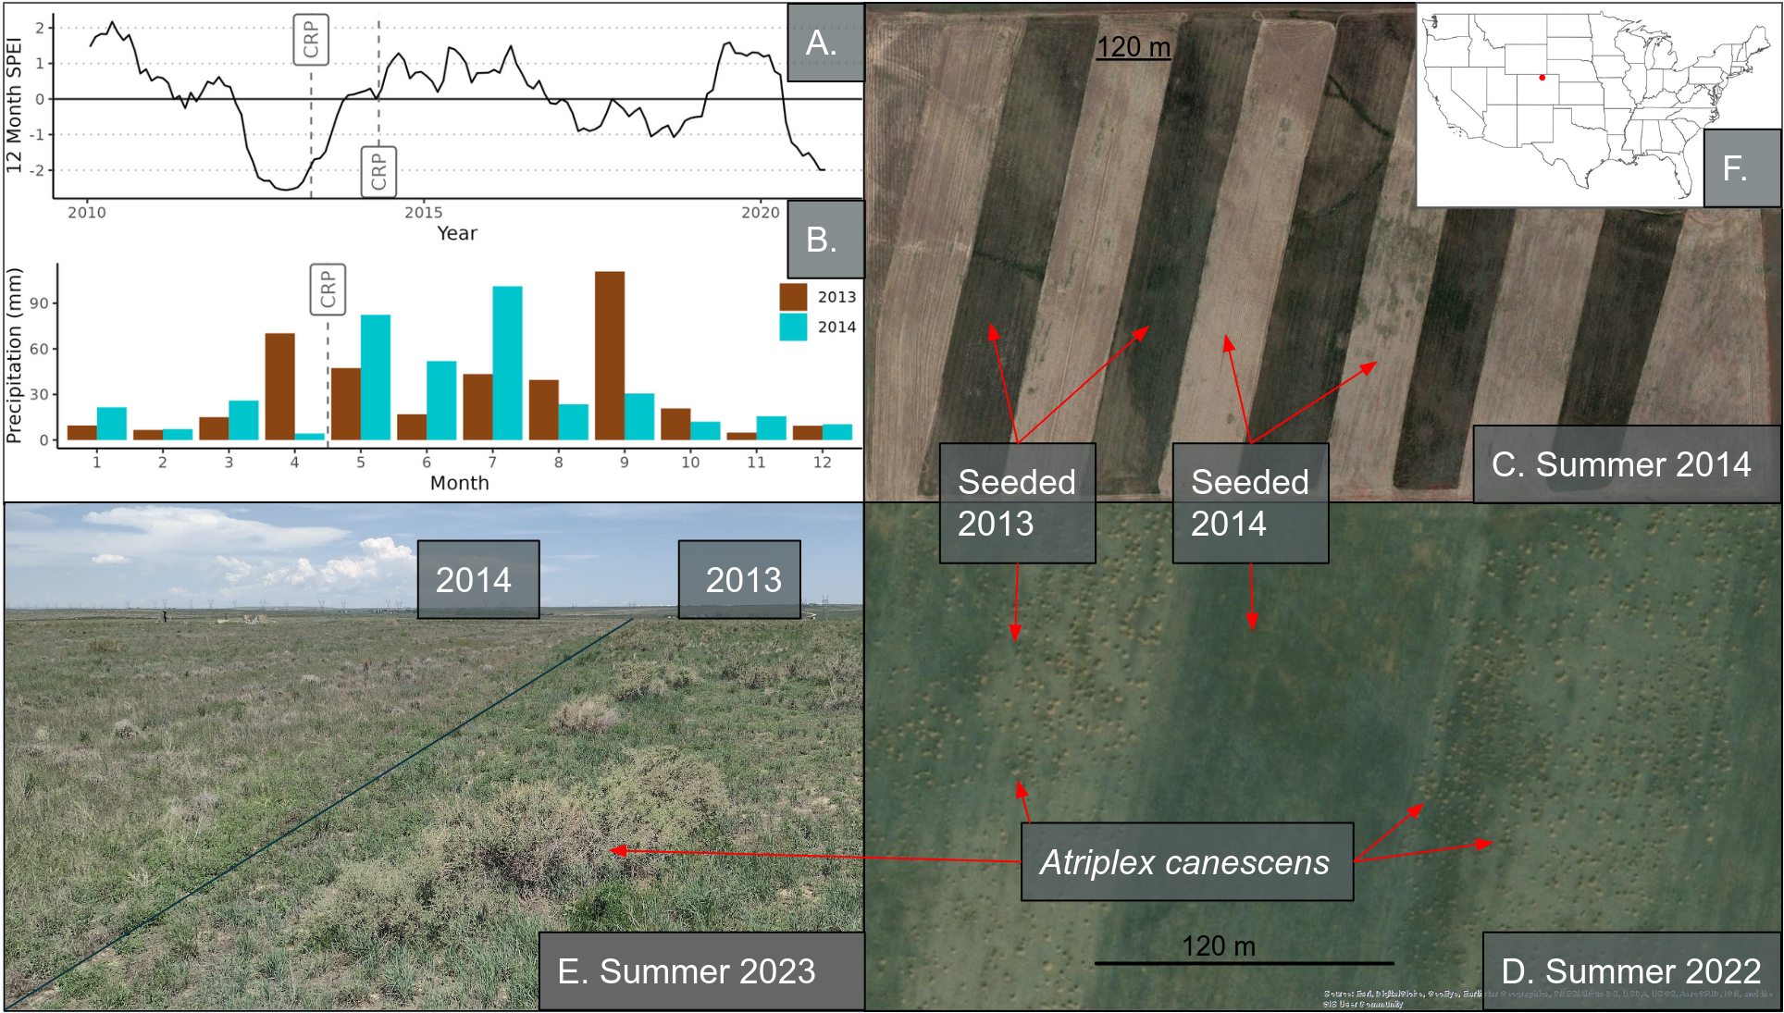

Figure 1

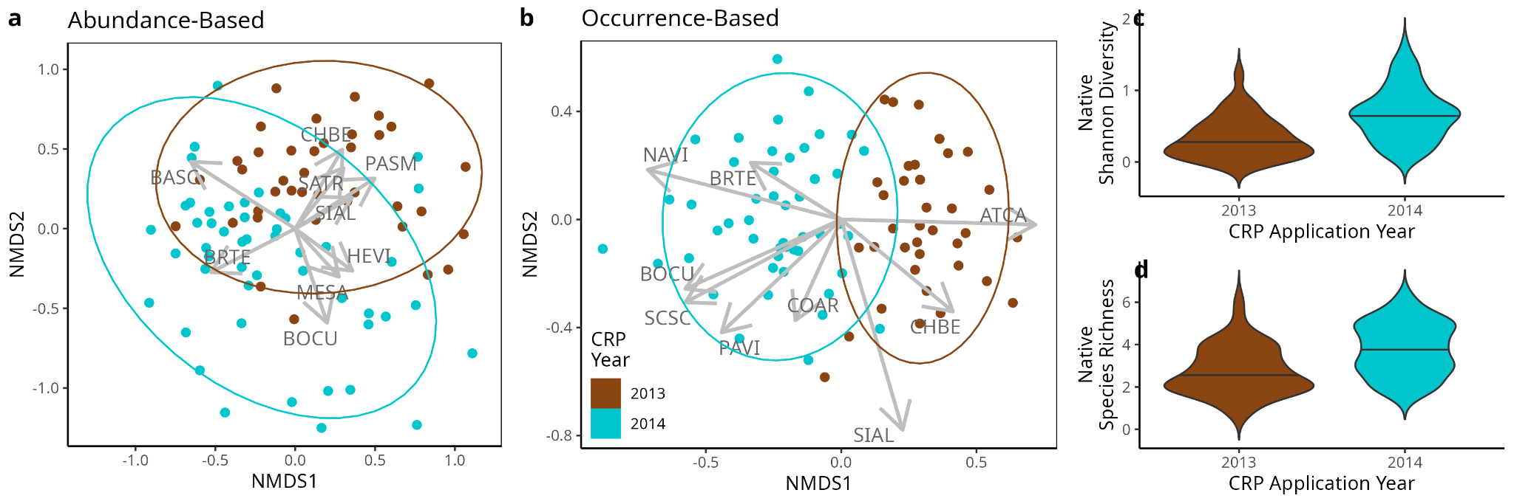

Figure 2

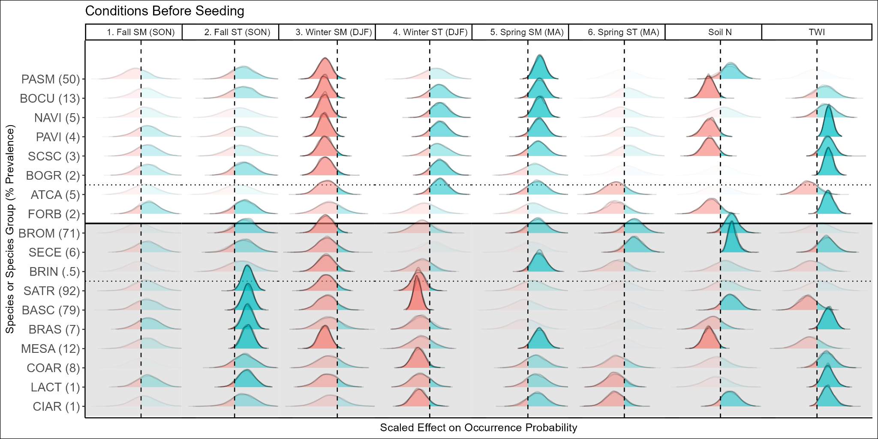

Figure 3

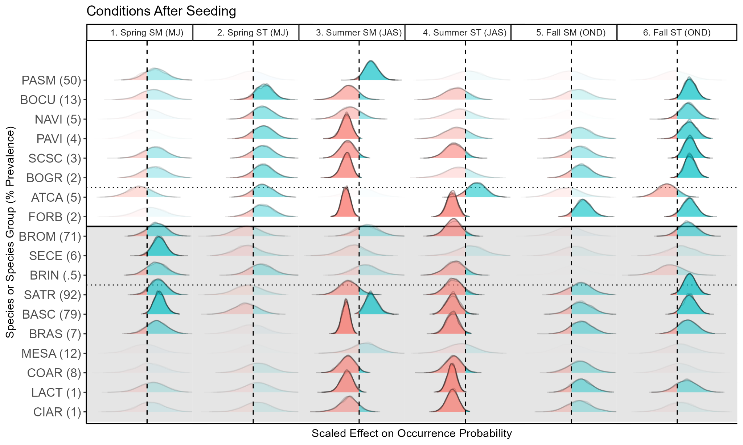

Figure 4

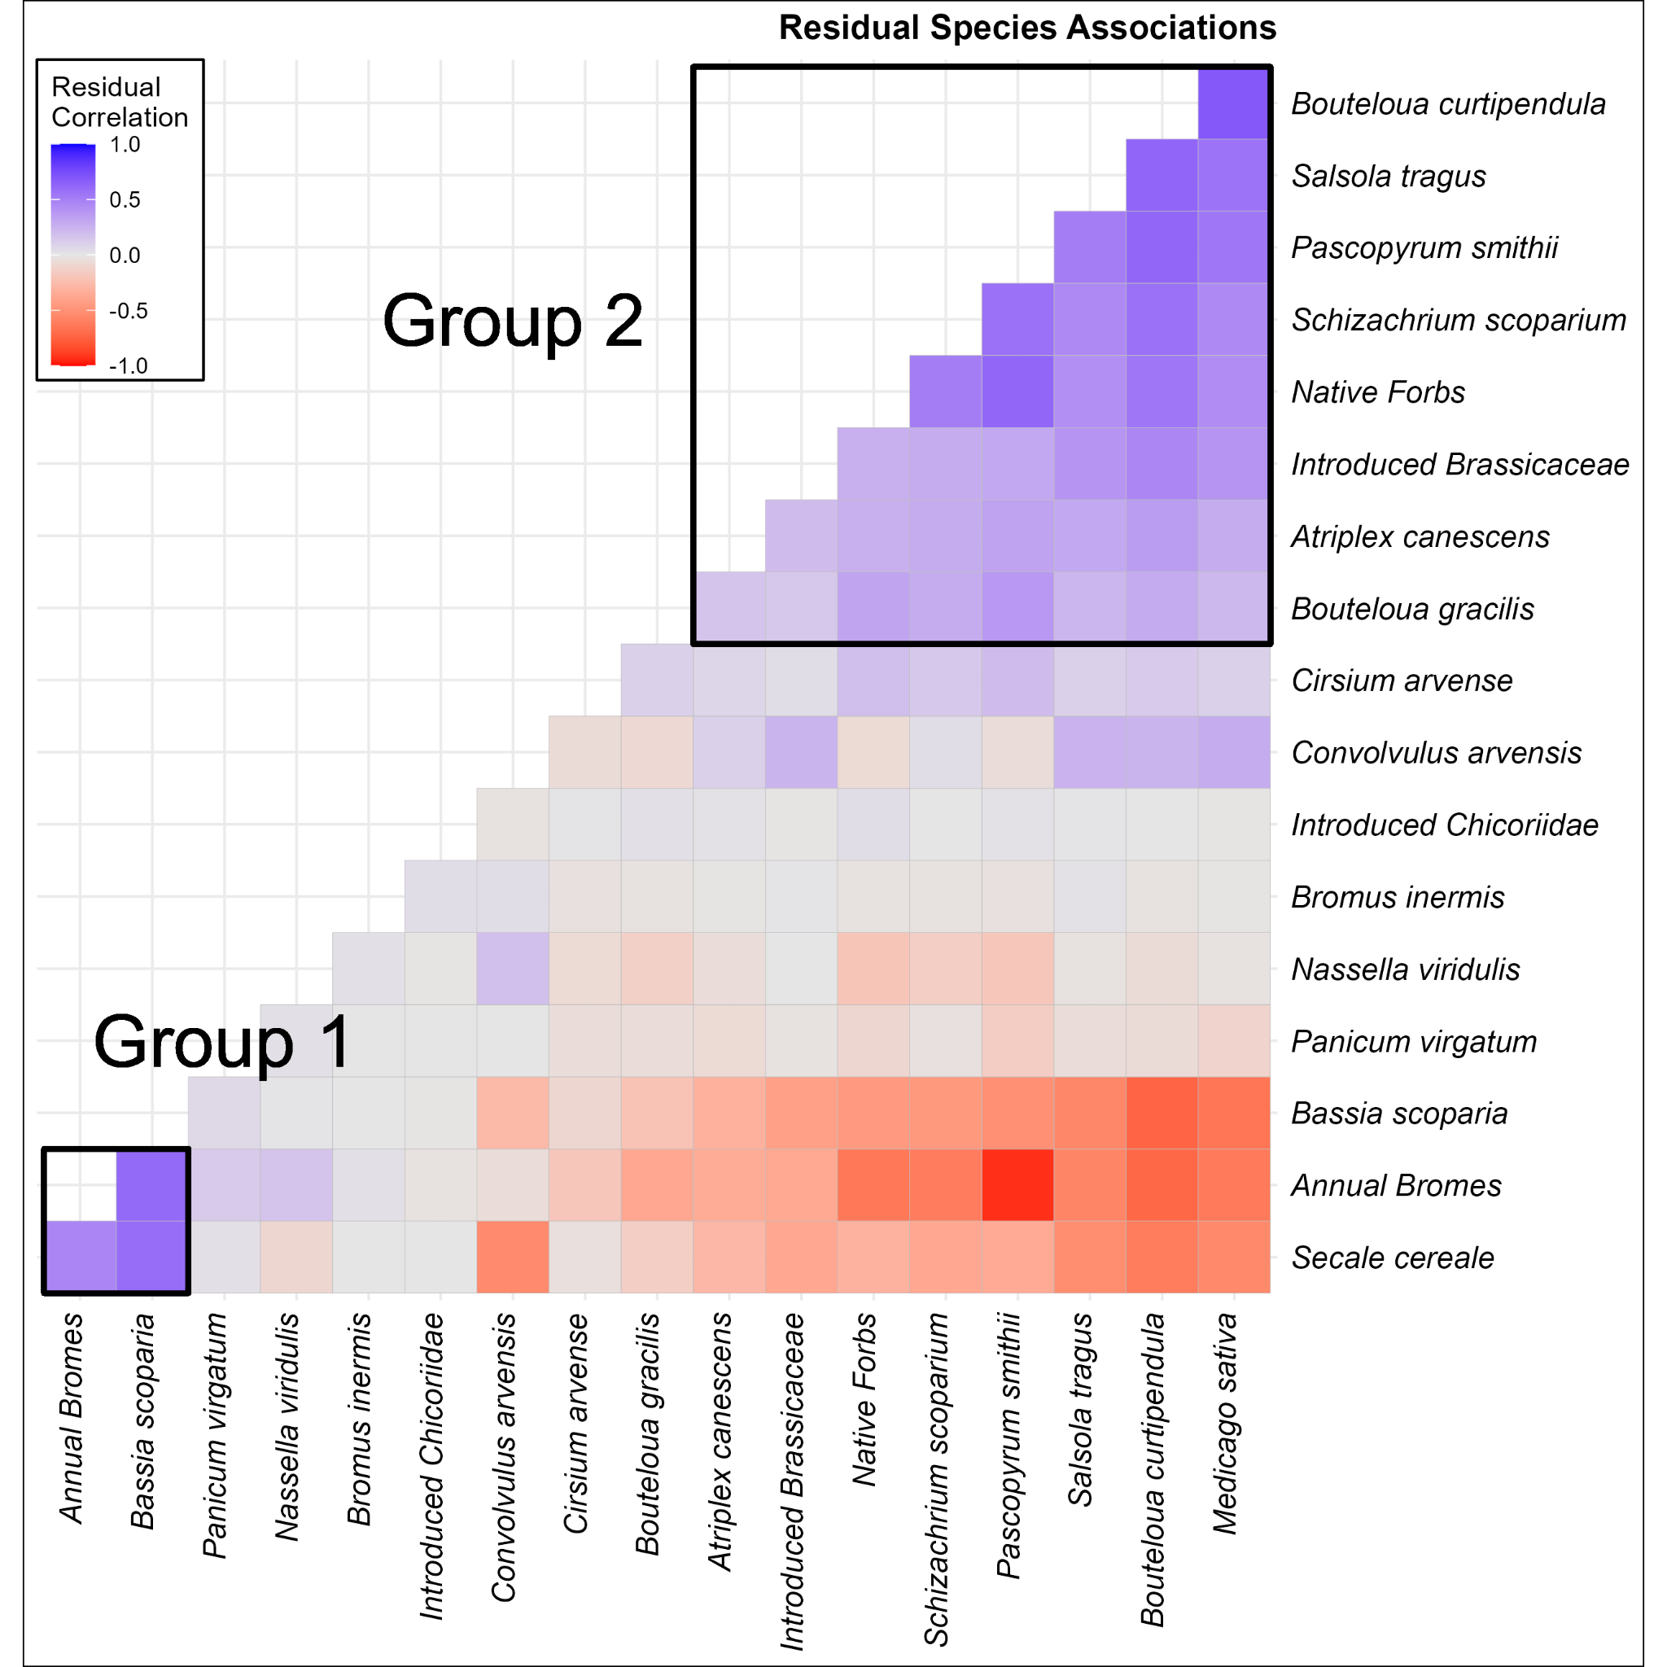Figure 5

Supplementary Figures and Tables

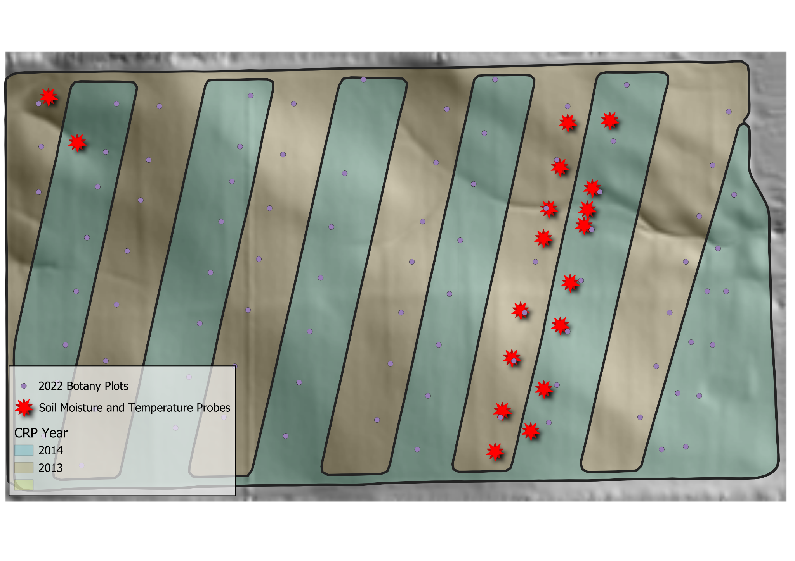

Figure S1. The study site. The background is a 5m digital elevation model, stars indicate the locations of soil temperature and moisture probes, dots indicate the location of 2022 botany plots, and the shaded areas indicate the year that the CRP seeding application was conducted. Probe locations were chosen to represent the range of topographic complexity while also allowing for the comparison of the effect of management. .

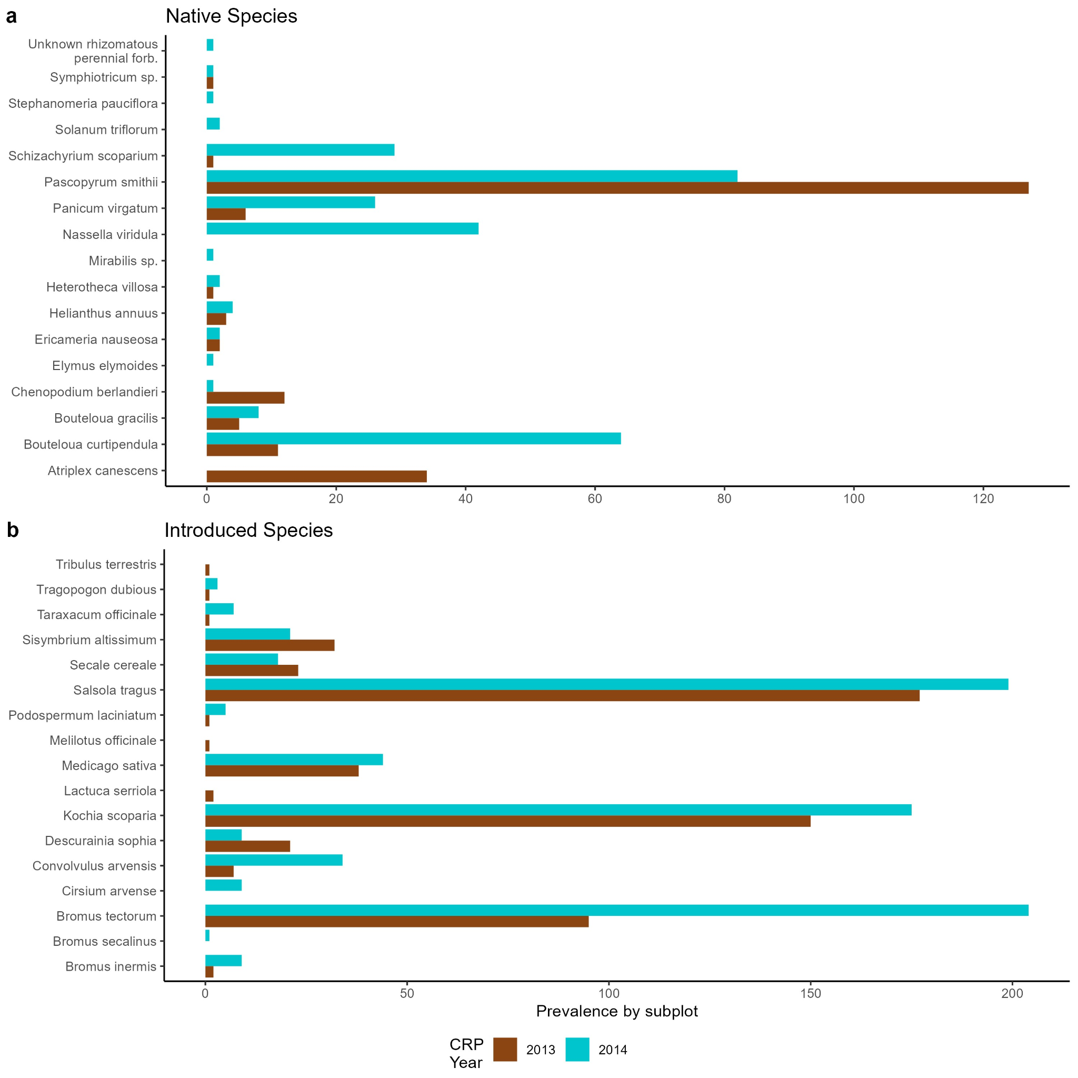

Figure S2. Species prevalence. Prevalence (number of plots in which a species was encountered) for each plant species encountered across the study site for native species (a) and introduced species (b).
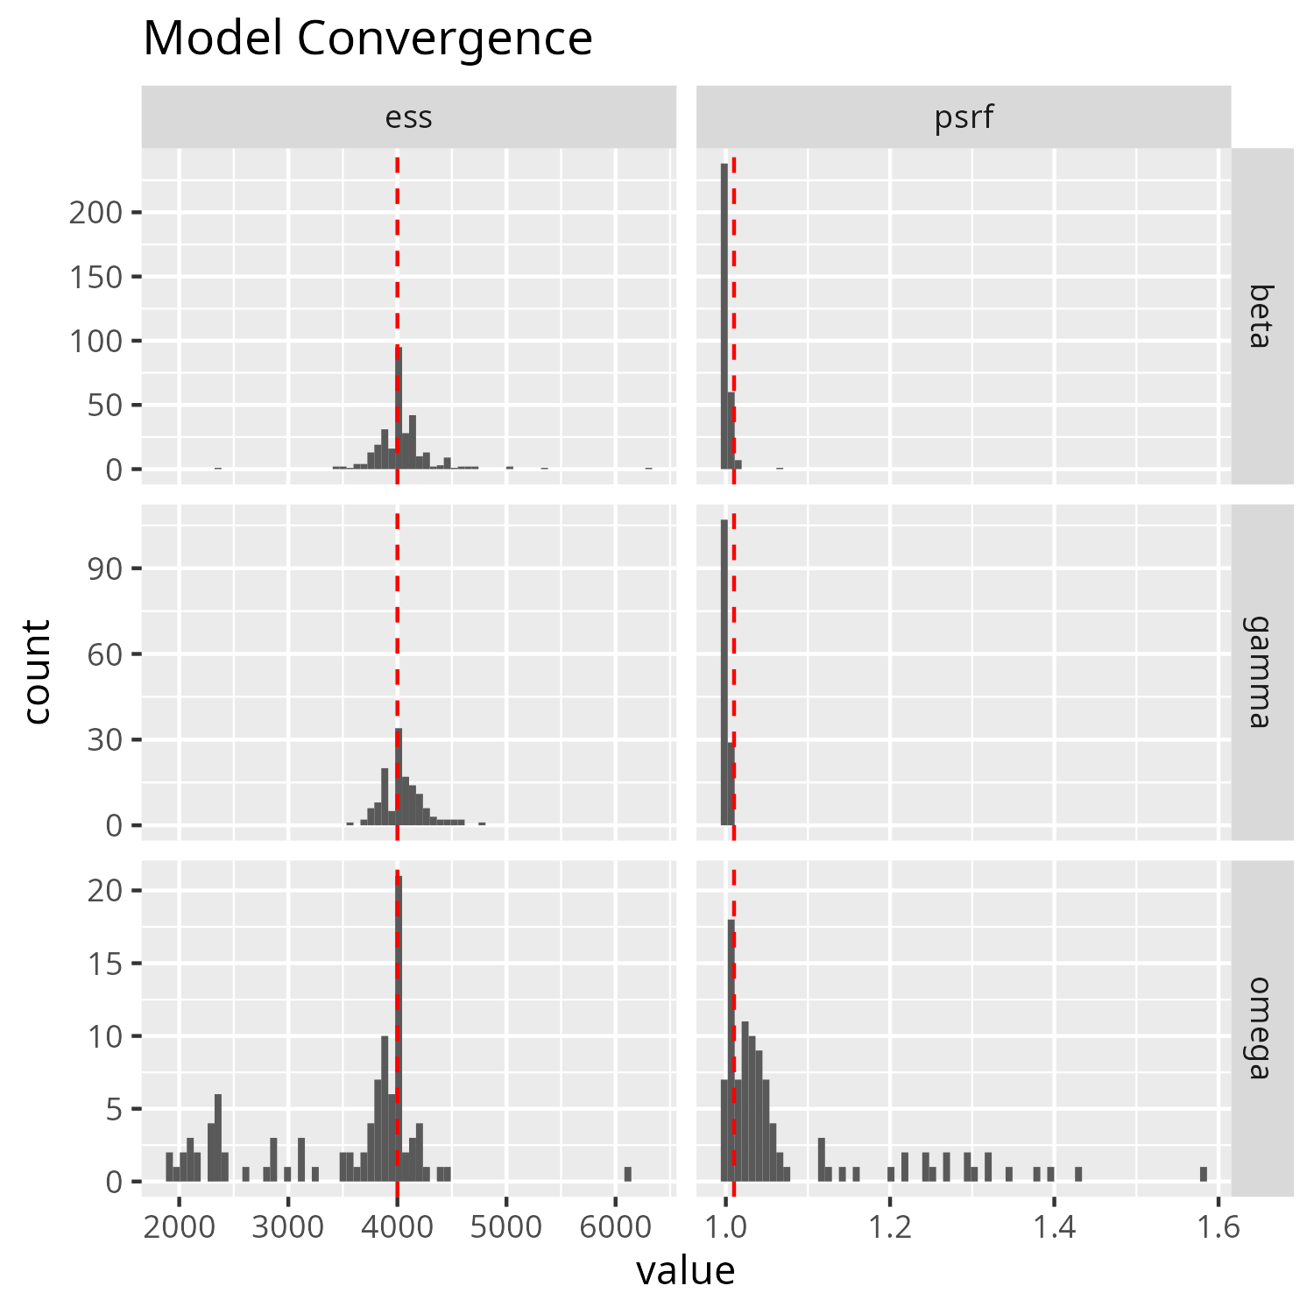

FIgure S3: Model convergence diagnostics. The potential scale reduction factor (PSRF) measures the convergence among chains, and being closer 1.0 is ideal. The vertical red dashed line lies at 1.001, a sensible target for most values to be less than. Effective sample size (ESS) measures autocorrelation between successive iterations within each chain, and higher values are better. Ideally ESS matches the number of posterior samples (indicated by the vertical red dashed line), but that is not fully necessary. Betas are the parameters for environmental filters, gammas are the parameters for the traits, and omegas are the parameters for the species associations.

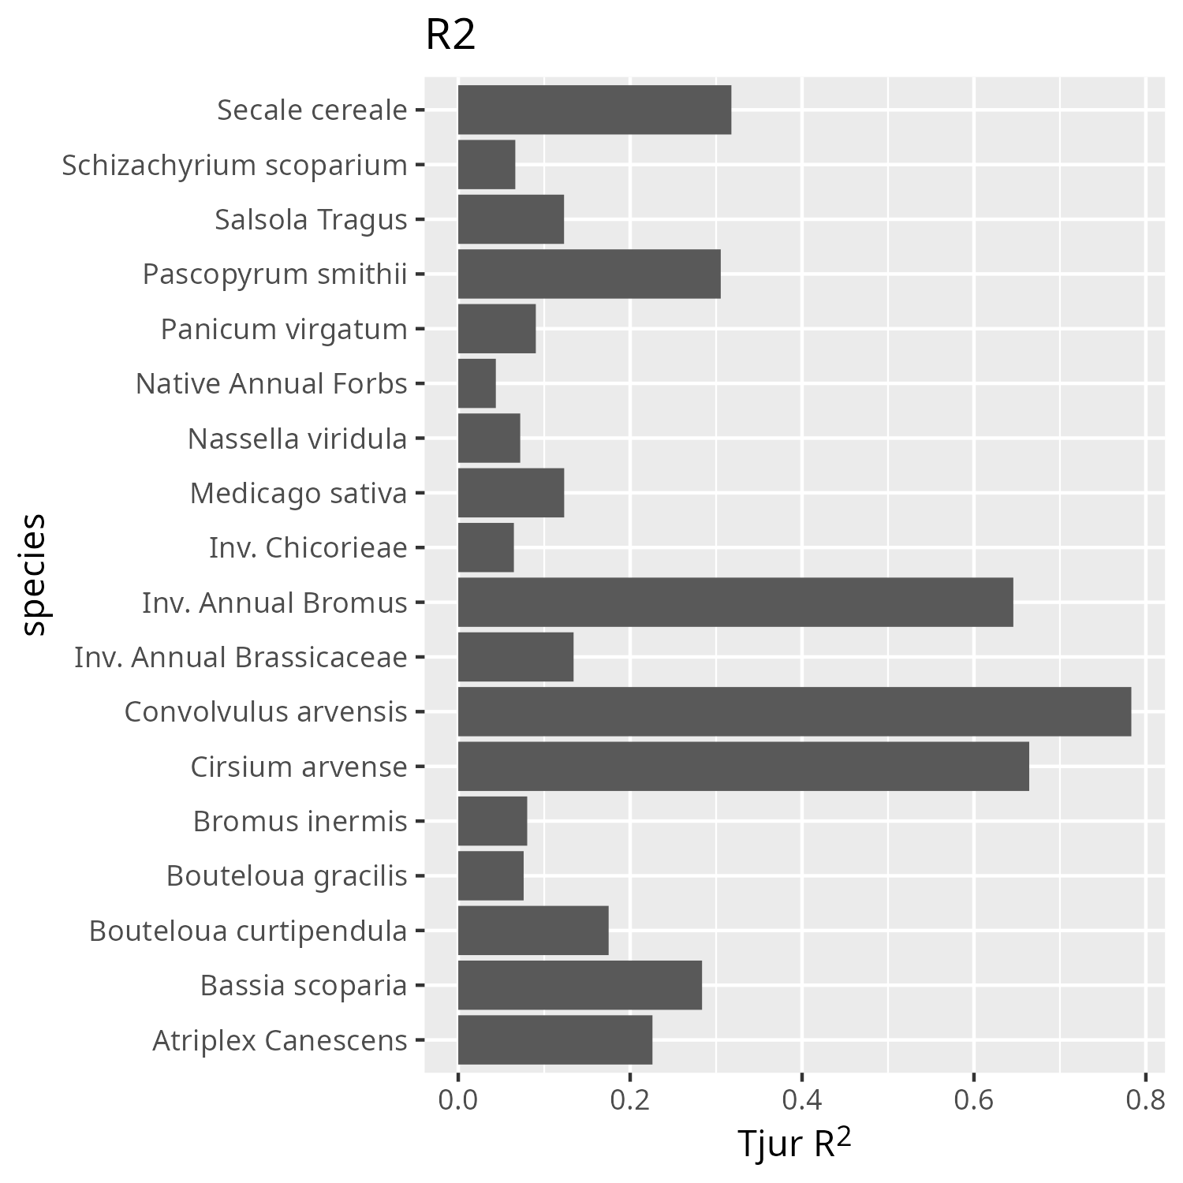

Figure S4: R2 values for each species or species group.

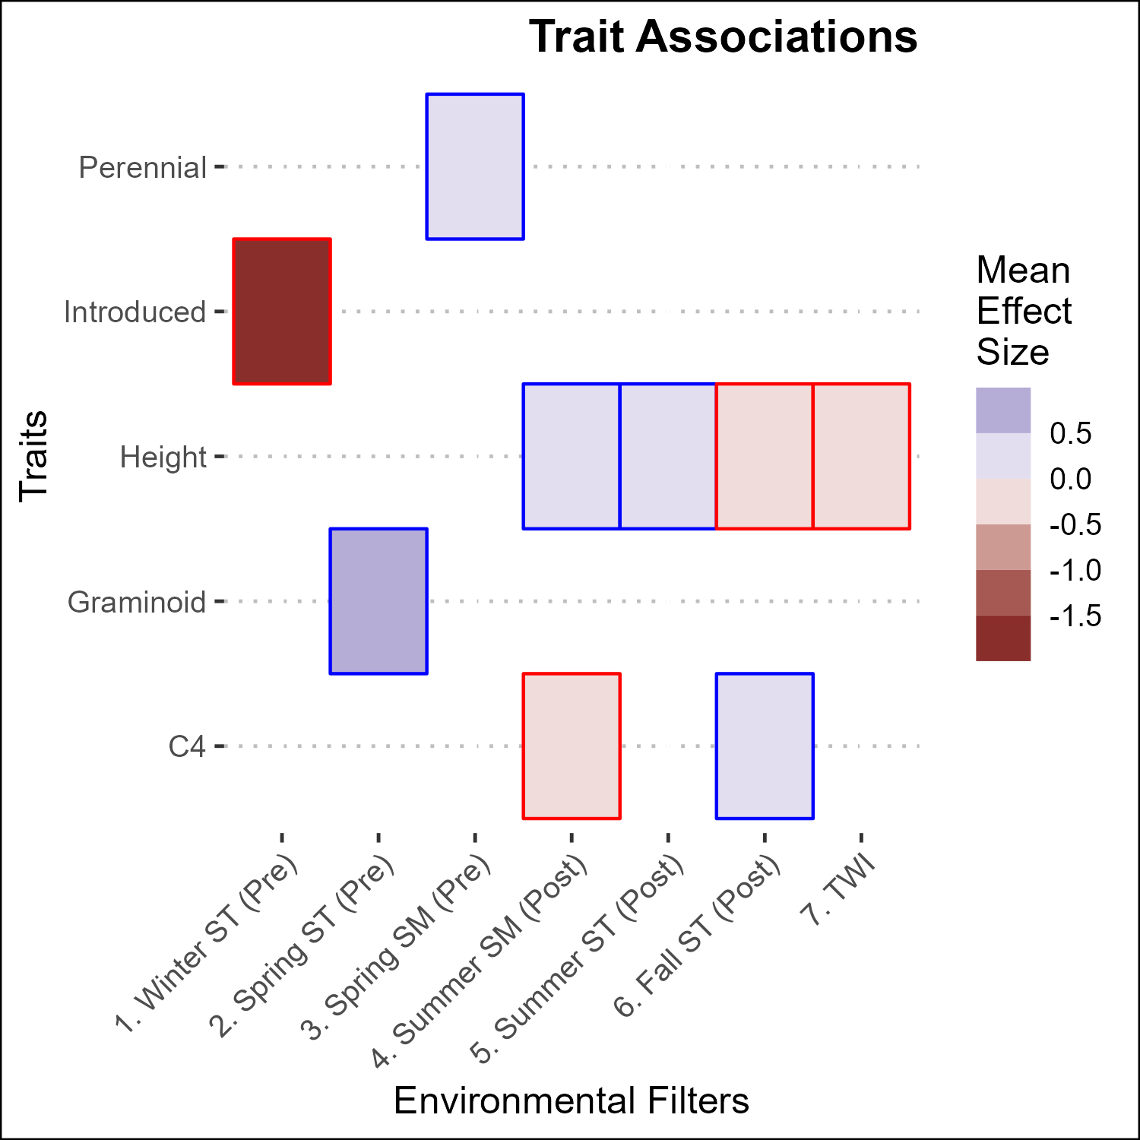

Figure S5. Associations between traits and environmental filters. Only associations whose posterior estimates were 89% positive or negative are shown. Boxes with blue outlines represent positive associations, red negative.
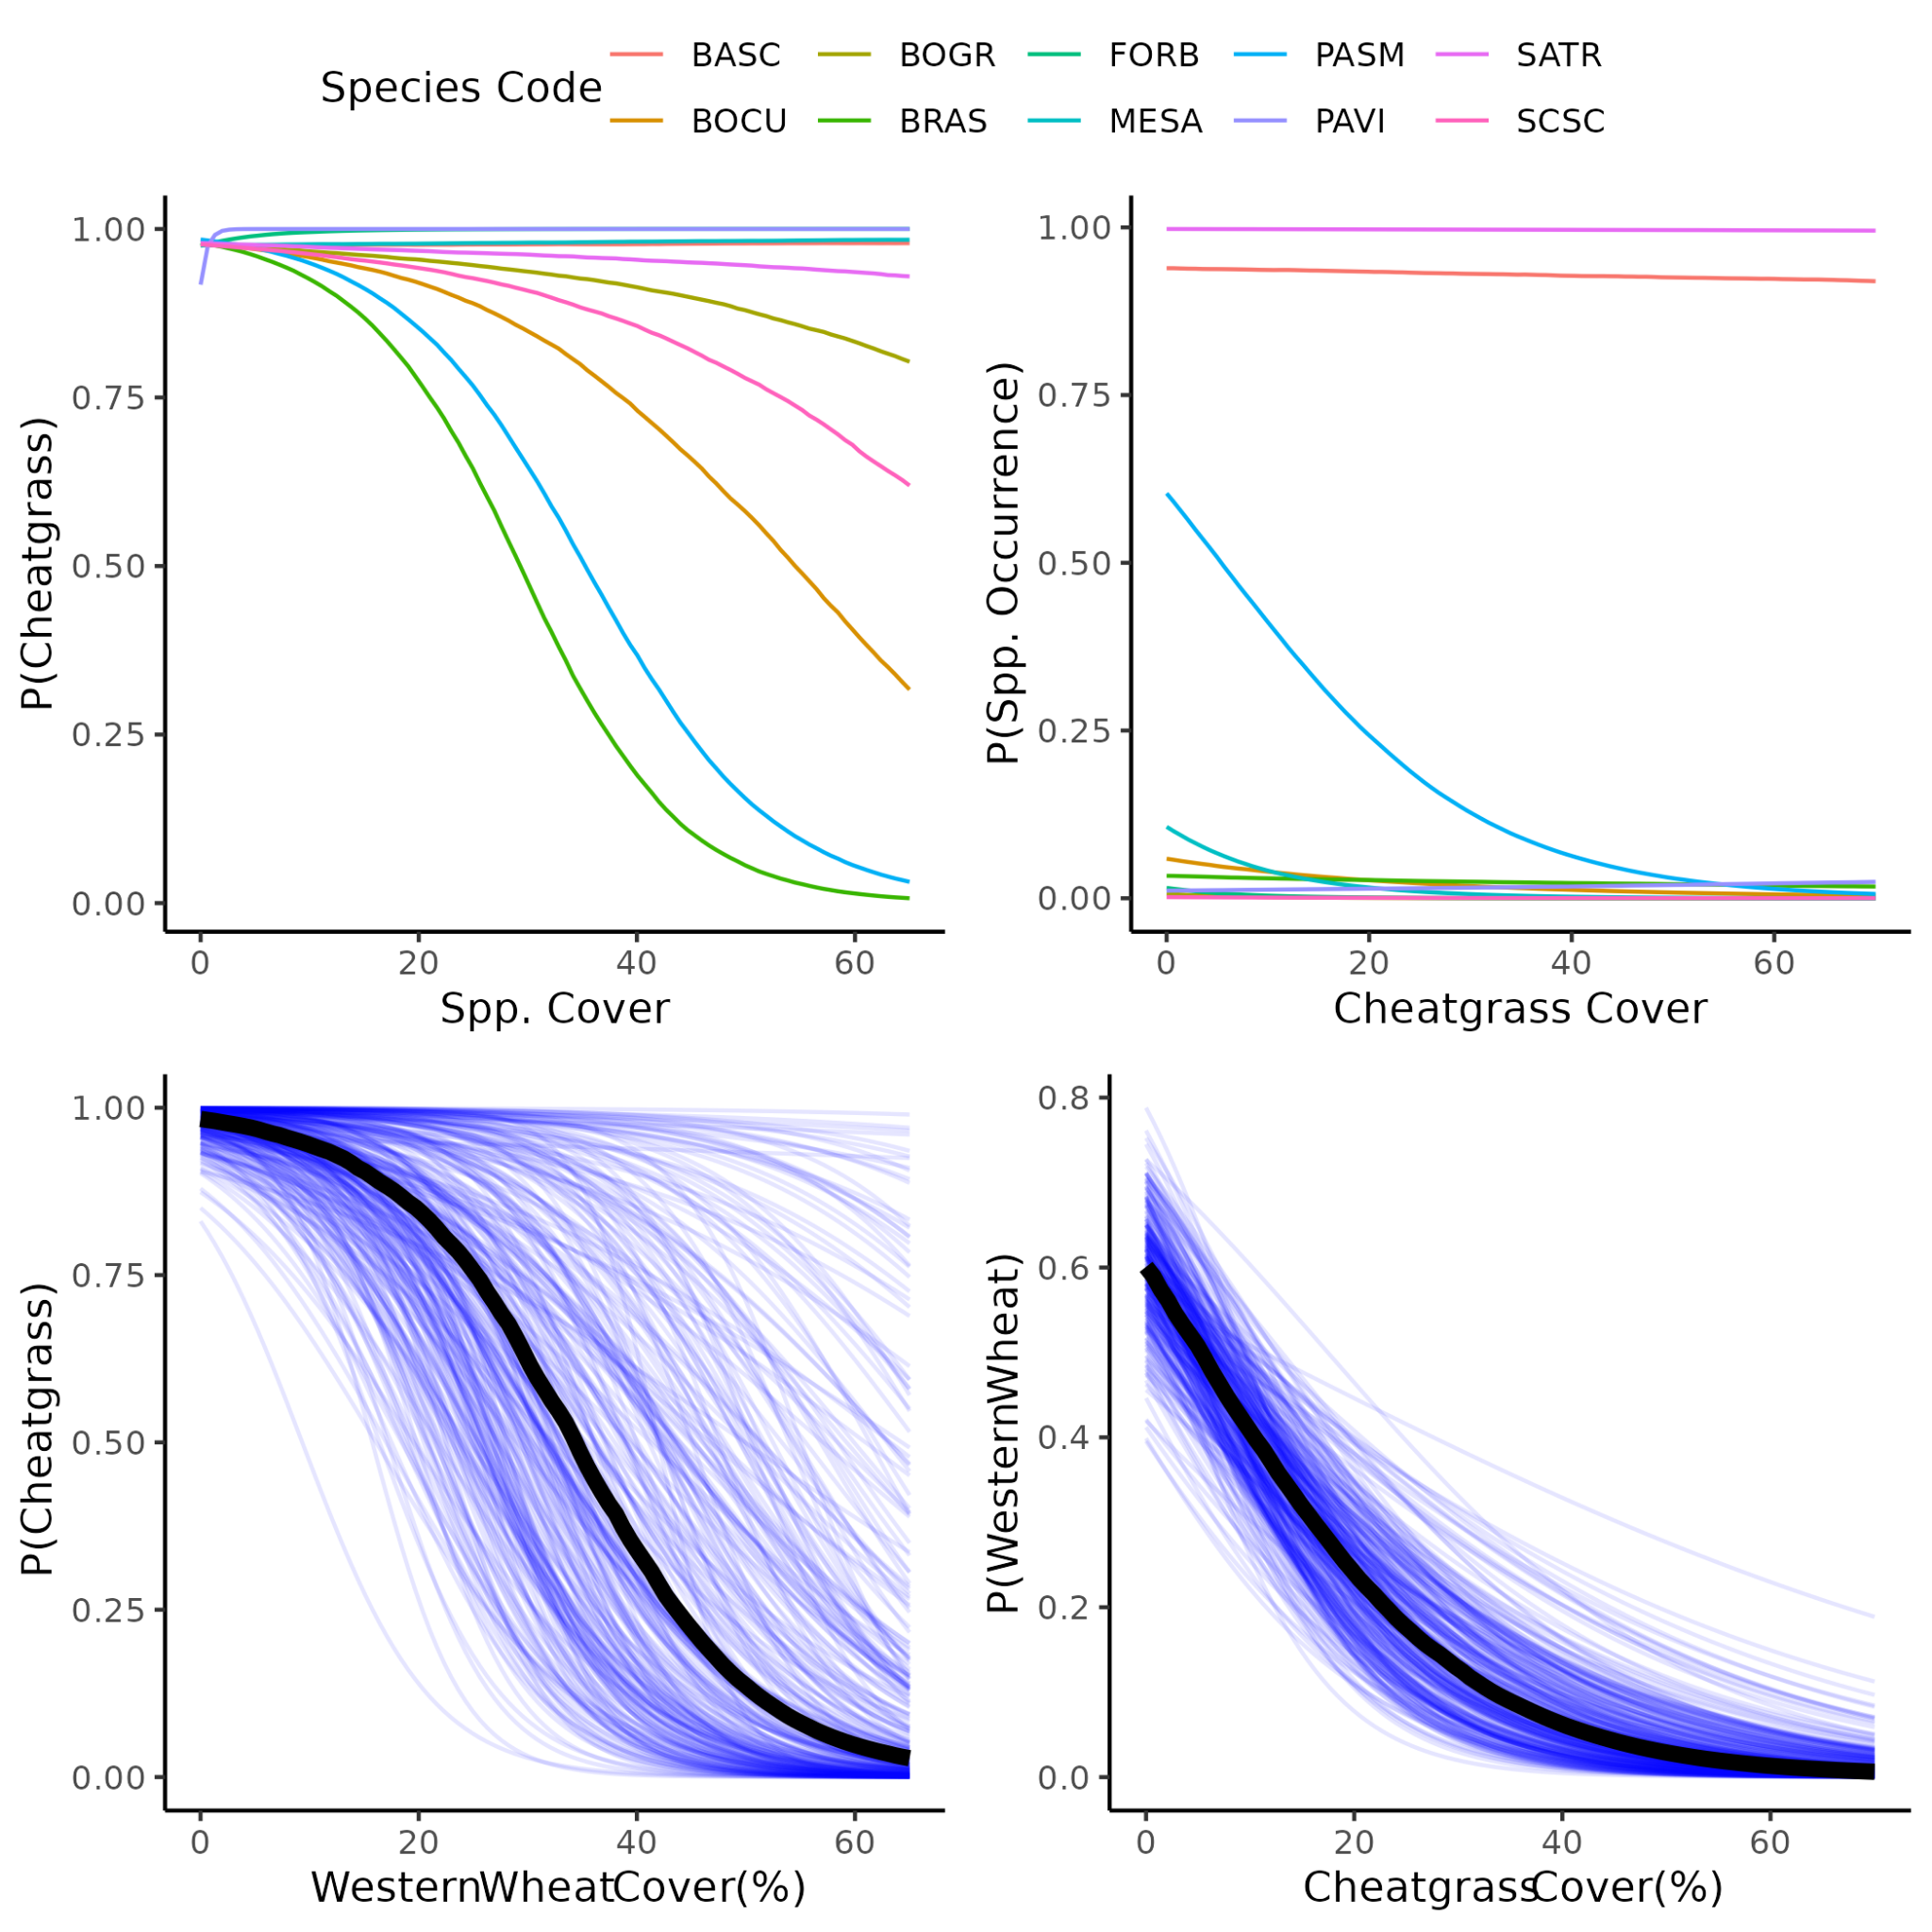

Figure S6. Western Wheatgrass and Cheatgrass interactions, compared to other species. This is using abundance data on the y axes to estimate the occurrence of a given species. P. smithii and cheatgrass had strong effects on each others’ occurrence, compared to other species. THis was consistent with field observations.

Table S1: All species encountered. Many species were encountered outside of the 0.1 m2 quadrats used for the JSDM, and so were not assigned to groups. Those species were still used in the diversity calculations.
Family | Genus | Specific epithet | Group Code | Group Name | CRP Mix | origin | Seed Applied (kg/ha)
Asteraceae | Gutierrezia | sarothrae | GUSA | Gutierrezia sarothrae | no | native
Asteraceae | Ericameria | nauseosa | ERNA | Ericameria nauseosa | no | native
Asteraceae | Heterotheca | villosa | HEVI | Heterotheca villosa | no | native
Asteraceae | Helianthus | annuus | HEAN | Helianthus annuus | no | native
Asteraceae | Stephanomeria | pauciflora | FORB | Native Forbs | no | native
Asteraceae | cf Aster | d_081_herb_05 | FORB | Native Forbs | no | native
Asteraceae | Antennaria | sp. | ANSP | Antennaria sp | no | native
Asteraceae | Artemisia | arbuscula | ARAR | Artemisia arbuscula | no | native
Chenopodiaceae | Atriplex | canescens | ATCA | Atriplex canescens | yes | native | 0.2676
Chenopodiaceae | Chenopodium | berlandieri | FORB | Native Forbs | no | native
Malvaceae | Sphaerelcea | coccinea | SPCO | Sphaerelcea coccinea | no | native
Papaveraceae | Argemone | cf hispida | ARHI | Argemone cf hispida | no | native
Poaceae | Bouteloua | curtipendula | BOCU | Bouteloua curtipendula | yes | native | 0.6244
Poaceae | Panicum | virgatum | PAVI | Panicum virgatum | yes | native | 0.1784
Poaceae | Schizachyrium | scoparium | SCSC | Schizachyrium scoparium | yes | native | 0.3568
Poaceae | Nassella | viridula | NAVI | Nassella viridula | yes | native | 0.7136
Poaceae | Pascopyrum | smithii | PASM | Pascopyrum smithii | yes | native | 1.784
Poaceae | Bouteloua | gracilis | BOGR | Bouteloua gracilis | yes | native | 0.1784
Poaceae | Elymus | elymoides | ELEL | Elymus elymoides | no | native
Solanaceae | Solanum | triflorum | FORB | Native Forbs | no | native
Nyctaginaceae | Mirabilis | sp | FORB | Native Forbs | no | native
unknown | Rhizomatous_perennial_forb | d_141_herb_09 | FORB | Native Forbs | no | native
Asteraceae | Scorzonera | laciniata | LACT | Introduced Cichorioideae | no | introduced
Asteraceae | Taraxacum | officinale | LACT | Introduced Cichorioideae | no | introduced
Asteraceae | Tragopogon | dubious | LACT | Introduced Cichorioideae | no | introduced
Asteraceae | Cirsium | arvense | CIAR | Cirsium arvense | no | introduced
Asteraceae | Onopordium | acanthium | ONAC | Onopordium acanthium | no | introduced
Asteraceae | Lactuca | serriola | LASE | Lactuca serriola | no | introduced
Brassicaceae | Sisymbrium | altissimum | BRAS | Introduced Brassicaceae | no | introduced
Brassicaceae | Descurainia | sophia | BRAS | Introduced Brassicaceae | no | introduced
Chenopodiaceae | Salsola | tragus | SATR | Salsola tragus | no | introduced
Chenopodiaceae | Bassia | scoparia | BASC | Bassia scoparia | no | introduced
Convolvulaceae | Convolvulus | arvensis | COAR | Convolvulus arvensis | no | introduced
Fabaceae | Medicago | sativa | MESA | Medicago sativa | yes | introduced | 0.3568
Fabaceae | Melilotus | officinale | MEOF | Melilotus officinale | no | introduced
Poaceae | Bromus | tectorum | BROM | Introduced Annual Bromus | no | introduced
Poaceae | Secale | cereale | SECE | Secale cereale | no | introduced
Poaceae | Bromus | inermis | BRIN | Bromus inermis | no | introduced
Poaceae | Bromus | secalinus | BROM | Introduced Annual Bromus | no | introduced
Poaceae | Agropyron | cristatum | AGCR | Agropyron cristatum | no | introduced
Zygophyllaceae | Tribulus | terrestris | TRTE | Tribulus terrestris | no | introduced

Table S2: R packages used in the analysis.
Package | Purpose | Citation
sf | Spatial vector data management | Pebesma 2018
terra | Raster data management | Hijmans 2023a
raster | Raster data management | Hijmans 2023b
vegan | Diversity and NMDS | Oksanen et al 2022
SPEI | Calculating SPEI | Beguería and Vicente-Serrano 2023
microclima | Calculating air temperature | Mosedale et al 2023
NicheMapR | Calculating air temperature | Kearney 2022
topmodel | Calculating TWI | Buytaert 2022
tidyverse | Data wrangling | Wickham et al 2019
lubridate | Date wrangling | Grolemond and Wickham 2011
vroom | Data wrangling | Hester et al 2023
Hmsc | Joint species distribution modeling | Tikhonov et al 2023
snow | parallelization | Tierney et al 2021
fields | spatial process models | Nychka et al 2021
ggpubr | visualization | Kassambara 2023
ggcorrplot | visualization | Kassambara 2022
ggthemes | visualization | Arnold 2021
ggtext | visualization | Wilke 2021
ggrepel | visualization | Slowikowski 2023
ggmcmc | visualization | Fernandez i Marin 2016
geomtextpath | visualization | Cameron and van den Brand 2022

Table S3. Species included in the CRP mix.
Common Name | Scientific Name | Amount Applied (kg/ha) | Origin
Western wheatgrass | Pascopyrum smithii | 1.784 | native
Green needlegrass | Nassela viridula | 0.7136 | native
Sideoats gramma | Bouteloua curtipendula | 0.6244 | native
Alfalfa | Medicago sativa | 0.3568 | introduced
Little bluestem | Schizachyrium scoparium | 0.3568 | native
Fourwing Saltbush | Atriplex canescens | 0.2676 | native
Blue gramma | Bouteloua gracilis | 0.1784 | native
Switchgrass | Panicum virgatum | 0.1784 | native

Table S4 life history traits of species used in the JSDM analysis.
species group | Mean height | introduced | perennial | woody | graminoid | rhizomatous | Photosynthetic pathway
Invasive Annual Bromus | 19 | yes | no | no | yes | no | c3
Bassia scoparia | 11 | yes | no | no | no | no | c3
Salsola tragus | 10 | yes | no | no | no | no | c4
Pascopyrum smithii | 22 | no | yes | no | yes | yes | c3
Bouteloua curtipendula | 24 | no | yes | no | yes | no | c4
Medicago sativa | 27.5 | yes | yes | no | no | no | c3
Invasive annual Brassicaceae | 21 | yes | no | no | no | no | c3
Nasella viridulis | 41.5 | no | yes | no | yes | no | c4
Invasive Chicorioideae | 10.5 | yes | yes* | no | no | no | c3
Native  Forbs | 6 | no | yes | no | no | no | c4
Cirsium arvense | 12 | yes | yes | no | no | yes | c3
Convolvulus  arvensis | 8.5 | yes | yes | no | no | yes | c3
Panicum virgatum | 27.5 | no | yes | no | yes | no | c4
Schizachyrium scoparium | 19 | no | yes | no | yes | no | c4
Atriplex canescens | 115 | no | yes | yes | no | no | c4
Bouteloua gracilis | 19 | no | yes | no | yes | no | c4
Bromus inermis | 33 | yes | yes | no | yes | yes | c3
Secale cereale | 38.5 | yes | no | no | yes | no | c3
* two species (5 occurrences) are perennial/biennial, one species (1 occurrence) is annual/biennial

Supplementary References

Jeffrey B. Arnold (2021). ggthemes: Extra Themes, Scales and Geoms for 'ggplot2'. R package version 4.2.4.
https://CRAN.R-project.org/package=ggthemes

Santiago Beguería and Sergio M. Vicente-Serrano (2023). SPEI: Calculation of the Standardized Precipitation-Evapotranspiration Index. R package version 1.8.1.
https://CRAN.R-project.org/package=SPEI

Wouter Buytaert (2022). topmodel: Implementation of the Hydrological Model TOPMODEL in R. R package version 0.7.5.
https://CRAN.R-project.org/package=topmodel

Allan Cameron and Teun van den Brand (2022). geomtextpath: Curved Text in 'ggplot2'. R package version 0.1.1.
https://CRAN.R-project.org/package=geomtextpath

Xavier Fernández i Marín (2016). ggmcmc: Analysis of MCMC Samples and Bayesian Inference. Journal of Statistical Software, 70(9), 1-20
www.doi.org/10.18637/jss.v070.i09

Garrett Grolemund, Hadley Wickham (2011). Dates and Times Made Easy with lubridate. Journal of Statistical Software, 40(3), 1-25.
https://www.jstatsoft.org/v40/i03/

Jim Hester, Hadley Wickham and Jennifer Bryan (2023). vroom: Read and Write Rectangular Text Data Quickly. R package version 1.6.3.
https://CRAN.R-project.org/package=vroom

Robert J. Hijmans (2023a). terra: Spatial Data Analysis. R package version 1.7-29.
https://CRAN.R-project.org/package=terra

Robert J. Hijmans (2023b). raster: Geographic Data Analysis and Modeling. R package version 3.6-20.
https://CRAN.R-project.org/package=raster

Alboukadel Kassambara (2022). ggcorrplot: Visualization of a Correlation Matrix using 'ggplot2'. R package
version 0.1.4. https://CRAN.R-project.org/package=ggcorrplot

Alboukadel Kassambara (2023). ggpubr: 'ggplot2' Based Publication Ready Plots. R package version 0.6.0.
https://CRAN.R-project.org/package=ggpubr

Michael Kearney (2022). NicheMapR: R implementation of Niche Mapper software for biophysical modelling. R package version 3.2.0.
https://github.com/mrke/NicheMapR

Jonathan Mosedale, Jonathan Bennie and James Duffy (2023). microclima: microclimate modelling with R. R package version 0.1.0.
https://github.com/ilyamaclean/microclima

Douglas Nychka, Reinhard Furrer, John Paige, Stephan Sain (2021). “fields: Tools for spatial data.” R package version 14.1.
https://github.com/dnychka/fieldsRPackage

Jari Oksanen, Gavin L. Simpson, F. Guillaume Blanchet, Roeland Kindt, Pierre Legendre, Peter R. Minchin, R.B. O'Hara, Peter Solymos, M. Henry H. Stevens, Eduard Szoecs, Helene Wagner, Matt Barbour, Michael Bedward, Ben Bolker, Daniel Borcard, Gustavo Carvalho, Michael Chirico, Miquel De Caceres, Sebastien Durand, Heloisa Beatriz Antoniazi Evangelista, Rich FitzJohn, Michael Friendly, Brendan Furneaux, Geoffrey Hannigan, Mark O. Hill, Leo Lahti, Dan McGlinn, Marie-Helene Ouellette, Eduardo Ribeiro Cunha, Tyler Smith, Adrian Stier, Cajo J.F. Ter Braak and James Weedon (2022). vegan: Community Ecology Package. R package version 2.6-4.
https://CRAN.R-project.org/package=vegan

Pebesma, E., 2018. Simple Features for R: Standardized Support for Spatial Vector Data. The R Journal 10 (1), 439-446,
https://doi.org/10.32614/RJ-2018-009

Kamil Slowikowski (2023). ggrepel: Automatically Position Non-Overlapping Text Labels with 'ggplot2'. R package version 0.9.3.
https://CRAN.R-project.org/package=ggrepel

Gleb Tikhonov, Otso Ovaskainen, Jari Oksanen, Melinda de Jonge, Oystein Opedal and Tad Dallas (2023). Hmsc: Hierarchical Model of Species Communities. R package version 3.0-14.
https://www.helsinki.fi/en/researchgroups/statistical-ecology/software/hmsc

Wickham H, Averick M, Bryan J, Chang W, McGowan LD, François R, Grolemund G, Hayes A, Henry L, Hester J, Kuhn M, Pedersen TL, Miller E, Bache SM, Müller K, Ooms J, Robinson D, Seidel DP, Spinu V, Takahashi K, Vaughan D, Wilke, Woo K, Yutani H (2019). “Welcome to the tidyverse.” Journal of Open Source Software, 4(43), 1686.
https://doi.org/10.21105/joss.01686

Claus O. Wilke and Brenton M. Wiernik (2022). ggtext: Improved Text Rendering Support for 'ggplot2'. R package version 0.1.2.
https://CRAN.R-project.org/package=ggtext

