Agent Systems homework Report

Jędrzej Fijałkowski

Adam Malewski

Jan Baraniewski

1. **Summary.**

The aim of this exercise is to test characteristics/boundaries of messaging in the JADE agents platform. This is done for example by implementing the so called “spamming scenario” in which we create multiple agents (one for a machine) spamming messages and receiving them with one agent supervise the communication start and end.

1. **Introduction.**

System consists of 3 types of agents:

- Spammer agent (SA) – for spamming messages of chosen size and the set amount of them (set in EMS) and is called to execute by the EMS as well.

- Message consuming agent (MCA) – for reading and counting messages send by the spamming agent when they read all messages the send confirmation to EMS.

- Experiment master agent (EMS) – for supervising the message exchange, it counts the time for different scenarios of sending messages between the above two agents. Starting when the first message is sent and ending with confirmation of receiving the last one.

Spammer and Message consuming agents exist on each computer as a pair. EMS is instantiated. The number of computers in simulation is changed to see a proper change in time of the test.

1. **Tests and benchmarks.**

We check the relation between message size/number of them and time on sets of machines.

The data collected during the experiment is displayed in a table below.

|  |  |  |  |
| --- | --- | --- | --- |
| Number of computers | N (number of messages) | M (size of the message in bytes) | Avg time in ms (after 10 measurements) |
| 2 | 100 | 128 | 281.1 |
| 2 | 100 | 1024 | 348.5 |
| 2 | 500 | 128 | 975.2 |
| 2 | 500 | 1024 | 1155.4 |
| 4 | 100 | 128 | 672.1 |
| 4 | 100 | 1024 | 706.1 |
| 4 | 500 | 128 | 1630.5 |
| 4 | 500 | 1024 | 1924.5 |
| 6 | 100 | 128 | 597.3 |
| 6 | 100 | 1024 | 735.8 |
| 6 | 500 | 128 | 1723.4 |
| 6 | 500 | 1024 | 1972.4 |

Chart represents the data from the table. It shows the dependence between number of computers, size of messages , number of them and a time elapsed doing a full “spamming cycle”.

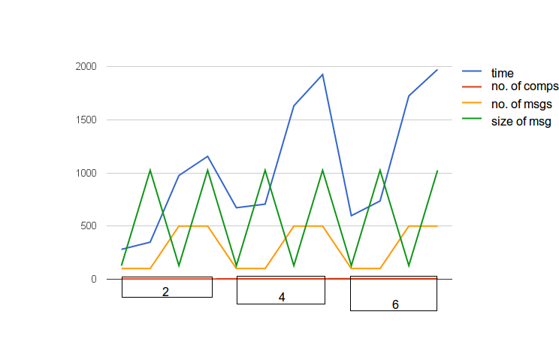

From this test we can directly conclude that the number of messages increases the time of the full spamming cycle by an increasing amount of time therefore it affects the performance of the platform in a severe way (when working with huge number of messages). However the size of the message seems to have not that great of an impact the function is almost linear. The difference in time for machines seems to spike after changing the number of machines from 2 to 4 but after that it stabilizes.

1. **Conclusions**

Java JADE agents platform seems, according to the results of the first test, to be very well optimised for huge messages exchanged between agents. The increase in time is predictable and increases in a moderate fashion for increasing message size.

Stabilisation of the time increase after adding the 4th computer indicates that the platform is capable of efficient handling of a huge number of agents.

The biggest spike in spamming cycle interval is shown for increased number of messages which may be a little worrying for agent systems handling exchange of vast amount of those.

Overall JADE platform performance characteristics seems to be that the platform is designed for huge numbers of agents exchanging efficiently big messages but the ability of handling huge amounts of messages is arguably poor but at the same time relatively efficient.