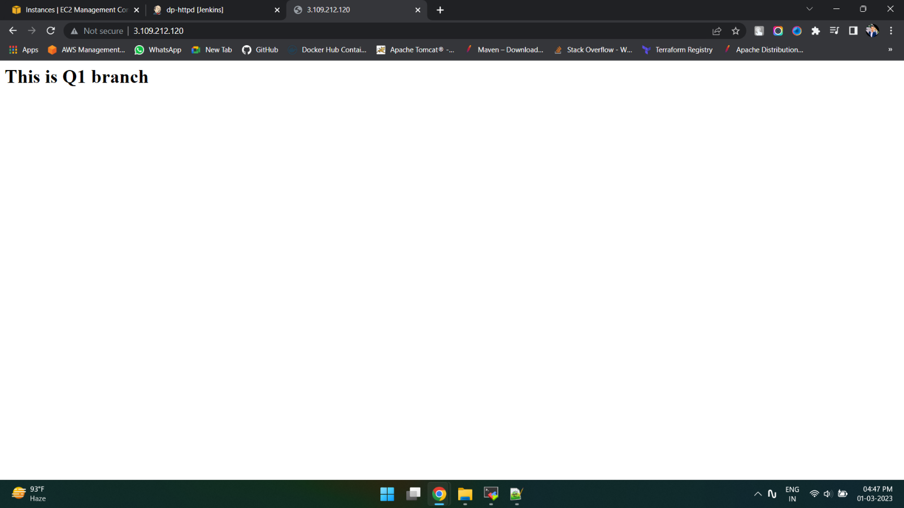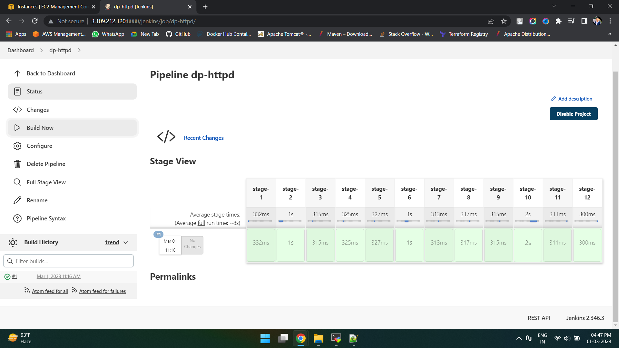Assignment- Pull index.html from 3 branches in git repo and deploy it in 3 docker container running in Jenkins master

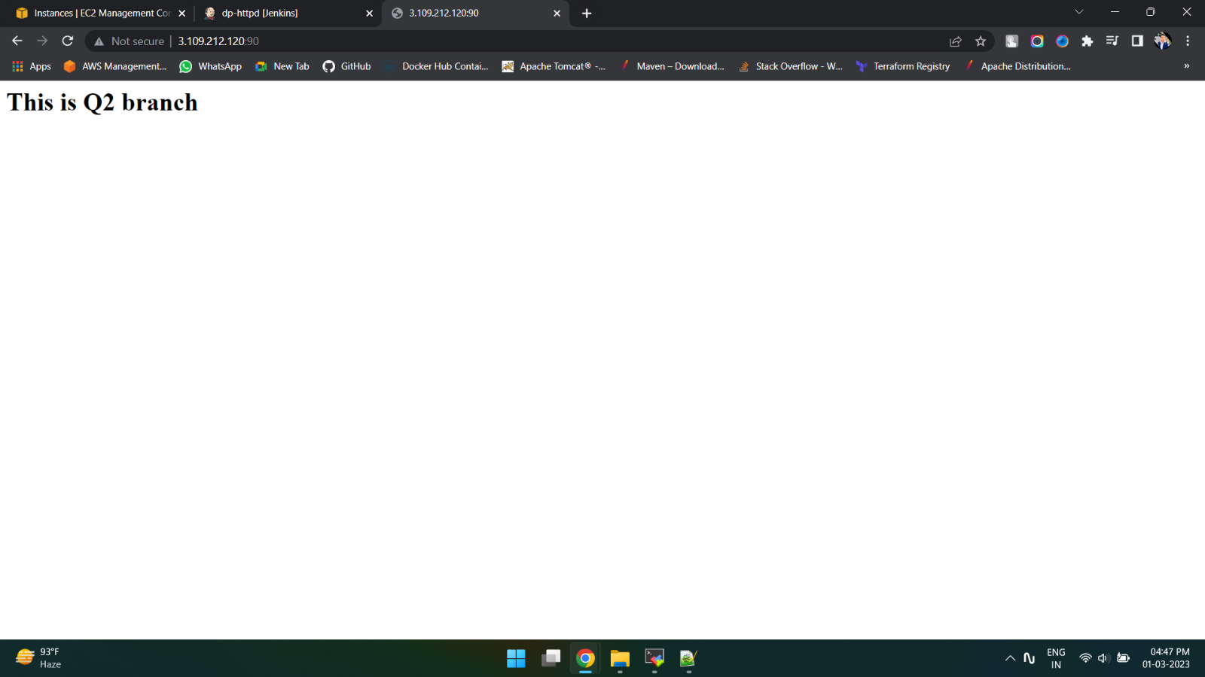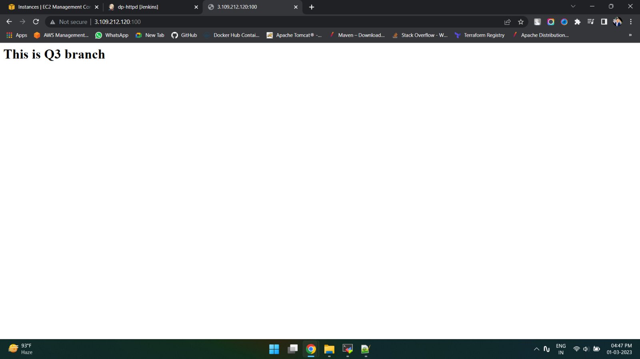

pipeline {

agent {

label{

label "built-in"

}

}

stages {

stage ('stage-1') {

steps {

sh "rm -rf /root/.jenkins/workspace/dp-httpd/httpd-index"

}

}

stage ('stage-2') {

steps {

sh "git clone https://github.com/admanerajat/httpd-index.git -b 23Q1"

}

}

stage ('stage-3') {

steps {

sh "chmod 777 /root/.jenkins/workspace/dp-httpd/httpd-index/index.html"

}

}

stage ('stage-4') {

steps {

sh "docker cp /root/.jenkins/workspace/dp-httpd/httpd-index/index.html httpd:/usr/local/apache2/htdocs"

}

}

stage ('stage-5') {

steps {

sh "rm -rf /root/.jenkins/workspace/dp-httpd/httpd-index"

}

}

stage ('stage-6') {

steps {

sh "git clone https://github.com/admanerajat/httpd-index.git -b 23Q2"

}

}

stage ('stage-7') {

steps {

sh "chmod 777 /root/.jenkins/workspace/dp-httpd/httpd-index/index.html"

}

}

stage ('stage-8') {

steps {

sh "docker cp /root/.jenkins/workspace/dp-httpd/httpd-index/index.html httpd1:/usr/local/apache2/htdocs"

}

}

stage ('stage-9') {

steps {

sh "rm -rf /root/.jenkins/workspace/dp-httpd/httpd-index"

}

}

stage ('stage-10') {

steps {

sh "git clone https://github.com/admanerajat/httpd-index.git -b 23Q3"

}

}

stage ('stage-11') {

steps {

sh "chmod 777 /root/.jenkins/workspace/dp-httpd/httpd-index/index.html"

}

}

stage ('stage-12') {

steps {

sh "docker cp /root/.jenkins/workspace/dp-httpd/httpd-index/index.html httpd2:/usr/local/apache2/htdocs"

}

}

}

}