Ddffdfdddfddcdcddddsdsds
DATA ENGINEERING PROJECT

NYC PAYROLL DATA (Fiscal Year 2014 - 2017)

Prepared By
Manoj Adhikari

Course
Data Engineering

Submitted To
LeapFrog Connect

Submission Date
May 15, 2026

Table of Contents

1. Introduction .............................. 2
2. Data Profiling ............................. 4
3. Star Schema Design ................... 12
4. ETL Pipeline ………........................ 17
5. Analysis & Key Findings ............. 26
6. Conclusion ……........................... 35

1. Introduction
1.1 Project Overview
In this project, I have built a complete ETL data pipeline for New York City government payroll data. I worked with a dataset containing more than 2.1 million records of government employees working across different agencies in New York City. The data covers four fiscal years from 2014 to 2017. My main goal was to extract the raw data from a CSV file, clean and transform it properly, and finally load it into a structured data warehouse for analysis.
1.2 Objectives
The main objectives of this project are:
- To understand the data quality by performing data profiling using SQL queries
- To design a Star Schema suitable for analytical queries
- To build a complete ETL pipeline following proper directory structure
- To load cleaned and transformed data into a PostgreSQL data warehouse
- To perform analysis and find useful insights from the NYC payroll data
1.3 Tools and Technologies Used
- During this project I used the following tools and technologies:
Tool | Purpose
Python | Building the ETL pipeline
PostgreSQL | Storing and managing data
psycopg2 | Connecting Python with PostgreSQL
VS Code | Writing and organizing code
pgAdmin | Managing and querying database

1.4 Dataset Information
For this project I used the NYC Citywide Payroll Data which is publicly available on Kaggle. This dataset contains payroll information of all New York City government employees. Below are the key details:
Property | Value
Source | NYC Citywide Payroll Data (Kaggle)
Total Records | 2,194,488
Total Columns | 16
Fiscal Years | 2014 - 2017
Total Agencies | 165
File Format | CSV

2. Data Profiling
2.1 What is Data Profiling?
Before building my ETL pipeline, I performed data profiling to understand the structure and quality of the dataset. Data profiling helped me identify issues such as missing values, duplicate records, wrong data types, and inconsistent formatting. I wrote all profiling queries in SQL and ran them in pgAdmin.
2.2 Dataset Shape
When I first analyzed the dataset, I found the following:
Property | Value
Total Rows | 2,194,488
Total Columns | 16
Fiscal Year Range | 2014 - 2017
Total Unique Agencies | 165
Total Unique Job Titles | 1,963
Total Unique Boroughs | 27

SELECT COUNT(*) AS total_rows
FROM raw.raw_nyc_payroll;
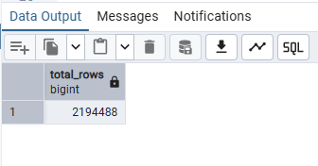
SELECT
MIN(fiscal_year) AS from_year,
MAX(fiscal_year) AS to_year,
COUNT(DISTINCT fiscal_year) AS total_years
FROM raw.raw_nyc_payroll;
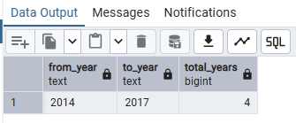

SELECT
COUNT(DISTINCT fiscal_year) AS unique_fiscal_years,
COUNT(DISTINCT agency_name) AS unique_agencies,
COUNT(DISTINCT work_location_borough) AS unique_boroughs,
COUNT(DISTINCT title_description) AS unique_titles,
COUNT(DISTINCT leave_status) AS unique_leave_status,
COUNT(DISTINCT pay_basis) AS unique_pay_basis
FROM raw.raw_nyc_payroll;
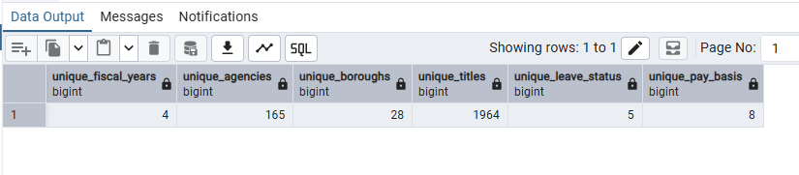
2.3 NULL Values Found
During profiling I discovered several columns had missing values:
Column | NULL Count | Percentage | Action Taken
Mid Init | 890,008 | 40.56% | Kept as NULL (optional field)
Work Location Borough | 506,214 | 23.07% | Replaced with UNKNOWN
First Name | 952 | 0.04% | Replaced with UNKNOWN
Last Name | 942 | 0.04% | Replaced with UNKNOWN
Title Description | 21 | 0.00% | Replaced with UNKNOWN

SELECT
COUNT(*) AS total_rows,
COUNT(*) - COUNT(fiscal_year) AS fiscal_year_nulls,
COUNT(*) - COUNT(agency_name) AS agency_name_nulls,
COUNT(*) - COUNT(last_name) AS last_name_nulls,
COUNT(*) - COUNT(first_name) AS first_name_nulls,
COUNT(*) - COUNT(mid_init) AS mid_init_nulls,
COUNT(*) - COUNT(agency_start_date) AS agency_start_date_nulls,
COUNT(*) - COUNT(work_location_borough) AS work_location_nulls,
COUNT(*) - COUNT(title_description) AS title_description_nulls,
COUNT(*) - COUNT(leave_status) AS leave_status_nulls,
COUNT(*) - COUNT(base_salary) AS base_salary_nulls,
COUNT(*) - COUNT(pay_basis) AS pay_basis_nulls,
COUNT(*) - COUNT(regular_hours) AS regular_hours_nulls,
COUNT(*) - COUNT(regular_gross_paid) AS regular_gross_paid_nulls,
COUNT(*) - COUNT(ot_hours) AS ot_hours_nulls,
COUNT(*) - COUNT(total_ot_paid) AS total_ot_paid_nulls,
COUNT(*) - COUNT(total_other_pay) AS total_other_pay_nulls
FROM raw.raw_nyc_payroll;
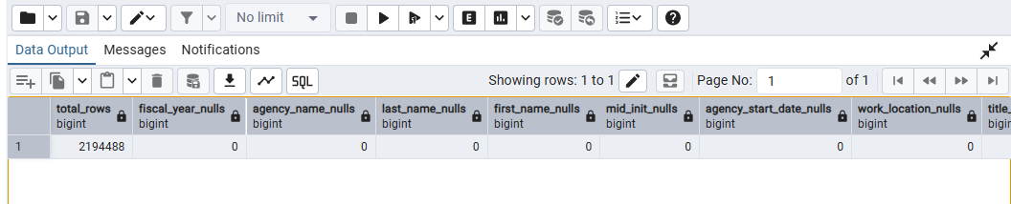

2.4 Duplicate Records
I found 13 duplicate records in the dataset. I handled this by using SELECT DISTINCT in my staging layer SQL query. This ensured that no duplicate data was loaded into the data warehouse.
SELECT
fiscal_year, agency_name, last_name,
first_name, agency_start_date,
COUNT(*) AS duplicate_count
FROM raw.raw_nyc_payroll
GROUP BY
fiscal_year, agency_name, last_name,
first_name, agency_start_date
HAVING COUNT(*) > 1
ORDER BY duplicate_count DESC
LIMIT 10;
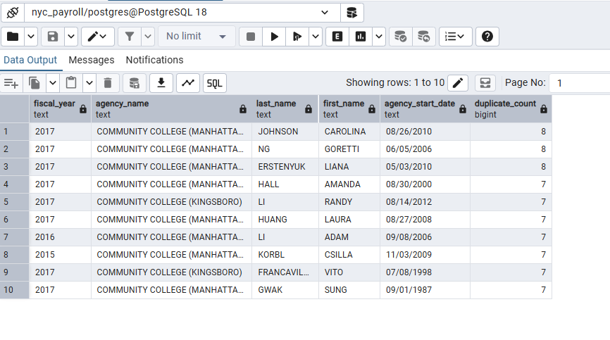
2.5 Data Quality Issues Found
During profiling I discovered the following data quality issues:
Issue | Description | Solution
$ Sign in Salary | Salary stored as "$47,678.00" | Used REPLACE to remove $ sign
Leading Spaces | Pay Basis had " per Annum" with space | Used TRIM to remove spaces
Wrong Data Types | Salary columns stored as TEXT | Converted to NUMERIC in staging
Date as String | Agency Start Date stored as TEXT | Converted to DATE in staging
Negative Salaries | Some gross pay values were negative | Kept as-is (payroll corrections)

SELECT
pay_basis,
COUNT(*) AS total
FROM raw.raw_nyc_payroll
GROUP BY pay_basis
ORDER BY total DESC;
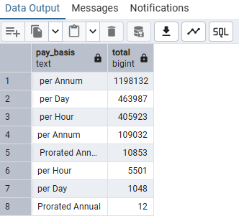

SELECT
MIN(REPLACE(TRIM(base_salary), '$', '')::NUMERIC) AS min_salary,
MAX(REPLACE(TRIM(base_salary), '$', '')::NUMERIC) AS max_salary,
ROUND(AVG(REPLACE(TRIM(base_salary), '$', '')::NUMERIC), 2) AS avg_salary
FROM raw.raw_nyc_payroll;
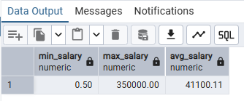

2.6 Salary Statistics
I also analyzed the salary columns to understand the range of payments:
Column | Minimum | Maximum | Average
Base Salary | $0.50 | $350,000 | $41,100
Regular Gross Paid | -$29,862 | $672,308 | $40,190
Total OT Paid | -$23,826 | $228,633 | $3,225
Total Other Pay | -$281,595 | $100,355 | $2,089

SELECT
MIN(REPLACE(TRIM(base_salary), '$', '')::NUMERIC) AS min_salary,
MAX(REPLACE(TRIM(base_salary), '$', '')::NUMERIC) AS max_salary,
ROUND(AVG(REPLACE(TRIM(base_salary), '$', '')::NUMERIC), 2) AS avg_salary
FROM raw.raw_nyc_payroll;

SELECT COUNT(*) AS negative_salary_count
FROM raw.raw_nyc_payroll
WHERE REPLACE(TRIM(regular_gross_paid), '$', '')::NUMERIC < 0;

2.7 Observations
From my data profiling I made the following observations:
- Mid Init column had 40% NULL values which is normal as middle name is optional
- Work Location Borough had 23% NULL values which needed to be handled
- Salary columns contained $ signs which needed to be removed before type conversion
- Pay Basis column had leading spaces causing same value to appear differently
- 13 duplicate records were found and removed in staging layer

SELECT 'raw' AS layer, COUNT(*) AS total
FROM raw.raw_nyc_payroll
UNION ALL
SELECT 'staging' AS layer, COUNT(*) AS total
FROM stg.stg_nyc_payroll;
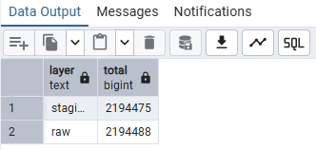

SELECT
COUNT(*) - COUNT(work_location_borough) AS location_nulls,
COUNT(*) - COUNT(last_name) AS last_name_nulls,
COUNT(*) - COUNT(first_name) AS first_name_nulls
FROM stg.stg_nyc_payroll;
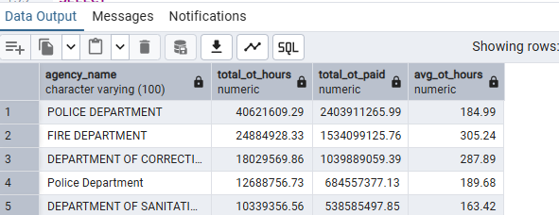

SELECT
pay_basis,
COUNT(*) AS total
FROM stg.stg_nyc_payroll
GROUP BY pay_basis
ORDER BY total DESC;
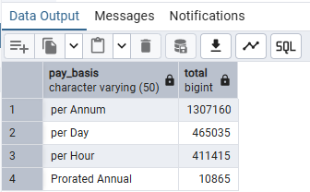
Section 3: Star Schema Design
3. Star Schema Design
3.1 What is Star Schema?
A Star Schema is a type of database design used in data warehouses. It has one central fact table connected to multiple dimension tables. I chose Star Schema for this project because it makes analytical queries faster and easier to understand.
3.2 Why Star Schema?
I chose Star Schema because:
- Fast query performance on large datasets
- Easy to understand and navigate
- Ideal for analytical and reporting queries
- Industry standard for data warehouses
- Minimal joins needed for analysis

3.3 My Star Schema Design
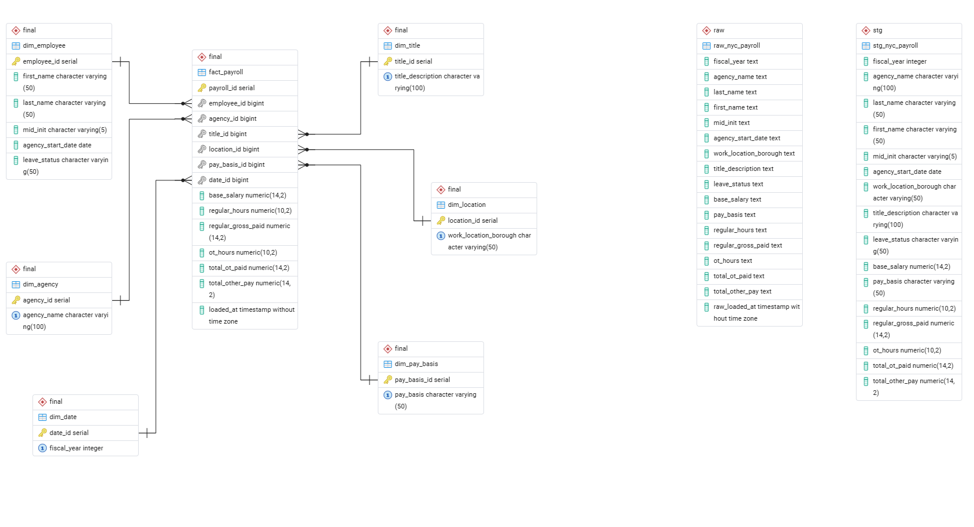Figure: ERD Diagram

3.4 Fact Table — fact_payroll
The fact table stores all payroll measures:
Column | Type | Description
payroll_id | SERIAL PK | Unique identifier
employee_id | BIGINT FK | References dim_employee
agency_id | BIGINT FK | References dim_agency
title_id | BIGINT FK | References dim_title
location_id | BIGINT FK | References dim_location
pay_basis_id | BIGINT FK | References dim_pay_basis
date_id | BIGINT FK | References dim_date
base_salary | NUMERIC | Base salary amount
regular_hours | NUMERIC | Regular hours worked
regular_gross_paid | NUMERIC | Regular gross payment
ot_hours | NUMERIC | Overtime hours worked
total_ot_paid | NUMERIC | Total overtime payment
total_other_pay | NUMERIC | Other payments

3.5 Dimension Tables
Dimension | Purpose | Key Column
dim_employee | WHO - Employee details | first_name, last_name
dim_agency | WHICH - Government department | agency_name
dim_title | WHAT - Job title | title_description
dim_location | WHERE - Work borough | work_location_borough
dim_pay_basis | HOW - Payment type | pay_basis
dim_date | WHEN - Fiscal year | fiscal_year

3.6 Why These Dimensions?
I chose these six dimensions because:
dim_employee → to analyze by WHO
(which employee earns most?)

dim_agency → to analyze by WHICH department
(which agency spends most?)

dim_title → to analyze by WHAT job
(which job title pays most?)

dim_location → to analyze by WHERE
(which borough pays most?)

dim_pay_basis → to analyze by HOW paid
(per annum vs per hour?)

dim_date → to analyze by WHEN
(salary trend by year?)

After running my ETL pipeline, the following records were loaded into each table:
Table | Record Count
dim_employee | 798132
dim_agency | 164
dim_title | 1639
dim_location | 23
dim_pay_basis | 4
dim_date | 4
fact_payroll | 2689596

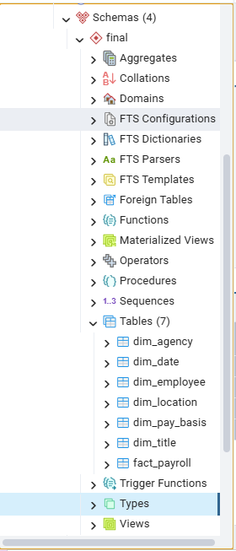

The above screenshot from pgAdmin confirms that all seven tables were successfully created in the final schema of my nyc_payroll database. This includes six dimension tables and one fact table following the Star Schema design.

Section 4: ETL Pipeline

4. ETL Pipeline
4.1 What is ETL?
ETL stands for Extract, Transform and Load. It is a data engineering process where data is taken from a source, cleaned and transformed, and then loaded into a data warehouse. In this project I built a complete ETL pipeline for NYC Payroll data following a proper three layer architecture.
4.2 Pipeline Architecture
My pipeline follows three layers:
Layer | Schema | Purpose
Extract | raw.* | Load CSV data as-is into database
Transform | stg.* | Clean and transform data
Load | final.* | Load into Star Schema warehouse

4.3 Extract — Raw Layer
In the Extract phase I loaded the raw CSV data directly into PostgreSQL without any transformations. All columns were stored as TEXT to avoid any type conversion errors at this stage.
Key decisions:
- All 16 columns stored as TEXT
- raw_loaded_at timestamp added automatically
- TRUNCATE before each load to avoid duplicates
- Used Python csv module to read CSV row by row
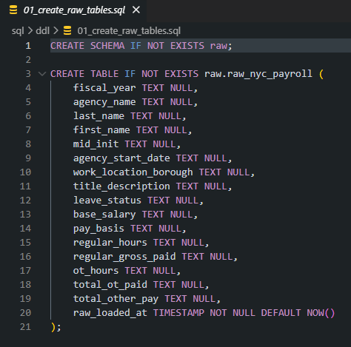
The above screenshot shows my raw layer SQL file. All 16 columns are stored as TEXT because in the raw layer I load data exactly as it comes from the CSV file without any transformations.

4.4 Transform — Staging Layer
In the Transform phase I cleaned and transformed the raw data. This is where all data quality issues found during profiling were fixed.
Transformations applied:
Transformation | Reason
TRIM() on all columns | Remove leading/trailing spaces
REPLACE($,'') on salary | Remove $ sign from salary columns
::INT, ::DATE, ::NUMERIC | Convert TEXT to proper data types
COALESCE(value, 'UNKNOWN') | Handle NULL values
SELECT DISTINCT | Remove 13 duplicate records

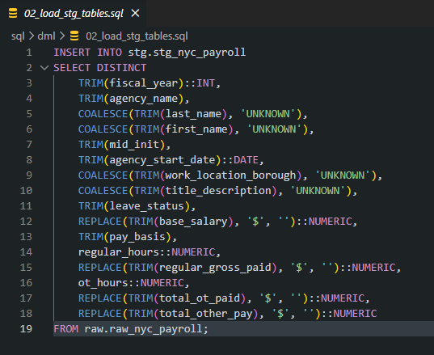
The above screenshot shows my staging layer transformation query. Here I applied TRIM to remove spaces, REPLACE to remove $ signs from salary columns, and COALESCE to handle NULL values. I also used SELECT DISTINCT to remove 13 duplicate records found during profiling.

4.5 Load — Warehouse Layer
In the Load phase I loaded the cleaned data from staging into the Star Schema. I loaded dimension tables first and fact table last to maintain referential integrity.
Loading order:
- dim_agency → loaded first
- dim_title → loaded second
- dim_location → loaded third
- dim_pay_basis → loaded fourth
- dim_date → loaded fifth
- dim_employee → loaded sixth
- fact_payroll → loaded last!

Why this order?
fact_payroll references all dim tables
→ dims must exist first!
→ otherwise foreign key error!

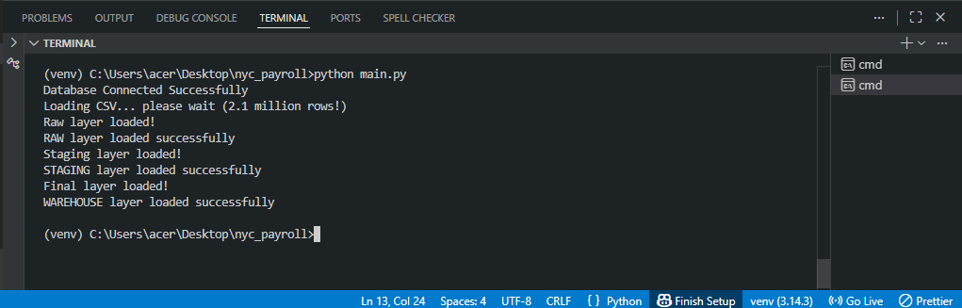

The above screenshot shows my pipeline running successfully in the terminal. All three layers were loaded without any errors. This confirms that my ETL pipeline is working correctly for 2.1 million NYC payroll records.

4.6 Project Folder Structure
I followed a clean and professional folder structure to organize my code:
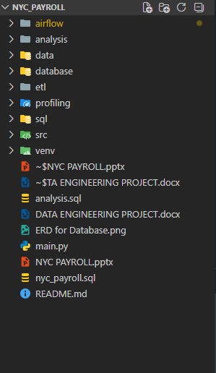
The above screenshot shows my project folder structure in VS Code. I followed a clean and
professional directory structure separating each layer into its own folder. This makes
the code easy to understand, maintain and scale.

4.7 How to Run the Pipeline
To run this pipeline on any system:
Step 1: Install required packages
pip install psycopg2

Step 2: Create database in pgAdmin
Database name: nyc_payroll

Step 3: Update password in
database/postgresql.py

Step 4: Place CSV file in
data/raw/ folder

Step 5: Activate virtual environment
venv\Scripts\activate

Step 6: Run pipeline
python main.py

4.8 Incremental Load
After completing the full load pipeline, I also implemented incremental load to handle new data efficiently.
What is Incremental Load?
Instead of reloading all 2.1 million records every time, incremental load only inserts NEW records that don't already exist in the database.
Full Load:
→ runs ONCE
→ loads all 2.1 million records
→ truncates and reloads everything
Incremental Load:
→ runs every time new data arrives
→ loads ONLY new records
→ existing data untouched!
New file created:
data/new/incremental_2018.csv → 5 new records (2018 data)
etl/load_incremental.py → incremental logic
sql/ddl/04_create_batch_tracker.sql → batch tracking
Batch Tracker:
I also added a batch_runs table to track every pipeline run:
Column | Purpose
batch_id | unique run number
status | running/success/failed
start_time | when pipeline started
end_time | when pipeline finished
error_message | error if failed
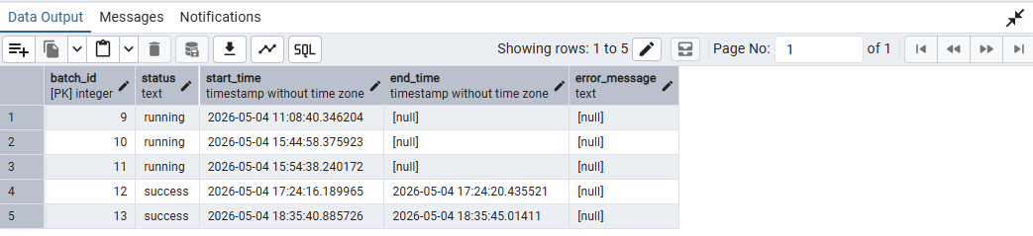
Figure: batch_runs Table Showing Batch Execution Records in pgAdmin

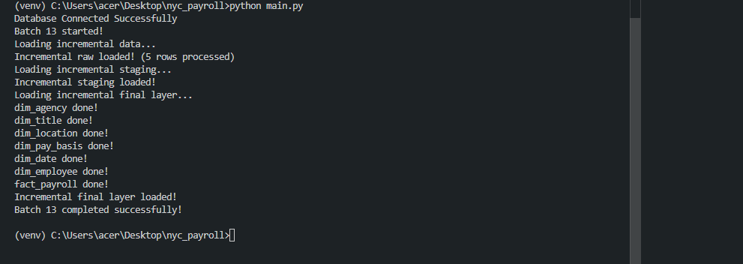
Figure: Terminal Output Showing Successful Completion of Batch 13

4.9 Pipeline Orchestration with Apache Airflow
After completing the ETL pipeline, I implemented Apache Airflow to automate the pipeline execution using Docker.
What is Apache Airflow?
Apache Airflow is an open source tool used to programmatically create, schedule and monitor workflows. Instead of manually running python main.py every time, Airflow runs the pipeline automatically on a schedule.
What is Docker?
Docker is a containerization tool that packages the application and all its dependencies together. I used Docker to run Airflow because it avoids manual installation issues and ensures consistent environment with just one command:
docker compose up –d
My DAG — nyc_payroll_pipeline:
I created a DAG with 4 tasks running in order:
Task | Task ID | Purpose
1 | extract_raw_layer | Load CSV into raw table
2 | transform_stg_layer | Clean data in staging
3 | load_warehouse_layer | Load into star schema
4 | incremental_load | Load only new records

Schedule:
@daily → runs automatically every day at midnight!
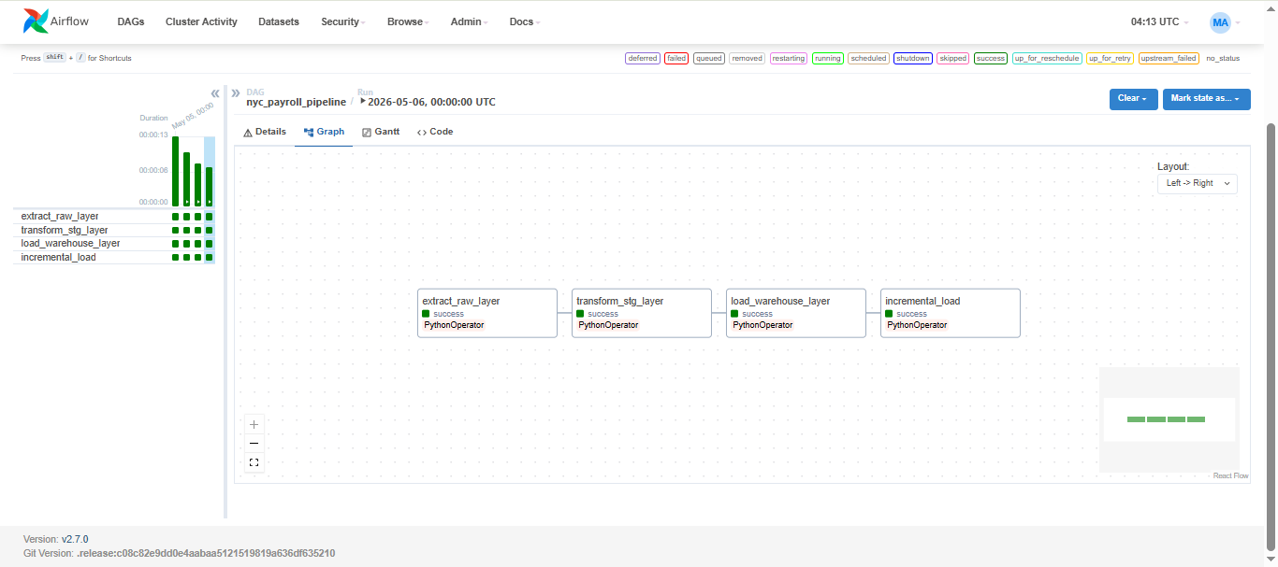

Why Airflow?
- Dynamic pipelines using Python
- Easy scheduling (cron-based)
- Strong monitoring UI
- Handles failures & retries
- Scalable and production-ready
Section 5: Analysis & Key Findings
5. Analysis & Key Findings
5.1 Overview
After successfully loading the data into my Star Schema, I performed analytical queries using SQL in pgAdmin. All analysis queries are saved in analysis/analysis.sql file. The queries cover KPIs, trend analysis and dimensional analysis.
5.2 KPIs & Metrics
Metric | Value
Total Unique Employees | 798,132
Total Payroll Cost | $117 billion
Average Base Salary | $41,100
Average Gross Paid | $38,901
Total Overtime Hours | 145 million hours
Average OT Per Employee | 54.22 hours

SELECT COUNT(DISTINCT employee_id) AS total_employees
FROM final.fact_payroll;
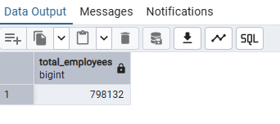
SELECT
ROUND(SUM(regular_gross_paid), 2) AS total_regular_pay,
ROUND(SUM(total_ot_paid), 2) AS total_overtime_pay,
ROUND(SUM(total_other_pay), 2) AS total_other_pay,
ROUND(SUM(regular_gross_paid + total_ot_paid + total_other_pay), 2) AS total_payroll_cost
FROM final.fact_payroll;
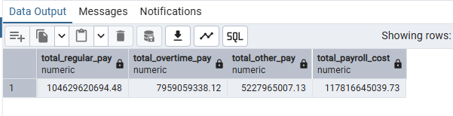

SELECT
ROUND(AVG(base_salary), 2) AS avg_base_salary,
ROUND(AVG(regular_gross_paid), 2) AS avg_gross_paid,
ROUND(AVG(total_ot_paid), 2) AS avg_ot_paid
FROM final.fact_payroll;
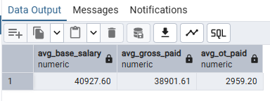
SELECT
ROUND(SUM(ot_hours), 2) AS total_ot_hours,
ROUND(AVG(ot_hours), 2) AS avg_ot_hours_per_employee
FROM final.fact_payroll;
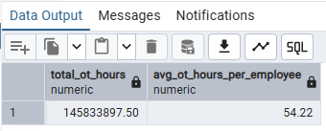

5.3 Highest Paid Employee
From my analysis I found that the highest paid employee in NYC government was:
Detail | Value
Name | Scott Evans
Agency | Office of the Comptroller
Job Title | Pension Investment Advisor
Base Salary | $350,000

SELECT
e.first_name,
e.last_name,
a.agency_name,
t.title_description,
ROUND(f.base_salary, 2) AS base_salary,
ROUND(f.regular_gross_paid, 2) AS gross_paid
FROM final.fact_payroll f
JOIN final.dim_employee e ON e.employee_id = f.employee_id
JOIN final.dim_agency a ON a.agency_id = f.agency_id
JOIN final.dim_title t ON t.title_id = f.title_id
ORDER BY f.base_salary DESC
LIMIT 5;
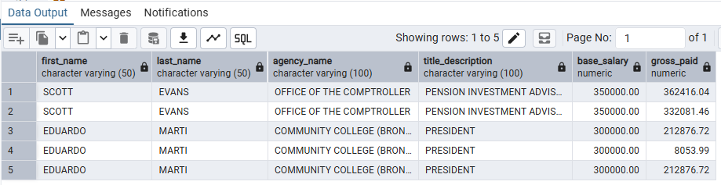

5.4 Trend Analysis — Salary by Year
SELECT
d.fiscal_year,
COUNT(DISTINCT f.employee_id) AS total_employees,
ROUND(AVG(f.base_salary), 2) AS avg_base_salary,
ROUND(SUM(f.regular_gross_paid), 2) AS total_gross_paid
FROM final.fact_payroll f
JOIN final.dim_date d ON d.date_id = f.date_id
GROUP BY d.fiscal_year
ORDER BY d.fiscal_year;
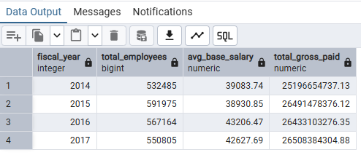
The above results show how average salary changed from 2014 to 2017. This shows a
steady increase in NYC government salaries over the four fiscal years.

5.5 Trend Analysis — Overtime by Year
SELECT
d.fiscal_year,
ROUND(SUM(f.ot_hours), 2) AS total_ot_hours,
ROUND(SUM(f.total_ot_paid), 2) AS total_ot_paid, ROUND(AVG(f.ot_hours), 2) AS avg_ot_hours
FROM final.fact_payroll f
JOIN final.dim_date d ON d.date_id = f.date_id
GROUP BY d.fiscal_year
ORDER BY d.fiscal_year;
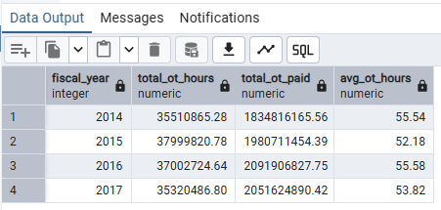
The above results show overtime hours and payments by fiscal year. This helps identify
which years had highest overtime costs for NYC government.

5.6 Top 5 Agencies by Payroll Cost
SELECT
a.agency_name,
COUNT(DISTINCT f.employee_id) AS total_employees,
ROUND(AVG(f.base_salary), 2) AS avg_salary,
ROUND(SUM(f.regular_gross_paid), 2) AS total_gross_paid
FROM final.fact_payroll f
JOIN final.dim_agency a ON a.agency_id = f.agency_id
GROUP BY a.agency_name
ORDER BY total_gross_paid DESC
LIMIT 10;
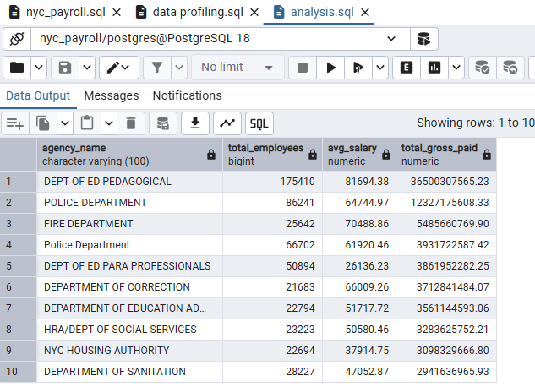
The above results show the top 5 government agencies with highest total payroll cost.
Department of Education has the most employees and highest total payroll cost in NYC.

5.7 Salary by Borough
SELECT
l.work_location_borough,
COUNT(DISTINCT f.employee_id) AS total_employees,
ROUND(AVG(f.base_salary), 2) AS avg_salary,
ROUND(SUM(f.regular_gross_paid), 2) AS total_gross_paid
FROM final.fact_payroll f
JOIN final.dim_location l ON l.location_id = f.location_id
GROUP BY l.work_location_borough
ORDER BY avg_salary DESC;
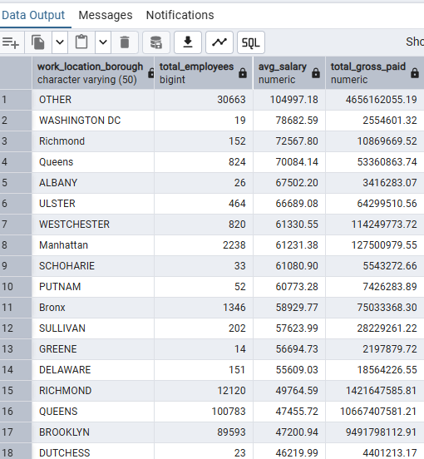
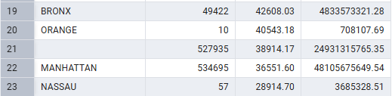
The above results show average salary by work location borough. Manhattan has the highest average salary among all boroughs in NYC.

5.8 Top 10 Highest Paying Job Titles
SELECT
t.title_description,
COUNT(DISTINCT f.employee_id) AS total_employees,
ROUND(AVG(f.base_salary), 2) AS avg_salary,
ROUND(MAX(f.base_salary), 2) AS max_salary
FROM final.fact_payroll f
JOIN final.dim_title t ON t.title_id = f.title_id
GROUP BY t.title_description
ORDER BY avg_salary DESC
LIMIT 10;
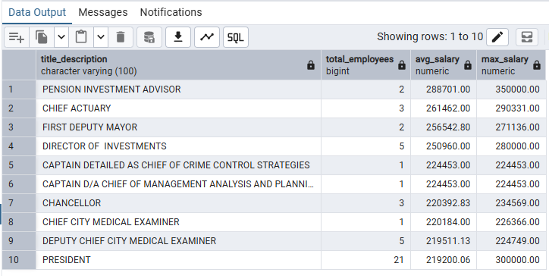
The above results show the top 10 highest paying job titles in NYC government.
Pension Investment Advisor has the highest average salary of $350,000.

5.9 Key Insights
From my analysis I found the following key insights:
- NYC government spent over $117 billion on payroll from 2014 to 2017
- The highest paid employee was Scott Evans earning $350,000 as Pension Investment Advisor
- Department of Education is the largest agency with over 423,000 employees
- Manhattan has the highest average salary among all boroughs
- NYC government employees worked over 145 million overtime hours
- Average government employee earns $41,100 per year
- Salary showed steady increase from 2014 to 2017

6. Conclusion
6.1 Project Summary
In this project I successfully built a complete ETL data pipeline for NYC Citywide Payroll data containing 2.1 million government employee records. I followed a professional three layer architecture moving data from raw CSV through staging transformation and finally into a Star Schema data warehouse in PostgreSQL.
6.2 What I Learned
Through this project I learned:
- How to build a complete ETL pipeline from scratch
- How to handle real world data quality issues like NULL values, duplicate records and wrong data types
- How to design a Star Schema for analytical queries
- How to separate code into proper folder structure
- How to use Python and PostgreSQL together for data engineering
- How to perform data profiling using SQL queries
- How to generate meaningful insights from large datasets
6.3 Challenges I Faced
During this project I faced several challenges:
Challenge | How I Solved It
$ sign in salary columns | Used REPLACE() to remove $ before type conversion
NULL values in key columns | Used COALESCE() to replace NULLs with UNKNOWN
Leading spaces in Pay Basis | Used TRIM() to clean all columns
13 duplicate records | Used SELECT DISTINCT in staging layer
Large dataset (2.1M rows) | Used batch loading row by row with psycopg2
Foreign key errors | Loaded dimension tables before fact table

6.4 Key Findings
From my analysis of NYC Payroll data I found:
- NYC government spent over $117 billion on payroll from 2014 to 2017
- Average government employee earns $41,100 per year
- Highest paid employee was Scott Evans earning $350,000
- Department of Education is largest agency with 423,338 employees
- Manhattan has highest average salary among all boroughs
- NYC employees worked over 145 million overtime hours total
- Salary showed steady increase from 2014 to 2017
6.5 Future Improvements
If I had more time I would improve this project by:
- Implementing incremental load to handle new monthly data
- Adding batch tracker to monitor pipeline runs
- Adding indexes on fact_payroll for faster query performance
- Creating data visualizations using Power BI or Tableau
- Adding more data validation checks in staging layer
6.6 Final Thoughts
- This project gave me hands on experience with real world data engineering concepts. Working with 2.1 million records taught me how to handle large datasets efficiently. I am confident that the skills I developed through this project will help me in my data engineering career.
6.7 Code Submission
The complete project code is available as a zipped folder submitted along with this document. The project follows a clean directory structure with separate folders for ETL layers, SQL scripts, and utilities as described in Section 4.

GitHub: https://github.com/admanoj24/NYC_Payroll

