Adrian Marquez
Module 10.2
07/19/2025
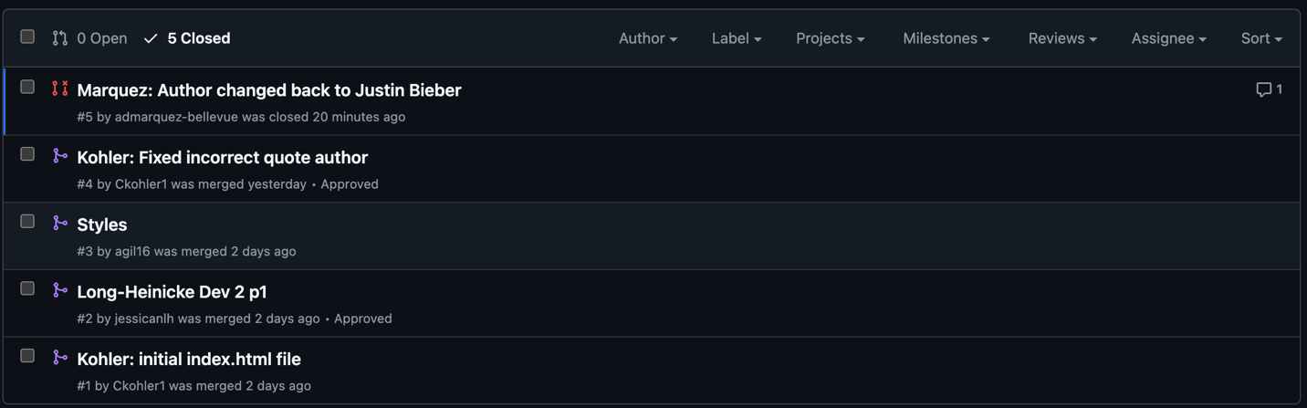
https://github.com/AverageTeammate/GitLab
https://github.com/admarquez-bellevue

