Design of Garbage Collection Robots In Tourism Area (Beach) With Artificial Neural Network Method

^{1st} Hanifudin Sukri
Department of Electrical Engineering
University of Trunojoyo Madura
Bangkalan - Indonesia
hanifudin@trunojoyo.ac.id
^{2nd} Ach. Dafid
Department of Informatic Engineering
University of Trunojoyo Madura
Bangkalan - Indonesia
ach.dafid@trunojoyo.ac.id
^{3rd} Ari Basuki
Department of Industrial Engineering
University of Trunojoyo Madura
Bangkalan - Indonesia
aribasuki@trunojoyo.ac.id

Abstract— The problem that is being faced by tourism managers in Madura about the form of a bad environment is problem of waste. This is caused by the behavior of tourists unaware of throwing garbage in its place. The inorganic waste dominates the waste generated from the tourism sector in the form of plastic waste; if accumulated it can reach ±6 tons/day of the total volume of ±7.6 tons/day. At the same time, the total number of officers is very few ± 44 people. This is very ineffective with such a large amount of waste and a tour operating time of 12 hours/day. Therefore, in this study, a robot can help ease the cleaning staff's work.
This robot can recognize bottle trash objects and avoid obstacles in real time using a camera with an object recognition system on a bottle. In addition, there is an ultrasonic sensor to detect any obstacles in a predetermined tracking area. The object recognition system applied to this garbage collection robot uses the Artificial Neural Network method with a success rate of 93.3%, which indicates that the technique works well on the system.
Keywords— Tourism, Garbage, Garbage Picking Robot, ANN

Introduction
Madura has quite a variety of tourism potential and is no less attractive than other areas to visit while on vacation. Besides being identical to the Suramadu bridge, Madura also has natural, historical,l and religious tourism. One of Madura's most abundant natural attractions is beach tourism, which reaches ±30 beach destinations with an average number of 842,241 beach visitors per year and continues to increase yearly [1][2].
The prospect of coastal tourism in Madura, which continues to grow, demands the development of facilities and infrastructure that can increase tourism competitiveness. This positively impacts the community's welfare, especially creative business actors around tourist sites, improving Regional Original Income (ROI), and introducing Madura customs and culture to outsiders. Besides the positive impact of the tourism sector, the number of tourists, as well as the development of facilities and infrastructure supporting tourism which continues to increase, also has a negative impact in the form of increasing the contribution of the amount of waste generated. This is caused by the behavior of tourists unaware of throwing garbage in its place. Debris that is not managed correctly or left behind in tourist areas can affect the cleanliness and comfort of tourist areas, especially coastal tourism in Madura, which has more visitors than other tours. More than that, the garbage produced by tourists can impact the pollution of the beach or marine environment more broadly[3].
The inorganic waste dominates the waste generated from the tourism sector in the form of plastic waste, which, if calculated, can reach 6 tons/day of the total volume of waste in Madura, which runs 7.6 tons/day. While the number of janitors is minimal, it is recorded that the status of Civil Servants (PNS) is ±130 people in the district of Madura, and only 44 people serve as freelance daily workers [2]. This is very ineffective with the amount of waste and the period of the tourist sites that still operate for 12 hours/day. Therefore, we need a technology that can help ease the cleaning staff's work in carrying out their duties and responsibilities[6].
Based on the description of the problem above, in this study, a robot can recognize objects from bottles or plastic wraps and avoid obstacles in real time with an object recognition strategy system on a bottle or plastic wrap using a camera. In addition, there is also an ultrasonic sensor that can detect obstacles in a predetermined tracking area. The object recognition system that will be applied to this garbage collection robot uses the Artificial Neural Network (ANN) method in classifying the features of bottle or plastic wrap object waste, which will then be collected into one trash can with a predetermined set point.
It is hoped that this research can contribute to handling waste in tourism areas, especially coastal tourism. This research helps answer problems and challenges for managers of coastal tourist destinations in Indonesia in general, especially useful for coastal tourism in other countries.

METHOD
The robot in this study, uses an Arduino Mega 2560 microcontroller as its main processing unit, an android camera device is used for image capture and image processing on the input section, four DC motors are used as a driving force for this robot, and a servo motor as an arm claw that functions to take pictures. or picking up detected bottle or plastic wrap trash objects as output targets. The system block diagram of the garbage collection robot can be seen in Figure 1 below:

Plastic bottle Data Set
In this study, training data were obtained independently by collecting images from various plastic bottles that had red, yellow, and green colors. In this case, the three colors of plastic bottles used are the basis for developing the method in other subjects and are limited to bottle-based waste. The training data is in the form of an image of a plastic bottle which is then stored to be used as training data for the robot. The plastic bottle data that was processed as training data consisted of 960 images divided into 320 images of red plastic bottles, 320 images of yellow plastic bottles, and 320 photos of green plastic bottles. Data testing is carried out in real-time by detecting bottle images directly.

Application of Artificial Neural Network (ANN) Method
The selection of an appropriate technique for image classification is a way of differing from one application to another. Selection of a suitable classification technique for better interpretation of object classes in image identification is a difficult task. In the process of image identification without physical contact with the detected object, a camera is used. The main camera uses an Android camera device that is used to capture the captured object frame by frame. Improved object image quality is needed to identify objects and extract their features[4]. To get a good image quality, things that need to be considered, among others:
1. Lighting quality
Adequate room lighting can provide good image capture quality.
2. Camera focus on an object
One type of image recognition algorithm is image classification. It takes an image (or part of an image) as input and predicts what's in it. The output is a class label, bottle type A, bottle B, bottle C and not a bottle object. Algorithms need to be trained to learn and differentiate between classes[17]–[19].
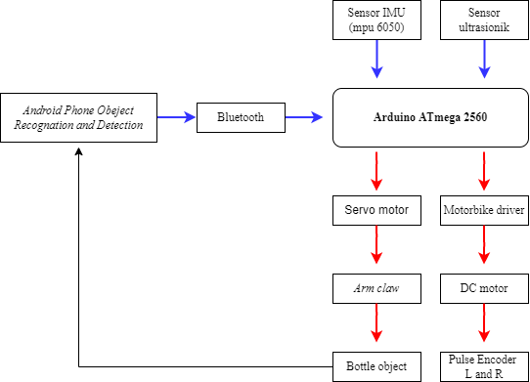
Figure 1. Block Diagram of Garbage Collector Robot System

The perceptron algorithm is a neural network that has the most extensive influence compared to the previous neural network model[10]. The Perceptron learning method is stronger than Hebb's ANN learning. The training procedure of the Perceptron, especially in the iteration process, can produce a convergent weight and this weight when tested against the input pattern can produce an output that is on target. Sensor and association units use binary activation, while output units use 1, 0, or –1 activation. The activation function for the association unit is a binary step function with a certain threshold value. The signal sent from the association unit to the output unit is binary (1 or 0). Where the activation function is equation 1:
f (y_in)=$\left\{\begin{matrix}oneone1 \\ 0 \\ -1\end{matrix} | \begin{aligned} if y_{in}> Ꝋ \\ if -Ꝋ≤y_{in}≤Ꝋ \\ if y_{in}<-Ꝋ\end{aligned}\right\}$ (1)
The weight from the association unit to the response unit (output) is regulated by perceptron learning rules. For each input data, the network training will calculate the response of the output unit. The network will determine if an error occurred in this input data (by comparing the calculated output value with the target value). The network will not consider an error if the output is 0 and the target is -1. Meanwhile, if the output is 1 and the target is -1, this is considered an error[20]-[22]. If an error occurs then the weight will be changed according to equation 2:
$w_{i}\left(new\right)=w_{i}\left(old\right)+αtx_{i}$ (2)
Where :
t = target value 1 or -1
$α$ = learning rate until training will be continued until no errors occur.

Obstacle Detection System Process
The initial status of the robot is designed to be able to move freely, as long as there are no obstacles (obstacles) the robot will move straight. In describing the placement of the ultrasonic sensor to avoid obstruction, it is described in Figure 2.
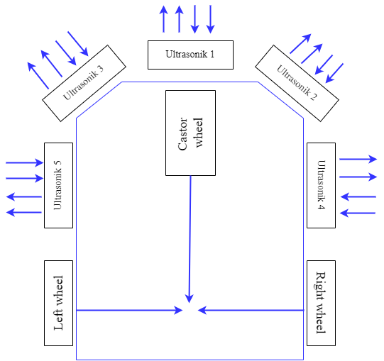
Figure 2. Ultrasonic Sensor Placement
The ultrasonic sensor work system is designed, the object detection distance is determined to solve the obstacle avoidance problem and is set at a distance of 30 cm. As long as the detection range of objects in front of and next to the robot is more than 30 cm, the obstacle object is ignored.
The PID control applied to the robot in response to the identified obstacle uses a control based on the fixed tuning parameter. Basically, PID control is a very specific function within the robot's rotational speed controller. In making adjustments to the configuration of the wheeled robot, the PID function is applied with several useful parameters so that the robot can avoid obstacles as quickly as possible. Before starting to adjust the PID, the planning robot has a configuration that can be tuned. In general, the use of PID in robot movement control to avoid obstacles is to correct errors and reduce shocks from uncontrolled robot motion[9]. Table 1 is the sensor detection process, the action to be carried out by the robot and the PID motion stability control set point.
Table 1. Robot Motion Scenario

Robot Stability Control System Process in forwarding Movement
When the robot moves forward freely, to make corrections to the robot's bow angle error due to the friction factor of the wheel with the media as well as the rotational speed of the left and right motors that are not the same, here a PID control is applied to correct the error. As a reference, the robot's bow uses the MPU6050 Gyro sensor. The reference angle used in the yaw orientation is shown in Figure 3.
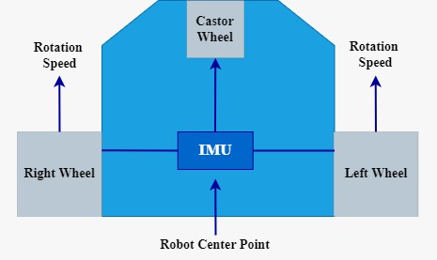
Figure 3. Placement of the MPU6050. IMU Sensor
As an illustration can be seen in Figure 4, which describes the angle error obtained from the IMU sensor as a reference to the desired angle. The value of the angle error will be transferred to the rotational speed of the right and left wheels.
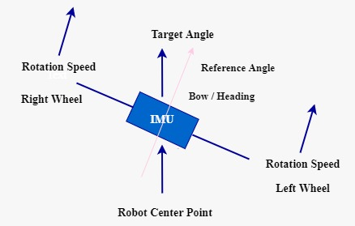
Figure 4. Robot Bow Angle Error with Target Angle
Based on Figure 4, it can be seen that the bow angle of the robot is positive with respect to the target angle. So in the error correction process, the rotational speed of the right motor must be greater than the rotational speed of the left motor. In the application using a closed-loop PID control, the control design is in the block diagram in Figure 5 When the robot moves forward the movement of the right and left wheel speeds will be calculated by the rotary encoder with the distance between the right and left motors for rotational speed. If there is an error value, a transfer function will be carried out to the rotational speed of the right and left wheels, so that the robot is able to move forward stably (smooth).
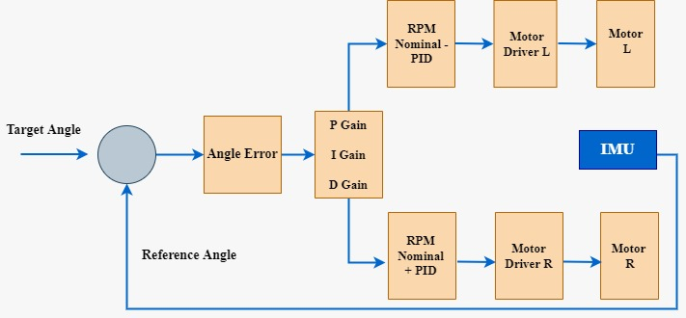
Figure 5. Forward Movement PID Control Block Diagram

Garbage Collector Robot Design
The implementation of robot mechanics is based on the mechanical design of the robot in the previous chapter so that it becomes a real form. The mechanical implementation of this robot uses balsa wood and Depron, considering the material is very easy to shape and cut. In gluing the materials used were fire glue and G glue[5].
Then at the finishing stage, a carbon model spotlight is used. Meanwhile, the drive system uses two DC motors type JGA25-370 150 RPM which has a torque of up to 4.6 kg because it is believed to be able to move the robot. As a power source, a 2-cell 18650 battery with a capacity of 6600 mAh is used. The following is the final result of the garbage collection robot (bottle) in Figure 6.
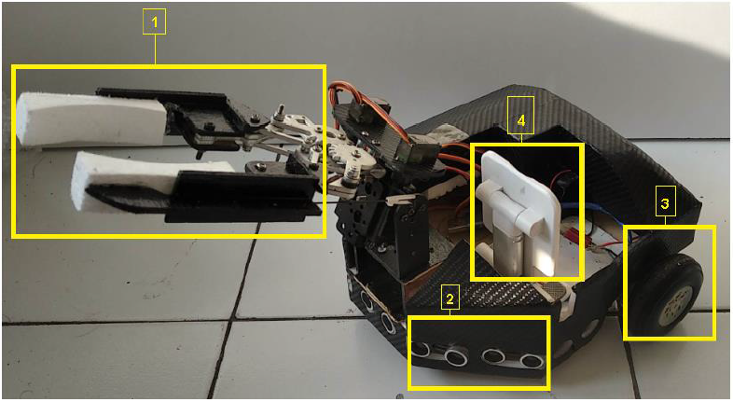
Figure 6. Garbage Picking Robot Side View Above.

RESULT AND DISCUSSION
The overall system flowchart will explain the process of the robot recognizing a different type of bottle object and placing it in its place according to the type of each bottle class using the ANN algorithm which will be shown in Figure 7.
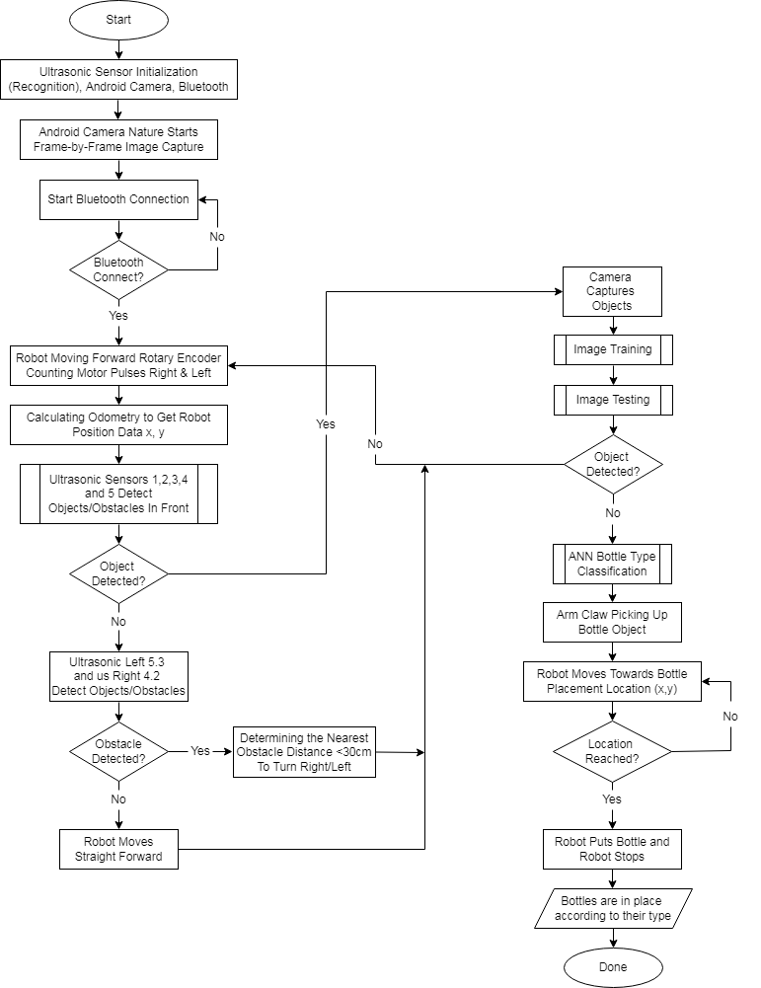
Figure 7. Overall System Flowchart

In this section, testing is carried out for the identification of bottle objects, which will be tested on 3 types of bottles, red, yellow and green. In this test, the author places the bottle in front of the robot so that it can be detected by Android devices. This stage is the bottle identification process followed by the classification process. The testing process is shown in Figure 8.
Figure 8. Object Identification Testing Process
In each bottle test, 10 times as shown in Figure 8. when testing on the bottle object it can be explained when the android camera identifies the bottle object in the color bounding box then the robot will walk and approach a distance of 30cm to position the midpoint of the bottle object so that it can be classified according to red bottle object. The classification process is carried out to find out the characteristics of the colored bottle data that are already in the training and testing data set, seen on the android camera screen showing that the similarity or confidence value (Similarity Value) in each trial is different due to less than optimal light conditions. The confidence value (Similarity Value) is the similarity value to a bottle object that is recognized during training and testing data which goes through the pre-processing stage and the histogram feature extraction so that testing data can be obtained. It can be explained in the trial of each bottle if the value below zero is the same as not the bottle and if the value above zero is the same as the predictive result of the bottle.
Figure 9. Detection of Red Bottle Object
Figure 10. Detection of Yellow Bottle Objects
Figure 11. Detection of Green Bottle Objects
From the test results, identification obtained results with 93.4% of 10 trials of each color (Red, Yellow and Green) which succeeded 28 and failed 2 times, with confidence values (Similarity Value) ​​as shown in table 2. Then the constraint factor in the failure of label detection caused lighting in the robot area that is less than optimal. The test results are processed in the form of a table shown in Table 2 explaining the detection value of the bottle object.
Table 2. Bottle Object Test Results
Based on the test results of the three red, yellow and green bottles, the yellow bottle produces the largest average confidence value (Similarity Value), namely the red bottle 0.76 because the bottle with the higher predictive value is the easiest to detect similarity to the training results and followed by the yellow bottle with an average value. average confidence (Similarity Value) of 0.75 and red bottles are bottles with an average confidence value (Similarity Value) of 0.65. The comparison graph of the average confidence value (Similarity Value) of the three objects is shown in Figure 12.
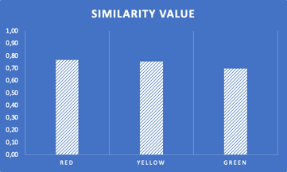
Figure 12. Comparison Graph of Average Confidence.

CONCLUSION
Based on observations about the design of the garbage collection robot in the tourism area, it is concluded that:
- This garbage collection robot hardware works well with specifications of 5 SRF04 ultrasonic sensors, 2 servo motors using the SG90s type, 18650 6400mAh battery, and an IMU sensor that functions as a measure of the robot's orientation on the yaw axis specifically used to measure robotic headings.
- The success of the robot in its role as a medium for collecting garbage is very high, this is evidenced by the high level of confidence (Similarity Value) in the average value of several experimental samples carried out.
- All system testing carried out in the manufacture of the garbage collection robot went well, starting from ultrasonic sensor testing, odometry testing, servo testing, bottle image detection testing, as well as testing the robot system to take bottle objects and place bottle objects at predetermined locations.
- This research helps answer problems and challenges for managers of coastal tourist destinations in Indonesia in general, especially useful for coastal tourism in other countries.

References
- Abdul Basri. (2020). Jumlah Pengunjung Tempat Wisata di Madura Dalam Satu Tahun Terakhir. Radarmadura.id.
- Taufikurrahman. (2020). Volume Sampah Sejak 3 Tahun Terakhir Meningkat. Portalmadura.com.
- Gabriella Natalie, Neva Nathania. (2019). Pemanfaatan Bahan Daur Ulang dalam Menunjang Kelestarian Wisata Bahari Pulau Madura. Prosiding Seminar Nasional Budaya Madura V. ISBN: 978-602-6378-54-5.
- Endarko, Adhitya Aris Wardhana. (2017). Apllikasi Pengolahan Citra dan Jaringan Saraf Tiruan untuk Pengenalan Pola Tulisan Tangan. Jurnal Fisika dan Aplikasi, vol. 1, No.2
- Irmawati Iskandar. (2020). Rancang Bangun Prototype Robot Pemungut Sampah Berbasis Arduino Mega. EPrints.unm.ac.id. Universitas Negeri Makassar.
- Triyo Utomo. (2019). Pariwisata Madura Berbasis Partisipasi Masyarakat. Jurnal Trunojoyo, Vol.10 No.1
- Dr. Junaidi S,Si., M.Sc, Yulian Dwi Prabowo. Katalog Dalam Terbitan (KDT) Project Sistem Kendali Elektronik Berbasis Arduino. Perpustakaan Nasional RI, ISBN : 978-602-5636-46-2.
- Eitel, Elisabeth. Basic Rotary Encoder. Overview and New Technologies. Machinedesign.com.
- Heni Dwi Juniar, Drs. Suwandi,M.Si, Dr.Eng. Asep Suhendi, S.Si., M.Si. (2018). Perancangan Object Follower Robot Untuk Sistem Scanning dan Tracking Object Follower Menggunakan Kontrol PID. E-Proceeding Of Engineering : Vol.5, No.1. Universitas Telkom Bandung.
- Aditya Yanuar.R. (2018). Artificial Neural Network (ANN). Machinelearning.mipa.ugm.ac.id.
- Hakim, Dzikri Maulana., Rainarli, Ednawati. 2019. “Convolutional Nerual Network untuk Pengenalan Citra Notasi Musik”. Teknik Infomatika dan Ilmu Komputer UNIKOM. Bandung. Techno.COM, Vol. 18, No. 3. 214-226
- Sher GI. 2012. “Developing a Feed Forward Neural Network”. Handbook of Neuroevolution Through Erlang.;:153–85
- Adem K, Kiliçarslan S, Cömert O. 2019. “Classification and diagnosis of cervical cancer with stacked autoencoder and softmax classification”. Expert Systems with Applications.;115:557–64.
- Activation Function: “The Brain Of Neural Network To Process Natural Language”. International Journal of Recent Trends in Engineering and Research. 2018;4(2):67– 70. [5] J. Kocić, N. Jovičić and V. Drndarević, "Sensors and Sensor Fusion in Autonomous Vehicles," 2018 26th Telecommunications Forum (TELFOR), 2018, pp. 420-425, doi: 10.1109/TELFOR.2018.8612054.
- Pathak, A. R., Pandey, M., & Rautaray, S. (2018). Application of deep learning for object detection. Procedia computer science, 132, 1706-1717.
- Phadnis, R., Mishra, J., & Bendale, S. (2018, April). Objects talk-object detection and pattern tracking using TensorFlow. In 2018 Second International Conference on Inventive Communication and Computational Technologies (ICICCT) (pp. 1216-1219). IEEE.
- L.-Q. Xu David, “Using Neural Network to Learn Spatial-Temporal Models for Moving Deformable Objects Tracking. IEEE.”
- A. Paula, L. Ferreira, and P. Martins Engel, “Positioning a Robot Arm: an Adaptive Neural Approach. IEEE.”
- L. Larsson, S. Krol, and I. Lagemann, “NeNEB-An Application Adjustable Single Chip Neural, IEEE”
- Akanksha, Gupta, M., & Tripathi, M. M. (2021). Smart robot for collection and segregation of garbage. Proceedings of International Conference on Innovative Practices in Technology and Management, ICIPTM 2021, 169–173. https://doi.org/10.1109/ICIPTM52218.2021.9388369
- Arai, Y., Miyagusuku, R., & Ozaki, K. (2021). Development and Testing of Garbage Detection for Autonomous Robots in Outdoor Environments. 2021 IEEE/SICE International Symposium on System Integration, SII 2021, 138–143. https://doi.org/10.1109/IEEECONF49454.2021.9382646
- Chang, Z., Hao, L., Tan, H., & Li, W. (2020). Design of mobile garbage collection robot based on visual recognition. 2020 IEEE 3rd International Conference on Automation, Electronics and Electrical Engineering, AUTEEE 2020,448–451. https://doi.org/10.1109/AUTEEE50969.2020.9315545

