Software Development
SRE and DevOps
Best Practices
  - Working agreement for software and integration development teams
Table of contents
Development lifecycle
Team working agreement
Peer development
Ownership and exceptions
Git branching and versioning
Testing evidence and quality gates
Developer testing in DEV
Evidence attached to the user story
Automated gates and peer review
Secure delivery and reliable operation
Configuration and secrets
Build once and promote
Release candidate versions
Resilience for integrations
Observability and service objectives
Incident response and improvement
Release readiness and Definition of Done
Release readiness checklist
Production verification
Definition of Done for a user story
Own each change from its user story through production verification. This agreement brings traceability, developer testing, independent review, secure delivery, and reliable operation into one repeatable workflow. It applies to application code, APIs, integrations, infrastructure, configuration, and deployment pipelines.

Development lifecycle
Stage | Required outcome
1 Story and feature branch | - Approve the story and acceptance criteria; link the repository.  - Create the feature branch from develop and implement the change.
2 PR to develop | - Open a PR, pass required checks, and obtain independent review.  - Merge the feature branch into develop.
3 DEV tests and evidence | - Deploy the integrated develop build and run DEV tests.  - Attach test evidence to the story before the release PR.
4 PR to release branch | - Review and approve the PR from develop to the release branch.  - Each merge into release creates the next RC version.
5 QA/UAT and sign off | - Validate the RC in QA/UAT and attach the test evidence.  - Obtain and record sign off before production promotion.
6 Production | - Deploy the approved, tested RC artifact unchanged.  - Verify production health and record the deployed candidate.
7 Branch Sync, Operate and improve | - After production verification, merge released source to main, tag it, and synchronize develop.  - Observe service health, respond to incidents, and backlog improvements.

Flow: Story → Feature Branch → PR → Develop → DEV tests → Evidence → PR → Release Branch (RC) → QA/UAT → Evidence and sign off → Production → Branch sync → Observe
Continuous integration (CI) checks run on pushes and PRs. Review and merge feature work into develop before DEV testing. Attach DEV evidence before the PR to the release branch. After QA/UAT, attach evidence and obtain sign off before production promotion.

Team working agreement
Practice | Team expectation
Traceable working branches | - Create the linked working branch from the story: features from develop; bugfixes from the target release.  - If the tool cannot create the branch, create it and add the repository link before coding.
Consistent naming | - Use feature/US-12345-description or bugfix/BUG-12345-description.  - Use hotfix/INC-12345-description for an urgent production correction.
Meaningful daily progress | - Commit and push meaningful development progress at least daily on days with changes.  - Keep commits small and logical; include the work-item ID.  - Report blockers rather than creating empty activity commits.
Branch synchronization | - Synchronize features with develop and bugfixes with their source release branch.  - Resolve conflicts on the working branch and rerun affected tests before merge.  - Follow the agreed merge or rebase policy; coordinate any shared-history rewrite.
Developer accountability | - Test the integrated develop build against acceptance criteria, error cases, integration behavior, and observability.  - Attach DEV evidence before release PR approval; attach QA/UAT evidence and sign off before production.
Protected shared branches | - Protect main, develop, and release branches.  - Require PRs, mandatory CI checks, and independent approval.  - Restrict direct pushes, force pushes, and deletion.
Reviewable PRs | - Keep changes focused.  - Explain what changed, why, testing performed, configuration and deployment impact, and rollback considerations.  - Link the story and evidence.
Independent peer review | - Obtain at least one qualified peer approval and code-owner review for critical areas.  - Resolve review comments; rerun checks and renew required approvals after material changes.
Changes as code | - Version application code, infrastructure, API policies, pipelines, configuration references, dashboards, and alert definitions.  - Record and reconcile any emergency manual change.

Peer development
- Assign a primary developer and a named backup developer to every active user story, integration, or development task. Record both names on the work item so coverage is always clear.
- The backup must be able to continue the work when the primary developer is absent. Confirm availability and assign an alternative backup if both developers will be unavailable.
- Work as peers through regular knowledge sharing, walkthroughs, and pairing on complex or critical changes. Both developers should understand the design, code, dependencies, test approach, and deployment or recovery steps.
- Keep code pushed and work-item notes current. Record progress, branch and PR links, test evidence, configuration references, unresolved issues, and next steps so the backup can take over without relying on private messages or local files.
- Before planned leave, complete a handover with the backup and confirm coverage. For an unexpected absence, the team lead confirms that the backup takes ownership and updates the work item.
- Ensure the backup has the approved repository, environment, and tool access needed for the work. Use individual accounts and approved secret-management processes; never share credentials.
- Peer development complements independent PR review. A developer who co-authored a change must not serve as its sole independent approver.

Ownership and exceptions
- The developer owns implementation and evidence; the reviewer owns independent assessment; the release owner coordinates promotion and recovery; the service owner maintains operational readiness.
- Record the named people on the story or release record.
- Use an established emergency process for urgent fixes.
- Record the reason, approver, compensating checks, and follow-up work.
- A failed mandatory gate blocks normal merging and promotion.

Git branching and versioning
Use main for verified production release history and develop for integrated feature work. Feature branches originate from develop; bugfix branches originate from the target release. Release branches isolate stabilization.
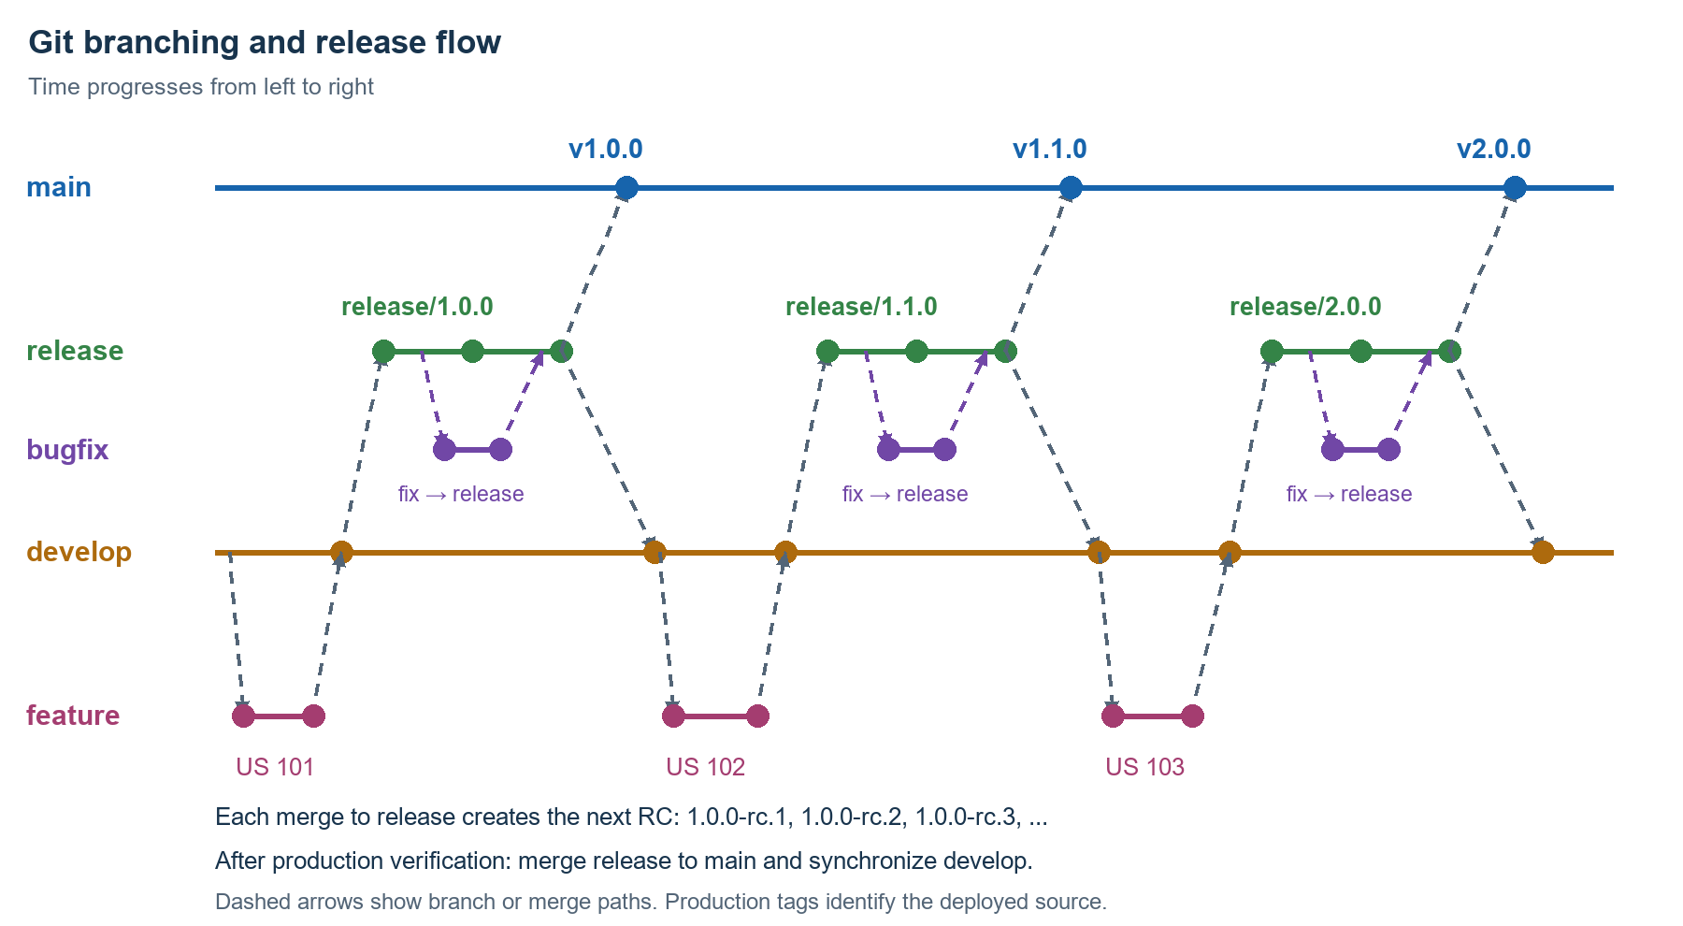
Branch or tag | Purpose and rule
feature/* and bugfix/* | - Features branch from develop and return to develop through PR review.  - Bugfixes branch from the target release and return to that release through PR review.
release/1.0.0 → 1.0.0-rc.1  release/1.1.0 → 1.1.0-rc.1  release/2.0.0 → 2.0.0-rc.1 | - Each merge creates the next RC, for example 1.0.0-rc.1, 1.0.0-rc.2, 1.0.0-rc.3.  - Maintain an independent RC sequence for each release branch.  - After QA/UAT evidence and sign off, promote the approved candidate; synchronize branches after production verification.
main and production tags | - After branch synchronization, tag the main commit matching the deployed release source.  - Record the RC, source commit, artifact digest, and deployment result; a tag alone does not prove deployment.
hotfix/* | - Branch from the production tag or commit actually deployed.  - Test and review the correction, release a new patch tag, and propagate the fix to develop and any affected active release branch.

Semantic versioning uses MAJOR.MINOR.PATCH: incompatible public-contract changes increase MAJOR, backward-compatible functionality increases MINOR, and backward-compatible fixes increase PATCH. Assess compatibility for APIs, schemas, messages, and consumers.

Testing evidence and quality gates

Developer testing in DEV
- Deploy the integrated develop build to DEV and validate against the story acceptance criteria.
- Use controlled test data.
- If shared DEV cannot isolate branches, coordinate a test slot or use an isolated DEV instance and record the exact deployed version.
Test area | Minimum relevant coverage
Functional behavior | - Happy path, invalid or missing inputs, and boundary values.  - Authorization and regression of affected behavior.
Integration contracts | - Connectivity, request and response schemas, and transformations.  - Headers, API policies, correlation IDs, and downstream error mapping.
Failure and recovery | - Timeouts, transient failures, and bounded retries.  - Duplicate delivery, idempotency, dead-letter handling, and safe replay.
Operational behavior | - Logs, metrics, traces, health checks, and expected alerts.  - Load and performance testing when the change warrants it.

Evidence attached to the user story
- Attach files or durable links to automated reports, pipeline runs, API test results, screenshots, and sanitized logs.
- Evidence must allow a reviewer to identify the tested change and reproduce relevant checks.
Evidence field | What to record
Identity and context | - Story ID, tester, test date, and DEV environment.  - Source commit, artifact or build ID, and configuration version.
Results and traceability | - Acceptance criterion or test case; inputs or steps.  - Expected and actual results; pass or fail status.  - Report link or correlation ID.
Defects and follow-up | - Linked defects, retest results, limitations, and explicit disposition.  - Remove secrets, tokens, and sensitive customer data.

Automated gates and peer review
- On pushes and PRs, run build or compilation, unit tests, linting and static analysis, secret detection, dependency scans, and applicable infrastructure or container scans.
- Set repository-specific quality and vulnerability thresholds. Block required checks that fail; assess test relevance as well as coverage. Rerun checks for the final revision and merge result.
- Review correctness, maintainability, security, contract compatibility, failure handling, performance, and production support. Validate the evidence rather than relying only on the author’s summary.

Secure delivery and reliable operation

Configuration and secrets
- Externalize environment-specific endpoints and settings.
- Store secret values in the approved secret manager; keep only references in source control.
- Prefer workload or managed identity where supported, apply least privilege, rotate credentials and certificates, and audit access and changes.
- Never place secrets in commits, artifacts, logs, or test evidence.

Build once and promote
- Package the approved release candidate once and promote the identical immutable artifact through DEV, QA/UAT, and production with environment-specific configuration supplied at deployment.
- Record the source commit and artifact digest.
- A code change creates a new candidate and requires relevant validation again.
- Branch builds support early developer checks; the lifecycle DEV test evidence must identify the integrated develop build.
- After production verification, merge the released source into main and confirm identical source content. Synchronize release fixes into develop and affected active releases; do not introduce untested changes into the deployed artifact.
- Retain the candidate artifact and its provenance for promotion and rollback.

Release candidate versions
- Every successful merge into release/X.Y.Z triggers CI to allocate a new RC version: X.Y.Z-rc.1, X.Y.Z-rc.2, X.Y.Z-rc.3, and so on. Use one sequence per release branch and never reuse a version.
- First candidates: release/1.0.0 → 1.0.0-rc.1; release/1.1.0 → 1.1.0-rc.1; release/2.0.0 → 2.0.0-rc.1. Each release branch maintains its own increasing RC sequence.
- Build and test the merged release commit. Failed candidates cannot be promoted; a later merge creates a new candidate. Promote the approved candidate unchanged, then map its digest to the final production tag after branch sync.

Resilience for integrations
- Define timeouts and use bounded retries with exponential backoff and jitter for transient failures. Avoid retries for permanent failures and uncontrolled retry amplification across services.
- Design idempotent processing where duplicates are possible. Use dead-letter queues, controlled replay, and reconciliation so recovery does not repeat business side effects.
- Handle downstream outages deliberately, using circuit breakers or graceful degradation when appropriate. Keep API, message, and database changes compatible during rollout.

Observability and service objectives
- Propagate an end-to-end trace or correlation ID across requests and messages.
- Use structured logs with service, environment, operation, source and target, duration, status, retry count, and error category.
- Mask sensitive information and apply retention and access controls.
- Define service-level indicators (SLIs) and service-level objectives (SLOs) with service owners.
- Track transaction success, availability, p95/p99 latency, processing delay, retry rates, dead-letter volume, and downstream failures as relevant.
- An illustrative SLO is 99.9% successful eligible requests per month; define the denominator, exclusions, and measurement window before adoption.
- Alert on customer impact and error-budget consumption.
- Route lower-severity signals to tickets or dashboards.
- Each alert needs an owner, impact context, investigation links, and a runbook.
- Agree how exhausted error budgets change release priorities.

Incident response and improvement
- Maintain runbooks for downstream failure, authentication errors, backlogs, dead-letter growth, certificate expiry, and safe reprocessing.
- Name on-call ownership and escalation paths.
- After incidents, review impact, timeline, contributing causes, detection gaps, and recovery without blame; assign preventive actions to the backlog.
- Automate recurring manual work.

Release readiness and Definition of Done

Release readiness checklist
The release owner records the decision and confirms each applicable item before production promotion. Mark an item not applicable only with a reason.
☐ Required DEV, integration, regression, QA, and UAT checks pass; evidence is attached and QA/UAT sign off is recorded before production promotion.
☐ Required PR and code-owner approvals are present; mandatory build, quality, and security gates pass for the approved candidate.
☐ Release branch, tested RC version, source commit, artifact digest, and configuration version are mapped; the production tag is planned for post-verification branch sync.
☐ Deployment dependencies, database or schema migrations, API compatibility, permissions, secrets, and certificates are verified.
☐ Release notes, deployment sequence, responsible people, communications, and required approval are recorded.
☐ Rollback or forward-recovery steps are practical and tested as appropriate, including data recovery for migrations that cannot be safely reversed.
☐ Smoke tests, health checks, dashboards, alerts, runbooks, on-call coverage, and stop or rollback thresholds are ready.

Production verification
- Use staged rollout where supported.
- Verify the deployed artifact and configuration, run smoke tests, inspect end-to-end transaction health, and watch agreed reliability signals for the release observation window.
- If thresholds fail, stop expansion and execute the recovery plan.
- Record the production verification outcome, then complete Branch Sync, Operate and improve: merge the released source to main, create its production tag, and synchronize develop.

Definition of Done for a user story
☐ Acceptance criteria are met and the story, repository, branch, commits, PR, and evidence are linked.
☐ Relevant automated tests are added or updated; DEV validation passes and sanitized evidence is attached.
☐ Independent review is complete, comments are resolved, checks pass, and the change is merged into its target branch: develop for features or the source release for bugfixes.
☐ Configuration, security, contract documentation, observability, and runbooks are updated where affected.
☐ Defects, limitations, and deployment or recovery impacts are resolved or explicitly accepted by the responsible owner.
Story completion and production release are separate milestones. If the team defines Done as released, production deployment and successful verification are also required. Otherwise, track release status explicitly after the story meets the checks above.

