**Question Results**

Score 1 of 1

**Question:**

**View the Exhibit and examine the structure of the CUSTOMERS table.**

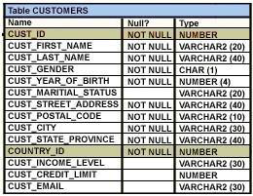

**Which two tasks would require subqueries or joins to be executed in a single statement?**  
(Choose two.)

**Response:**

|  |  |
| --- | --- |
|  | listing of customers who do not have a credit limit and were born before 1980 |
| Correct | listing of those customers, whose credit limit is the same as the credit limit of customers residing in the city 'Tokyo'. |
|  | finding the number of customers, in each city, who’s marital status is 'married'. |
| Correct | finding the number of customers, in each city, whose credit limit is more than the average credit limit of all the customers |
|  | finding the average credit limit of male customers residing in 'Tokyo' or 'Sydney' |

Score 1 of 1

**Question:**

**Review the following illustration:**

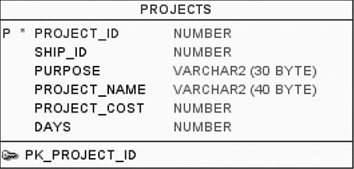

**Which of the following SQL statements will execute correctly?**

**Response:**

|  |  |
| --- | --- |
|  | SELECT RANK(7500000) GROUP BY (ORDER BY PROJECT_COST) FROM PROJECTS; |
| Correct | SELECT RANK(100000) WITHIN GROUP (ORDER BY PROJECT_COST) FROM PROJECTS; |
|  | SELECT RANK(100,000) WITHIN GROUP (ORDER BY PROJECT_COST) FROM PROJECTS; |
|  | SELECT RANK('Upgrade') WITHIN GROUP (ORDER BY PROJECT_COST) FROM PROJECTS; |

Score 1 of 1

**Question:**

**Which two tasks can be performed by using Oracle SQL statements?**

**Response:**

|  |  |
| --- | --- |
|  | starting up a database instance |
|  | executing operating system (OS) commands in a session |
| Correct | changing the password for an existing database user |
|  | connecting to a database instance |
| Correct | querying data from tables across databases |

Score 1 of 1

**Question:**

**Review the illustration. Your task is to define a SELECT statement that groups rows according to their value for PURPOSE and, for each purpose, adds up the values stored in DAYS.**

**Which one of the following queries will perform this task?**



**Response:**

|  |  |
| --- | --- |
| Correct | https://www.dbexam.com/files/dbexam/download/1Z0-071_ch7_10_A.png |
|  | https://www.dbexam.com/files/dbexam/download/1Z0-071_ch7_10_D.png |
|  | https://www.dbexam.com/files/dbexam/download/1Z0-071_ch7_10_C.png |
|  | https://www.dbexam.com/files/dbexam/download/1Z0-071_ch7_10_B.png |

Score 1 of 1

**Question:**

**Which of the following reserved words is required in a complete DELETE statement?**

**Response:**

|  |  |
| --- | --- |
|  | FROM |
|  | None of the above |
|  | WHERE |
| Correct | DELETE |

Score 1 of 1

**Question:**

**Review the following statement:**

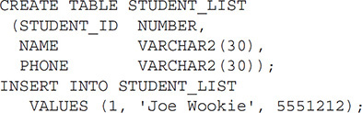

**The table will create successfully. What will result from the INSERT statement?**

**Response:**

|  |  |
| --- | --- |
| Correct | The INSERT will execute—the table will contain one row of data. |
|  | The INSERT will fail because the literal value for PHONE is numeric and PHONE is a character data type. |
|  | None of the above. |
|  | The INSERT will fail because there is no list of columns after STUDENT_LIST. |

Score 1 of 1

**Question:**

**The unique identifier of a row in a database table is a(n):**

**Response:**

|  |  |
| --- | --- |
|  | Column |
|  | ID |
|  | Primary column |
| Correct | Primary key |

Score 1 of 1

**Question:**

**One place to get a master list of all the views that form the data dictionary is:**

**Response:**

|  |  |
| --- | --- |
| Correct | DICTIONARY |
|  | USER_CATALOG |
|  | DATA_DICTIONARY |
|  | CATALOG |

Score 0 of 1

**Question:**

**The ORDER BY clause can be included in a SELECT with set operators if:**

**Response:**

|  |  |
| --- | --- |
|  | The ORDER BY clause cannot be used in a SELECT with set operators. |
| Should have chosen | It follows the final SELECT statement. |
| Wrong | It follows the first SELECT statement. |
|  | It is used in each SELECT statement and its ORDER BY expressions match in data type. |

Score 1 of 1

**Question:**

**A table alias:**  
(Choose two.)

**Response:**

|  |  |
| --- | --- |
| Correct | Exists only for the SQL statement that declared it. |
| Correct | Can be used to clear up ambiguity in the query. |
|  | Is the same thing as a database object synonym. |
|  | Renames a table in the database so that future joins can use the new name. |

Score 1 of 1

**Question:**

**The data dictionary is owned by:**

**Response:**

|  |  |
| --- | --- |
|  | PUBLIC |
|  | SYSTEM |
|  | Each individual user |
| Correct | SYS |

Score 0 of 1

**Question:**

**Which two statements are true about Data Manipulation Language (DML) statements?**

**Response:**

|  |  |
| --- | --- |
| Wrong | A DELETE FROM..... statement can remove multiple rows based on multiple conditions on a table. |
|  | An UPDATE...SET.... statement can modify multiple rows based on only a single condition on a table. |
| Should have chosen | AH INSERT INTO. . .VALUES. . statement can add multiple rows per execution to a table. |
|  | An UPDATE...SET... statement can modify multiple rows based on multiple conditions on a table. |
| Wrong | An INSERT INTO...VALUES..... statement can add a single row based on multiple conditions on a table. |
| Should have chosen | A DELETE FROM ..... statement can remove rows based on only a single condition on a table. |

Score 1 of 1

**Question:**

**User account MUSKIE owns a table called CBAY. Which of the following statements can be executed by MUSKIE and enable user ONEILL to execute UPDATE statements on the CBAY table?**  
(Choose three.)

**Response:**

|  |  |
| --- | --- |
| Correct | GRANT ALL ON CBAY TO ONEILL; |
| Correct | GRANT INSERT, UPDATE ON CBAY TO ONEILL; |
|  | GRANT ALL TO ONEILL; |
| Correct | GRANT ALL PRIVILEGES TO ONEILL; |

Score 0 of 1

**Question:**

**Review the following data listing for the SHIPS table:**

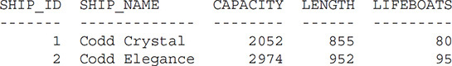

**Now review the following SQL statement (line numbers are added for readability):**

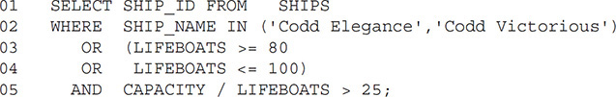

**Which of the following statements is true about this SELECT statement?**

**Response:**

|  |  |
| --- | --- |
| Wrong | Line 5 is missing parentheses. |
|  | The syntax on lines 3 and 4 is incorrect. |
|  | Lines 3 and 4 have correct syntax but could be replaced with OR LIFEBOATS BETWEEN 80 AND 100. |
| Should have chosen | The syntax is correct. |

Score 1 of 1

**Question:**

**Which task can be performed by using a single Data Manipulation Language (DML) statement?**

**Response:**

|  |  |
| --- | --- |
|  | adding a column with a default value when inserting a row into a table |
|  | adding a column constraint when inserting a row into a table |
|  | removing all data only from one single column on which a primary key constraint is defined |
| Correct | removing all data only from one single column on which a unique constraint is defined |

Score 1 of 1

**Question:**

**Which of the following topics are not included in the SQL Fundamentals I exam but are addressed on the SQL Associate exam?**  
(Choose all that apply.)

**Response:**

|  |  |
| --- | --- |
| Correct | Conversion functions |
| Correct | External tables |
| Correct | FLASHBACK |
| Correct | MERGE |

Score 1 of 1

**Question:**

**Consider the following set of SQL statements:**

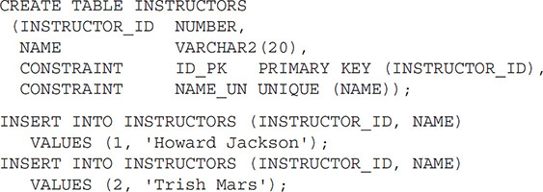

**The table will create successfully. What will be the result of the two INSERT statements?**

**Response:**

|  |  |
| --- | --- |
|  | Neither will execute. |
|  | The first will execute, but the second will fail. |
|  | The first will fail, but the second will execute. |
| Correct | Both will execute successfully. |

Score 1 of 1

**Question:**

**View the Exhibit and examine the description of the PRODUCT_INFORMATION table. Which SQL statement would retrieve from the table the number of products having LIST_PRICE as NULL?**

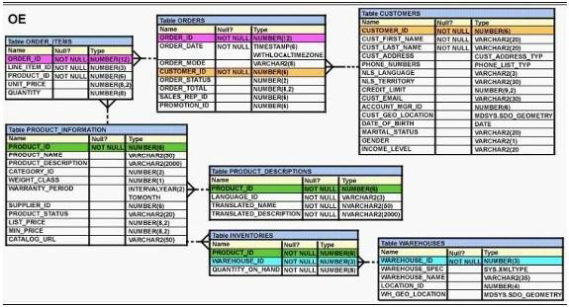

**Response:**

|  |  |
| --- | --- |
|  | SELECT COUNT (list_price) FROM product_information WHERE list_price is NULL |
| Correct | SELECT COUNT (NVL(list_price, 0)) FROM product_information WHERE list_price is NULL |
|  | SELECT COUNT (list_price) FROM product_information WHERE list_price i= NULL |
|  | SELECT COUNT (DISTINCT list_price) FROM product_information WHERE list_price is NULL |

Score 1 of 1

**Question:**

**Evaluate the following SQL query;**

**https://www.dbexam.com/files/dbexam/download/1z0-071_43.png**

**What would be the outcome?**

**Response:**

|  |  |
| --- | --- |
|  | 200 |
|  | 100 |
|  | 16 |
|  | 150 |
| Correct | 160 |

Score 1 of 1

**Question:**

**Review the following series of SQL statements:**

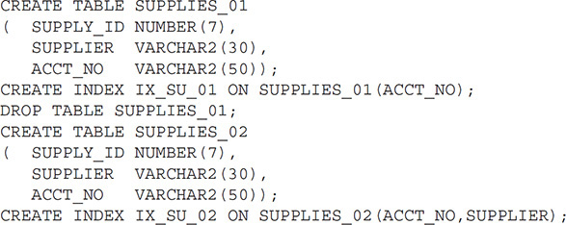

**Assuming there are no objects already in existence named SUPPLIES_01 or SUPPLIES_02 prior to the execution of the preceding statements, what database objects will result from these statements?**

**Response:**

|  |  |
| --- | --- |
|  | A table called SUPPLIES_02 and two indexes called IX_SU_01 and IX_SU_02 |
|  | None of the above |
|  | A table called SUPPLIES_02 and nothing else |
| Correct | A table called SUPPLIES_02 and an index called IX_SU_02 |

Score 1 of 1

**Question:**

**Examine the following query:**

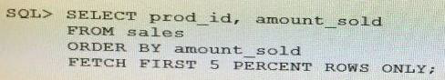

**What is the output of this query?**

**Response:**

|  |  |
| --- | --- |
|  | It results in an error because the ORDER BY clause should be the last clause. |
|  | It displays the first 5 percent of the rows from the SALES table. |
| Correct | It displays 5 percent of the products with the lowest amount sold. |
|  | It displays 5 percent of the products with the highest amount sold. |

Score 1 of 1

**Question:**

**Your user account owns a table BACK_ORDERS, and you want to grant privileges on the table to a user account named CARUSO, which already has the system privileges CREATE SESSION and UNLIMITED TABLESPACE.**

**Examine the following SQL statement:**GRANT SELECT ON BACK_ORDERS TO CARUSO;

**Once this statement has been executed, which of the following statements will be true for user CARUSO?**

**Response:**

|  |  |
| --- | --- |
| Correct | CARUSO will have SELECT privileges on BACK_ORDERS but not the ability to give other users SELECT privileges on BACK_ORDERS. |
|  | CARUSO will have SELECT, INSERT, UPDATE, and DELETE privileges on BACK_ORDERS but not the ability to give other users those same privileges on BACK_ORDERS. |
|  | CARUSO will have SELECT and ALTER TABLE privileges on BACK_ORDERS but not the ability to give other users those same privileges on BACK_ORDERS. |
|  | CARUSO will have SELECT privileges on BACK_ORDERS, as well as the ability to give other users SELECT privileges on BACK_ORDERS. |

Score 1 of 1

**Question:**

**Review the following SQL statement:**

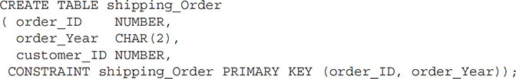

**Assume there is no table already called SHIPPING_ORDER in the database. What will be the result of an attempt to execute the preceding SQL statement?**

**Response:**

|  |  |
| --- | --- |
|  | The statement will fail because the data type for ORDER_YEAR is a CHAR, and CHAR data types aren’t allowed in a PRIMARY KEY constraint. |
|  | The statement will fail because there is no precision for the ORDER_ID column’s data type. |
| Correct | The statement will succeed: the table will be created, and the primary key will also be created. |
|  | The table will be created, but the primary key constraint will not be created because the name does not include the _PK suffix. |

Score 1 of 1

**Question:**

**When is a query considered a multirow subquery?**  
(Choose the best answer.)

**Response:**

|  |  |
| --- | --- |
|  | All of the above |
| Correct | If it returns multiple rows at the time of execution |
|  | If it may or may not return multiple rows, as determined by its WHERE clause |
|  | If it returns numeric data, regardless of the number of rows of data it returns |

Score 1 of 1

**Question:**

**View the Exhibit and examine the structure of the ORDERS table. The ORDER_ID column is the PRIMARY KEY in the ORDERS table. Evaluate the following CREATE TABLE command:**

CREATE TABLE new_orders(ord_id, ord_date DEFAULT SYSDATE, cus_id) AS SELECT order_id.order_date,customer_id FROM orders;

**Which statement is true regarding the above command?**

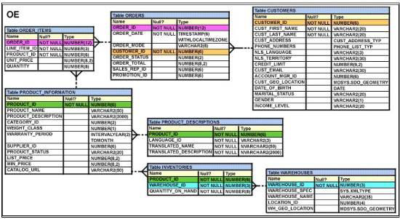

**Response:**

|  |  |
| --- | --- |
|  | The NEW_IDRDERS table would not get created because the column names in the CREATE TABLE command and the SELECT clause do not match. |
|  | The NEW_IDRDERS table would not get created because the DEFAULT value cannot be specified in the column definition. |
| Correct | The NEW_IDRDERS table would get created and only the NOT NULL constraint defined on the specified columns would be passed to the new table. |
|  | The NEW_IDRDERS table would get created and all the constraints defined on the specified columns in the ORDERS table would be passed to the new table. |

Score 1 of 1

**Question:**

**Which of the following are valid CREATE TABLE statements?**  
(Choose three.)

**Response:**

|  |  |
| --- | --- |
|  | https://www.dbexam.com/files/dbexam/download/1Z0-071_ch2_4_A.png |
| Correct | https://www.dbexam.com/files/dbexam/download/1Z0-071_ch2_4_B.png |
| Correct | https://www.dbexam.com/files/dbexam/download/1Z0-071_ch2_4_C.png |
| Correct | https://www.dbexam.com/files/dbexam/download/1Z0-071_ch2_4_D.png |

Score 1 of 1

**Question:**

**Review the PORTS and SHIPS tables shown. Then review the following SQL code:**

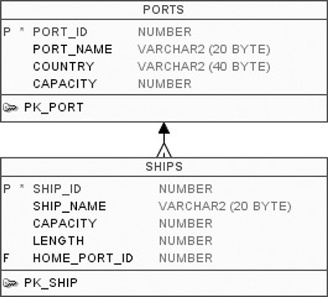

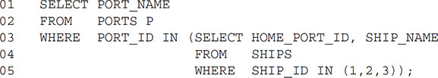

**Which of the following is true of this statement?**

**Response:**

|  |  |
| --- | --- |
|  | None of the above. |
| Correct | The statement will fail with a syntax error because of line 3. |
|  | Whether the statement fails depends on how many rows are returned by the subquery in lines 3 through 5. |
|  | The statement will fail with a syntax error because of line 5. |

Score 1 of 1

**Question:**

**Which of the following comparison operators can be used with a multiple-row subquery?**  
(Choose two.)

**Response:**

|  |  |
| --- | --- |
|  | = |
| Correct | >= ALL |
| Correct | IN |
|  | LIKE |

Score 1 of 1

**Question:**

**Review this WORK_HISTORY table.**

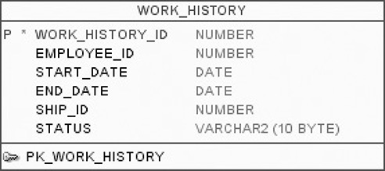

**Your task is to create a query that will list—for each ship—all of the EMPLOYEE_ID values for all the employees who have the shortest work history for their ship.**

**In other words, if there are two ships, you want to list all the employees assigned to the first ship who have the shortest work history, all the employees assigned to the second ship who have the shortest work history, and so on.**

**Which of the following queries will accomplish this task?**  
(Choose two.)

**Response:**

|  |  |
| --- | --- |
|  | https://www.dbexam.com/files/dbexam/download/1Z0-071_ch9_7_D.png |
|  | https://www.dbexam.com/files/dbexam/download/1Z0-071_ch9_7_B.png |
| Correct | https://www.dbexam.com/files/dbexam/download/1Z0-071_ch9_7_C.png |
| Correct | https://www.dbexam.com/files/dbexam/download/1Z0-071_ch9_7_A.png |

Score 1 of 1

**Question:**

**Which of the following actions will not cause the contents of the data dictionary to be changed in some way?**

**Response:**

|  |  |
| --- | --- |
|  | Modify the data type of an existing column |
| Correct | None of the above |
|  | Create a new table |
|  | Execute a valid COMMENT statement |

Score 0 of 1

**Question:**

**You are tasked with querying the data dictionary view that lists only those sequences to which you currently have privileges but don’t necessarily own. To do this, you log in to your own user account and query the data dictionary view called:**

**Response:**

|  |  |
| --- | --- |
| Should have chosen | ALL_SEQUENCES |
| Wrong | USER_SEQUENCES |
|  | DBA_SEQUENCES |
|  | USER_PRIV_SEQUENCES |

Score 1 of 1

**Question:**

**Review the PORTS and SHIPS tables:**



**Next, review the following SQL code:**

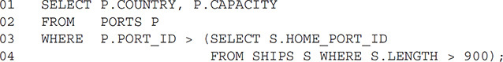

**You know that there are five rows in the SHIPS table with a length greater than 900. What will result from an attempt to execute this SQL statement?**

**Response:**

|  |  |
| --- | --- |
|  | The statement will execute and produce output as intended. |
|  | None of the above. |
| Correct | An execution error will result because the subquery will return more than one row and the parent query is expecting only one row from the subquery. |
|  | A syntax error will result because PORT_ID and HOME_PORT_ID in line 3 have different column names. |

Score 1 of 1

**Question:**

**Which of the following SQL statements creates a table that will reject attempts to INSERT a row with NULL values entered into the POSITION_ID column?**

**Response:**

|  |  |
| --- | --- |
| Correct | https://www.dbexam.com/files/dbexam/download/1Z0-071_ch2_12_B.png |
|  | None of the above |
|  | https://www.dbexam.com/files/dbexam/download/1Z0-071_ch2_12_C.png |
|  | https://www.dbexam.com/files/dbexam/download/1Z0-071_ch2_12_A.png |

Score 1 of 1

**Question:**

**The set operators do not include which one of the following keywords?**

**Response:**

|  |  |
| --- | --- |
|  | UNION |
|  | MINUS |
| Correct | SET |
|  | ALL |

Score 1 of 1

**Question:**

**Consider the following SQL statement: SELECT SOUNDEX('Donald') FROM DUAL; Which of the following is most likely to be the output of this SELECT statement?**  
(Choose the best answer.)

**Response:**

|  |  |
| --- | --- |
|  | DON3 |
|  | Donalt |
|  | Donalk |
| Correct | D543 |

Score 0 of 1

**Question:**

**Which of the following statements will grant the role OMBUDSMAN to user JOSHUA in such a way that JOSHUA may grant the role to another user?**

**Response:**

|  |  |
| --- | --- |
| Wrong | GRANT OMBUDSMAN TO JOSHUA WITH GRANT OPTION; |
|  | GRANT OMBUDSMAN TO JOSHUA CASCADE; |
|  | GRANT OMBUDSMAN TO JOSHUA WITH ROLE OPTION; |
| Should have chosen | GRANT OMBUDSMAN TO JOSHUA WITH ADMIN OPTION; |