Eduvos Assessment Coversheet
Academic Details
Campus: | Mowbaray
Faculty: | IT
Module Code: | ITECA3-34
Lecturer’s Name: | Mandlenkosi Mlotshwa
Group (if applicable)
Assessment Details
Assessment Type: | PROJECT SUBMISSION
Assignment/Brief Number:
Due Date/ Submission Date: | 30/10/2026
Student Details (Group, if applicable)
# | Full Name | Student Number | Contact Number | % Participation | Signature
1
2
3
4
5
6

Student Details (Individual, if applicable)
Student Full Name: | Admildo Netchitchi Fernandes Manuel
Student Number:
Academic Integrity
AI Disclosure Completed | Yes X | No
Declaration:
I declare that this assessment is my own original work except for source material explicitly acknowledged. I confirm that this work has not previously been submitted for assessments in any course. I acknowledge the institutional AI policy and confirm that AI tools have only been used as stipulated and documented in the AI Disclosure Appendix.

Student Signature | Admildo Manuel
Date | 30/10/2026

Lecturer Use Only
Lecturer Comments:
Marks Awarded (%):
Lecturer Signature:
Date:

Assessment

Introduction

Oneholy Lab is an ecommerce website based on a friend's business. It is built with PHP, MySQL, and CSS with Tailwind CSS. It’s currently available at https://oneholylab.admildomanuel.com.
The website is responsive, performant and has two main views: the normal shopper view and the admin view. Both can log in and have separation of concerns.

This document contains the documentation of the project as well as the important UML diagrams. In this documentation, we list the main classes, processes, security practices and much more.
The information on how to use the app, as well as the screenshots, is in the other document called the user manual. This document focuses on the code, abstraction and technical aspects.

Architecture
Read the diagram from the top. Each layer calls the one under it.
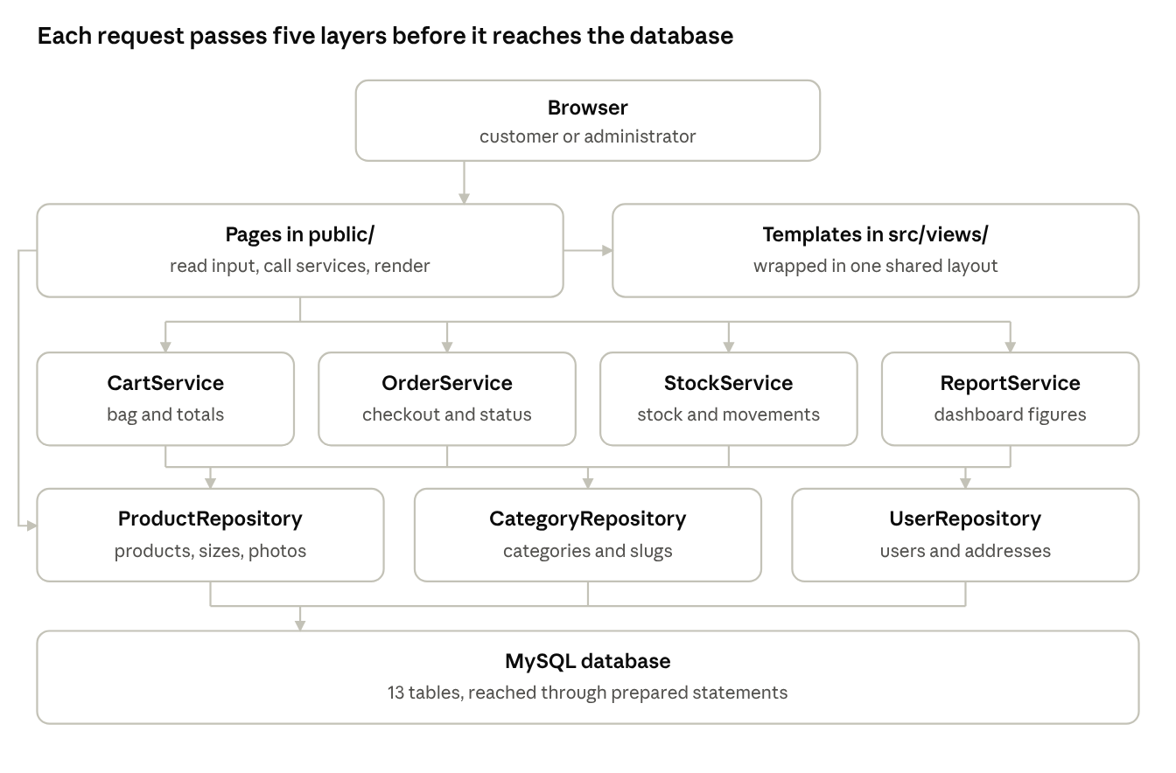
Request path through five layers
What each layer does:
The browser sends the request and then shows the HTML that is sent back.
The pages which are public read the input and call the services; simple reads go directly to the repositories, as in the case of shop.php. The data is then passed on to a template.
The templates in src/views/ are contained within a single shared layout, and the browser receives the result in the form of HTML.
The services contain the business rules for the bag, the checkout, the stock and the dashboard.
Repositories contain the SQL for a group of tables.
The Database makes use of a single shared connection for MySQL, and sometimes the Services contact the Database directly; for example, OrderService::place() does so when carrying out its transaction.
There are some classes which lie outside of these layers; Auth and Csrf protect the pages, AuditLog keeps a record of administrative changes, and OrderService makes use of Mailer and the payment gateway when carrying out the checkout process.

System context and use cases
The context diagram draws the whole system as one process. The use case diagram shows what each actor can do.
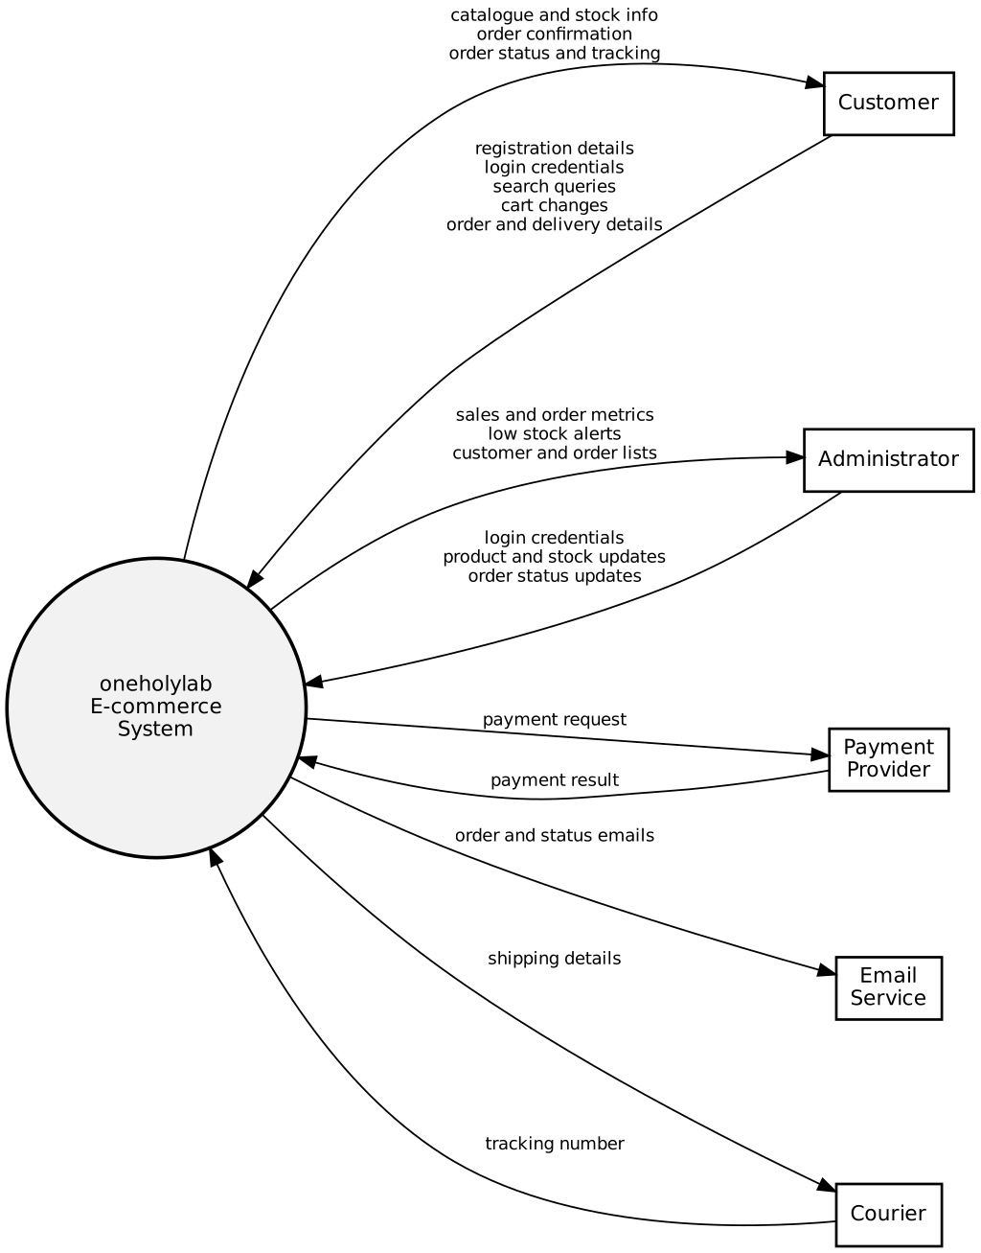

Five outside parties exchange data with the system:
The customer sends registration details, login credentials, searches, cart changes and delivery details. The customer gets catalogue information, order confirmations and status updates.
The administrator sends login credentials, product and stock updates, and order status changes. The administrator gets sales metrics, low stock alerts and order lists.
The payment provider receives payment requests and sends back payment results. The code has only the demo gateway, so no real provider is called yet.
The email service receives order and status emails. The code does not use a separate service. Mailer calls PHP mail() or writes to storage/mail.log.
The courier has two flows: shipping details out, and tracking numbers in. The code does not call a courier. Staff type the tracking number into the order by hand.

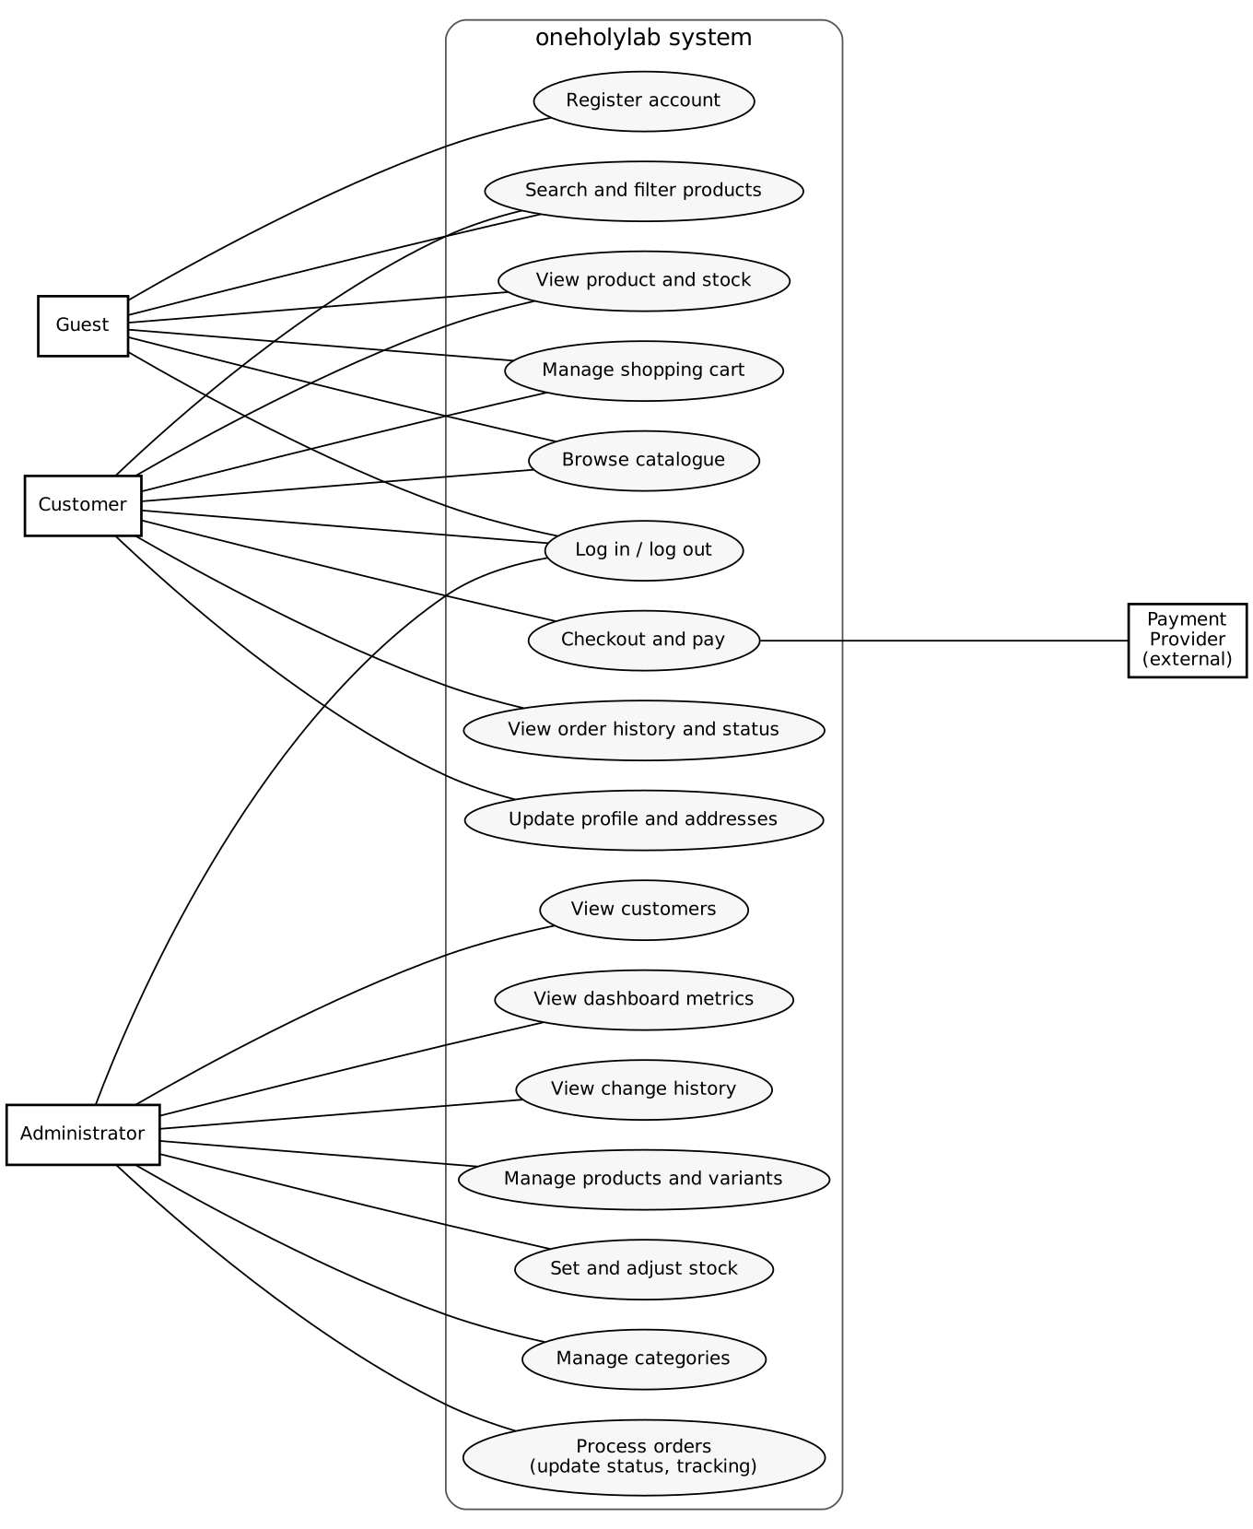

Guests are able to browse, search for items, see the products, manage their shopping bag, register and log in, but they cannot carry out a checkout since checkout requires a login. Customers, on the other hand, can check out, see their order history and update their profile. Administrators can manage the products, set the stock, manage the categories and process orders, and they can also view the customers, the dashboard and the change history. It is only the checkout process that goes to the payment provider.

Database design

The database has 13 tables. The EERD shows how they relate. The database diagram lists each column with its type.

Group | Tables | Notes
Accounts | users, addresses | Customers and admins share users. The role column tells them apart.
Catalogue | categories, products, product_variants, product_images | Stock is stored on product_variants, one row per size.
Cart | carts, cart_items | A cart belongs to a user or to a guest's session token.
Orders | orders, order_items, payments | order_items keeps the name, size and price from the time of purchase.
Records | stock_movements, audit_log | Every stock change and admin action is logged here.

Relationships (EERD)
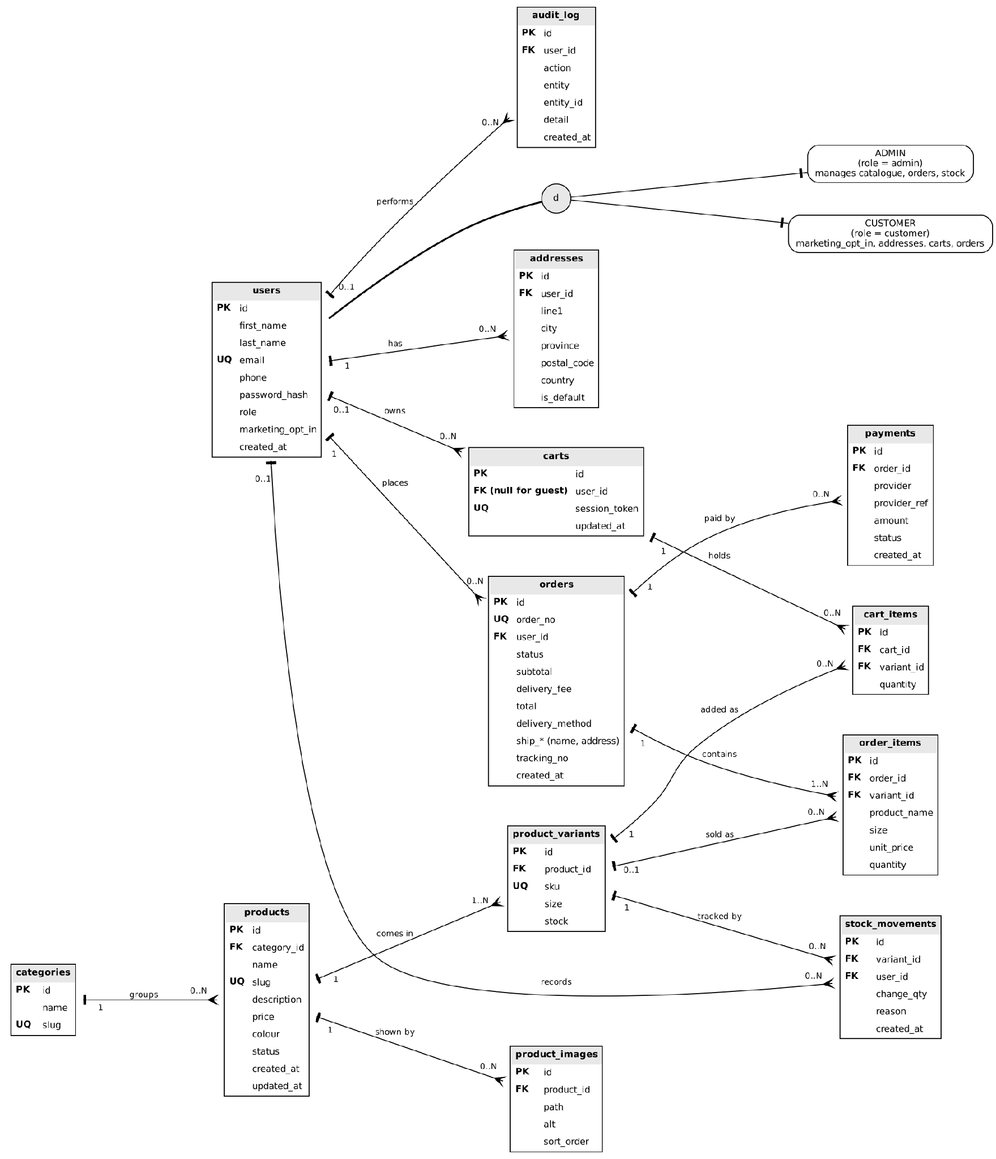
The EERD shows users as customers and admins. The two are disjoint, so each user is one or the other. The split is a role column, not two tables.

Columns and types
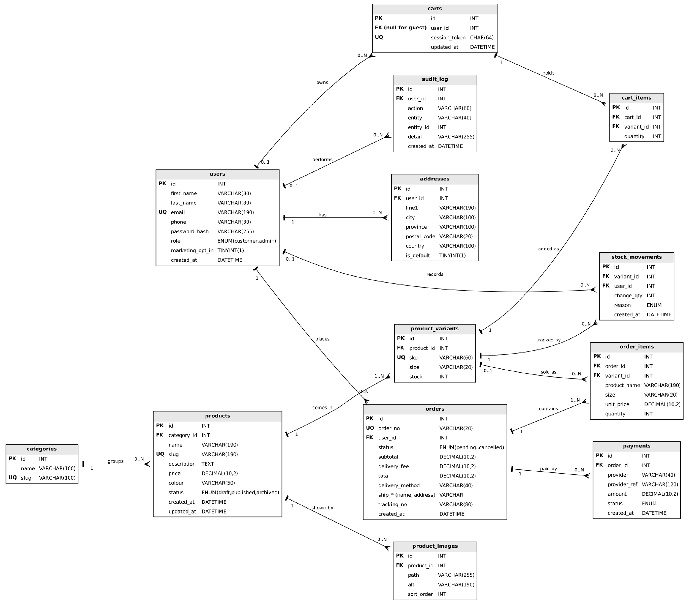
The two diagrams are drawn separately from the SQL. When you change sql/schema.sql, update both diagrams as well.

Data flow
The level 0 diagram consists of seven processes and five data stores, three of the external entities supplying data into the system and taking data out: the customer, the administrator and the payment provider.
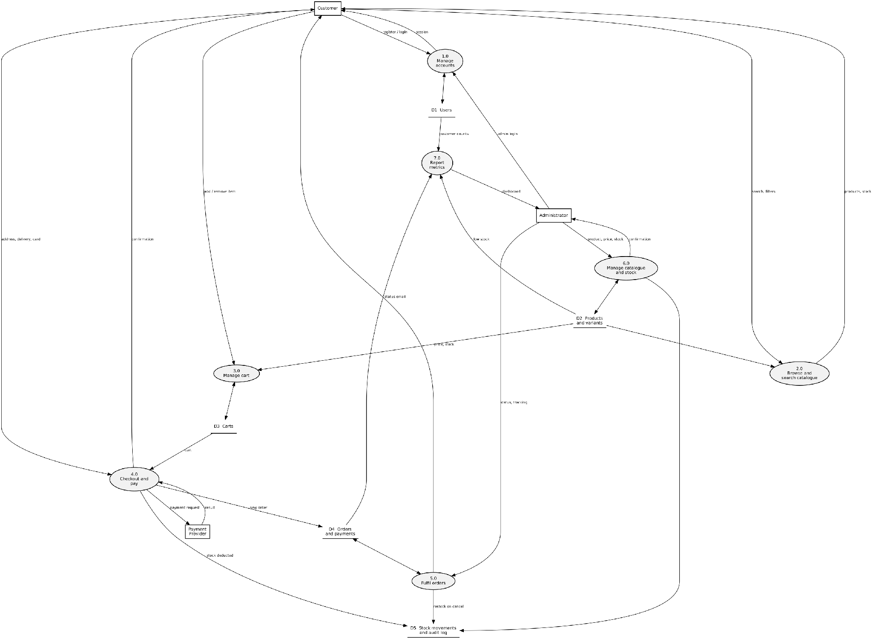

Process | Where the code is
1.0 Manage accounts | Auth, UserRepository, login.php, register.php, account.php
2.0 Browse and search catalogue | ProductRepository::search(), shop.php, product.php
3.0 Manage cart | CartService, cart.php
4.0 Checkout and pay | OrderService::place(), DemoGateway, checkout.php
5.0 Fulfil orders | OrderService::updateStatus(), admin/orders.php
6.0 Manage catalogue and stock | ProductRepository, CategoryRepository, ImageUpload, StockService, the admin product pages
7.0 Report metrics | ReportService, admin/index.php

The five data stores are D1 Users, D2 Products and Variants, D3 Carts, D4 Orders and Payments, and D5 Inventory and Audit Log. These data stores correspond to tables in the database part.

Folder map

Everything the web server can reach is in public/. The rest is code, configuration or data, and stays outside the web root.
Path | What it holds
public/*.php | Customer pages: home, shop, product, cart, checkout, order, account, login, register and logout.
public/admin/*.php | Admin pages: dashboard, products, product_edit, orders, customers, categories, activity (History), login and logout.
public/assets/css/app.css | Built Tailwind CSS, generated from assets-src/app.css. Don't edit it by hand.
public/assets/js/app.js | It handles the phone menu, photo dots, confirmation prompts, filters that submit on change, and card number formatting.
public/assets/img/ | Placeholder, hero and seeded product images.
public/uploads/products/ | Product photos uploaded in the admin. PHP is blocked here.
src/ | Application classes, plus bootstrap.php and helpers.php. Outside the web root.
src/views/ | Templates. layout/ has the shop and admin shells, shop/ and admin/ hold the pages, and partials/ has reusable pieces such as the product card.
config/ | config.php holds the defaults. You create config.local.php to override them.
sql/ | schema.sql creates the 13 tables. seed.php adds demo data and the first admin.
storage/ | mail.log, where emails go when the mail transport is log.
tests/smoke.sh | Tests the main customer and admin flows.
docs/ | Existing system docs: CRC cards, diagrams and a PDF copy.
assets-src/, package.json, tailwind.config.js, node_modules/ | CSS build tooling. You only need it if you change styles.
.htaccess (project root) | Sends requests to public/, so http://localhost/oneholylab/ works.
public/.htaccess | Turns off directory listings and PHP error display, and blocks PHP in uploads.

Classes follow one naming pattern. Repository classes read and write one group of tables. Service classes hold business rules. The other classes are helpers with one purpose each.

Class walkthrough

Pages call services and repositories. Services never produce HTML.
Class | Layer | What it does | Main methods
Database | Data access | Holds one shared mysqli connection and runs every query as a prepared statement. | all(), one(), value(), run(), insert(), begin(), commit(), rollback()
ProductRepository | Data access | Products, their sizes and photos. Also runs the shop search. | search(), findBySlug(), variants(), save(), addVariant(), addImage(), deleteImage()
CategoryRepository | Data access | Categories, and the URL slug each one gets from its name. | all(), nameTaken(), create(), rename(), delete()
UserRepository | Data access | Customers and admins, and each customer's saved address. | find(), findByEmail(), create(), updateProfile(), saveAddress(), customersWithTotals()
CartService | Business rules | Builds the bag for a guest (session token) or a customer (account). Checks stock when an item is added, works out totals, and merges the guest bag at login. | add(), setQuantity(), clear(), summary(), deliveryFee(), mergeGuestCartInto()
OrderService | Business rules | Turns the bag into an order inside one transaction, and changes order status. | place(), updateStatus(), forUser(), all(), find(), byNumber()
StockService | Business rules | Changes the stock of existing sizes and logs each change to stock_movements. New sizes are the exception; see Known gaps. | change(), set(), lowStock(), recentMovements()
ReportService | Business rules | Dashboard figures: sales, orders, new customers, sales per day and top sellers. Cancelled orders are left out. | kpis(), dailySales(), topProducts()
Auth | Security | Login state, password checks, role checks and redirects for guests. | user(), attempt(), login(), logout(), requireLogin(), requireAdmin()
Csrf | Security | One token per session, checked on every POST. | token(), field(), check()
AuditLog | Support | Logs admin actions along with the user who made them. | record(), recent()
View | Presentation | Renders a template inside a layout, and renders partials. | render(), partial()
Mailer | Support | Sends order emails, either to storage/mail.log or through PHP mail(). | orderConfirmation(), statusChanged(), send()
ImageUpload | Support | Checks and saves product photos. | save()
PaymentGateway | Payments | The interface every payment provider implements. | charge()
DemoGateway | Payments | The test gateway. Checks the card number (Luhn), expiry and CVC, and declines 4000 0000 0000 0002. | charge()

src/helpers.php holds plain functions rather than a class: config(), e(), money(), url(), asset(), redirect(), flash(), input() and slugify().

Main flows:

Placing an order (OrderService::place)

Adding to the bag and logging in (CartService, Auth::login)

Changing an order's status (OrderService::updateStatus)

Saving a product (admin/product_edit.php)

Security measures

Check the file named for each protection before you change related code.
Protection | Where | How it works
SQL injection | src/Database.php | Values go into prepared statements as bound parameters. Only fixed fragments are written into query text. The search and the report build SQL this way, and the report's row limit is cast to an integer.
Passwords | UserRepository::create(), Auth::attempt() | Passwords are stored with password_hash() and checked with password_verify(). For an unknown email the code still checks a dummy hash, so response time does not reveal which emails exist.
Sessions | src/bootstrap.php, Auth::login(), Auth::logout() | Cookies are HttpOnly and SameSite=Lax, plus Secure on HTTPS. The session id changes at login. Logout clears the data and destroys the session.
Form forgery (CSRF) | src/Csrf.php | Csrf::field() adds a hidden token to each form. Csrf::check() compares it with hash_equals() and returns HTTP 419 on a mismatch. There is one token per session, not one per form.
Output escaping | e() in src/helpers.php | e() wraps htmlspecialchars() with ENT_QUOTES. Templates pass user input and stored text through it.
Customer pages only | Auth::requireLogin() | Guests go to the login page and come back afterwards. order.php looks up the order by the id of the user who is logged in, so one customer cannot open another's order.
Admin pages only | Auth::requireAdmin(), public/admin/login.php | Every admin page calls requireAdmin(). The admin login accepts only the admin role, so customer accounts cannot get in.
Uploads | src/ImageUpload.php, public/.htaccess | Only JPG, PNG and WebP files up to 5 MB are accepted. The type comes from the file contents, not the name, and the file gets a random name. PHP files are denied in uploads/.
Source code | Root .htaccess | Requests go to public/, so src/, config/, sql/ and storage/ cannot be fetched by URL.
Stock | StockService::change(), OrderService::place() | Variant rows are locked during checkout. A change that would make stock negative is refused by the UPDATE itself.
Card data | DemoGateway, payments table | Card values go to the gateway and are not saved. The payments table keeps only the provider's reference.
Error detail | src/bootstrap.php, Database::connection() | Errors show only when app_env is development. Database errors are logged, and the customer sees a plain message.

Configuration

The default values can be found in config/config.php. The settings can be changed through two methods. The environment variable with the same name determines the default value. Any value set in config/config.local.php takes precedence over it, and the latter over the environment variables. The file config.config.local.example.php should be used to create the file.

Setting | Default | Environment variable | What it controls
app_env | production | APP_ENV | development shows errors on screen. Any other value hides them.
base_url | Detected | BASE_URL | The site path used in links. Set it only when detection gets it wrong.
db.host | 127.0.0.1 | DB_HOST | The MySQL or MariaDB server.
db.name | oneholylab | DB_NAME | The database name.
db.user | root | DB_USER | The database user.
db.pass | Empty | DB_PASS | The database password.
db.charset | utf8mb4 | None | The connection character set, fixed in config.php.
currency | R | None | The prefix on every price.
free_delivery_over | 1000.00 | None | Standard delivery is free at or above this subtotal.
delivery_methods | Standard R 100.00, express R 150.00, collection free | None | The label, note and fee for each method.
low_stock_threshold | 5 | None | Sizes at or below this count show as low stock.
payment_provider | demo | PAYMENT_PROVIDER | Shown on checkout and used by the test mode notice. It does not choose the gateway (see below).
mail_from | orders@oneholylab.test | MAIL_FROM | The sender address on order emails.
mail_transport | log | MAIL_TRANSPORT | log writes emails to storage/mail.log. mail sends them with PHP mail().

Setting PAYMENT_PROVIDER does not alter which gateway will be used. OrderService::gateway() will always return DemoGateway. In order to use a real provider, make a class which implements PaymentGateway, have it returned from gateway(), and set payment_provider. The README instructs you to only set PAYMENT_PROVIDER, but that is insufficient.
For the live host, set app_env to production and mail_transport to mail. All other steps are detailed in the README under the deploy section.

Conclusion

All the major objectives of the project have been achieved since the functional requirements of the shop, shopping cart, checkout, orders and administration back-office have been met.

Non-functional requirements, including the aspects of security, reliability, maintainability and mobile usability, have been fulfilled in the context of the project. PHP coding standards and an object-oriented approach were adhered to as much as possible; the system code has been separated into pages, services, data access and views.

The system works locally under XAMPP and can be deployed to any shared hosting service; the installation and deployment procedure has been outlined.

Live payment functionality is still quite limited and will be the focus of future enhancements. Overall, the project results in a working and maintainable e-commerce solution that satisfies the project requirements and can be further developed.

Reference list

Barth, A. (2011) HTTP State Management Mechanism. RFC 6265. Internet Engineering Task Force. Available at: https://www.rfc-editor.org/rfc/rfc6265 (Accessed: [date accessed]).
Fowler, M. (2003) Patterns of Enterprise Application Architecture: Catalog. Available at: https://martinfowler.com/eaaCatalog/ (Accessed: [date accessed]).
Fowler, M. (2004) ‘Inversion of Control Containers and the Dependency Injection pattern’, martinfowler.com, 23 January. Available at: https://martinfowler.com/articles/injection.html (Accessed: [date accessed]).
Martin, R.C. (2014) ‘The Single Responsibility Principle’, The Clean Code Blog, 8 May. Available at: https://blog.cleancoder.com/uncle-bob/2014/05/08/SingleReponsibilityPrinciple.html (Accessed: [date accessed]).
Martin, R.C. (2020) ‘Solid Relevance’, The Clean Code Blog, 18 October. Available at: https://blog.cleancoder.com/uncle-bob/2020/10/18/Solid-Relevance.html (Accessed: [date accessed]).
Oracle Corporation (n.d.) MySQL 8.0 Reference Manual: InnoDB Locking Reads. Available at: https://dev.mysql.com/doc/refman/8.0/en/innodb-locking-reads.html (Accessed: [date accessed]).
OWASP Foundation (n.d.) OWASP Cheat Sheet Series. Available at: https://cheatsheetseries.owasp.org/ (Accessed: [date accessed]).
OWASP Foundation (2025) OWASP Top 10:2025. Available at: https://owasp.org/Top10/2025/ (Accessed: [date accessed]).
PHP Documentation Group (n.d.) PHP Manual. Available at: https://www.php.net/manual/en/ (Accessed: [date accessed]).
PHP-FIG (n.d.) PSR-4: Autoloader. Available at: https://www.php-fig.org/psr/psr-4/ (Accessed: [date accessed]).
PHP-FIG (2017) PSR-12: Extended Coding Style. Available at: https://www.php-fig.org/psr/psr-12/ (Accessed: [date accessed]).
Refactoring.Guru (n.d.a) Design Patterns. Available at: https://refactoring.guru/design-patterns (Accessed: [date accessed]).
Refactoring.Guru (n.d.b) Duplicate Code. Available at: https://refactoring.guru/smells/duplicate-code (Accessed: [date accessed]).

AI Evidence Section

AI Disclosure Appendix
AI tool used | Purpose / how it was used | How I verified or adapted the output

Declaration:
I/we declare that this assessment is my/our own original work, except for source material explicitly acknowledged. I/we confirm that any use of Artificial Intelligence (AI) tools has been applied only as permitted by the assessment instructions and has been fully disclosed where required.
I/we understand that I/we remain responsible for the accuracy, originality, and academic quality of this submission. I/we am/are aware of the institution’s policies on academic integrity and the requirements relating to the responsible use of AI in assessments.
I/we acknowledge that failure to comply with these requirements, including undeclared or inappropriate AI use, may result in academic penalties or disciplinary procedures in accordance with institutional policy.

Student Signature(s) | Date
Admildo Manuel | 30/10/2026

