Eduvos Assessment Coversheet
Academic Details
Campus: | Mowbaray
Faculty: | IT
Module Code: | ITECA3-34
Lecturer’s Name: | Mandlenkosi Mlotshwa
Group (if applicable)
Assessment Details
Assessment Type: | PROJECT SUBMISSION
Assignment/Brief Number:
Due Date/ Submission Date: | 30/10/2026
Student Details (Group, if applicable)
# | Full Name | Student Number | Contact Number | % Participation | Signature
1
2
3
4
5
6

Student Details (Individual, if applicable)
Student Full Name: | Admildo Netchitchi Fernandes Manuel
Student Number:
Academic Integrity
AI Disclosure Completed | Yes x | No
Declaration:
I declare that this assessment is my own original work except for source material explicitly acknowledged. I confirm that this work has not previously been submitted for assessments in any course. I acknowledge the institutional AI policy and confirm that AI tools have only been used as stipulated and documented in the AI Disclosure Appendix.

Student Signature | Admildo Manuel
Date | 30/10/2026

Lecturer Use Only
Lecturer Comments:
Marks Awarded (%):
Lecturer Signature:
Date:

Assessment
ONEHOLYLAB USER MANUAL

How to shop on oneholylab and how to run the store from the admin area. Every screenshot in this manual was taken from the local version of the site, using demo data.

Live website:
https://oneholylab.admildomanuel.com

I had to create a subdomain from my personal domain because the provider was having trouble with the domain I bought for the store. So I made a different deployment.

The other domain was:
theonelab.co.za

Where to find the local version
Area | Address when XAMPP serves the site | Address with php -S
Shop | http://localhost/oneholylab/ | http://127.0.0.1:8080/
Admin | http://localhost/oneholylab/admin/ | http://127.0.0.1:8080/admin/

Setup steps are in docs/XAMPP.md and the README.
Test mode: No real money moves. Payments use test card numbers (see Appendix A). In the local version, emails are written to storage/mail.log instead of being sent.

Screenshots of the admin area use a test admin account named Manual Admin. Customer names and email addresses in those screenshots were replaced with demo values.

Part 1: Shopping
This part follows a shopper from the home page to a delivered order. You do not need an account to browse or to fill your bag. You need one to check out.

1. Find products

The home page
The home page opens with a large banner and two buttons: Shop the collection and Shop the hoodie. Below it, you find New in the four newest products, Shop by category and a featured product.
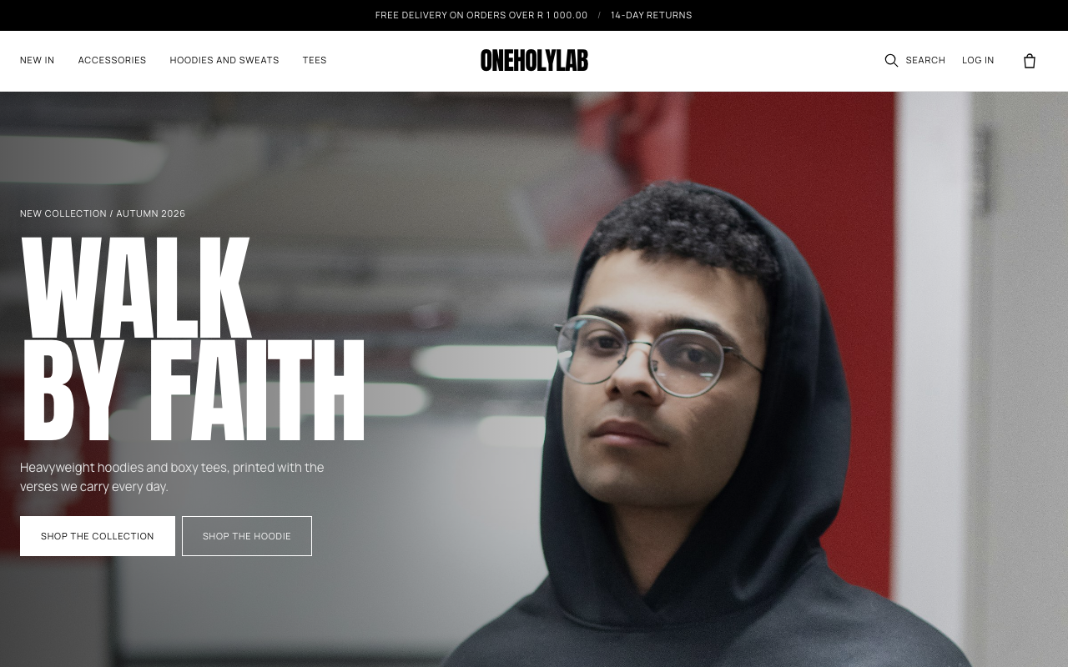
The home page on a desktop screen.

The menu
The top menu lists New in and then each category. The black bar above it announces free delivery over R 1 000.00 and 14-day returns.

The shop page
Choose New in in the menu, or click Shop the collection, to open every product. Use the controls above the grid to narrow the list:
- Category buttons: All, Accessories, Hoodies and sweats, Tees.
- Size: Any size, or one size such as M. Only products with that size in stock show up.
- Sort: Newest, Price: low to high, or Price: high to low.
The count next to the controls shows how many products match.
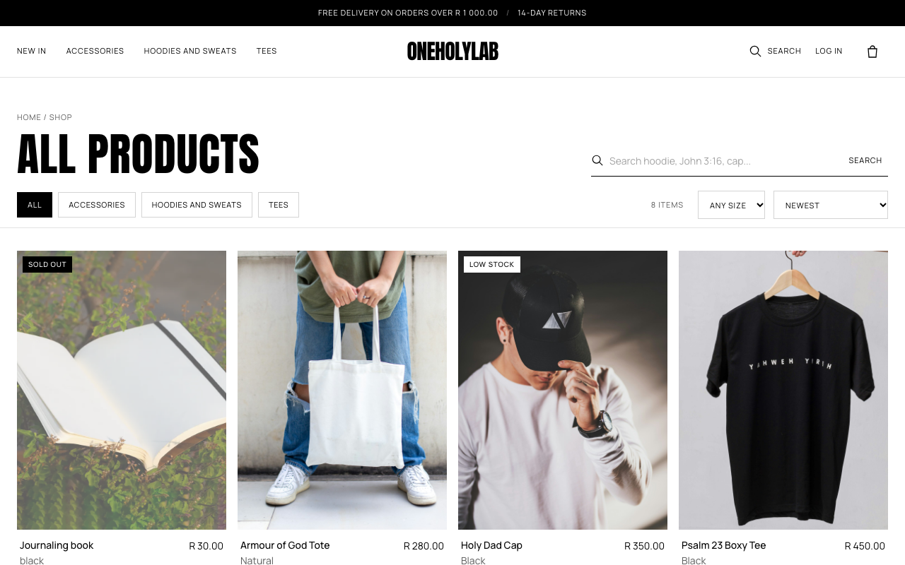
The shop page. The top row of controls filters the grid below.
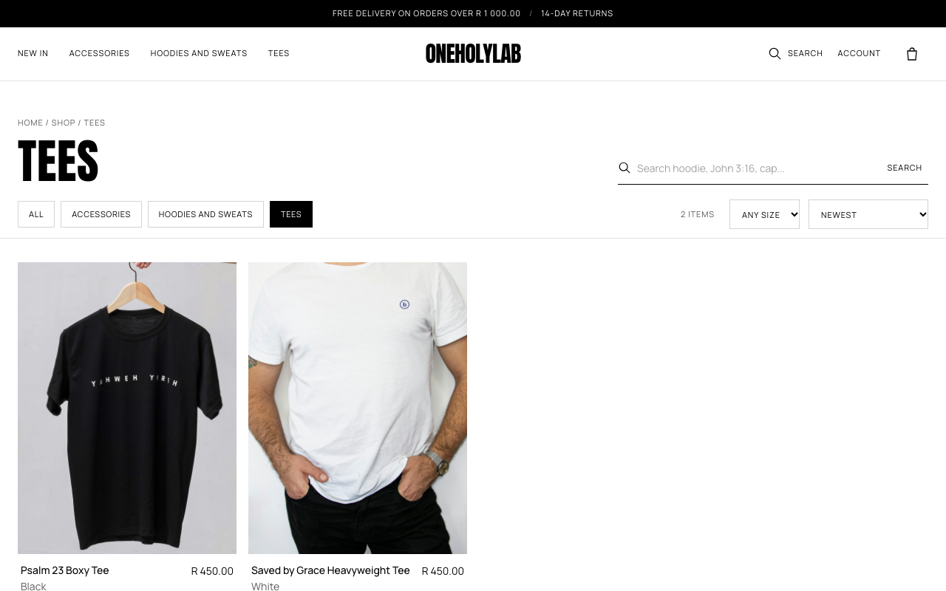
The shop page after choosing the Tees category.
Each product card carries one of two labels:
- Sold out means no size is left.
- Low stock means five units or fewer are left across all sizes.

Search
Type a word into the search box on the shop page, such as hoodie, John 3:16 or cap. You can also click the magnifying glass in the top bar, which jumps to the search box on the shop page.
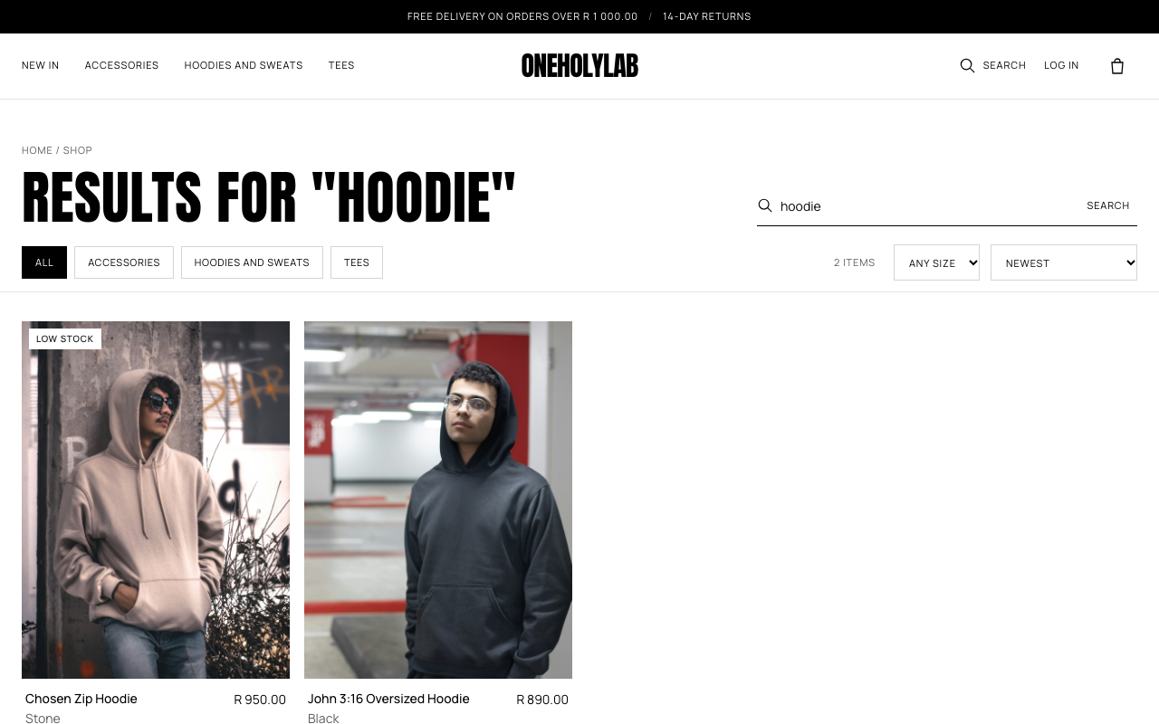
Search results for “hoodie”.

2. Choose a size and add to bag
Open a product by clicking its photo or name. The product page shows the photos, price, description and sizes.
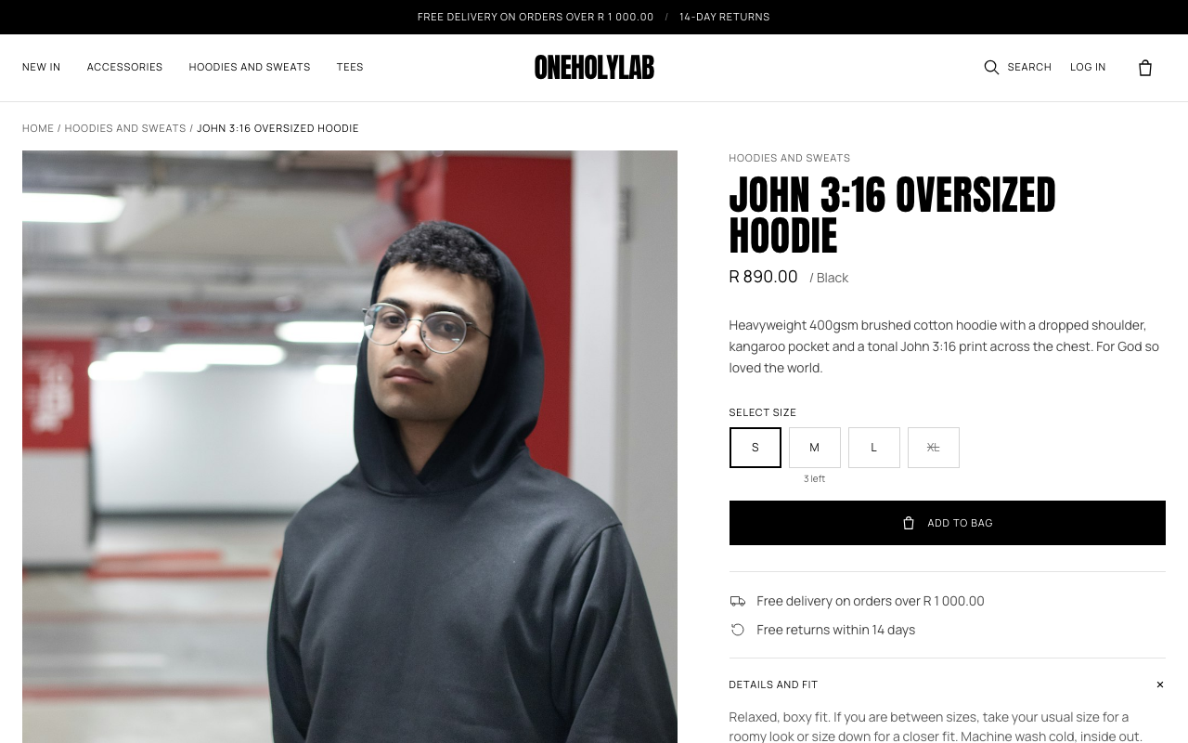
A product page. The size buttons sit above the Add to bag button.
- Pick a size. A size with a line through it is sold out and cannot be chosen. If a size is running low, the product page shows how many are left under it, for example 3 left.
- Press Add to bag. The message Added to your bag. appears, and the bag icon in the top right shows the new count.
Limits: You can put up to 10 of the same item in your bag, and never more than the stock on hand. If you ask for more than is left, you see a message such as Only 2 left in size M. or Sorry, that size is sold out.
Under the button, Shipping and returns holds the delivery and returns policy. Details and fit holds the fit advice, but only for clothing. Accessories such as caps, totes and books do not show it.

3. Review your bag
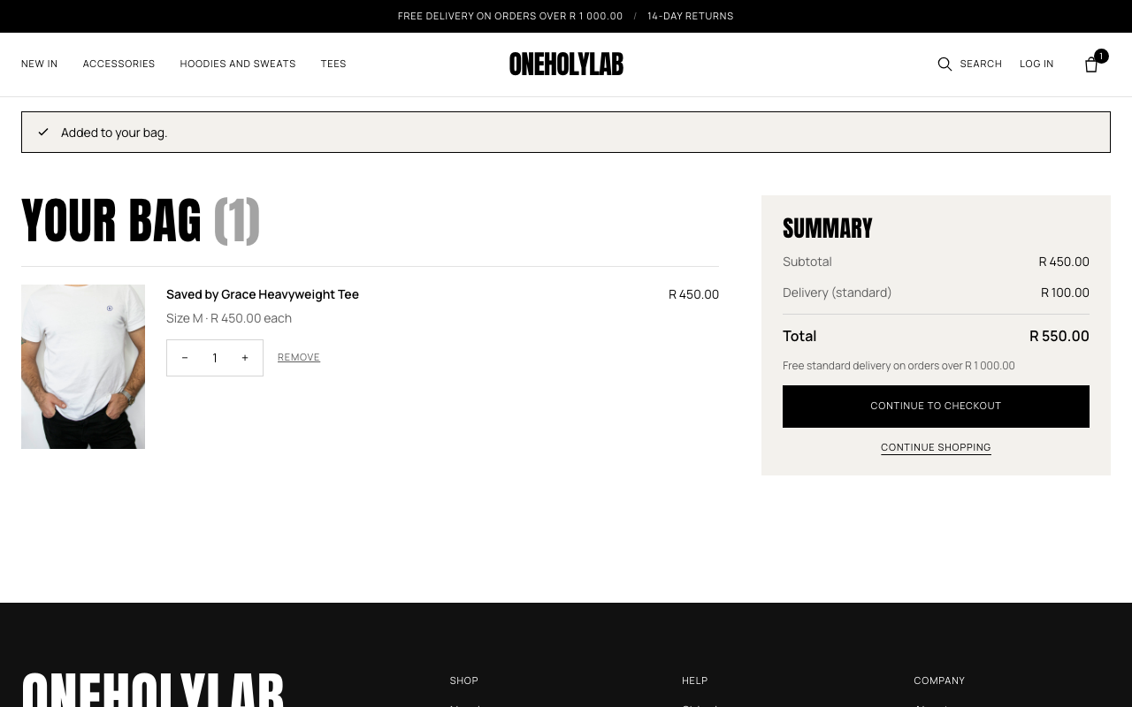
The bag has one item. Delivery is shown as standard courier.
- Change the quantity with the − and + buttons.
- Remove an item with the Remove link under it.
- Check the summary: subtotal, delivery and total. Standard delivery is free on orders of R 1 000.00 or more.
- Press Continue to checkout when you are ready, or Continue shopping to add more.
If stock changes while your item is in the bag, the line says Only N left. Please reduce the quantity. Lower the quantity before you check out.

4. Log in or sign up
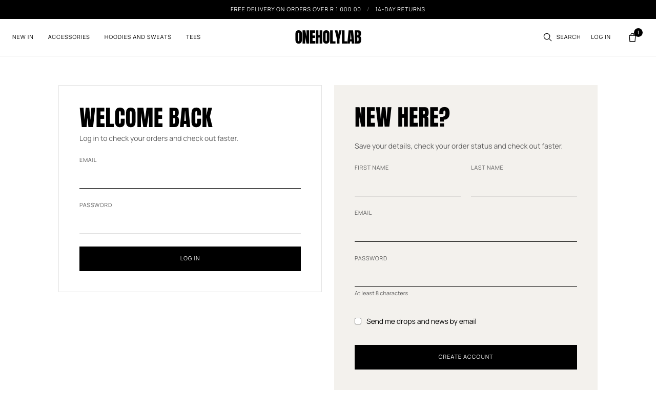
The login page. Returning customers use the left form. New customers use the right form.

Create an account
- Under New here?, enter your first name, last name, email address and a password.
- The password must be at least 8 characters.
- Tick Send me drops and news by email only if you want marketing emails.
- Press Create account.

Log in
Enter your email and password under Welcome back, then press Log in. If they do not match, you see Email or password is not correct.
Your bag comes with you: Items you added while logged out move into your account when you log in, so nothing is lost. If a page such as checkout sent you to log in, you return to that page after you log in. If you used the Log in link at the top of the shop, you land on My account.

5. Check out
Checkout needs an account. If you press Continue to checkout while logged out, you see the login page first. The checkout page has three numbered steps and an order summary on the right.

Step 1: Delivery address
Your saved address fills in the form. Change any field you need. The box Save this address to my account is ticked by default, so the address is ready next time.
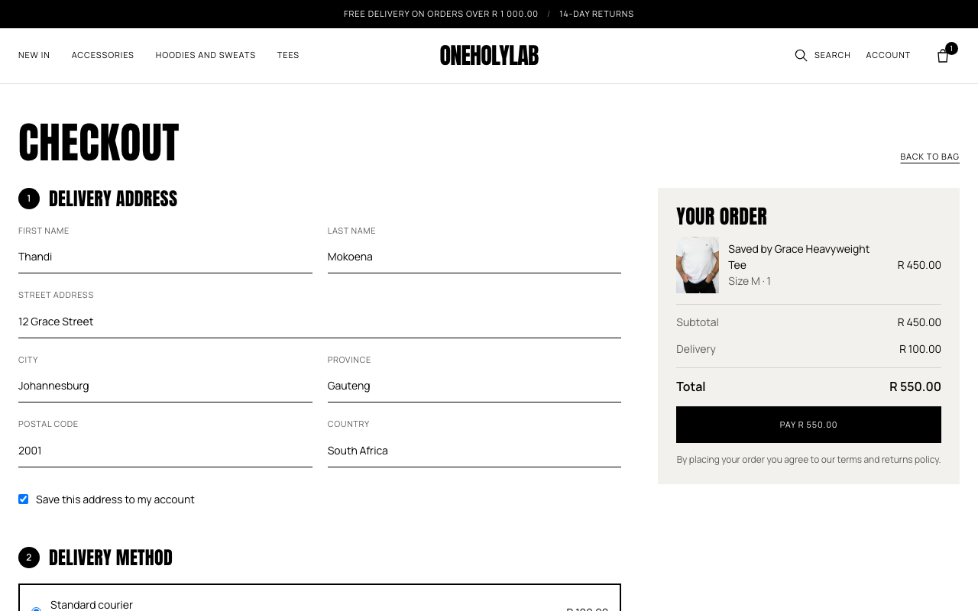
Step 1 of checkout, with the saved address filled in.

Step 2: Delivery method
Pick one option. The total on the right updates as soon as you choose.
Option | When it arrives | Cost
Standard courier | 2 to 5 working days | R 100.00, free on orders of R 1 000.00 or more
Express courier | Next working day in main cities | R 150.00
Collect from pick-up point | Ready in 3 working days | Free

Step 3: Payment
Enter the card number, expiry date (MM / YY) and the CVC, the security code printed on the card. In test mode, use the card numbers in Appendix A.
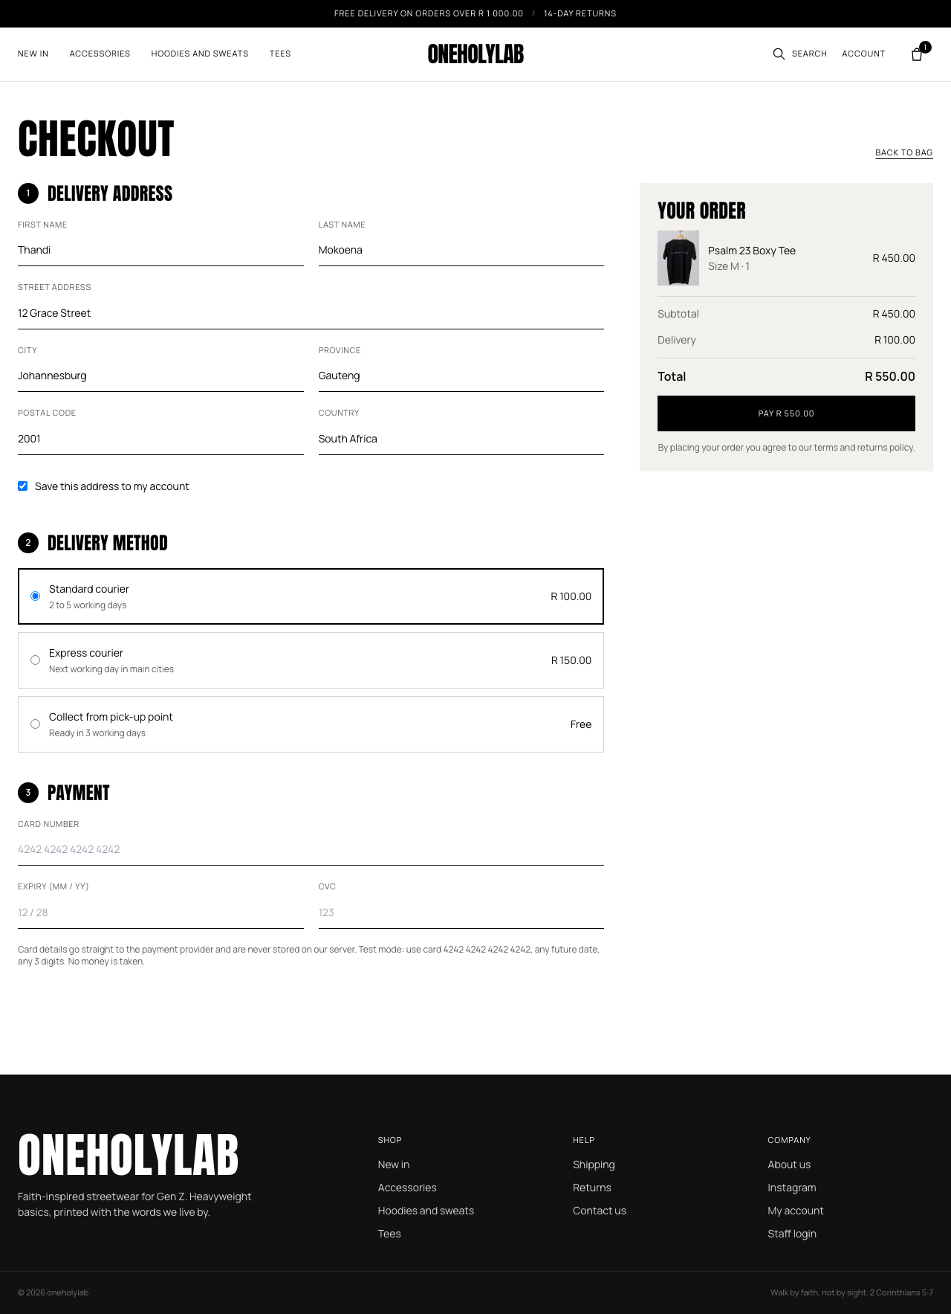
The whole checkout page: delivery method and payment (test mode).
When everything is right, press the black Pay button. It shows the total you will pay.

If something is wrong
Checkout shows the problem above the form. Your delivery address stays filled in, but the card number, expiry date and CVC are cleared, so enter them again. Nothing is saved when a payment fails: no order is created, and no stock is taken.
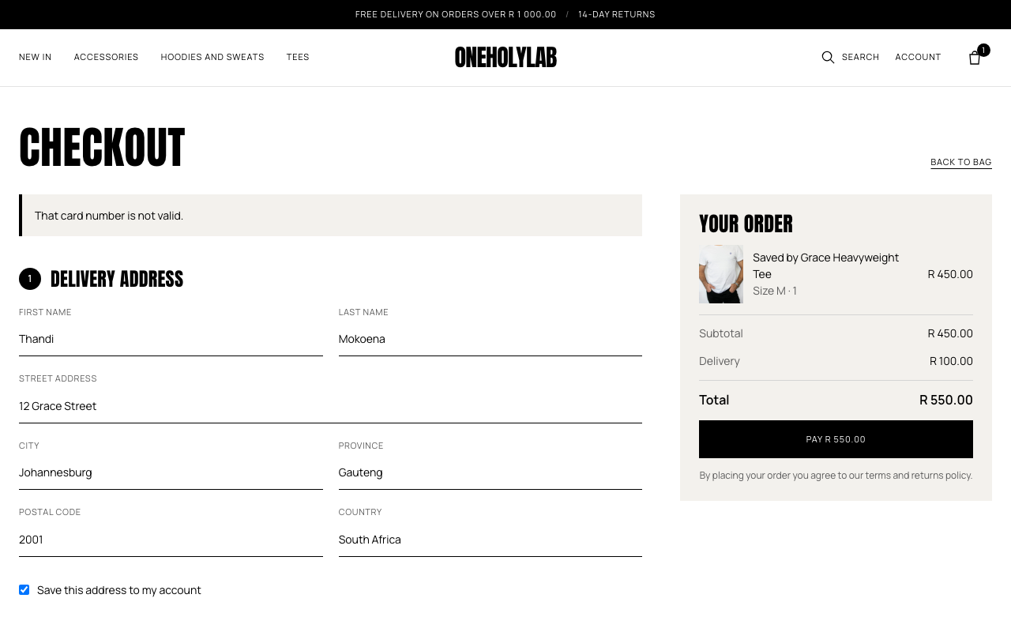
A card number that fails the check shows the message at the top of the form.
Message | What to do
That card number is not valid. | Check the card number. Use 4242 4242 4242 4242 in test mode.
The card has expired or the date is not valid (MM / YY). | Enter a future month and year, for example 12 / 30.
Enter the 3 digit security code. | Enter the 3 or 4 digit CVC.
The card was declined. | Use a different card. In test mode, 4000 0000 0000 0002 always declines.
Sorry, [product] (size [size]) is no longer available in that quantity. | Go back to the bag, lower the quantity and try again.
Sorry, [product] is no longer for sale. | Remove that item from the bag, then try again.
Something went wrong while placing your order. You have not been charged. | Try again in a few minutes. If it keeps happening, contact the store.

6. Order confirmation
After a successful payment, you land on the order confirmation page. It shows your order number (for example OHL-10003), the items, the delivery cost, the total you paid and where the order is going.
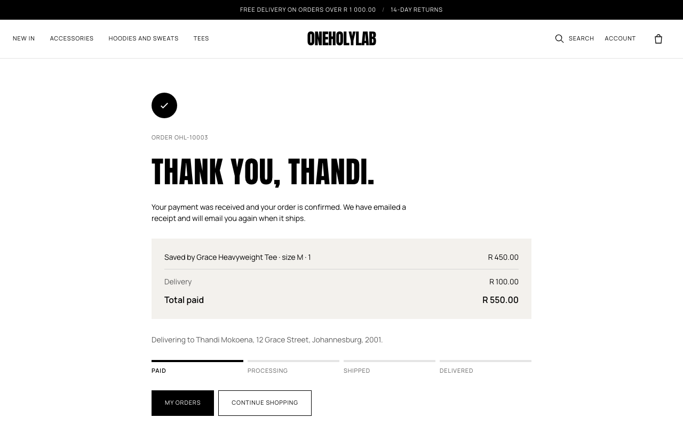
The confirmation page. The four steps at the bottom show where the order is.
The bar of four steps (Paid, Processing, Shipped, Delivered) moves forward as the store updates the order. A confirmation email is sent at the same time.

7. Track orders and manage your account
Click Account in the top bar to open your account. It opens with Hi, [first name] and three tabs.

My orders
Each order shows its number, date, number of items, status and total. Click View order to see the full order.
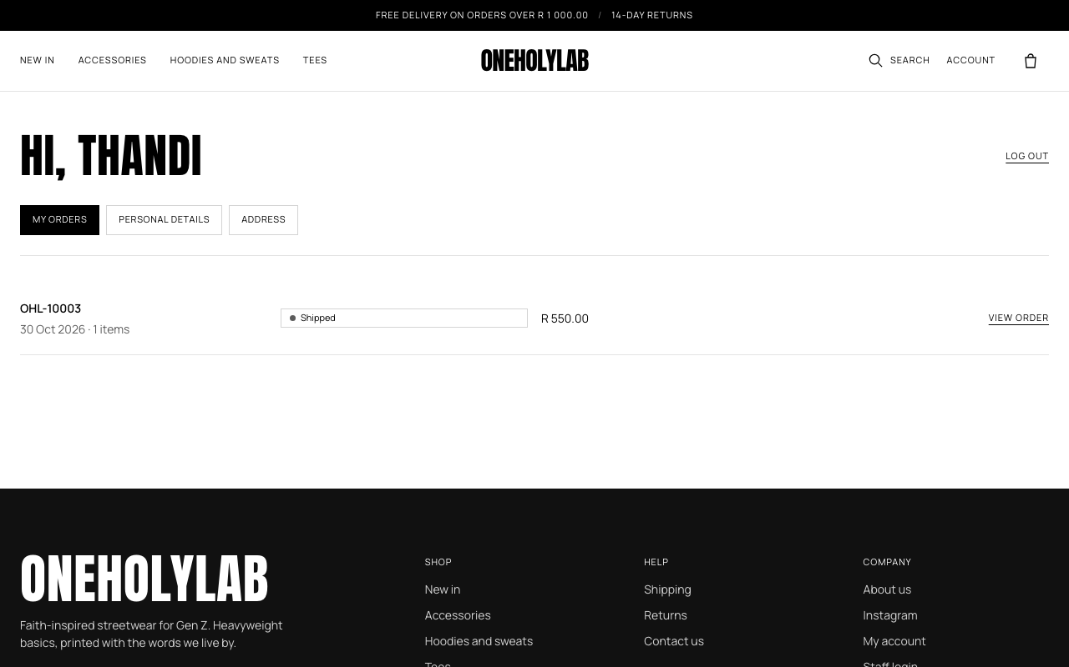
The My orders tab after the order has shipped.
When the store ships an order, the order page shows a tracking number under the steps:
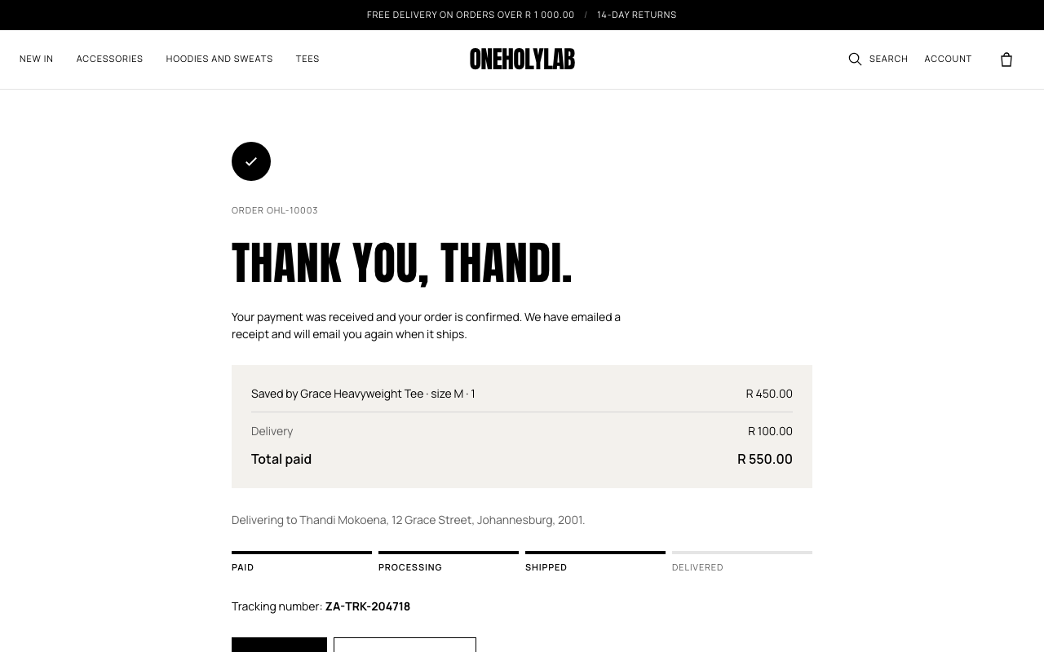
An order page after shipping. The tracking number is printed under the steps.

Personal details
Change your first name, last name and phone number, then press Save changes. Your email address is shown but cannot be changed from this page.
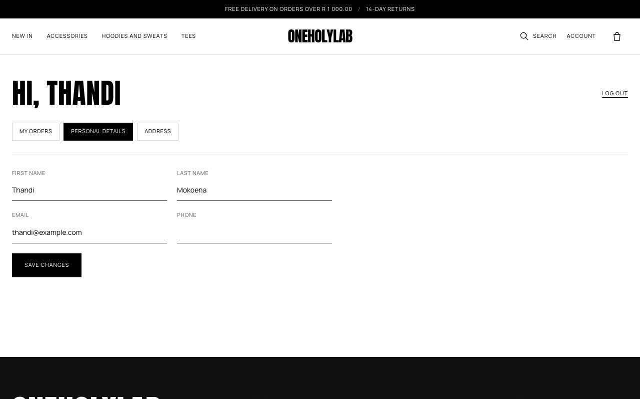
The Personal details tab.

Address
This is the address that checkout fills in for you. Update the street, city, province, postal code or country, then press Save address.
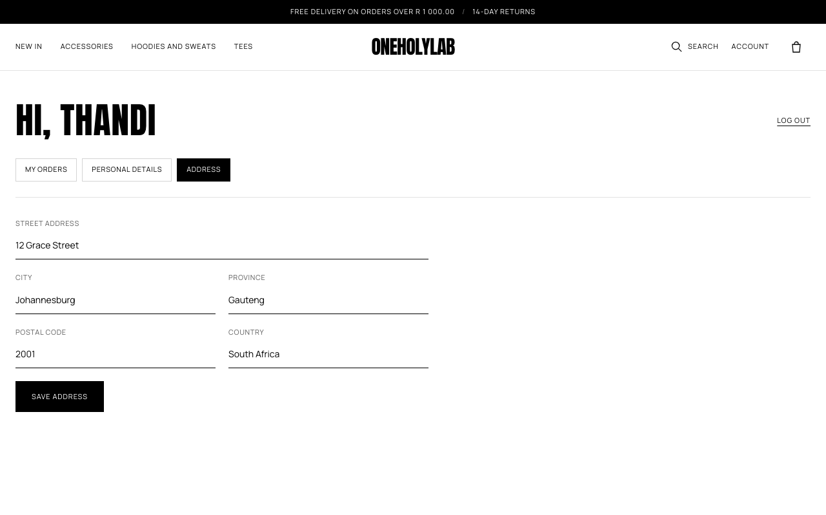
The Address tab.
Press Log out at the top of the account page when you are finished on a shared computer.

8. Shopping on a phone
The shop is built for phones first. The menu is behind the icon with three lines at the top left. Search and the bag sit at the top right. On a product page, swipe sideways through the photos.
Screen | What to look for
Home | The banner and the Shop the collection button.
Product | Swipe the photos. Size buttons and Add to bag sit under the price.
Menu | Categories first. Then My account and Log out when you are logged in, or Log in or register when you are not.

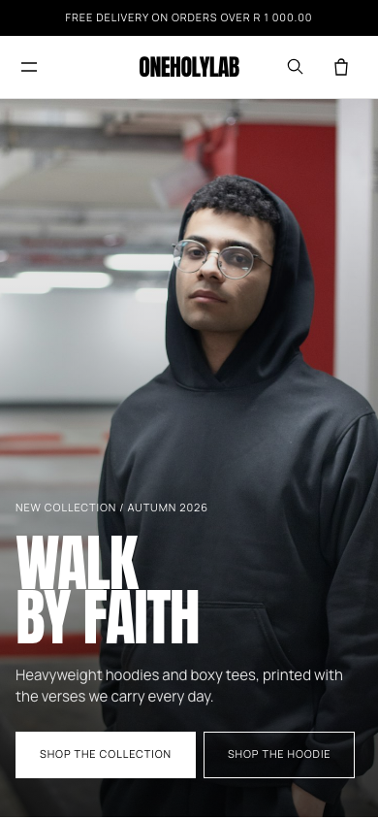 | 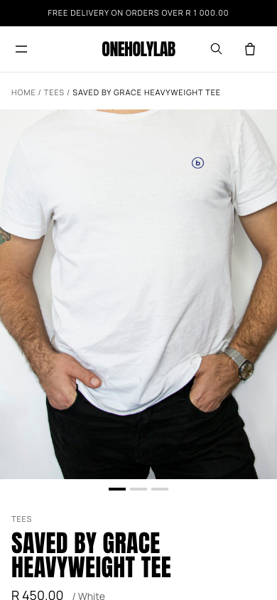 | 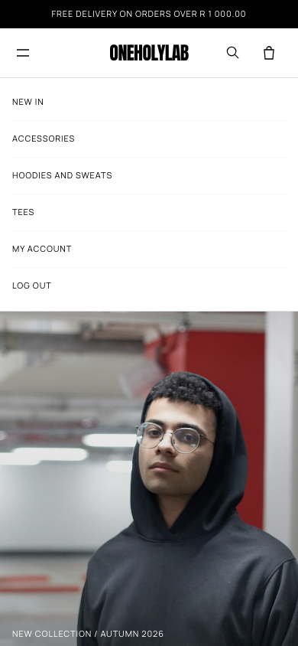
Home, product page and open menu on a phone. These were taken while logged in as a customer.

Part 2: Running the store
This part is for staff who manage the store. Every screen here sits behind the admin login. A customer account cannot open it.

9. Log in to the admin area
Go to /admin/ (for example http://localhost/oneholylab/admin/). The Staff login link in the shop footer also goes there.
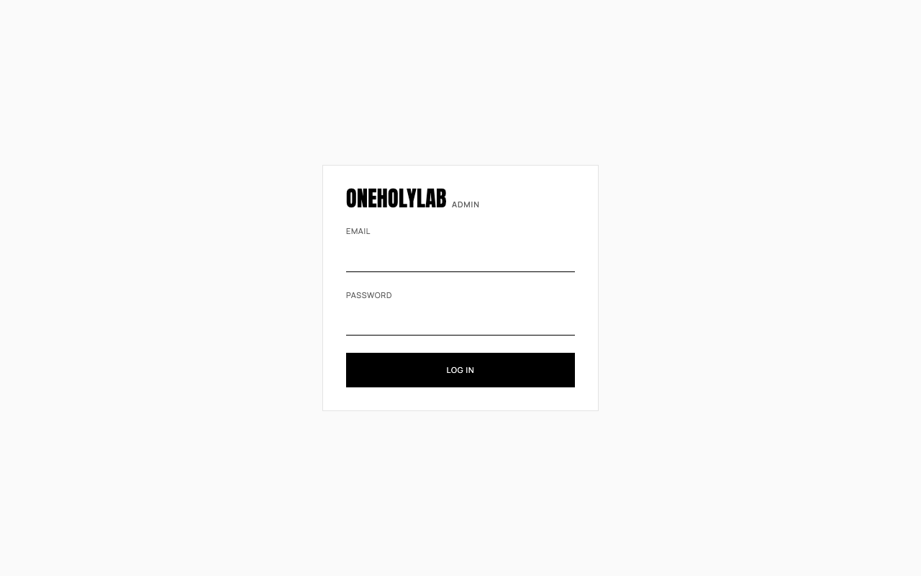
The admin login form.
Use the admin email and password that were set when the first admin was created (see sql/seed.php in the README). If you are logged in as a customer, you are sent to this page and cannot continue.
The menu on the left holds every admin page:
Menu item | What it is for
Dashboard | Sales, orders to pack and low stock warnings
Products | Add, edit and find products, and change stock
Orders | See every order, update its status and add tracking
Customers | Find customers and see what they have spent
Categories | Add, rename and delete categories
History | Who changed what, and every stock movement
View shop | Opens the shop in a new tab
Log out | Ends your admin session. Your name appears on this button.

10. Dashboard
The dashboard is the first screen after you log in. It shows sales, orders and stock for a period you choose.
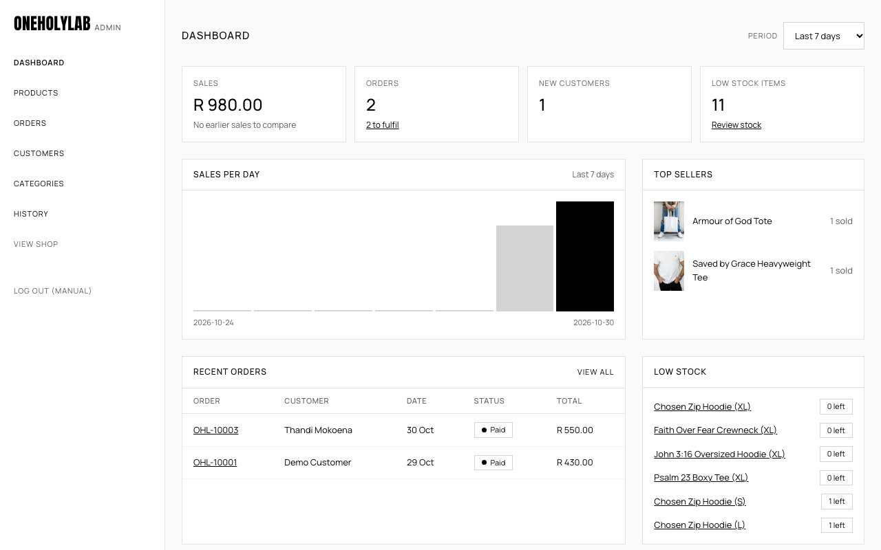
The dashboard for the last 7 days.
- Period: choose Last 7 days, Last 30 days or Last 90 days. The page updates on change.
- Sales: total of all orders in the period except cancelled ones, with a comparison to the period before when there is one.
- Orders: the number of orders in the period. The link under it, N to fulfil, opens the paid orders that still need packing.
- New customers: accounts created in the period.
- Low stock items: sizes with five or fewer units. Review stock opens the list of low stock products.
- Sales per day: a bar for each day in the period.
- Top sellers: the products that sold the most.
- Recent orders: the latest six orders. Click an order number to open it.
- Low stock: the sizes that need restocking, with the units left.

11. Products and stock

Find a product
The products page lists everything in the store, including drafts and archived items. Use the search box (name or SKU), the category menu, or the Low stock only button to narrow the list. Click a product name, or Edit, to change it.
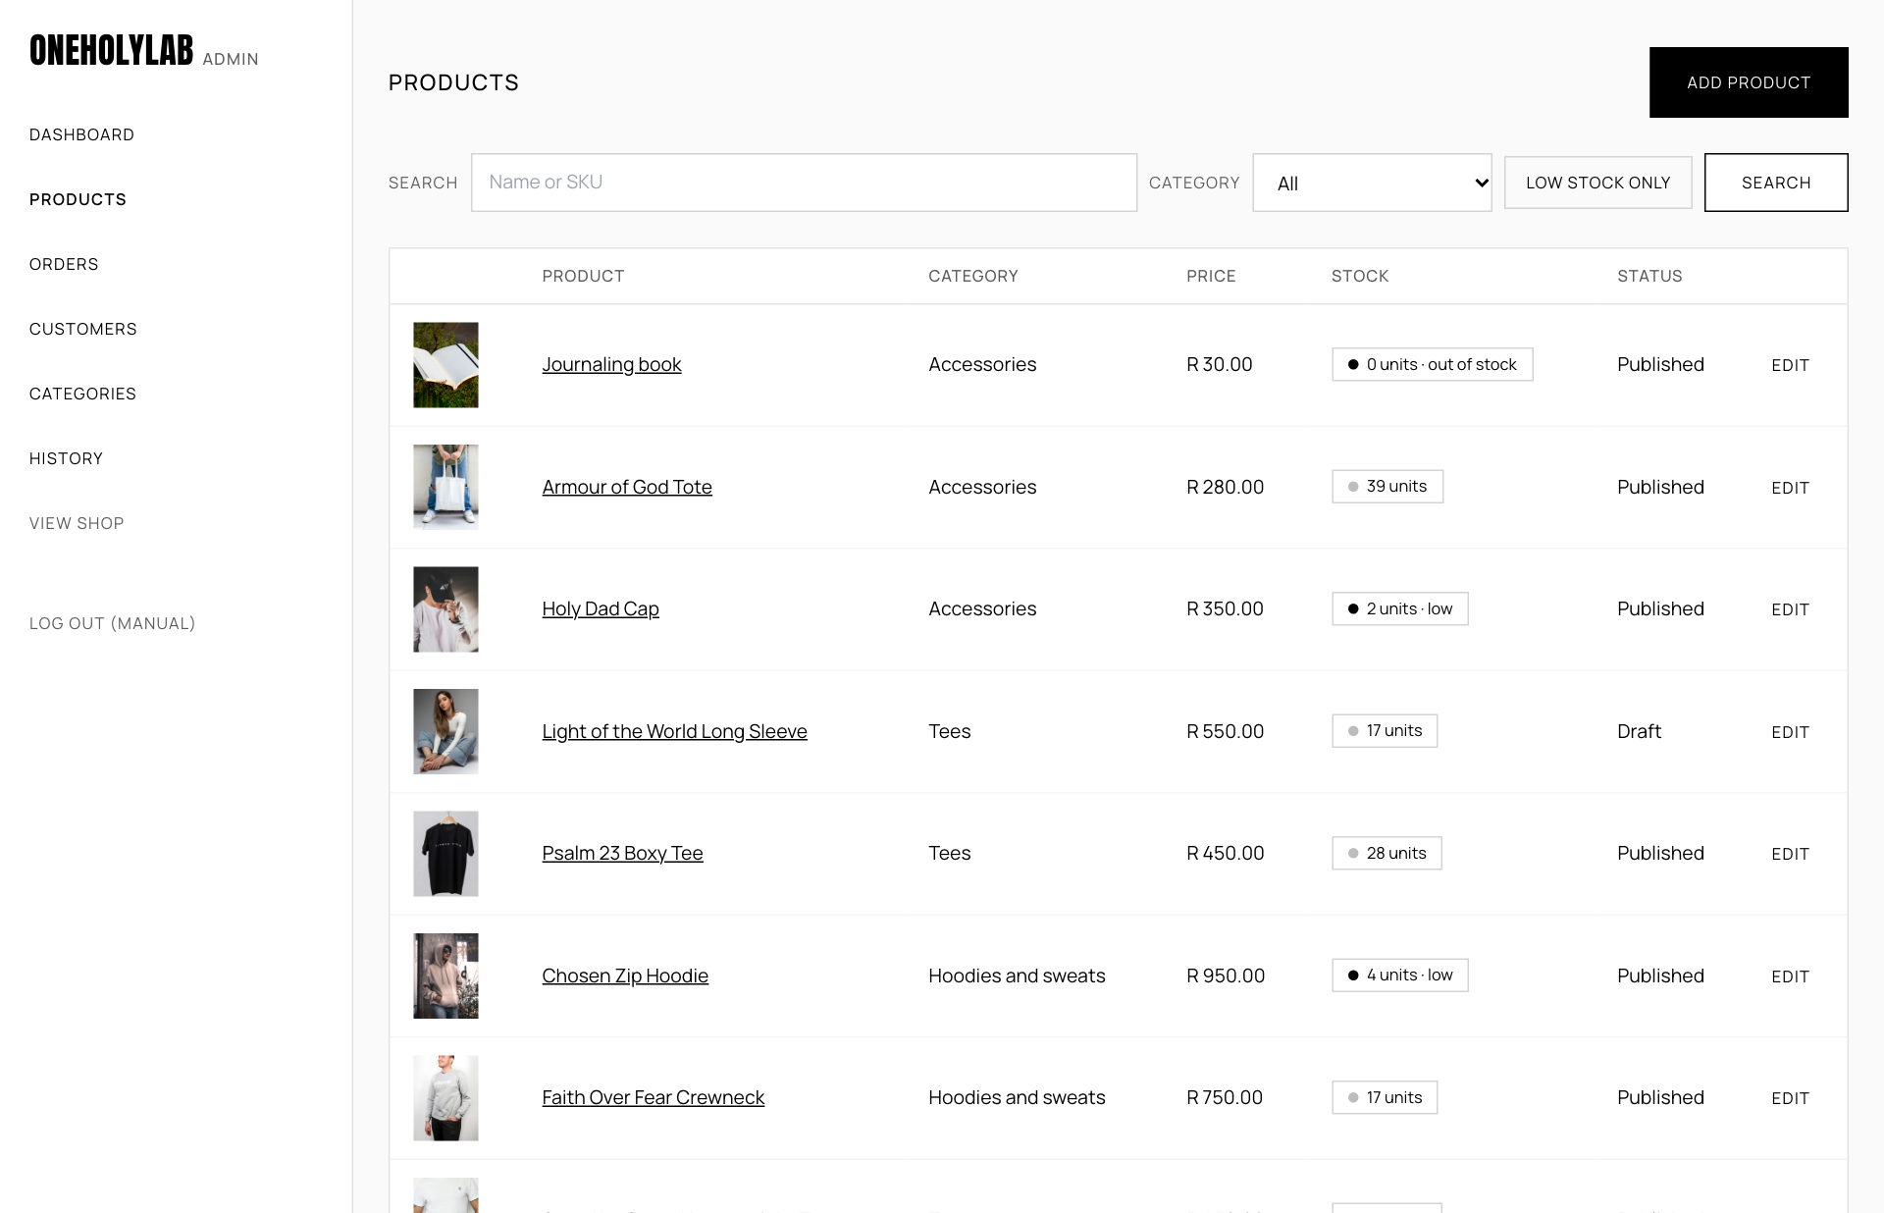
The products list. The stock column shows units, out of stock, or low.
The stock column uses these labels:
- 0 units · out of stock: no units left in any size.
- 2 units · low: five or fewer units left in total.
- 17 units: enough stock.
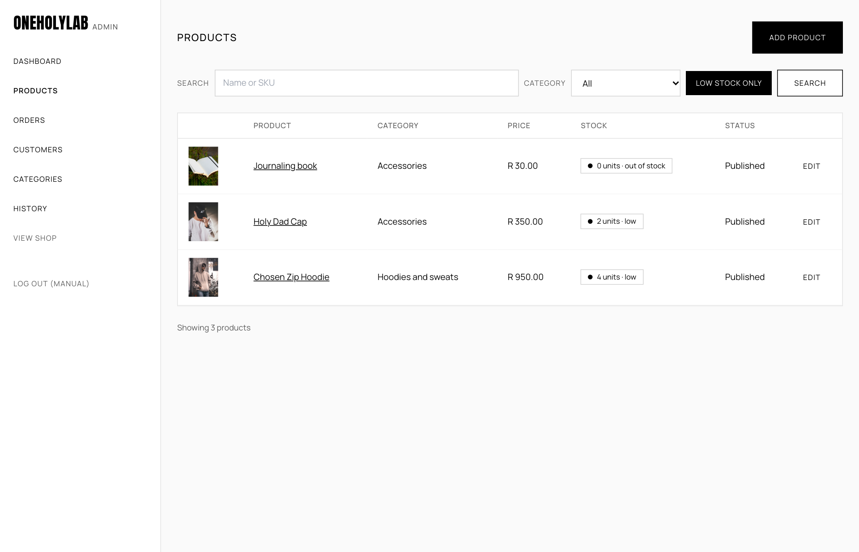
The list after Low stock only. Use it to decide what to reorder.

Add a product
- On the products page, press Add product.
- Name is required. Add a Description for the product page.
- Price (R) is required. Type the number, for example 890.00.
- Colour is optional. It shows under the price on the product page.
- Category is required. Choose one from the list.
- Status controls whether the product is visible in the shop:
  - Draft (hidden): saved, but not shown in the shop. Use it while you prepare the listing.
  - Published: shown in the shop.
  - Archived (hidden): removed from the shop, but kept for the records.
- Under Photos, choose a photo. Accepted files are JPG, PNG or WebP, up to 5 MB each.
- Under Sizes and stock, type a size in New size (for example M) and the number of units in Stock. The SKU is created for you when you save.
- Press Save product. The page reopens on the product so you can add more sizes and photos.
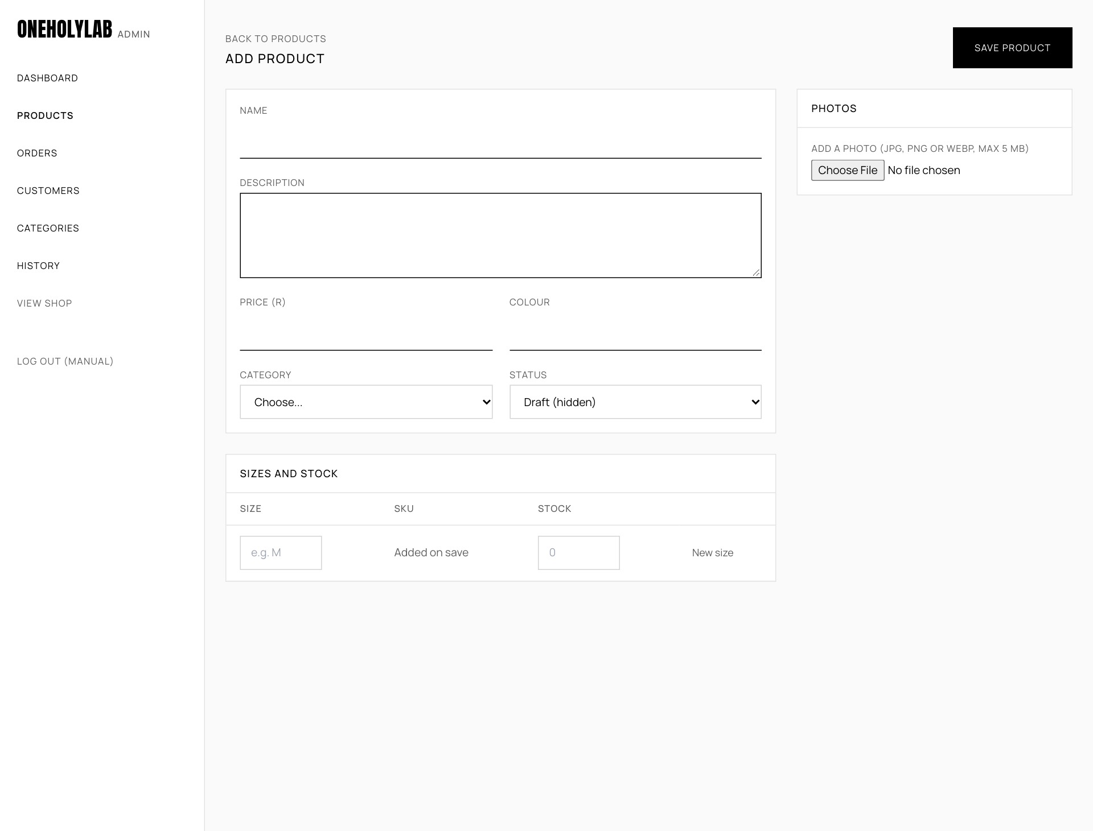
The Add product form, before anything is entered.
Photos: The first photo is the one shown on the shop page. Photos appear in the order they were added, so add the main photo first.

Edit a product and change stock
Open a product from the list. Change any field, then press Save product.
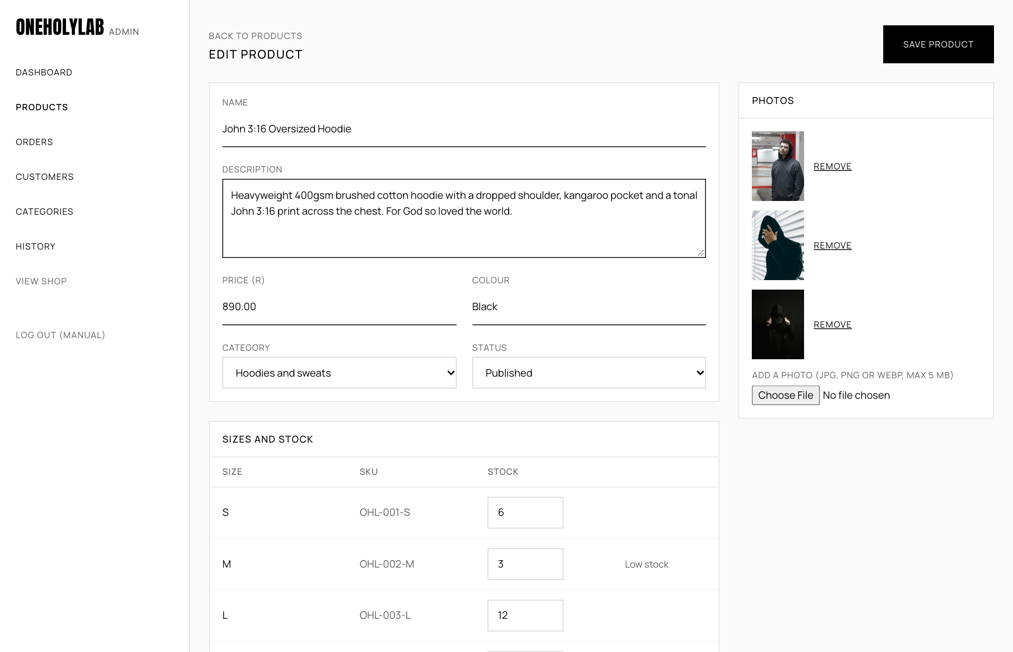
Editing an existing product: details on the left, photos on the right, and the sizes table underneath.
- Change stock: type the new total for a size in the Stock box and save. The number you type replaces the old one. Each change is recorded in History.
- Add a size: type a size and stock in the empty row and save. If the size already exists, the page says Size M already exists, so it was not added.
- Remove a photo: press Remove under the photo and confirm.
- Add a photo: choose a file under Photos and save. It is added to the end of the list.
Stock of zero: A size at zero shows as sold out in the shop. If every size is zero, the product shows the Sold out label.

12. Orders
The orders page lists every order, newest first. Use the buttons along the top to show only one status: All, Pending, Paid, Processing, Shipped, Delivered or Cancelled. Click an order number to open its details on the right.
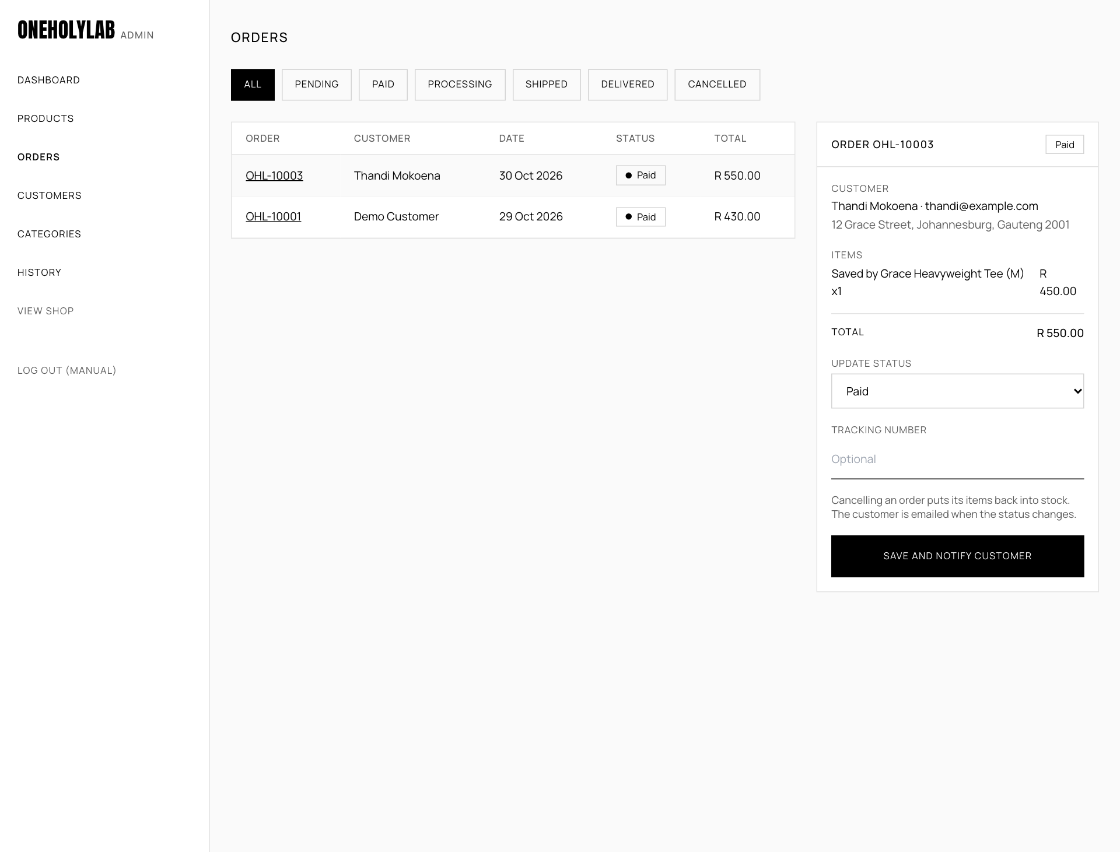
The orders page with order OHL-10003 open, before its status is changed.

The order statuses
Status | Meaning | What the store does next
Pending | The order exists but payment is not confirmed yet. | Normally orders go straight to Paid, so this is rare.
Paid | Payment received. | Pack the order.
Processing | Being packed. | Hand it to the courier, then mark it Shipped.
Shipped | With the courier. | Add the tracking number.
Delivered | Arrived with the customer. | Nothing more.
Cancelled | The order will not go ahead. | The items go back into stock. A cancelled order cannot be reopened.

Update an order
- Open the order from the list.
- Under Update status, choose the new status.
- Under Tracking number, type the courier's tracking number. This is optional, but customers need it once an order ships.
- Press Save and notify customer. The page shows Order updated and the customer was notified. The customer receives an email about the change.
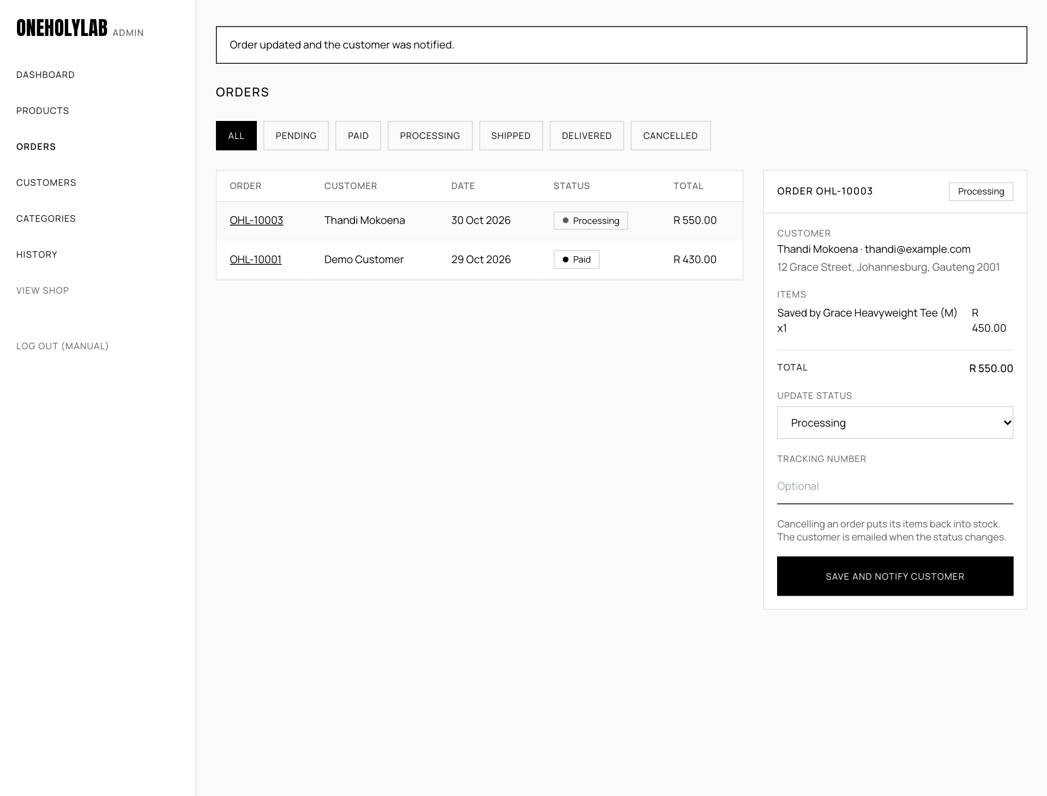
After saving the Processing status, the page confirms the change at the top.
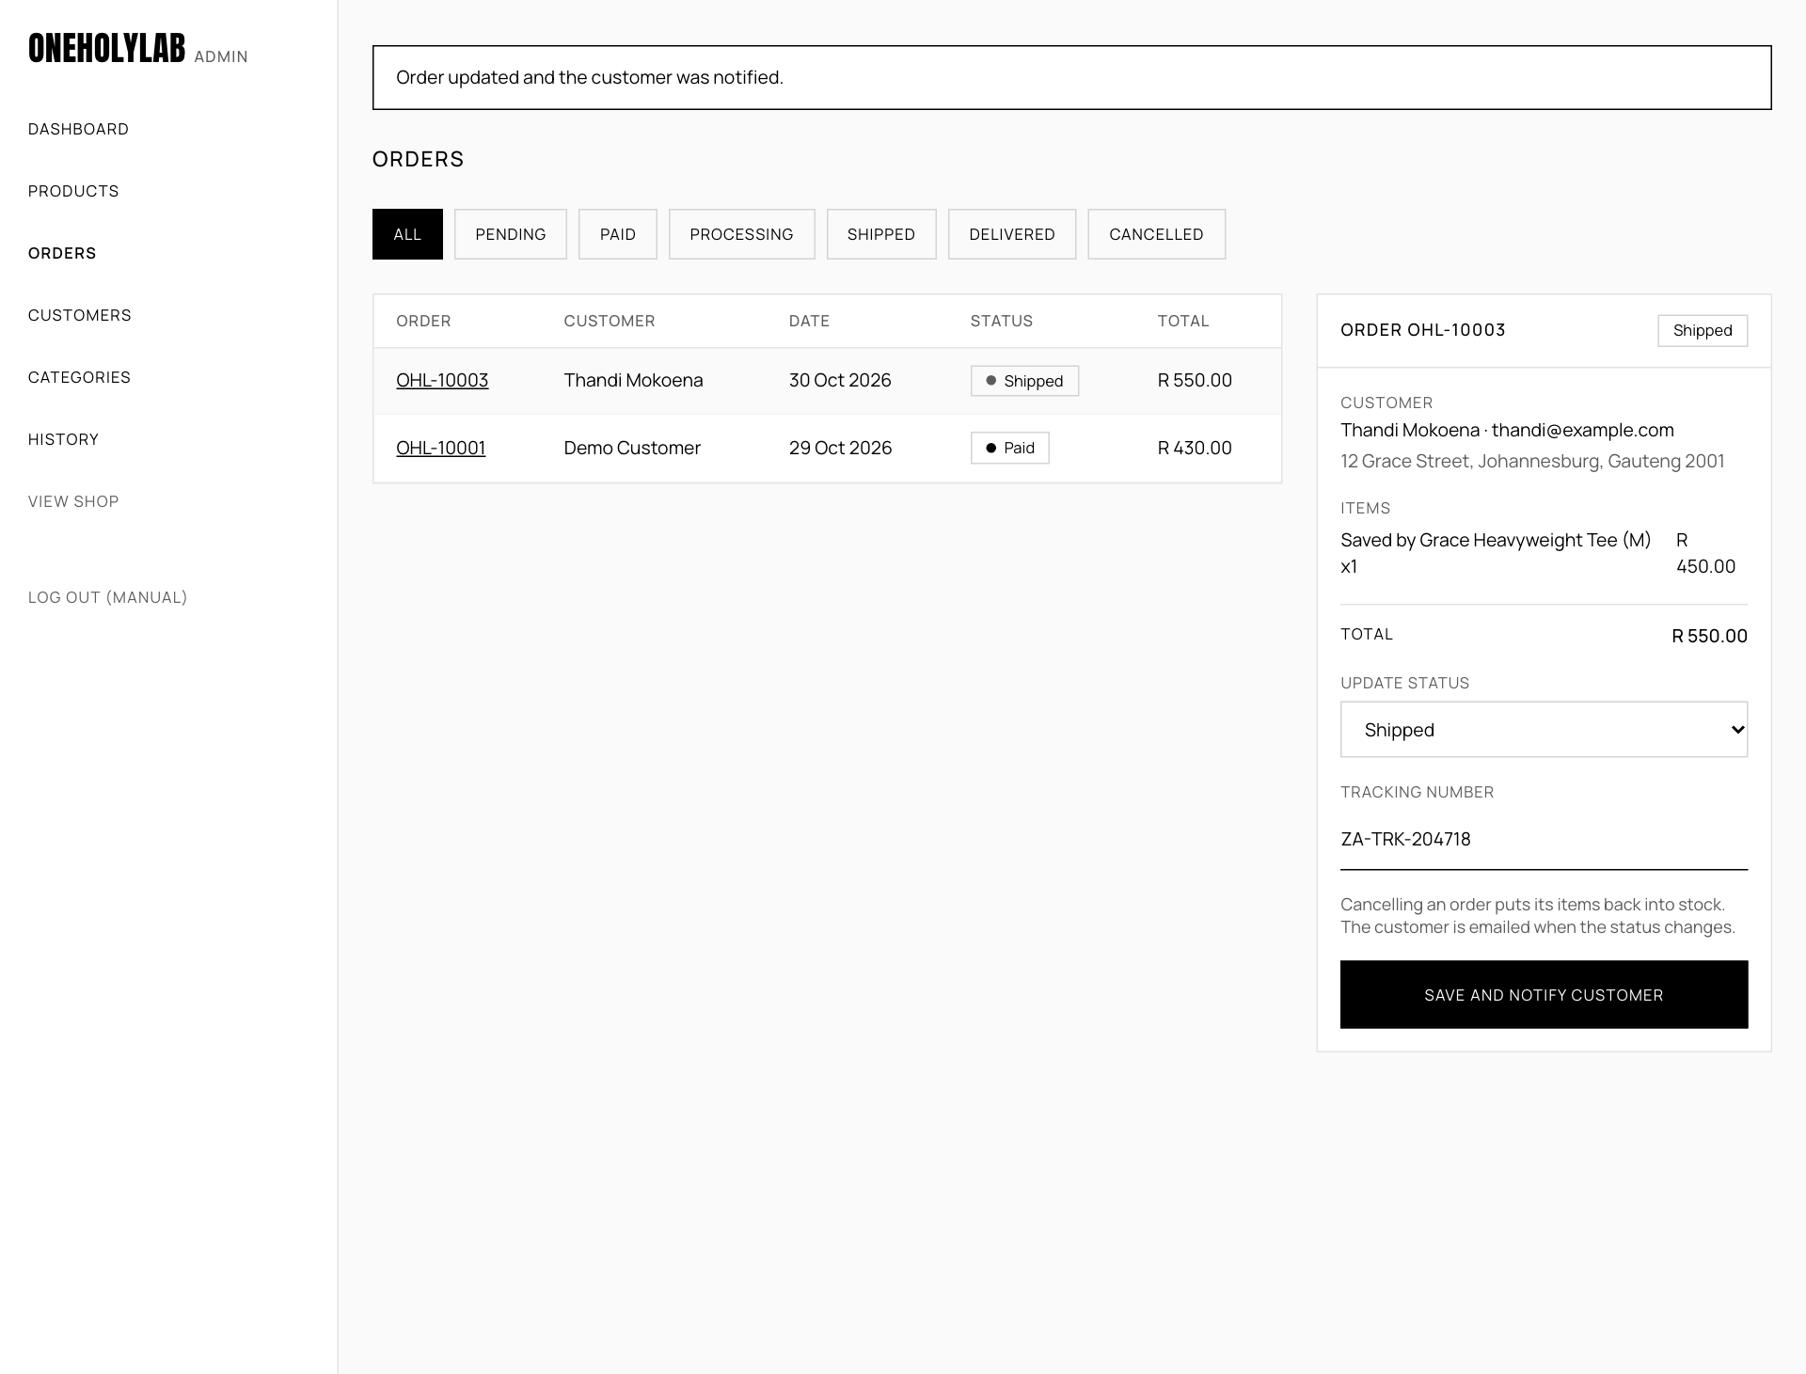
The same order marked Shipped with a tracking number. The customer sees it on their order page.
Cancelling: Setting an order to Cancelled puts its items back into stock. This cannot be undone: a cancelled order cannot be reopened.

13. Customers
The customers page lists every customer account, with the date they joined, the number of orders and the total they have spent. Type a name or email in the search box and press Search to narrow the list.
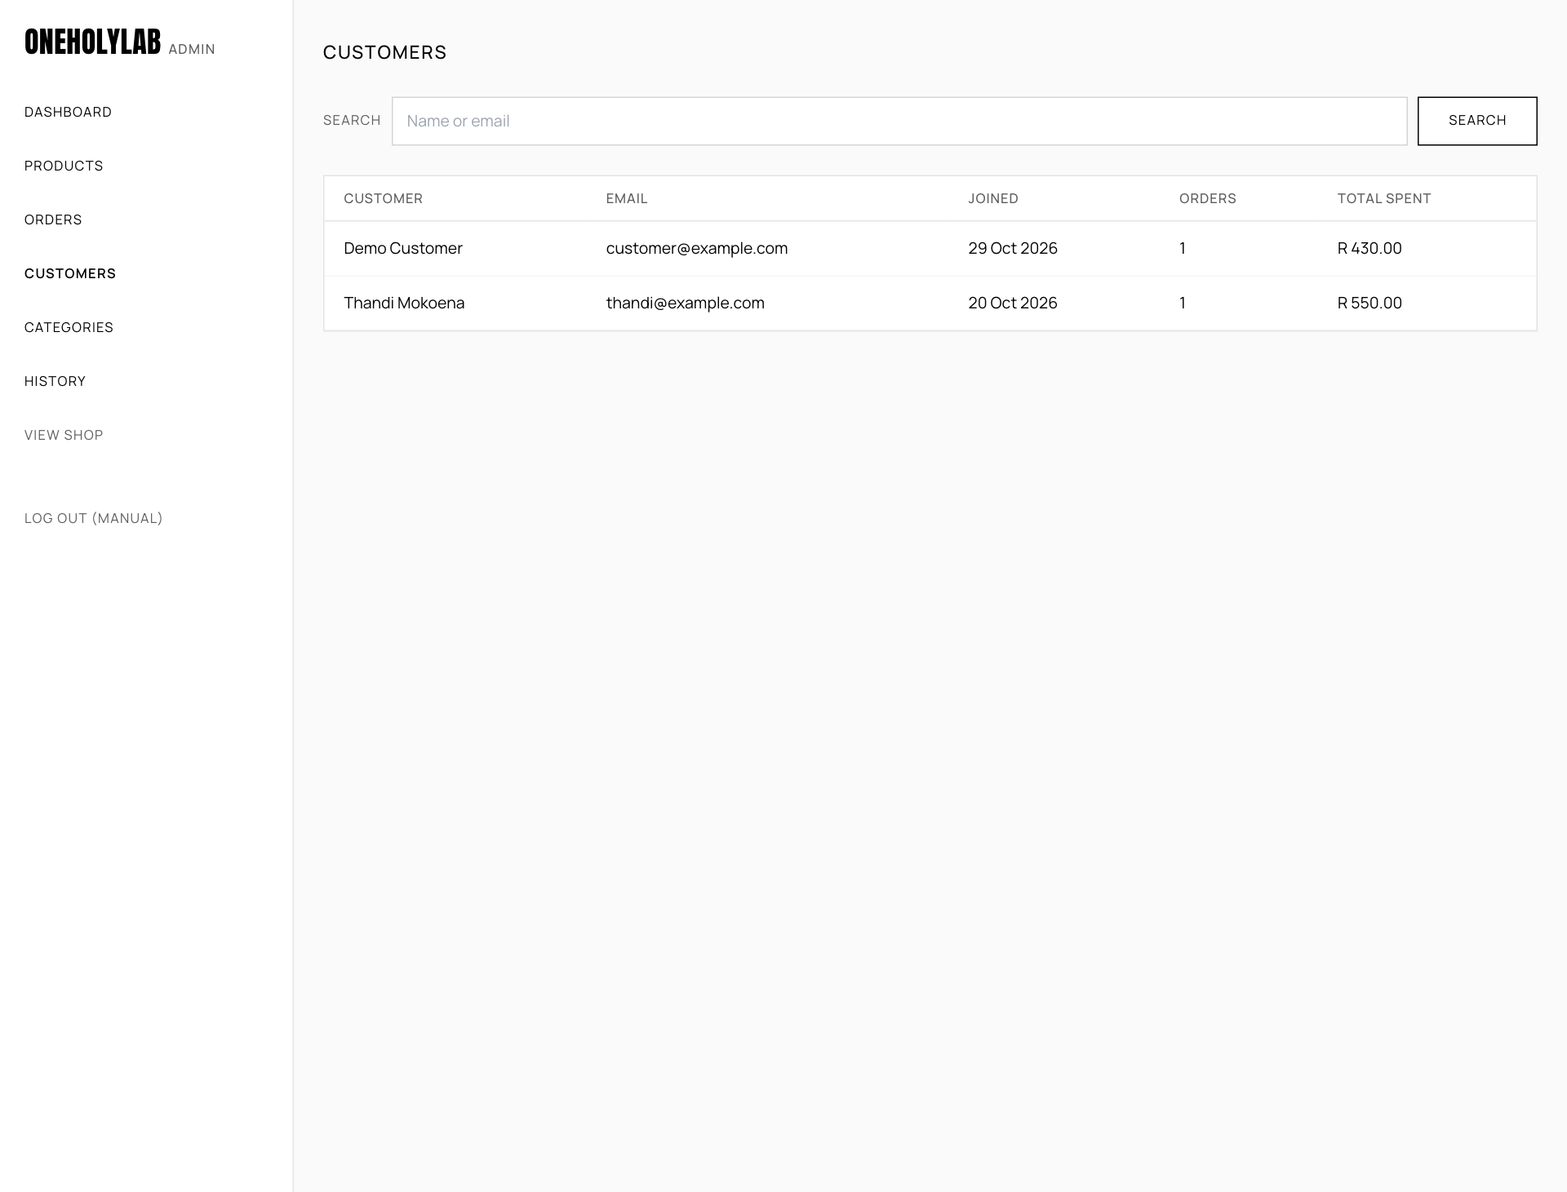
The customers page.

14. Categories
Categories group the products in the menu and the shop filter. The categories page has three actions:
- Add: type a name in New category name and press Add.
- Rename: change the name in its box and press Rename.
- Delete: press Delete. A category can only be deleted when it has no products. Move the products to another category first.
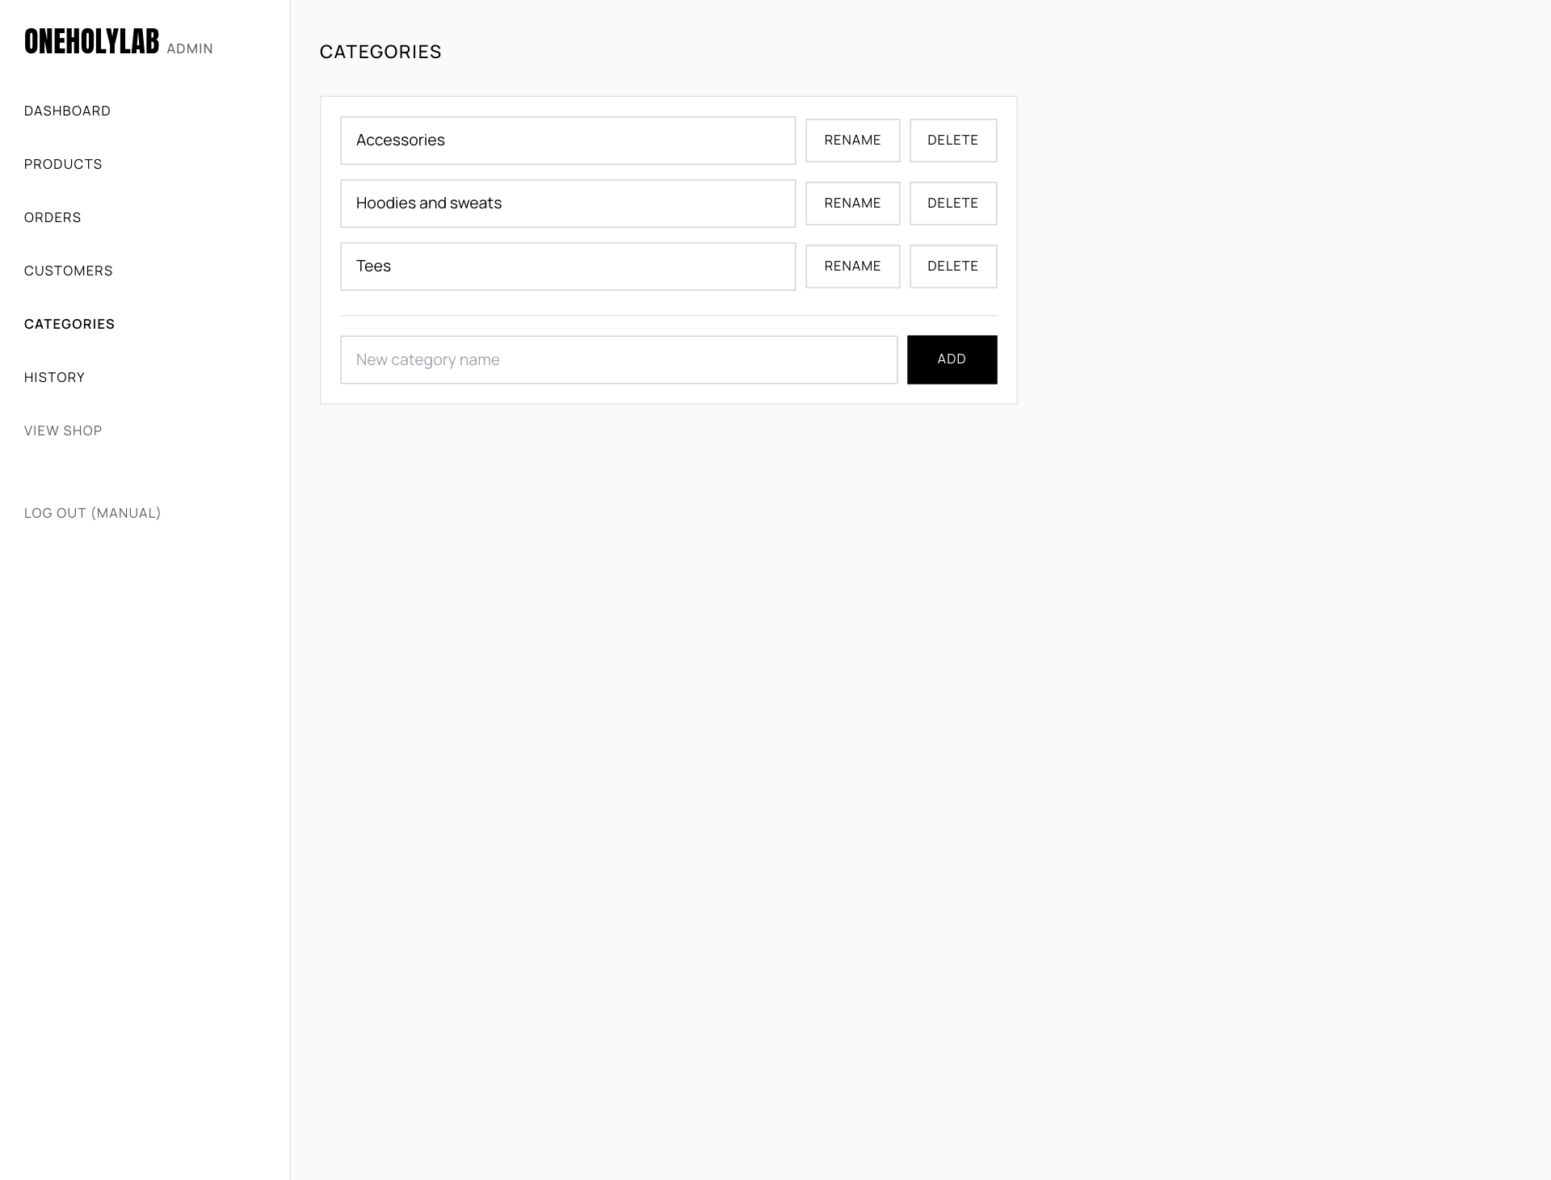
The categories page.
Names must be unique: If a category with that name already exists, you see A category with that name already exists.

15. History
The history page is the audit trail. It has two tables:
- Admin changes: when a change happened, who made it, and what changed. For example, status order: OHL-10003: processing to shipped.
- Stock movements: each change to stock, with the item, the amount (for example -1) and the reason: an order, a restock, a manual adjustment or a cancellation.
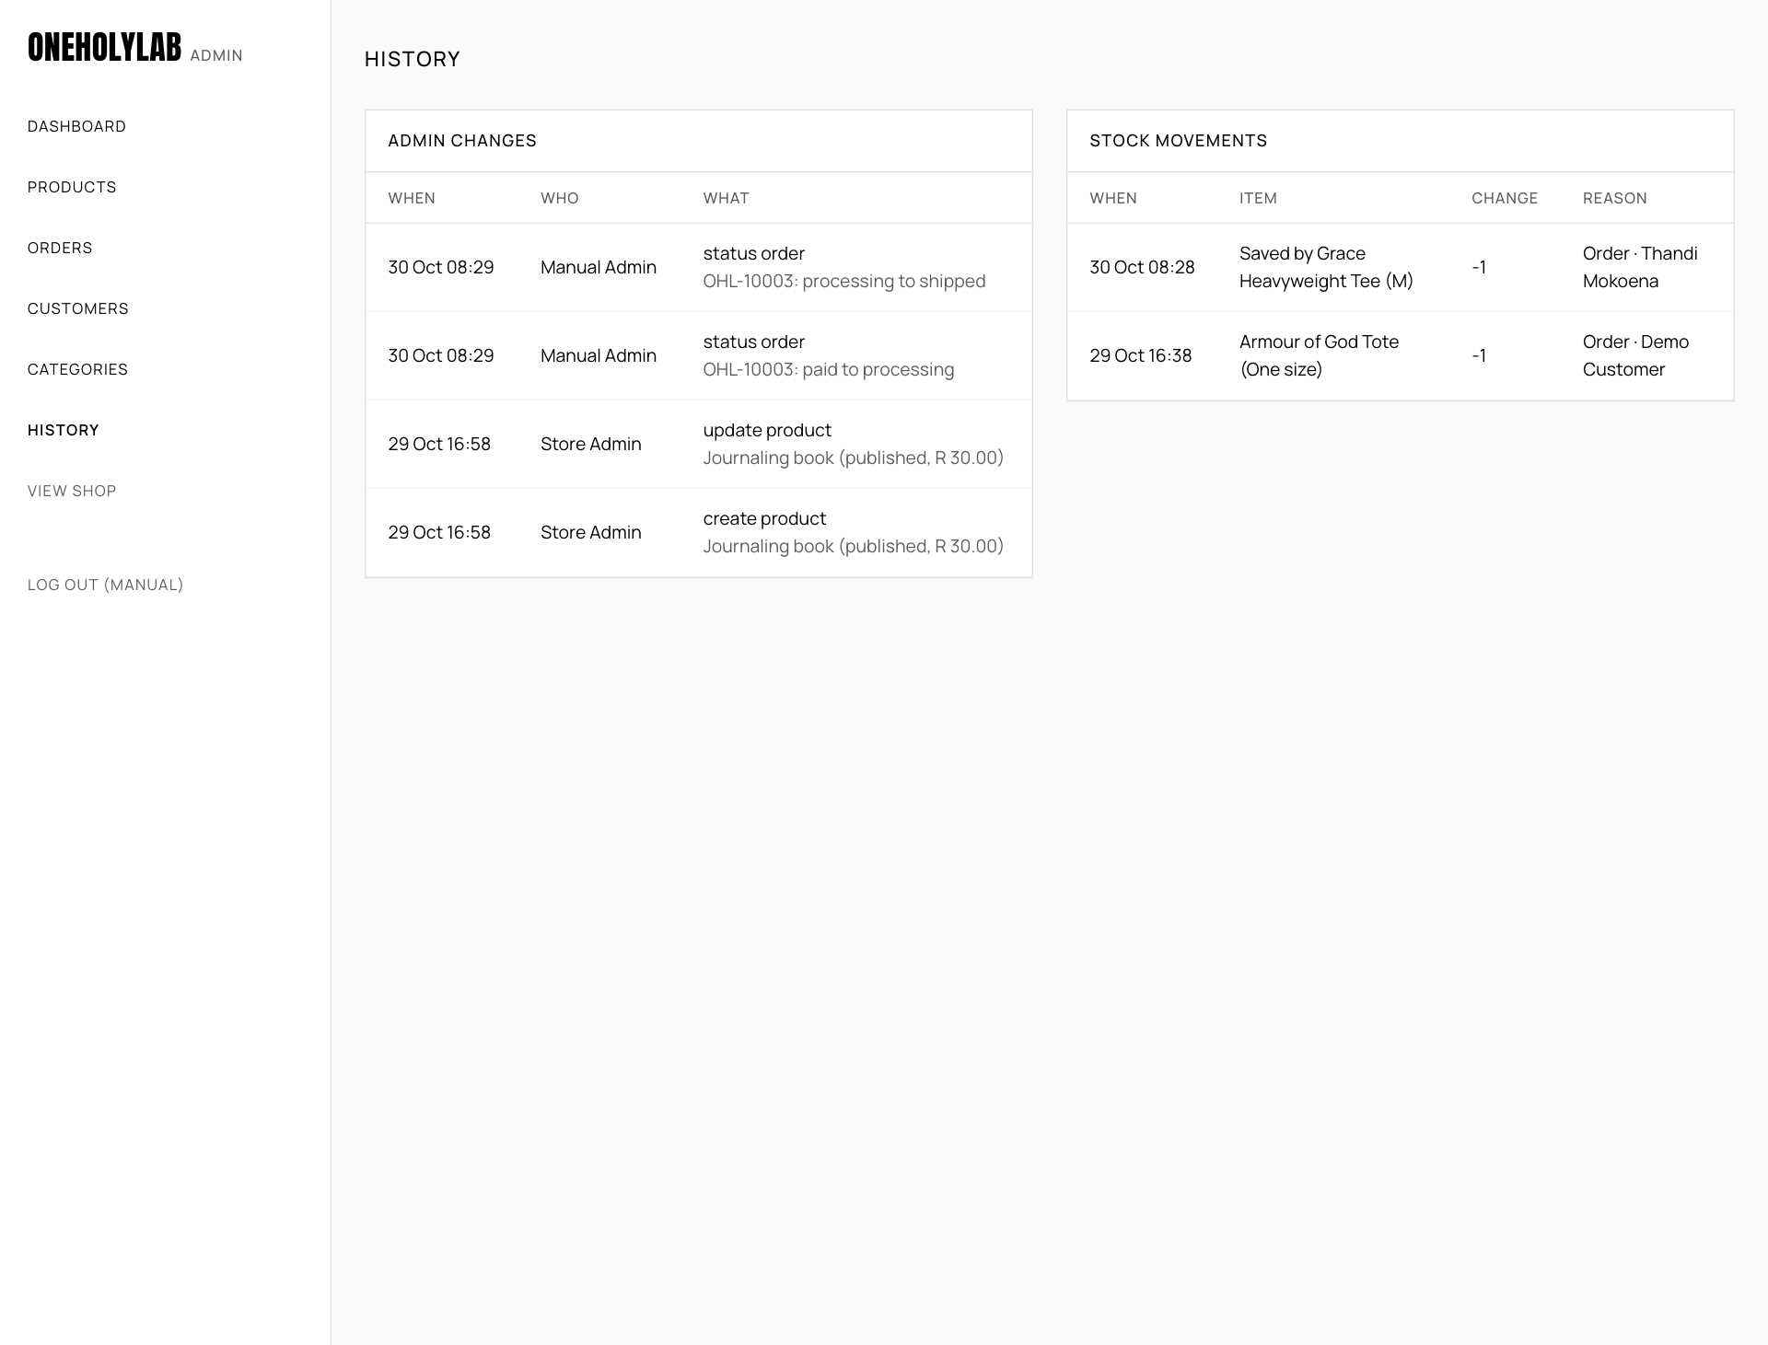
The history page after an order was processed and shipped.

Part 3: Help

16. Troubleshooting
Most problems come from the local setup. Start with the message you see.
What you see | What to do
"The shop is temporarily unavailable" or a database message | MySQL is not running, the oneholylab database does not exist, or the tables were not imported. See the table of fixes in docs/XAMPP.md.
403 Forbidden, or a Not found page | The project folder is not inside htdocs, or the address is missing /oneholylab/.
The page has no styling, or links go to the wrong place | Check that config/config.local.php exists and contains 'base_url' => '/oneholylab'.
A blank white page | Set 'app_env' => 'development' in config/config.local.php to show the error. Change it back when you are done.
Email or password is not correct. | Check the spelling of the email. Admin pages only accept admin accounts. Customers log in from the shop, staff from /admin/.
A product is missing from the shop | Check its status in Admin. Draft and Archived products are hidden. A product with zero stock in every size shows as Sold out.
The image could not be uploaded (max 5 MB). | The file is larger than 5 MB, or it is not a JPG, PNG or WebP image.
Uploaded photos do not appear | The folder public/uploads/products/ must be writable by the web server.
Order emails do not arrive | In the local version, emails are written to storage/mail.log. Open that file to read them.
Database is not empty when seeding | The demo data is already in place. To start over, drop all tables, import sql/schema.sql again, then run the seed command. This deletes all existing data.

Appendix A: Test data
Use these values in the local version only. They are not real accounts or cards.
What | Value | Notes
Demo customer | thandi@example.com / password123 | Created by the seed command.
Admin | The email and password you set with sql/seed.php | Log in at /admin/.
Test card, approved | 4242 4242 4242 4242 | Any future expiry date (for example 12 / 30) and any 3 digit CVC.
Test card, declined | 4000 0000 0000 0002 | Shows The card was declined.
Test card, invalid | Any number that fails the check, for example 1234 5678 1234 5678 | Shows That card number is not valid.

Appendix B: Settings
These values are set in config/config.php. To change one on your computer, copy the line into config/config.local.php, which overrides the defaults.
Setting | Default | What it controls
currency | R | The symbol shown before prices.
free_delivery_over | 1000.00 | Standard delivery is free on orders at or above this amount.
delivery_methods | Standard R 100, Express R 150, Collect R 0 | The delivery options, their notes and fees.
low_stock_threshold | 5 | Units at or below this number count as low stock.
payment_provider | demo | The payment gateway. demo is test mode.
mail_transport | log | log writes emails to storage/mail.log. mail uses PHP mail().

Conclusion

All the major objectives of the project have been achieved since the functional requirements of the shop, shopping cart, checkout, orders and administration back-office have been met.

Non-functional requirements, including the aspects of security, reliability, maintainability and mobile usability, have been fulfilled in the context of the project. PHP coding standards and an object-oriented approach were adhered to as much as possible; the system code has been separated into pages, services, data access and views.

The system works locally under XAMPP and can be deployed to any shared hosting service; the installation and deployment procedure has been outlined.

Live payment functionality is still quite limited and will be the focus of future enhancements. Overall, the project results in a working and maintainable e-commerce solution that satisfies the project requirements and can be further developed.

Reference list

Barth, A. (2011) HTTP State Management Mechanism. RFC 6265. Internet Engineering Task Force. Available at: https://www.rfc-editor.org/rfc/rfc6265 (Accessed: [date accessed]).
Fowler, M. (2003) Patterns of Enterprise Application Architecture: Catalog. Available at: https://martinfowler.com/eaaCatalog/ (Accessed: [date accessed]).
Fowler, M. (2004) ‘Inversion of Control Containers and the Dependency Injection pattern’, martinfowler.com, 23 January. Available at: https://martinfowler.com/articles/injection.html (Accessed: [date accessed]).
Martin, R.C. (2014) ‘The Single Responsibility Principle’, The Clean Code Blog, 8 May. Available at: https://blog.cleancoder.com/uncle-bob/2014/05/08/SingleReponsibilityPrinciple.html (Accessed: [date accessed]).
Martin, R.C. (2020) ‘Solid Relevance’, The Clean Code Blog, 18 October. Available at: https://blog.cleancoder.com/uncle-bob/2020/10/18/Solid-Relevance.html (Accessed: [date accessed]).
Oracle Corporation (n.d.) MySQL 8.0 Reference Manual: InnoDB Locking Reads. Available at: https://dev.mysql.com/doc/refman/8.0/en/innodb-locking-reads.html (Accessed: [date accessed]).
OWASP Foundation (n.d.) OWASP Cheat Sheet Series. Available at: https://cheatsheetseries.owasp.org/ (Accessed: [date accessed]).
OWASP Foundation (2025) OWASP Top 10:2025. Available at: https://owasp.org/Top10/2025/ (Accessed: [date accessed]).
PHP Documentation Group (n.d.) PHP Manual. Available at: https://www.php.net/manual/en/ (Accessed: [date accessed]).
PHP-FIG (n.d.) PSR-4: Autoloader. Available at: https://www.php-fig.org/psr/psr-4/ (Accessed: [date accessed]).
PHP-FIG (2017) PSR-12: Extended Coding Style. Available at: https://www.php-fig.org/psr/psr-12/ (Accessed: [date accessed]).
Refactoring.Guru (n.d.a) Design Patterns. Available at: https://refactoring.guru/design-patterns (Accessed: [date accessed]).
Refactoring.Guru (n.d.b) Duplicate Code. Available at: https://refactoring.guru/smells/duplicate-code (Accessed: [date accessed]).

AI Evidence Section

AI Disclosure Appendix
AI tool used | Purpose / how it was used | How I verified or adapted the output

Declaration:
I/we declare that this assessment is my/our own original work, except for source material explicitly acknowledged. I/we confirm that any use of Artificial Intelligence (AI) tools has been applied only as permitted by the assessment instructions and has been fully disclosed where required.
I/we understand that I/we remain responsible for the accuracy, originality, and academic quality of this submission. I/we am/are aware of the institution’s policies on academic integrity and the requirements relating to the responsible use of AI in assessments.
I/we acknowledge that failure to comply with these requirements, including undeclared or inappropriate AI use, may result in academic penalties or disciplinary procedures in accordance with institutional policy.

Student Signature(s) | Date
Admildo Manuel | 30/10/2026

