# **Multimodal Management of Allergic Rhinitis in Pediatric Patients**

# **Case Study: Multimodal Management of Perennial Allergic Rhinitis and Acute Bacterial Sinusitis in a 12-Year-Old Girl**

**Introduction:** Perennial allergic rhinitis is a common chronic condition in children that can predispose them to complications such as bacterial sinusitis due to ongoing nasal inflammation and congestion. This case study presents the diagnostic evaluation and weight-based management of a 12-year-old girl whose longstanding allergic rhinitis was complicated by acute bacterial sinusitis.

**Case Presentation:**

**Patient Profile:**

* **Name:** Priya (de-identified)
* **Age:** 12 years
* **Weight:** 35 kg
* **Residence:** Urban India
* **Past Medical History:** Persistent allergic rhinitis
* **Family History:** Positive for allergic rhinitis (elder sister)

**Chief Complaints:**

* Persistent nasal congestion and continuous clear rhinorrhea for several years
* Recent onset (3 weeks) of thick, yellowish-green nasal discharge
* Facial pain and pressure over the forehead and cheeks
* Occasional headaches
* Prominent dark circles under the eyes, exacerbated by nasal symptoms
* No fever reported

**Physical Examination:**

* **General:** Priya was well-nourished but appeared tired and in mild discomfort due to facial pain.
* **ENT Examination:**
  + *Nasal Findings:* Pale, edematous nasal mucosa with significant congestion; presence of thick, purulent discharge; markedly swollen turbinates.
  + *Sinuses:* Tenderness elicited over the frontal and maxillary sinuses.
  + *Throat:* Mild post-nasal drip; no tonsillar enlargement or exudates.
  + *Ears:* Left ear exam revealed a bulging, erythematous tympanic membrane with loss of light reflex and reduced mobility on pneumatic otoscopy; right ear was normal.
* **Systemic Examination:** Respiratory, cardiovascular, and abdominal findings were unremarkable.

**Laboratory Investigations:**

* **Nasal Smear for Eosinophils:** Revealed increased eosinophils, consistent with allergic inflammation.
* **Total Serum IgE:** Elevated, supporting an allergic etiology.
* **Nasal Swab Culture:** Grew *Streptococcus pneumoniae*, sensitive to amoxicillin-clavulanate.
* **Nasal Endoscopy:** Demonstrated inflamed nasal mucosa with purulent discharge in the middle meatus; no structural abnormalities identified.

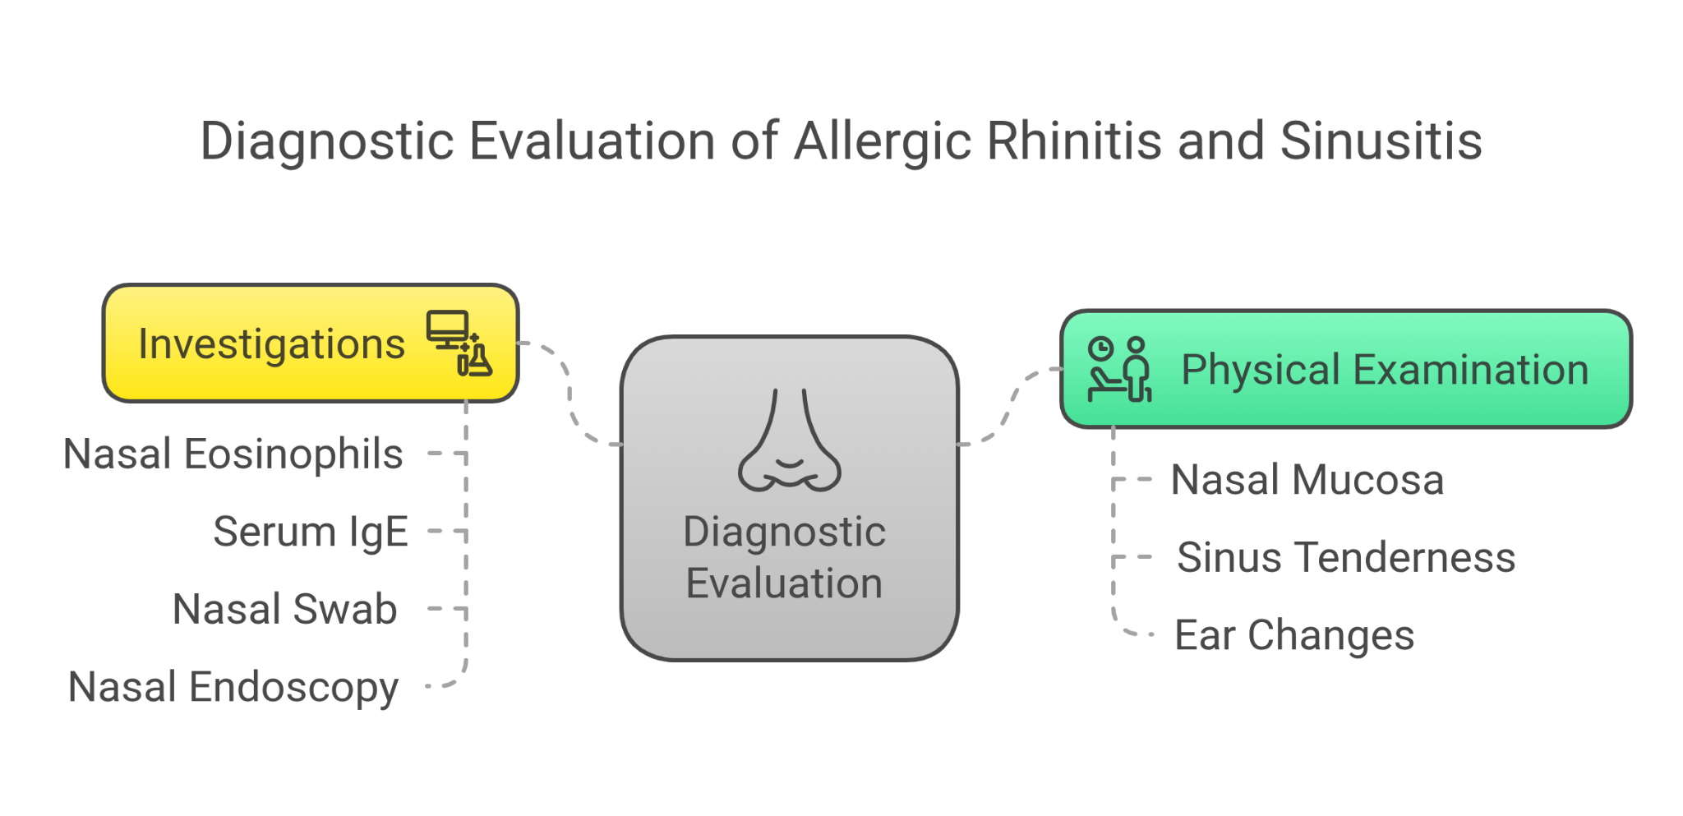

**Differential Diagnosis:**

1. Acute bacterial sinusitis superimposed on perennial allergic rhinitis
2. Viral upper respiratory tract infection with prolonged symptoms
3. Non-allergic rhinitis with secondary sinusitis
4. Structural nasal abnormalities

**Diagnosis:**

* **Primary:** Perennial allergic rhinitis with allergic shiners
* **Secondary:** Acute bacterial sinusitis

**Management:**

1. **Pharmacological Treatment:**
   * **Antibiotic:**
     + *Oral Amoxicillin-Clavulanate Suspension (250 mg/5 mL):* 10 mL twice daily for 10 days.
   * **Corticosteroid:**
     + *Fluticasone Propionate Nasal Spray (50 mcg/spray):* Two sprays in each nostril once daily in the morning.
   * **Antiallergic Therapy:**
     + *Fexofenadine 120 mg Tablet:* One tablet once daily in the evening for 10 days to alleviate allergic symptoms.
   * **Analgesic:**
     + *Oral Paracetamol Tablet (500 mg):* One tablet every 6–8 hours as needed for headache and facial pain (ensuring no more than three doses per day).
2. **Supportive Measures:**
   * **Nasal Saline Irrigation:** Twice daily to clear nasal mucus and reduce congestion.
   * **Hydration and Rest:** Encourage increased fluid intake and adequate rest.
3. **Parental Education:**
   * Detailed explanation of medication dosing based on weight and the importance of adhering to the treatment regimen.
   * Discussion of potential side effects (e.g., drowsiness from levocetirizine) and guidance on allergen avoidance strategies (e.g., dust mite control, mold reduction).
   * Advice to monitor for symptom worsening and to complete the full course of antibiotics.

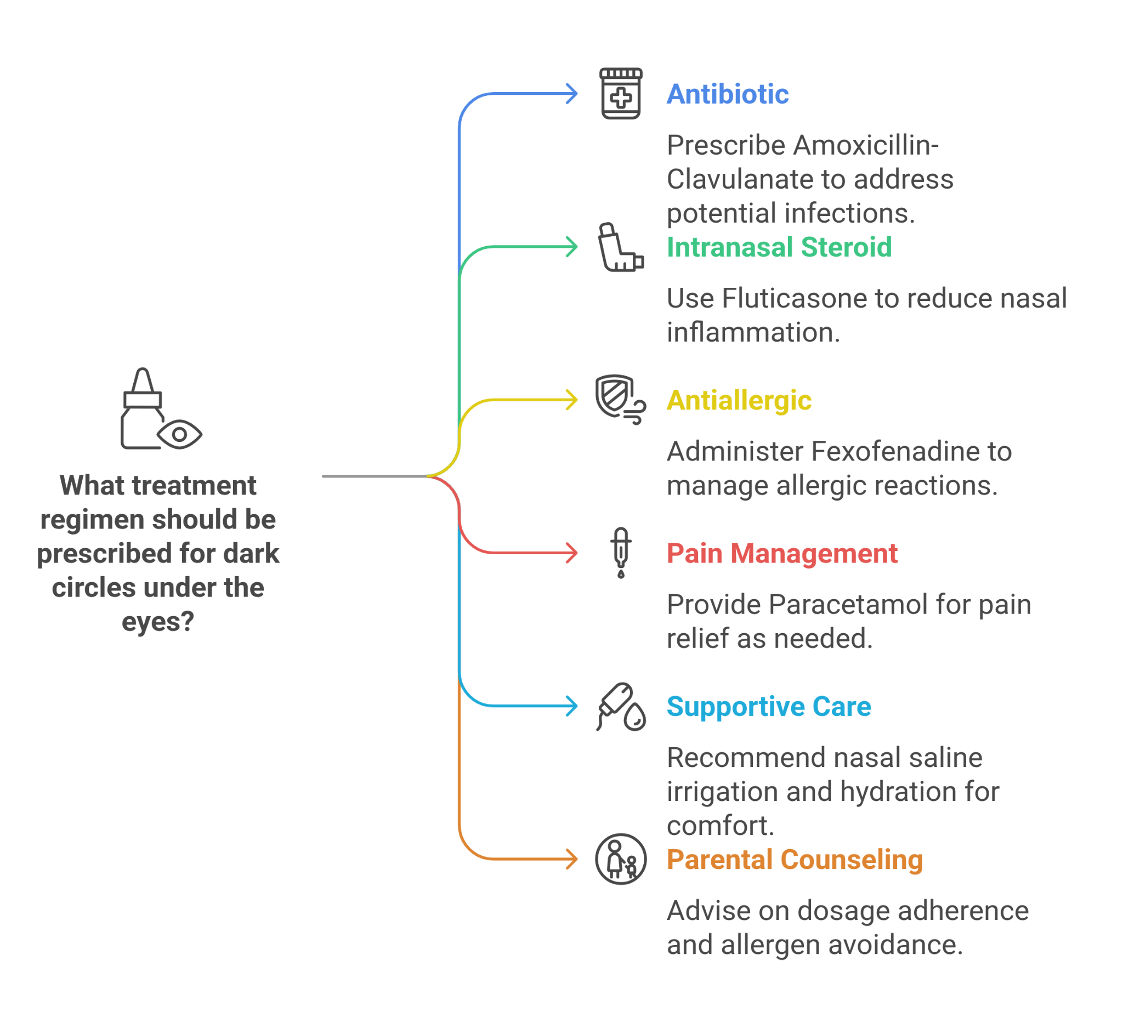

1. **Follow-Up:**
   * Short-term: Parents were instructed to seek re-evaluation within 48–72 hours if symptoms worsened.
   * Long-term: A follow-up appointment was scheduled at 4 weeks to assess the resolution of sinusitis and allergic symptoms.

**Outcome:** At the 4-week follow-up, Priya’s nasal congestion, purulent discharge, and facial pain had resolved significantly. Her allergic symptoms were well controlled, and the left ear findings had normalized with restored tympanic membrane mobility. Priya was advised to continue maintenance therapy with intranasal corticosteroids and, if needed, the levocetirizine–montelukast tablet.

**Discussion:** This case demonstrates how a comprehensive approach can effectively manage the overlapping issues of chronic allergic rhinitis and acute bacterial sinusitis in a pediatric patient. Priya’s longstanding allergic inflammation contributed to Eustachian tube dysfunction and subsequent otitis media. The integrated treatment—using targeted antibiotics, intranasal corticosteroids, and an oral anti histaminic tablet—addressed both the infectious and inflammatory components. Supportive care and parental education further enhanced the overall management, underscoring the importance of individualized treatment strategies in pediatric practice.

**Conclusion:** A multimodal approach that combines weight-based pharmacotherapy with supportive care is crucial in managing pediatric allergic rhinitis complicated by bacterial sinusitis. Priya’s case highlights the efficacy of this strategy in resolving acute symptoms and improving long-term allergic control, emphasizing the need for tailored treatment regimens and allergen avoidance education in pediatric patients.

**Case Study: Management of Allergic Rhinitis Complicated by Acute Otitis Media in a 6-Year-Old Indian Child**

**Introduction:** Allergic rhinitis is a common pediatric condition characterized by sneezing, nasal congestion, and rhinorrhea. In some cases, prolonged allergic inflammation can lead to complications such as acute otitis media. This report describes the evaluation and management of a 6-year-old boy with a longstanding history of allergic rhinitis who presented with new-onset left ear pain, ultimately diagnosed as acute otitis media.

**Case Presentation:**

**Patient Profile:**

* **Name:** Rohan (de-identified)
* **Age:** 6 years
* **Weight:** Approximately 19 kg
* **Residence:** Urban area, India
* **Past Medical History:** No significant past illnesses; family history of allergic rhinitis (elder sister).

**Chief Complaints:**

* Persistent sneezing and clear, watery rhinorrhea for 3 days.
* Marked nasal congestion causing difficulty in breathing, particularly at night.
* Left ear pain described as a dull ache with occasional sharp twinges, accompanied by decreased hearing.
* Increased irritability and difficulty sleeping.
* No fever, cough, or sore throat reported.

**Physical Examination:**

* **General:** Rohan appeared well-nourished but in mild discomfort.
* **ENT Examination:**
  + *Nose:* The nasal mucosa was pale and edematous with clear watery discharge. Nasal turbinates were significantly swollen, leading to marked narrowing of the nasal passages. A nasal smear was obtained for eosinophil count.
  + *Throat:* Mild post-nasal drip was observed; no tonsillar enlargement or exudates.
  + *Ears:* The left tympanic membrane was bulging, erythematous, and exhibited loss of the normal light reflex; pneumatic otoscopy revealed reduced mobility. The right ear appeared normal.
* **Other Systems:** Respiratory, cardiovascular, and abdominal examinations were unremarkable.

**Laboratory Investigations:**

* **Nasal Smear for Eosinophils:** Increased eosinophils, consistent with an allergic process.
* **Total Serum IgE:** Elevated, further supporting an allergic etiology.

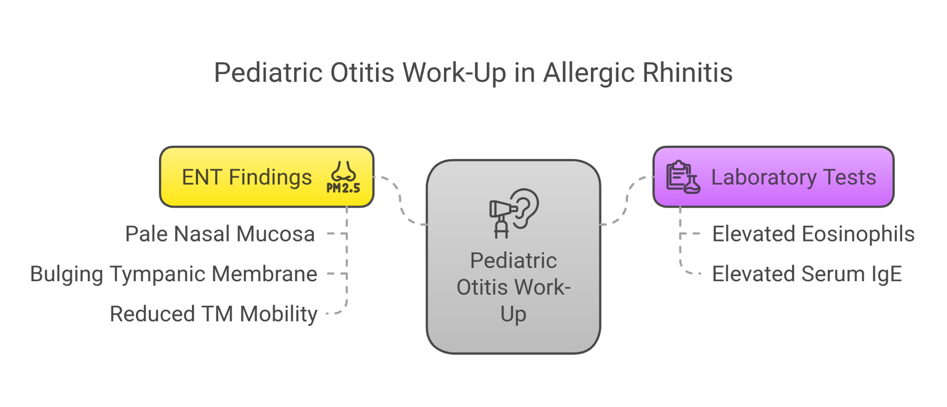

**Differential Diagnosis:**

1. Allergic Rhinitis with Secondary Acute Otitis Media
2. Viral Upper Respiratory Tract Infection
3. Bacterial Rhinosinusitis (less likely, given the absence of fever and thick, discolored discharge initially)
4. Otitis Media with Effusion (ruled out by the acute pain and tympanic membrane erythema)

**Diagnosis:**

* **Primary:** Perennial allergic rhinitis, supported by persistent sneezing, clear rhinorrhea, nasal congestion, positive nasal eosinophilia, and elevated total IgE.
* **Secondary:** Acute otitis media of the left ear, based on otoscopic findings and reported ear pain.

**Management:**

1. **Pharmacological Treatment:**
   * **Antibiotic:**
     + *Oral Amoxicillin Suspension (250 mg/5 mL):* 5 mL administered three times daily for 7 days.
   * **Analgesic:**
     + *Oral Paracetamol Syrup (250 mg/5 mL):* Approximately 5 mL per dose every 4–6 hours as needed (maximum four doses per day) for pain relief.
   * **Antiallergic Therapy:**
     + *Oral Fexofenadine suspension (30 mg per 5 ml):* 5 mL twice daily for 7 days to alleviate allergic rhinitis symptoms.
2. **Supportive Measures:**
   * Encourage increased fluid intake to maintain hydration.
   * Provide rest and use warm compresses on the affected ear for additional pain relief.
3. **Parental Education:**
   * Detailed instructions on the dosage and timing of medications based on Rohan’s weight (19 kg).
   * Discussion of potential side effects (e.g., mild drowsiness from levocetirizine and possible behavioral changes with montelukast).
   * Emphasis on completing the full course of antibiotics and on the importance of follow-up if symptoms persist or worsen.
   * Guidance on allergen avoidance measures, including reducing dust mite exposure.
4. **Follow-Up:**
   * A follow-up appointment was scheduled 7 days after initiating therapy to assess the resolution of the ear infection and improvement of allergic symptoms.

**Outcome:** At the 7-day follow-up, Rohan’s parents reported significant improvement. His left ear pain resolved within 48 hours of antibiotic initiation, and his nasal symptoms—sneezing, rhinorrhea, and congestion—improved considerably. Otoscopic re-evaluation showed the left tympanic membrane returning to near-normal appearance with improved mobility. Rohan was advised to continue the levocetirizine–montelukast suspension for an additional week for allergic rhinitis maintenance and to use nasal saline irrigation as needed. A referral to an allergist was arranged for further assessment.

**Discussion:** This case demonstrates the interplay between perennial allergic rhinitis and its potential complication of acute otitis media. Chronic nasal inflammation, as evidenced by eosinophilia and elevated IgE, predisposed Rohan to Eustachian tube dysfunction and subsequent middle ear infection. The management strategy included weight-based dosing of antibiotics and analgesics, along with targeted antiallergic therapy using an oral Fexofenadine suspension . Although high-dose amoxicillin is sometimes recommended for acute otitis media, the dosage selected (approximately 39 mg/kg/day) was deemed appropriate based on clinical judgment and local treatment protocols for mild to moderate infections. Supportive care and parental education further contributed to the positive outcome. This case emphasizes the need for a comprehensive, individualized approach in managing pediatric patients with overlapping allergic and infectious conditions.

**Conclusion:** A structured, multimodal approach addressing both the underlying allergic rhinitis and its acute complication—acute otitis media—resulted in a favorable outcome for Rohan. Weight-based dosing ensured safe and effective treatment, while supportive measures and parental education played critical roles in his recovery. Continued management and specialist referral are essential for long-term control of allergic rhinitis and prevention of future complications.

**Case Study: Multimodal Management of Seasonal Allergic Rhinitis and Associated Headache in an 8-Year-Old Boy**

**Introduction:** Seasonal allergic rhinitis is common among children and may be complicated by secondary symptoms such as headache due to nasal congestion and inflammation. This case study outlines the diagnostic evaluation and weight-based management of an 8-year-old boy whose seasonal allergic rhinitis was associated with recurrent mild headaches.

**Case Presentation:**

**Patient Profile:**

* **Name:** Aryan (de-identified)
* **Age:** 8 years
* **Weight:** 28 kg
* **Residence:** Semi-urban India
* **Past Medical History:** Seasonal allergic rhinitis
* **Family History:** Positive for atopy in first-degree relatives

**Chief Complaints:**

* Persistent sneezing, clear rhinorrhea, and watery, itchy eyes for several years (seasonal exacerbations)
* Prominent dark circles under the eyes
* Recent onset of dull, pressure-like headaches primarily in the afternoon on days with severe allergic symptoms

**Physical Examination:**

* **General:** Aryan appeared well-nourished, though slightly tired.
* **ENT Examination:**  - **Nasal Cavity:** Pale, edematous nasal mucosa with clear, watery discharge; swollen nasal turbinates; evidence of the “allergic salute.”  
    - **Eyes:** Mild conjunctival injection with watery discharge.
* **Other Systems:** Neurological and general systemic examinations were unremarkable.

**Diagnostic Investigations:**

* **Allergy Testing:** Skin prick test demonstrated significant sensitivity to grass and tree pollens, confirming seasonal triggers.

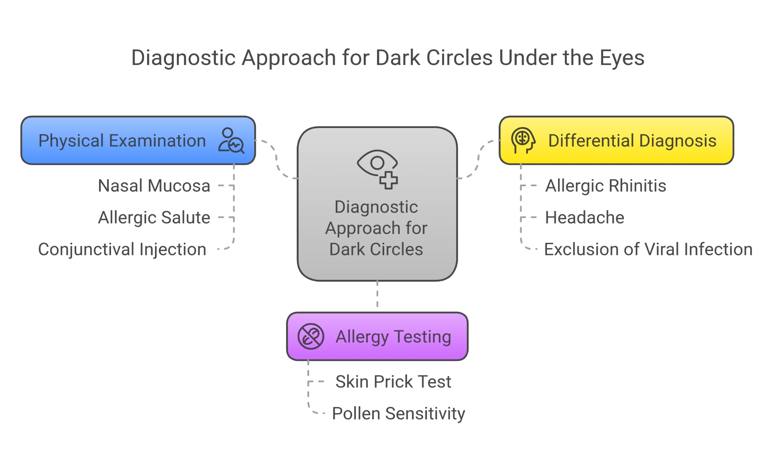

**Differential Diagnosis:**

1. Seasonal Allergic Rhinitis with Allergic Shiners
2. Headache secondary to nasal congestion and allergic inflammation
3. Viral upper respiratory infection

**Diagnosis:**

* **Primary:** Seasonal Allergic Rhinitis with associated allergic shiners
* **Secondary:** Headache likely secondary to nasal congestion and allergic inflammation

**Management:**

**Pharmacological Treatment:**

* **Antiallergic Therapy:**  - **Medication:** Levocetirizine Syrup   
    - **Concentration:** Levocetirizine 2.5 mg per 5 mL  
    - **Dosage:** 10 mL once daily in the evening
* **Intranasal Corticosteroid:**  - **Medication:** Budesonide Nasal Spray  
    - **Dosage:** One spray in each nostril once daily (administered in the morning)
* **Analgesic for Headache Relief:**  - **Medication:** Paracetamol Syrup (120 mg/5 mL)  
    - **Dosage:** 10 mL every 4–6 hours as needed (maximum four doses per day)

**Supportive Measures:**

* **Allergen Avoidance:**  - Parents were advised to minimize exposure to known allergens (e.g., keeping windows closed during high pollen periods, using air purifiers, and ensuring the child changes clothes and showers after outdoor exposure).
* **Non-Pharmacological Care:**  - Adequate hydration and rest.

**Parental Education:**

* Detailed explanation of the weight-based dosing and the importance of adherence to the treatment regimen.
* Discussion of potential side effects (e.g., mild drowsiness from levocetirizine) and strategies for allergen avoidance.

**Follow-Up:**

* **Short-Term:** Parents were advised to seek re-evaluation within 48–72 hours if Aryan’s symptoms worsened.
* **Long-Term:** A follow-up appointment was scheduled for four weeks to assess symptom resolution and treatment response.

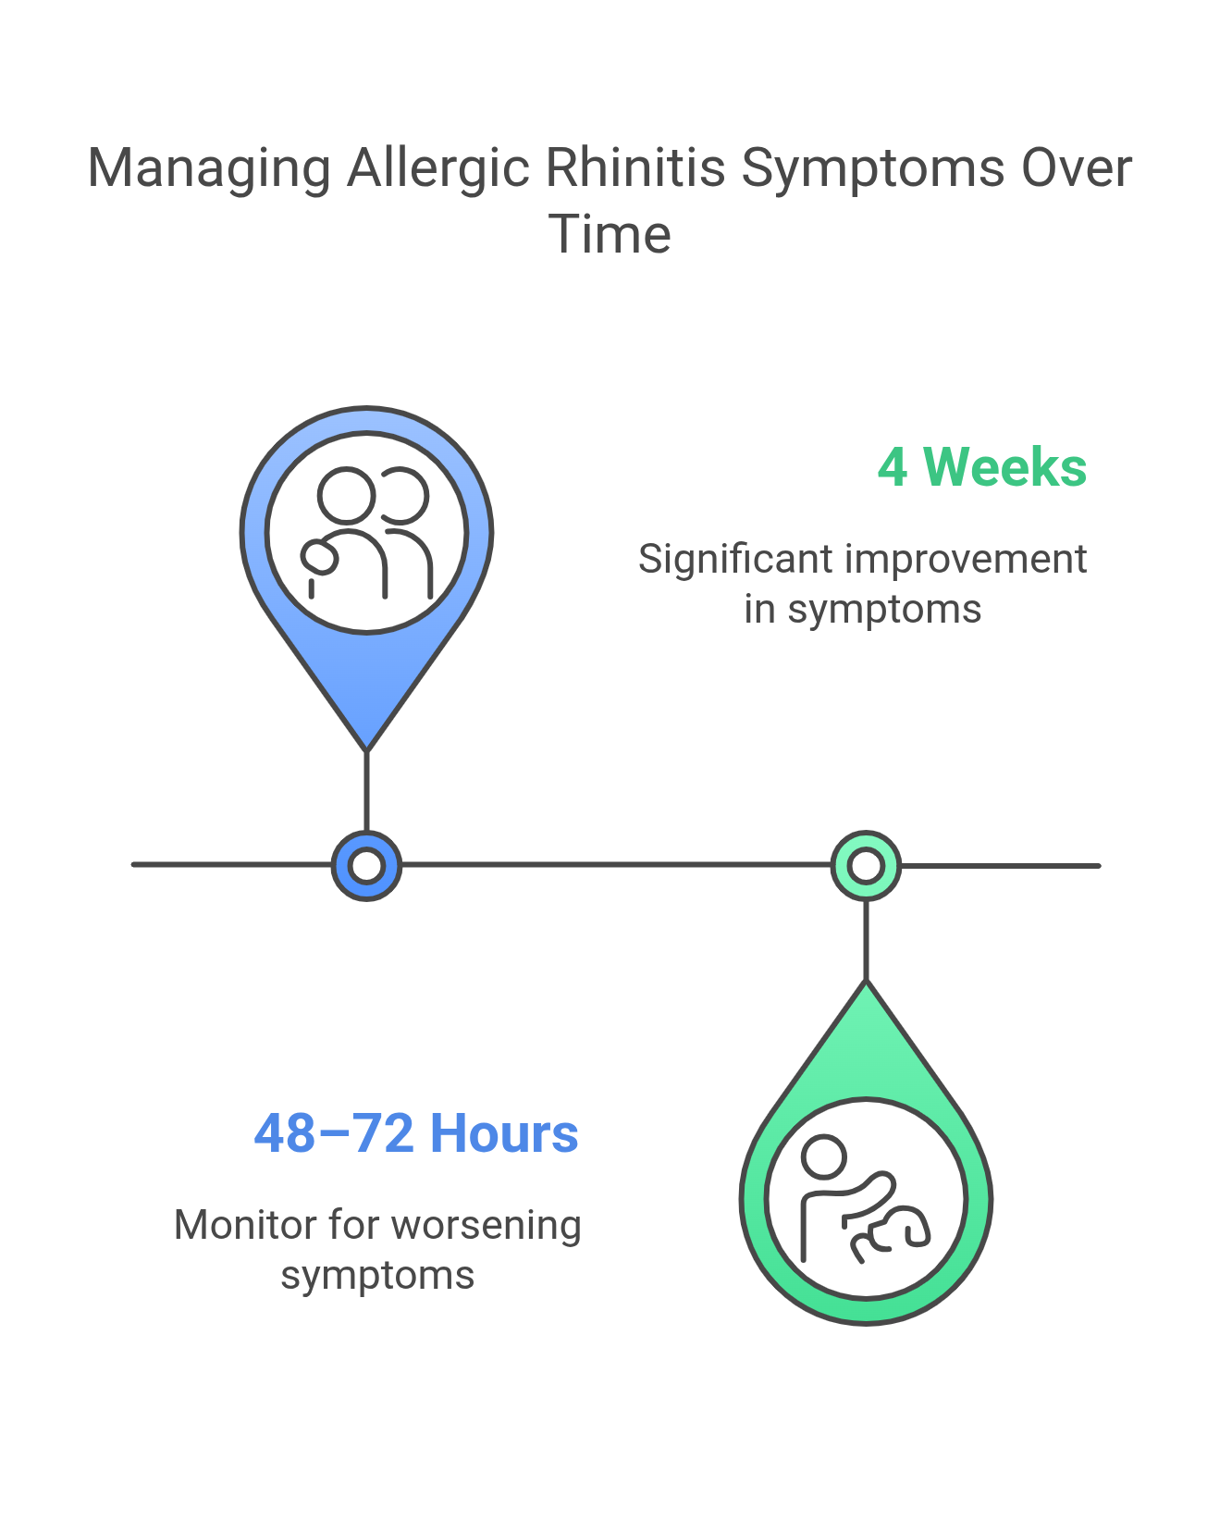

**Outcome:** At the four-week follow-up, Aryan’s nasal congestion and watery discharge had improved markedly. His headaches were effectively controlled with paracetamol, with relief noted within 30–45 minutes of administration. The overall allergic symptoms were well managed, and parental education on allergen avoidance was reinforced.

**Discussion:** This case illustrates the importance of a comprehensive, multimodal approach in managing seasonal allergic rhinitis complicated by secondary symptoms such as headache. Aryan’s treatment plan was tailored to his age (8 years) and weight (28 kg) using a combination of a levocetirizine syrup, intranasal corticosteroids, and paracetamol for symptomatic headache relief. Although the paracetamol dose (approximately 8.6 mg/kg) was on the lower end of the recommended range, it was sufficient for Aryan’s mild headache episodes. This approach underscores the significance of individualized treatment strategies and parental education in pediatric practice.

**Conclusion:** A comprehensive treatment strategy that includes weight-based pharmacotherapy and supportive measures is effective in managing seasonal allergic rhinitis and its associated symptoms in children. Aryan’s case demonstrates that appropriate use of an antiallergic combination, intranasal corticosteroids, and careful dosing of paracetamol can lead to significant improvement in both allergic and headache symptoms, ensuring better quality of life.